Data Dictionary — Alma Natural Cosmetics
This document describes the custom data model of the Alma Natural Cosmetics Salesforce org.

Object Relationships
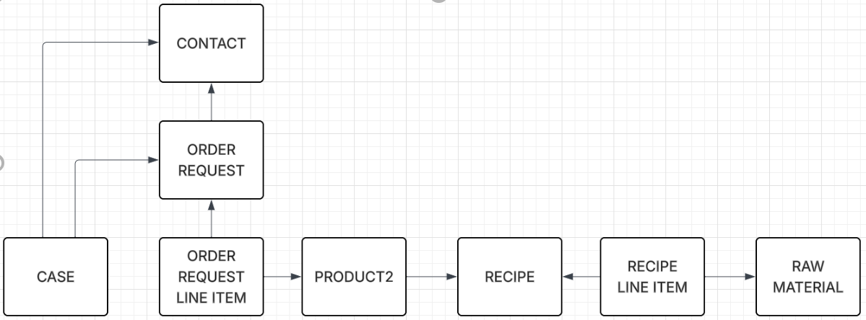

Contact (standard object — custom fields)
Standard Salesforce object representing a customer.
API Name | Label | Type | Description
Customer_Type__c | Customer Type | Picklist | Segmentation: Family, Friend, School, Known, New, Other
Communication_Preferences__c | Communication Preferences | Multiselect Picklist | Preferred channels: Email, Phone, WhatsApp, In Person
Opt_In__c | Opt In | Checkbox | Marketing communications consent
Opt_In_Date__c | Opt In Date | Date | Date consent was given
Product_Categories__c | Product Categories | Multiselect Picklist | Categories of interest: Cleaning, Cosmetics, Baby Cosmetics, Gels, Shampoo
Preference_Notes__c | Preference Notes | Long Text Area | Preferences, special requests, personal notes
First_Order_Request__c | First Order Request | Date | Date of the customer's first order
Last_Order_Request__c | Last Order Request | Date | Date of the customer's most recent order

OrderRequest__c — Order
Stores customer order headers. Auto-number: ORD-{0000}. Sharing model: ReadWrite.
API Name | Label | Type | Req | Description
Name | Order Number | Auto-number | — | Auto-generated identifier, e.g. ORD-0001
Contact__c | Contact | Lookup → Contact | — | Customer who placed the order
Order_Date__c | Order Date | Date | ✓ | Date the order was placed
Status__c | Status | Picklist | ✓ | Requested · In Progress · Ready · Delivered
Payment_Method__c | Payment Method | Picklist | — | Bizum · Cash · Bank Transfer
Total_Amount__c | Total Amount | Currency | — | Calculated by Flow — sum of all line items including deposits
Notes__c | Notes | Long Text Area | — | Internal notes, delivery instructions, special requests

OrderRequestLineItem__c — Order Line Item
Individual product lines within an order. Auto-number: LI-{0000}. Sharing model: Controlled by Parent.
API Name | Label | Type | Req | Description
Name | Line Item Name | Auto-number | — | Auto-generated identifier, e.g. LI-0001
OrderRequest__c | Order Request | Master-Detail → OrderRequest__c | ✓ | Parent order — deleting the order deletes all its line items
Product__c | Product | Lookup → Product2 | — | Product from the Alma catalogue
Quantity__c | Quantity | Number | ✓ | Units ordered
Unit_Price__c | Unit Price | Currency | ✓ | Price per unit at the time of the order
Deposit_Container__c | Deposit Container | Checkbox | — | Whether a container deposit is included (return programme)
Deposit_Price__c | Deposit Price | Currency | — | Deposit amount — discounted on next order when container is returned
Photo__c | Photo | URL | — | Link to product photo (Google Drive or external storage)

Product2 — Product (standard object — custom fields)
Standard Salesforce product catalogue, extended with Alma-specific fields.
API Name | Label | Type | Description
Price__c | Price | Currency | Selling price
Production_Cost__c | Production Cost | Currency | Production cost, excluding container deposit
Deposit_Price__c | Deposit Price | Currency | Container deposit amount for this product
Stock__c | Stock | Number | Units currently available
Batch_Production__c | Batch Production | Number | Units produced per batch
Quantity_ml__c | Quantity (ml) | Number | Product volume in ml
Euros_Margin__c | Euros Margin | Currency | Margin in euros (Price − Production Cost)
Margin_Percent__c | Margin % | Percent | (Margin / Cost) × 100
Recipe__c | Recipe | Lookup → Recipe__c | Recipe linked to this product
Product_Image__c | Product Image | HTML | Image of the finished product

Recipe__c — Cosmetic Recipe
Stores the formulation (recipe) for each cosmetic product.
API Name | Label | Type | Description
Name | Recipe Name | Text | Name of the recipe
Description__c | Description | Text | Recipe description
Product_Category__c | Product Category | Picklist | Cleaning product · Cosmetic · Kids cosmetic · Shower gel · Shampoo
Skin_Type__c | Skin Type | Picklist | Normal · Dry Skin · Oily Skin · Family Skin Care
PAO__c | PAO | Number | Period After Opening — months of use once opened
Expiration_Date__c | Expiration Date | Number | Shelf life in months (unopened)
Total_Quantity_ml__c | Total Quantity (ml) | Number | Total ml produced by the recipe

Recipe_Line_Item__c — Recipe Ingredient Line
Each row represents one ingredient (raw material) and its quantity within a recipe.
API Name | Label | Type | Description
Recipe__c | Recipe | Lookup → Recipe__c | Parent recipe
Raw_Material__c | Raw Material | Lookup → Raw_Material__c | Ingredient used
Quantity__c | Quantity | Number | Amount in grams
Price__c | Price | Currency | Cost of this ingredient in the recipe

Raw_Material__c — Raw Material
Ingredient catalogue used in cosmetic recipes.
API Name | Label | Type | Description
Name | Raw Material Name | Text | Common name of the ingredient
INCI__c | INCI | Text | Official name per INCI nomenclature (International Nomenclature of Cosmetic Ingredients)
Material_Category__c | Material Category | Picklist | Tensionactivo · Principio activo · Aceite esencial/Aroma · Liquido · Conservante · Emulsionante · Aceites
Quantity__c | Quantity | Number | Stock in grams
Price__c | Price | Currency | Price in euros

Generated from Salesforce metadata · Alma Natural Cosmetics · 2026

