Project: Mzimkhulu water

The project is going to give people of Mzimkhulu 15 Jojo water tanks. In the project we will buy Jojo tanks, Transport them and than install them. The project is sponsered by the Mzimkhulu housing counsel and the Jojo tanks are temporary before taps are put in the houses.

1. Stakeholder list

Stakeholder

|  |  |  |  |  |  |
| --- | --- | --- | --- | --- | --- |
| Stakeholder | support | influance | Impact | Attitude | Tactic to get more support |
| Mzimkhulu housing counsel | high | high | high | They want the project to succeed so its high | Nothing |
| Jojo tank seller | high | low | high | They are getting a tender and will want more so they support us | Nothing |
| Track owner | high | low | high | They are getting a tender and will want more so they support us | Nothing |
| Workers/ tank installers | mediam | Low | high | They are just doing their job they don’t care about the project | we will promise them bonus |
| Community | high | high | high | The community will benefit from the tanks so they support the project | We will update the community all the time 00 |
| Project manager | High | High | High | I will give the project a lot of support because it will make me a better project manager and I will manage more projects | I am very motivated |

|  |  |
| --- | --- |
| **Project management** | **General management** |
| temporary | Ongoing and repetitive |
| People from different places work together | People from the same department work together |
|  |  |

1. The Mzimkhulu housing counsel will give a lot of support, influence and impact because they sponaring the project and want to see it succeed and they can pull out of the project anytime. We will get the Jojo tanks from the seller who is 50 km away from the community we will be buying 15 Jojo tanks. Because this is a government job they will want to support us to they can get more tenders. The truck owner will want more jobs as well so they will give us support. They boys that will be working will be doing their work and they will not care if the project succeeds or not so we will give them bonus to encarage them. The community can strick and stop us from working to we must make show they are ok when the work goes on.

Task 2

1. Email, telephone, sms

The project team must communicate everyday during the project. I as the project meneger will have a meeting with the workers everyday. I will communicate with the Jojo tank seller everyday until the sale is final. I will talk to the community everyweek in a meeting and I will also see them and talk to them everyday as I come to the work site. I will communicate with the Mzimkhulu housing counsel at the beginning of the project and at the end of the project when we finish

Confidatial information at FNB are customer detials

1. Communication strategy

|  |  |  |  |
| --- | --- | --- | --- |
| For who | From who | objective | Key stakeholders |
| Community | Project manager | So they calm down and accept the work | * Community * Workers * Mzimkhulu housing counsel |
| Mzimkhulu housing counsel | Project manager | To make sure that everyone knows how many we will be installing | * Mzimkhulu housing counsel * Seller of the Jojo tanks * Truck driver |
| Workers | Project manager | So that everyone know their job | * workers |
|  |  |  |  |

1. Email

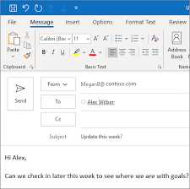

I communicate with the Mzimkhulu housing counsel with email

Meetings

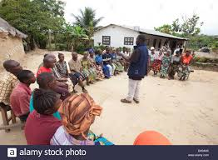

I will have meetings with the community

Invoice

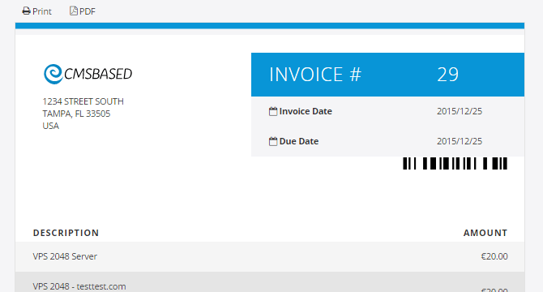

I will give the driver of the truck the invoice to go collect the Jojo tanks

Task 3

Risk

|  |  |  |
| --- | --- | --- |
| **Risk** | **Response** | **Contengency** |
| **Stakeholders** |  |  |
| A worker getting hurt on the job | Mitigate | We will give them PPE |
| Workers not coming to work | Mitigate | We will get more boys to work |
| **Resource** |  |  |
| The Jojo tanks not being avialible | Mitigate | We will order before the project starts |
| Jojo tanks breaking | Mitigate | We will order extra but only buy what we need |
| Delays | Mitigate | We will calm down the community and adjust our schedule |
| **Quality** |  |  |
| If the boys don’t do good work | mitigate | We will add money for their bonuses |
| Water not being delivered | Avoid | The delivery of the water is not in the scope of the project |
| **Financial** |  |  |
| If the price of the Jojo tanks goes up | Mitigate | We will have reseaves we will take from |

Task 4

|  |  |  |
| --- | --- | --- |
| **Team member** | **Role and responsibility** | **Performance indicate** |
| Jojo tank seller | They must sell us jojo tanks | They must provide good quality jojo tanks |
| Track owner | He must fetch the Jojo tanks from the seller to the site | All Jojo tanks delivered at the site in one peace |
| Workers/ tank installers | Install the Jojo tanks at the site | They must install the Jojo tanks at the places we have set |

* + Jojo tank seller:
    - * + Role: Sell Jojo Tanks
        + Expectation: They must provide good quality jojo tanks
        + Tasks:

Take my order

Give me a quatation

Accept payment

Give me an invoice and tell me the date for collection

* + - * + Signiture: ___________________________
  + Truck driver
    - * + Role: collect the Jojo tanks from the seller and bring them to the site
        + Expectation: All Jojo tanks delivered at the site in one peace
        + Tasks:
    1. Drive to the seller with the workers
    2. Load the Jojo Tanks that can fit on the truck
    3. Drive back to the site
    4. Offload the Jojo tanks
    5. Repeat untill all tanks are at the site
       - * Signiture: ___________________________
  + Workers/ tank installers
    - * + Role: Help the driver collect the Jojo tanks and install the tanks
        + Expectations: Jojo tanks that are installed and ready to work
        + Task:
    1. Help the driver collect the tanks
    2. Offload the tanks at the site
    3. Position the tanks
    4. Build the structure for the tanks
    5. Place the tanks
       - * Signiture: ___________________________
* Making my order for the Jojo from the seller

From: Mfundo Mjoli

To: Jojo tank seller

Massage:

Good day sir

I would like to order 17 Jojo tanks for the Mzimkhulu community. I need 15 tanks the 2 are incase anything happens.

Regards

Mfundo Mjoli

Project manager

Quatation from the Jojo tank supplier is evidance of perfomance

The seller gave me the quatation on time

* Instruction to the truck driver to collect the Jojo tanks
  + Instruction: I will send him a Whatsapp telling him the direction to the jojo tanks shop
  + Evidance: the Jojo tanks where delivered to the work site
  + All the jojo tanks where delivered in good condition
* Instruction to the workers to Installing the jojo tanks

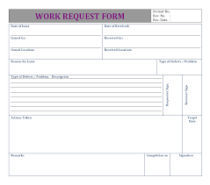

Here I write all the work that the boys will do

* Evidance: all the Jojo tank are installed and ready to work
* Feedback: the boys did a good job all the Jojo tanks are installed like I wanted

Task 5

* + - 1. Scope

**Project description**

The project is going to give people of Mzimkhulu 15 Jojo water tanks. In the project we will buy Jojo tanks, Transport them and than install them. The project is sponsered by the Mzimkhulu housing counsel and the Jojo tanks are temporary before taps are put in the houses.

**Deliverables**

15 Jojo tanks installed and ready for water

**Stakeholders**

Mzimkhulu housing counsel

Jojo tank seller

Track owner

Workers/ tank installers

Community

Project manager

**Resources Required**

Human resources

* 6 Workers

Material

* 15 jojo Tanks
* Structure wood

**Acceptance criteria**

* 15 Jojo tanks installed and ready for water

**Limitations & Risk**

* The Risk management plan was done in task 3

**Assumption and exclusions**

TheMzimkhulu housing counsel will bring water to the community

* + - 1. Project schedule
  + Delivarables: the
  + WBS
  + Gantt chart: the Gantt chaer is attached
  + Change log

|  |  |
| --- | --- |
| **Content** | **Description** |
| Change discription | Changing from a 260 L tank to a 500 L tank |
| By | Project manager |
| Priority | High |
| Raised by | Community leaders |
| Date raised | 3 Aug 2020 |
| Status | Approved for anlysis |

3.Stakeholder management was done in 1

4.Risk management was done in task 3

5.Project Budget

|  |  |  |  |
| --- | --- | --- | --- |
| Discription | Budgeted | Actual | Variance |
| Jojo tanks x15 | 81000 | 67500 | -13500 |
| Truck hire | 2500 | 2800 | 200 |
| Workers x 6 | 9000 | 9000 | 0 |
| Wood | 12000 | 10000 | -2000 |
| Equipment | 1000 | 900 | -100 |
| PPE | 4000 | 3500 | -500 |
|  | 109500 | 93700 | -15800 |

6.Team performance management was done in task 4

7.