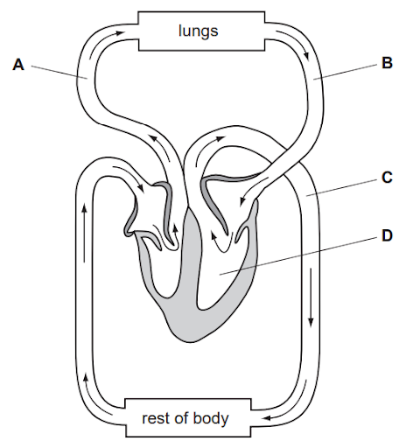
Theme; Excretion
TOPIC; EXRETION IN ANIMALS
Excretion is the removal of waste products of metabolism from the body. Metabolism refers to chemical processes (reactions) that occur within a living organism to maintain life.
There are two types of metabolism namely
1. Anabolism
This refers to biochemical reactions that build up large and complex molecules from small and simple molecules. Eg photosynthesis that forms large molecules (glucose molecules) from small molecules (water and carbon dioxide molecules).
2. Catabolism
This refers to biochemical reactions in which large and complex molecules are broken down into simple small molecules eg respiration.
Exercise
Name the excretory products formed during photosynthesis and during respiration.

The need to remove unwanted substances from the body
- Excretion removes toxic waste products eg carbon dioxide whose accumulation in the body would cause death of the organism.
- Excretion removes excess materials in the body which when left to accumulate would cause chemical imbalances in the body.
- Excretion maintains the internal environment (tissue fluid) within normal range whose deviation would affect body’s metabolic reactions.

Types of excretory products
- Nitrogenous excretory products
These are excretory products that contain nitrogen. These include ammonia, urea, uric acid and trimethylamine oxide. These are produced as a results of deamination of amino acids.
2. Non-nitrogenous excretory products
These are excretory products that contain no nitrogen. Eg carbon dioxide, bile pigments, excess water, and excess salts.
Excretion, Egestion, and Secretion
Excretion is the removal of metabolic waste from cells. Egestion is the removal of undigested and indigestible food materials from the digestive system. Secretion is release of useful substances eg saliva, mucus, etc from cells.
Egested substances eg faeces are not excretory products because they are not involved in metabolism. Although digestion involves chemical reactions, it does not occur in cells to sustain life processes.
Also secretions eg saliva and mucus are not excretory products because they would not accumulate in cells and become toxic.
IMPLICATIONS IF LIVING CELLS FAIL TO REMOVE EXCRETORY PRODUCTS
If carbon dioxide is not removed from cells, it would react with water to form carbonic acid. This would lower the pH within cells leading to denaturation of enzymes. This in turn would slow down metabolism leading to death of an organism.
If ammonia, is not removed from cells, it would raise the pH of cells which would denature enzymes.
If other waste products eg excess water, excess salts, urea, etc are not removed, they would affect the osmotic balance between cells and tissue fluid, resulting in cells gaining or losing water by osmosis leading to bursting or crenation of cells.

EXCRETORY ORGANS
The organs used to remove excretory products from the body are called excretory organs. The table below shows some organisms and their excretory organs.
Organism | Excretory organs
Amoeba | Contractile vacuole
Platyhelminthes eg tapeworm | Flame cells
Annelids eg earth worm | Nephridia
Insects | Malpighian tubules
Fish | Kidneys, gills
Amphibians | Skin, lungs, kidneys
Reptiles | Kidneys, lungs
Birds | Kidneys, lungs
Mammals eg humans | Kidneys, lungs, skin, liver
Different excretory organs excrete different excretory products as shown in the table below

Organ | Excretory products
Skin | Traces of urea, ammonia, lactic acid, excess mineral salts, carbon dioxide and excess water. These waste products are excreted as sweat
Lungs | Carbon dioxide and excess water
Kidney | Urea, ammonia, uric acid, excess salts and excess water. These are excreted as urine
Liver | Bile pigments,

Exercise
Copy and complete the table below
Excretory organ | Main excretory product | Where it is made | How it is made | Excreted as
Lungs
Kidney
Skin
Liver

THE MAMMALIAN EXCRETORY SYSTEM
The excretory system in mammals consists of the following organs and structures
- Kidneys
- Ureter
- Urinary bladder
- Urethra

Diagram showing Human Excretory system

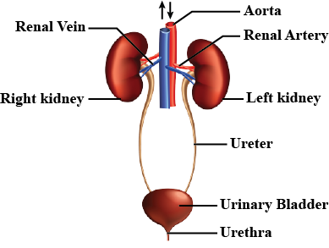
Functions of parts
- Renal artery; carries oxygenated blood to kidneys
- Renal vein; carries deoxygenated blood from kidneys to vena cava
- Kidneys; remove excretory products from blood and form urine
- Ureter; carries urine from kidneys to urinary bladder
- Urinary bladder; stores urine temporarily. When it is filled, one fills the urge to urinate
- Urethra; it is a passage of urine from urinary bladder to outside

THE MAMMALIAN KIDNEY
The mammalians kidneys are a pair of bean-shaped organs located on either sides of the vertebral column, below the ribcage.
Functions of Kidneys
1. Excretion; it removes urea, excess water, excess salts, etc from the body.
2. Osmoregulation; it regulates the amount of water and mineral salts in the body.
3. Secretion of Hormones; it secretes some hormones eg renin, angiotensin and erythropoietin
4. Regulation of blood pressure
5. Regulation of pH of body fluids

Structure of Mammalian Kidney

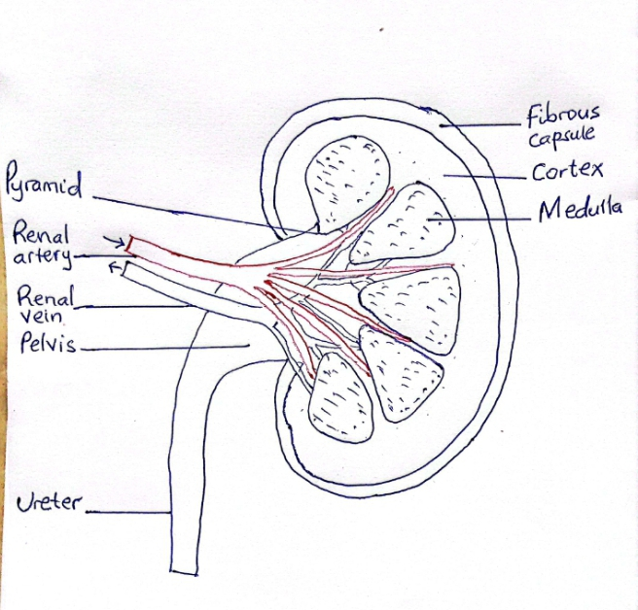

1. Cortex; It contains dense network of capillaries called glomeruli (singular glomerulus), Bowman’s capsule and convoluted tubules of a nephrons. It is dark red in colour.
2. Medulla; it contains loops of Henle and collecting ducts of nephrons. It is pale red in colour. It consists of several cone-shaped structures called pyramids.
3. Pelvis; It is the expanded upper part of ureter. It collects urine from collecting ducts.

THE NEPHRONE
The nephron is the structural and functional part of a kidney. A single kidney is composed of millions of nephrons and they are these nephrons which carry out the functions of the kidney

Structure of a nephron
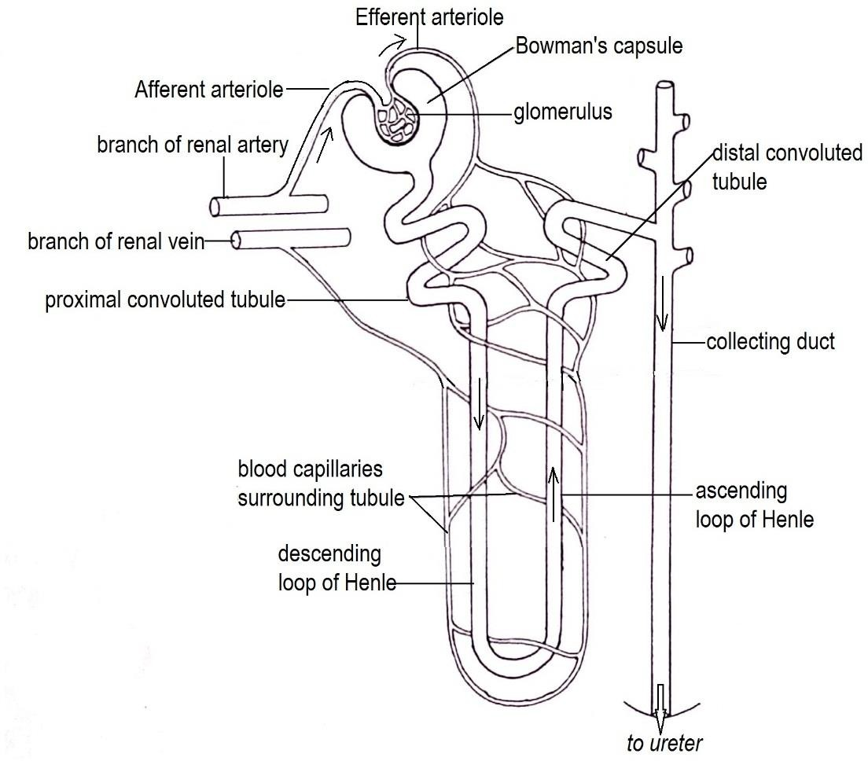
Parts of a nephron
1. Afferent arteriole; it carries oxygenated blood from renal artery to glomerulus.
2. Efferent arteriole; it carries oxygenated blood from glomerulus to vasa recta (blood capillaries that surround the loop of Henle)
3. Glomerulus; it is a dense network of blood capillaries surrounded by Bowman’s capsule where ultrafiltration occurs to form glomerular filtrate.
4. Bowman’s capsule; it is a cup-shaped structure that collects glomerular filtrate.
5. Proximal convoluted tubule; it where most selective reabsorption occurs. Here all glucose, amino acids, some water and mineral salts are reabsorbed.
6. Loop of Henle; it is a U-shaped tubule with two limbs namely the descending limb and the ascending limb. Most water is reabsorbed from glomerular filtrate in the descending limb whereas most of sodium ions are reabsorbed in the ascending limb.
7. Distal convoluted tubule; it is where tubular secretion (secretion of some substances into glomerular filtrate) and reabsorption of some water and salts occurs.
8. Collecting duct; it collects glomerular filtrate from several distal convoluted tubules and it where concentration and volume of urine is controlled.

HOW URINE IS FORMED (URINE FORMATION PROCESS)
The process of urine formation takes place in the nephron. It occurs in three processes namely
- Ultrafiltration
- Selective reabsorption
- Tubular secretion

Ultrafiltration
It is the formation of glomerular filtrate from blood due to high pressure in the glomerulus. Blood from renal artery enters glomerulus under high pressure. This high pressure forces small molecules and ions such as water, glucose, amino acids, and mineral ions, urea, hormones, vitamins, etc out of blood into the capsular space through small pores in the capillary wall.
Much blood enters the glomerulus through afferent arteriole than that which leaves through efferent arteriole because the afferent arteriole is wider than the efferent arteriole.
Plasma proteins and blood cells are retained in the blood capillaries because they are too large to pass through the small pores in the capillary walls.
Selective reabsorption
It is the movement of some substances from the glomerular filtrate back to blood. From capsular space, the glomerular filtrate flows into proximal convoluted tubule where useful substances are selectively reabsorbed back into the blood capillaries.
In the proximal convoluted tubule, all the glucose, amino acids, vitamins, hormones and a big percentage of sodium chloride and water are reabsorbed into the blood capillaries. The glomerular filtrate flows into loop of Henle.
In the descending limb of the loop of Henle, water is reabsorbed back into the capillaries by osmosis leading to increased concentration of the filtrate down the descending limb.
In the ascending limb, sodium chloride is reabsorbed by active transport. The glomerular filtrate flows to the distal convoluted tubule.
In the distal convoluted tubule, selective reabsorption of salts occurs. Also water is reabsorbed depending on the permeability of the tubules which is affected by hormones.
Tubular secretion
It is the movement of some unwanted substances from blood into glomerular filtrate. It primarily occurs in the distal convoluted tubule. Substances secreted are potassium ions, hydrogen ions, drugs and ammonium ions.
From distal convoluted tubule, the glomerular filtrate flows to the collecting ducts. Here more
water is reabsorbed under the control of a hormone called ADH (antidiuretic hormone) depending on the concentration of blood. If blood is more concentrated (contains less water), more water will be absorbed from glomerular filtrate into blood. However, if blood is dilute (contains more water), less water or no water will be absorbed from glomerular filtrate.
The remaining filtrate is now called urine. The urine drains into the pelvis. It then flows to the urinary bladder through the ureter.
Diagram showing urine Formation
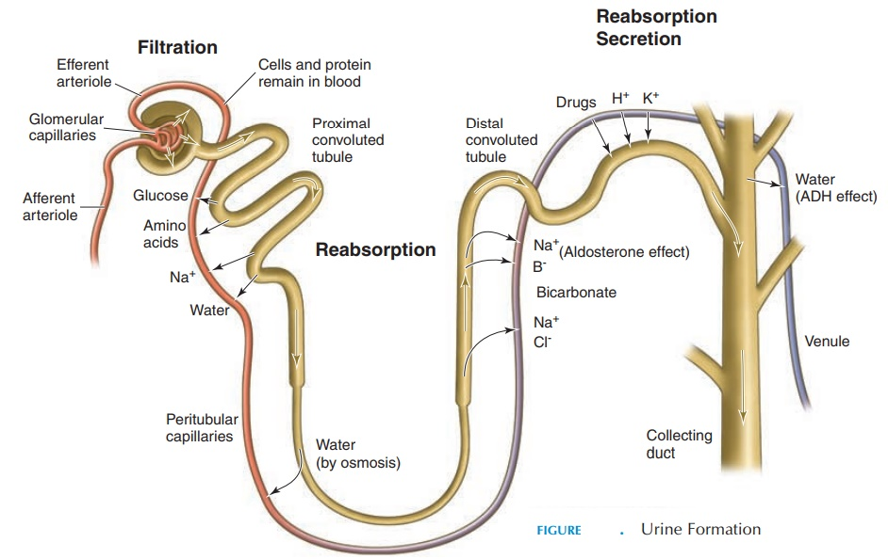

Comparison of proportions of substances in blood and in urine
Substance | Percentage in blood | Percentage in urine
Urea | 0.03 | 2.0
Proteins | 7-9 | 0
Glucose | 0.1 | 0
Chloride ions | 0.37 | 0.6
Sodium ions | 0.32 | 0.35
Water | 93 | 95
1.a) Using the information in the table above state substances that are
i. in blood but not in urine
ii. at high concentration in urine but at less concentration in blood
b. Explain why the substances you named in (a)(i) are present in blood but absent in urine
HOW URINE IS EXCRETED (urination process)
Urine flows from collecting ducts to ureters and trickles down to the urinary bladder. The urethral sphincter muscles close the exit from urinary bladder to urethra to prevent urine from escaping. As the urinary bladders fills with urine, it stretches and when it reaches certain volume, stretch receptors send nerve impulses to the brain and one feels the urge to urinate.
To urinate, the brain sends nerve impulses to the urethral sphincter muscles to relax and open the orifice, letting urine flow out of urinary bladder into the urethra to be passed out of the body.
EXERCISE
1. Study the diagram below to answer the questions that follow
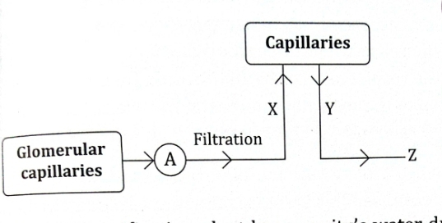
a. Name the part labelled A, giving its adaptations to its function
b. Identify the processes labelled X, Y, and Z
c. Give the importance of processes Xand Y
2. A water purification plant keeps the water of a city clean as it removes waste from water. How can this be likened to the kidneys in the human body.

HOW CARBON DIOXIDE LEVELS AFFECT BREATHING RATE
When the level of carbon dioxide in blood increases, the breathing rate also increases to remove more carbon dioxide from the body. During aerobic respiration, cells use oxygen and produce carbon dioxide as a by-product. Carbon dioxide then diffuses into blood to lungs to be excreted.
During vigorous exercise, the rate of respiration increases to produce the more energy required and so does the amount of carbon dioxide in the blood. Increased levels of carbon dioxide in blood stimulates the respiratory centre in the brain which in turn sends nerve impulses to intercostal muscles, and diaphragm to contract, thus increasing the rate and depth of breathing. The volume of lungs is also increased during inspiration.
During exercise, the heart beat also increases. This increases the rate at which oxygen is transported to tissues and increases the rate at which carbon dioxide is transported from tissues to lungs for removal.
KIDNEY FAILURE (RENAL FAILURE)
It refers to loss of function by kidneys due to partial or entire destruction of nephrons. In this condition, kidneys do not work as they should.
Kidney failure can be acute or chronic. Acute kidney failure occurs suddenly and there is a chance that kidneys may recover and function again.
Chronic kidney failure on the other hand develops over a long period of time and leads to permanent loss of kidney function,
Causes of Kidney Failure
Acute kidney failure is caused by the following
- Low blood supply to kidneys due to over bleeding
- Swelling of kidneys
- Sudden blockage of ureters
- Very high blood pressure
- Severe dehydration
- Diabetes mellitus
- Low blood pressure
Chronic kidney failure is caused by the following
- Kidney infections
- Diabetes mellitus
- Hypertension
- Chronic glomerulonephritis
- Polycystic kidney disease
- Obesity
- Blocked urinary tract
Symptoms of kidney failure
- Decreased urine output
- Breathlessness
- Nausea and vomiting
- Swelling of hands, feet and face (oedema)
- Internal bleeding
- Confusion
- Seizures and coma
- Loss of appetite
- Yellow-brown skin colour
- Numbness and tingling
- Itching and easy bruising
- Chest pains
- Muscle twitches and cramps
Treatment of kidney failure
Acute kidney failure is treated by resolving the underlying cause eg by treating high blood pressure if it is the cause. Sometimes dialysis is necessary for a short time.
Chronic kidney failure is treated by dialysis or kidney transplant (surgical replacement of kidneys with healthy kidneys from a donor) if both kidney have failed below 10% of normal function.
Dialysis
It is a medical procedure in which a machine is used to remove waste products from blood of a person in case of kidney failure. There are two types of dialysis
1. Haemodialysis; tubes (catheters) from dialysis machine are connected into the vein of the patient in the neck, arm or leg. It is done at least three times a week in adults at a haemodialysis centre.

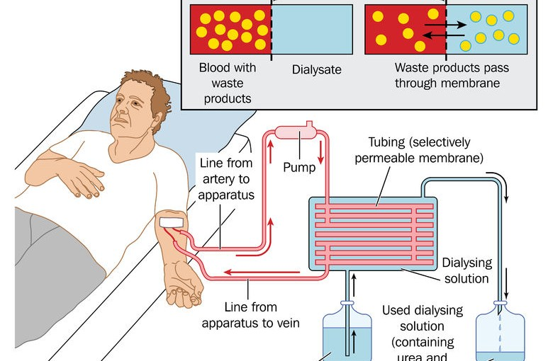

NB; Do not draw the above diagram
2. Peritoneal dialysis; it is done through a tube permanently set in the patients’ belly. It is done at least three times a day mostly in children at home.
NB. Do not draw this diagram 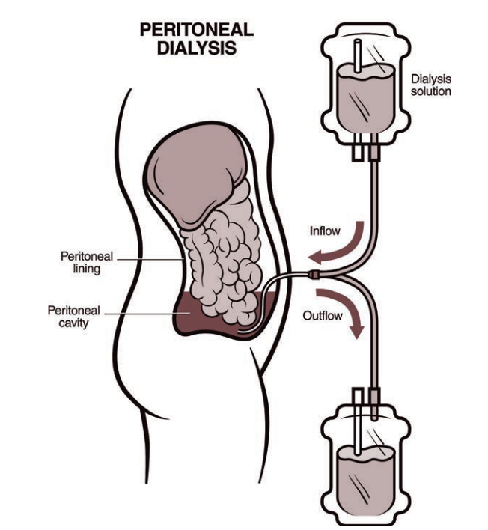
DETECTION OF GLUCOSE IN URINE
Activity
To determine whether urine contains glucose
Requirements
- Benedict’s solution
- Test tube
- Tube holder
- Two pipettes
- Urine sample
- Source of heat
What to do
i. Examine the urine sample carefully using your eyes and record its colour.
ii. Using a pipette, measure 5ml of Benedict’s solution and put it in a test tube.
iii. Using a separate pipette measure 5ml of the urine sample and add it into the test tube containing Benedict’s solution.
iv. Heat the mixture for two minutes.
v. Observe the colour changes if any
Discussion
i. What colour changes took place on heating the mixture?
ii. What conclusions can you make from the colours changes observed?
iii. What set-up can be used as a control experiment?

Presence of glucose in urine
Normally there is no or very little sugar (glucose) in urine. A condition whereby there is a high amount of glucose in urine is called glycosuria. This may indicate that the person from whom the urine sample has been collected is suffering from diabetes mellitus.
DETECTION OF PROTEIN IN URINE
Activity
To determine whether urine contains proteins.
Requirements
- Copper (II) sulphate solution
- Sodium hydroxide solution
- Test tube
- Tube holder
- Two pipettes
- Urine sample
What to do
i. Put 3ml of urine sample in a test tube
ii. Using a dropper, add 3ml of sodium hydroxide solution followed by copper (II)sulphate solution drop by drop and shake.
Discussion
i. What colour changes were observed?
ii. Why would proteins be present in urine?
ii. What set-up can be used as a control experiment?
Presence of protein in urine
The presence of proteins in urine is a disorder called albuminuria (due to presence of protein albumin in urine) or proteinuria. This disorder occurs due to increased permeability in the wall of blood capillaries in the glomerulus which can be caused by bacterial infection.
Also the presence of protein in urine may a sign of high blood pressure, diabetes, or kidney disease.
A specialist in kidney diseases such as kidney failure, kidney stones, proteinuria, glycosuria, etc is called a nephrologist. You can study hard and become a nephrologist in future.

PROPER DISPOSAL OF HUMAN WASTE
Waste disposal means removal of unwanted substances from the environment. Human waste are substances that come out of the body eg
- Faeces
- Urine
- Sweat
- Carbon dioxide
NB; Human wastes are not necessarily excretory products. Eg faeces, urine, and sweat are not excretory products.
The following are proper methods of disposing human waste
1. Recycling
This means transforming waste into useful products. By treating sewage (a mixture of urine, faeces and water from toilets), clean water and fertilizer are obtained.
2. Pit latrines
Human excreta can be deposited into pit latrines where microorganisms decompose it to form mineral salts.
3. Production of biogas
Human excreta can be added to biogas plants to increase production of biogas. This gas can be burnt to produce heat and light energy for cooking, heating and lighting homes.
4. Use as fertilizer
Human urine contains urea and ammonia which contain high amounts of nitrogen. Therefore, when applied to farms, urine is a good source of nitrogen into the soil.
5. Source of hydrogen fuel
When an electric current is passed through human urine, hydrogen gas is produced. This hydrogen can be harvested and burnt to produce heat and light energy.
6. Source of medicine
Urine contains substances eg proteins useful in medical therapy such as ureacin, urecholine, and urowave.
Urine from postmenopausal women is rich in gonadotropins which are used in fertility therapy. Urine from pregnant women contains enough Human Chorionic Gonadotropin (HCG) which can be commercially extracted and purified to produce hCG for medication.
The need for proper disposal of human waste
If human waste is not properly disposed, it may result in the following
1. Spread of diseases
Human waste such as sewage can contaminate human food and water. If contaminated food or water is ingested, it will result in diseases eg cholera, typhoid, poliomyelitis, hepatitis, etc
2. Water pollution
If human waste is dumped into water bodies, it will pollute water which may result in death of aquatic organisms such as fish, growth of algal blooms, etc
3. Foul smell/odour
When human waste is left in the environment, it will decompose and result in the intense stench in the environment.
4. Bad appearance
When left in the environment, human waste causes the environment to appear unpleasant to people.
5. Accidents
Some human waste eg faeces is slippery. Thus when left in the environment, people will slide and fall down resulting in wounds, fractures, etc

WHY BUILD-UP OF SWEAT CAN BECOME SMELLY
Sweat itself is odourless (has no smell). However, when sweat accumulates on the body, the substances in sweat are broken down by bacteria found on human body to produce substances that have bad smell.
For example, when bacteria breakdown lipids in sweat, a volatile fatty acid called butyric acid is formed. This acid has a rancid or vomit-like odour.
How to prevent foul body smell
- Regular bathing to wash away sweat, bacteria, and smelly substances
- Wearing clean, dry and ironed cloths.
- Wearing loose-fitting cloths made of natural fabrics eg cotton, linen etc that allow air to pass through and reach the skin.
- Drink plenty of water to produce dilute sweat that contains less amount of substances decomposed by bacteria.
- Manage stress and anxiety to reduce sweating.
- Eat healthy foods (avoid processed foods, and spicy foods) which will result in production of sweat with less waste that is acted upon by bactreia.

