This project presents the design and implementation of an offline voice-interactive chatbot developed for the TME Education 10th Anniversary celebration. The system uses an Arduino Uno as the main controller and a VC-02 offline voice recognition module to recognize predefined spoken questions and provide corresponding voice responses without requiring an internet connection. Users can interact with the chatbot to obtain information about TME Education and its 10th anniversary celebration.
To enhance user interaction, a SH1106 OLED display presents animated chatbot expressions, including blinking, eye movements, happy and excited faces, and celebration animations. A 16×2 LCD continuously displays the anniversary message, while NeoPixel LEDs provide dynamic colorful lighting to enhance the celebratory experience. The project demonstrates how embedded systems, offline voice recognition, displays, and interactive visual effects can be integrated to create an engaging and educational human-machine interaction system.
The TME Education 10th Anniversary Voice-Interactive Chatbot was developed by integrating the TME Education Board (TME-EDU-ARD-2) with the external VC-02 offline voice recognition module. The development process followed these steps:
- Define the chatbot requirements. The first step was to determine what the system should do. The chatbot was designed to recognize predefined questions about TME Education and the 10th anniversary celebration, provide spoken responses, display expressive animations, show an anniversary message, and provide colourful lighting effects. 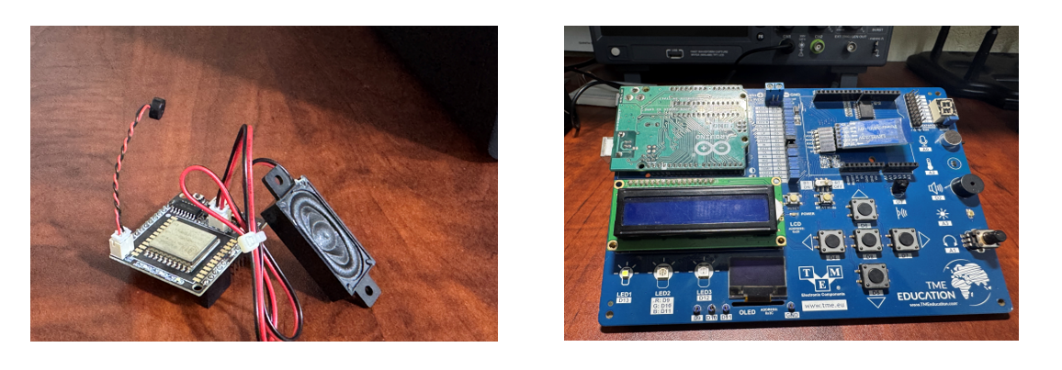
- Prepare the TME-EDU-ARD-2 board. The TME Education Board was selected as the main development platform. Its integrated Arduino Uno-based controller, OLED display, 16×2 LCD, and addressable NeoPixel LEDs were used for the visual and control functions of the chatbot.
- VC-02 Offline Voice Module Configuration. The VC-02 was configured through the Ai-Thinker Voice Open Platform (https://voice.ai-thinker.com/) to perform offline speech recognition, generate predefined voice responses, and transmit command bytes to the TME Education Board. The configuration was carried out in three main stages. UART Pin Selection and Configuration. The UART interface was first configured to enable communication between the VC-02 and the TME Education Board. From the pin configuration page, GPIO_B7 was assigned as UART1_TX, while GPIO_B6 was assigned as UART1_RX. The UART communication parameters were configured as:
Baud rate → 9600 Data bits → 8 Stop bits → 1 Parity → No check bit
For this project, the important signal is UART1_TX, because the VC-02 sends a command to the Arduino whenever a recognized offline command is triggered.
For this project, the important signal is UART1_TX, because the VC-02 sends a command to the Arduino whenever a recognized offline command is triggered.
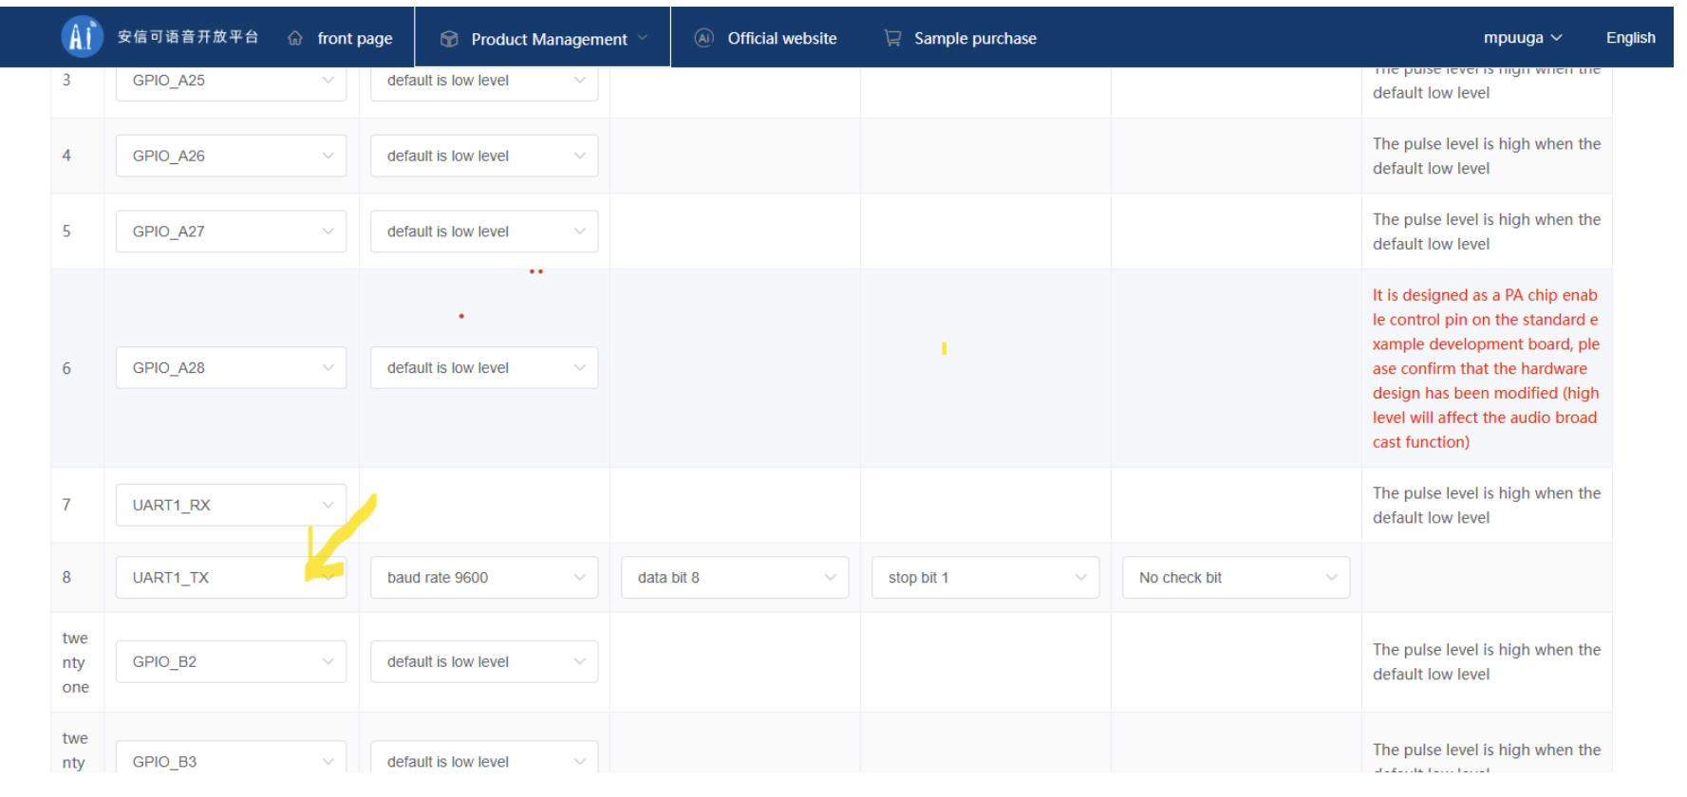
The physical communication connection is therefore:
VC-02 (UART1_TX) - TME Education Board / Arduino RX (D2) we used the softwareSerial libray.A common GND must also be provided between the VC-02 and the TME Education Board.
Customized Offline Command Configuration. The next stage was performed under “Customize offline command words and response words.” Each chatbot interaction was created using three important fields. Click the add button to add a custom offline command of your choice.
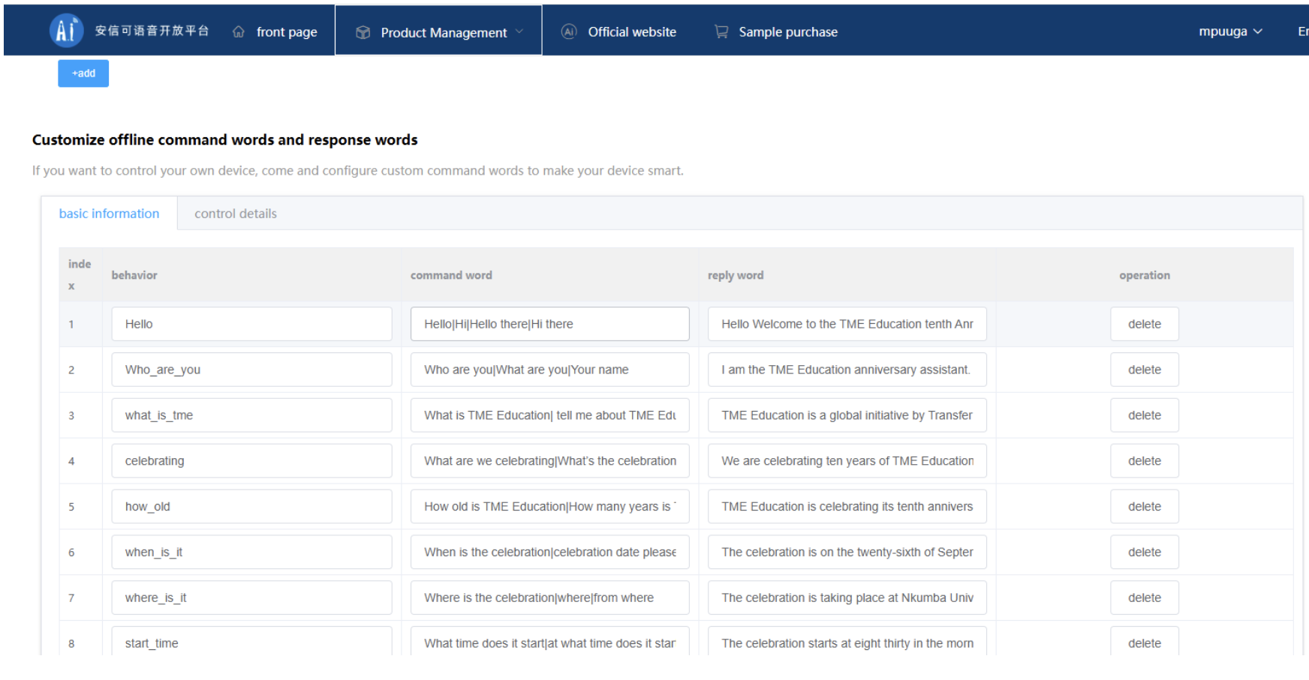

Configuring the Control Details. After creating each offline command, the Control Details section is used to tell the VC-02 what data should be transmitted when that particular behavior is activated.
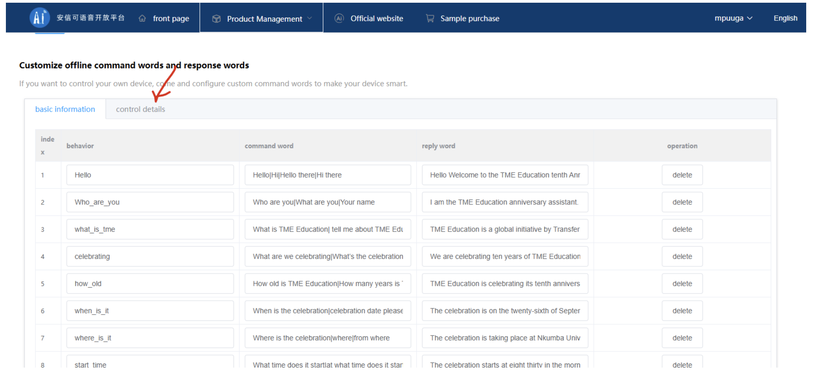
For each command for example, for the Hello behavior: The parameter field uses hexadecimal data. Therefore, 01 represents the byte value 0x01; it should not be treated as the ASCII characters "0" and "1".
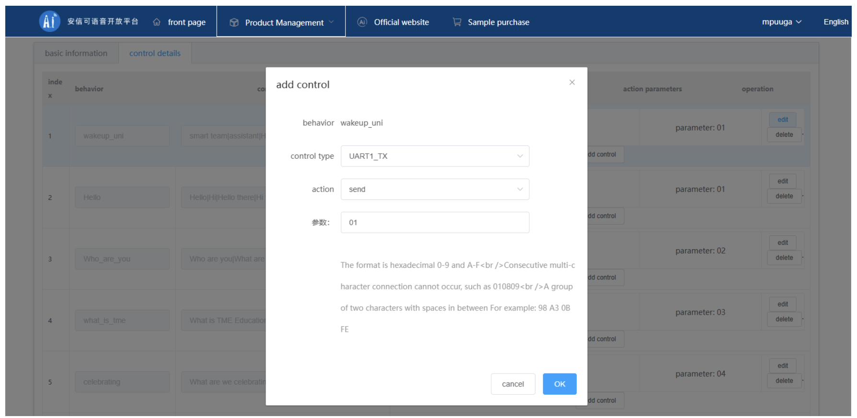
Assigning Unique UART Commands
A unique hexadecimal value should be assigned to every chatbot behavior so that the Arduino can determine which question was recognized.
For this project, the command structure is:
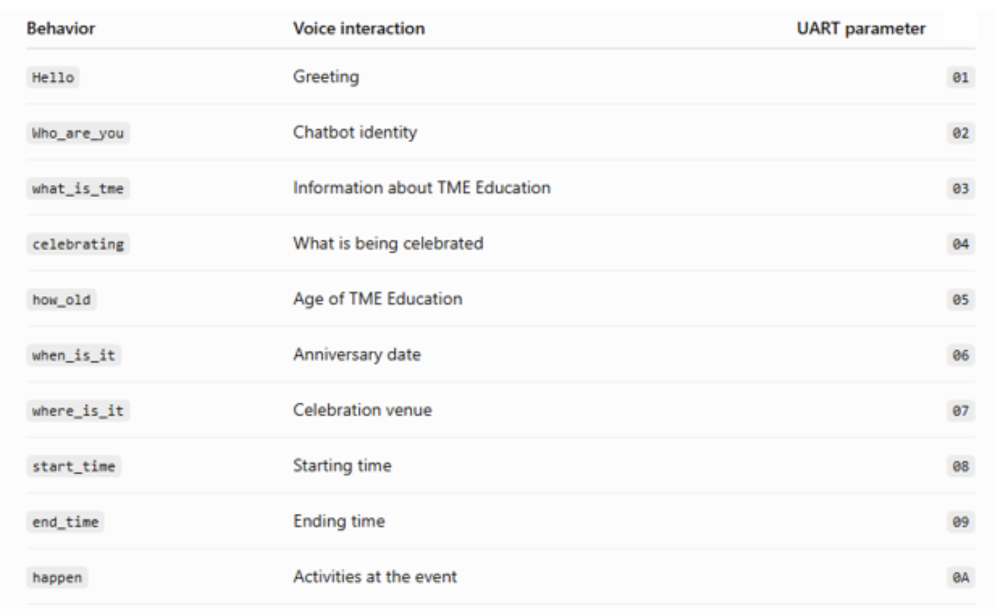
- For more information about the ai-thinker offline module configuration watch this youtube video to guide you https://www.youtube.com/watch?v=dAqX4CmozfM&t=6s
- Develop the OLED chatbot animations. Different animations were programmed for the board's OLED display to give the chatbot a visual personality. These included normal eyes, blinking, double blinking, looking left and right, happy expressions, excited expressions, anniversary animations, dancing characters, and celebration effects. Different animations were associated with different voice commands.
- Configure the 16×2 LCD. The board's LCD was programmed to continuously display a simple anniversary message without scrolling: This provides a permanent visual indication of the purpose of the project while the OLED performs the interactive chatbot animations.

- Program the NeoPixel lighting. The integrated addressable NeoPixel LEDs were programmed to remain illuminated and continuously change through different colors. The changing colors create a more attractive celebration effect and make the chatbot visually engaging during demonstrations.
- Integrate voice commands with animations. A command-processing function was developed on the Arduino. When a hexadecimal command is received from the VC-02, the program identifies the command and executes the corresponding OLED animation. For example, asking about the age of TME Education triggers the 10-year celebration animation, while the celebration command activates the dancing and anniversary sequence.

The final code below contains custom Arduino libraries for the TME-EDU-ARD-2, make sure you import them before you try to upload the code to the Arduino Uno.

