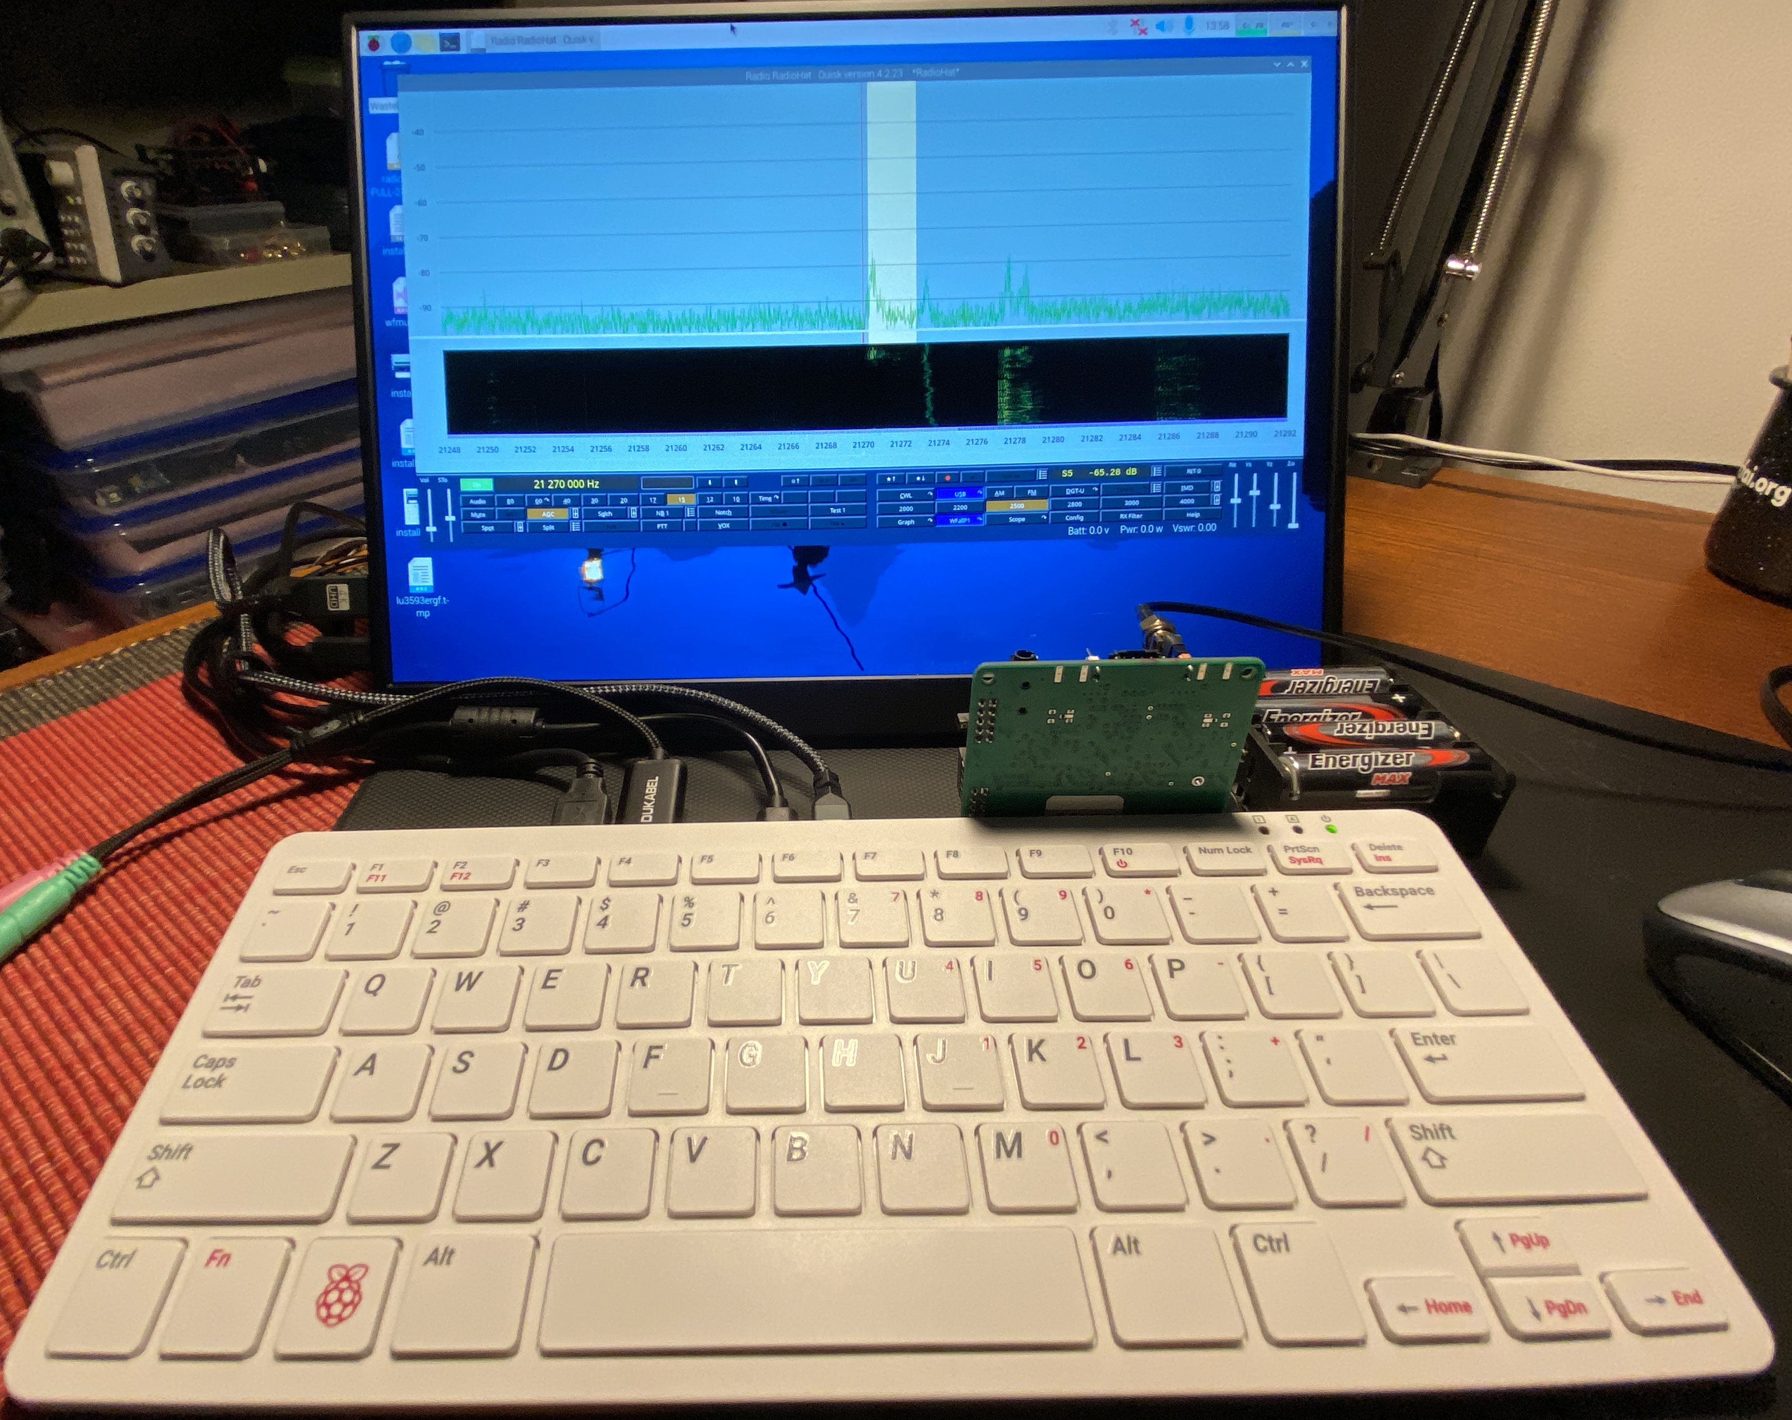

A Simple RadioHat Installation for Bookworm 32/64 2024-Mar-26

1. Configure and install the RadioHat1 or RadioHat2 card
Set Board Power Jumper as required:
1. EITHER Set Card to get power from Raspberry Pi (Noisy, and the tx lp filters and predriver on RadioHat2 will not be operating, but OK for a quick test):
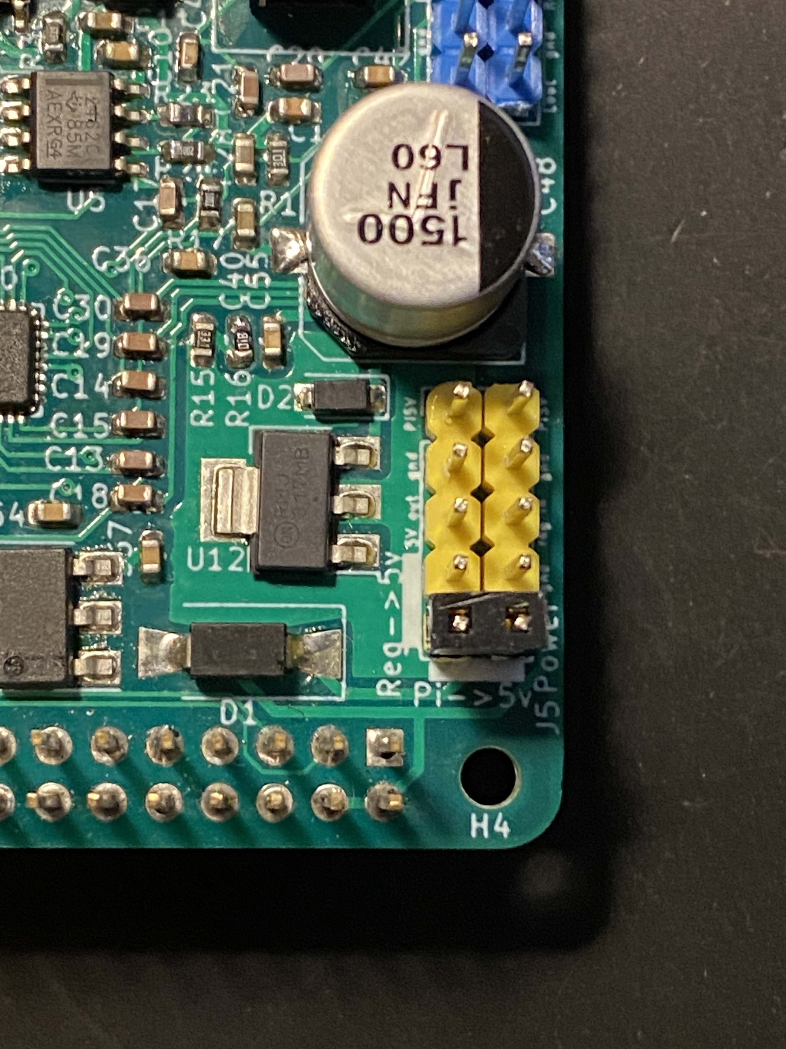
Install a BiPin Jumper between pins 9 and 10 as shown here:

2. OR Set Card to get power from an external 7-15 Volt supply (Better):
1. Install a BiPin Jumper between pins 9 and 7 (bare) of J5 as shown:
2. Connect power + (red) to pin 6 as shown:
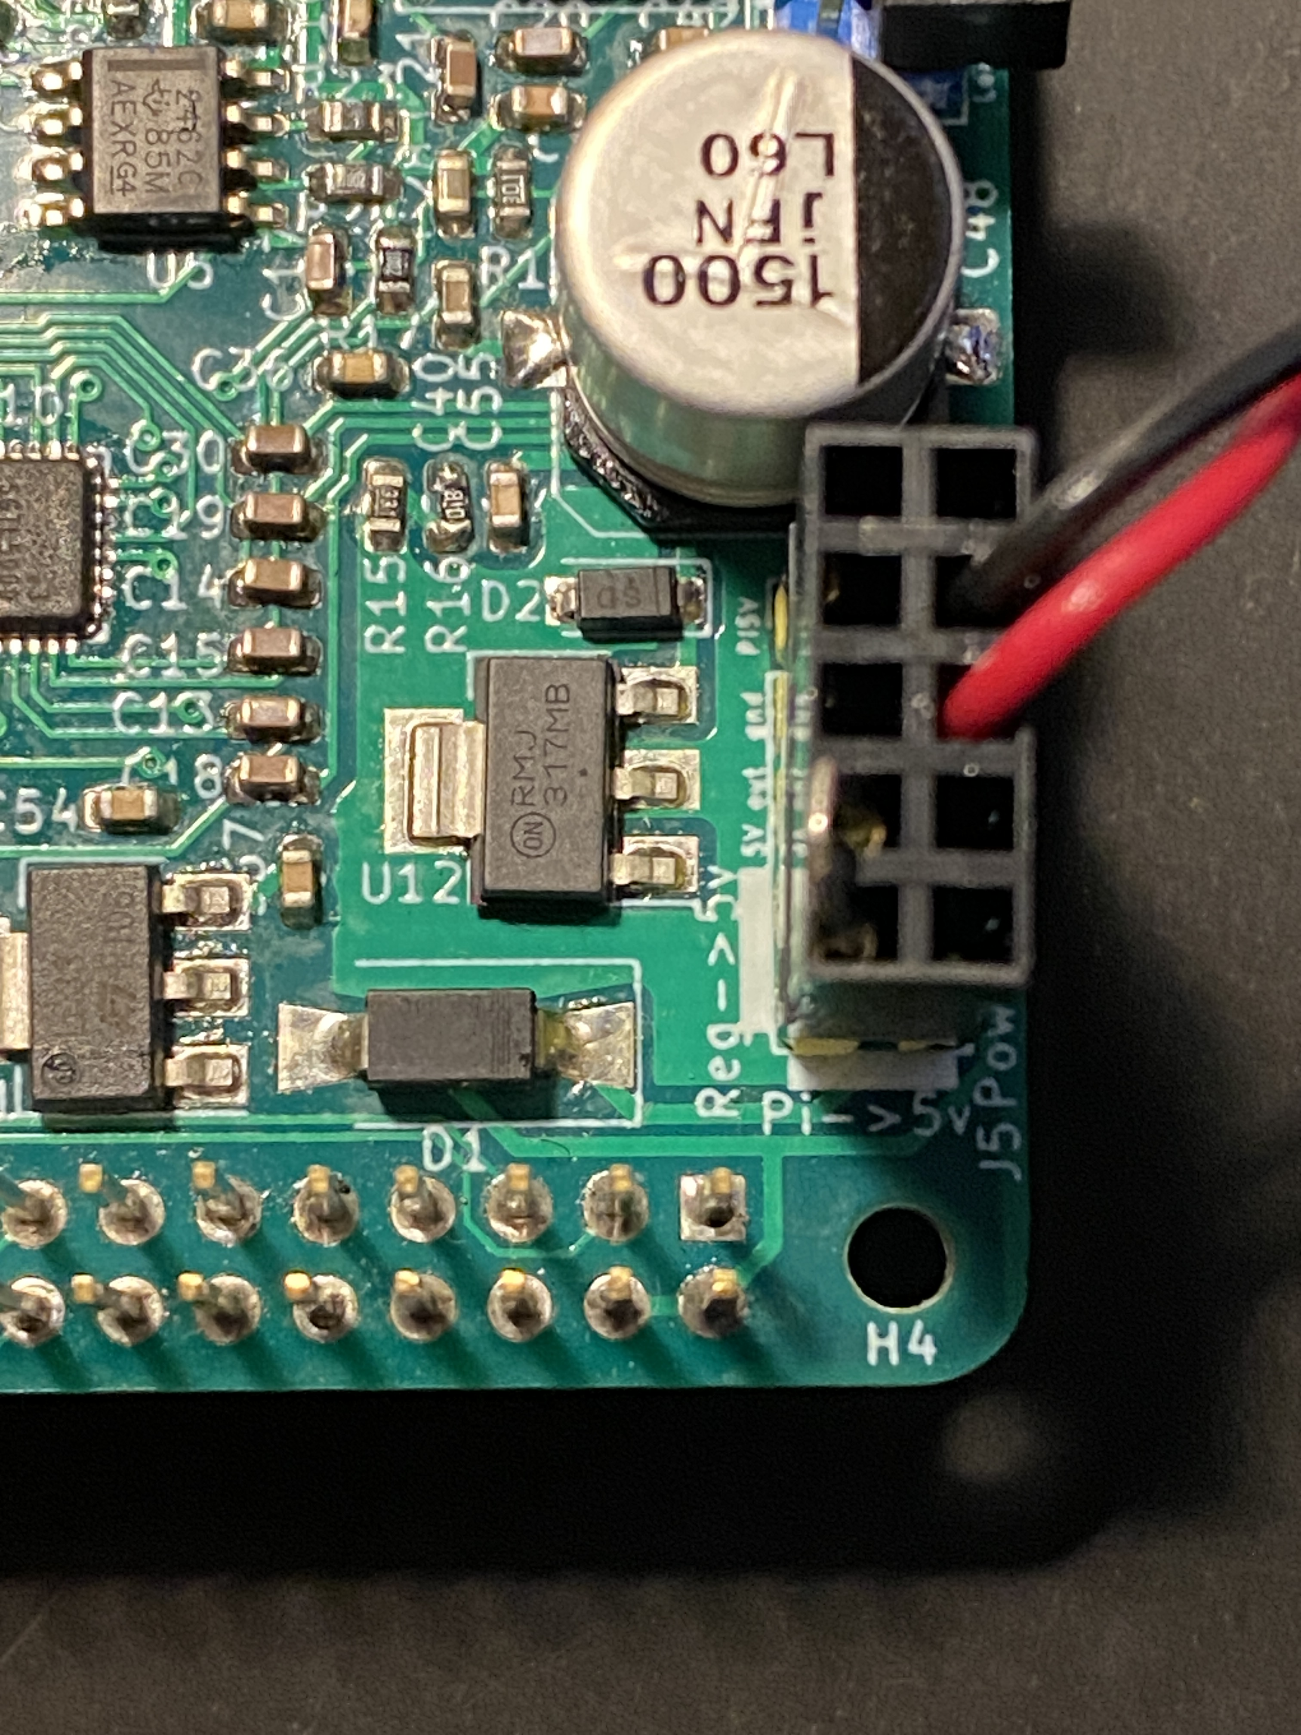
3. Connect power – (black) to pin 4 as shown:

3. Carefully install the card on the GPIO connector of your Pi. MAKE SURE THE CONNECTOR IS PROPERLY ALIGNED WITH THE GPIO PINS AND NOT OFF BY ONE!

2. Install some useful utilities from the raspbian repository

sudo apt install wsjtx fldigi qsstv pavucontrol-qt pipx

2. unzip (or clone from github) the radiohat directory into your home directory then:

git clone git@github.com:mpvano/radiohat2.git
sudo apt install libncurses-dev libgpiod-dev
cd radiohat2/libradiohat ; make clean ; make
sudo make install
The codec will not be available until the next restart!

TO INSTALL THE VERY OLD QUISK FROM THE RASPBIAN REPOSITORY:

1. Run the following command from a shell:
sudo apt install quisk
2. setup quisk to use a radio of type Softrock and browse
to point the hardware file to:
~/radiohat/libradiohat/QUISK/radiohatpkg/hardware_radiohat1.py
3. Set the various audio io selections to (quisk allows shortened device names):
alsa:USB
alsa:USB
alsa:Radiohat
alsa:Radiohat
swap the I and Q on the radio IO sound configuration window

TO INSTALL THE LATEST QUISK (Best!)

1. Run the following commands from a shell:
sudo apt install pipx
sudo apt install libasound2-dev python3-dev libpython3-dev \
python3-usb python3-setuptools portaudio19-dev \
libpulse-dev libgtk-4-dev libgtk-3-dev libgtk2.0-dev \
libcurl4-openssl-dev
#NOTE THAT PIPX DOES NOT REQUIRE SUDO OR ROOT ACCESS
pipx install quisk # MAY TAKE AROUND AN HOUR
pipx ensurepath

2. setup quisk to use a radio of type Softrock and browse to point the hardware file to:
~/radiohat2/libradiohat/QUISK/radiohatpkg/hardware_radiohat1.py

3. Set the various audio io selections to the following (quisk allows shortened device names):
alsa:USB
alsa:USB
alsa:Radiohat
alsa:Radiohat
swap the I and Q on the radio IO sound configuration window

4. If you have I2C Voltage and VSWR sensors connected to an ADS1115 ADC board with reverse=CH0, forward=CH2 and (battery/10)=CH2 as described in vswr.cpp, then browse in the Quisk radio configuration to set the widgets file to point to:
~/radiohat2/libradiohat/QUISK/radiohatpkg/widgets_tx.py

FOR BEST RESULTS WITH RadioHat 0.9/1.0 boards and Quisk
These changes will widen and flatten the receiver bandwidth to allow nicer spectrum and waterfall displays over the entire passband.
1. REMOVE C6 and C7 (note empty SMT pads) as shown below:
2. CHANGE R3, R4, R7, R8 to 0 (marked 000) ohm jumpers as shown:
3. CHANGE R11, R12 to 5k1 (marked 512) as shown:
4. Use a generic USB audio interface for microphone and headphone – otherwise use pulse:default for “radio sound output” and/or “microphone input” in the “sound” dialog.
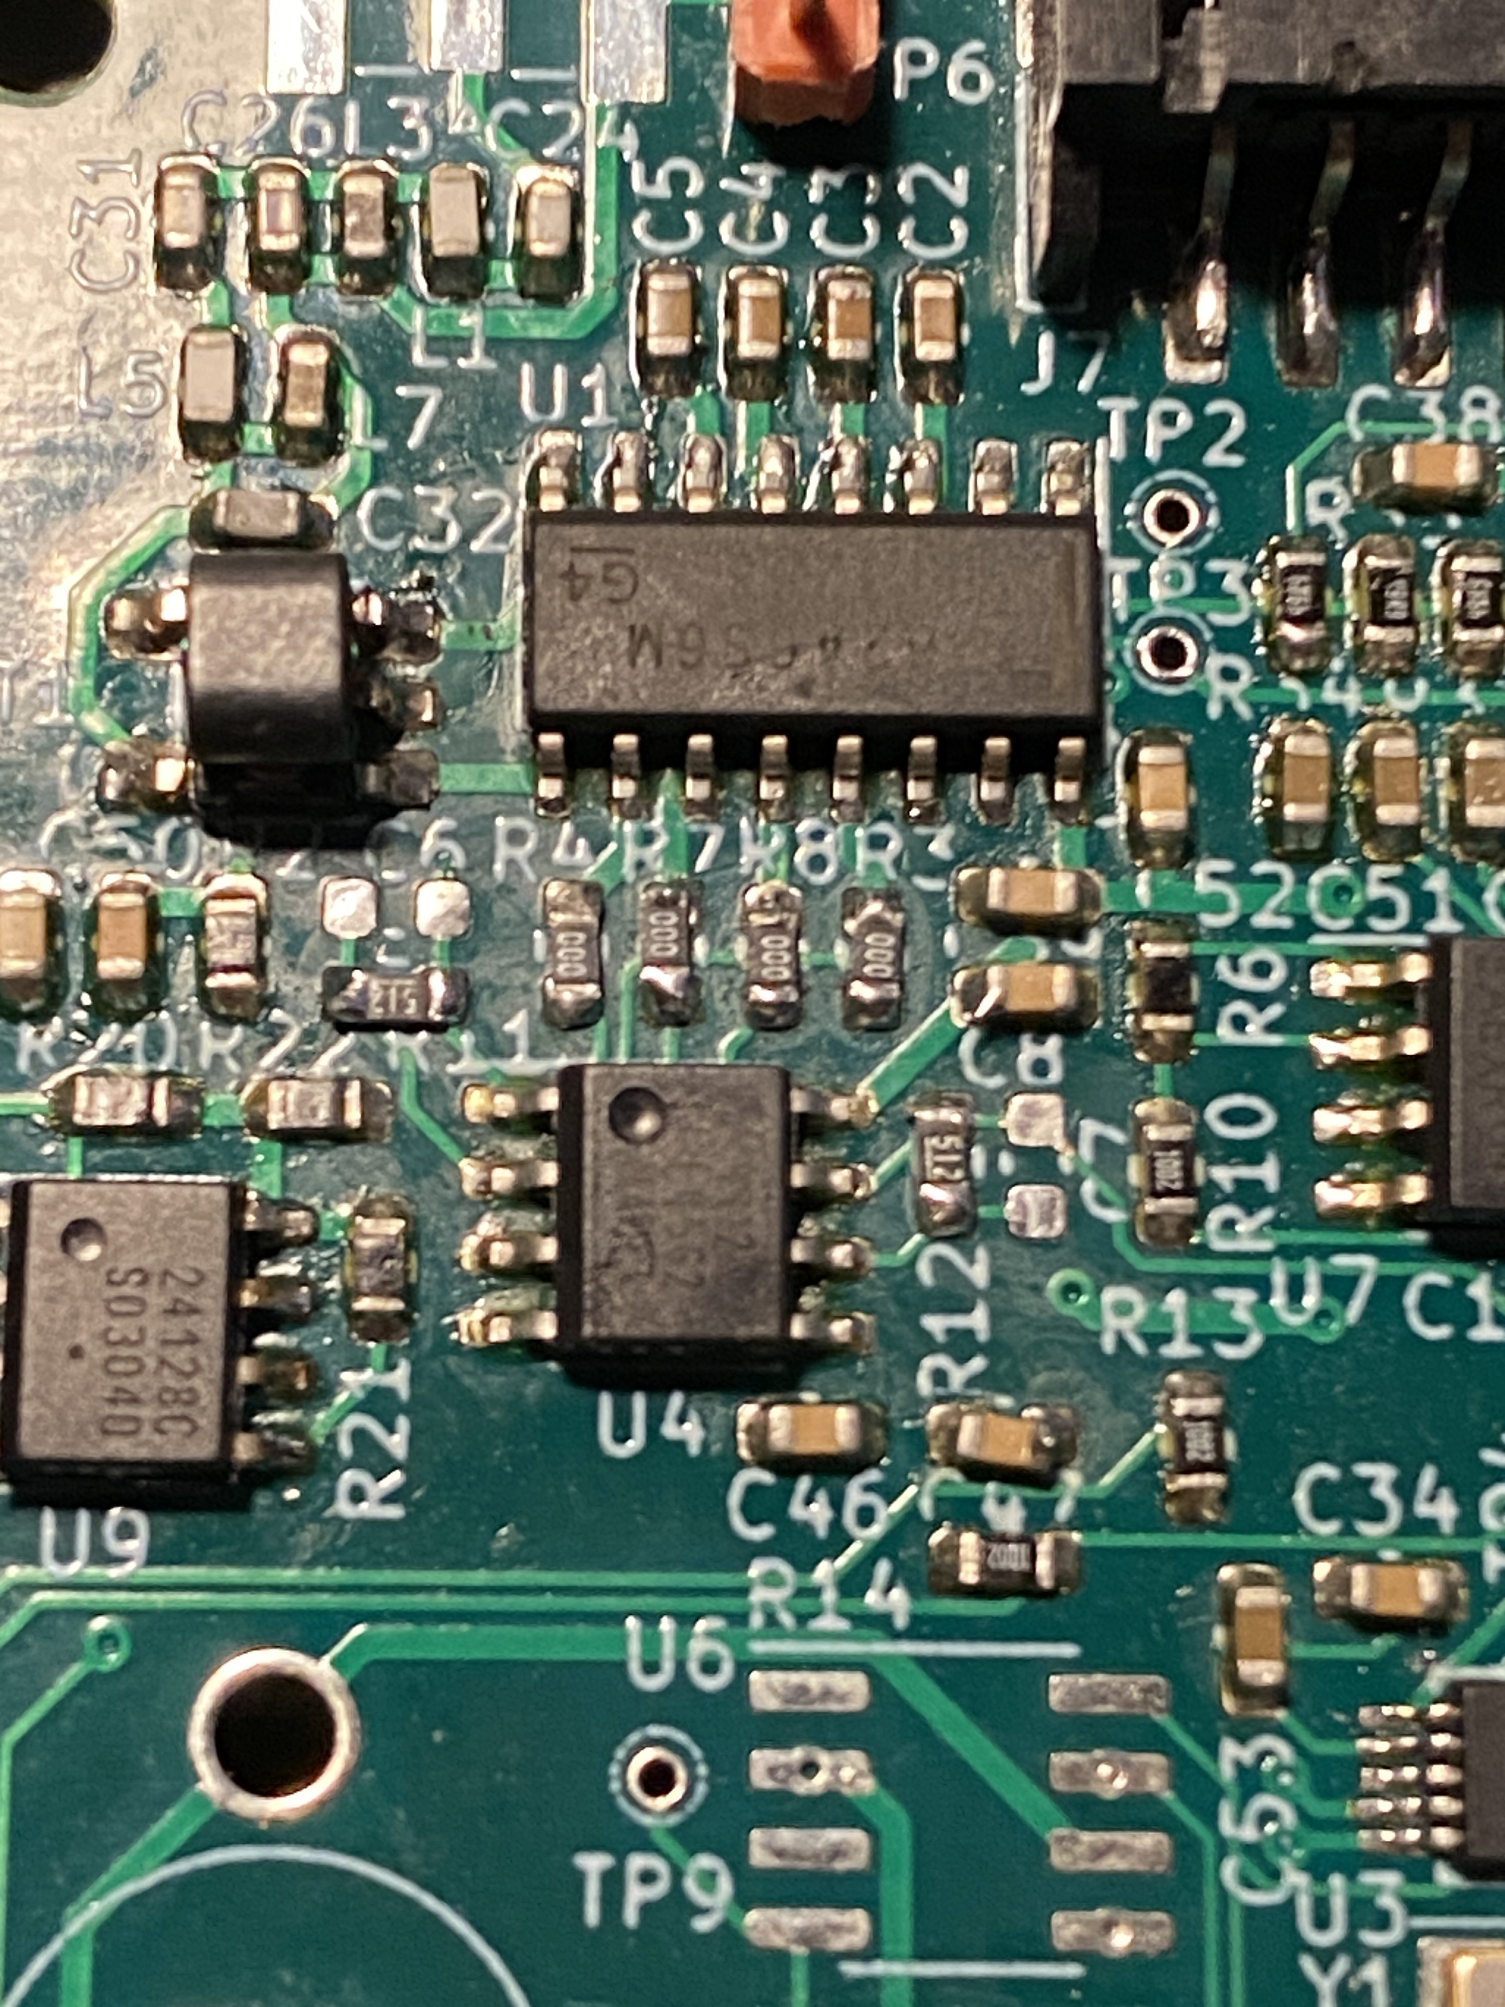

FOR GNURADIO
Note that GNURADIO is currently working very badly with Wayland and generates many long-winded warnings during execution. It's not very compatible with BOOKWORM. GNURADIO is NOT required for quisk to operate with RadioHat – it’s only needed if you wish to play with some of the other included test software.
1. sudo apt install gnuradio
2. delete any __pycache__ directories in ~/radiohat/libradiohat/GRC and
its subfolders
3. Open all dsp graphs (.grc files) you intend to use and correct any
version incompatibilities in them or in their sub modules,
then regenerate them.
4. Quit gnuradio-companion and restart it

