Assignment 2: BASH and AWK

|  |  |
| --- | --- |
| **Date:** | Monday, June 1st |
| **Due:** | Wednesday, June 3rd by 1pm |
| **Assignment Type:** | Group (Up to 6 – may be randomly assigned) |
| **Assignment Title:** | BASH and AWK (6 problems) |
| **Style:** | One problem at a time on Discord – WORK TOGETHER |
| **External Sources:** | You are allowed notes, books, and searches |
| **Description:** | This lab uses some additional Bash features and then awk. Please review the page below for all user input asked for in the problem set given. |
| **Points** | 10 |
| **Starting Files** | **mkdir lab2**  **cd lab2**  **cp –r /afs/umbc.edu/users/j/d/jdixon/pub/cs433/lab2/* .** |

Enter your group member names here:

|  |
| --- |
| **This lab was designed by Jeremy Dixon** |

**Formatting in Bash**

1.     Create the Bash script “lab2a_1.sh” that will read in everything from the file “lab2_data.txt” and display it. It should look like this:

Name: Amos Harrison             Score1:69 Score2:18 Score3:88

Name: Ava Miranda               Score1:25 Score2:10 Score3:81

Name: Blake Little             Score1:55 Score2:93 Score3:15

Name: Harding Calderon          Score1:81 Score2:28 Score3:47

Name: Denise Duncan             Score1:6 Score2:69 Score3:98

Name: Emma Kent                 Score1:62 Score2:27 Score3:32

Name: Deborah Ball              Score1:89 Score2:26 Score3:28

+ many more

Show both code and result view!!

 Ilya’s Version:

 #!/bin/bash

fileNameInput="lab2_data.txt"

namePart="Name: "

scoreOnePart="Score1:"

scoreTwoPart=" Score2:"

scoreThreePart=" Score3:"

if [ -e "$fileNameInput" ]; then

  while read lineRead; do

      unset $readLineSplit

      IFS=',' read -r -a readLineSplit <<< "$lineRead"

      firstPart="$namePart""${readLineSplit[0]} ""${readLineSplit[1]}"

      spacesAdded=""

      for ((i = 0 ; i < (32-${#firstPart}) ; i++)); do

        spacesAdded="$spacesAdded"" "

      done

      secondPart="$scoreOnePart""${readLineSplit[2]}""$scoreTwoPart""${readLineSplit[3]}""$scoreThreePart""${readLineSplit[4]}"

      echo "$firstPart""$spacesAdded""$secondPart"

  done < $fileNameInput

fi

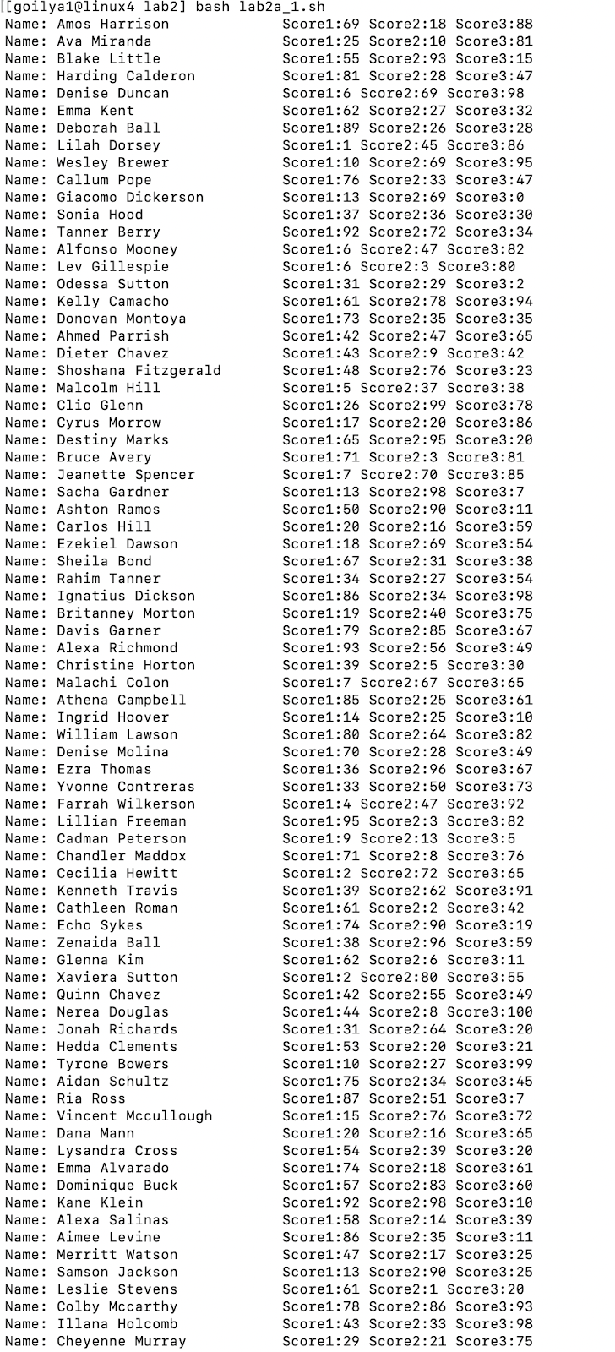

Michael’s Version (this works now)

#!/bin/bash

while IFS=, read -r first second third fourth fifth; do

    printf 'name: %s %s score1: %s score2:second: %s score3: %s\n' "$first" "$s\

econd" "$third" "$fourth" "$fifth"

    done<"lab2_data.txt"

**Arithmetic and Selection in Bash**

2.     Create the Bash script “lab2a_2.sh” that is a modified version of lab2a_1.sh from above. In lab2a_2.sh, replace the student’s lowest score with the student’s highest score minus 10. It should look like below.

Name: Amos Harrison             Score1:69 Score2:78 Score3:88

Name: Ava Miranda               Score1:25 Score2:71 Score3:81

Name: Blake Little              Score1:55 Score2:93 Score3:83

Name: Harding Calderon          Score1:81 Score2:71 Score3:47

Name: Denise Duncan             Score1:88 Score2:69 Score3:98

Name: Emma Kent                 Score1:62 Score2:52 Score3:32

Name: Deborah Ball              Score1:89 Score2:79 Score3:28

+ many more

Show both code and result view!!

 Ilya’s Version:

#!/bin/bash

fileNameInput="lab2_data.txt"

namePart="Name: "

scoreOnePart="Score1:"

scoreTwoPart=" Score2:"

scoreThreePart=" Score3:"

if [ -e "$fileNameInput" ]; then

  while read lineRead; do

      unset $readLineSplit

      IFS=',' read -r -a readLineSplit <<< "$lineRead"

      firstPart="$namePart""${readLineSplit[0]} ""${readLineSplit[1]}"

      spacesAdded=""

      for ((i = 0 ; i < (32-${#firstPart}) ; i++)); do

        spacesAdded="$spacesAdded"" "

      done

      listToSort="${readLineSplit[2]} ""${readLineSplit[3]} ""${readLineSplit[4]}"

      listSorted=($(tr ' ' '\n' <<<"${listToSort[@]}" | sort -n))

      if [ "${readLineSplit[2]}" = "${listSorted[0]}" ]; then

        readLineSplit[2]="$((${listSorted[2]}-10))"

      elif [ "${readLineSplit[3]}" = "${listSorted[0]}" ]; then

        readLineSplit[3]="$((${listSorted[2]}-10))"

        elif [ "${readLineSplit[4]}" = "${listSorted[0]}" ]; then

            readLineSplit[4]="$((${listSorted[2]}-10))"

      fi

      secondPart="$scoreOnePart""${readLineSplit[2]}""$scoreTwoPart""${readLineSplit[3]}""$scoreThreePart""${readLineSplit[4]}"

      echo "$firstPart""$spacesAdded""$secondPart"

  done < $fileNameInput

fi

Michael’s Version

#This basically reads line by line, and finds the biggest and smallest values, and then replaces the smallest value with the biggest value minus 10

#!/bin/bash

while IFS=, read -r first second third fourth fifth; do

     printf 'name: %s %s score1: %s score2:second: %s score3: %s\n\n\n' "$first" "$second" "$third" "$fourth" "$fifth"

    if (($third> $fourth && $third>$fifth))

    then

        echo "$third is largest integer"

        largest=$third

    elif (($fourth> $third && $fourth>$fifth))

    then

        largest=$fourth

        echo "$fourth is the largest integer"

    else

        largest=$fifth

        echo "$fifth is the largest integer"

    fi

    if (($third< $fourth &&  $third< $fifth))

    then

        smallest=$third

        echo "$third is smallest  integer"

        third="$(($largest-10))"

    elif (($fourth< $third && $fourth< $fifth))

    then

        smallest=$fourth

        echo "$fourth is the smallest integer"

        fourth="$(($largest-10))"

    else

        smallest=$fifth

        echo "$fifth is the smallest integer"

        fifth="$(($largest-10))"

    fi

    printf 'name: %s %s score1: %s score2:second: %s score3: %s\n\n\n' "$first" "$second" "$third" "$fourth" "$fifth"

    done<"lab2_data.txt"

**Arithmetic and Formatting in Bash**

3.     For this problem, create the Bash script “lab2a_3.sh” that is a modified version of lab2a_2.sh from above. In lab2a_3.sh, calculate the average based on the modified scores from ex2.sh. It should display two digits of precision (unless it is even). It should look like below.

Name: Amos Harrison             Score1:69 Score2:78 Score3:88 Average:78.33

Name: Ava Miranda               Score1:25 Score2:71 Score3:81 Average: 59

Name: Blake Little              Score1:55 Score2:93 Score3:83 Average: 77

Name: Harding Calderon          Score1:81 Score2:71 Score3:47 Average: 63.33

+many more

Show both code and result view!!

 Ilya’s Version:

 #!/bin/bash

fileNameInput="lab2_data.txt"

namePart="Name: "

scoreOnePart="Score1:"

scoreTwoPart=" Score2:"

scoreThreePart=" Score3:"

if [ -e "$fileNameInput" ]; then

  while read lineRead; do

      unset $readLineSplit

      IFS=',' read -r -a readLineSplit <<< "$lineRead"

      firstPart="$namePart""${readLineSplit[0]} ""${readLineSplit[1]}"

      spacesAdded=""

      for ((i = 0 ; i < (32-${#firstPart}) ; i++)); do

        spacesAdded="$spacesAdded"" "

      done

      listToSort="${readLineSplit[2]} ""${readLineSplit[3]} ""${readLineSplit[4]}"

      listSorted=($(tr ' ' '\n' <<<"${listToSort[@]}" | sort -n))

      if [ "${readLineSplit[2]}" = "${listSorted[0]}" ]; then

        readLineSplit[2]="$((${listSorted[2]}-10))"

      elif [ "${readLineSplit[3]}" = "${listSorted[0]}" ]; then

        readLineSplit[3]="$((${listSorted[2]}-10))"

        elif [ "${readLineSplit[4]}" = "${listSorted[0]}" ]; then

            readLineSplit[4]="$((${listSorted[2]}-10))"

      fi

      avg="$((${readLineSplit[2]}+${readLineSplit[3]}+${readLineSplit[4]}))"

      if [ $((avg%3)) -eq 0 ]; then

          avg=$(echo "scale=0; $avg/3" | bc)

      else

          avg=$(echo "scale=2; $avg/3" | bc)

      fi

      secondPart="$scoreOnePart""${readLineSplit[2]}""$scoreTwoPart""${readLineSplit[3]}""$scoreThreePart""${readLineSplit[4]}"" Average:""$avg"

      echo "$firstPart""$spacesAdded""$secondPart"

  done < $fileNameInput

fi

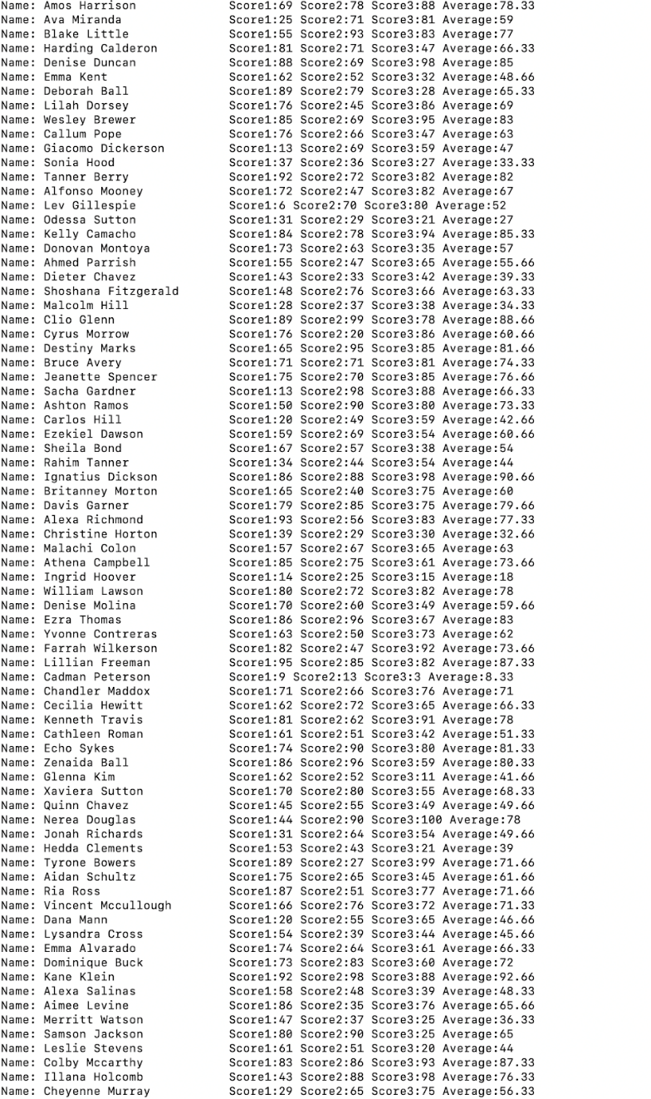

Michael Wellen

I need to get this to work with fractions.

#!/bin/bash

while IFS=, read -r first second third fourth fifth; do

     printf 'name: %s %s score1: %s score2:second: %s score3: %s\n\n\n' "$first" "$second" "$third" "$fourth" "$fifth"

     average="$(($third+$fourth+$fifth))"

     tenAverage="$((average*10))"

     realAverage="$(($average/3))"

     realAverageDec="$(($tenAverage%10))"

    if (($third> $fourth && $third>$fifth))

    then

        echo "$third is largest integer"

        largest=$third

    elif (($fourth> $third && $fourth>$fifth))

    then

        largest=$fourth

        echo "$fourth is the largest integer"

    else

        largest=$fifth

        echo "$fifth is the largest integer"

    fi

    if (($third< $fourth &&  $third< $fifth))

    then

        smallest=$third

        echo "$third is smallest  integer"

        third="$(($largest-10))"

    elif (($fourth< $third && $fourth< $fifth))

    then

        smallest=$fourth

        echo "$fourth is the smallest integer"

        fourth="$(($largest-10))"

    else

        smallest=$fifth

        echo "$fifth is the smallest integer"

        fifth="$(($largest-10))"

    fi

    printf 'name: %s %s score1: %s score2:second: %s score3: %s average: %s . %s\n\n\n' "$first" "$second" "$third" "$fo\

urth" "$fifth" "$realAverage" "$realAverageDec"

    done<"lab2_data.txt"

**Formatting in AWK**

**NOTE THESE ARE IN AWK NOT BASH! Refer to the slides on AWK to help complete.

4.     Create the AWK script “lab2b_1.sh” that will read in everything from the file “lab2_data.txt” and display it. It should look like this:

Name: Amos Harrison             Score1:69 Score2:18 Score3:88

Name: Ava Miranda               Score1:25 Score2:10 Score3:81

Name: Blake Little              Score1:55 Score2:93 Score3:15

Name: Harding Calderon          Score1:81 Score2:28 Score3:47

Name: Denise Duncan             Score1:6 Score2:69 Score3:98

Name: Emma Kent                 Score1:62 Score2:27 Score3:32

Name: Deborah Ball              Score1:89 Score2:26 Score3:28

+ many more

Show both code and result view!!

 Michael’s version:

 #!/bin/sh

awk 'BEGIN {FS=","}

{print "Name:",$1,$2,"\t\t\t" "Score1:",$3,"Score2:",$4,"Score3:",$5}' lab2_data.txt

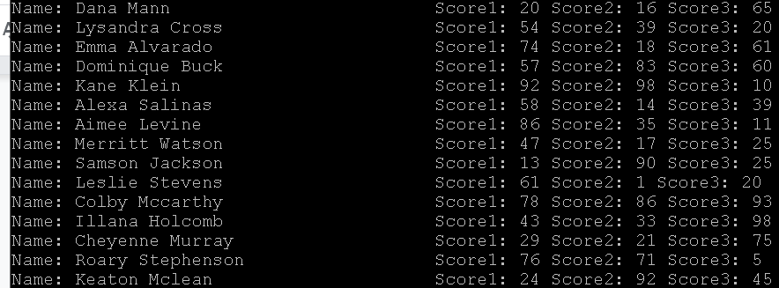

**Arithmetic and Selection in AWK**

5.     Create the AWK script “lab2b_2.sh” that is a modified version of lab2b_1.sh from above. In lab2b_2.sh, replace the student’s lowest score with the student’s highest score minus 10. It should look like below.

Name: Amos Harrison             Score1:69 Score2:78 Score3:88

Name: Ava Miranda               Score1:25 Score2:71 Score3:81

Name: Blake Little              Score1:55 Score2:93 Score3:83

Name: Harding Calderon          Score1:81 Score2:71 Score3:47

Name: Denise Duncan             Score1:88 Score2:69 Score3:98

Name: Emma Kent                 Score1:62 Score2:52 Score3:32

Name: Deborah Ball              Score1:89 Score2:79 Score3:28

+ many more

Show both code and result view!!

 Michael’s version:

 #!/bin/sh

PREC="double"

awk 'BEGIN {FS=","}

{

if($3>$4 && $3>$5){max=$3}

if($4>$3 && $4>$5){max=$4}

if($5>$3 && $5>$4){max=$5}

if($3<$4 && $3<$5){min=$3;$3=max-10}

if($4<$3 && $4<$5){min=$4;$4=max-10}

if($5<$3 && $5<$4){min=$5;$5=max-10}

print "Name:",$1,$2,"\t\t\t" "Score1:",$3,"Score2:",$4,"Score3:",$5}' lab2_data.txt

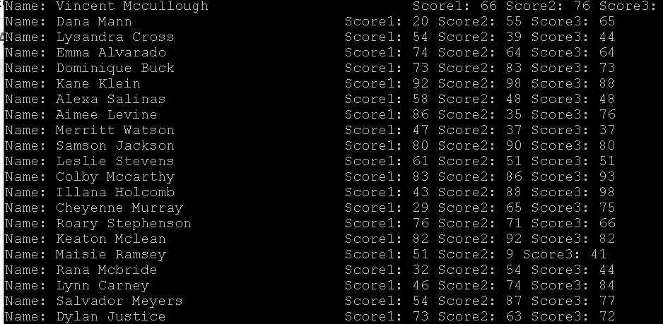

**Arithmetic and Formatting in AWK**

6.     For this problem, create the AWK script “lab2b_3.sh” that is a modified version of lab2b_2.sh from above. In lab2b_3.sh, calculate the average based on the modified scores from ex2.sh. It should display two digits of precision (unless it is even). It should look like below.

Name: Amos Harrison             Score1:69 Score2:78 Score3:88 Average:78.33

Name: Ava Miranda               Score1:25 Score2:71 Score3:81 Average: 59

Name: Blake Little              Score1:55 Score2:93 Score3:83 Average: 77

Name: Harding Calderon          Score1:81 Score2:71 Score3:47 Average: 63.33

+many more

Show both code and result view!!

 Michael’s version:

#!/bin/sh

PREC="double"

awk 'BEGIN {FS=","}

{

if($3>$4 && $3>$5){max=$3}

if($4>$3 && $4>$5){max=$4}

if($5>$3 && $5>$4){max=$5}

if($3<$4 && $3<$5){min=$3;$3=max-10}

if($4<$3 && $4<$5){min=$4;$4=max-10}

if($5<$3 && $5<$4){min=$5;$5=max-10}

total=$3+$4+$5

average=total/3

if(total%3==0)

{

printf "Name:%s %s \t\t\t Score1:%.0f Score2:%.0f Score3:%.0f Average:%.0f \n",$1,$2,$3,$4,

$5,average}

else

{

printf "Name:%s %s \t\t\t Score1:%.0f Score2:%.0f Score3:%.0f Average:%.2f \n",$1,$2,$3,$4,$5,average}

}

' lab2_data.txt

