04_Format Output

Martha Wetzel

2022-09-22

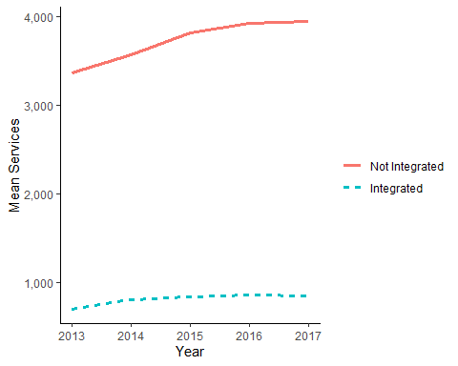 ##Question 3

|  | **Services on Integration** |
| --- | --- |
| Integration | 0.67 |
|  | [0.66, 0.68] |
| Age | 0.91 |
|  | [0.73, 1.15] |
| Num.Obs. | 2080213 |
| Std.Errors | by: npi |
| FE: npi | X |
| FE: Year | X |

##Question 5

|  | **2SLS** | **Stage 1** | **Reduced Form** |
| --- | --- | --- | --- |
| Integration | 6.73 [4.79, 9.47] |  |  |
| Age | 0.8 [0.54, 1.17] | 0.98753 [0.9482, 1.02848] | 0.7779 [0.5683, 1.0649] |
| Expected Revenue Change |  | 1.00004 [1.00004, 1.00004] | 1.0001 [1.0001, 1.0001] |
| Num.Obs. | 1126501 | 1126501 | 1126501 |
| Std.Errors | by: npi | by: npi | by: npi |
| FE: npi | X | X | X |
| FE: Year | X | X | X |