MPX NYC
Key findings and recommendations
Keletso Makofane
2024-05-23
Table of contents

To Do
- Measures of centrality and density
- References
- Results
- Introduction
- Discussion
- Appendices

Methods

Data Collection
As part of The Rapid Epidemiologic Study of Prevalence, Networks, and Demographics of Monkeypox Infection (RESPND-MI), we implemented a brief, anonymous, online survey among transgender people and gay, bisexual, and other men who have sex with men. Data were collected from 20 August 2022 to 15 November 2022 in New York City.

RESPND-MI Community Forum
To elicit input about the study from queer and trans individuals and organizations who do health-related work, we held a rapid consultation meeting at the outset of the project. Investigators compiled a list of 53 invitees and invited them. To maximize uptake, we attempted to match each invitee with an investigator they had a prior relationship with.
At the consultation meeting, participants requested that the RESPND-MI team host a weekly meeting since there were no other venues for discussing the outbreak from the perspectives of organizations that deliver services to queer and trans individuals, and individuals who had experienced mpox infection. We named the space the RESPND-MI Queer and Trans Community Forum and held it weekly from June to August 2022. Though the main purpose of the Community Forum was to share information and allow organizations and individuals to coordinate political action , it was also used to consult on study-related decisions. About 80 individuals participated in the Community Forum over the 2-month period we held it. Further details can be found in a previous publication (Roth et al. 2023).

Recruitment
We collaborated with a marketing agency to design and implement a study recruitment campaign in English and Spanish. The brief was to create a name and visual identity that convey scientific rigor, build trust with the community, and to stand out in a crowded online advertising space (see Figure 1). As a starting point, we suggested a campaign that playfully communicates using emojis that have sexual connotations. Two campaign names and four marketing concepts (see Figure 2) were developed by the marketing agency and presented to the RESPND-MI Community Forum. The final concept and name were decided by consensus during that meeting.
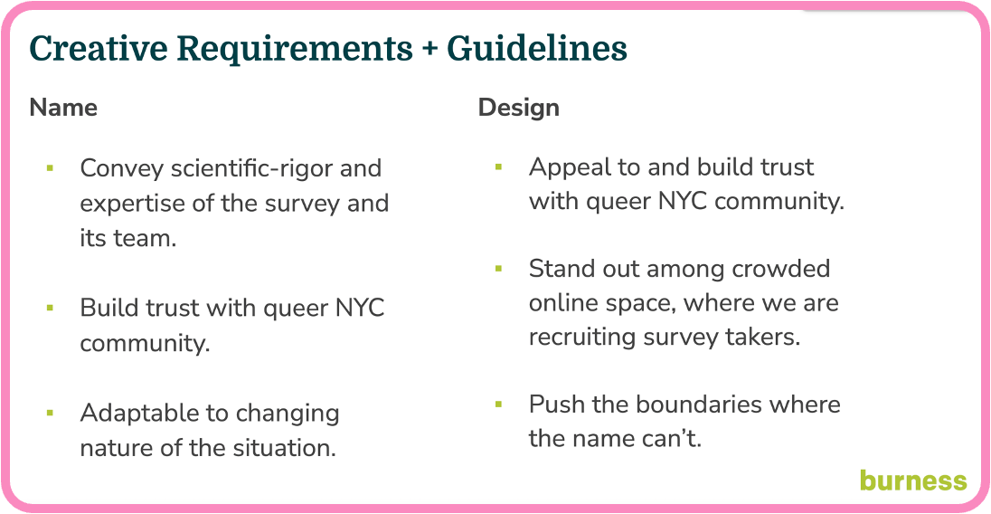
Figure 1: Requirements for MPX NYC Study
Marketing materials included graphics, videos by queer influencers, and a style guide (including colors, icons, and fonts) for all public-facing materials of the MPX NYC study. We organized these materials into a “social media toolkit” so that they would be easy for individuals and organizations to share through their own social media accounts. Advertisements were placed through Grindr, Twitter, Instagram, and outdoor electronic billboards.
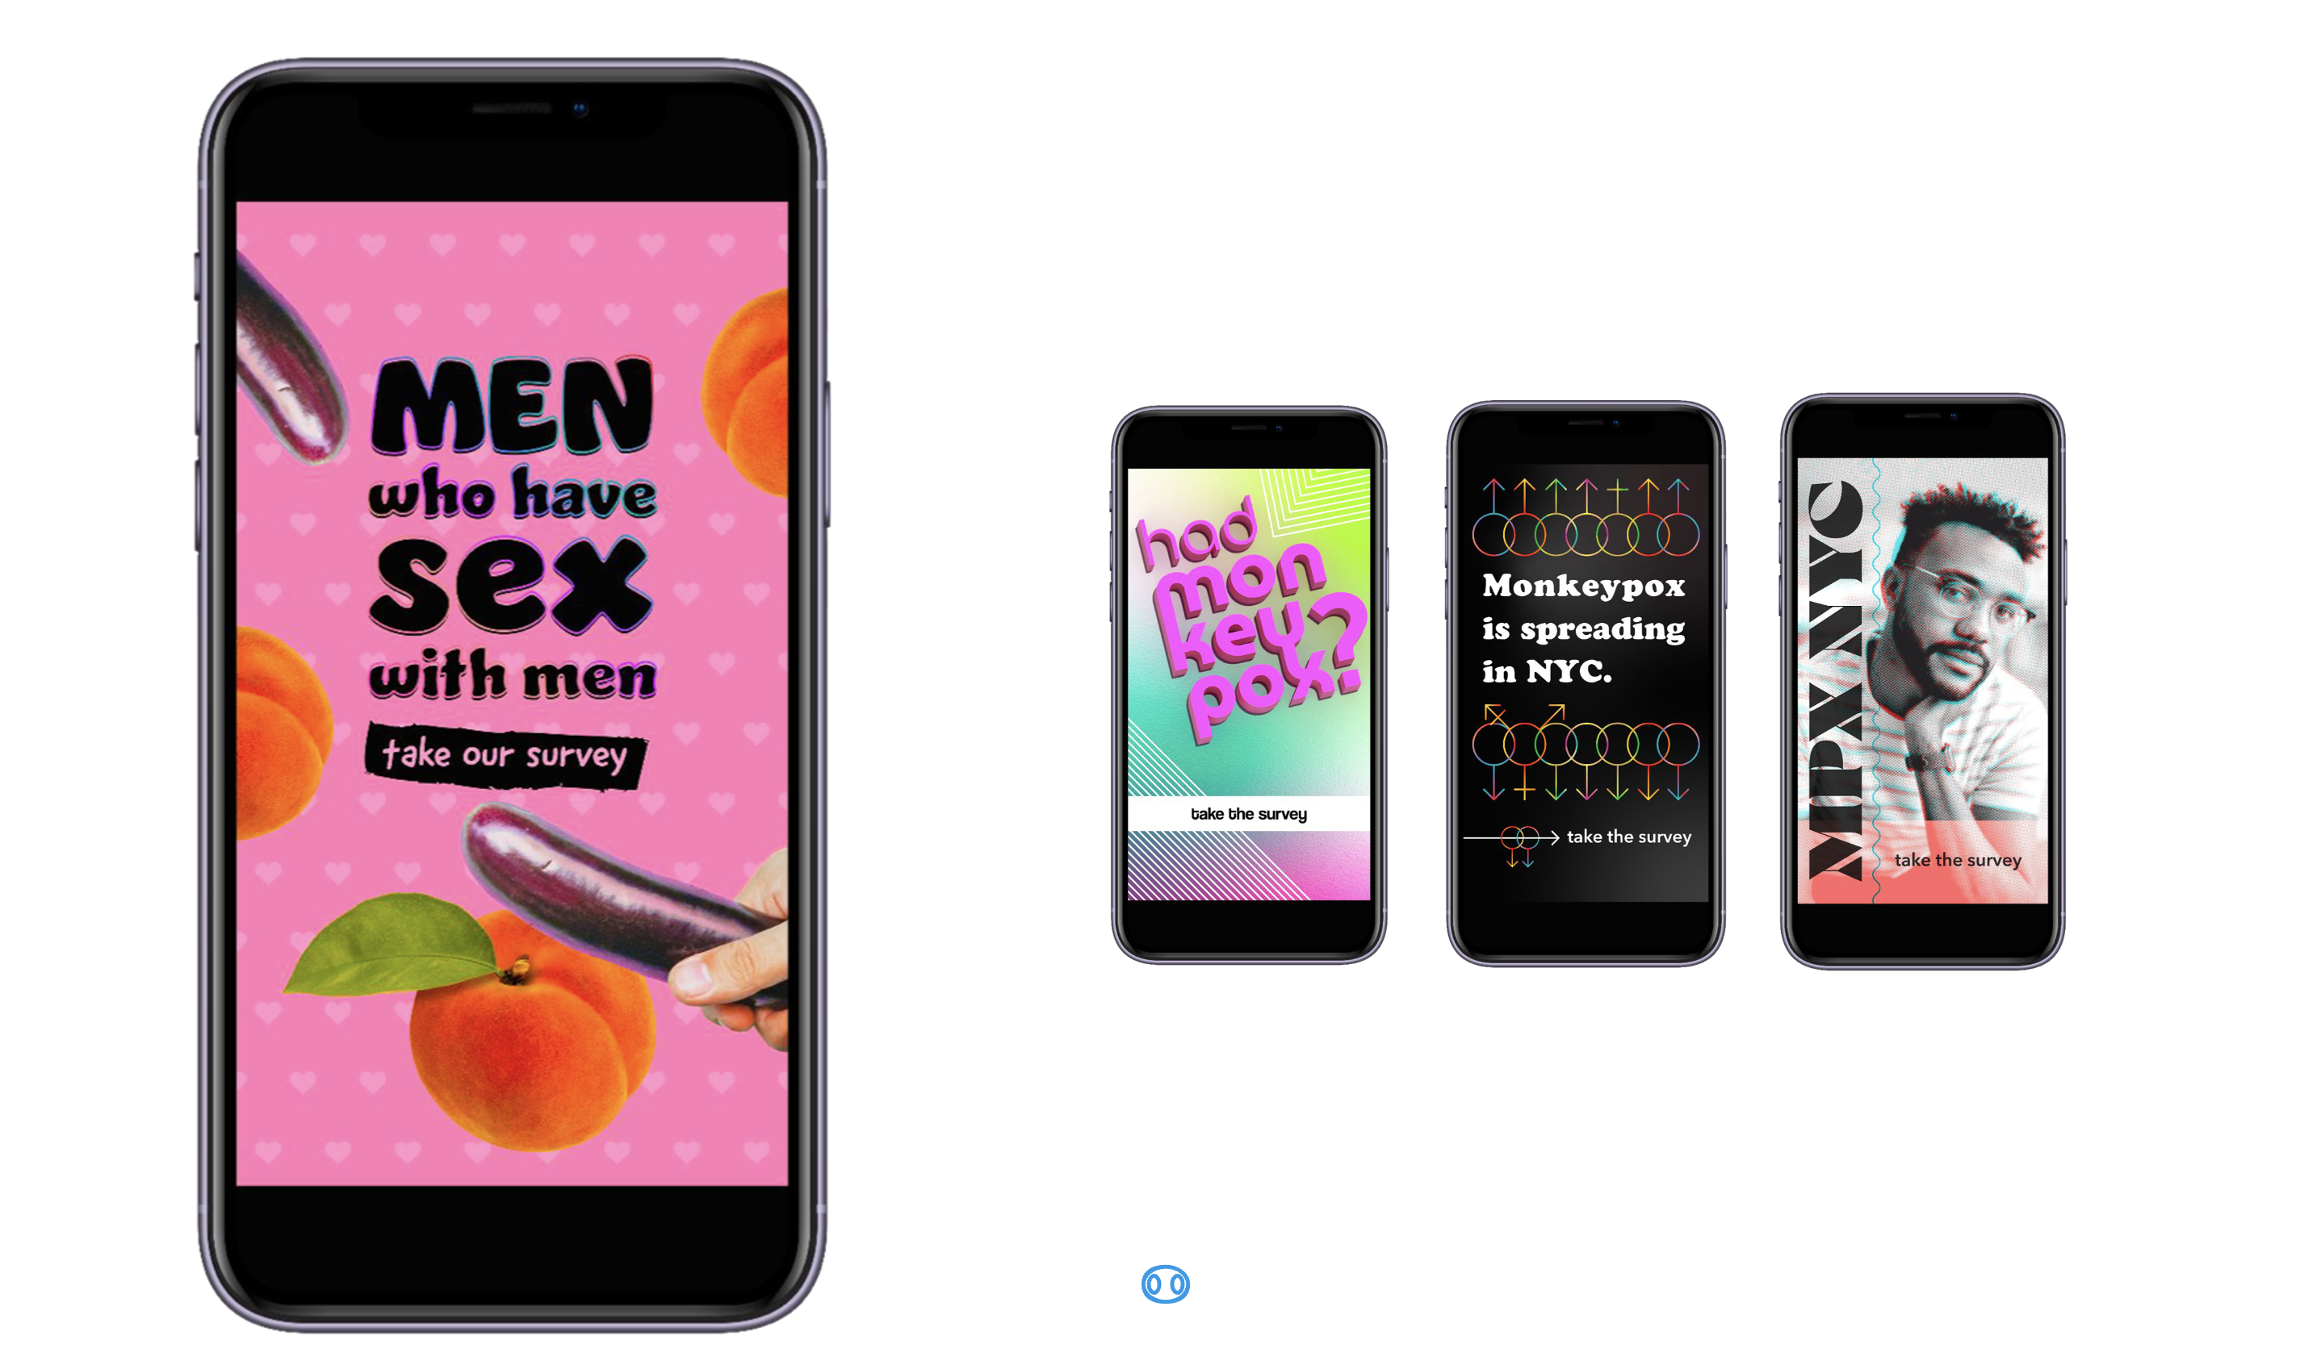
Figure 2: Options for visual identity of MPX NYC

Data collection instrument
We designed and implemented a novel online survey instrument which captures coarsened spatial information to maintain anonymity. Along with standard question formats (multiple choice, single choice, text field etc.) we developed a question format to elicit spatial data.
In the map-input question format, participants are prompted to indicate all places of a particular type by tapping on a displayed map (see Figure 3). Each time the user taps on the map, a marker appears and a pop-up window asks them to answer a series of questions related to that location. Spatial data were coarsened by transforming longitude-latitude coordinates into the identifiers of the census tract that contain them. Census tracts are a spatial unit that exhaustively divides the United States into areas ranging from $2500$ to $8000$ in population size (US Census 2022).
The look and feel of the data collection instrument was based on the MPX NYC style guide. The front end was developed as a single-page web application using the React/NextJS framework (“NextJS Documentation” 2024). It uses the Google Maps (Google 2024) and Federal Communications Commission (“Federal Communications Commission API,” n.d.) APIs to collect and transform spatial data. The backend was a custom-built neo4j graph database (Neo4j 2024) hosted on a commercial cloud server platform. The instrument underwent two rounds of user testing before data collection started.
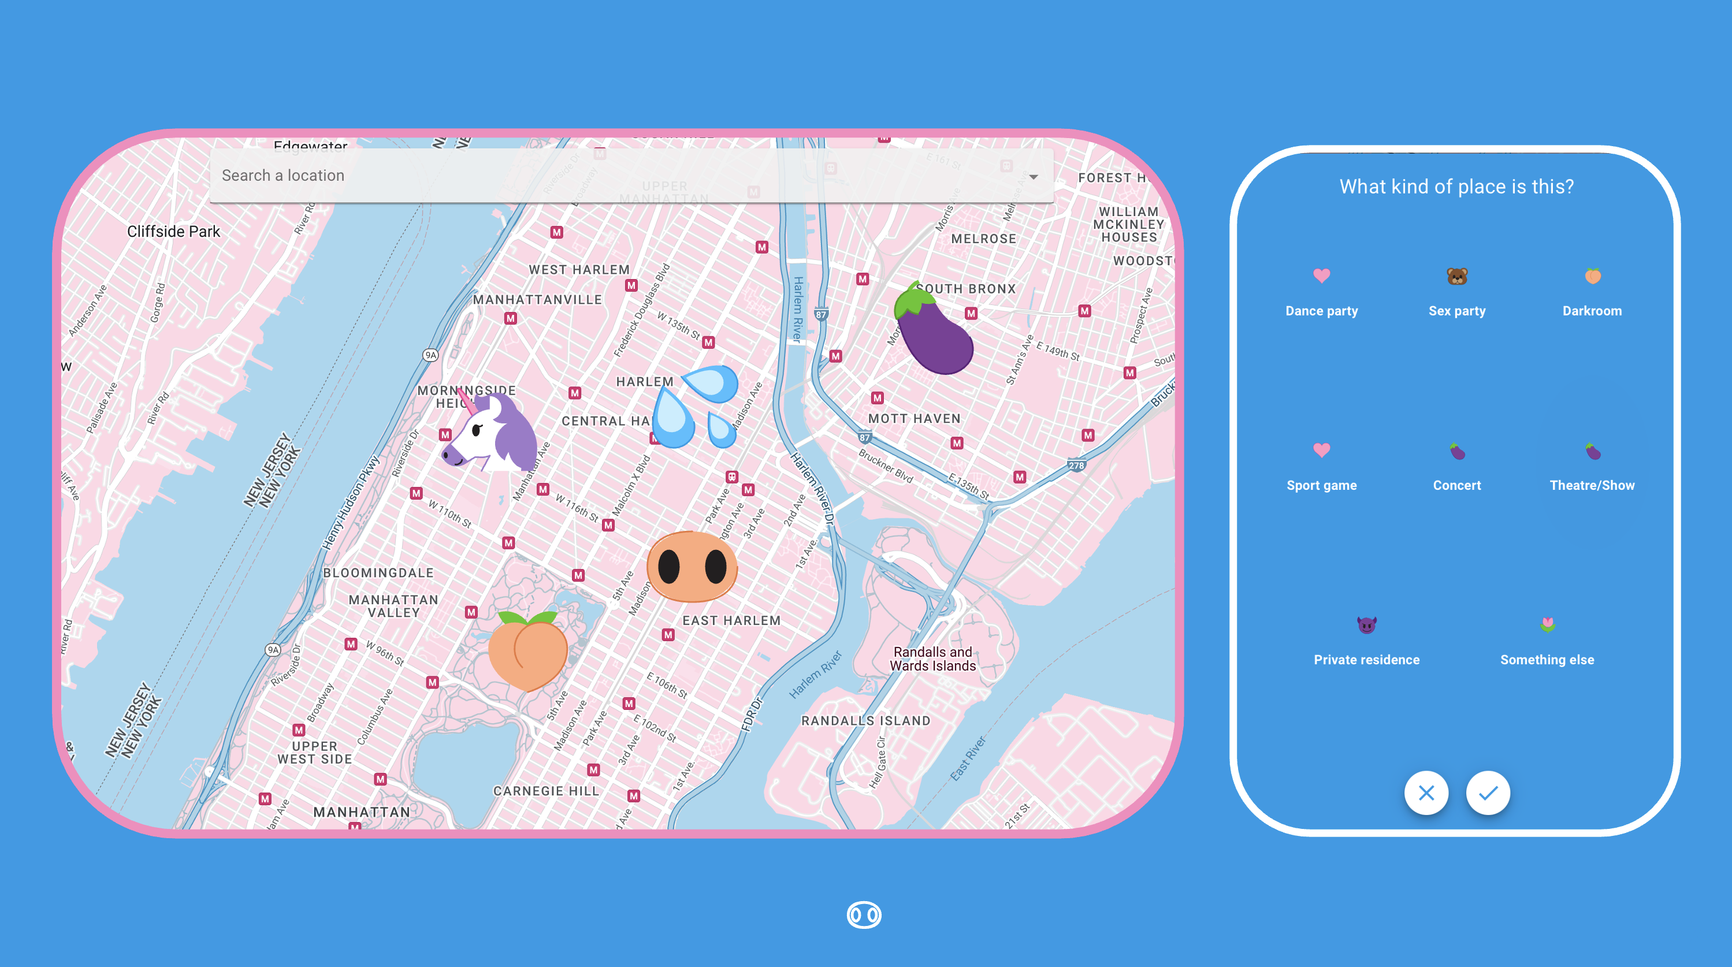
Figure 3: Map input question format developed for MPX NYC

Inclusion and Exclusion Criteria
Potential participants were included in the study if they consented to participate, were over 18 years of age, identified as transgender, gay, bisexual, or as men who have sex with other men, and were in New York City in the four weeks preceding the survey. Potential participants were excluded if they were younger than 18 years of age or they withdrew consent.

Translation
All study materials were professionally translated from English to Spanish. The translation was reviewed by six professionals in health-related fields whose primary language is Spanish.

Ethical Review
The study was reviewed and approved by the T.H. Chan School of Public Health Institutional Review Board (IRB22-0761).

Measures

Participants
The brief (5 minute) questionnaire was implemented in English and Spanish. It measured participant demographics, utilization of healthcare services; and connection to queer or transgender community.
Gender identity was measured using a two-step approach: first, we solicited the participant’s current gender (man, woman, trans man, trans woman, non-binary, other), and then sex assigned at birth (male, female, other). Those whose gender identity and sex assigned at birth were not concordant were categorized as transgender. We used current gender to further categorize transgender people into men and women.
Race was measured using a multiple selection question based on census categories (white, black, latino/a/x, asian, pacific islander, other). We combined gender identity and race to form a gender-race variable, collapsing small cells across racial groups (white cisgender man, latinx cisgender man, black cisgender man, other cisgender man, non-binary person, transgender man, transgender woman, cisgender woman, another demographic).

Residence and Contact venues
Using the map-input question format, we solicited the census tract of participants’ primary residences. Among those who reported physical or sexual contact in a group setting in the preceding 4 weeks, we solicited the locations of the venues at which the contact happened. We refer to these locations as “contact venues”. For each contact venue (see Figure 3), participants indicated the type of place it was (dance party, sex party, darkroom, sport game, concert, theatre/show, private residence, sex club, bathhouse, park, something else) and whether they had sexual (vs. non-sexual) contact there.

Statistical Analysis

Participant and contact venue characteristics
Participant characteristics were tabulated by contact in the preceding 4 weeks. We also tabulated contact venue characteristics by distance from home and by sexual contact.
Census tract identifiers were converted into community district identifiers. Census tracts are nested in community districts. They are defined by the City of New York (NYC OpenData 2022). For each contact venue, we approximated the distance from home to that venue using an ordinal variable with three levels: same community district as home; different community district but same borough as home; different borough than home.

Spatial sorting and mixing
To understand how different demographic groups mix in physical space, we defined $ψ_{a→b}∈\left[−1,∞\right]$ as the spatial selection coefficient of subgroup $a$ for subgroup $b$. The spacial selection coefficient is defined as the spacial selection ratio less 1. The numerator for this ratio is the conditional probability of someone in subgroup $a$ sharing a community district with someone in subgroup $b$. The denominator is the marginal probability of having characteristic $b$.
This measure is $0$ when contact venues and residences for subgroups $a$ and $b$ are distributed independently of each other in space; positive if contact venues and residences for subgroup $a$ tend to be in the same community districts as those for subgroup $b$; and negative if subgroup $a$ tends to be in community districts that do not have contact venues and residences for subgroup $b$.

Community district overlap network
We constructed a community district overlap network where nodes are participants and weighted ties indicate that number of community districts shared by those participants. We say two participants share a community district if both have a residence or contact venue in that community district.
In this network, the weighted degree of a node represents the number of individuals that node shares a community district with. The density of the network represents the extent to which all individuals are connected to all other individuals through shared community districts. The centrality of a node represents the degree to which the individual represented by that node acts as a bridge between different, otherwise disconnected parts of the spatial overlap network.

Hypothetical immunization intervention
We examined the coverage efficiency and network impact of a hypothetical intervention to slow down the wide dissemination of a novel pathogen. The intervention a) lists community districts in decreasing order of count of residences and contact venues, b) immunizes all individuals who have a residence or contact venue in the top district, c) removes all contact venues and residences for immunized individuals. We say the hypothetical intervention is of order $k∈Z$ if steps are completed $k$ times (or until everybody is immunized).

Efficiency
We examined coverage efficiency by plotting the proportion of immunized individuals against the order of the hypothetical intervention ($k$) carried out in community districts. For low $k$, the proportion of immunized individuals will grow faster than the order of the hypothetical intervention.

Spatial network impact
We used the community district overlap network to understand how the hypothetical intervention would likely affect transmission dynamics. In that network, immunizing a community district removes all individuals who have a residence or contact place in that that community district from the network. For each $k$, we calculated density and centrality measures to show how it would evolve as more community districts are immunized.

Statistical Inference
We used the non-parametric bootstrap to calculate point estimates and 95% confidence intervals (CI). Participants were re-sampled with replacement 10 times. For each measure, the lower and upper bound of confidence intervals were calculated as the 0.025th and 0.975th quantiles of the empirical distribution produced by re-sampling. ?@tbl-descriptives

Results

Participants
 |  | No Contact | Contact | Overall
Total participants
 | Count (%) | 774 (100%) | 530 (100%) | 1304 (100%)
Age
 | 18-24 | 103 (13%) | 92 (17%) | 195 (15%)
 | 25-34 | 304 (39%) | 234 (44%) | 538 (41%)
 | 35-44 | 190 (25%) | 135 (25%) | 325 (25%)
 | 45-54 | 97 (13%) | 48 (9%) | 145 (11%)
 | 55+ | 80 (10%) | 21 (4%) | 101 (8%)
Gender Identity
 | Cisgender Man | 630 (81%) | 427 (81%) | 1057 (81%)
 | Cisgender Woman | 43 (6%) | 19 (4%) | 62 (5%)
 | Another Demographic | 0 (0%) | 2 (0%) | 2 (0%)
 | Non Binary | 57 (7%) | 39 (7%) | 96 (7%)
 | Another Demographic | 12 (2%) | 12 (2%) | 24 (2%)
 | Transgender Man | 17 (2%) | 17 (3%) | 34 (3%)
 | Transgender Woman | 15 (2%) | 14 (3%) | 29 (2%)
Race
 | Another Group | 40 (5%) | 19 (4%) | 59 (5%)
 | Asian | 52 (7%) | 32 (6%) | 84 (6%)
 | Black | 96 (12%) | 60 (11%) | 156 (12%)
 | Latinx | 128 (17%) | 103 (19%) | 231 (18%)
 | Multi Racial | 42 (5%) | 37 (7%) | 79 (6%)
 | White | 416 (54%) | 279 (53%) | 695 (53%)
Sexual Orientation
 | Bisexual | 119 (15%) | 67 (13%) | 186 (14%)
 | Gay | 498 (64%) | 362 (68%) | 860 (66%)
 | Queer | 88 (11%) | 71 (13%) | 159 (12%)
 | Another Orientation | 19 (2%) | 16 (3%) | 35 (3%)
 | Straight | 50 (6%) | 14 (3%) | 64 (5%)
Recruitment Channel
 | Grindr | 444 (57%) | 262 (49%) | 706 (54%)
 | Partner toolkit | 82 (11%) | 60 (11%) | 142 (11%)
 | Instagram | 65 (8%) | 47 (9%) | 112 (9%)
 | Twitter | 43 (6%) | 19 (4%) | 62 (5%)
 | Unknown | 140 (18%) | 142 (27%) | 282 (22%)
HIV Status/ PrEP Use
 | Living with HIV | 81 (10%) | 60 (11%) | 141 (11%)
 | Not on PrEP | 440 (57%) | 218 (41%) | 658 (50%)
 | On PrEP | 253 (33%) | 252 (48%) | 505 (39%)
MPOX Test
 | No | 727 (94%) | 472 (89%) | 1199 (92%)
 | Yes | 47 (6%) | 58 (11%) | 105 (8%)
MPOX Vaccination
 | Unvaccinated | 313 (40%) | 121 (23%) | 434 (33%)
 | Vaccinated | 461 (60%) | 409 (77%) | 870 (67%)
Queer/Trans Friends
 | 0 | 155 (20%) | 64 (12%) | 219 (17%)
 | 1-5 | 333 (43%) | 206 (39%) | 539 (41%)
 | 6-10 | 167 (22%) | 136 (26%) | 303 (23%)
 | 11-15 | 41 (5%) | 49 (9%) | 90 (7%)
 | 16+ | 78 (10%) | 75 (14%) | 153 (12%)
Physical contact partners
 | 0 | 301 (39%) | 98 (18%) | 399 (31%)
 | 1 | 191 (25%) | 68 (13%) | 259 (20%)
 | 2 | 105 (14%) | 66 (12%) | 171 (13%)
 | 3 | 64 (8%) | 46 (9%) | 110 (8%)
 | 4 | 32 (4%) | 47 (9%) | 79 (6%)
 | 5+ | 81 (10%) | 205 (39%) | 286 (22%)
Sex partners
 | 0 | 272 (35%) | 48 (9%) | 320 (25%)
 | 1 | 258 (33%) | 86 (16%) | 344 (26%)
 | 2 | 110 (14%) | 96 (18%) | 206 (16%)
 | 3 | 62 (8%) | 82 (15%) | 144 (11%)
 | 4 | 29 (4%) | 62 (12%) | 91 (7%)
 | 5+ | 43 (6%) | 156 (29%) | 199 (15%)
Borough
 | Bronx | 66 (9%) | 31 (6%) | 97 (7%)
 | Brooklyn | 258 (33%) | 176 (33%) | 434 (33%)
 | Manhattan | 320 (41%) | 259 (49%) | 579 (44%)
 | Queens | 119 (15%) | 58 (11%) | 177 (14%)
 | Staten Island | 11 (1%) | 6 (1%) | 17 (1%)
?(caption)
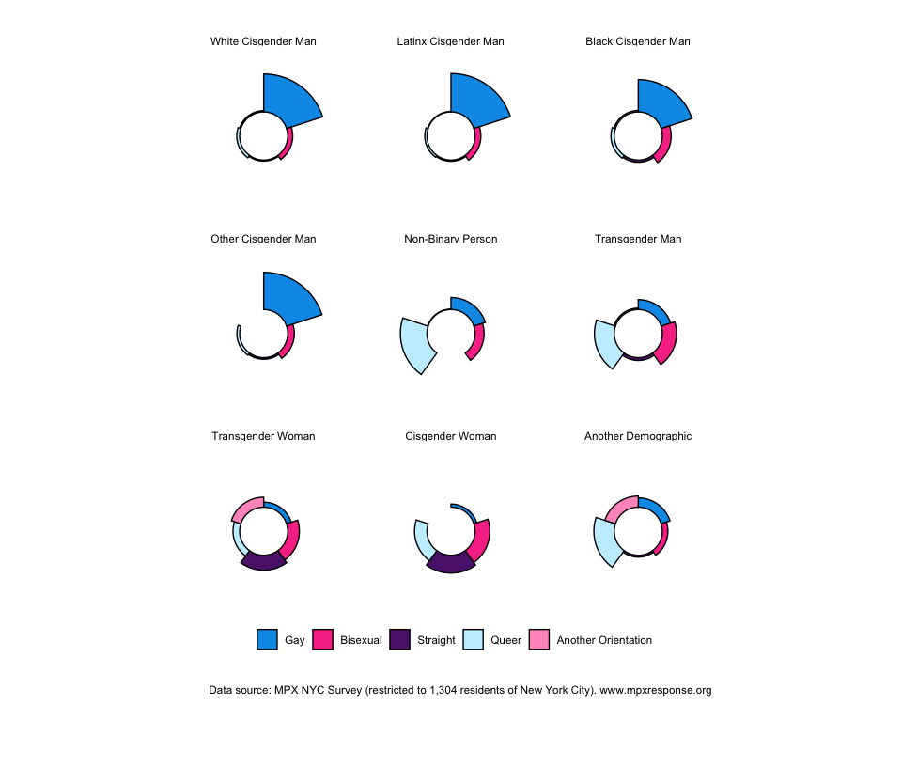
Figure 4: Sexual orientation of MPX NYC participants by race and gender
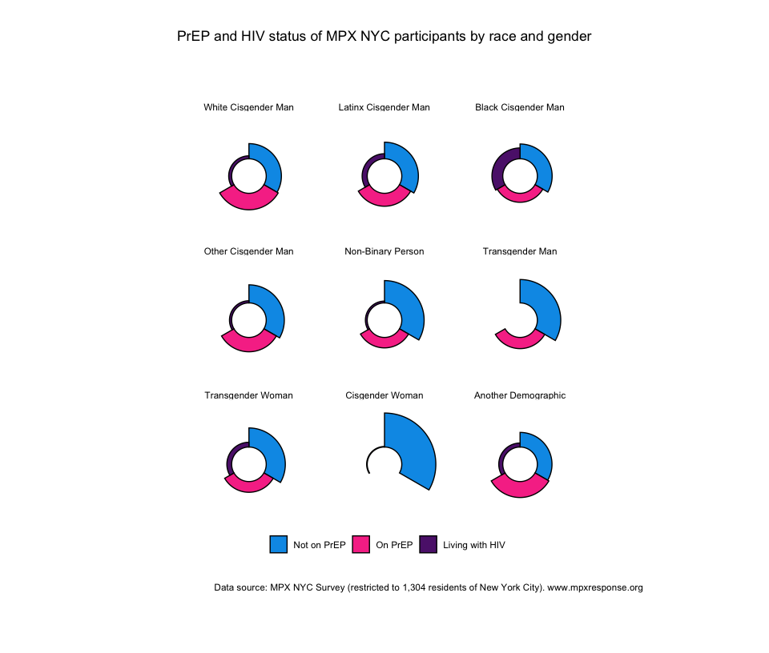

Contact venues
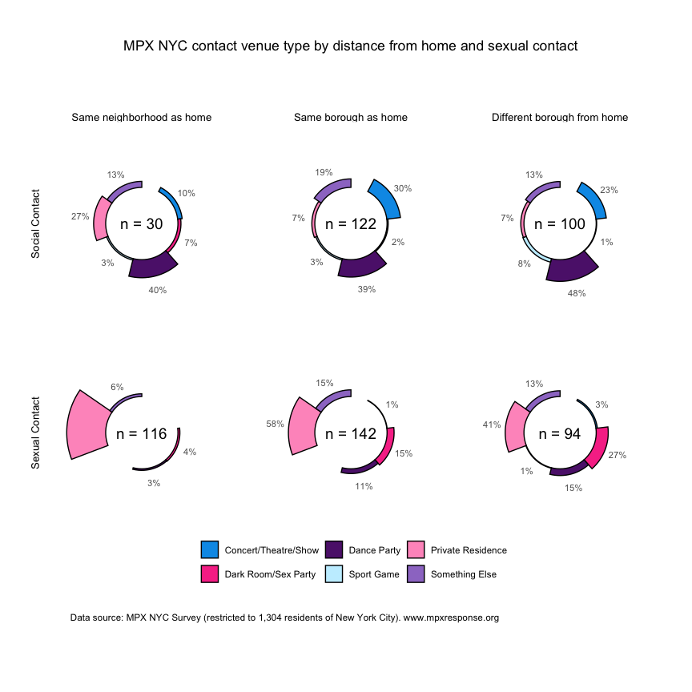

Participants connecting through contact venues
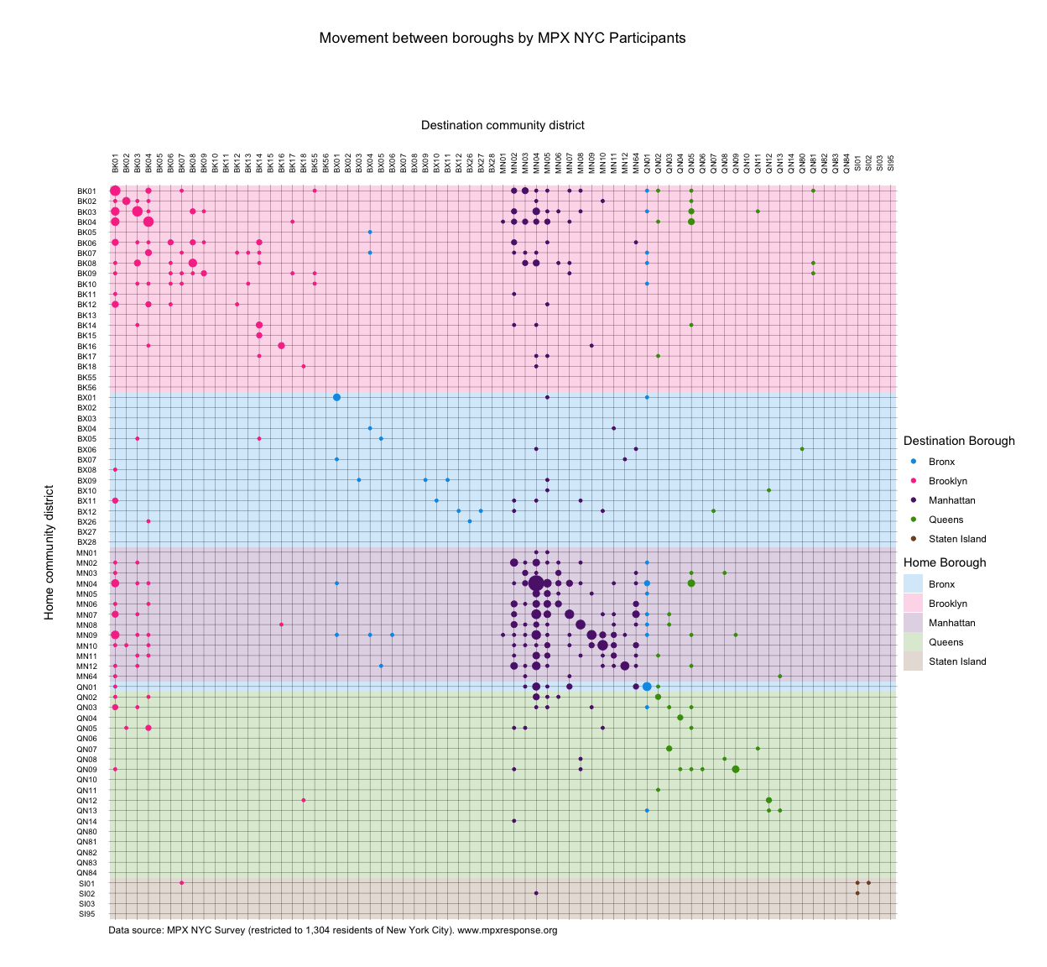
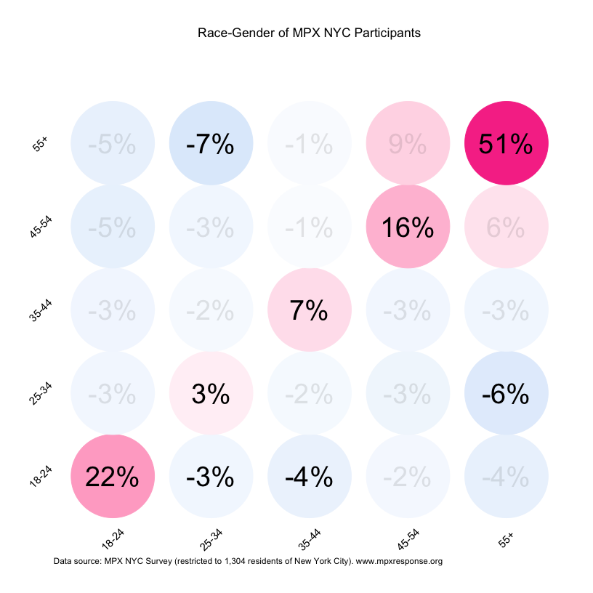
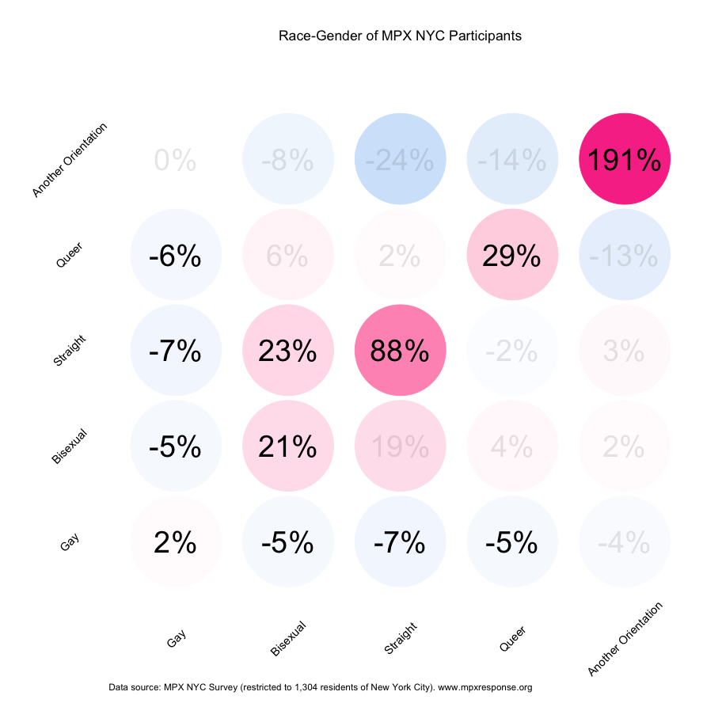
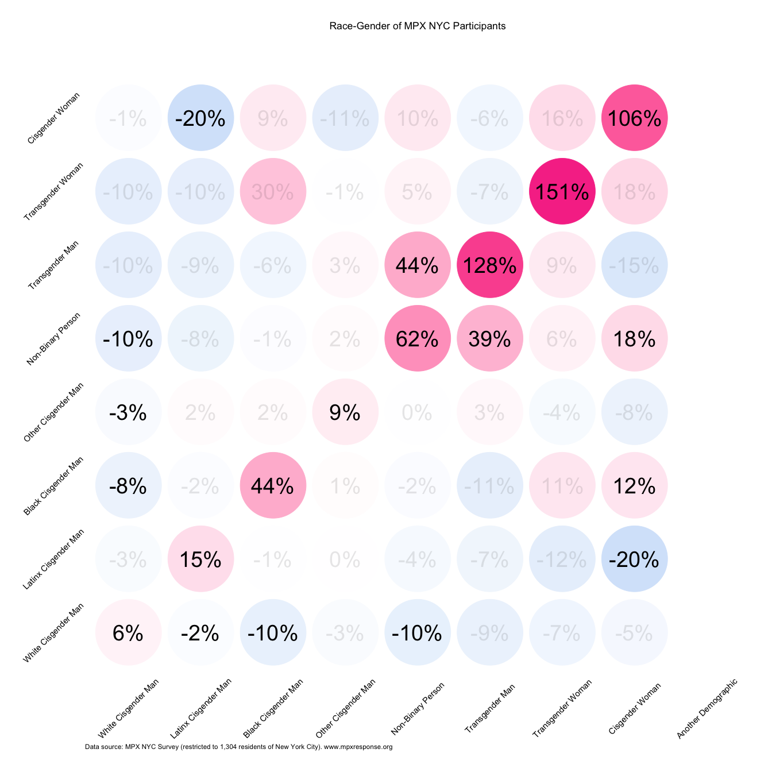

Efficient and effective interventions
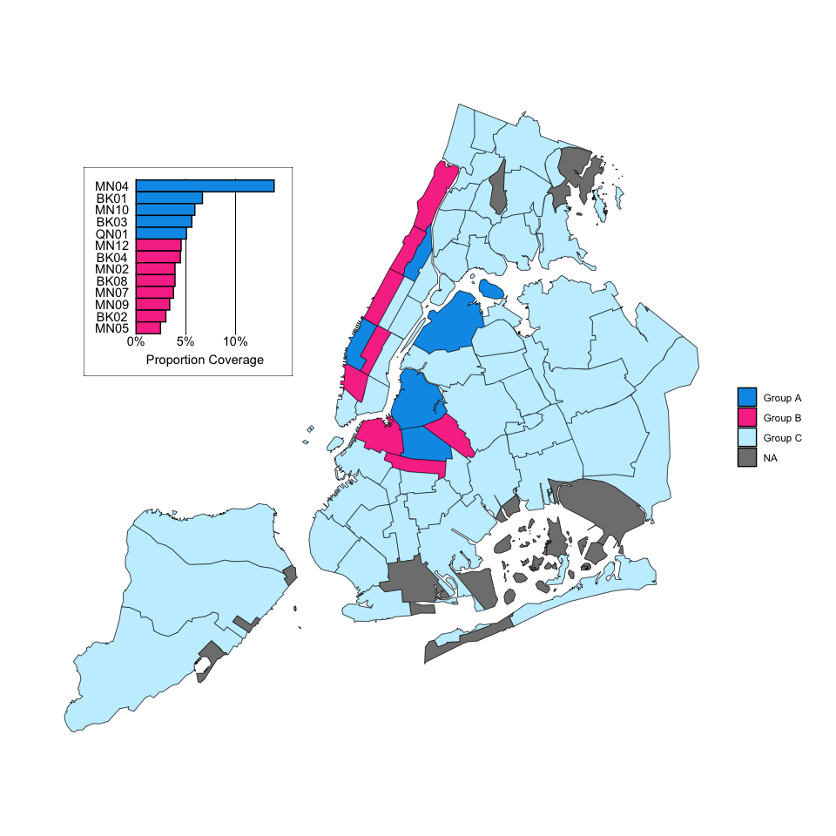
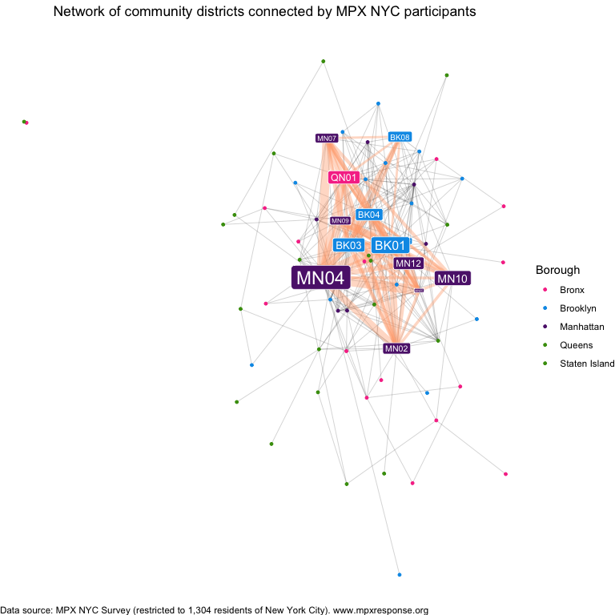
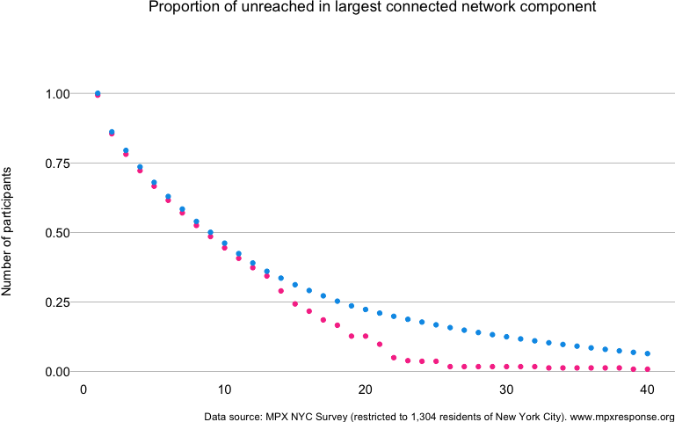

Acknowledgements
We are grateful to sponsors of the study: amfAR; Center for AIDS research at Harvard University; UCLA, and to the XX individual donors who gave amounts ranging from XX to XX. LinkNYC and Grindr advertisements donated free advertising to the study, neo4j provided a free license for their proprietary database software. Cody Patrick Nolan coordinated translation of the survey instrument and marketing materials. Antón Castellanos-Usiglu conducted the translation and verified them with Cody Patrick Nolan, Chema Jiménez, Juan Pablo Amaya Amaris, Santiago Aguilera Mijares, and María Andrea Santos Guzmán. We thank the MPX NYC participants for contributing to the study. Pedro Carneiro and Nguyen Tran drafted the questionnaire. Lisa Berkman, Tom Carpino, David Barr, and Judy Auerbach reviewed the questionnaire. Sudipta Saha coordinated study activities. Keletso Makofane developed and coded the survey instrument. The survey instrument uses the FCC Data API but is not endorsed or certified by the FCC.

References
“Federal Communications Commission API.” n.d. https://www.fcc.gov/reports-research/developers/api-terms-service.
Google. 2024. “Maps JavaScript API.” https://developers.google.com/maps/documentation/javascript.
Neo4j. 2024. “Neo4j Documentation.” https://neo4j.com/docs/?utm_source=Google&utm_medium=PaidSearch&utm_campaign=Evergreen&utm_content=AMS-Search-SEMCE-DSA-None-SEM-SEM-NonABM&utm_term=&utm_adgroup=DSA&gad_source=1&gbraid=0AAAAADk9OYpn-veLtg3MSa3HV-mXEgnRC&gclid=Cj0KCQjwlvW2BhDyARIsADnIe-KKo4LZmo02jxyexPVweelrw_q-AwBtFSFPqVlfJ5YjiNyd1w7txfUaAk62EALw_wcB.
“NextJS Documentation.” 2024. https://nextjs.org/docs.
NYC OpenData. 2022. “New York City Community Districts.” https://data.cityofnewyork.us/City-Government/Community-Districts/yfnk-k7r4.
Roth, Grant, Jennifer Barnes-Balenciaga, Joseph Osmundson, Martez DR Smith, Nguyen K Tran, Nicholas Diamond, and Keletso Makofane. 2023. “Global North Learning from Global South: A Community-Led Response to Mpox in New York City.” PLOS Global Public Health 3 (6): e0002042.
US Census. 2022. “Census Tracts.” https://www2.census.gov/geo/pdfs/education/CensusTracts.pdf.

