V*-fit

VS-fit is a Python application that implements the DC DFT periodogram (a very basic, mostly nominal implementation) and performs curve fitting using a combination of algebraic and trigonometric polynomials. The program was inspired by I. L. Andronov’s MCV software.

Download the program from its repository at https://github.com/mpyat2/VS-fit/
Go to the Releases section (https://github.com/mpyat2/VS-fit/releases) and download the ZIP file containing the source code (the program is written in Python, so the source code is essentially the program itself). Then unpack it to any desired location on your machine.

In Windows, launch VS-fitW.bat. In Linux, launch vs-fit.sh. Note that in both cases it is assumed that Python is installed on the machine. You may edit VS-fitW.bat (or vs-fit.sh) if the name of the Python interpreter differs from the expected one (py in Windows and python3 in Linux, respectively), or if the interpreter is not in the system PATH.

The program requires the following Python packages:
- astropy
- scipy
- matplotlib
- pandas

After launching, the main program window and the “Log” window will appear. The main window contains only the main menu and tool buttons:
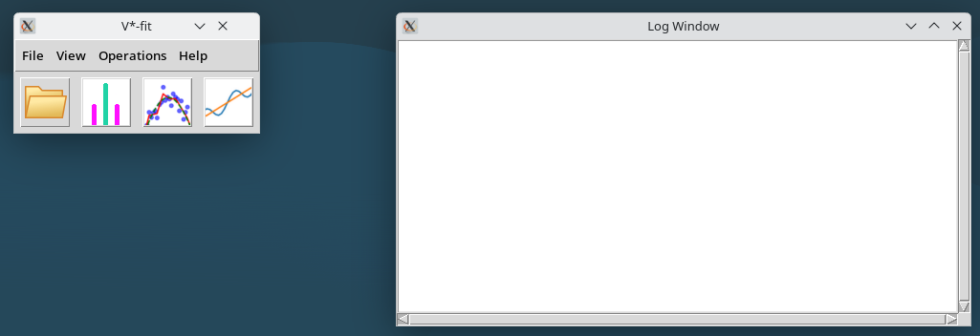
Use the first tool button (or File → Open Data File… from the menu) to open a data file. The program recognises files with columns delimited by spaces or tabs. Consecutive spaces are treated as a single delimiter, while each tab is treated as a separate delimiter. Empty lines and lines beginning with “#” are ignored. Only the first and second columns are read. It is assumed that the first column contains the X-values (i.e., times) and the second column contains the Y-values (i.e., magnitudes). You can find example data files in the data folder.
Let’s open the tcas.tsv file (T Cas observations). A new window will open showing the plot:
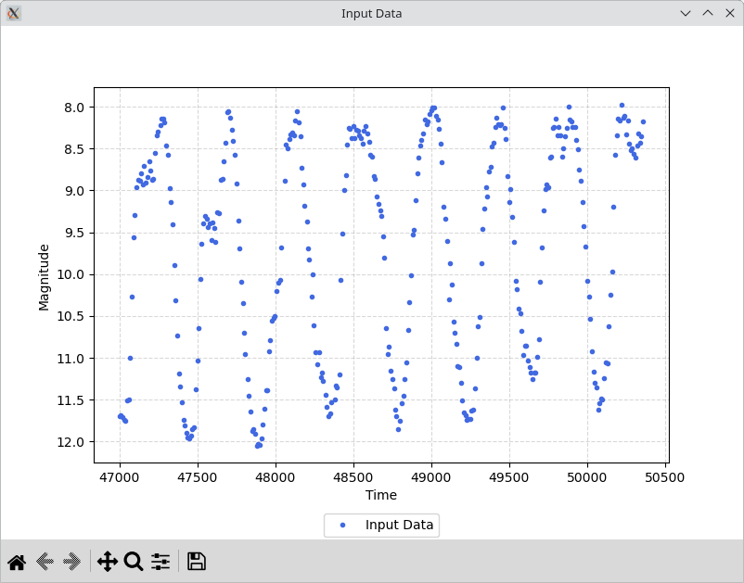

Let’s build a periodogram. Use Operations → DC DFT (Ferraz-Mello)... to do this. Specify the lowest and highest frequencies to analyze, as well as the number of intervals (which is one less than the number of frequencies). For this example, a reasonable choice would be:
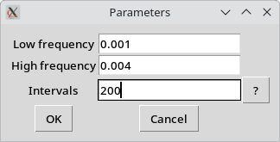

This corresponds to periods ranging from 250 to 1000 days. Press OK. Shortly thereafter, a new window displaying the periodogram will open:

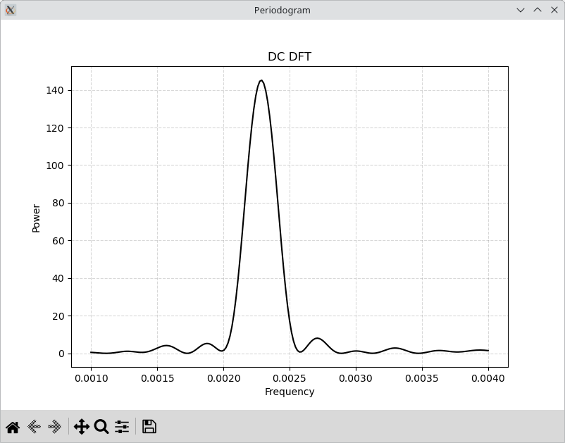
Use the “magnifying glass” icon and your mouse to zoom in on the region near the maximum:
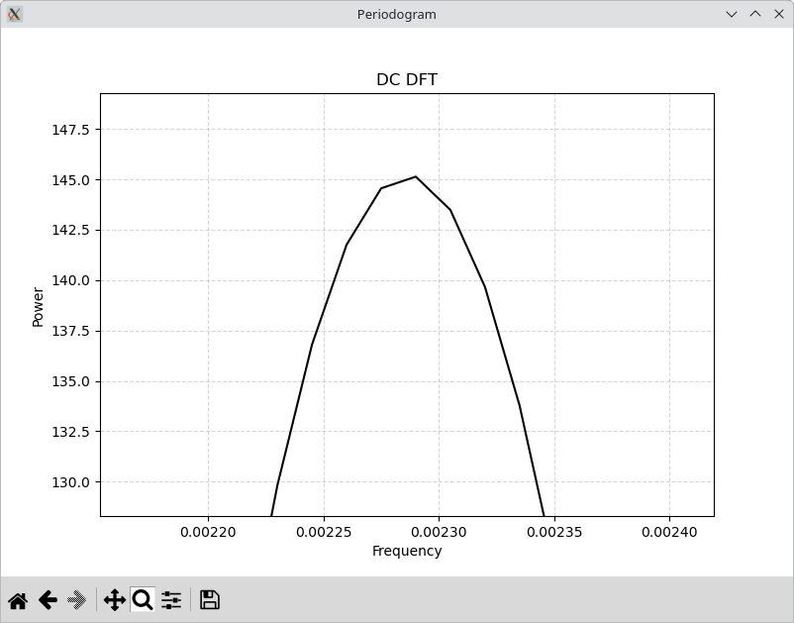
The maximum occurs near a frequency 0.0023 d-1, corresponding to a period of approximately 435 days. Right-click the maximum to copy its X value (frequency) to the clipboard. To refine this estimate, use the Operations → Polynomial Fit… menu command. You may enter the preliminary period value manually (435) or paste (Ctrl+V) it from the clipboard. Since the value in the clipboard (e.g., 0.00229) is given as a frequency, while the dialog expects a period, use the expression 1/0.00229. Then set the trigonometric polynomial degree to 4 (an arbitrary choice for demonstration purposes). Also, set the algebraic polynomial degree to 1, which is appropriate given the upward trend in the data. Finally, enable the “Optimize” option.
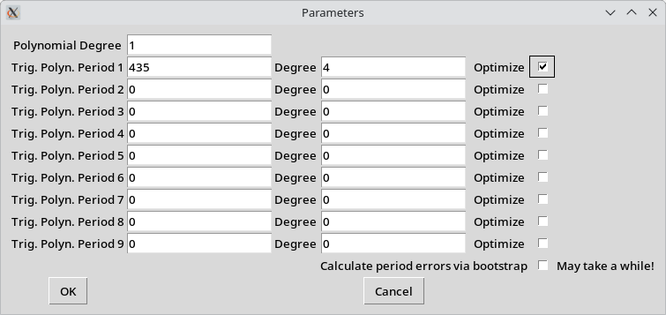
Press OK. Shortly, the approximation will be shown in the ‘Input’ window alongside the original data:
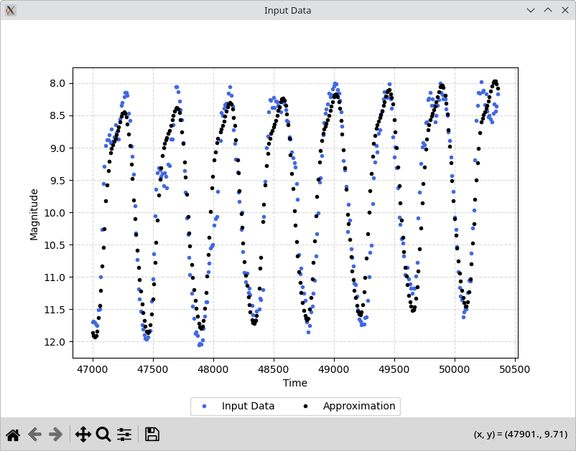
Check the Log window. Here you will find the refined period value: 438.97 ± 0.54 days.
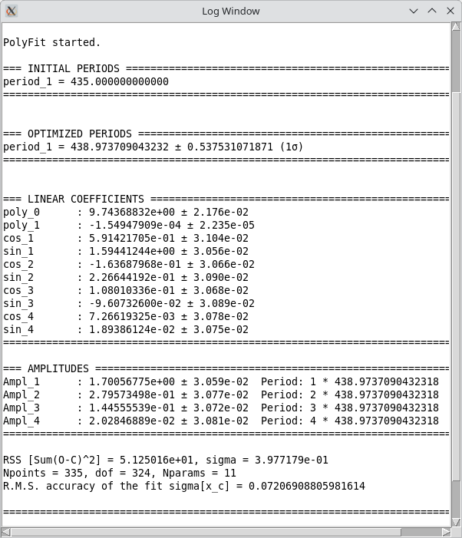
Now, reopen the tcas.tsv file, go to the View menu, select Plot Input → Phase, and enter the period value:
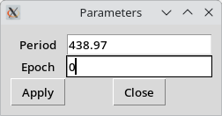
Enter 0 in the “Epoch” field for now, then press “Apply.”
A phase plot will be displayed. You can further refine the initial epoch to align the maximum with phase = 0.
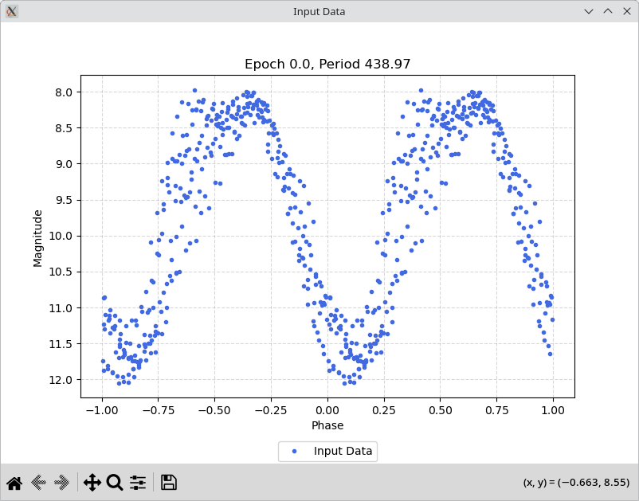
The period value of 438.97 days is quite close to the one listed in the VSX database.
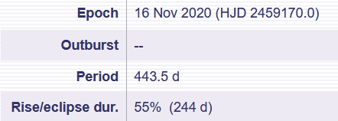

(End of the document)

