TYC 3637-1152-1 is a high-amplitude delta Scuti star with multiple periods (2019NewA...68...39P). Let’s find its periods using TESS data and refine them.
Use the “TYC_3637-1152-1_Sector57_TESS-SPOC_part.txt” file from the ‘data’ folder.

To obtain preliminary period estimates, we will use the LCV program (https://github.com/mpyat2/LightCurveViewer). Then we will refine the values of the periods with V*-fit.

Using the LCV program, calculate a periodogram with the following parameters:
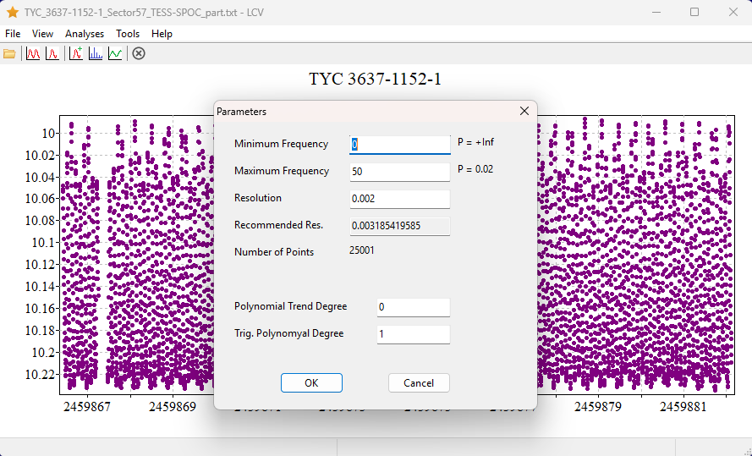

The periodogram displays a prominent peak at a period of 0.09966 days. The second harmonic is also visible at P=0.04983 days, and upon zooming in, the third and fourth harmonics become apparent.
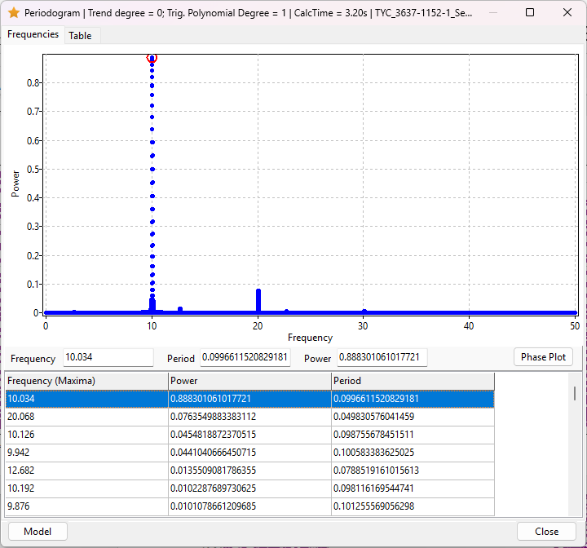

Let’s create a model. Select the most prominent period in the table (the first entry), then click the ‘Model’ button. In the dialog that appears, set Degree1 to 4 and click OK:
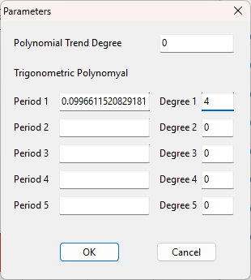

"Now, select Analyses → Detrend from the menu. The residual light curve will then be displayed: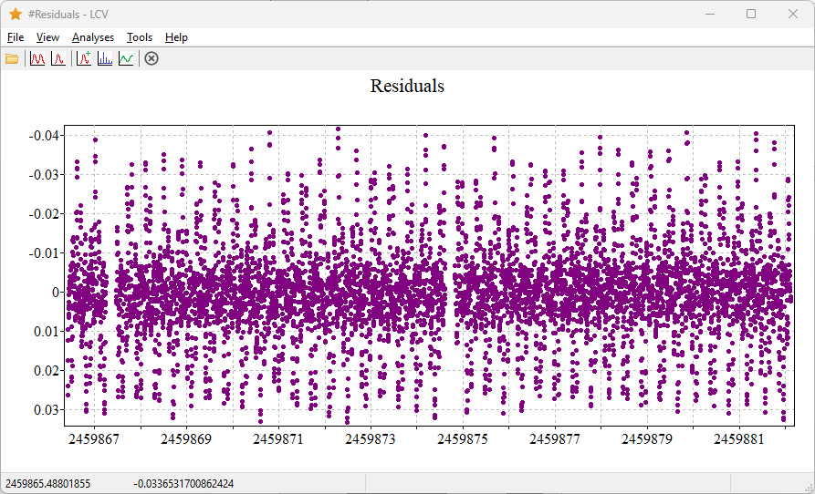

Rebuild the periodogram using the same parameters as before. You should now observe another prominent peak at a period of 0.07885 days.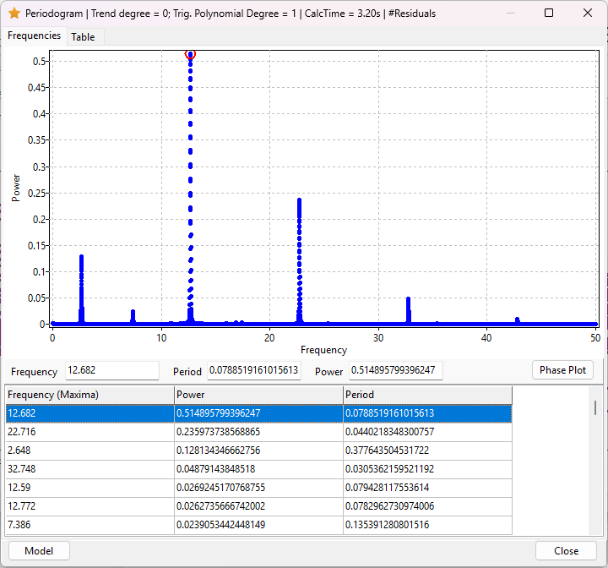

Create a model using this period with Degree1 set to 1, then recalculate the residuals.
Here’s a polished version of your sentence for clarity and flow:
By repeating these steps several times, additional periods can be identified. The table below lists the first seven periods along with their corresponding frequencies:

N | Period | Frequency | Comment
1 | 0.09966 | 10.0341
2 | 0.07885 | 12.6823
3 | 0.04402 | 22.7160 | f1+f2
4 | 0.37793 | 2.6460 | f1-f2
5 | 0.03054 | 32.7439 | 2*f1+f2
6 | 0.13535 | 7.3883 | 2*f1-f2
7 | 0.02337 | 42.7899 | 3*f1+f2

To refine these periods, run V*-fit and open the file named TYC_3637-1152-1_Sector57_TESS-SPOC_part.txt. Then, click the Polynomial Fit button 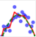. Enter the periods, setting the degree to 4 for the first one and to 1 for each of the others. Also, make sure to check the 'Optimize' box for all periods.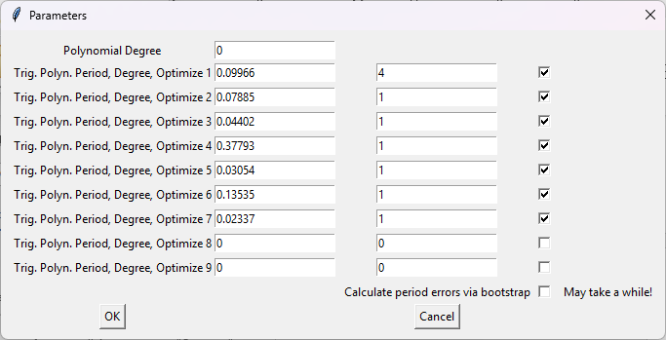

Then click OK. Within a few seconds, a plot showing the approximation will appear. Below is a zoomed-in section of the plot, where blue dots represent the original data and black dots indicate the model approximation: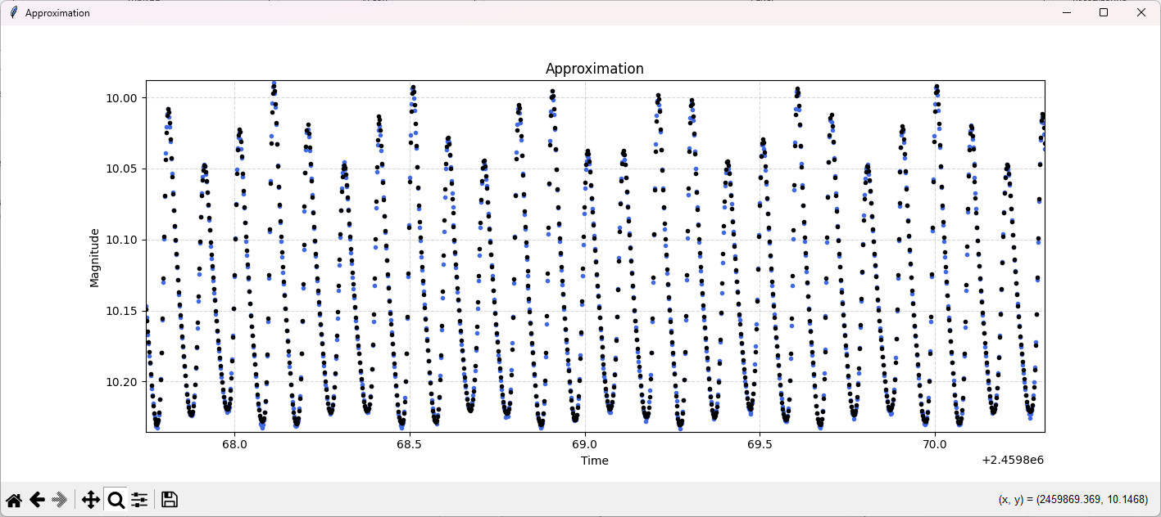

In the Log window, you will find the refined periods, their estimated errors, and additional useful information, including the polynomial coefficients and their associated uncertainties.
The table below presents the initial period values, the refined period values, and their associated errors.
N | Period | Frequency | Comment | Improved period | Error
1 | 0.09966 | 10.0341 |  | 0.09966148 | 0.00000012
2 | 0.07885 | 12.6823 |  | 0.07885759 | 0.00000074
3 | 0.04402 | 22.7160 | f1+f2 | 0.04402356 | 0.00000034
4 | 0.37793 | 2.6460 | f1-f2 | 0.377798 | 0.000034
5 | 0.03054 | 32.7439 | 2*f1+f2 | 0.03053551 | 0.00000036
6 | 0.13535 | 7.3883 | 2*f1-f2 | 0.135369 | 0.000010
7 | 0.02337 | 42.7899 | 3*f1+f2 | 0.02337424 | 0.00000049

Note that only the first and second periods are independent. The remaining periods correspond to linear combinations of these fundamental frequencies and should therefore not be optimized independently. However, this constraint is not currently supported in V*-fit.

