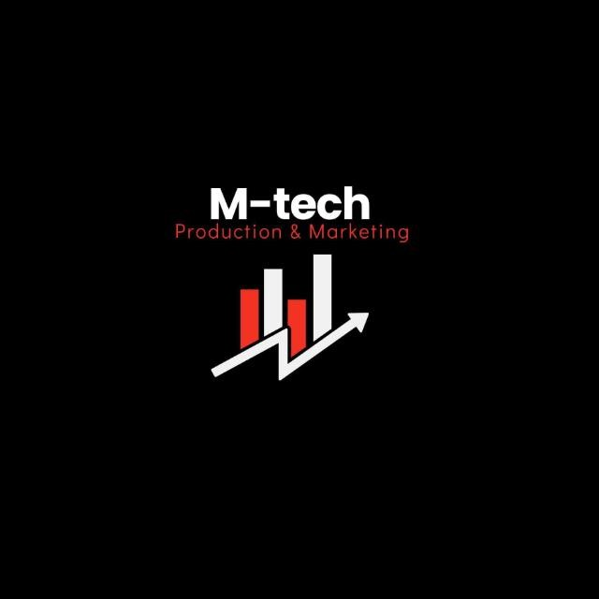

M-Tech Production & Marketing
Technology | Training | Marketing | Projects
PROJECT REPORT
Internship Program — Batch 2026

Submitted By:
Muhammad Qasim
Department:
Data Science
ID:
Mtech-DS26016
_______________________ | Supervisor:

Haripur Main Bazar, Khyber Pakhtunkhwa, Pakistan
mtechproductionandmarketing@gmail.com | +92 336 2222480

Introduction

This report presents the work completed for Task 1 of the M-Tech Production & Marketing AI/ML
Internship Program, Batch 2026. The internship focuses on practical exposure to core concepts in Artificial Intelligence and Machine Learning, equipping interns with skills applicable to real-world technology and marketing challenges.
M-Tech Production & Marketing is a forward-looking company based in Haripur, KPK, specializing in Technology, Training, Marketing, and Projects. The internship is structured in a 9-Phase roadmap designed to progressively build theoretical knowledge and hands-on project experience.

Objectives

The objectives of this task were to:
- Understand how a professional, Power BI-style executive dashboard is designed and structured.
- Build a multi-page, cross-filtering Business Intelligence application in Python using PyQt5 and Matplotlib.
- Model realistic retail data (Region, Store, Category, Product, Month) in a star-schema-like structure.
- Implement hierarchical drill-down and cross-filtering (Region → Store → Product) across all report pages.
- Deliver a working prototype demonstrating KPI tracking, trend analysis, and target-vs-actual visuals.

Task Description

The assigned task was to design and build a Retail Chain Executive Dashboard, an advanced-level, single-file BI application (retail_dashboard.py) built with PyQt5 and Matplotlib, styled to resemble Power BI’s reporting experience. The dashboard needed a left navigation rail, a shared cross-filter state (Region → Store → Product hierarchy plus Category) visible in a breadcrumb bar, click-to-drill charts, KPI cards showing YoY growth and Target-vs-Actual variance, and a semicircular gauge visual for target achievement. The application is organised into four report pages – Overview, Regional Analysis, Store Drill-down, and Product & YoY – all driven by a single synthetic fact table covering two fiscal years (2024–2025) across four regions, twelve stores, four product categories, and eleven products.

Work Done

The following components were designed and implemented:
- Data model: a synthetic star-schema fact table (Region, Store, Category, Product, Month) with realistic seasonality and year-over-year growth trends, plus a DataModel class exposing filtering and aggregation helpers for KPIs, by-region, by-store, by-product, by-category, and monthly-trend views.
- UI widgets: a Power BI colour palette, KPI cards with coloured YoY/achievement deltas, a clickable Matplotlib chart canvas that emits drill-down events, chart-card containers with drop shadows, and a breadcrumb filter bar.
- Four report pages: Overview (KPI tiles, Sales-by-Region drill entry point, 12-month current-vs-prior-year trend, Target-vs-Actual by region), Regional Analysis, Store Drill-down, and Product & YoY (including the semicircular target-achievement gauge).
- Cross-filtering logic: a shared FilterState, so clicking any chart bar on any page updates the filter hierarchy and refreshes every page, auto-navigating to the next logical drill level in a Power BI-style workflow.
- Navigation shell: a left navigation rail, top bar with breadcrumb and manual region selector, and a “Reset Filters” control.

Challenges Faced

- Synchronising a single shared filter state across four independent pages without redundant or inconsistent re-renders.
- Making Matplotlib bars clickable and mapping each click back to the correct categorical label to drive cross-filtering.
- Replicating Power BI’s semicircular gauge visual using only Matplotlib primitives.
- Keeping YoY and Target-vs-Actual calculations correct as region, store, category, and product filters are combined hierarchically.
- Matching the visual polish of a native BI tool (card shadows, rounded corners, spacing) using PyQt5 and Matplotlib alone.

Key Learnings

- Gained practical experience translating BI/UX concepts – cross-filtering, drill-down, breadcrumbs – into a working desktop application.
- Deepened understanding of PyQt5’s signal/slot architecture for building decoupled, event-driven interfaces.
- Learned to separate a data-model layer from the UI layer for a more maintainable, testable application.
- Improved Matplotlib skills for building custom, interactive, and consistently styled visuals beyond default chart types.
- Developed a stronger appreciation for how commercial BI tools manage state, filtering, and navigation internally.

Conclusion

Task 1 of the internship was completed successfully with the delivery of a fully functional Retail Chain Executive Dashboard prototype. The application demonstrates a realistic, Power BI-style reporting experience – including KPI tracking, YoY and Target-vs-Actual analysis, a semicircular achievement gauge, and hierarchical drill-down – built entirely in Python. Beyond the technical deliverable, the task provided valuable, hands-on exposure to BI application design, event-driven UI architecture, and data modelling practices that will support later phases of the internship roadmap.

