Supporting Information

Oxygen-Vacancy Energetics and Dopant-Induced Holes in Pr- and Rb-Substituted Anatase TiO₂: A DFT+U Comparison
Mohammad Ghadimimehr, Azimah Binti Omar*, Siti Rohani Binti Sheikh Raihan — Universiti Malaya
Contents. S1 Pristine V_{O} convergence · S2 Additional PDOS and Löwdin site moments · S3 Hubbard-U sweep · S4 k-mesh verification · S5 Bader analysis · S6 Alternative V_{O} sites · S7 Hybrid, dual-U and dispersion calculations · S8 Methods details, structural data and file inventory · S9 Full-precision energy ledger · S10 Run settings and manifest · S11 Force-convergence trajectories

S1. Pristine V_{O} baseline: convergence recovery
The pristine anatase V_{O} reference reported in Table 2 of the main text (E_{f} = +4.74 eV) required two attempts. The first used mixing_mode = local-TF with mixing_beta = 0.3, not the damped mixing_beta = 0.1 of the doped-cell relaxations (Section 2.6), and oscillated, with the SCF accuracy estimate moving between 0.05 and 0.14 Ry over iterations 14–17, an instability associated with the two vacancy electrons occupying a dense manifold of conduction-band states. The second attempt (run Pristine_VO_v3) changed six settings together: mixing_beta 0.3 → 0.1; mixing_ndim → 12; Gaussian smearing degauss 0.005 → 0.01 Ry (≈ 136 meV); electron_maxstep → 300; diago_thr_init → 1×10⁻³ Ry; and starting_magnetization = 0.05 on both species as a symmetry-breaking nudge. The SCF then converged monotonically in 96 iterations of the first BFGS step to conv_thr = 1×10⁻⁸ Ry. Six further BFGS steps brought the maximum force to 0.00563 Ry/Bohr, slightly above the 0.005 Ry/Bohr production threshold, at which point the relaxation was stopped. The final total energy of the 47-atom cell is −4233.15036 Ry; against E(Pristine_perfect) = −4275.01530 Ry and ½E(O₂) = −41.51621 Ry this gives E_{f} = +4.74 eV. The converged cell is non-magnetic. The single-point inputs derived from the doped-cell production runs (U sweep) use degauss = 0.005 Ry, so the converged pristine V_{O} cell may differ in smearing width from the other cells (Section 2.4 of the main text). Because the two vacancy electrons of the pristine V_{O} cell occupy conduction-band states, its −TS term need not be negligible at 0.01 Ry. [AUTHOR ACTION: confirm degauss of the production relaxations from their inputs, and report the “smearing contrib. (−TS)” line of runs 1 and 2 (Table S9).]

S2. Additional projected densities of states and Löwdin site moments
S2.1 Settings. The projected densities of states (PDOS) of Figure 4 of the main text and Figure S2 were computed with projwfc.x on 2×2×2 non-self-consistent runs (tetrahedron occupations; 260 bands for Pr_VO, 226 for Rb_VO) that read a Γ-only self-consistent density regenerated on the final relaxation geometry. The self-consistent runs used Gaussian smearing of 0.01 Ry and starting_magnetization = 0 (Pr_VO) or 0.3 on Ti (Rb_VO); the Rb_VO run reproduced the production Fermi energy (7.1329 eV) to 0.1 meV, although the from-scratch Rb_VO solution differs from it by only 13 meV (Section 3.3 of the main text). The non-self-consistent Fermi energies are 7.1440 eV (Rb_VO) and 10.306 eV (Pr_VO). In the Rb_VO run the majority-spin Kohn–Sham gap is 2.87 eV (valence-band top 0.22 eV below and conduction-band minimum 2.65 eV above E_{F}), and the hole is a single minority-spin band 0.04–0.13 eV above E_{F}; pw.x reported 33–37 unconverged eigenvalues per k-point, normally the highest of the 226 bands. The Rb_VO cell retains two symmetry operations (identity and a mirror plane), which the Löwdin moments respect (pairs O6/O17, Ti4/Ti15 and O29/O41). projwfc.x used Gaussian broadening of 0.01 Ry (0.136 eV) and an energy step of 0.02 eV. The atomic wavefunctions read from the datasets are Ti 3s/3p/3d, O 2s/2p, Pr 5p/5d and Rb 4s; there is no Pr-4f and no Rb-d projector, so the Pr curve is Pr-5d and no dopant-d curve exists for Rb_VO. The spilling parameters are 0.0030 (Pr_VO) and 0.0032 (Rb_VO). The summed projections are deposited as PDOS_Pr_VO(_spin).csv and PDOS_Rb_VO(_spin).csv and are plotted without smoothing or rescaling by figures/make_pdos_figures.py (Pr-5d multiplied by 5 where labelled).
S2.2 Löwdin site moments. The same projwfc.x runs give Löwdin charges and spin polarisations for every atom (lowdin_Pr_VO.csv, lowdin_Rb_VO.csv; extracted by figures/extract_lowdin.py). In Pr_VO no site exceeds 0.0006 μ_{B} in magnitude (sum −0.001 μ_{B}, sum of magnitudes 0.004 μ_{B}). In Rb_VO (Figure S1) the moments sum to +1.006 μ_{B} and their magnitudes to 1.242 μ_{B} (m_{abs} of the production relaxation: 1.21 μ_{B}). The largest moment is +0.595 μ_{B} on O8, which is bonded to two Ti atoms (1.958 Å) and to the displaced Rb ion (2.564 Å) and lies 3.39 Å from the vacant site. O6 and O17 (3.26 Å from Rb) carry +0.114 μ_{B} each, O29 and O41 +0.059 μ_{B} each and O20 +0.039 μ_{B}; the 31 oxygens together carry +1.124 μ_{B}. The Ti sublattice carries −0.117 μ_{B}, at most −0.033 μ_{B} on any site (Ti4 and Ti15, the two Ti bonded to O8), and Rb −0.001 μ_{B}. O8 is also the oxygen with the largest Bader depletion (Table S3). In Pr_VO the four lowest oxygen populations are on O9, O30, O11 and O23 (four of the five remaining first-shell oxygens of the dopant site) and the highest Ti-3d populations on Ti2, Ti25 and Ti26, consistent with the same vacancy site as in Rb_VO, where Ti2 and Ti26 are the Ti bonded to the vacant site. Löwdin populations depend on the projector basis; they are used only to locate the spin density.
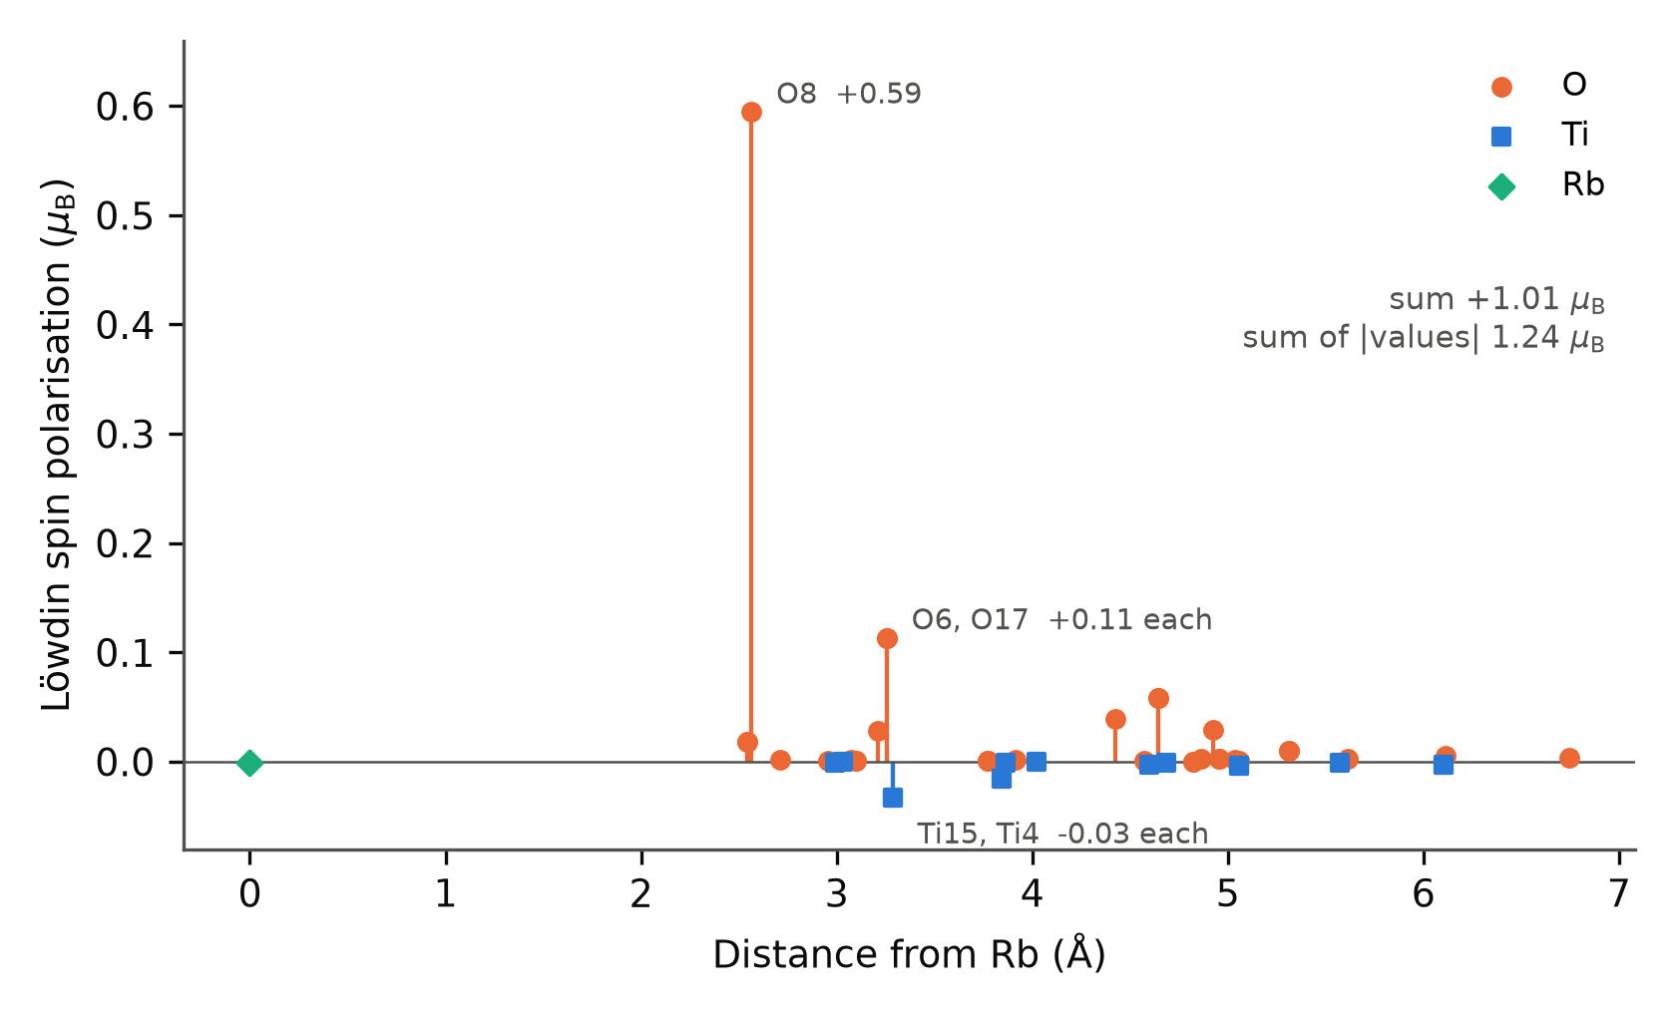
Figure S1. Löwdin spin polarisation of every atom of the Rb_VO cell against its minimum-image distance from Rb (projwfc.x, 2×2×2 non-self-consistent run on the relaxed cell). Orange circles: O; blue squares: Ti; green diamond: Rb. Symmetry-equivalent pairs (identical distance and moment) are labelled together.
S2.3 Spin-summed densities of states. Figure S2 shows the companion of Figure 4 without spin decomposition. Pr_VO: E_{F} = 10.31 eV inside the Ti-3d conduction band, valence-band top about 2.9 eV below E_{F}. Rb_VO: E_{F} = 7.14 eV at the top of the O-2p valence band, with a small feature centred just above E_{F} (the empty minority-spin state of Figure 4) and the conduction-band onset about 2.5 eV above E_{F}.
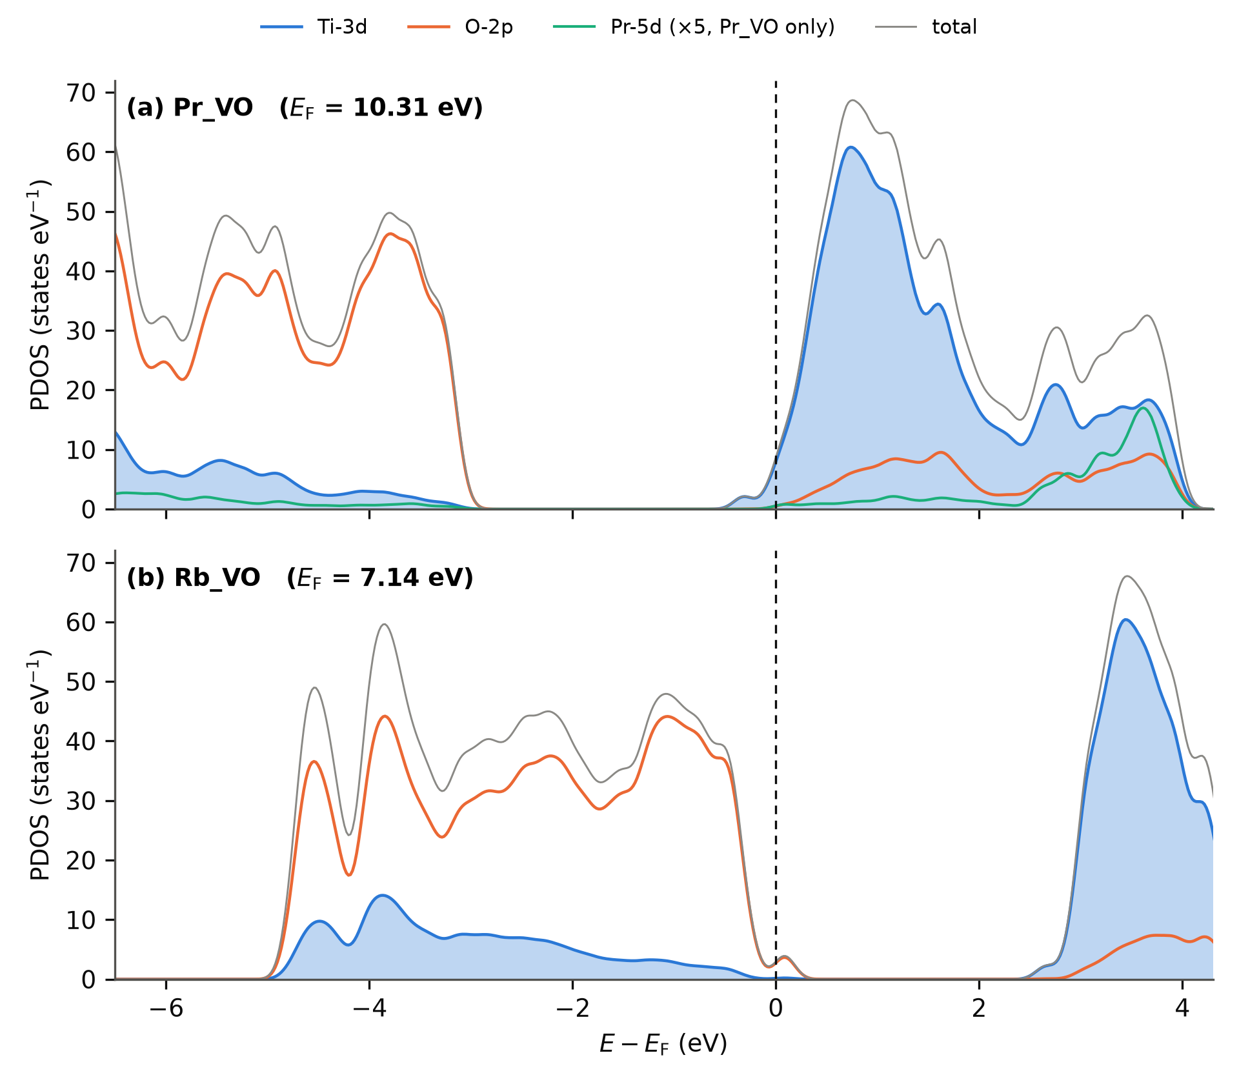
Figure S2. Projected densities of states of (a) Pr_VO and (b) Rb_VO without spin decomposition (same runs and settings as Figure 4). Filled blue: Ti-3d; orange: O-2p; green: Pr-5d ×5 (Pr_VO only); grey: total.

S3. Hubbard-U sensitivity sweep
Single-point calculations on the relaxed Pristine_perfect, Pr_VO and Rb_VO cells at U(Ti-3d) = 3.0, 4.0 and 4.5 eV (Γ-only, 40 Ry, ortho-atomic projectors, Gaussian smearing 0.005 Ry, starting_magnetization = 0 on all species). The geometries were not re-relaxed at each U. The U = 3.5 eV entries are the production relaxations.
Table S1. Total energy, total magnetisation and printed Fermi energy across the U(Ti-3d) sweep. m is the total magnetisation; for the production Rb_VO relaxation m_{abs} = 1.21 μ_{B}. Total energies at different U are not comparable as energies, but their smooth variation (6.1–6.6 eV per 0.5 eV step in every cell) shows that no electronic instability occurs in this range. Runs 38–46 of Table S9.
Cell | Quantity | U = 3.0 | U = 3.5 (production) | U = 4.0 | U = 4.5
Pristine_perfect | E_{tot} (Ry) | −4275.49753 | −4275.01530 | −4274.53719 | −4274.06329
 | m (μ_{B}) | 0.00 | 0.00 | 0.00 | 0.00
 | E_{F} (eV) | 8.184 | 7.887 ª | 8.312 | 8.381
Pr_VO | E_{tot} (Ry) | −4535.55974 | −4535.10106 | −4534.64041 | −4534.18631
 | m (μ_{B}) | 0.00 | 0.00 | 0.00 | 0.00
 | E_{F} (eV) | 9.906 | 9.990 | 10.078 | 10.166
Rb_VO | E_{tot} (Ry) | −4289.62997 | −4289.17135 | −4288.71556 | −4288.26409
 | m (μ_{B}) | 1.00 | −0.97 | 1.00 | 1.00
 | E_{F} (eV) | 7.082 | 7.133 | 7.159 | 7.197
ª The pristine cell is insulating and its printed E_{F} lies in the gap at a position set by the smearing; a Γ-only single point at the same total energy prints 8.244 eV (Table S2a).

S4. k-mesh verification
Single-point SCF energies on the Γ-relaxed geometries (40 Ry, U(Ti-3d) = 3.5 eV, Monkhorst–Pack meshes without offset). Table S2a gives the k-mesh series of Pristine_perfect, Pr_VO and Rb_VO; Table S2b the formation-energy check at 2×2×2.
Table S2a. k-mesh series (runs 26–37 of Table S9). All single points start from scratch (starting_magnetization = 0). The Γ entries differ slightly from the production relaxation endpoints (Pristine: < 1×10⁻⁵ Ry; Pr_VO: +0.00281 Ry = +0.038 eV; Rb_VO: +0.00047 Ry = +6.4 meV, the from-scratch Rb_VO solution with m = 1.00 μ_{B}, Section 3.3 of the main text).
Cell | Mesh (k-points) | E_{tot} (Ry) | E − E(3×3×2) (meV/atom) | m (μ_{B}) | E_{F} (eV)
Pristine_perfect | Γ (1) | −4275.01530 | −21.8 | 0.00 | 8.244
 | 2×2×1 (4) | −4274.93420 | +1.15 | 0.00 | 8.244
 | 2×2×2 (8) | −4274.93072 | +2.13 | 0.00 | 8.247
 | 3×3×2 (18) | −4274.93826 | 0 | 0.00 | 8.248
Pr_VO | Γ (1) | −4535.09825 | −23.0 | 0.00 | 9.992
 | 2×2×1 (4) | −4535.02249 | −1.05 | 0.00 | 10.274
 | 2×2×2 (8) | −4535.01814 | +0.20 | 0.00 | 10.277
 | 3×3×2 (18) | −4535.01885 | 0 | 0.00 | 10.271
Rb_VO | Γ (1) | −4289.17088 | −24.7 | 1.00 | 7.120
 | 2×2×1 (4) | −4289.08408 | +0.42 | 0.99 | 7.053
 | 2×2×2 (8) | −4289.08034 | +1.50 | 0.99 | 7.043
 | 3×3×2 (18) | −4289.08553 | 0 | 1.00 | 7.058
The Γ-only energies lie 22–25 meV per atom below the 3×3×2 values; beyond 2×2×1 the energies agree with 3×3×2 to within 2.1 meV per atom, not monotonically. The magnetisations are mesh-independent.
Table S2b. Total energies at Γ-only and 2×2×2 (Ry) and the resulting formation energies (eV). The Γ column holds the production relaxation endpoints; the Pr_VO and Rb_VO 2×2×2 entries are runs 32 and 36 of the k-mesh series (runs 9 and 11 of Table S9), and the Pr_perfect and Rb_perfect entries are runs 8 and 10. Because the 2×2×2 single points start from scratch, the Γ-to-2×2×2 differences include the small from-scratch offsets noted under Table S2a.
Cell | E_{tot}, Γ (Ry) | E_{tot}, 2×2×2 (Ry) | ΔE = E(2×2×2) − E(Γ) (Ry) | ΔE (eV)
Pr_perfect | −4576.71224 | −4576.62183 | +0.09041 | +1.230
Pr_VO | −4535.10106 | −4535.01814 | +0.08292 | +1.128
Rb_perfect | −4330.38890 | −4330.28761 | +0.10129 | +1.378
Rb_VO | −4289.17135 | −4289.08034 | +0.09101 | +1.238
E_{f}(V_{O}; Pr) | +1.292 eV | +1.190 eV
E_{f}(V_{O}; Rb) | −4.063 eV | −4.203 eV
ΔE_{f} (Pr − Rb) | +5.356 eV | +5.394 eV |  | ΔΔE = +0.038 eV
ΔΔE is defined as the 2×2×2 contrast minus the Γ-only contrast. The pristine V_{O} cell was not computed at 2×2×2. [AUTHOR ACTION: add run identifiers (output file names) for runs 8 and 10.]

S5. Bader topological-charge analysis
Bader analysis of the relaxed Pr_VO and Rb_VO cells: pp.x charge density (plot_num = 0, output_format = 6, Gaussian cube) decomposed with the Henkelman grid-based code (v1.05, 2023-08-19). [AUTHOR ACTION: state the FFT grid dimensions and whether the all-electron PAW density was reconstructed; if not, say that the comparison uses the smooth valence density.]
Table S3. Summary Bader metrics. Charges are Bader electron populations in e; “depletion” is the population difference Rb_VO − Pr_VO for the corresponding atom.
Quantity | Pr_VO | Rb_VO
Total electrons (Bader sum) | 376.998 | 374.998
Mean Ti population (15 atoms) | 9.683 | 9.671
Mean O population (31 atoms) | 7.187 | 7.155
Dopant Bader charge (Z_{val} minus population) | Pr: +2.14 e | Rb: +0.82 e
O sublattice total difference (Rb_VO − Pr_VO) | reference | −0.97 e
Largest single-atom O depletion | reference | −0.257 e on O8 (bonded to Rb, 2.56 Å; 3.39 Å from the vacant site; largest Löwdin moment, S2.2)
Second-largest O depletion | reference | −0.14 e on O30 (3.07 Å from Rb; 3.64 Å from the vacant site)
Mean Ti depletion | reference | −0.012 e per Ti (−0.18 e total); none exceeds −0.05 e
The Bader sums reproduce the valence electron counts of Table 1 of the main text (377 and 375) and thereby confirm the Z_{val} = 11 (4f-in-core) Pr dataset. [AUTHOR ACTION: the dopant charges are inconsistent with the mean populations above (sum rule: 376.998 − 15 × 9.683 − 31 × 7.187 = 8.956 e on Pr, i.e. +2.04 e; 374.998 − 15 × 9.671 − 31 × 7.155 = 8.128 e on Rb, i.e. +0.87 e); re-extract all values from ACF.dat, add the full 47-row per-atom tables for both cells as Tables S3a and S3b, and note that grid convergence of the Bader charges was not tested.] The atom indices of Table S3 follow the pw.x ordering, which is the same in both cells (S2.2); distances are from the relaxed Rb_VO coordinates (Table S8).

S6. Alternative V_{O} sites in the Pr cell
Table S4. V_{O} formation energies at four selected oxygen sites of the Pr-substituted cell (BFGS, U(Ti-3d) = 3.5 eV only, Γ-only, 40 Ry). Sites 1 and 17 are symmetry-equivalent; their agreement to 0.1 meV is an internal consistency check. Coordinates are the Cartesian positions (Å) of the removed oxygen in the perfect cell; distances are minimum-image distances from the ideal cation site (1.909, 1.909, 4.890 Å).
Site (index in orchestration input) | Removed O position (Å) | Distance from dopant site (Å) | E_{tot} (Ry) | E_{f}(V_{O}) (eV) | Relative to production site (eV)
Production Pr_VO (first-shell, equatorial) | (0.000, 1.909, 4.479) ª | 1.95 (ideal) | −4535.10106 | +1.29 | 0
Site 1 (second shell) | (−0.017, −0.029, 1.983) | 3.99 | −4535.04367 | +2.07 | +0.78
Site 7 (distant) | (1.909, −0.029, 9.431) | 4.94 | −4534.99608 | +2.72 | +1.43
Site 17 (second shell, equivalent to site 1) | (3.835, −0.029, 1.983) | 3.99 | −4535.04366 | +2.07 | +0.78
ª Ideal position of the vacant site identified from the relaxed Rb_VO coordinates (Section S8); the Löwdin populations of Pr_VO are consistent with the same site (S2.2). Site labels are those of the orchestration input, not pw.x atom numbers. The value ≈2.17 Å quoted in earlier drafts for the production site appears to be a relaxed Pr–O distance; its source is not documented. [AUTHOR ACTION: confirm the production vacancy of the Pr cell from its input, and give the relaxed Pr–V_{O}-site distance.]

S7. Hybrid-functional, dual-Hubbard and dispersion calculations
Table S5. Results of the additional calculations (Sections 3.4, 3.6 and 3.7 of the main text). m is the total magnetisation (the quantity recorded for these runs).
Calculation | Cell | Run type | E_{tot} (Ry) | Key observable
HSE06 single point (α = 0.25, ω = 0.106 Bohr⁻¹) | Pristine_perfect | single point | −3926.66858 | E_{F} = 8.286 eV; m = 0.00 μ_{B}
Dual-U (U(Ti-3d) = 3.5 eV, U(O-2p) = 5.5 eV), control | Pristine_perfect | single point | −4269.72111 | m = 0.00 μ_{B}; E_{F} = 7.218 eV
Dual-U | Pr_perfect | relaxation, F_{max} = 0.0049 Ry/Bohr | −4571.33095 | m = 1.00 μ_{B}; E_{F} = 6.689 eV
Dual-U | Rb_perfect | relaxation | −58844.4305 eV as logged ^{b} | m = 3.00 μ_{B}
Dual-U | Rb_VO | relaxation, not completed when logged | −58287.1934 eV as logged ^{b} | m = 1.00 μ_{B} (preliminary)
D3(BJ) single point (dftd3_version = 4, no three-body) | Pr_VO | single point, from scratch | −4535.85464 | D3 term = −0.75639 Ry (−10.29 eV); m = 0.00 μ_{B}; E_{F} = 9.992 eV
D3(BJ) single point | Rb_VO | single point, from scratch | −4289.91254 | D3 term = −0.74166 Ry (−10.09 eV); m = 1.00 μ_{B}; E_{F} = 7.120 eV
^{b} The dual-U Rb energies were recorded in eV only in the run spreadsheet, whose Ry-to-eV factor is not documented; they are listed for completeness and are not used anywhere. [AUTHOR ACTION: give the printed Ry energies, m_{abs} and completion status of the two dual-U Rb runs from their outputs.]
Removing the D3 term from each single point leaves −4535.09825 Ry (Pr_VO) and −4289.17088 Ry (Rb_VO), identical to within 10⁻⁵ Ry to the from-scratch Γ single points of the k-mesh series (Table S2a); the 0.038 eV offset of Pr_VO from the production relaxation endpoint is therefore a property of the from-scratch SCF solution, not of the D3 term. The D3 single points were not performed on Pr_perfect, Rb_perfect or O₂, so no D3-corrected formation energy can be formed (main text Section 3.7). The HSE06 total energy is not comparable with the PBE+U totals.

S8. Methods details, structural data and file inventory
Quantum ESPRESSO v7.5; PSlibrary 1.0.0 PAW datasets (Table S7); nspin = 2; HUBBARD (ortho-atomic) with U(Ti-3d) = 3.5 eV and, for the dual-U runs, U(O-2p) = 5.5 eV; Dudarev formulation as printed by pw.x.
The input templates, orchestrator scripts, raw output files, ACF.dat files, PDOS files, Löwdin tables, the energy ledger (energy_ledger.csv, with check_ledger.py, which recomputes every derived energy in the paper) and the master spreadsheet are deposited on Zenodo (DOI in the Data availability statement of the main text). Local directory names of the authors’ computing facility are not reported.
Table S6. Wall-time summary (Intel i5-3570, 4 cores).
Stage | Wall time | Outcome
Production single-U relaxations (5 cells) | ≈ 3 days each | below 0.005 Ry/Bohr (Pr_VO stopped manually; Section 2.6)
Pristine V_{O} relaxation (after mixing recovery, S1) | ≈ 14 h | F_{max} = 0.0056 Ry/Bohr
HSE06 single point, Pristine_perfect | 8 days | done
Dual-U: Pristine single point and Pr_perfect relaxation | ≈ 24 h | done
Dual-U relaxations, Rb_perfect and Rb_VO | [AUTHOR ACTION] | Rb_perfect done; Rb_VO not completed when logged
D3 single points, Pr_VO and Rb_VO | ≈ 12 h total | done
Alternative-site Pr_VO relaxations (3) | ≈ 33 h total | done
Bader, Pr_VO and Rb_VO | ≈ 2 h | done (Pristine not completed)
2×2×2 single points of Pr_perfect and Rb_perfect | ≈ 6 h total | done
Charged cells (4 relaxations) | [AUTHOR ACTION] | done
U sweep (9 single points) | [AUTHOR ACTION] | done
k-mesh series at Γ, 2×2×1, 2×2×2, 3×3×2 (3 cells, 12 runs) | [AUTHOR ACTION] | done
PDOS: Γ SCF, 2×2×2 NSCF and projwfc.x (Pr_VO, Rb_VO) | ≈ 7 h (Rb_VO NSCF) | done
Table S7. Pseudopotential datasets. Z_{val} and MD5 checksums as printed by pw.x; projectors as listed by projwfc.x.
Dataset | Z_{val} | MD5 checksum (pw.x) | Atomic wavefunctions used by projwfc.x
Ti.pbe-spn-kjpaw_psl.1.0.0.UPF | 12 | 01f69b0d8ba4438b2e03ac6ea4af1c0b | 3s, 3p, 3d
O.pbe-n-kjpaw_psl.1.0.0.UPF | 6 | e99d9cef9b487d1ca56f5b95ecd0fd7a | 2s, 2p
Pr.pbe-spdn-kjpaw_psl.1.0.0.UPF | 11 | [AUTHOR ACTION] | 5p, 5d (no 4f)
Rb.pbe-spn-kjpaw_psl.1.0.0.UPF | 9 | a11e6fb9d11e64d6427b9eb26aa4a0b1 | 4s
[AUTHOR ACTION: add the MD5 checksum of the Pr dataset (printed in the header of any Pr-cell pw.x output) and the “Valence configuration” block of each UPF header.]
Table S8. Local structure of the relaxed Rb_VO cell. From the final coordinates of the production relaxation as printed in the header of the 2×2×2 non-self-consistent run. Displacements are relative to ideal anatase sites built with the lattice parameters of this work (u = 0.208) after removal of the mean displacement of all atoms.
Quantity | Value
Rb displacement from the ideal cation site | 1.27 Å, towards the vacant oxygen site
Ideal cation site to vacant oxygen site | 1.95 Å (equatorial first-shell oxygen)
Relaxed Rb to vacant oxygen site | 0.87 Å
Rb–O distances, six nearest | 2.542 (O11), 2.542 (O23), 2.564 (O8), 2.709 (O9), 2.954 (O33), 3.074 (O30) Å
Ti bonded to the removed oxygen: distance to the vacant site | 2.362 (Ti2; ideal 2.03) and 2.378 Å (Ti26; ideal 1.95)
O8 (largest Löwdin moment): neighbours | Ti4 and Ti15 at 1.958 Å; Rb at 2.564 Å
[AUTHOR ACTION: add the corresponding values for Pr_VO, Pr_perfect and Rb_perfect from their final coordinates (figures/make_fig1_structures.py prints them when the pw.x output is placed in figures/data/).]

S9. Full-precision energy ledger
All values are the final “!” total energies printed by pw.x (smearing free energies for the smeared cells; see Section 2.4 of the main text) as recorded in the authors’ run spreadsheet and output files; conversions use 1 Ry = 13.605693 eV. In the Protocol column, single-U denotes U(Ti-3d) = 3.5 eV only and dual-U denotes U(Ti-3d) = 3.5 eV plus U(O-2p) = 5.5 eV. N_{e} of the charged cells: Pr_VO 376 (q = +1) and 375 (q = +2); Rb_VO 374 (q = +1) and 373 (q = +2). The same ledger is deposited as energy_ledger.csv; check_ledger.py recomputes every formation energy, energy difference and per-atom k-mesh offset quoted in the paper from it.
Table S9. Energy ledger. m: total magnetisation; m_{abs}: absolute magnetisation (– = not recorded).
Run | Cell | q | Protocol | k-mesh | E_{tot} (Ry) | m / m_{abs} (μ_{B}) | Derived quantity
1 | Pristine_perfect | 0 | single-U | Γ | −4275.01530 | 0.00 / 0.00 | reference
2 | Pristine_VO_v3 | 0 | single-U | Γ | −4233.15036 | 0.00 / – | E_{f} = +4.745 eV
3 | Pr_perfect | 0 | single-U | Γ | −4576.71224 | 0.00 / 0.00 | reference
4 | Pr_VO (production site) | 0 | single-U | Γ | −4535.10106 | 0.00 / 0.00 | E_{f} = +1.292 eV
5 | Rb_perfect | 0 | single-U | Γ | −4330.38890 | 1.00 / 1.00 | reference
6 | Rb_VO | 0 | single-U | Γ | −4289.17135 | −0.97 / 1.21 | E_{f} = −4.063 eV
7 | O₂ (12 Å box, triplet) | 0 | PBE | Γ | −83.03243 | 2.00 / 2.00 | ½E(O₂) = −41.51621 Ry = −564.857 eV
8 | Pr_perfect | 0 | single-U | 2×2×2 | −4576.62183 | –
9 | Pr_VO (= run 32) | 0 | single-U | 2×2×2 | −4535.01814 | 0.00 / – | E_{f} = +1.190 eV
10 | Rb_perfect | 0 | single-U | 2×2×2 | −4330.28761 | –
11 | Rb_VO (= run 36) | 0 | single-U | 2×2×2 | −4289.08034 | 0.99 / – | E_{f} = −4.203 eV
12 | Pr_VO, site 1 | 0 | single-U | Γ | −4535.04367 | – | E_{f} = +2.073 eV
13 | Pr_VO, site 7 | 0 | single-U | Γ | −4534.99608 | – | E_{f} = +2.720 eV
14 | Pr_VO, site 17 | 0 | single-U | Γ | −4535.04366 | – | E_{f} = +2.073 eV
15 | Pr_VO | +1 | single-U, uniform background | Γ | −4535.83092 | 0.00 / 0.00 | spin diagnostic only
16 | Pr_VO | +2 | single-U, uniform background | Γ | −4536.36183 | 0.00 / 0.00 | spin diagnostic only
17 | Rb_VO | +1 | single-U, uniform background | Γ | −4289.68663 | 1.99 / – | spin diagnostic only
18 | Rb_VO | +2 | single-U, uniform background | Γ | −4290.19380 | 2.99 / 3.82 | spin diagnostic only
19 | Pr_perfect | 0 | dual-U | Γ | −4571.33095 | 1.00 / – | relaxed
20 | Pristine_perfect | 0 | dual-U | Γ | −4269.72111 | 0.00 / – | single point
20a | Rb_perfect | 0 | dual-U | Γ | Table S5 ^{b} | 3.00 / – | relaxed
20b | Rb_VO | 0 | dual-U | Γ | Table S5 ^{b} | 1.00 / – | preliminary
21 | Pristine_perfect | 0 | HSE06 | Γ | −3926.66858 | 0.00 / – | not comparable with PBE+U totals
22 | Pr_VO | 0 | single-U + D3(BJ) | Γ | −4535.85464 | 0.00 / – | minus D3 term = run 30
23 | Rb_VO | 0 | single-U + D3(BJ) | Γ | −4289.91254 | 1.00 / – | minus D3 term = run 34
24 | Pr_VO, magnetic trial | 0 | single-U, magnetic start | Γ | −4535.07207 | 1.00 / 1.13 | +0.281 eV above run 25; +0.394 eV above run 4
25 | Pr_VO, non-magnetic value logged with run 24 | 0 | single-U | Γ | −4535.09269 | 0.00 / 0.00 | comparison value for run 24
26–29 | Pristine_perfect, k-mesh series | 0 | single-U | Γ … 3×3×2 | Table S2a | 0.00 / –
30–33 | Pr_VO, k-mesh series | 0 | single-U | Γ … 3×3×2 | Table S2a | 0.00 / – | run 30: +0.038 eV above run 4
34–37 | Rb_VO, k-mesh series | 0 | single-U | Γ … 3×3×2 | Table S2a | 1.00 / – | run 34: +6.4 meV above run 6
38–46 | U sweep (3 cells × 3 U values) | 0 | U(Ti-3d) = 3.0, 4.0, 4.5 eV | Γ | Table S1 | Table S1
^{b} Recorded in eV only; see Table S5.
[AUTHOR ACTION: confirm that run 25 is an earlier step of the production Pr_VO relaxation (the 0.281 eV quoted in earlier drafts is relative to it).]
Derived differences: E_{f}(Pr) − E_{f}(Pristine) = −3.453 eV; E_{f}(Rb) − E_{f}(Pristine) = −8.808 eV; ΔE_{f}(Pr − Rb) = 5.356 eV (Γ), 5.394 eV (2×2×2); ΔΔE = +0.038 eV.

S10. Run settings and manifest
Table S10. Input settings by run family, as recorded in the run log and in the input templates supplied for this revision. All runs: PBE, PAW (Table S7), 40/320 Ry, nspin = 2, conv_thr = 1×10⁻⁸ Ry (relaxations and single points), Gaussian smearing, HUBBARD ortho-atomic.
Run family (Table S9) | calculation | degauss (Ry) | starting_magnetization | Other settings | Source
Production relaxations (3–6) | relax (BFGS, forc_conv_thr 0.005 Ry/Bohr) | 0.005 or 0.01 ^{c} | 0 on all species (run log) | mixing_beta 0.1, bfgs_ndim 3 | run log; [AUTHOR ACTION: confirm from inputs]
Pristine_perfect (1) | [AUTHOR ACTION: scf or relax] ^{d} | 0.005 or 0.01 ^{c} | 0 on all species (run log) |  | run log
Pristine V_{O} (2) | relax | 0.01 | 0.05 on Ti and O | mixing_beta 0.1, mixing_ndim 12, electron_maxstep 300 | Section S1
Pr_VO magnetic trial (24) | relax | [AUTHOR ACTION] | Ti 0.3, Pr 0.5, O 0 | separate prefix | run log
U sweep (38–46) | scf | 0.005 | 0 on all species | mixing plain, beta 0.1, atomic+random start | input templates
k-mesh series (26–37) | scf | [AUTHOR ACTION] | 0 (from scratch) |  | run log
PDOS SCF (Pr_VO, Rb_VO) | scf | 0.01 | Pr_VO: 0; Rb_VO: Ti 0.3 | mixing_beta 0.1 | input templates
PDOS NSCF | nscf, 2×2×2, 260/226 bands | tetrahedra | – |  | input templates, outputs
projwfc.x | – | Gaussian 0.01 Ry broadening | – | DeltaE 0.02 eV, E −8 to 16 eV | input template
^{c} The U-sweep templates derived from the production runs use 0.005 Ry, but the PDOS SCF at 0.01 Ry reproduces the production Rb_VO Fermi energy to 0.1 meV, so the production value is not established. ^{d} The run log lists an earlier pristine perfect run as an SCF with a residual force of 0.0225 Ry/Bohr; whether the production energy of run 1 comes from a relaxed geometry has to be confirmed (main text Section 2.6). [AUTHOR ACTION: complete this table from the input files, including etot_conv_thr, forc_conv_thr, nosym and any magnetisation constraint, and list the output file name of every run in Table S9.]

S11. Force-convergence trajectories
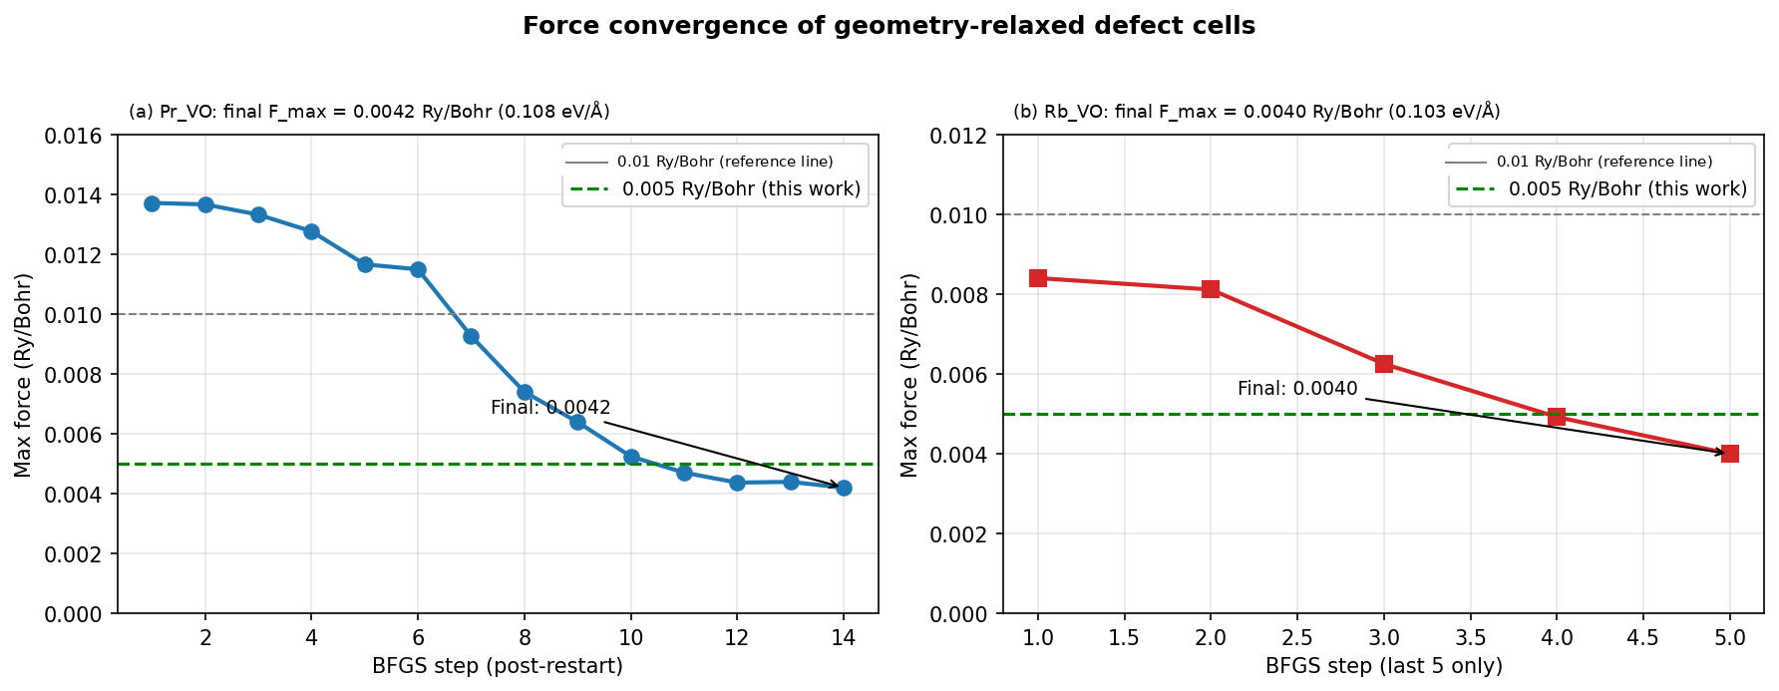
Figure S3. Maximum-force trajectories of the (a) Pr_VO (last 14 BFGS steps after restart) and (b) Rb_VO (last 5 steps) relaxations. Dashed green: the 0.005 Ry/Bohr threshold of this work. Final values 0.0042 and 0.0040 Ry/Bohr (0.108 and 0.103 eV/Å). [AUTHOR ACTION: the panel titles and the legend entry of the grey 0.01 Ry/Bohr line (formerly labelled as a literature standard without a source) were patched in the interim artwork; regenerate from the BFGS logs with labels in eV/Å, drop or source the 0.01 Ry/Bohr line, and show the complete trajectories.]

