Feedback: Splunk Profiling-Backend Internal API (/v2/*)
Prepared by: mbui · 2026-08-01 · Source: hands-on integration testing (o11y-code-remediation prototype)

Context: Built a working prototype integration against the internal profiling-backend `api` service (reachable only from inside its own Docker network / internal mesh — confirmed 404 from the public gateway, 200 when called directly) to source flamegraph and hotspot data for an AI code-remediation tool, as a side-by-side alternative to self-decoding raw OTLP/pprof profiling data. This document summarizes the test architecture, methodology, and findings from that integration effort.

Architecture Overview
Two independent Docker Compose stacks were connected together for this test, rather than modifying either one’s own compose file:
- profiling-backend/deployment/dev_profiling — the real internal profiling stack under test. Services: zookeeper, kafka, druid (storage/query engine), processor (ingests raw profiling payloads), collector, gdi, and api (the internal REST service exposing /v2/*). A smoke_test container ships synthetic CPU/memory profiling samples into this stack via HEC to generate realistic test data on demand.
- o11y-code-remediation — the prototype AI code-remediation tool being integrated. Normally only talks to its own OTLP receiver (self-decode path). For this test it was additionally joined onto the dev_profiling stack’s Docker network (docker network connect dev_profiling_default o11y-code-remediation) so it could resolve and call the api container directly by name.
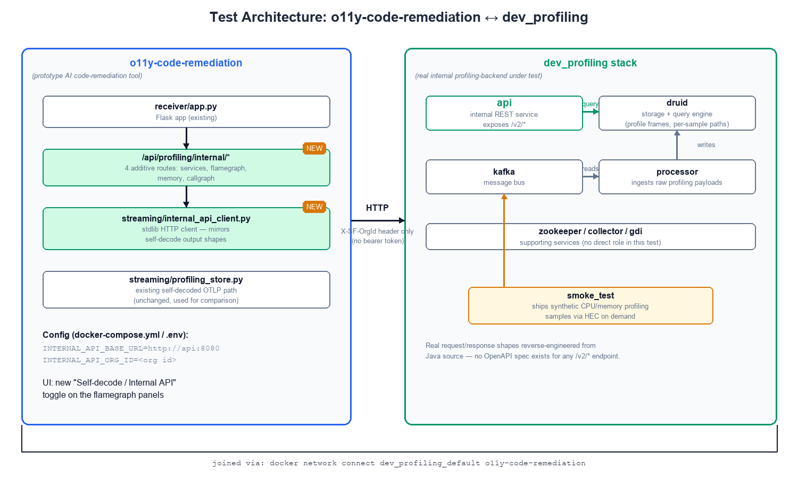
- Client: streaming/internal_api_client.py — new stdlib-only HTTP client calling api directly at http://api:8080. Sends only an X-SF-OrgId header (auth happens upstream of this service, not here) and env/since/until as query params. Mirrors the existing self-decode module’s (profiling_store.py) output shapes exactly, so it is a drop-in alternative data source.
- Routes: 4 new additive Flask routes under /api/profiling/internal/... (services, flamegraph/<service>, memory/<service>, callgraph/<service>/<trace_id>) added to receiver/app.py, side-by-side with the existing self-decode routes — nothing existing was removed or changed.
- Config: INTERNAL_API_BASE_URL (http://api:8080) and INTERNAL_API_ORG_ID configured via docker-compose.yml / .env for o11y-code-remediation. No AWS/Bedrock-style credentials needed — the internal API’s own auth model (header-only, see Security section below) required none.
- UI: Added a UI toggle ("Self-decode" vs "Internal API") on the CPU/Memory flamegraph panels so the two data sources can be visually compared side-by-side in the same dashboard.

How We Tested It
Testing proceeded in layers, each validated before moving to the next:
- Reachability: confirmed the api service is unreachable from the public gateway/mesh (404) but reachable with a 200 when called directly inside its own Docker network — this is what motivated joining o11y-code-remediation onto dev_profiling_default rather than trying to reach it through any public path.
- Raw endpoint calls via curl/Python, directly against api:8080, to learn real response shapes for /v2/services, /v2/table, and /v2/call-graphs/.../slow-methods — since no documentation exists, shapes were confirmed by reading Java source (PprofSamples.java, SlowMethodQueryImpl.java, SlowMethodRequest) alongside live responses.
- Built streaming/internal_api_client.py against those confirmed shapes, then re-tested each function directly via docker exec ... python3 -c "..." inside the o11y-code-remediation container to confirm the client correctly parses real API responses (including the composite functionName(fileName:lineNumber) frame-string format).
- Wired the 4 new Flask routes and re-tested each one with curl against the running container (localhost:4319/api/profiling/internal/...), confirming real data flows end-to-end from Druid through the new client through the new routes.
- End-to-end product test: took real internal-API-sourced hotspot data (function/file/line/self-time) and POSTed it to the existing /api/fix endpoint, first against a local Ollama model (surfaced a real JSON-formatting reliability issue in that model, unrelated to the new integration) and then against AWS Bedrock (clean, valid, specific fix suggestion) — confirming the new data source is fully compatible with the existing fix-generation pipeline.
- Regenerated fresh smoke-test data on demand (docker compose run --rm smoke_test) to re-validate against non-stale data, and visually verified the new "Internal API" toggle in the dashboard UI itself, including checking which panels do/don’t populate under each data source (see Call-graph gap below for why some panels are self-decode-only).

Executive Summary
The internal API is functional and the core data (CPU/memory profiling samples, ranked hotspot frames) is real and usable — end-to-end integration through to LLM-based fix generation worked correctly using this data source. The most significant issues found are: (1) no entitlement enforcement at this service’s own layer — it relies entirely on the public gateway as the only security boundary, (2) call-graph / caller-callee structure is not exposed as usable API output, which blocks any feature needing "what app code called this hot frame," and (3) there is no API documentation — every integration detail (required headers, response shapes, frame-string encoding) had to be reverse-engineered directly from Java source.

Findings at a Glance
Severity | Finding | Area
High | No entitlement check at the API layer itself; auth depends entirely on the public gateway never letting a stray request through | Security
Medium | Call-graph / caller-callee structure is not exposed by any endpoint in a usable form (slow-methods is leaf-only; /v2/table is a flat ranked list) | API Design
Medium | No OpenAPI spec or docs for any /v2/* endpoint — required reading Java source across 3+ packages | Documentation
Medium | /v2/call-graphs/.../slow-methods discards file/line info that exists upstream, right before responding | API Design
Low | /v2/table’s frame field is an undocumented opaque composite string, not structured JSON | API Design
Low | Silent limit-clamping on slow-methods (requested limit silently capped at 5, no signal) | API Design
Low | Public gateway returns a bare 404 for all cases (missing, not entitled, wrong URL) — no way to distinguish | Discoverability
Info | reason field (OK/LIMITED/NO_SAMPLES) on slow-methods is a good pattern, worth extending to other endpoints | API Design
Info | Test/smoke-test data includes timestamp-suffixed service names — worth double-checking cardinality safety for a customer-facing service picker | Observational

Security / Auth Model
- Finding: /v2/call-graphs, /v2/table, /v2/services, and other endpoints validate only that an X-SF-OrgId header is present (SignalboostHeaders.ORG_ID) — nothing checks that the calling principal is actually entitled to read that org’s data. This is presumably safe today only because the public gateway/mesh returns a hard 404 before any request reaches this service. That makes the gateway the single point of failure for a real security boundary: if a routing/mesh config change ever lets a stray path through, any caller reachable on the internal network could read any org’s profiling data simply by setting a header to an arbitrary org ID.
- Recommendation: Either document/enforce the assumption that this service must never be reachable except through the gateway (e.g. network policy, mTLS restricted to the gateway’s identity), or add a real entitlement check at this layer too, as defense-in-depth rather than a single-hop trust boundary.

API Design

Call-graph / caller-callee structure is not usable
- Finding: Neither of the two endpoints tried exposes a usable parent → child call structure: /v2/call-graphs/.../slow-methods returns individual leaf methods with a real measured totalSelfTimeMs, but no concept of an "app frame" that called into it. /v2/table returns a flat, ranked list of leaf frames (via topFrame) with no ordering/tree relationship between them.
- Detail: The underlying Druid query layer (ProfileFramesQuery) does have a separate path dimension that holds the full ordered per-sample call stack, so the raw data to reconstruct call chains does exist — but no endpoint returns it pre-aggregated into a parent-child tree. Every consumer wanting caller/callee relationships has to independently parse and aggregate the raw per-sample path strings themselves. This is a real engineering-effort barrier, not a hard blocker, but it means every internal-API consumer building anything beyond "flat top-N hotspots" ends up re-implementing the same tree-reconstruction logic.
- Recommendation: Consider exposing a dedicated call-graph/tree endpoint (parent → child edges with aggregated weight per edge) so consumers don’t all have to reimplement path-string parsing and aggregation independently.

slow-methods discards file/line info that exists upstream
- Finding: SlowMethodQueryImpl.parseFrame() explicitly strips the (file:line) suffix off the raw frame string before building SlowMethodSummary — but that information is present in the very same string being parsed. For any consumer wanting to jump to source (our exact use case), this is a real, easily fixable gap.
- Recommendation: Parse file/line into the response instead of discarding them.

/v2/table’s frame field is an undocumented composite string
- Finding: The frame field is functionName(fileName:lineNumber) — a single opaque string, not separate JSON fields. Understanding this required tracing three modules deep (processor → API → Druid query layer) to a single string-concatenation line in PprofSamples.java. Any client wanting function/file/line separately has to write its own regex parser against an undocumented format.
- Recommendation: Expose function/file/line as real, separate JSON fields.

Silent limit-clamping with no signal
- Finding: SlowMethodRequest’s compact constructor caps limit at 5 regardless of what’s requested (limit = Math.min(limit, DEFAULT_LIMIT)), with nothing in the response indicating the effective limit was reduced. A caller asking for 50 results silently gets 5 with no error or warning.
- Recommendation: Either honor the requested limit (with a documented max), or echo the effective limit used back in the response.

reason field is a good pattern — worth extending
- Finding: The reason field on slow-methods (OK / LIMITED / NO_SAMPLES) explicitly disambiguates "empty because there’s no data" from other empty-result cases. This is a genuinely good, explicit design choice.
- Recommendation: Extend this pattern to /v2/table and /v2/services, which currently give no signal for why a result set came back empty.

Discoverability / Documentation
- Finding: There is no OpenAPI/Swagger spec or README for any of the /v2/* internal endpoints. Every required parameter, response shape, and header requirement had to be read directly out of Java source across the rest/, slowmethods/, and druid/query/ packages. For any team (including internal ones) wanting to build on this API, that is a real velocity tax.
- Recommendation: Even an internal-only OpenAPI document, generated from the existing request/response record types, would meaningfully reduce onboarding time for the next integrator.
- Finding: The public gateway returns a bare 404 for every case — "not implemented," "not entitled," and "wrong URL" are all indistinguishable. If there is ever a plan to expose call-graph data externally, a clearer rejection code/reason would help API consumers debug faster.

Minor / Observational
- Observation: Service names returned by /v2/services in smoke-test data included timestamp-suffixed entries (e.g. profiling-smoke-test-CPU-pprof-gzip-base64-2026-08-01T...). Almost certainly just test-harness naming and not a real issue, but worth confirming no real customer service-naming path could ever produce high-cardinality/unique-per-request service names, since that would break any UI service dropdown built directly on this endpoint.

What Was Actually Validated
The following was confirmed working end-to-end against the real internal API, not simulated:
- Direct connectivity from inside the service’s Docker network (org-scoped via X-SF-OrgId header, no bearer token required — auth happens upstream of this service).
- /v2/services — returns real, current service names ingested via the smoke-test/HEC path.
- /v2/table — returns real ranked CPU and memory hotspot frames with correct function/file/line once the composite string is parsed client-side.
- End-to-end: internal-API hotspot data → AI fix-generation pipeline (LLM call) → valid, specific, correctly-scoped code fix suggestion.
- Known gap confirmed live: Method Hotspots, Snapshot Trace Explorer, and Error Trace Analysis views (which need caller/callee structure) could not be wired to this API today — this directly traces back to the call-graph gap above.

