 | Page 1 of 32 - Cover Page | Submission ID | trn:oid:::6:262983049
Test Author
English.docx
 | Universidad Javeriana - Académico
Document Details
Submission ID
trn:oid:::6:262983049  Submission Date  Sep 28, 2026, 9:17 AM GMT | 30 Pages  5,791 Words  33,564 Characters
Download Date
Oct 2, 2026, 9:18 AM GMT
File Name
English.docx
File Size
772.1 KB
 | Page 1 of 32 - Cover Page | Submission ID | trn:oid:::6:262983049

 | Page 2 of 32 - AI Writing Overview | Submission ID | trn:oid:::6:262983049

57% detected as AI
AI detection includes the possibility of false positives. Although some text in this submission is likely AI generated, scores below the 20% threshold are not surfaced because they have a higher likelihood of false positives.

Caution: Review required.

It is essential to understand the limitations of AI detection before making decisions about a student’s work. We encourage you to learn more about Turnitin’s AI detection capabilities before using the tool.

Disclaimer
Our AI writing assessment is designed to help educators identify text that might be prepared by a generative AI tool. Our AI writing assessment may not always be accurate (it may misidentify writing that is likely human generated as AI generated and likely AI generated as human generated) so it should not be used as the sole basis for adverse actions against a student. It takes further scrutiny and human judgment in conjunction with an organization's application of its specific academic policies to determine whether any academic misconduct has occurred.
 | Page 2 of 32 - AI Writing Overview | Submission ID | trn:oid:::6:262983049

 | Page 3 of 32 - AI Writing Submission | Submission ID | trn:oid:::6:262983049
Periodontitis oral smORFs yield micropeptides that occupy the AChE
peripheral site: 22-task UniDL4BioPep scoring, docking, and 100-ns
dynamics
Abstract
Periodontitis has been tied to Alzheimer’s disease (AD) in clinical and experimental work, yet a peptide-level ligand that could act on a synaptic enzyme is still missing. Here we scored already-processed oral small open reading frames (smORFs) with UniDL4BioPep, docked twelve 7–9-residue peptides into human acetylcholinesterase (AChE, PDB 4EY6), and ran 100-ns molecular dynamics (MD) on apo AChE and three complexes. The healthy-labelled library (11,269,961 sequences) and the periodontitis-labelled library (11,721,988 sequences) were both passed through 22 UniDL4BioPep classifiers at ≥0.80. Only the periodontitis branch was then matched to oral genomic and metaproteomic catalogues. Blood–brain-barrier (BBB) hits numbered 1,095,861 (9.72%) in the healthy library and 1,125,832 (9.60%) in the periodontitis library. Intersection of the periodontitis BBB set with 33,786 unique, catalogue-supported peptides left 3,518 sequences; NTxPred2, mebipred and AnOxPePred reduced that list to twelve explicit peptides. All twelve carry a net positive charge at pH 7.4. Local AutoDock Vina (three runs) gave best poses between −8.25 and −9.60 kcal/mol. FLLHTTR, YLSLLQR and LLHPLRL contact the peripheral anionic site (PAS). Over 100 ns the FLLHTTR and YLSLLQR complexes stay more compact than apo AChE (backbone RMSD 0.1640 and 0.1625 nm versus 0.1897 nm). FLLHTTR keeps a dense hydrogen-bond net (7.03 ± 1.28); only YLSLLQR shrinks solvent-accessible surface area. These calculations outline a possible route in which oral micropeptides sit on the same PAS that accelerates amyloid-β (Aβ) assembly.
 | Page 3 of 32 - AI Writing Submission | Submission ID | trn:oid:::6:262983049

 | Page 4 of 32 - AI Writing Submission | Submission ID | trn:oid:::6:262983049
Keywords: Alzheimer’s disease; Porphyromonas gingivalis; periodontitis; smORF; micropeptide; acetylcholinesterase; peripheral anionic site; UniDL4BioPep; molecular docking; molecular dynamics
Introduction
Alzheimer’s disease (AD) combines amyloid deposition, tau pathology, synaptic failure, immune activation and vascular injury over a long preclinical course [1]. Sequential cleavage of APP by β- and γ-secretases releases Aβ40 and Aβ42; soluble oligomers injure synapses; familial APP/PSEN mutations change peptide length and amount [2]. Amyloid load does not explain the spatial or clinical heterogeneity of the disease, so peripheral inflammatory exposures have been examined as possible modifiers of vulnerability rather than as single sufficient causes.
Loss of basal-forebrain acetylcholine accounts for a large fraction of the cognitive picture, which is why AChE inhibitors remain in routine use [3]. Catalysis is only part of the enzyme’s role. AChE accelerates Aβ fibril growth through the peripheral anionic site (PAS), and AChE–Aβ particles are more toxic than free peptide [4]. A short hydrophobic PAS motif is sufficient for that chaperone effect [5]. PAS-directed small molecules can block AChE-induced aggregation in biochemical assays [19]. The same protein surface therefore joins cholinergic failure to amyloid deposition.
Chronic periodontitis maintains a low-grade inflammatory load at a disrupted mucosal barrier and allows microbial products into blood [6]. Oral activity is species- and site-specific, so 16S abundance cannot stand in for a molecular ligand [7]. Meta-analyses report associations between periodontal disease and cognitive disorders, although effect sizes move with case definitions [10]. In an AD cohort, periodontitis tracked later decline [11]. A two-sample Mendelian randomization analysis did not support a genetic causal effect of periodontal disease
 | Page 4 of 32 - AI Writing Submission | Submission ID | trn:oid:::6:262983049

 | Page 5 of 32 - AI Writing Submission | Submission ID | trn:oid:::6:262983049
on AD [14]. Epidemiology therefore motivates a molecular search; it does not identify the ligand.
Gingipains and outer-membrane vesicles of Porphyromonas gingivalis supply one mapped virulence pair [8–9]. The organism and gingipains have been reported in AD brains [12], and repeated oral infection in mice produces neuroinflammation and Aβ-related changes [13]. Those observations justify looking at oral products. They do not, by themselves, name a peptide that occupies AChE.
Microbiome smORFs encode a large pool of uncharted small proteins [15–16]. Mining of human microbiomes for peptide antibiotics first scored millions of translated open reading frames and then applied experimental filters [31]. UniDL4BioPep supplies more than twenty binary bioactivity heads on ESM-2 embeddings [23]. That order—predict, then match to catalogues—is the order used here. Classifier scores do not answer the structural question of whether a 7–9-aa periodontitis peptide can occupy the Aβ-binding PAS.
Accelerated MD places Aβ on the AChE surface and treats the enzyme as a nucleation centre [17]. A 1-μs PAS-centred AChE–Aβ trajectory remains bound, with the main residence at residues 344–361 [18]. PDB 4EY6 gives a 2.40 Å human AChE frame for docking [20]. The aromatic gorge that joins the catalytic triad to the PAS was mapped on Torpedo AChE [36]. What remains missing is a peptide-level ligand drawn from oral smORFs and tested on that same PAS.
Here we scored already-processed oral smORF libraries from PRJNA678453 with 22 UniDL4BioPep heads, compared healthy and periodontitis hit rates, matched the periodontitis branch to oral genomic and metaproteomic catalogues, and reduced the list with NTxPred2, mebipred and AnOxPePred. Twelve 7–9-aa peptides were docked into human AChE. Three complexes, together with apo enzyme, were simulated for 100 ns to test whether the peptides remain at the PAS without unfolding the fold.
 | Page 5 of 32 - AI Writing Submission | Submission ID | trn:oid:::6:262983049

 | Page 6 of 32 - AI Writing Submission | Submission ID | trn:oid:::6:262983049
Materials and methods
Study design
The work is computational. No new patients, specimens, sequencing runs or wet assays were added. Healthy and periodontitis tags are library labels; they are not peptide-level clinical diagnoses. Docking used local three-run AutoDock Vina poses. MD used 100-ns GROMACS trajectories of apo AChE and three peptide complexes.
Source libraries
Translated smORFs of 4–50 aa were taken as already-processed peptide strings. We did not reassemble reads or call genes de novo. The public source of the paired oral metagenomes and metatranscriptomes is PRJNA678453 [7]. A derived MGnify third-party assembly, PRJEB65451 (metaSPAdes v3.15.3), exists for that BioProject; it is not a second clinical cohort. Library sizes were 11,269,961 healthy-labelled and 11,721,988 periodontitis-labelled sequences.
UniDL4BioPep (22 tasks)
UniDL4BioPep was applied first to both full libraries, following the predict-then-filter order used when mining microbiome peptide antibiotics [23,31]. Du et al. freeze ESM-2 (esm2_t6_8M_UR50D; 6 layers, 8 million parameters, 320-dimensional residue states) and average residue embeddings so that peptides of any length collapse to one fixed vector. A convolutional classifier is then trained, per bioactivity, on that vector; the same backbone is reused across datasets rather than designing a new network for each endpoint. In the original report the architecture beat the previous state of the art on 15 of 20 binary peptide tasks. We did not retrain the networks. We scored 22 published heads: ACE inhibitory, DPP-IV inhibitory, Bitter, Umami, Antimicrobial, Antimalarial (alternative), Antimalarial (main), Quorum sensing, Anticancer (main), Anticancer (alternative), Anti-MRSA, TTCA, BBB (BBP), Anti-
 | Page 6 of 32 - AI Writing Submission | Submission ID | trn:oid:::6:262983049

 | Page 7 of 32 - AI Writing Submission | Submission ID | trn:oid:::6:262983049
parasitic (APP), NeuroPred, Antibacterial, Antifungal, Antiviral, Toxicity, Antioxidant FRS, Allergenicity, and cell-penetrating peptide (CPP). Every head used a score cut of ≥0.80. “BBB-high” is that operational cut on the BBP head, not measured transcytosis. Other BBB peptide tools (for example Augur) are trained on different positives and encodings, so their published AUCs do not transfer to these 4–50-aa oral strings [35].
Catalogue matching (periodontitis branch only)
After scoring, only periodontitis-labelled sequences were exact-matched to oral genomic and metaproteomic resources and collapsed to unique peptides. HOMD and eHOMD supply curated aerodigestive genomes [21,32]. Salivary metaproteomes record peptides inside their own false-discovery framework [22]. Further oral metaproteomic sets add sequence observations from other clinical contexts [33–34]. A match supports prior observation of the string; it does not prove expression in PRJNA678453 samples. The periodontitis library yielded 33,786 unique catalogue-supported peptides. Intersection with the 1,125,832 periodontitis BBB (BBP) hits recovered 3,518 sequences (3,446 of 5–30 aa; 72 of 31–50 aa). The healthy library was left at the 22-task score tables and was not dereplicated.
NTxPred2
NTxPred2 trains separate peptide and protein models because a single neurotoxin classifier does not transfer between length classes [24]. The peptide set has 877 neurotoxic and 877 non-toxic sequences; the protein set has 775 of each. Composition and binary-profile machine-learning models reach AUC 0.97 (peptides) and 0.85 (proteins). Fine-tuning ESM2-t30 on the peptide set raises independent-set AUC to 0.98 (MCC 0.90). The public server uses ESM2-t30 for 7–50-aa inputs (default probability 0.5) and an extra-trees model for sequences ≥51 aa. We used the peptide (ESM2-t30) mode on 7–50-aa members of the 3,518-set. A positive call is a classifier label, not a neuronal assay.
 | Page 7 of 32 - AI Writing Submission | Submission ID | trn:oid:::6:262983049

 | Page 8 of 32 - AI Writing Submission | Submission ID | trn:oid:::6:262983049
mebipred
mebipred predicts metal-binding from sequence alone, without alignments, so it can be applied to short translated fragments [25]. Inputs are 219 sequence features: amino-acid composition, physicochemical descriptors, and counts of metal-binding 5-mers. A first feed-forward net (two hidden layers of 219 ReLU units, dropout 0.2, RMSprop) separates metal-binding from non-binding proteins; a second tier names 11 ions. The authors report >80% accuracy for ligand presence and an area under the precision–recall curve of 0.91. Default ion probability is 0.5; raising it to 0.9 increases precision at some cost in recall. We kept Cu-, Fe- and Zn-related scores at 0.50. The output is not a measured Kd and does not assign a coordination geometry.
AnOxPePred
AnOxPePred is a one-dimensional CNN with two heads, trained to score free-radical scavenging (FRS) and metal chelation (CHEL) from one-hot peptide sequences [26]. Positives were taken from BIOPEP-UWM and from antioxidant-peptide papers; each sequence is labelled FRS, chelator, or both. Reported FRS performance exceeds a k-NN baseline; the chelator head is weaker because that training subset is small. Both heads emit a score in [0, 1]. Serial cuts here were CHEL≥0.25, then CHEL≥0.25 with FRS<0.50, then CHEL≥0.25 with FRS<0.45. Concordance among UniDL4BioPep, NTxPred2, mebipred and AnOxPePred is a filter stack, not independent experimental replication.
Physicochemical descriptors
For the twelve unique 7–9-aa strings we recalculated length, histidine, cysteine and Arg+Lys counts, average molecular weight, isoelectric point, net charge at pH 7.4, Kyte–Doolittle GRAVY, Ikai aliphatic index, hydrophobic residue fraction (A, I, L, M, F, V, W, Y),
 | Page 8 of 32 - AI Writing Submission | Submission ID | trn:oid:::6:262983049

 | Page 9 of 32 - AI Writing Submission | Submission ID | trn:oid:::6:262983049
and Boman index. Scales were applied to the amino-acid strings only; no experimental HPLC or CD was performed.
Molecular docking
Human recombinant AChE (PDB 4EY6, 2.40 Å) was stripped of galantamine and crystal waters, chain breaks were repaired, and protonation was set at pH 7.4 [20]. The twelve ligands ALLLHRC, FCLHLQLR, FLLHTTR, HLLTLKKHV, HLPLLHRCC, HVLLLRQCA, LLHLPKRTT, LLHPLRC, LLHPLRL, WLLVHLKK, YHHLLCRR and YLSLLQR were docked with AutoDock Vina, exhaustiveness 32 [27–28]. The grid was centred on the PAS (Tyr72, Asp74, Thr75, Leu76, Trp286, His287, Tyr341) and covered the gorge neck (Phe295), the choline subsite (Trp86, Glu202, Tyr337) and the catalytic triad (Ser203, His447, Glu334). Each ligand was run three times. We report best-run affinity, three-run mean ± SD, hydrogen-bond count and PAS contact from the single best pose. Vina scores rank poses; they are not experimental free energies.
Molecular dynamics
Four explicit-solvent systems were built in GROMACS with Amber99SB-ILDN and TIP3P water at 0.15 M NaCl [29–30]: apo AChE (chain A) and the ALLLHRC, FLLHTTR and YLSLLQR complexes. Each box was triclinic with a 1.0 nm solute-to-wall buffer. Equilibration was 2,000 steps of steepest descent, 1.0 ns restrained NVT to 300 K, 1.0 ns restrained NPT, and 1.0 ns free NPT. Production was 100 ns (dt = 2.0 fs) at 300 K and 1.0 bar with LINCS, 1.2 nm cut-offs and particle-mesh Ewald. Frames were stored every 20 ps.
Metrics matched Figures 5–7: Cα RMSD, per-residue RMSF, SASA, Rg, DSSP occupancy, and intermolecular hydrogen bonds (gmx hbond; donor–acceptor ≤ 3.0 Å). Peptide self-fit RMSD and persistent contacts (7.0 Å) were stored as extras. Means ± SD use the
 | Page 9 of 32 - AI Writing Submission | Submission ID | trn:oid:::6:262983049

 | Page 10 of 32 - AI Writing Submission | Submission ID | trn:oid:::6:262983049
last 20 ns (80–100 ns). The design follows the AChE–Aβ MD logic of Atanasova et al., at 100 ns rather than 1 μs [18].
Results
Twenty-two UniDL4BioPep tasks on both libraries
Figure 1 summarises the cascade. Both libraries were scored at ≥0.80 on all 22 heads (Tables 1 and 2). Hit rates sit close to each other. Antimicrobial called 10,302,093/11,721,988 periodontitis sequences (87.89%) and 9,882,657/11,269,961 healthy sequences (87.69%). BBB (BBP) called 1,125,832 (9.60%) versus 1,095,861 (9.72%). Anti-parasitic (APP) and quorum sensing were the next largest heads; DPP-IV inhibitory was the smallest in both libraries. Labels overlap, so one peptide can sit in several rows. Because the two BBB rates differ by only 0.12 percentage points, BBB-high is not a periodontitis-specific stamp. The two libraries are close on most of the 22 heads (Table 3). Periodontitis exceeds healthy by ≥1 percentage point only for quorum sensing (+1.39). Healthy exceeds periodontitis by ≥1 point for antifungal (−2.50), anti-parasitic (−2.36), antioxidant FRS (−1.95), antiviral (−1.89), antibacterial (−1.42), CPP (−1.24), anticancer-main (−1.22) and umami (−1.00). Antimicrobial is essentially tied (87.89% vs 87.69%). These are library-wide score rates, not sequence-level differential peptides: we do not have a row-wise overlap map, so we cannot say that the twelve docking sequences are absent from the healthy library. Downstream docking used the periodontitis, catalogue-matched branch only.
Table 1. UniDL4BioPep counts for the periodontitis-labelled library (11,721,988 smORFs; ≥0.80).
No. | Task | n | %
1 | ACE inhibitory | 1,236,442 | 10.55
2 | DPP-IV inhibitory | 139,056 | 1.19
3 | Bitter | 1,831,185 | 15.62
4 | Umami | 3,100,811 | 26.45
5 | Antimicrobial | 10,302,093 | 87.89
 | Page 10 of 32 - AI Writing Submission |  |  | Submission ID | trn:oid:::6:262983049

 | Page 11 of 32 - AI Writing Submission |  |  | Submission ID | trn:oid:::6:262983049
No. | Task | n | %
6 | Antimalarial (alternative) | 695,608 | 5.93
7 | Antimalarial (main) | 2,010,724 | 17.15
8 | Quorum sensing | 4,491,507 | 38.32
9 | Anticancer (main) | 2,357,718 | 20.11
10 | Anticancer (alternative) | 2,015,652 | 17.20
11 | Anti-MRSA | 843,977 | 7.20
12 | TTCA | 2,666,759 | 22.75
13 | BBB (BBP) | 1,125,832 | 9.60
14 | Anti-parasitic (APP) | 5,462,493 | 46.60
15 | NeuroPred | 1,714,373 | 14.63
16 | Antibacterial | 2,597,877 | 22.16
17 | Antifungal | 2,960,118 | 25.25
18 | Antiviral | 3,275,203 | 27.94
19 | Toxicity | 1,714,299 | 14.62
20 | Antioxidant FRS | 2,521,106 | 21.51
21 | Allergenicity | 1,713,798 | 14.62
22 | Cell-penetrating peptide | 925,627 | 7.90
22 | (CPP)
Table 2. UniDL4BioPep counts for the healthy-labelled library (11,269,961 smORFs; ≥0.80).
No. | Task | n | %
1 | ACE inhibitory | 1,237,451 | 10.98
2 | DPP-IV inhibitory | 131,426 | 1.17
3 | Bitter | 1,840,368 | 16.33
4 | Umami | 3,094,287 | 27.46
5 | Antimicrobial | 9,882,657 | 87.69
6 | Antimalarial (alternative) | 703,632 | 6.24
7 | Antimalarial (main) | 1,954,667 | 17.34
8 | Quorum sensing | 4,161,825 | 36.93
9 | Anticancer (main) | 2,404,084 | 21.33
10 | Anticancer (alternative) | 1,979,643 | 17.57
11 | Anti-MRSA | 769,955 | 6.83
12 | TTCA | 2,618,849 | 23.24
13 | BBB (BBP) | 1,095,861 | 9.72
14 | Anti-parasitic (APP) | 5,517,278 | 48.96
15 | NeuroPred | 1,690,436 | 15.00
 | Page 11 of 32 - AI Writing Submission |  |  | Submission ID | trn:oid:::6:262983049

 | Page 12 of 32 - AI Writing Submission |  |  | Submission ID | trn:oid:::6:262983049
No. | Task | n | %
16 | Antibacterial | 2,658,234 | 23.59
17 | Antifungal | 3,128,057 | 27.76
18 | Antiviral | 3,362,295 | 29.83
19 | Toxicity | 1,725,268 | 15.31
20 | Antioxidant FRS | 2,643,538 | 23.46
21 | Allergenicity | 1,635,019 | 14.51
22 | Cell-penetrating peptide | 1,029,770 | 9.14
22 | (CPP)
Table 3. Score-rate difference between libraries (periodontitis % minus healthy %). BBB is shown for
reference.
Task |  | Healthy % | Periodontitis % | Δ pp
Quorum sensing |  | 36.93 | 38.32 | +1.39
Umami |  | 27.46 | 26.45 | −1.00
Anticancer (main) |  | 21.33 | 20.11 | −1.22
Cell-penetrating peptide (CPP) |  | 9.14 | 7.90 | −1.24
Antibacterial |  | 23.59 | 22.16 | −1.42
Antiviral |  | 29.83 | 27.94 | −1.89
Antioxidant FRS |  | 23.46 | 21.51 | −1.95
Anti-parasitic (APP) |  | 48.96 | 46.60 | −2.36
Antifungal |  | 27.76 | 25.25 | −2.50
BBB (BBP) |  | 9.72 | 9.60 | −0.12
 | Page 12 of 32 - AI Writing Submission |  |  |  | Submission ID | trn:oid:::6:262983049

 | Page 13 of 32 - AI Writing Submission | Submission ID | trn:oid:::6:262983049
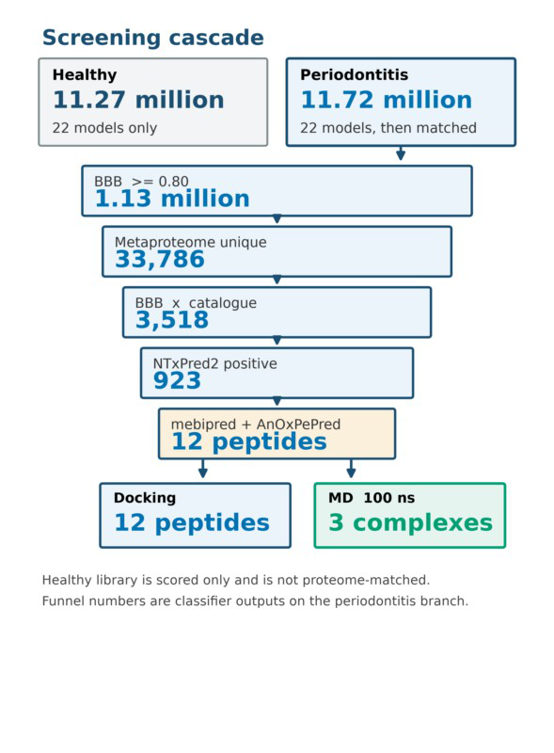
Figure 1. Screening cascade. UniDL4BioPep (22 tasks) was applied to both libraries. Catalogue matching and
later filters were applied only to the periodontitis branch, ending in twelve 7–9-aa peptides for docking and three
complexes for 100-ns MD.
Periodontitis funnel to twelve sequences
 | Page 13 of 32 - AI Writing Submission | Submission ID | trn:oid:::6:262983049

 | Page 14 of 32 - AI Writing Submission | Submission ID | trn:oid:::6:262983049
Catalogue matching of the periodontitis library kept 33,786 unique peptides. Intersection with BBB-high gave 3,518 sequences. NTxPred2 scored 3,299/3,518 (93.77%) and called 923/3,299 (27.98%) positive. Later cuts left 111 mebipred-positive peptides, 15 with CHEL≥0.25, 12 with CHEL≥0.25 and FRS<0.50, and 8 with the stricter FRS<0.45 (Table 4). All 923 NTxPred2-positive peptides were ≤30 aa, so the metal/CHEL/FRS steps kept short peptides only.
Table 4. Periodontitis branch after UniDL4BioPep scoring.
Stage | Rule | n | Denominator
Periodontitis smORFs | 4–50 aa | 11,721,988 | Library
BBB (BBP) | score ≥0.80 | 1,125,832 | 11,721,988
Catalogue-supported | Exact match | 33,786 | 11,721,988
unique peptides | Exact match | 33,786 | 11,721,988
BBB-high ∩ catalogue- | Intersection | 3,518 | 1,125,832 ∩ 33,786
supported | Intersection | 3,518 | 1,125,832 ∩ 33,786
Short (5–30 aa) | Length | 3,446 | 3,518
Long (31–50 aa) | Length | 72 | 3,518
NTxPred2 scored | 7–50 aa | 3,299 | 3,518
NTxPred2-positive | Model label | 923 | 3,299
mebipred-positive | ≥0.50 | 111 | —
CHEL-priority | CHEL≥0.25 | 15 | 111
Main set | CHEL≥0.25 and | 12 | 111
Main set | FRS<0.50 | 12 | 111
Stricter subset | CHEL≥0.25 and | 8 | —
Stricter subset | FRS<0.45 | 8 | —
Physicochemical profile of the twelve peptides
These descriptors characterise the twelve docking ligands. They are not a comparison of the healthy and periodontitis libraries.
The twelve strings are unique 7–9-aa peptides of standard residues (Table 5). Eleven contain histidine; six contain cysteine; every sequence has at least one Arg or Lys. Molecular weights fall between 825.03 and 1,097.30 Da. Isoelectric points are alkaline (8.28–11.54). Net charge at pH 7.4 is positive for all twelve (0.85–2.08). GRAVY is positive for ten sequences, in
 | Page 14 of 32 - AI Writing Submission | Submission ID | trn:oid:::6:262983049

 | Page 15 of 32 - AI Writing Submission | Submission ID | trn:oid:::6:262983049
line with leucine-rich cores; LLHLPKRTT (−0.36) and YHHLLCRR (−0.95) are the two hydrophilic exceptions. Aliphatic indices run from 97.5 (YHHLLCRR) to 222.9 (LLHPLRL). YLSLLQR is the only peptide without histidine. These numbers describe composition; they are not HPLC or CD measurements.
Table 5. Composition and calculated physicochemical descriptors of the twelve 7–9-aa peptides.
Peptide | aa | MW | pI | z (pH | GRAVY | AI | His | Cys | R+K
Peptide | aa | (Da) | pI | 7.4)
ALLLH | 7 | 825.03 | 9.00 | 0.92 | 1.14 | 181.4 | 1 | 1 | 1
RC
FCLHL | 8 | 1029.26 | 9.00 | 0.92 | 0.69 | 146.2 | 1 | 1 | 1
QLR
FLLHT | 7 | 887.04 | 11.09 | 1.04 | 0.19 | 111.4 | 1 | 0 | 1
TR
HLLTL | 9 | 1088.35 | 10.63 | 2.08 | 0.08 | 162.2 | 2 | 0 | 2
KKHV
HLPLL | 9 | 1091.35 | 8.28 | 0.85 | 0.43 | 130.0 | 2 | 2 | 1
HRCC
HVLLL | 9 | 1052.30 | 9.00 | 0.92 | 0.97 | 173.3 | 1 | 1 | 1
RQCA
LLHLP | 9 | 1078.32 | 11.54 | 2.04 | −0.36 | 130.0 | 1 | 0 | 2
KRTT
LLHPL | 7 | 851.07 | 9.00 | 0.92 | 0.66 | 167.1 | 1 | 1 | 1
RC
LLHPL | 7 | 861.09 | 11.09 | 1.04 | 0.84 | 222.9 | 1 | 0 | 1
RL
WLLVH | 8 | 1036.32 | 10.63 | 2.04 | 0.46 | 182.5 | 1 | 0 | 2
LKK
YHHLL | 8 | 1097.30 | 9.91 | 1.96 | −0.95 | 97.5 | 2 | 1 | 2
CRR
YLSLL | 7 | 892.06 | 9.89 | 0.99 | 0.04 | 167.1 | 0 | 0 | 1
QR
Docking to human AChE
All twelve ligands produced favourable Vina scores (Table 6, Figure 2). Best-run values ran from −8.25 to −9.60 kcal/mol; three-run means ran from −8.07 ± 0.16 to −9.44 ± 0.09 kcal/mol. Best-pose order was FLLHTTR (−9.60), YLSLLQR (−9.49), ALLLHRC (−9.29). Mean order put YLSLLQR first (−9.44 ± 0.09) and ALLLHRC second (−9.18 ± 0.11).
 | Page 15 of 32 - AI Writing Submission | Submission ID | trn:oid:::6:262983049

 | Page 16 of 32 - AI Writing Submission | Submission ID | trn:oid:::6:262983049
FLLHTTR has the strongest single pose and the largest SD (−8.77 ± 1.41). Best poses made 3–
10 hydrogen bonds (mean length 2.83–3.28 Å; Figures 3 and 4).
Table 6. Three-run AutoDock Vina scores against human AChE (PDB 4EY6).
Peptide |  | H-bonds | Best | Mean ± SD | PAS | Principal
 |  | H-bonds | Best | (n=3) | PAS | contacts
ALLLHRC |  | 3 | −9.29 | −9.18 ± 0.11 | No | Ser125, Ser203,
 |  |  |  |  |  | Tyr124
FCLHLQLR |  | 7 | −9.27 | −8.96 ± 0.48 | Yes | Ser203, Thr75,
 |  |  |  |  |  | Tyr341
FLLHTTR |  | 8 | −9.60 | −8.77 ± 1.41 | Yes | Asp74, Tyr72,
 |  |  |  |  |  | His287
HLLTLKKHV |  | 6 | −8.88 | −8.69 ± 0.20 | Yes | Tyr72, Phe346
HLPLLHRCC |  | 4 | −8.35 | −8.28 ± 0.07 | No | Ser125, Tyr124,
 |  |  |  |  |  | Tyr337
HVLLLRQCA |  | 4 | −8.25 | −8.07 ± 0.16 | Yes | Thr75
LLHLPKRTT |  | 3 | −9.01 | −8.89 ± 0.16 | Adjacent | Ser203, Val340
LLHPLRC |  | 4 | −8.91 | −8.78 ± 0.11 | No | Ser125, Ser293
LLHPLRL |  | 10 | −8.94 | −8.91 ± 0.05 | Yes | Trp286, Tyr341,
 |  |  |  |  |  | His447
WLLVHLKK |  | 4 | −8.94 | −8.64 ± 0.26 | No | Asn283, Gln279
YHHLLCRR |  | 7 | −9.03 | −8.62 ± 0.43 | No | Trp86, Ser203
YLSLLQR |  | 7 | −9.49 | −9.44 ± 0.09 | Yes | Tyr72, Thr75,
 |  |  |  |  |  | Glu202
 | Page 16 of 32 - AI Writing Submission |  |  |  |  | Submission ID | trn:oid:::6:262983049

 | Page 17 of 32 - AI Writing Submission | Submission ID | trn:oid:::6:262983049
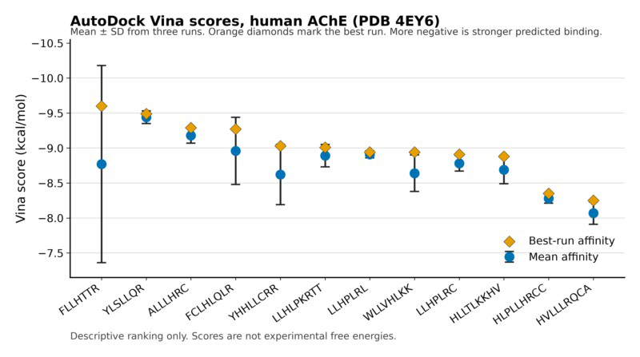
Figure 2. Three-run Vina scores against human AChE (PDB 4EY6). Blue circles, mean; whiskers, SD;
orange diamonds, best run. Order follows best-run rank.
 | Page 17 of 32 - AI Writing Submission | Submission ID | trn:oid:::6:262983049

 | Page 18 of 32 - AI Writing Submission | Submission ID | trn:oid:::6:262983049
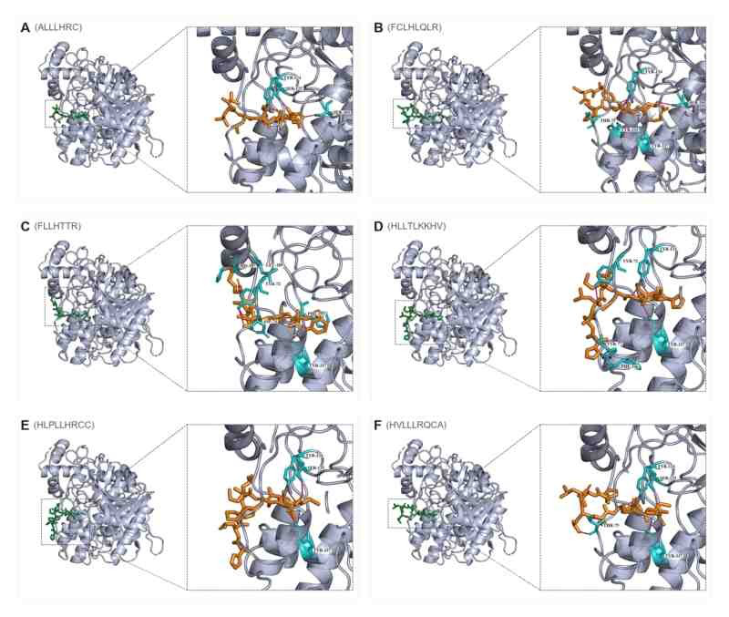
Figure 3. Best docking poses, peptides 1–6 (A–F). Peptide, orange; contacting residues, cyan. FLLHTTR (C)
is the densest PAS pose.
 | Page 18 of 32 - AI Writing Submission | Submission ID | trn:oid:::6:262983049

 | Page 19 of 32 - AI Writing Submission | Submission ID | trn:oid:::6:262983049
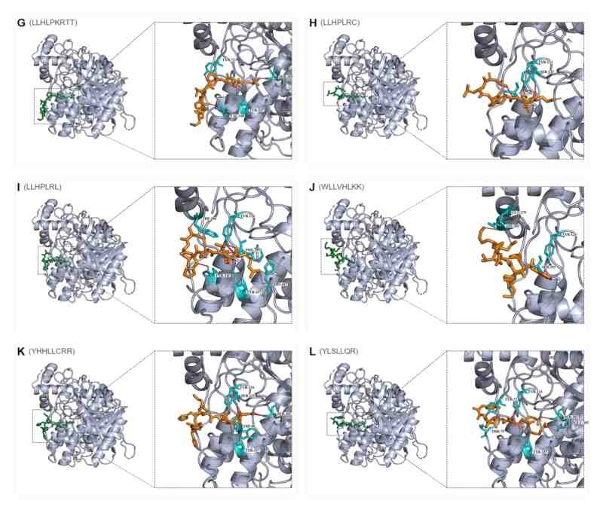
Figure 4. Best docking poses, peptides 7–12 (G–L). LLHPLRL (I) spans PAS Trp286/Tyr341 to catalytic His447. YLSLLQR (L) bridges PAS and the gorge mouth.
PAS contacts in the best pose were seen for FLLHTTR (Figure 3C), YLSLLQR (Figure 4L), FCLHLQLR, HVLLLRQCA, HLLTLKKHV and LLHPLRL (Figure 4I). ALLLHRC binds catalytic Ser203 with the shortest mean hydrogen bond (2.83 Å) rather than the outer PAS aromatics (Figure 3A). Three-run means separate ligands that stay strong across runs (YLSLLQR, ALLLHRC, LLHPLRL) from ligands whose best pose is better than the run average (FLLHTTR, FCLHLQLR, YHHLLCRR).
 | Page 19 of 32 - AI Writing Submission | Submission ID | trn:oid:::6:262983049

 | Page 20 of 32 - AI Writing Submission | Submission ID | trn:oid:::6:262983049
100-ns dynamics of apo AChE and three complexes
Production runs finished for apo AChE and the ALLLHRC, FLLHTTR and YLSLLQR complexes (Table 7, Figures 5–7). Each six-panel figure compares apo with one complex: RMSD (A), RMSF (B), SASA (C), Rg (D), last-20-ns DSSP (E) and intermolecular hydrogen bonds (F).
 | Page 20 of 32 - AI Writing Submission | Submission ID | trn:oid:::6:262983049

 | Page 21 of 32 - AI Writing Submission | Submission ID | trn:oid:::6:262983049
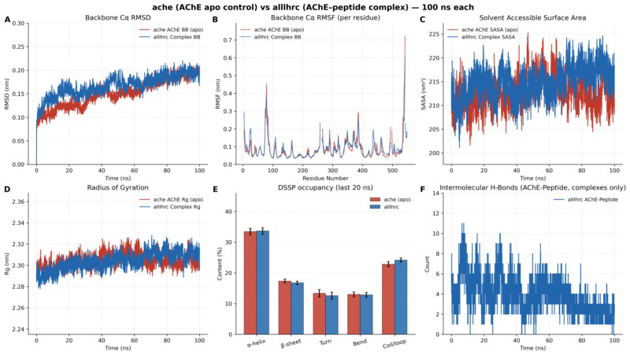
Figure 5. Apo AChE versus AChE–ALLLHRC. Panels A–F match Table 7. Complex RMSD (A) tracks apo;
hydrogen bonds (F) fall from early occupancy to about two in the last 20 ns.
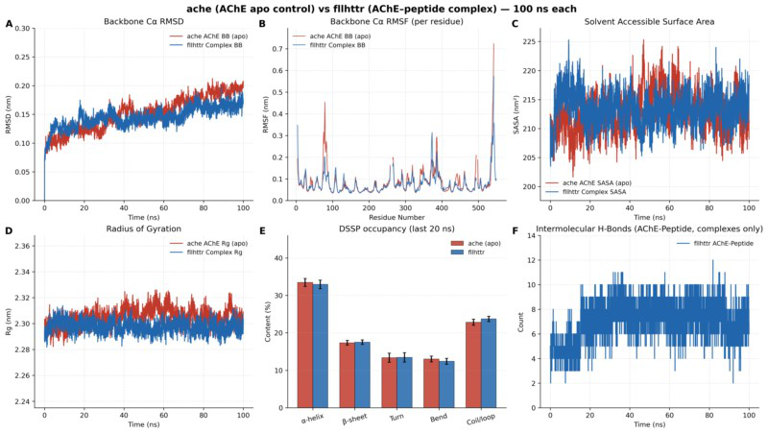
Figure 6. Apo AChE versus AChE–FLLHTTR. After ~50 ns, complex RMSD (A) lies below apo. Hydrogen-
bond counts (F) stay in the 6–10 range for the full 100 ns.
 | Page 21 of 32 - AI Writing Submission | Submission ID | trn:oid:::6:262983049

 | Page 22 of 32 - AI Writing Submission | Submission ID | trn:oid:::6:262983049
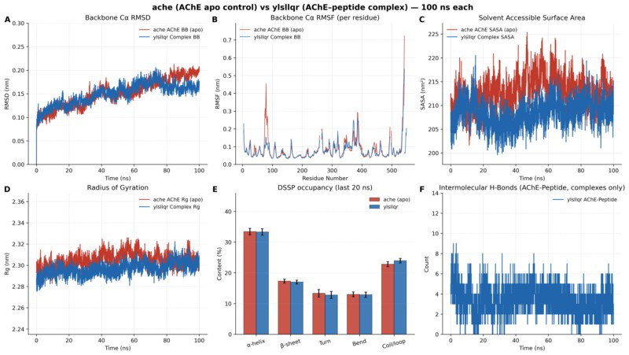
Figure 7. Apo AChE versus AChE–YLSLLQR. Late RMSD (A) is below apo. SASA (C) is the only complex that contracts relative to apo.
Table 7. Last-20-ns metrics (mean ± SD) for apo AChE and three complexes.
Metric | apo AChE | ALLLHRC | FLLHTTR | YLSLLQR
Cα RMSD (nm) | 0.1897 ± 0.0090 | 0.1916 ± 0.0092 | 0.1640 ± 0.0080 | 0.1625 ± 0.0078
Peptide self-fit | — | 0.2518 ± 0.0136 | 0.1752 ± 0.0111 | 0.0911 ± 0.0098
RMSD (nm)
RMSF mean (nm) | 0.0835 ± 0.0659 | 0.0876 ± 0.0581 | 0.0778 ± 0.0504 | 0.0771 ± 0.0498
SASA (nm²) | 212.25 ± 2.89 | 217.47 ± 2.49 | 213.88 ± 2.36 | 209.71 ± 2.35
Rg (nm) | 2.3045 ± 0.0056 | 2.3107 ± 0.0052 | 2.2967 ± 0.0047 | 2.3028 ± 0.0051
Intermolecular H- | — | 2.19 ± 0.80 | 7.03 ± 1.28 | 2.93 ± 1.14
bonds
Persistent contact | — | 7 | 7 | 7
pairs
DSSP α-helix / β- | 33.44 / 17.35 | 33.66 / 16.76 | 32.92 / 17.52 | 33.31 / 17.02
sheet (%)
Apo RMSD levels near 0.19 nm (Figures 5A–7A). ALLLHRC follows that control (complex 0.1916 nm). FLLHTTR and YLSLLQR drop below apo after 50–70 ns (0.1640 and 0.1625 nm), which reads as rigidification, not unfolding. Peptide self-fit RMSD is highest for ALLLHRC (0.2518 nm) and lowest for YLSLLQR (0.0911 nm). Catalytic-core RMSF stays
 | Page 22 of 32 - AI Writing Submission | Submission ID | trn:oid:::6:262983049

 | Page 23 of 32 - AI Writing Submission | Submission ID | trn:oid:::6:262983049
low; mean RMSF is below apo for FLLHTTR and YLSLLQR. Rg remains 2.30–2.31 nm. SASA rises for ALLLHRC (217.47 nm²), sits near apo for FLLHTTR (213.88 nm²), and falls only for YLSLLQR (209.71 nm²; Figure 7C). Hydrogen-bond histories differ: ALLLHRC decays to 2.19 ± 0.80; FLLHTTR holds 7.03 ± 1.28 for the whole run (Figure 6F); YLSLLQR averages 2.93 ± 1.14. Helix (~33%) and sheet (~17%) overlay the apo bars. Each complex keeps seven persistent contact pairs. Centre-of-mass RDF peaks lie at 1.22 nm (ALLLHRC), 1.80 nm (FLLHTTR) and 1.62 nm (YLSLLQR), i.e. surface residence rather than bulk solvent.
Discussion
Principal findings
Twenty-two UniDL4BioPep heads scored 11.27 million healthy-labelled and 11.72 million periodontitis-labelled oral smORFs at ≥0.80. Catalogue matching, NTxPred2, mebipred and AnOxPePred then reduced the periodontitis branch to twelve explicit 7–9-aa peptides. All twelve docked to human AChE with best-run Vina affinities between −8.25 and −9.60 kcal/mol (Figure 2, Table 6). FLLHTTR, YLSLLQR and LLHPLRL contact the PAS. Over 100 ns, apo AChE and the ALLLHRC, FLLHTTR and YLSLLQR complexes remain globular; FLLHTTR and YLSLLQR become more compact than apo, and FLLHTTR keeps the densest intermolecular hydrogen-bond net (Table 7, Figures 5–7). These objects define a computational ligand set for the same PAS that accelerates Aβ assembly [4,18]. They do not demonstrate transport, expression or disease causality.
How the two libraries differ
The healthy and periodontitis libraries are close on most UniDL4BioPep heads (Tables 1–3). BBB (BBP) rates differ by 0.12 percentage points (9.72% versus 9.60%), so a BBB-high call is not a periodontitis stamp. Periodontitis exceeds healthy by ≥1 percentage point only for quorum sensing (+1.39). Healthy is higher for antifungal (−2.50), anti-parasitic (−2.36),
 | Page 23 of 32 - AI Writing Submission | Submission ID | trn:oid:::6:262983049

 | Page 24 of 32 - AI Writing Submission | Submission ID | trn:oid:::6:262983049
antioxidant FRS (−1.95), antiviral (−1.89), antibacterial (−1.42), CPP (−1.24), anticancer-main (−1.22) and umami (−1.00). Antimicrobial is essentially tied (87.89% versus 87.69%). Those percentages are library-wide score rates. Without a row-wise overlap map, the twelve docking sequences cannot be shown to be absent from the healthy library, and the periodontitis label cannot be transferred to an individual peptide. Physicochemical descriptors in Table 5 characterise the docking ligands; they are not a disease contrast.
Serial agreement among UniDL4BioPep, NTxPred2, mebipred and AnOxPePred is a filter stack. ESM embeddings, composition features and task-specific training sets can share correlated errors [23–26]. Near-universal antimicrobial positivity in both libraries illustrates the point: a score above 0.80 ranks sequences, it does not establish BBB transport, neurotoxicity, metal binding or redox chemistry. The same predict-then-filter order used to mine microbiome peptide antibiotics [31] is therefore retained as triage. Catalogue matches against HOMD, eHOMD and oral metaproteomes support prior observation of a string [21–22,32–34]; they do not prove translation in PRJNA678453 samples [7,15–16].
A possible PAS-centred path from oral peptides to AD
AD pairs amyloid deposition with cholinergic failure [2–3]. Independently of catalysis, AChE accelerates Aβ fibril assembly through the PAS, and AChE–Aβ complexes are more neurotoxic than Aβ alone [4]. A hydrophobic PAS motif is sufficient to promote that chaperone activity [5]. PAS-directed ligands suppress AChE-induced aggregation in biochemical assays [19]. Accelerated MD places Aβ on the AChE surface as a nucleation centre [17]. A 1-μs trajectory keeps Aβ at the PAS, with principal residence at residues 344–361 [18]. Periodontitis and P. gingivalis supply an exposure context: the organism and gingipains have been reported in AD brains, and repeated oral infection in mice produces neuroinflammation and Aβ-related changes [6,12–13]. Docking and 100-ns trajectories indicate that periodontitis-derived micropeptides can occupy that same PAS. Four linked steps outline a possible mechanism.
 | Page 24 of 32 - AI Writing Submission | Submission ID | trn:oid:::6:262983049

 | Page 25 of 32 - AI Writing Submission | Submission ID | trn:oid:::6:262983049
1. PAS recognition and gorge-entrance occupancy.
Best poses of the twelve peptides concentrate at the PAS and gorge mouth of human AChE (PDB 4EY6; Figures 2–4). FLLHTTR anchors the canonical PAS residues Asp74, Tyr72 and His287 (best-run −9.60 kcal/mol; Figure 3C). YLSLLQR contacts PAS (Tyr72, Thr75) and the catalytic entrance (three-run mean −9.44 ± 0.09 kcal/mol; Figure 4L). LLHPLRL spans the PAS gatekeepers Trp286/Tyr341 to catalytic His447 (Figure 4I). HLLTLKKHV reaches Tyr72 and Phe346 in the 344–361 residence zone reported for Aβ. That geometry is the PAS Inestrosa identified as the pro-fibrillar site and that Atanasova occupied with Aβ. The aromatic gorge that joins the triad to the PAS was mapped on Torpedo AChE [20,36]. Vina ranks poses inside a fixed grid; the scores are not experimental free energies [27–28].
2. A surface-bound enzyme–peptide complex.
Over 100 ns the enzyme remains globular (RMSD 0.16–0.19 nm, Rg 2.30–2.31 nm, helix ~33% / sheet ~17%; Figures 5–7). FLLHTTR and YLSLLQR complexes become more compact than apo in late RMSD (0.1640 and 0.1625 nm versus 0.1897 nm), so the peptide stays on the surface and stiffens the fold. Intermolecular hydrogen bonds persist: FLLHTTR holds a dense polar net throughout (7.03 ± 1.28; Figure 6F), YLSLLQR averages 2.93 ± 1.14, and ALLLHRC retains seven contact pairs after early rearrangement. Peptide self-fit RMSD is lowest for YLSLLQR (0.0911 nm) and highest for ALLLHRC (0.2518 nm). Centre-of-mass RDF peaks lie at 1.22–1.80 nm, consistent with surface residence rather than bulk solvent. Lushchekina and Atanasova described a surface-bound, non-dissociating AChE–Aβ complex; the same occupancy pattern appears here for oral micropeptides, on a 100-ns rather than 1-μs window.
3. Restricted acetylcholine access.
 | Page 25 of 32 - AI Writing Submission | Submission ID | trn:oid:::6:262983049

 | Page 26 of 32 - AI Writing Submission | Submission ID | trn:oid:::6:262983049
The PAS sits at the mouth of the 20-Å gorge that feeds the catalytic triad [3,20]. Physical occupancy of Asp74/Tyr72/Trp286/Tyr341 can hinder substrate entry even while the catalytic core remains folded (low RMSF in panels B of Figures 5–7). A pose that docks to the PAS therefore intersects the cholinergic axis of AD: reduced access of acetylcholine at synapses already depleted after basal-forebrain loss.
4. Pathological chaperone activity.
Because the PAS is a documented pro-fibrillar site [4–5], a heterologous peptide that remains there can lower the nucleation barrier for endogenous Aβ. FLLHTTR supplies a persistent polar net on the PAS (Figure 6F) that matches its docking pose (Figure 3C). YLSLLQR buries surface (SASA 209.71 versus 212.25 nm²; Figure 7C) and is the most rigid bound peptide. Folded AChE then presents a peptide-coated PAS on which Aβ oligomers can co-assemble, which is Lushchekina’s nucleation-centre picture applied to an oral ligand. AChE–Aβ assemblies are already more synaptotoxic than free Aβ [4]. A bacterial micropeptide on the same site is a possible route to hybrid nuclei.
From the oral cavity to cortical AChE
Chronic periodontitis can move P. gingivalis products into blood through a disrupted epithelium, gingipains and outer-membrane vesicles [8–9]. Systemic cytokines and proteases increase BBB leakiness [6]. Short, leucine-rich, cationic peptides that scored BBB-high—a label almost as common in the healthy library—could in principle reach interstitial fluid [12,35]. PAS docking then supplies a landing site on an enzyme that is both a cholinergic hydrolase and an amyloid chaperone. Meta-analyses link periodontal disease to cognitive disorders, although effect sizes move with case definitions [10], and periodontitis tracked later decline in an AD cohort [11]. A two-sample Mendelian randomization analysis did not support a genetic causal effect of periodontal disease on AD [14]. The twelve sequences are treated as pathogenic candidates because they occupy the experimentally mapped Aβ-binding PAS and
 | Page 26 of 32 - AI Writing Submission | Submission ID | trn:oid:::6:262983049

 | Page 27 of 32 - AI Writing Submission | Submission ID | trn:oid:::6:262983049
remain bound for 100 ns. Complex RMSD that stays at or below apo is local adaptation of a folded enzyme, not evidence that the peptide is harmless or that it is proven to seed amyloid in tissue.
The calculation therefore connects three literatures that are usually kept apart: oral smORF peptide space [15,31], the PAS chaperone activity of AChE [4,18], and the periodontitis–AD exposure context [12–13]. What it supports is a bounded structural hypothesis. What it does not replace is measured expression, transport, affinity or an Aβ-aggregation assay.
Conclusions
Twelve 7–9-aa peptides from a periodontitis-labelled oral smORF library dock to human AChE. FLLHTTR, YLSLLQR and ALLLHRC remain on the surface for 100 ns without unfolding the enzyme. FLLHTTR forms the densest PAS hydrogen-bond net; YLSLLQR is the only complex that buries solvent-accessible surface. Healthy and periodontitis libraries differ little on BBB-high rate; quorum sensing is the only head at which periodontitis is higher by ≥1 percentage point. Read against the amyloid cascade [2], the cholinergic hypothesis [3], and the PAS chaperone work of Inestrosa, Lushchekina and Atanasova, the calculations support a possible mechanism in which oral pathogenic peptides occupy AChE, hinder acetylcholine access, and co-nucleate Aβ on the same PAS.
References
1. Scheltens P, De Strooper B, Kivipelto M, et al. Alzheimer’s disease. Lancet.
2021;397(10284):1577–1590. doi:10.1016/S0140-6736(20)32205-4.
2. Selkoe DJ, Hardy J. The amyloid hypothesis of Alzheimer’s disease at 25 years. EMBO Mol Med. 2016;8(6):595–608. doi:10.15252/emmm.201606210.
 | Page 27 of 32 - AI Writing Submission | Submission ID | trn:oid:::6:262983049

 | Page 28 of 32 - AI Writing Submission | Submission ID | trn:oid:::6:262983049
3. Hampel H, Mesulam MM, Cuello AC, et al. The cholinergic system in the
pathophysiology and treatment of Alzheimer’s disease. Brain. 2018;141(7):1917–1933. doi:10.1093/brain/awy132.
4. Inestrosa NC, Alvarez A, Pérez CA, et al. Acetylcholinesterase accelerates assembly of amyloid-β-peptides into Alzheimer’s fibrils. Neuron. 1996;16(4):881–891.
doi:10.1016/s0896-6273(00)80108-7.
5. De Ferrari GV, Canales MA, Shin I, et al. A structural motif of acetylcholinesterase that promotes amyloid β-peptide fibril formation. Biochemistry. 2001;40(35):10447–10457. doi:10.1021/bi0101392.
6. Chalmers JC, Hernandez-Kapila YL. The role of the oral microbiome, host response, and periodontal disease treatment in Alzheimer’s disease: a primer. Periodontol 2000.
2025;98(1):220–227. doi:10.1111/prd.12631.
7. Belstrøm D, Constancias F, Drautz-Moses DI, et al. Periodontitis associates with species-specific gene expression of the oral microbiota. npj Biofilms Microbiomes. 2021;7:76. doi:10.1038/s41522-021-00247-y.
8. Guo Y, Nguyen KA, Potempa J. Dichotomy of gingipains action as virulence factors. Periodontol 2000. 2010;54(1):15–44. doi:10.1111/j.1600-0757.2010.00377.x.
9. Ho MH, Chen CH, Goodwin JS, et al. Functional advantages of Porphyromonas gingivalis vesicles. PLoS One. 2015;10(4):e0123448. doi:10.1371/journal.pone.0123448.
10. Larvin H, Gao C, Kang J, et al. The impact of study factors in the association of periodontal disease and cognitive disorders. Age Ageing. 2023;52(2):afad015.
doi:10.1093/ageing/afad015.
11. Ide M, Harris M, Stevens A, et al. Periodontitis and cognitive decline in Alzheimer’s disease. PLoS One. 2016;11(3):e0151081. doi:10.1371/journal.pone.0151081.
 | Page 28 of 32 - AI Writing Submission | Submission ID | trn:oid:::6:262983049

 | Page 29 of 32 - AI Writing Submission | Submission ID | trn:oid:::6:262983049
12. Dominy SS, Lynch C, Ermini F, et al. Porphyromonas gingivalis in Alzheimer’s disease brains. Sci Adv. 2019;5(1):eaau3333. doi:10.1126/sciadv.aau3333.
13. Ilievski V, Zuchowska PK, Green SJ, et al. Chronic oral application of a periodontal pathogen results in brain inflammation, neurodegeneration and amyloid beta production in wild type mice. PLoS One. 2018;13(10):e0204941. doi:10.1371/journal.pone.0204941. 14. Hu C, Li H, Huang L, et al. Periodontal disease and risk of Alzheimer’s disease: a two- sample Mendelian randomization. Brain Behav. 2024;14(4):e3486.
doi:10.1002/brb3.3486.
15. Sberro H, Fremin BJ, Zlitni S, et al. Large-scale analyses of human microbiomes reveal thousands of small, novel genes. Cell. 2019;178(5):1245–1259.e14.
doi:10.1016/j.cell.2019.07.016.
16. Durrant MG, Bhatt AS. Automated prediction and annotation of small open reading frames in microbial genomes. Cell Host Microbe. 2021;29(1):121–131.e4.
doi:10.1016/j.chom.2020.11.002.
17. Lushchekina SV, Kots ED, Novichkova DA, Petrov KA, Masson P. Role of acetylcholinesterase in β-amyloid aggregation studied by accelerated molecular dynamics. BioNanoScience. 2017;7(2):396–402. doi:10.1007/s12668-016-0375-x.
18. Atanasova M, Dimitrov I, Ivanov S. Molecular dynamics simulations of acetylcholinesterase–beta-amyloid peptide complex. Cybern Inf Technol.
2020;20(6):140–154. doi:10.2478/cait-2020-0068.
19. Bartolini M, Bertucci C, Cavrini V, Andrisano V. β-Amyloid aggregation induced by human acetylcholinesterase: inhibition studies. Biochem Pharmacol. 2003;65(3):407–416. doi:10.1016/s0006-2952(02)01514-9.
 | Page 29 of 32 - AI Writing Submission | Submission ID | trn:oid:::6:262983049

 | Page 30 of 32 - AI Writing Submission | Submission ID | trn:oid:::6:262983049
20. Cheung J, Rudolph MJ, Burshteyn F, et al. Structures of human acetylcholinesterase in complex with pharmacologically important ligands. J Med Chem. 2012;55(23):10282–10286. doi:10.1021/jm300871x.
21. Chen T, Yu WH, Izard J, et al. The Human Oral Microbiome Database: a web accessible resource for investigating oral microbe taxonomic and genomic information. Database (Oxford). 2010;2010:baq013. doi:10.1093/database/baq013.
22. Belstrøm D, Jersie-Christensen RR, Lyon D, et al. Metaproteomics of saliva identifies human protein markers specific for individuals with periodontitis and dental caries compared to orally healthy controls. PeerJ. 2016;4:e2433. doi:10.7717/peerj.2433.
23. Du Z, Ding X, Xu Y, Li Y. UniDL4BioPep: a universal deep learning architecture for binary classification in peptide bioactivity. Brief Bioinform. 2023;24(3):bbad135.
doi:10.1093/bib/bbad135.
24. Rathore AS, Jain S, Choudhury S, Raghava GPS. A large language model for predicting neurotoxic peptides and neurotoxins. Protein Sci. 2025;34(8):e70200.
doi:10.1002/pro.70200.
25. Aptekmann AA, Buongiorno J, Giovannelli D, et al. mebipred: identifying metal-binding potential in protein sequence. Bioinformatics. 2022;38(14):3532–3540.
doi:10.1093/bioinformatics/btac358.
26. Olsen TH, Yesiltas B, Marin FI, et al. AnOxPePred: using deep learning for the prediction of antioxidative properties of peptides. Sci Rep. 2020;10:21471.
doi:10.1038/s41598-020-78319-w.
27. Trott O, Olson AJ. AutoDock Vina: improving the speed and accuracy of docking with a new scoring function. J Comput Chem. 2010;31(2):455–461. doi:10.1002/jcc.21334.
 | Page 30 of 32 - AI Writing Submission | Submission ID | trn:oid:::6:262983049

 | Page 31 of 32 - AI Writing Submission | Submission ID | trn:oid:::6:262983049
28. Eberhardt J, Santos-Martins D, Tillack AF, Forli S. AutoDock Vina 1.2.0: new docking methods, expanded force field, and Python bindings. J Chem Inf Model.
2021;61(8):3891–3898. doi:10.1021/acs.jcim.1c00203.
29. Abraham MJ, Murtola T, Schulz R, et al. GROMACS: high performance molecular simulations through multi-level parallelism from laptops to supercomputers. SoftwareX. 2015;1–2:19–25. doi:10.1016/j.softx.2015.06.001.
30. Lindorff-Larsen K, Piana S, Palmo K, et al. Improved side-chain torsion potentials for the Amber ff99SB protein force field. Proteins. 2010;78(8):1950–1958.
doi:10.1002/prot.22711.
31. Torres MDT, Brooks EF, Cesaro A, et al. Mining human microbiomes reveals an untapped source of peptide antibiotics. Cell. 2024;187(19):5453–5467.e15.
doi:10.1016/j.cell.2024.07.027.
32. Escapa IF, Chen T, Huang Y, et al. New insights into human nostril microbiome from the expanded Human Oral Microbiome Database (eHOMD). mSystems. 2018;3(3):e00187-18. doi:10.1128/mSystems.00187-18.
33. Jiang X, Zhang Y, Wang H, et al. In-depth metaproteomics analysis of oral microbiome for lung cancer. Research (Wash D C). 2022;2022:9781578. doi:10.34133/2022/9781578. 34. Yuan J, Cao Q, Chen M, et al. OSaMPle workflow for salivary metaproteomics analysis reveals dysbiosis in inflammatory bowel disease patients. npj Biofilms Microbiomes. 2025;11:63. doi:10.1038/s41522-025-00692-z.
35. Gu Y, Chen P, Wang B, et al. Prediction of blood-brain barrier penetrating peptides based on data augmentation with Augur. BMC Biol. 2024;22:86. doi:10.1186/s12915-024-01883-4.
 | Page 31 of 32 - AI Writing Submission | Submission ID | trn:oid:::6:262983049

 | Page 32 of 32 - AI Writing Submission | Submission ID | trn:oid:::6:262983049
36. Kryger G, Silman I, Sussman JL. Structure of acetylcholinesterase complexed with E2020 (Aricept): implications for drug design. Structure. 1999;7(3):297–307.
doi:10.1016/s0969-2126(99)80040-9.
 | Page 32 of 32 - AI Writing Submission | Submission ID | trn:oid:::6:262983049

