抗菌肽分子对接：靶点选择依据、方法学文献支持与结果记录
生成时间：2026-10-05 17:49:52

1. 研究对象与输出概览
本报告记录三条抗菌肽针对 E. coli 与 S. aureus 相关靶点的 AutoDock Vina 基线对接、靶点选择依据、方法学文献支持和 PyMOL SCI 图件输出。每个 peptide-target pair 进行 3 次独立 seed 重复，报告最佳构象分数均值。
肽序列：FVNKLNRIIPVKGFSMR；ISLAIPLASKISGFTLALVKNAST；LISNTKKFGTAIASHR

2. 靶点选择原因与文献支持
病原体 | 靶点/PDB | 选择原因 | 结构选择依据 | 文献支持
Escherichia coli | FtsZ cell-division protein / 6UNX | FtsZ is an essential tubulin-like bacterial cytokinesis protein. It organizes the Z-ring/divisome; perturbing this process is a recognized antimicrobial strategy and peptide-FtsZ interactions have been experimentally implicated for antimicrobial peptides. | 6UNX is a high-resolution E. coli FtsZ(L178E)-GTP crystal structure, suitable for a nucleotide-pocket/assembly-core baseline docking model. | Schumacher et al., 2020; de Boer et al., 1992; RayChaudhuri and Park, 1992; Di Somma et al., 2020.
Escherichia coli | DNA gyrase B ATPase domain / 4DUH | DNA gyrase is essential for bacterial DNA topology, replication and transcription. The GyrB N-terminal ATPase pocket is a validated antibacterial target distinct from quinolone GyrA cleavage-complex chemistry, making it attractive for orthogonal antimicrobial screening. | 4DUH is the 24 kDa E. coli GyrB ATPase domain co-crystallized with a small-molecule inhibitor, providing a defined inhibitor/ATP pocket for grid placement. | Brvar et al., 2012; Maxwell and Lawson, 2011.
Staphylococcus aureus | FtsZ cell-division protein / 5MN4 | S. aureus FtsZ is an essential cell-division target with extensive anti-staphylococcal inhibitor precedent, including benzamide/TXA-series compounds and synergy with beta-lactams in MRSA models. | 5MN4 is a 1.5 A S. aureus FtsZ 12-316 GDP open-form crystal structure from the polymerization-associated conformational-switch study, making it appropriate for a SaFtsZ structural baseline. | Wagstaff et al., 2017; Haydon et al., 2008; Ferrer-Gonzalez et al., 2021.
Staphylococcus aureus | Sortase A transpeptidase / 1T2W | Sortase A anchors LPXTG-containing surface proteins to the Gram-positive cell wall. Because these surface proteins mediate adhesion, biofilm and virulence, SrtA is commonly treated as an antivirulence/anti-infective target for S. aureus. | 1T2W is a crystal structure of S. aureus Sortase A in complex with an LPETG sorting peptide. The co-bound substrate peptide provides a biologically interpretable active-site reference. | Zong et al., 2004; Bentley et al., 2008; Shulga and Kudryavtsev, 2022.

3. 方法学与文献支持
受体标准化：RCSB PDB 结构；保留 first model protein ATOM，移除水、离子及共晶小分子，输出 rigid receptor PDBQT。
肽配体构建：RDKit MolFromFASTA，加氢，ETKDGv3 conformer 生成，UFF 能量最小化，取最低能构象作为 rigid peptide baseline。
对接引擎：AutoDock Vina 1.2.7 CLI；每个 peptide-target pair 使用 3 个独立 seed，汇总最佳 pose score 的 mean、SD 与 best single。
可视化：PyMOL headless 渲染 receptor overview 与 4 Å contact zoom，标注接触残基，绘制可能氢键虚线。

4. 对接结果记录
病原体 | 靶点 | PDB | 肽序列 | n | Mean best | SD | Best single
Escherichia coli | FtsZ cell-division protein | 6UNX | FVNKLNRIIPVKGFSMR | 3 | -7.242 | 0.02 | -7.261
Escherichia coli | FtsZ cell-division protein | 6UNX | LISNTKKFGTAIASHR | 3 | -8.793 | 0.022 | -8.819
Escherichia coli | FtsZ cell-division protein | 6UNX | ISLAIPLASKISGFTLALVKNAST | 3 | 2.433 | 0.021 | 2.41
Escherichia coli | DNA gyrase B ATPase domain | 4DUH | FVNKLNRIIPVKGFSMR | 3 | -10.753 | 0.006 | -10.76
Escherichia coli | DNA gyrase B ATPase domain | 4DUH | LISNTKKFGTAIASHR | 3 | -9.75 | 0.083 | -9.811
Escherichia coli | DNA gyrase B ATPase domain | 4DUH | ISLAIPLASKISGFTLALVKNAST | 3 | -8.172 | 0.413 | -8.642
Staphylococcus aureus | FtsZ cell-division protein | 5MN4 | FVNKLNRIIPVKGFSMR | 3 | 1.02 | 5.436 | -3.766
Staphylococcus aureus | FtsZ cell-division protein | 5MN4 | LISNTKKFGTAIASHR | 3 | -6.741 | 0.187 | -6.957
Staphylococcus aureus | FtsZ cell-division protein | 5MN4 | ISLAIPLASKISGFTLALVKNAST | 3 | 0.548 | 0.055 | 0.495
Staphylococcus aureus | Sortase A transpeptidase | 1T2W | FVNKLNRIIPVKGFSMR | 3 | 197.733 | 13.378 | 186.2
Staphylococcus aureus | Sortase A transpeptidase | 1T2W | LISNTKKFGTAIASHR | 3 | 49.73 | 26.132 | 32.43
Staphylococcus aureus | Sortase A transpeptidase | 1T2W | ISLAIPLASKISGFTLALVKNAST | 3 | 605.833 | 443.85 | 288.3

4.1 每条肽在每个病原体内的较优靶点
病原体 | 肽序列 | 较优靶点 | Mean best | 主要 4 Å 接触残基
Escherichia coli | FVNKLNRIIPVKGFSMR | ecoli_GyrB_4DUH | -10.753 | B:LYS57(2.924A); A:GLY15(3.201A); B:GLU161(3.256A); A:GLU92(3.312A); B:ASP74(3.415A); A:ASP17(3.465A); A:VAL149(3.526A); A:LEU16(3.567A); B:GLY138(3.606A); B:LYS162(3.711A)
Staphylococcus aureus | FVNKLNRIIPVKGFSMR | saureus_FtsZ_5MN4 | 1.02 | A:MET179(1.911A); A:GLU139(3.059A); A:LEU170(3.065A); A:ALA138(3.106A); A:ARG143(3.256A); A:ALA73(3.257A); A:PHE136(3.411A); A:ALA182(3.876A); A:GLY72(3.904A); A:GLY21(3.997A)
Escherichia coli | LISNTKKFGTAIASHR | ecoli_GyrB_4DUH | -9.75 | B:ASP74(2.974A); B:THR163(3.001A); B:GLU161(3.181A); A:GLY15(3.185A); A:ARG20(3.324A); B:LYS162(3.378A); A:LEU16(3.5A); A:ASP17(3.523A); A:GLU86(3.561A); A:VAL149(3.589A)
Staphylococcus aureus | LISNTKKFGTAIASHR | saureus_FtsZ_5MN4 | -6.741 | A:GLY21(2.71A); A:GLY70(2.969A); A:ARG143(3.2A); A:MET179(3.346A); A:ALA49(3.35A); A:ALA73(3.353A); A:GLY72(3.402A); A:ASN24(3.421A); A:GLU139(3.454A); A:ASN44(3.495A)
Escherichia coli | ISLAIPLASKISGFTLALVKNAST | ecoli_GyrB_4DUH | -8.172 | A:VAL149(2.367A); A:GLU86(3.112A); B:GLU161(3.149A); A:GLU85(3.168A); B:ASP74(3.248A); B:LYS162(3.26A); B:GLY54(3.296A); B:HIS55(3.369A); B:LYS57(3.429A); A:VAL97(3.551A)
Staphylococcus aureus | ISLAIPLASKISGFTLALVKNAST | saureus_FtsZ_5MN4 | 0.548 | A:ASN25(1.728A); A:MET179(2.373A); A:MET180(2.467A); A:ALA138(2.536A); A:GLY72(2.777A); A:ASP46(2.782A); A:GLY21(2.921A); A:GLY70(2.961A); A:GLY104(3.041A); A:GLU139(3.064A)
结果解释：在本 rigid-peptide Vina baseline 中，三条肽对 E. coli 的较优目标均为 GyrB ATPase domain（4DUH）；对 S. aureus 的较优目标均为 FtsZ（5MN4）。Sortase A（1T2W）的正值/极高分数提示当前刚性肽构象与该口袋拟合较差，应作为筛选提示而非物理结合自由能。

5. SCI 图件
Figure_4_Part1_A-F_300dpi.png
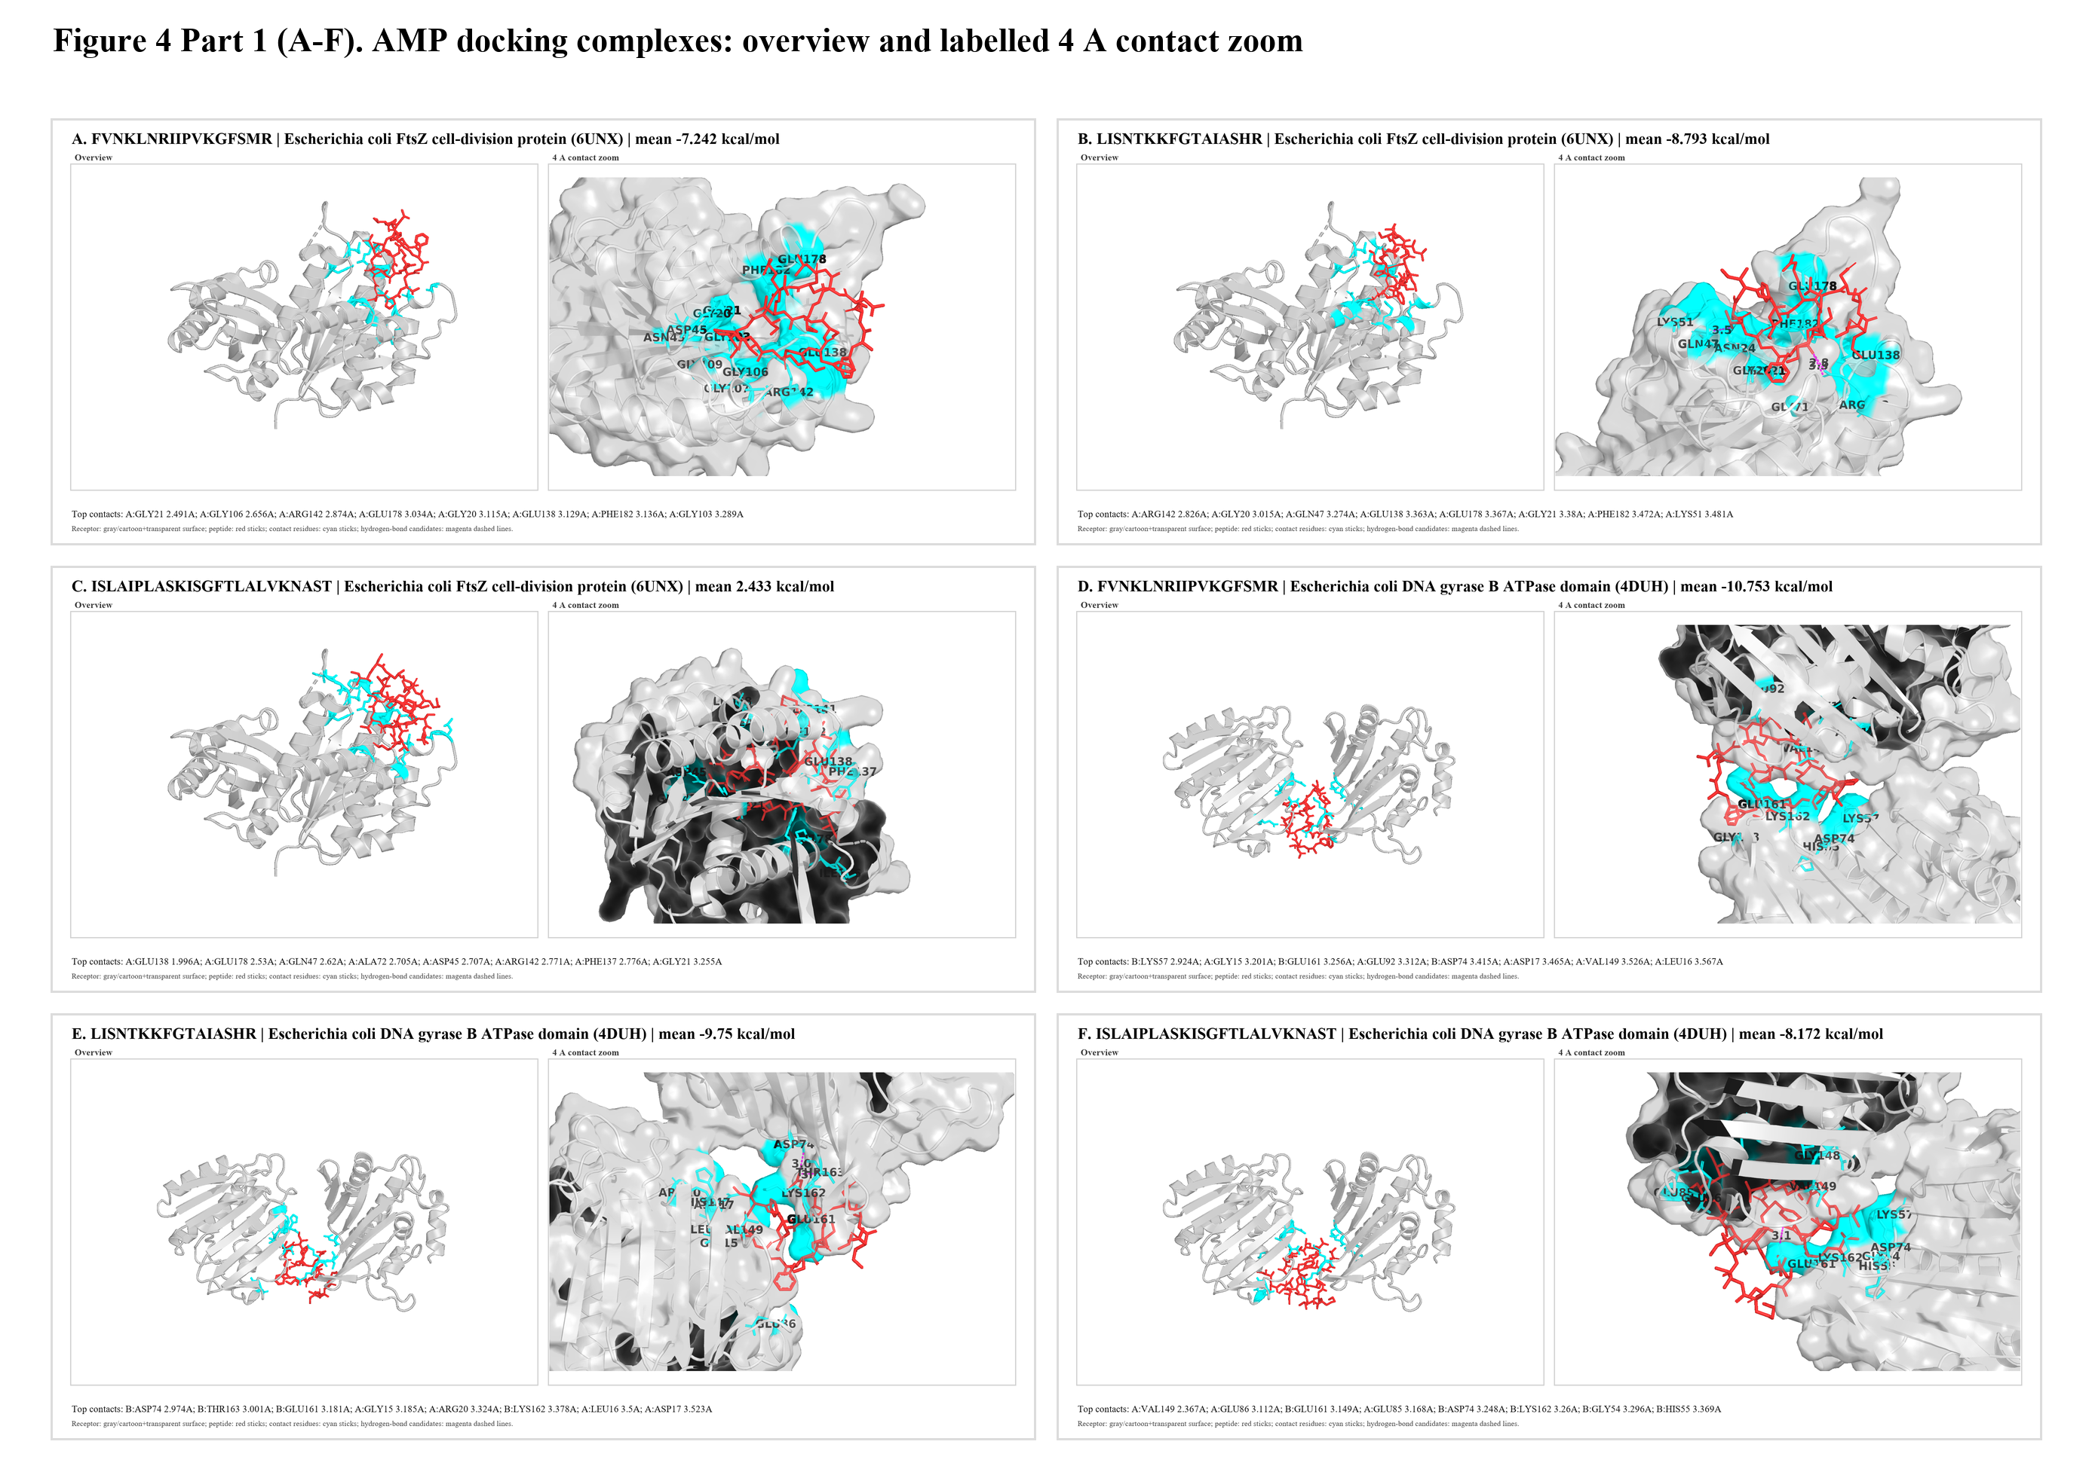
Figure_4_Part2_G-L_300dpi.png
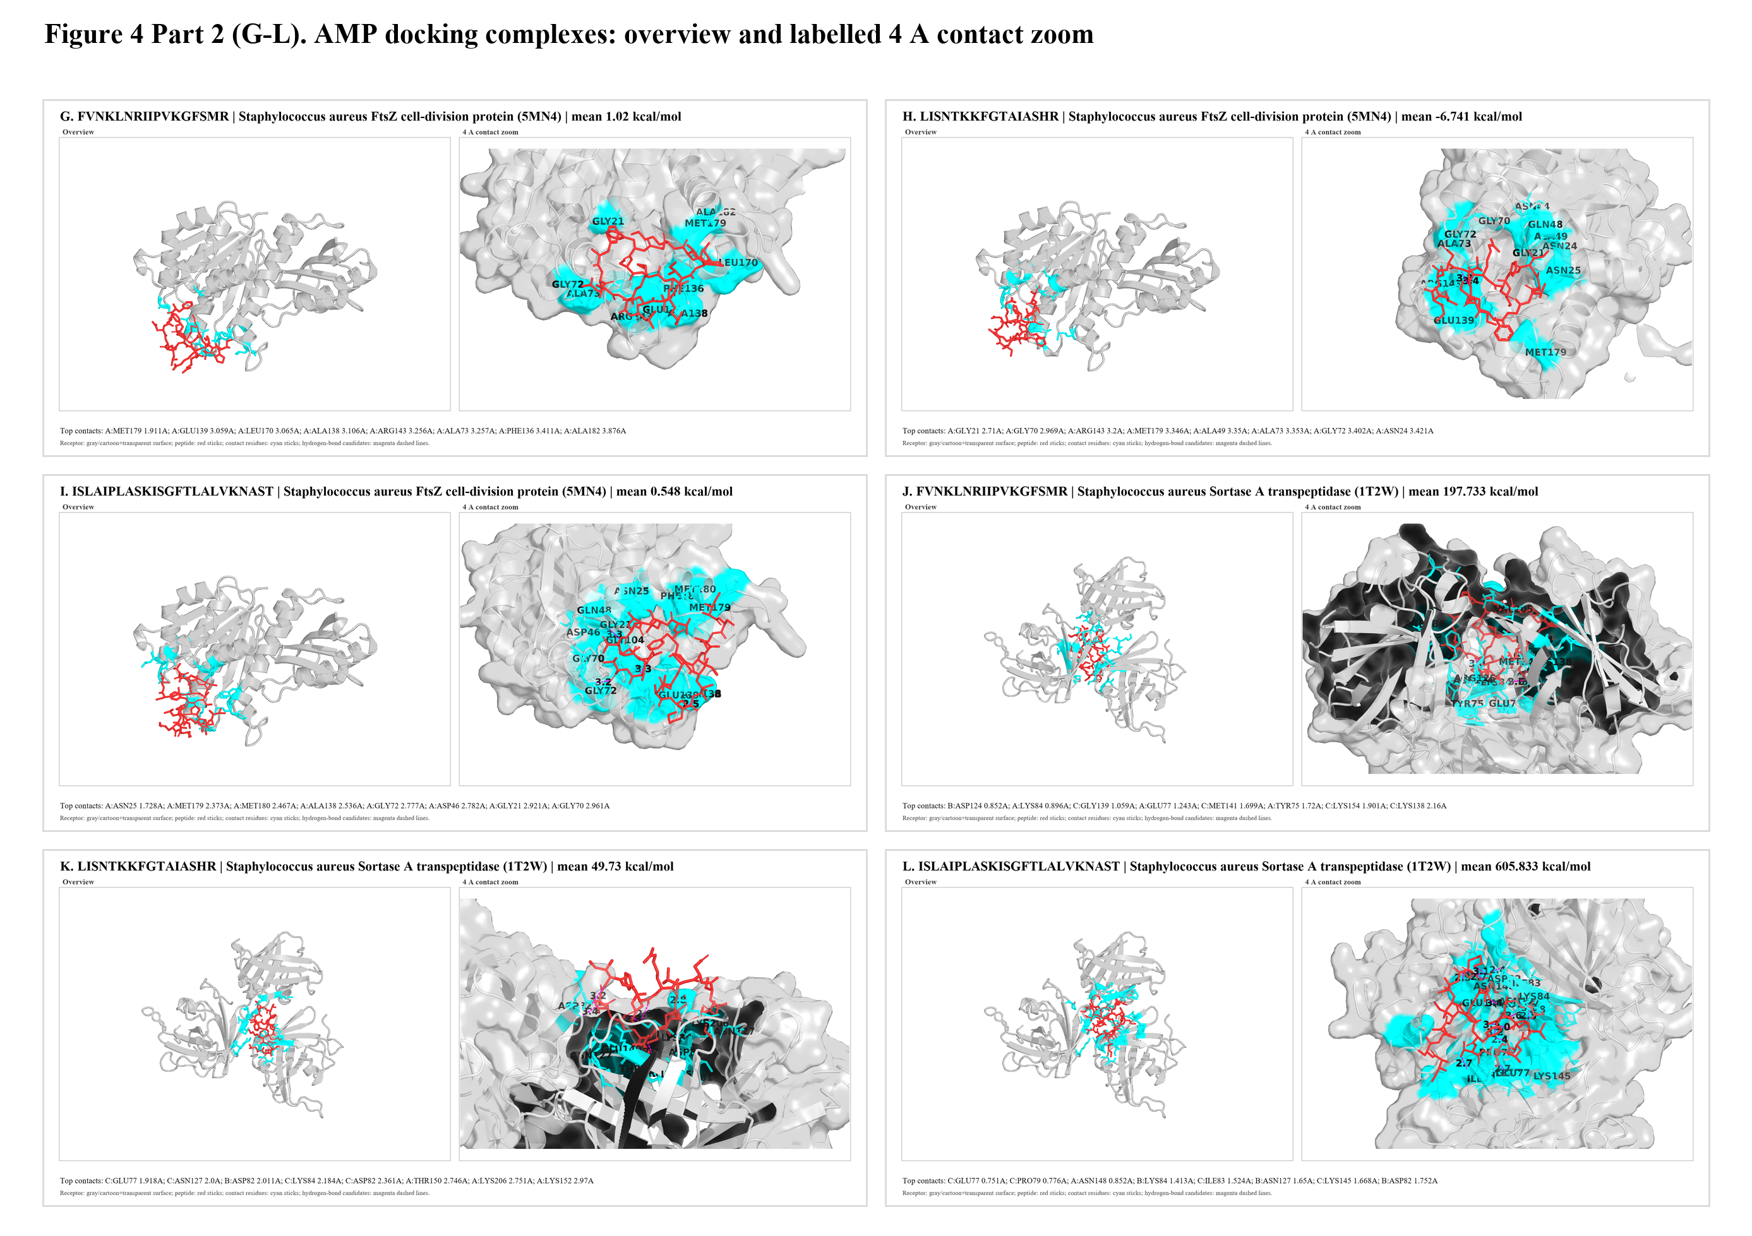
Figure_S1_12_Combined_300dpi.png
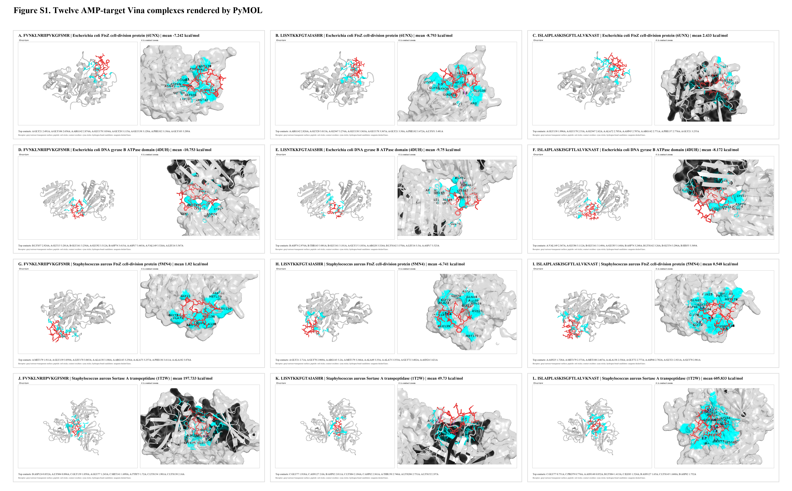

6. 局限性
Vina 不是专用 flexible peptide-protein docking 引擎。本结果适合作为可复现的开放源代码初筛；投稿级机制结论建议进一步进行 flexible peptide docking、MD、MM/GBSA 或实验验证。

7. 参考文献
de Boer, P. A. J.; Crossley, R. E.; Rothfield, L. I. The essential bacterial cell-division protein FtsZ is a GTPase. Nature 1992, 359, 254-256.
RayChaudhuri, D.; Park, J. T. Escherichia coli cell-division gene ftsZ encodes a novel GTP-binding protein. Nature 1992, 359, 251-254.
Schumacher, M. A.; Ohashi, T.; Corbin, L.; Erickson, H. P. High-resolution crystal structures of Escherichia coli FtsZ bound to GDP and GTP. Acta Crystallogr. F 2020, 76, 94-102. DOI: 10.1107/S2053230X20001132. PDB: 6UNX.
Di Somma, A.; Moretta, A.; Canè, C.; Cirillo, A.; Duilio, A. The antimicrobial peptide Temporin L impairs E. coli cell division by interacting with FtsZ and the divisome complex. Biochim. Biophys. Acta Biomembr. 2020, 1862, 183310.
Brvar, M.; Perdih, A.; Renko, M.; Anderluh, G.; Turk, D.; Solmajer, T. Structure-based discovery of substituted 4,5'-bithiazoles as novel DNA gyrase inhibitors. J. Med. Chem. 2012, 55, 6413-6426. DOI: 10.1021/jm300395d. PDB: 4DUH.
Maxwell, A.; Lawson, D. M. The ATP-binding site of type II topoisomerases as a target for antibacterial drugs. Curr. Top. Med. Chem. 2003, 3, 283-303; see also DNA gyrase drug-target reviews.
Haydon, D. J.; Stokes, N. R.; Ure, R.; Galbraith, G.; Bennett, J. M.; Brown, D. R.; et al. An inhibitor of FtsZ with potent and selective anti-staphylococcal activity. Science 2008, 321, 1673-1675.
Wagstaff, J. M.; Tsim, M.; Oliva, M. A.; Garcia-Sanchez, A.; Kureisaite-Ciziene, D.; Andreu, J. M.; Lowe, J. A polymerization-associated structural switch in FtsZ that enables treadmilling of model filaments. mBio 2017, 8, e00254-17. DOI: 10.1128/mBio.00254-17. PDB: 5MN4.
Ferrer-Gonzalez, E.; Huh, H.; Al-Tameemi, H. M.; Boyd, J. M.; Lee, S. H.; Pilch, D. S. Impact of FtsZ inhibition on the localization of the penicillin binding proteins in methicillin-resistant Staphylococcus aureus. J. Bacteriol. 2021, 203, e00204-21.
Zong, Y.; Bice, T. W.; Ton-That, H.; Schneewind, O.; Narayana, S. V. L. Crystal structures of Staphylococcus aureus sortase A and its substrate complex. J. Biol. Chem. 2004, 279, 31383-31389. DOI: 10.1074/jbc.M401374200. PDB: 1T2W.
Bentley, M. L.; Lamb, E. C.; McCafferty, D. G. Mutagenesis studies of substrate recognition and catalysis in the Sortase A transpeptidase from Staphylococcus aureus. J. Biol. Chem. 2008, 283, 14762-14771.
Shulga, D. A.; Kudryavtsev, K. V. Theoretical studies of Leu-Pro-Arg-Asp-Ala pentapeptide (LPRDA) binding to Sortase A of Staphylococcus aureus. Molecules 2022, 27, 8182.
Trott, O.; Olson, A. J. AutoDock Vina: improving the speed and accuracy of docking with a new scoring function, efficient optimization, and multithreading. J. Comput. Chem. 2010, 31, 455-461. DOI: 10.1002/jcc.21334.
Eberhardt, J.; Santos-Martins, D.; Tillack, A. F.; Forli, S. AutoDock Vina 1.2.0: new docking methods, expanded force field, and Python bindings. J. Chem. Inf. Model. 2021, 61, 3891-3898. DOI: 10.1021/acs.jcim.1c00203.
Riniker, S.; Landrum, G. A. Better informed distance geometry: using what we know to improve conformation generation. J. Chem. Inf. Model. 2015, 55, 2562-2574. DOI: 10.1021/acs.jcim.5b00654.
Rappe, A. K.; Casewit, C. J.; Colwell, K. S.; Goddard, W. A. III; Skiff, W. M. UFF, a full periodic table force field for molecular mechanics and molecular dynamics simulations. J. Am. Chem. Soc. 1992, 114, 10024-10035.
AMP_DOC_REPORT_DONE=True; SCI_COMPOSITE_FIGURES_DONE=True

