## Plan Study

Java programming exercises 作为练习提高之用

## Track Records

http://docs.oracle.com/javase/8/docs/api/

http://docs.oracle.com/javase/tutorial/index.html

https://docs.oracle.com/javase/tutorial/tutorialLearningPaths.html

## 10/25/2016

A List is an ordered Collection (sometimes called a sequence). Lists may contain duplicate elements. In addition to the operations inherited from Collection.

## 10/24/2016

Java platform contains three general-purpose Set implementations: HashSet, TreeSet, and LinkedHashSet. HashSet, which stores its elements in a hash table, is the best-performing implementation; however it makes no guarantees concerning the order of iteration. TreeSet, which stores its elements in a red-black tree, orders its elements based on their values; it is substantially slower than HashSet. LinkedHashSet, which is implemented as a hash table with a linked list running through it, orders its elements based on the order in which they were inserted into the set (insertion-order). LinkedHashSet spares its clients from the unspecified, generally chaotic ordering provided by HashSet at a cost that is only slightly higher.

## the union, intersection, or set difference of two sets

Set<Type> union = new HashSet<Type>(s1);

union.addAll(s2);

Set<Type> intersection = new HashSet<Type>(s1);

intersection.retainAll(s2);

Set<Type> difference = new HashSet<Type>(s1);

difference.removeAll(s2);

## ::符號

<http://docs.oracle.com/javase/tutorial/java/javaOO/methodreferences.html>

## **Kinds of Method References**

There are four kinds of method references:

|  |  |
| --- | --- |
| **Kind** | **Example** |
| Reference to a static method | ContainingClass::staticMethodName |
| Reference to an instance method of a particular object | containingObject::instanceMethodName |
| Reference to an instance method of an arbitrary object of a particular type | ContainingType::methodName |
| Reference to a constructor | ClassName::new |

## Java Collections Framework

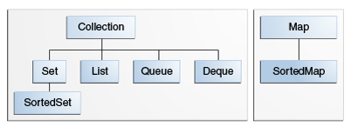

## HEAD2

## Unknown Problem

Object::toString() 其中的四点运算符