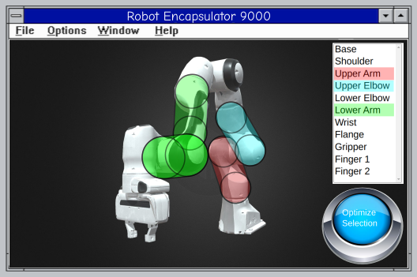
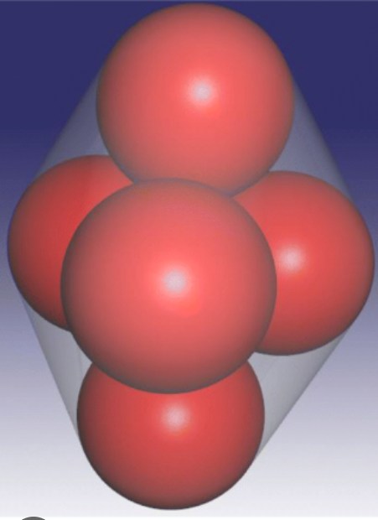
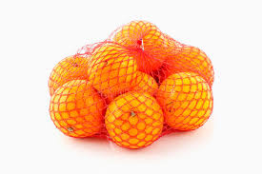
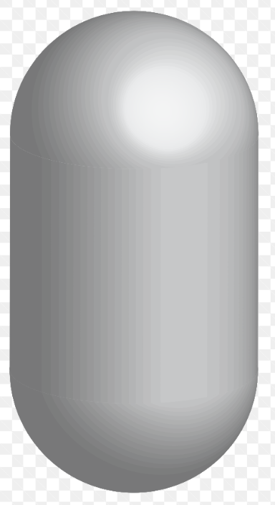
In the new trajectory planner, all collision primitives in robots must be convex hulls around a set of spheres (which we will call orange nets).

This can be a single sphere, a capsule (convex hull of two spheres) or a hull of multiple spheres.
Note:
- spheres can intersect
- all spheres in a single orange net must have the same radius
- different orange nets can have different sphere radii

Each rigid body in a robot should be semi-automagically approximated by such nets.

Sometimes it might be best to approximate a shape with a single orange net (like an arm link of the UR5 which is basically already a sausage). Sometimes it might be better to use multiple orange nets for a single shape (for instance an L shape like the green forearm of the Panda). Sometimes multiple shapes can be combined to a single orange net (as long as they all belong to the same link and have no joint between them).

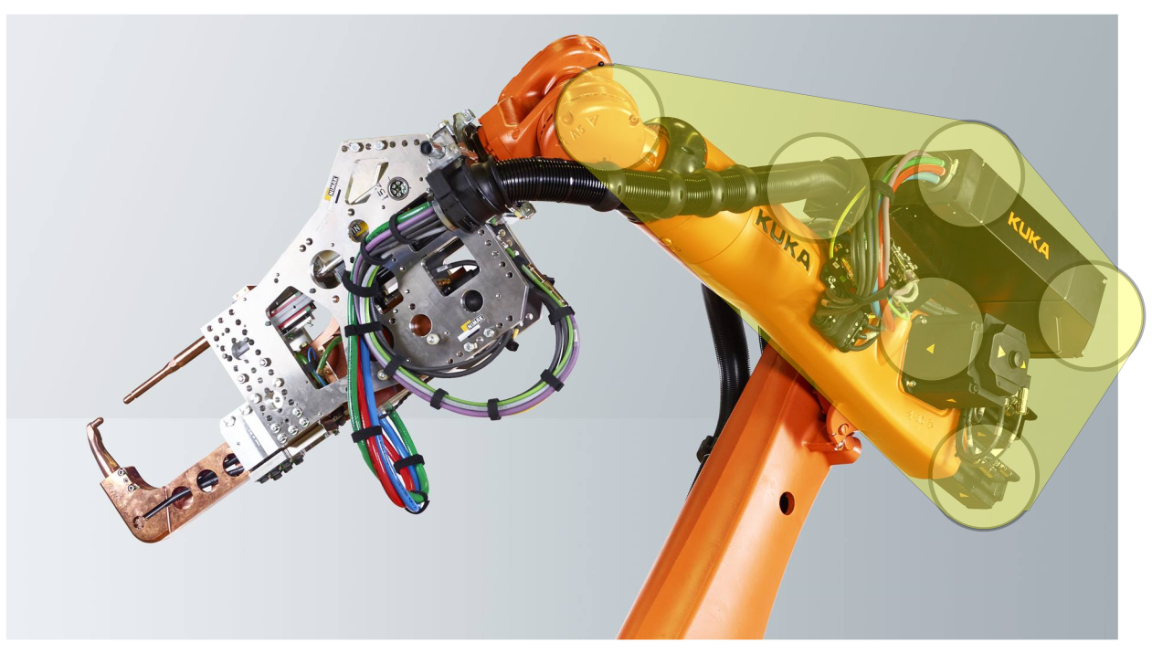
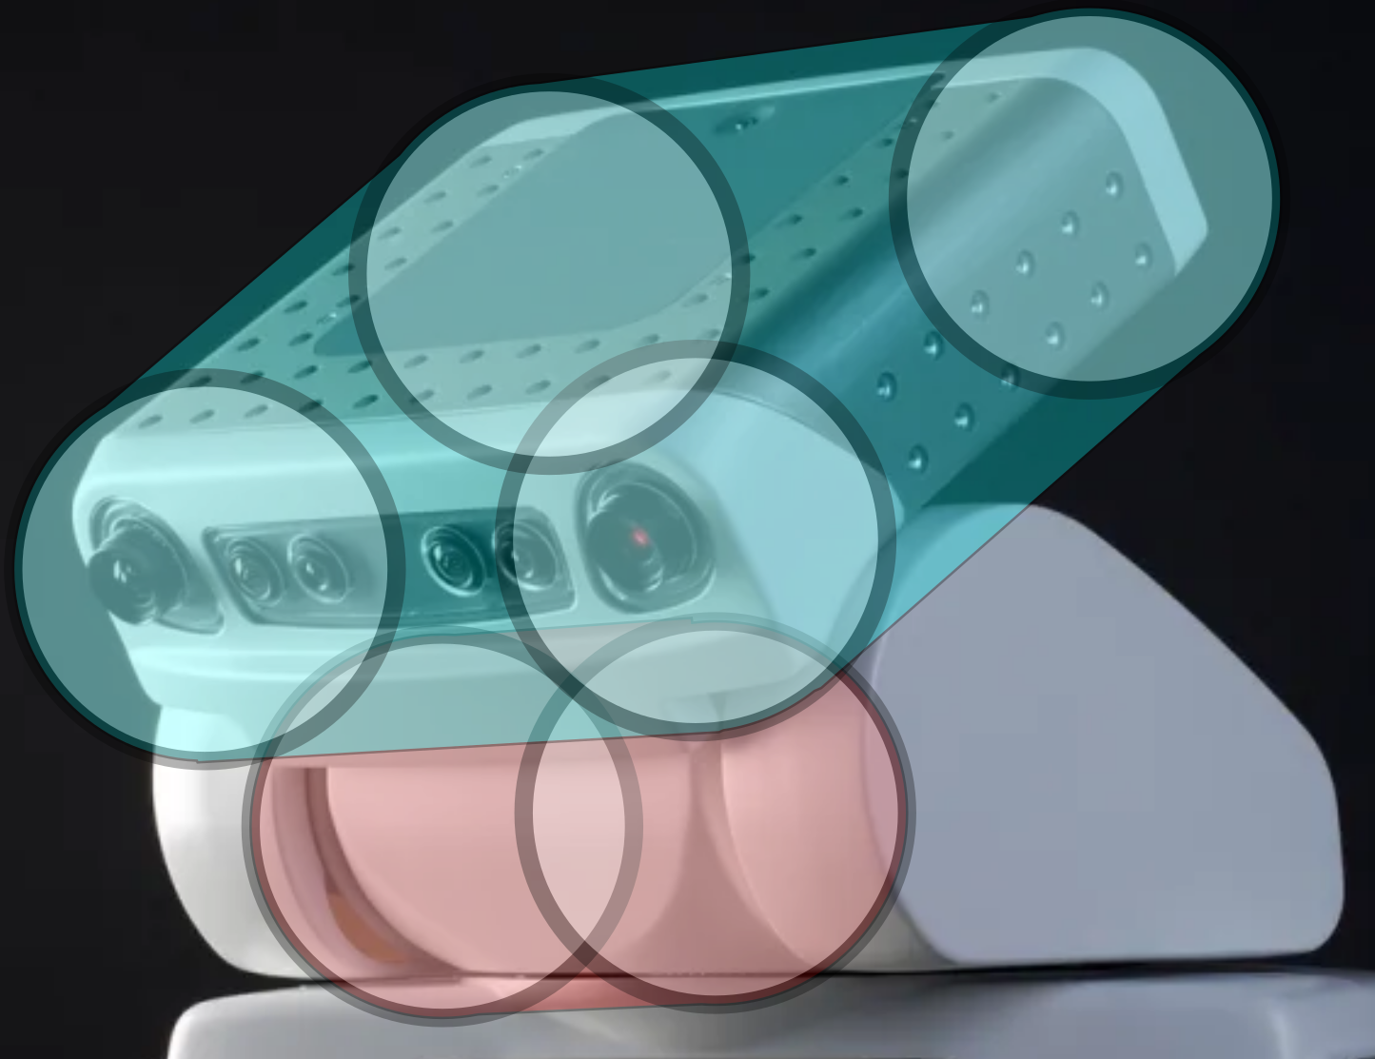
Here, the forearm and the black box can theoretically be combined into a single orange net.

Here we can maybe use two orange nets for the head, one with 4 spheres for the VHS Player head and one for the neck sausage. However, one net with 6 spheres will probably result in faster computation than two nets with two and four spheres.

It is ok if orange nets that belong to neighboring links collide (like the cyan and the red link on the Panda) as neighboring links are usually not checked for collision.

Each point on the robot should be contained within an orange net.
User Story:

I start the program and open a URDF file with it. There should be a 3D View of the robot and a list view listing each collision primitive in the robot, grouped by links. I can select multiple primitives (from a single link) in the list view which I am going to encapsulate next. I define how many nets with how many spheres I want to use for this part and the algorithm does its magic. When done with all parts, I save the new robot in a format for the new planner.

State of the art:

The current planner already contains an algorithm that was supposed to encapsulate arbitrary shapes (defined by a list of vertices) into a single capsule. It creates two spheres with center points (x1, y1, z1) and (x2, y2, z2). These six coordinates form the parameters that can be tweaked by a Nelder Mead optimization (https://docs.scipy.org/doc/scipy/reference/optimize.minimize-neldermead.html). The cost function works like this:

- imagine a line segment between the sphere centers
- for every vertex of the shape, determine the distance to the line segment
- use the maximum distance as the capsule radius (so that each vertex will be contained by the capsule)
- compute the volume of the capsule and return it as cost

This tries to find a capsule with minimal volume that still contains the complete shape. Although the idea is theoretically super genius because I am just the smartest, it somehow didn’t work very well in practice.

In theory, your program can use the same approach. Optimizing an orange net of n spheres has 3n+1 parameters, (3n if the radius is determined automatically).

Recommendations:

- use python
- Sometimes optimization works best by gradually increasing the number of parameters. Instead of throwing 20 spheres at random into the scene and letting the optimizer run, it might be better to start with 1 sphere, optimize, add another sphere, optimize and so on.
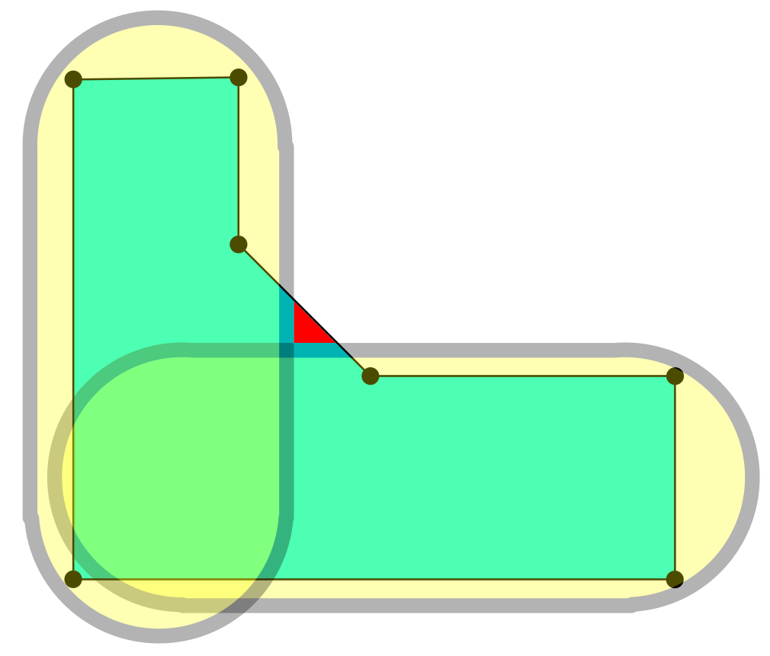
- The algorithm of the current planner does not work if we want to approximate a shape with multiple orange nets. First we do not know which of the radii to increase to include each vertex, second it might be that every vertex is included but parts of the robot are still not covered, like this:

Emergency solution: we do not consider this case and if it comes up, the user has to manually edit the URDF and split the model of the part into multiple parts with blender or something. But maybe you have a better idea how to deal with this.

Have fun!

