**Numerical Analysis – Fall 2023**

Assignment #2

Issued: Oct. 8, 2023  **Due: Oct. 17, 2023**

**Problem 1：**



**Problem 2：**

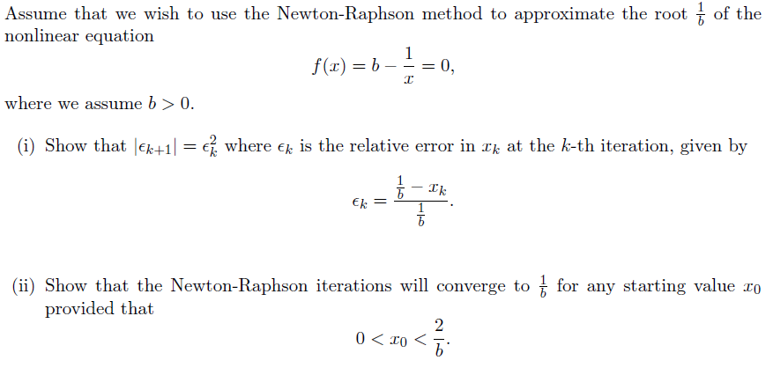

**Problem 3：**

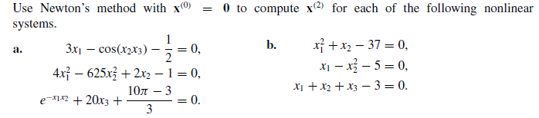 

**Problem 4：**

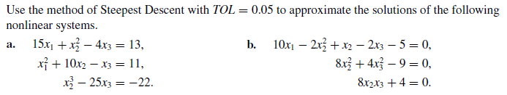

Problem 5: The nonlinear system



can be transformed into the fixed-point problem



(a) Show that  mapping into  has a unique fixed point in



(b) Let , and perform two steps of the fixed point iteration to find 