Reading the Rosetta Stone:

Introduction to Ptolemaic Hieroglyphs

Taught by Foy Scalf

Notes by Minh-Tâm Trinh

1 1/26/2026

- most signs in “Ptolemaic” hieroglyphs reflect standard, conventional use, as reflected in e.g. Gardiner’s sign list
  - example from temple text: the one unusual sign is a dog [jackal?] signifying the phonetic value ii
  - Ptolemaic has “7000” signs, but in practice, most texts rely predominantly on the “700” or so standard signs that most students will know
  - Leitz on a ritual scene from the temple of Dendara: 362 signs, 342 of which are conventional, 10 are common Late Egyptian substitute uniliterals
- Ptolemaic inscriptions often juxtapose playful or unusual writings against more standard writings

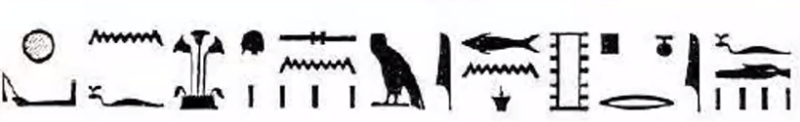
xwi.n=f HA=sn m inb pn r ifd nn iry m ifd

He made protection around them with this wall on the four sides of these [gods].

- standing baboon with arms raised: an unusual but common Ptolemaic writing of nfr
- TempleTexte: https://www.tempeltexte.uni-tuebingen.de/portal/
- [ The Temple of Esna: An Evolving Translation, by David Klotz: https://bookdown.org/shemanefer/Esna3/ ]
- “Ptolemaic” can be a misleading term. Ptolemaic hieroglyphs do not only appear in Ptolemaic or Roman inscriptions. Conversely, not all such inscriptions stick to “Ptolemaic” readings/values of given hieroglyphs, but may use older readings/values.
- PA-di-Imn-nb-ns.t-tA.wy: In his copy of the Book of the Dead, his name uses the Ptolemaic obelisk sign for the name Amun
- m-Xnw evolves phonetically to sound like mw Xr nw, which is then spelled: m(w) Xr nw
- pri spelled with an f viper leaving a box(!); aq spelled with the viper entering the box
- the principles by which Ptolemaic glyphs derive their values were not new to the Ptolemaic Period, but (expansions of) older, existing principles
- Traditional Egyptian: “From 404 BCE [to] 394 CE hieroglyphic texts were in general composed in the high-status language variety termed Traditional Egyptian.” https://escholarship.org/uc/item/8g73w3gp
  - inconsistent n vs m distinction
  - inconsistent sDm=f vs sDm.n=f
  - reduction of statives, infinitives, affixes
  - phonetic changes reflected in script
  - imitation of earlier phases
  - text-specific idiosyncrasies
  - attested from the New Kingdom through Roman Periods
  - “linguistic interference” from all stages of the language
- Joachim Quack doesn’t believe that Ptolemaic hieroglyphs exist as a true separate category: There is no phase of the language that can be definitively called Ptolemaic.
- the following glyphs all signified phonetic k in what Champollion read:

- Leitz: “[Ptolemaic] is not some arcane branch”!
- hieroglyph theory:
  - a literal description of the ba bird as depicted in the bA sign
  - Dendera VI, 157, 2: “As for Sobek who is in this place, it is Seth. As for the feather which is upon his head, it is Osiris.” Then a glyph of a literal crocodile wearing a maat feather
- BD 17: “I know the name of this Medjed, who is among those inside of the temple of Osiris, who shoots with his eye, but one cannot see him; who circles heaven with flames of his mouth, who announces the flood, but one cannot see him.”
- our main sign list:

Kurth, A Ptolemaic A Ptolemaic Sign-List. Hieroglyphs used in the Temples of the Graeco-Roman Period of Egypt and their Meanings

- our main dictionary/lexicon:

Wilson, A Ptolemaic Lexikon: a Lexicographical Study of the Texts in the Temple of Edfu (Orientalia Lovaniensia Analecta)

- derivation principles:
  - acrophony [think: “acronyms”]: we will mainly avoid this
  - the consonantal principle: drop weak sounds in multiliterals
  - phonetic shifts: p vs b, m to b, m vs n, d vs t, q vs k
  - class (f vs D snakes) and shape (x vs ra signs) substitutions, synonymy
  - direct representation (viper leaving/entering box; feather-wearing crocodile; “colorful of feathers, who comes forth from the horizon”)
  - antonomasia (nTr aA < epithet of Ihy < sistrum player, iqr < epithet of Thoth < ibis), metonymy (ny-sw.t < King of Upper Egypt < white crown; nTr < god < star [compare: Sumerian dingir sign])
  - synecdoche
  - logograms, the rebus principle
  - puns
  - ??? (tA.wy < two lands < scarab?)

2. 2/2/26

- example derivations of “new” readings:
  - mAa.(t)-xrw < “wreath of justification” < Gardiner M2
  - Imn < n m iw (Gaudard 2010), i m n (Sethe 1993), im + n (Fairman 1943)
  - Dd, e.g., in the name +d-Hr < Dd mdw.(t) < +Hwty?
- quasi-phonetic spellings of royal names:
  - Ptwlmys < Ptolemy
  - QliwpAdrA < Cleopatra
  - KAysrs < Caesar
- use of the dual was fairly limited: e.g., to pairs of gods, pairs of body parts
- like in Late Egyptian (LE):
  - the feminine -t was no longer pronounced in the spoken language, so it was often dropped in the script
  - no gender/number agreement needed in the indirect genitive
  - definite articles pA, tA, nA
  - adverbial predicates are tenseless by default, with tense marked by converters
- iwa n nTr.wy pri.wy < “heir of the manifest gods” < heir of Πτολεμαῖος Ἐπιφανής Εὐχάριστος < heir of Ptolemaĩos Epiphanḗs Eukháristos < heir of Ptolemy V the Manifest, the Beneficent < Ptolemy VIII
- “Ptolemy VIII was a super-not-great dude… It was very Game-of-Thrones in this time period”
- BAq.t, “The Shining One”, is an epithet (not replacement) for Km.t, much like “a shining city on a hill” for Puritan Massachusetts
- If you memorize the cult epithets of the various Ptolemies, it can help with identifying these kings in Egyptian texts where they are named only by epithet.
- sxm anx Imn, “living image of Amun”, is a Ptolemaic evocation of the New Kingdom &w.t-anx-Imn (!)
- the nty in aHay nty aA.t rwD.(t): maybe a precursor of the Coptic indefinite nt- prefix
- updates to the suffix pronouns:
  - -tw established as the impersonal 3rd person singular pronoun
  - -w now used as 3rd person plural pronoun
- Zoom chat: “what does imps mean?” “impersonal”
- in the spelling of hy, “male, husband”: a penis
- is, derived from isT/ist, marks the start of an independent clause, usually an adverbial predicate
- Some people claim that there are no Egyptian creation myths with creator goddesses. “I’m here to tell you, that’s bunk!”
- the particle iw can take different, contradictory roles:
  - when used as in the Middle Egyptian (ME) iw for (circumstantial) adverbial predicates, it is a circumstantial converter marking an independent clause
  - when used as in LE, it marks a dependent clause
- wnn.in: imperfect converter used in narrative contexts
- wn: imperfect converter used in non-narrative contexts
- Esna 206: a Neith creation myth documented on a single column of the temple of Esna

3. 2/9/26

- How to identify when iw is marking the circumstantial first present? Sometimes, can tell from whether the surrounding text has more ME or more LE characteristics.
- adverbial predicates can often occur with no introductory particle
- cartouches:
  - the Greek cult epithet usually appears outside, not inside, cartouches
  - within the birth-name cartouche of a Ptolemy, the name is often followed by the epithets anx D.t mry PtH
  - within the throne-name cartouche, the name is often followed by sxm anx Imn
  - nearby the name of the ruler, one often finds epithets for the parent(s) of the ruler
- example use of epithets from the Rosetta Stone:


Xnty n ny-sw.t bity Ptlmys anx D.t mry PtH nTr pri nb nfr.w
statue of the king of upper and lower Egypt, Ptolemy, living forever, beloved of Ptah, the manifest god, lord of perfection
- [Kom Ombo: site of a Ptolemaic temple dedicated “dually” to Sobek and Haroeris (@r-wr)]
- an oddity: they switch between %bq and %bq-Ra even in the same (columnar) text
- Aurelio: Would kairos (καιρος) be an appropriate translation of A.t?
- In the Getty and other places, they refer to Trajan as “Augustus Caesar”: but if you look at the actual cartouches, it’s Trajan with the title Autocrator Caesar
- last line of the Rosetta Stone:
[xti=tw] sxAwy pn Hr aHay nty aA.t rwD.(t) m sS n mdw.w-nTr

This decree should be engraved upon a stela of hard stone in hieroglyphs [“the writing of the gods’ words”].
- apart from the Rosetta Stone, most of the texts we’re reading in class are from temple walls, and occur as description of a (theological) scene
- common structure of a temple scene: the king gives an offering to a god; the god then promises some benefit to the king
- The Ptolemaic spellings of the 3^{rd-}person masculine and feminine dependent pronouns often overlap: Why? Because by that point in time, sw and sy were being pronounced the same.
- infrequently, they use the LE dependent pronouns in place of the ME ones: tw=i, tw=k, tw=t, tw=n, tw=tn in place of wi, tw, tn, n, tn
- Why is xpr spelled without the complementary r? Because by that point in time, they were not pronouncing the r: They pronounced it shope [as in Coptic].

4. 2/16/26

- “When you see those winged [sun] disks everywhere in temples in Egypt, those are depictions of Horus of Edfu.”
- Monumental inscription sight-reading practice:
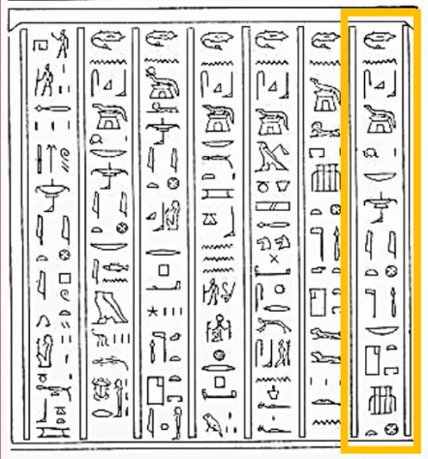
snD n Sbk-Ra nb Nby.t nTr aA nb Hw.t xnt
Have fear of Sobek-Re, lord of Ombos, great god, lord of the temple of the south.
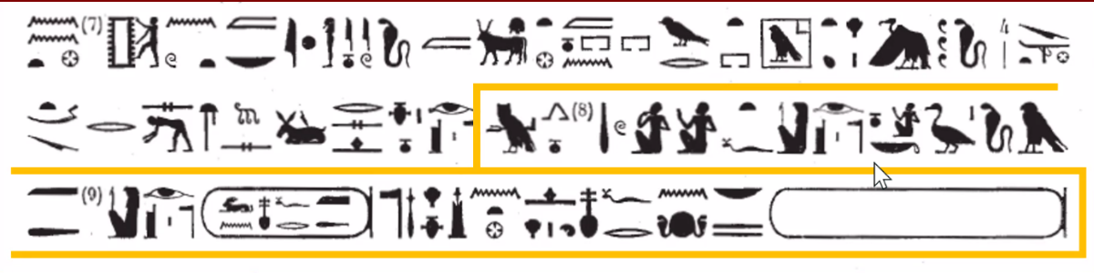
mi n xrw=i it=i Wsir
ink sA=k Hr mAa xrw
Wsir Wn-nfr mAa xrw nTr aA Hry ib Iwn.t
Htp Hr=k nfr n ny-sw.t bity nb tA.wy ( )|
Come to my voice, my father, Osiris.
I am your son, Horus, true of voice.
Osiris Wennefer [“Perfect Being”], true of voice, great god who is in Dendera.
May your beautiful face be content with the dual king, the lord of the two lands, ( )|.
- LE sDm=f forms:
  - perfective sDm=f: a.k.a, preterite, perfect
  - prospective sDm=f: a.k.a., subjunctive
- ambiguity in the phrase iwa n nTr.wy pri.wy: could be either Ptolemy VI or Ptolemy VIII, since they were brothers
- exercise: find iwa n nTr.wy pri.wy in Urk. VIII, no. 76
- “The left eye will be joining the right eye”
- real example where the feminine 3rd-person dependent pronoun is spelled with -w, because the (semi)vowel is just not pronounced anymore:
sw m Hm.t n Imn-Ra
She [not “he”] is the wife of Amun-Re.
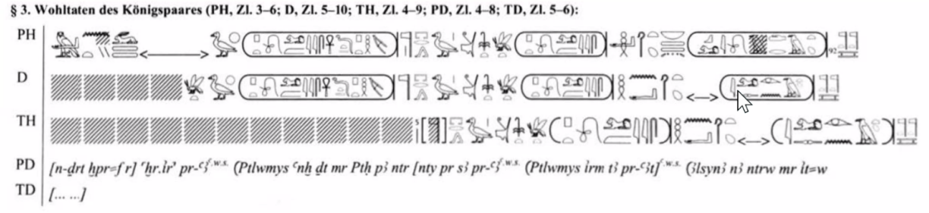
- “They were supposed to write his mother’s name, but accidentally wrote his first wife’s name: Cleopatra [the First].” “They should all have been named Arsinoe.” “Right. Or Berenike… We have, what, seven Cleopatras…”
- very common in monumental captions:
Dd mdw.(w) in [name of god]
speaking [infinitive] of word[s] by [name of god]
- in reference books: “Tableau” = an illustrated scene; “Titre et Formule” = the title caption
- twA p.t = “raising the sky [said of the king-as-Shu]”
- mi n=k / n=t = “take for yourself”
- the Hr / r + infinitive construction:
  - in Ptolemaic writing [or LE], Hr + ___ need not have progressive aspect
  - may be modified by preceding converters
  - may omit the Hr or r, as they were no longer included in the spoken version
- in Ptolemaic, iw=i, iw=k, iw=t, etc. will just refer to the LE third future
- Coptic ϣⲁ ⲥⲱⲧⲙ comes from Egyptian xr sDm, not Hr sDm
- “Remember, if you’re Egyptian, you’re facing south. So ‘the West’ is to the right.”
- “[In the West], you could get attacked by Apophis; you have the damned who get their heads cut off every night…Of course, in the Christian era, the West is recast as the bad pagan place.”

5. 2/23/26

- And why is Horus of Edfu portrayed as a winged disk? The following excerpt from the Legend of the Winged Disk, using the imperfect converter wn.in and spelling apy, “winged disk”, with a literal winged disk:
wn.in Hr bHdty (Hr) iri.(t) xpr=f m apy Hr thn.(t) n Ra
[Then] Horus of Edfu transformed himself into the winged disk upon the prow of the boat of Re.
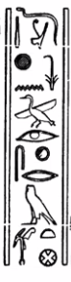
- Again from Urk. VIII, no. 76:
Dd-mdw (in) #nsw pA ir-sXr m WAs.t
Recitation said by Khonsu, the one who dissembles in Thebes.
- superpower diplomacy:
iw=t (r) di.(t) n=f nA wr.w n.(w) tA.(w) nb.(w) xAs.wt nb.w(t) niy.w sp-sn iw md=f Hr tp=sn
You will give to him the chiefs of all lands, [and] lords of all foreign places, peacefully while his staff is upon their head [not “heads”].
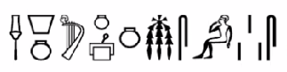
- Cool harp sign:
aHa.n Dd.n=s n ms.w=s
Then she said to her children. (Esna 206, 4)
- What is the origin of Apep?
is(t) A dr.n=s npa.t n sA=s
Then she [Neith] cast off [circumstantial sDm.n=f] the umbilical cord of her son [Re]. (Esna 206, 10–11)
- Uses of the nominal sDm=f and sDm.n=f:
  - objects of verbs and prepositions
  - subjects of verbs
  - Wechselsatz
  - emphatic construction
- Recall two ways to translate the emphatic construction:
sDm.n=f n pr
cleft sentence It is in the house that he heard.
fronting That he heard, [was] in the house.
- Examples of Wechselsatz:
iri.n=s xpr=s m id.t wHm.n=s irw=s m aHA
As she made her form as a cow, so she repeated [“her making”] as a Nile perch. (Esna 206, 1)
wAH.n=s tA m Hr-ib Nwn iri.n=s rn=f m qA qA
As she set land within [“in the heart of”] Nun, so she made its name as High Mound. (Esna 206, 4)
mA.n=f sbi.w m Hr.t sni.n=f m Hr=sn m apy wr
As he saw the rebels from the sky, so he passed over them [“in upon them”] as the great winged disk. (Edfu VI, 112)
- other names for the stative: qualitative, old perfective, pseudoparticiple, resultative
- Main difficulty in identifying the stative in LE, hence in Ptolemaic: three paradigms for spelling:
  - Paradigm 1: ME endings
-k(wi) -(w)n
-tw / -ti -tn
[null] (m.), -tw / -ti (f.) [null], -y
  - Paradigm 2: uniform ending -tw / -ti
  - Paradigm 3: uniform null ending

6. 3/2/26

- proposal by Brose[?] that in the Esna creation myth, sDm=f is used to mark primeval time, sDm.n=f to mark general past tense, etc.
- consensus after Polotsky:
  - that there is an emphatic construction to emphasize adverbials
  - that there are Wechselsatzen
  - that the second-tense converters in LE and Coptic are related
  - that the systematic distribution of iw mri=f vs. [null] mrr=f is meaningful
  - that the systematic distribution of iw=f ii.w vs. iw.n=f is meaningful
- disagreement after Polotsky:
  - that there is a separate emphatic form of the verb
  - that verb forms can be nouns, adverbs, adjectives, etc.
  - that verb forms require particles to stand in independent use
  - that in the second tense, the second tense form marks the logical subject, and the emphasized element marks the logical predicate
- Another Wechselsatz:
wn.n=f ir.t=f xpr HDd
axm.=f s(y) xpr kk
As he opened his eye, so light manifested.
As he closed it, so darkness manifested.
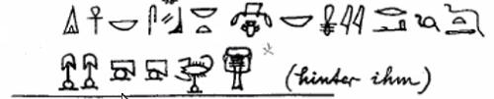
- The end of the second line below remains untranslated:
- “[One of] my favorite sentence[s] in Egyptology”: is(t) A dr.n=s npa.t n sA=s
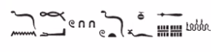
- “120 is a common number in these texts”:
Hf n mH 120 D(d).tw n=f aApp
…a snake of 120 cubits, [while] he was called [“one said to him”] Apep…
- check out: Ritner, “The Origin of Evil in Egyptian Theological Speculation” https://isac.uchicago.edu/sites/default/files/uploads/shared/docs/Publications/SAOC/saoc70.pdf#page=294
- “The ben ben is not the primeval mound [qA qA], but a symbol of that mound.”
- why the egg sign can stand for iri:
iri [to see] < eye < pupil < round thing < egg
- “As Ritner points out, mHy means ‘to swim’, so the Great Cow is the ‘Great Swimmer’…”
- “The TLA is rapidly becoming our new main dictionary. But anyone who wants to add something to the TLA, can… I think the TLA editors should do a little quality control…”
- imy.t-pr = house contract
[from http://www.virtual-egypt.com/newhtml/special/women/index.html:
…a legal unilateral deed for donating property. As a living will, it was made and perhaps executed while the husband was still alive. In this will, the husband would assign to his wife what he wished of his own private property, i.e., what he acquired before his marriage. An example of this is the imyt-pr of Wah from el-Lahun. 2) If there were no children, and the husband did not wish his brothers and sisters to receive two-thirds of the community property, he could legally adopt his wife as his child and heir and bequeath all the property to her. Even if he had other children, he could still adopt his wife, so that, as his one of his legal offspring, she would receive some of the two-thirds share, in addition to her normal one-third share of the community property.]
- The independent pronouns:
ink inn
ntk (m.) / ntt (f.) nttn
ntf (m.) / nts (f.) ntsn
- nominal predicate example:
imn.t=f pw itn
iAb.t=f pw iAH
bA=f pw Sw
The sun disk is his right eye.
The moon is his left eye.
The sunlight is his ba.

7. 3/9/26

8. 3/16/26

