git commit -am “type a message here” (shortcut for staging)

$ git log --pretty=oneline (get all your commits – shows you all the SHA)
$ git log –-oneline (get all commits but part of the SHA)

To use my editor

code [plus name of file for example, index.html]

$ git checkout -b footer master
new feature of the git checkout command to create our new footer branch and have this footer branch start at the same location as the master branch:
git log --oneline --decorate --graph --all
This shows all branches and therefore all commits in the repository.
if you make a merge on the wrong branch, use this command to undo the merge:
git reset --hard HEAD^
(Make sure to include the ^ character! It's a known as a "Relative Commit Reference" and indicates "the parent commit"
Whichever branch the special HEAD pointer is pointing at, that's the branch that will have the merge commit.
$ git branch alt-sidebar-loc 42a69f

git commit --amend will let you provide a new commit message and will let you include files (or changes to files) you might've forgotten to include.
you can amend the last commit (the one that updated the color of all of the other links) to include this forgotten one. To do get the forgotten link included, just:
- edit the file(s)
- save the file(s)
- stage the file(s)
- and run git commit –amend

$ git revert <SHA-of-commit-to-revert>
This command:
- will undo the changes that were made by the provided commit
- creates a new commit to record the change

$ git reset <reference-to-commit>
It can be used to:
- move the HEAD and current branch pointer to the referenced commit
- erase commits
- move committed changes to the staging index
- unstage committed changes

git remote add is used to add a connection to a new remote repository.
git remote -v is used to see the details about a connection to a remote.

You can think of the git pull command as doing two things:
- fetching remote changes (which adds the commits to the local repository and moves the tracking branch to point to them)
- merging the local branch with the tracking branch
The git fetch command is just the first step. It just retrieves the commits and moves the tracking branch. It does not merge the local branch with the tracking branch. The same information provided to git pull is passed to git fetch:
- the shortname of the remote repository
- the branch with commits to retrieve
$ git fetch origin master

Recap
The git log command is extremely powerful, and you can use it to discover a lot about a repository. But it can be especially helpful to discover information about a repository that you're collaborating on with others. You can use git log to:
- group commits by author with git shortlog
- $ git shortlog
- filter commits with the --author flag
- $ git log --author="Richard Kalehoff"
- filter commits using the --grep flag
- $ git log --grep="border radius issue in Safari"
grep is a complicated topic and you can find out more about it here on the Wiki page or in our Shell Workshop course.

git shortlog -s -n
couple of flags: -s to show just the number of commits (rather than each commit's message) and -n to sort them numerically (rather than alphabetically by author name).
git shortlog with the -s -n flags to show only the number of commits each author has made, sorted numerically.
Another way that we can display all of the commits by an author is to use the regular git log command but include the --author flag to filter the commits to the provided author.
$ git log --author=Surma

If we wanted to see only the commits by Paul Lewis we have to run:
$ git log --author="Paul Lewis"
Pay attention to the use of the quotes in the previous command. If it were written without the quotes like this git log --author=Paul Lewis, it would not work. If it's formatted this way without the quotes, Git would think that Lewis is not part of the "author" flag, and it would cause an error.
Let see an example of extra details in a commit in the lighthouse project by looking at commit 5966b66:
$ git show 5966b66

filter down to just the commits that reference the word "bug". We can do that with either of the following commands:
$ git log --grep=bug
$ git log --grep bug

Grep is a pattern matching tool.
https://docs.google.com/document/d/1dRY3BVWWTPPTldNZtA20SRo-qVTRTSIDJXlf7F7xgmU/edit#heading=h.sj65bfg1lk2g
GitHub Repository Link
https://github.com/mquinonez/pdsnd_github

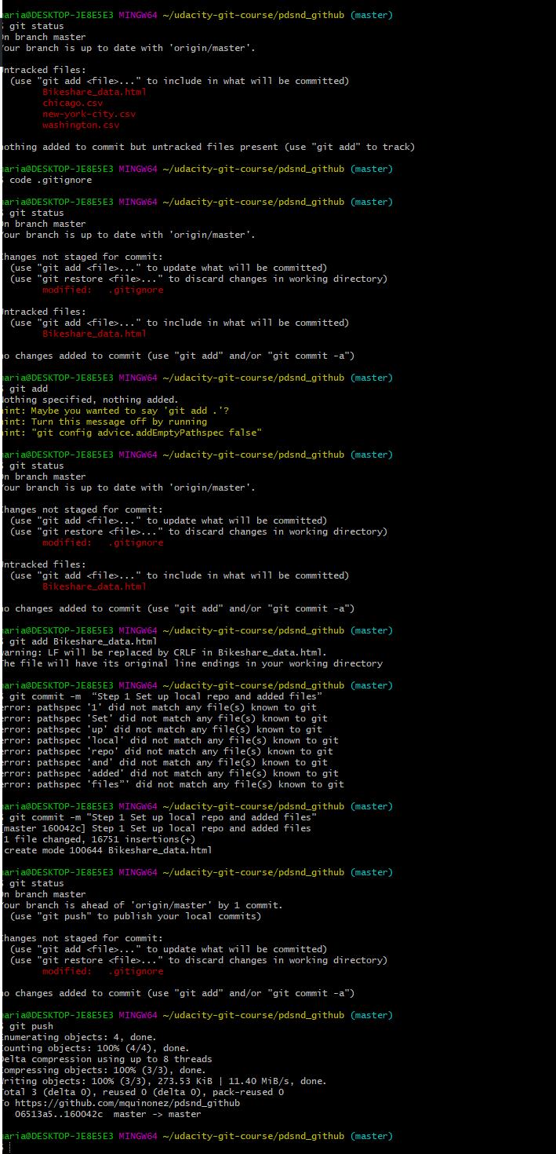
pd
6 ls
457 ls
458 touch .gitignore
459 ls
460 ls -a
461 code .gitignore
462 ls -a
463 view .gitignore
464 git status
465 git add Bikeshare_data.html
466 git status
467 git commit -am "Step 1 Set up local repo and added files"
468 git status
469 git push
470 git branch
471 git ^M
472 git log --oneline
473 git branch
474 git push
475 git push origin
476 git push -u orgin master
477 git remote set -url origin https://github.com/mquinonez/course-git-blog-project
478 git clone https://github.com/mquinonez/pdsnd_github
479 pwd
480 cd ..
481 cd ..
482 pwd
483 ls
484 git clone
485 git clone https://github.com/mquinonez/pdsnd_github
486 ls
487 cd pdsnd_github/
488 ls
489 touch .gitignore
490 git status
491 git status
492 code .gitignore
493 git status
494 git add
495 git status
496 git add Bikeshare_data.html
497 git commit -m “Step 1 Set up local repo and added files”
498 git commit -m "Step 1 Set up local repo and added files"
499 git status
500 git push
501 ls
502 cd udacity-git-course/
503 cd pdsnd_github/
504 git status
505 git branch documentation
506 git log --oneline --decorate --graph --all
507 git checkout
508 git checkout documentation
509 code .gitignore
510 code .README.md
511 git status
512 git add .README.md
513 git commit -m "Step 2 Update README.md file to be consistent with work done in the Bikeshare project"
514 git status
515 git push
516 git push --set-upstream origin documentation
517 git checkout master
518 git checkout documentation
519 code .README.md
520 git add .README.md
521 git commit -m "Step 3 Additional Changes to README.md file"
522 git push
523 git checkout master
524 git status
525 git checkout documentation
526 git checkout master
527 git log --oneline --decorate --graph --all
528 git branch refactoring
529 git checkout refactoring
530 code Bikeshare_data.html
531 git status
532 git commit -am "Change font family [Section 4]"
533 git push
534 git push --set-upstream origin refactoring
535 code Bikeshare_data.html
536 git commit -am "Change h1 font size [Section 4]"
537 git push
538 code Bikeshare_data.html
539 git commit -am "Change border color [Section 4]"
540 git push
541 git checkout master
542 history

maria@DESKTOP-JE8E5E3 MINGW64 ~/udacity-git-course/pdsnd_github (master)
$ !506
git log --oneline --decorate --graph --all
* a678b1a (origin/refactoring, refactoring) Change border color [Section 4]
* 41f8061 Change h1 font size [Section 4]
* a4038f0 Change font family [Section 4]
| * 7b430d9 (origin/documentation, documentation) Step 3 Additional Changes to README.md file
| * 5f8728f Step 2 Update README.md file to be consistent with work done in the Bikeshare project
|/
* 160042c (HEAD -> master, origin/master, origin/HEAD) Step 1 Set up local repo and added files
* 06513a5 Update manual.yml
* 6b288e4 Create .gitignore
* f7d8fb1 Create manual.yml
* f10e84c Update README.md
* 33ca4c6 Update README.md
* b5052a6 Update README.md
* 46a5819 Create README.md

maria@DESKTOP-JE8E5E3 MINGW64 ~/udacity-git-course/pdsnd_github (master)
$

