https://flowingdata.com/2015/02/18/loading-data-and-basic-formatting-in-r/

Ctrl+Enter to run your code in my computer it is Alt+Enter

Quick R
R Cookbook
R-Bloggers
StackOverflow About R
StackOverflow R FAQ
Google's R Style Guide

Saving subsets into new variables
stateSubset <- subset(staesInfo, state.region ==1)
head(stateSubset, 2)
dim(stateSubset)

stateSubsetBracket <- statesInfo[statesInfo$state.region ==1, ]
head(stateSubsetBracket, 2)
dim(stateSubsetBracket)

newdata <- subset(mydata, age >= 20 | age < 10,
select=c(ID, Weight))

which states have an illiteracy rate of 0.5%?
which states have high school graduation rates above 50%?

stateSubsetBracket <- statesInfo[statesInfo$illiteracy ==1.0]
head(stateSubsetBracket, 4)
dim(stateSubsetBracket)

stateSubsetBracket <- statesInfo[statesInfo$highschoolgrad >50%]
head(stateSubsetBracket, 5)
dim(stateSubsetBracket)

getwd() – used to know what directory you are in
setwd('~/Downloads') – used to set the directory you need

statesInfo <- read.csv('stateData.csv')
View(statesInfo)

subset(statesInfo, state.region ==1)

statesInfo[statesInfo$state.region == 1, ]

stateSubsetBracket <- statesInfo[statesInfo$state.region ==1, ]
head(stateSubsetBracket)
dim(stateSubset)

stateSubset <- subset(staesInfo, state.region ==1)
head(stateSubset, 2)
dim(stateSubset)

stateSubsetBracket <- statesInfo[statesInfo$state.region ==1, ]
head(stateSubsetBracket, 2)
dim(stateSubsetBracket)

stateSubset <- subset(stateInfo, illiteracy ==0.5)
head(stateSubset, 3)
dim(stateSubset)

stateSubsetBracket <- statesInfo[statesInfo$illiteracy ==1.0]
head(stateSubsetBracket, 4)
dim(stateSubsetBracket)

stateSubsetBracket <- statesInfo[statesInfo$highschoolgrad >50%]
head(stateSubsetBracket, 5)
dim(stateSubsetBracket)

# You can type a '?' before any command or a data set to learn
# more about it. The details and documentation will appear in
# the 'Help' tab. i.e. ?mtcars

# This is a vector containing the mpg (miles per gallon) of
# the 32 cars. Run this next line of code to get the average mpg for
# for all the cars. What is it?

# Enter this number for the quiz on the Udacity website.
# https://www.udacity.com/course/viewer#!/c-ud651/l-729069797/e-804129314/m-830829287

mean(mtcars$mpg

Insert chunk
Cmd+Option+I for me Ctrl+Alt+I

To know how many variables you have run
str(cars) in this case ‘cars’ is the data file

There is a difference between using the hash or pound symbol# inside and outside of a {r} block of code.
```{r}
# The hash or pound symbol inside the r block creates
# a comment. These three lines of are not code and cannot be # executed.
x <- [1:10]
mean(x)
```
If you use the # symbol outside of an {r} block of code, you can create headers of text.
Markdown Tutorial: You can also use Markdown to format your posts in the discussions.

The str() function gives us the variable names and their types.
The summary() function gives us an idea of the values a variable can take on.

3. How many cars get more than 23 mpg? Use one of the commands you
learned in the demystifying.R to answer this question.

subset(mtcars, mpg >= 23)

4. We can also use logical operators to find out which car(s) get greater
than 30 miles per gallon (mpg) and have more than 100 raw horsepower.
```{r}
subset(mtcars, mpg > 30 & hp > 100)

Note: You may be familiar with the || operator in Java. R uses one single & for the logical
operator AND. It also uses one | for the logical operator OR.

subset(mtcars, mpg < 14 | disp > 390)

The command above creates a data frame of cars that have mpg less than 14
OR a displacement of more than 390. Only one of the conditions for a car
needs to be satisfied so that the car makes it into the subset. Any of the
cars that fit the criteria are printed to the console.

8. You can also create new variables in a data frame. Let's say you wanted
to have the year of each car's model. We can create the variable
mtcars$year. Here we'll assume that all of the models were from 1974.
Run the code below.
```{r}
mtcars$year <- 1974
```
To drop a variable, subset the data frame and select the variable you
want to drop with a negative sign in front of it.
```{r}
mtcars <- subset(mtcars, select = -year)
```
Error in subset.data.frame(mtcars, select = -1973, -1974) :
'subset' must be logical
3.stop("'subset' must be logical")
2.subset.data.frame(mtcars, select = -1973, -1974)
1.subset(mtcars, select = -1973, -1974)

10. Now you are going to get a preview of ifelse(). For those new
to programming this example may be confusing. See if you can understand
the code by running the commands one line at a time. Read the output and
make sense of what the code is doing at each step.

```{r}
mtcars$wt
cond <- mtcars$wt < 3
cond
mtcars$weight_class <- ifelse(cond, 'light', 'average')
mtcars$weight_class
cond <- mtcars$wt > 3.5
mtcars$weight_class <- ifelse(cond, 'heavy', mtcars$weight_class)
mtcars$weight_class
```

You have some variables in your workspace or environment like 'cond' and
efficient. You want to be careful that you don't bring in too much data
into R at once since R will hold all the data in working memory. We have
nothing to worry about here, but let's delete those variables from the
work space.

```{r}
rm(cond)
rm(efficient)
```
The downloaded binary packages are in
C:\Users\maria\AppData\Local\Temp\RtmpG2Cd4Q\downloaded_packages
install.packages('knitr', dependencies = T)
library(knitr)

Which car(s) have an mpg (miles per gallon) greater than or equal to 30
OR hp (horsepower) less than 60? Create an R chunk of code to answer the question.

```{r}
subset(mtcars, mpg > 30 | hp < 60)

how to fix Error in setwd("~/Downloads") : cannot change working directory in R

- getwd()
- then go to the lower right window.
- files tab and choose the folder that you want.
- go to more tab and choose set as working directory the setwd() will show automatically in. console window with the new directory you choose.
- and to see file in that directory dir()

Exploring your data:

reddit <- read.csv('reddit.csv')
pseudo_facebook <- read.tsv(‘pseudo_facebook’)

table(reddit$employment.status)

summary(reddit)
str(reddit)
levels(reddit$age.range)

Data Types
R has a wide variety of data types including scalars, vectors (numerical, character, logical), matrices, data frames, and lists.

Vectors
a <- c(1,2,5.3,6,-2,4) # numeric vector
b <- c("one","two","three") # character vector
c <- c(TRUE,TRUE,TRUE,FALSE,TRUE,FALSE) #logical vector

https://www.statmethods.net/input/datatypes.html

You will then be able to load ggplot2 in RStudio. See the following stackoverflow links for reference here and here.

Best video on how to install packages
https://www.youtube.com/watch?v=-wTcDqJWSzA

ses.order <- ordered(ses, levels = c("low", "middle", "high"))
ses

Setting Levels of Ordered Factors

reddit$age.range <- ordered(reddit$age.range, levels = c("Under 18", "18-24", "25-34", "35-44", "45-54", "55-64", "65 or Above"), ordered = T)

table(reddit$income.range)

reddit$income.range <- ordered(reddit$income.range, levels = c(“Under 20,000”, “20,000-29,999”, “30,000-39,999”, “40,000-49,999”, “50,000-69,999”, “70,000-99,999”, “100,000-149,999”, “150,000 or more”), ordered = T)

Other example

install.packages('ggplot2')
library(ggplot2)
tShirts <- factor(c('medium', 'small', 'large', 'medium', 'large', 'large'), levels = c('medium','small','large'))
tShirts
qplot(x = tShirts)
tShirts <- ordered(tShirts, levels = c('small', 'medium', 'large')) tShirts
qplot(x = tShirts)

qplot(x = friend_count, data = pseudo_facebook, binwidth = 10) +
scale_x_continuous(lim = c(0, 1000), breaks = seq(0, 1000, 50)) +
facet_wrap(~gender)

The parameter color determines the color outline of objects in a plot.
The parameter fill determines the color of the area inside objects in a plot.
You might notice how the color black and the hex code color of #099DD9 (a shade of blue) are wrapped inside of I(). The I() functions stand for 'as is' and tells qplot to use them as colors.
Learn more about what you can adjust in a plot by reading the ggplot theme documentation
Equivalent ggplot syntax for plots:
ggplot(aes(x = tenure), data = pf) +
geom_histogram(binwidth = 30, color = 'black', fill = '#099DD9')

ggplot(aes(x = tenure/365), data = pf) +
geom_histogram(binwidth = .25, color = 'black', fill = '#F79420')

## Tenure
qplot(x = tenure, data = pseudo_facebook,
color = I('black'), fill = I('#099009'))

qplot(x = tenure/365, data = pseudo_facebook, binwidth = 1,
color = I('black'), fill = I('#F79420')

Better graph:
qplot(x = tenure/365, data = pseudo_facebook, binwidth = .5,
color = I('black'), fill = I('#F79420')) +
scale_x_continuous(breaks = seq(1,7,1), limits = c(0, 7))

Equivalent ggplot syntax:
ggplot(aes(x = tenure / 365), data = pf) +
geom_histogram(color = 'black', fill = '#F79420') +
scale_x_continuous(breaks = seq(1, 7, 1), limits = c(0, 7)) +
xlab('Number of years using Facebook') +
ylab('Number of users in sample')

Labelling your Axes

qplot(x = tenure/365, data = pseudo_facebook,
xlab = 'Number of years using Facebook',
ylab = 'Number of users in sample',
color = I('black'), fill = I('#F79420')) +
scale_x_continuous(breaks = seq(1,7,1), limits = c(0, 7))
Note: The use of the scale_x_discrete() layer as shown in the video is depreciated as of ggplot2 version 2.0. You can use scale_x_continuous() instead to get the break points, or use ggplot() syntax as shown below.
Equivalent ggplot syntax:
ggplot(aes(x = age), data = pf) +
geom_histogram(binwidth = 1, fill = '#5760AB') +
scale_x_continuous(breaks = seq(0, 113, 5))

#Histogram of ages
qplot(x = age, data = pseudo_facebook,
xlab = 'Users Ages',
ylab = 'Number of users in sample',
color = I('black'), fill = I('#F79420')) +
scale_x_continuous(limits = c(10,100))

seq means that ages will go from 0 to 113 in increments of 5 years

qplot(x = age, data = pseudo_facebook, binwidth = 1,
xlab = 'Users Ages',
ylab = 'Number of users in sample',
fill = I('#5760ab')) +
scale_x_discrete(breaks = seq(0, 113,5))

Lesson 3: Transforming Data

> summary(log10(pseudo_facebook$friend_count + 1))
Min. 1st Qu. Median Mean 3rd Qu. Max.
-Inf 1.491 1.914 -Inf 2.314 3.692
-Inf means negative infinitive meaning that some users have a friend count of zero. So, when we take the log of base 10 of zero, that would be undefined.

Avoiding undefined answers using square root sqrt:

summary(sqrt(pseudo_facebook$friend_count))
Min. 1st Qu. Median Mean 3rd Qu. Max.
0.000 5.568 9.055 11.088 14.353 70.164
Around 0:25 Chris mentions that the data is over-dispersed. "Over-dispersed" is always relative to some particular posited distribution. For example, data might be over-dispersed compared with a Poisson distribution with that mean.
Create Multiple Plots in One Image Output
Add Log or Sqrt Scales to an Axis
Assumptions of Linear Regression
Normal Distribution
You need to run the following lines of code before trying to create all three histograms on one plot.
install.packages('gridExtra')
library(gridExtra)

## Tenure
qplot(x =(tenure/365), data = pseudo_facebook) + binwidth = 1,
color = I('black'), fill = I('#099009'))

qplot(x = tenure/365, data = pseudo_facebook, binwidth = .5,
color = I('black'), fill = I('#F79420')) +
scale_x_continuous(breaks = seq(1,7,1), limits = c(0, 7))

#Labelling Plots
qplot(x = tenure/365, data = pseudo_facebook,
xlab = 'Number of years using Facebook',
ylab = 'Number of users in sample',
color = I('black'), fill = I('#F79420')) +
scale_x_continuous(breaks = seq(1,7,1), limits = c(0, 7))

#Histogram of ages
qplot(x = age, data = pseudo_facebook,
xlab = 'Users Ages',
ylab = 'Number of users in sample',
color = I('black'), fill = I('#F79420')) +
scale_x_continuous(limits = c(10,100))

qplot(x = age, data = pseudo_facebook, binwidth = 1,
xlab = 'Users Ages',
ylab = 'Number of users in sample',
fill = I('#5760ab')) +
scale_x_discrete(breaks = seq(0, 113,5))

install.packages('gridExtra')
library(gridExtra)

summary(log10(pseudo_facebook$friend_count + 1))
gplot(x = friend_count, data = pseudo_facebook)

summary(pseudo_facebook$friend_count)
summary(log10(pseudo_facebook$friend_count))
summary(sqrt(pseudo_facebook$friend_count))

install.packages('gridExtra')
library(gridExtra)

p1 <- qplot(x = friend_count, data = pseudo_facebook)
p2 <- qplot(x = log10(friend_count + 1), data = pseudo_facebook)
p3 <- qplot(x = sqrt(friend_count), data = pseudo_facebook)

grid.arrange(p1, p2, p3,ncol=1)

#Transforming Data Alternate Solution
## Use scales!
p1 <- ggplot(aes(x = friend_count), data = pseudo_facebook) + geom_histogram()
p2 <- p1 + scale_x_log10()
p3 <- p1 + scale_x_sqrt()

grid.arrange(p1, p2, p3,ncol = 1)

Add a Scaling Layer
Adding a Scale Layer

logscale <- qplot(x = log10(friend_count), data = pseudo_facebook)

countScale <- ggplot(aes(x = friend_count), data = pseudo_facebook) +
geom_histogram() +
scale_x_log10()

grid.arrange(logscale, countScale, ncol = 2)

Histogram transformed using log base 10

logscale <- qplot(x = log10(friend_count), data = pseudo_facebook)

countScale <- ggplot(aes(x = friend_count), data = pseudo_facebook) +
geom_histogram() +
scale_x_log10()

grid.arrange(logscale, countScale, ncol = 2)

qplot(x = friend_count, data = pseudo_facebook) +
scale_x_log10()

Frequency Polygons

Note that the shape of the frequency polygon depends on how our bins are set up - the height of the lines are the same as the bars in individual histograms, but the lines are easier to make a comparison with since they are on the same axis.

Equivalent ggplot syntax:
ggplot(aes(x = friend_count, y = ..count../sum(..count..)),
data = subset(pseudo_facebook, !is.na(gender))) +
geom_freqpoly(aes(color = gender), binwidth=10) +
scale_x_continuous(limits = c(0, 1000), breaks = seq(0, 1000, 50)) +
xlab('Friend Count') +
ylab('Proportion of users with that friend count')
Note that sum(..count..) will sum across color, so the proportions displayed are based on total users. To plot these proportions within each group, you can try y = ..density...
Equivalent ggplot syntax for solution video:
ggplot(aes(x = www_likes), data = subset(pseudo_facebook, !is.na(gender))) + geom_freqpoly(aes(color = gender)) +
scale_x_log10()

#Frequency Polygons Solution
qplot(x = www_likes, data = subset(pseudo_facebook, !is.na(gender)),
geom = 'freqpoly', color = gender)

More information

#Frequency Polygons Solution
qplot(x = www_likes, data = subset(pseudo_facebook, !is.na(gender)),
geom = 'freqpoly', color = gender) +
scale_x_continuous() +
scale_x_log10()

how many www_likes there are in the entire data set for males.

by(pseudo_facebook$www_likes, pseudo_facebook$gender, sum)

> by(pseudo_facebook$www_likes, pseudo_facebook$gender, sum)
pseudo_facebook$gender: female
[1] 3507665
------------------------------------------------------------------
pseudo_facebook$gender: male
[1] 1430175
------------------------------------------------------------------
pseudo_facebook$gender: NA
[1] 8590

Box Plots

qplot(x = gender, y = friend_count,
data = subset(pseudo_facebook, !is.na(gender)),
geom = 'boxplot')

How to read and use a Boxplot
The interquartile range or IQR includes all of the values between the bottom and top of the boxes in the boxplot.
Visualization of the IQR with a normal probability distribution function with \mu=1μ=1 and \sigma^2=1σ2=1 (pdf).
Intro to Descriptive Statistics Exercise: Match Box Plots

Better outcome limiting outliers

Friendcount btw 0 and 1000:

qplot(x = gender, y = friend_count,
data = subset(pseudo_facebook, !is.na(gender)),
geom = 'boxplot', ylim = c(0, 1000))

the ylim parameter removes data points from the calculation. Another way to do so that also removes data points is:

qplot(x = gender, y = friend_count,
data = subset(pseudo_facebook, !is.na(gender)),
geom = 'boxplot') +
scale_y_continuous(limits = c(0, 1000))

the coord_cartesian approximates the data closer in the boxplot:

qplot(x = gender, y = friend_count,
data = subset(pseudo_facebook, !is.na(gender)),
geom = 'boxplot') +
coord_cartesian(ylim = c(0, 1000))

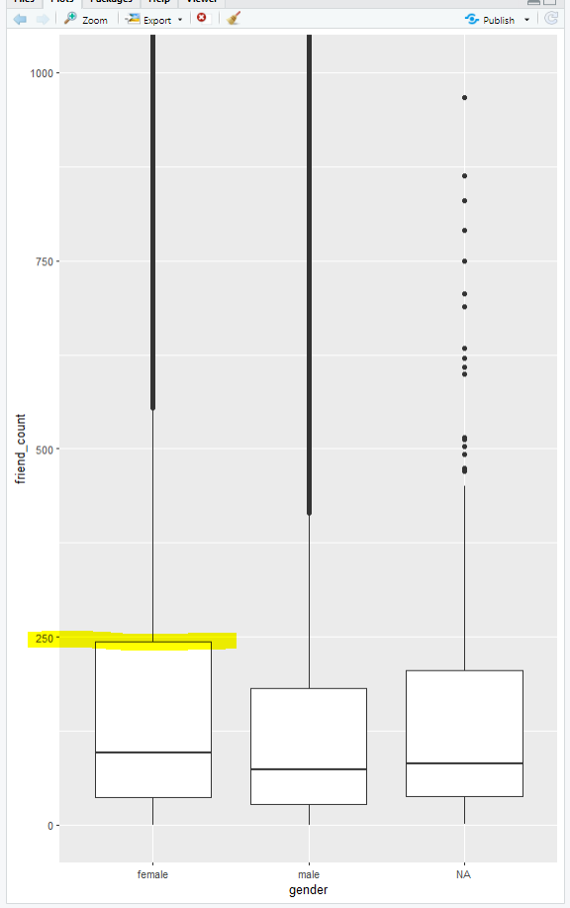

Box Plots, Quartiles, and Friendships
By getting the limit closer to the upper quartile (250) we get a better understanding of the median, etc.
qplot(x = gender, y = friend_count,
data = subset(pseudo_facebook, !is.na(gender)),
geom = 'boxplot') +
coord_cartesian(ylim = c(0, 250))
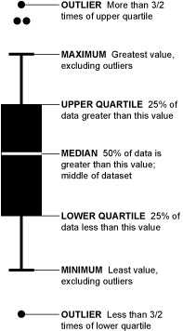
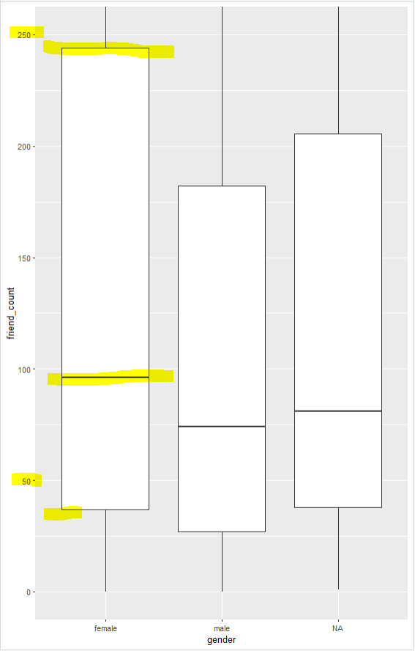

To get min and max values for both genders, as well as the core tiles:
by(pseudo_facebook$friend_count, pseudo_facebook$gender, summary)
pseudo_facebook$gender: female
Min. 1st Qu. Median Mean 3rd Qu. Max.
0 37 96 242 244 4923
------------------------------------------------------------------
pseudo_facebook$gender: male
Min. 1st Qu. Median Mean 3rd Qu. Max.
0 27 74 165 182 4917
------------------------------------------------------------------
pseudo_facebook$gender: NA
Min. 1st Qu. Median Mean 3rd Qu. Max.
1.0 38.0 81.0 184.4 205.5 2548.0

On average, who initiated more friendships in our sample?
Men or women
To get the name of the variables:
names(pseudo_facebook)
> names(pseudo_facebook)
[1] "userid" "age" "dob_day"
[4] "dob_year" "dob_month" "gender"
[7] "tenure" "friend_count" "friendships_initiated"
[10] "likes" "likes_received" "mobile_likes"
[13] "mobile_likes_received" "www_likes" "www_likes_received"

by(pseudo_facebook$friendships_initiated, pseudo_facebook$gender, summary)
for visualization:
qplot(x = gender, y = friendships_initiated,
data = subset(pseudo_facebook, !is.na(gender)),
geom = 'boxplot') +
coord_cartesian(ylim = c(0, 150))

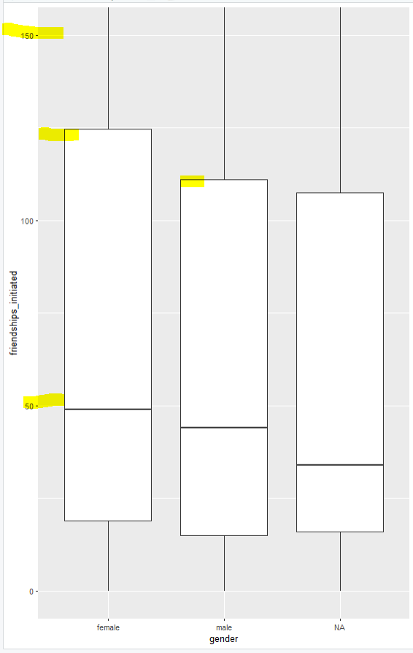
pseudo_facebook$gender: female
Min. 1st Qu. Median Mean 3rd Qu. Max.
0.0 19.0 49.0 113.9 124.8 3654.0
------------------------------------------------------------------
pseudo_facebook$gender: male
Min. 1st Qu. Median Mean 3rd Qu. Max.
0.0 15.0 44.0 103.1 111.0 4144.0
------------------------------------------------------------------
pseudo_facebook$gender: NA
Min. 1st Qu. Median Mean 3rd Qu. Max.
0.00 16.00 34.00 92.57 107.50 1130.00

Getting Logical
At 1:05, line 521 of code should read pf$mobile_check_in <- NA. This creates a new variable in the data frame with NA values.
Do not include the % symbol when entering the answer.
The sum() function will not work since mobile_check_in is a factor variable. You can use the length() function to determine the number of values in a vector.
We could have also made mobile_check_in to hold boolean values. The sum()function will work on booleans (true is 1, false is 0).

Creating the mobile_check_in variable
summary(pseudo_facebook$mobile_likes)

summary(pseudo_facebook$mobile_likes > 0)

mobile_check_in <- NA
pseudo_facebook$mobile_check_in <- ifelse(pseudo_facebook$mobile_likes > 0, 1, 0)
pseudo_facebook$mobile_check_in <- factor(pseudo_facebook$mobile_check_in)
summary(pseudo_facebook$mobile_check_in)

Percentage of users using mobile check in:

> summary(pseudo_facebook$mobile_check_in)
0 1
35056 63947
> sum(pseudo_facebook$mobile_check_in == 1)/length(pseudo_facebook$mobile_check_in)
[1] 0.6459097

Lesson 4

Diamonds

As a reminder, you can use these commands to load the diamonds data set.
library(ggplot2) #must load the ggplot package first
data(diamonds) #loads the diamonds data set since it comes with the ggplot package
You need to run these command each time you launch RStudio to access the diamonds data set. RStudio won't remember which packages and data sets you loaded unless you change your preferences or save your workspace.
You should notice that the diamonds data set will be listed as a 'Promise' in the workspace. This is a special object in R, and you need to run a command on the data to fully load the data set. Try running a summary:
summary(diamonds)
There are other data sets that come with R. You can load these data sets by typing the command data(DATA_SET_NAME).
You can learn more about the diamonds data set by typing ?diamonds.
Read the help file to determine the best color for the diamonds data set. When you run diamonds$color, you will notice that the levels of color are set as D < E < F < ...
This does not indicate that D is the worst color but rather an ordering to the colors.

qplot(x = price, data = diamonds)
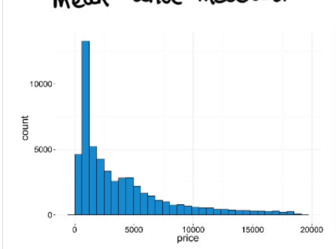
> subset(diamonds, price > 15000 | price == 15000)
# A tibble: 1,656 x 10
carat cut color clarity depth table price x y z
<dbl> <ord> <ord> <ord> <dbl> <dbl> <int> <dbl> <dbl> <dbl>
1 1.6 Ideal G VS2 61.9 56 15000 7.53 7.47 4.64
2 1.54 Premium E VS2 62.3 58 15002 7.31 7.39 4.58
3 1.19 Ideal F VVS1 61.5 55 15005 6.82 6.84 4.2
4 2.1 Premium I SI1 61.5 57 15007 8.25 8.21 5.06
5 1.69 Ideal D SI1 60.8 57 15011 7.69 7.71 4.68
6 1.5 Very Good G VVS2 62.9 56 15013 7.22 7.32 4.57
7 1.73 Very Good G VS1 62.8 57 15014 7.57 7.72 4.8
8 2.02 Premium G SI2 63 59 15014 8.05 7.95 5.03
9 2.05 Very Good F SI2 61.9 56 15017 8.13 8.18 5.05
10 1.5 Very Good F VS1 61.6 58 15022 7.35 7.43 4.55
# ... with 1,646 more rows

To save the plot:
qplot(x = price, data = diamonds, binwidth = 5000)
ggsave('priceHistogram.png')
Better plot
qplot(x = price, data = diamonds, color = I('black'), fill = I('#099DD9'), binwidth = 50) +
scale_x_continuous(limits= c(0,2400), breaks=seq(0,2400,200))

There are no diamonds that cost $1500.
For diamonds that cost less than $2,000, the most common price of a diamond is around $700 with the mode being $605 (binwidth = 1).
# Break out the histogram of diamond prices by cut.
# You should have five histograms in separate
# panels on your resulting plot.

Scales and Multiple Histograms

# In the two last exercises, we looked at
# the distribution for diamonds by cut.

# Run the code below in R Studio to generate
# the histogram as a reminder.
# ===============================================================
qplot(x = price, data = diamonds) + facet_wrap(~cut)

Better pLot
qplot(x =price, data = diamonds, color = I('black'), fill = I('#099DD9'), binwidth = 500) +
facet_wrap(~cut)

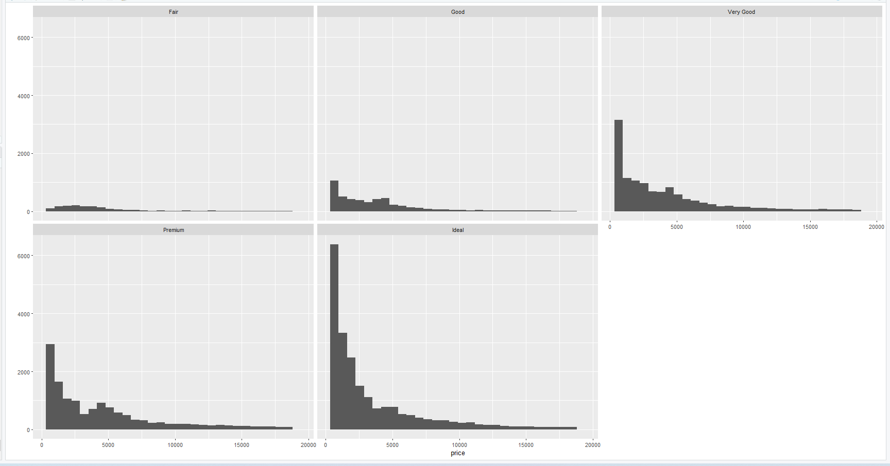
==============================================================
# In the last exercise, we looked at the summary statistics
# for diamond price by cut. If we look at the output table, the
# the median and quartiles are reasonably close to each other.

by(diamonds$price, diamonds$cut, summary)
by(diamonds$price,diamonds$cut,summary, digits = max(getOption('digits')))
qplot(x =price, data = diamonds, color = I('black'), fill = I('#099DD9'), binwidth = 600) +
facet_wrap(~cut, scales="free_y")

# diamonds$cut: Fair
# Min. 1st Qu. Median Mean 3rd Qu. Max.
# 337 2050 3282 4359 5206 18570
# ------------------------------------------------------------------------
# diamonds$cut: Good
# Min. 1st Qu. Median Mean 3rd Qu. Max.
# 327 1145 3050 3929 5028 18790
# ------------------------------------------------------------------------
# diamonds$cut: Very Good
# Min. 1st Qu. Median Mean 3rd Qu. Max.
# 336 912 2648 3982 5373 18820
# ------------------------------------------------------------------------
# diamonds$cut: Premium
# Min. 1st Qu. Median Mean 3rd Qu. Max.
# 326 1046 3185 4584 6296 18820
# ------------------------------------------------------------------------
# diamonds$cut: Ideal
# Min. 1st Qu. Median Mean 3rd Qu. Max.
# 326 878 1810 3458 4678 18810

# This means the distributions should be somewhat similar,
# but the histograms we created don't show that.

# The 'Fair' and 'Good' diamonds appear to have
# different distributions compared to the better
# cut diamonds. They seem somewhat uniform
# on the left with long tails on the right.

# Let's look in to this more.

# Look up the documentation for facet_wrap in R Studio.
# Then, scroll back up and add a parameter to facet_wrap so that
# the y-axis in the histograms is not fixed. You want the y-axis to
# be different for each histogram.

Hint: Read about free scales .

Price per Carat by Cut

# Create a histogram of price per carat
# and facet it by cut. You can make adjustments
# to the code from the previous exercise to get
# started.

qplot(x = price/carat, data = diamonds) + facet_wrap(~cut)+
scale_x_log10()

Better version
qplot(x =price/carat, data = diamonds, color = I('black'), fill = I('#099DD9'), binwidth = 600) +
facet_wrap(~cut, scales="free_y")

# Adjust the bin width and transform the scale
# of the x-axis using log10.

Did you find normal-ish distributions and a slightly bimodal distribution for Very Good cuts? (If the Very Good facet looks smooth, try decreasing your bin width! If the data looks skewed, did you remember to perform a log10 transform?)

Price Box Plots

https://rpubs.com/oneryalcin/udacityPS3

# Investigate the price of diamonds using box plots,
# numerical summaries, and one of the following categorical
# variables: cut, clarity, or color.

# There won’t be a solution video for this
# exercise so go to the discussion thread for either
# BOXPLOTS BY CLARITY, BOXPLOT BY COLOR, or BOXPLOTS BY CUT
# to share you thoughts and to
# see what other people found.

# You can save images by using the ggsave() command.
# ggsave() will save the last plot created.
# For example...
# qplot(x = price, data = diamonds)
# ggsave('priceHistogram.png')

# ggsave currently recognises the extensions eps/ps, tex (pictex),
# pdf, jpeg, tiff, png, bmp, svg and wmf (windows only).

# Copy and paste all of the code that you used for
# your investigation, and submit it when you are ready.

ANSWERS
by(diamonds$price,diamonds$clarity,summary, digits = max(getOption('digits')))

qplot(x = clarity, y = price,
data = subset(diamonds),
geom = 'boxplot') +
coord_cartesian(ylim = c(0, 8000))

Or Without subset:

qplot(x = clarity, y = price, data = diamonds, geom = "boxplot") +
coord_cartesian(ylim = c(0,7000))

qplot(x = color, y = price, data = diamonds, geom = "boxplot") +
coord_cartesian(ylim = c(0,8000))

qplot(x = cut, y = price, data = diamonds, geom = "boxplot") +
coord_cartesian(ylim = c(0,7000))

IQR = Q3 – Q1
by(diamonds$price,diamonds$color,summary)

Q11) Price per Carat Box Plots by Color
# Investigate the price per carat of diamonds across
# the different colors of diamonds using boxplots.
qplot(x = color, y = price/carat, data = diamonds, geom = "boxplot")

You can use the function IQR() to find the interquartile range. Pass it a subset of the diamonds data frame.
For example:
IQR(subset(diamonds, price <1000)$price)
Remember that subset() returns a data frame so we need to use $price on the end to access that variable.

Price per Carat Box Plots by Color

# Investigate the price per carat of diamonds across
# the different colors of diamonds using boxplots.

qplot(x = color, y = price/carat, data = diamonds, geom = "boxplot")

# You can save images by using the ggsave() command.
# ggsave() will save the last plot created.
# For example...
# qplot(x = price, data = diamonds)
# ggsave('priceHistogram.png')

qplot(x = color, y = price/carat, data = diamonds, geom = "boxplot")
ggsave('Price_CaratBoxplot.png'

Note :The boxplot above and below shows that best color D has lots of outliers and outliers tend to decrease when we go to worse colors the IQR for all colors tend to be pretty similar with close median values.

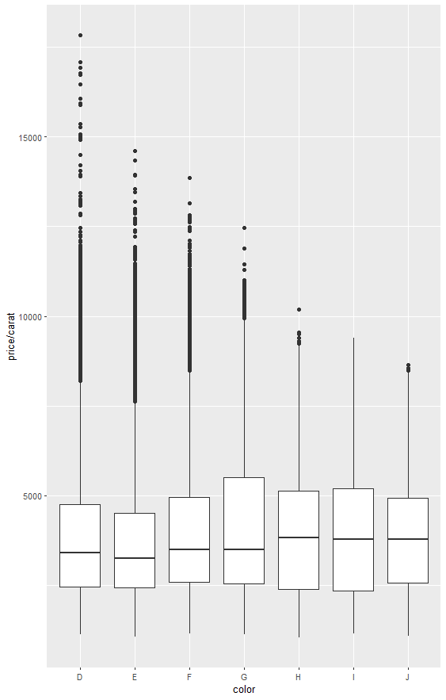

Better
qplot(x = color, y = price/carat, data = diamonds, geom = "boxplot") +
coord_cartesian(ylim = c(0,6000))

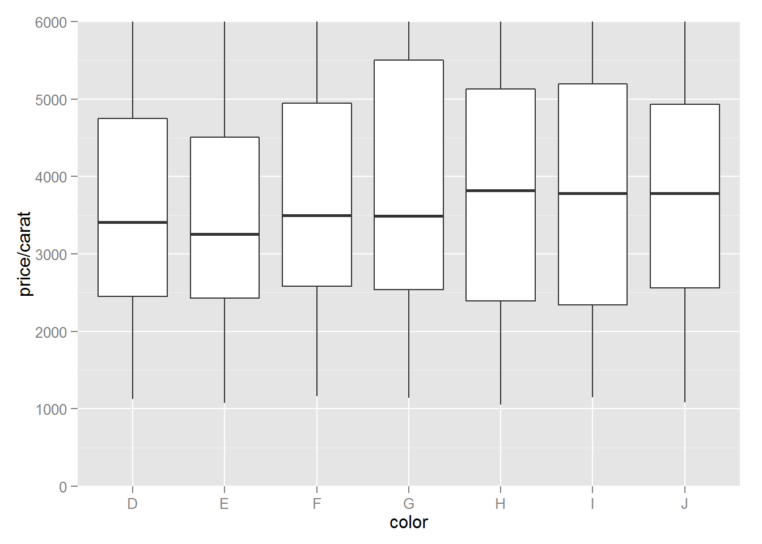

Q12 Carat Frequency Polygon
Investigate the weight of diamonds (carat) using a freq polygon. Use different binwidths to see how teh freq polygon changes. What carat size has a count greater than 2000?
qplot(x = carat,
data = diamonds,
binwidth =0.01,
geom = 'freqpoly') +
scale_x_continuous(lim = c(0,5), breaks = seq(0,5,0.3))
## Warning: Removed 2 rows containing missing values (geom_path).
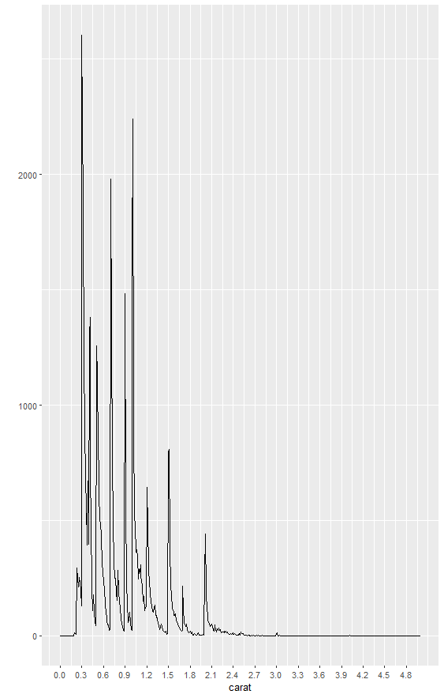
To count and summarize data:
library(plyr)
count(diamonds, 'carat')
The carat size that has a count greater than 2000 is 0.3 and 1.01
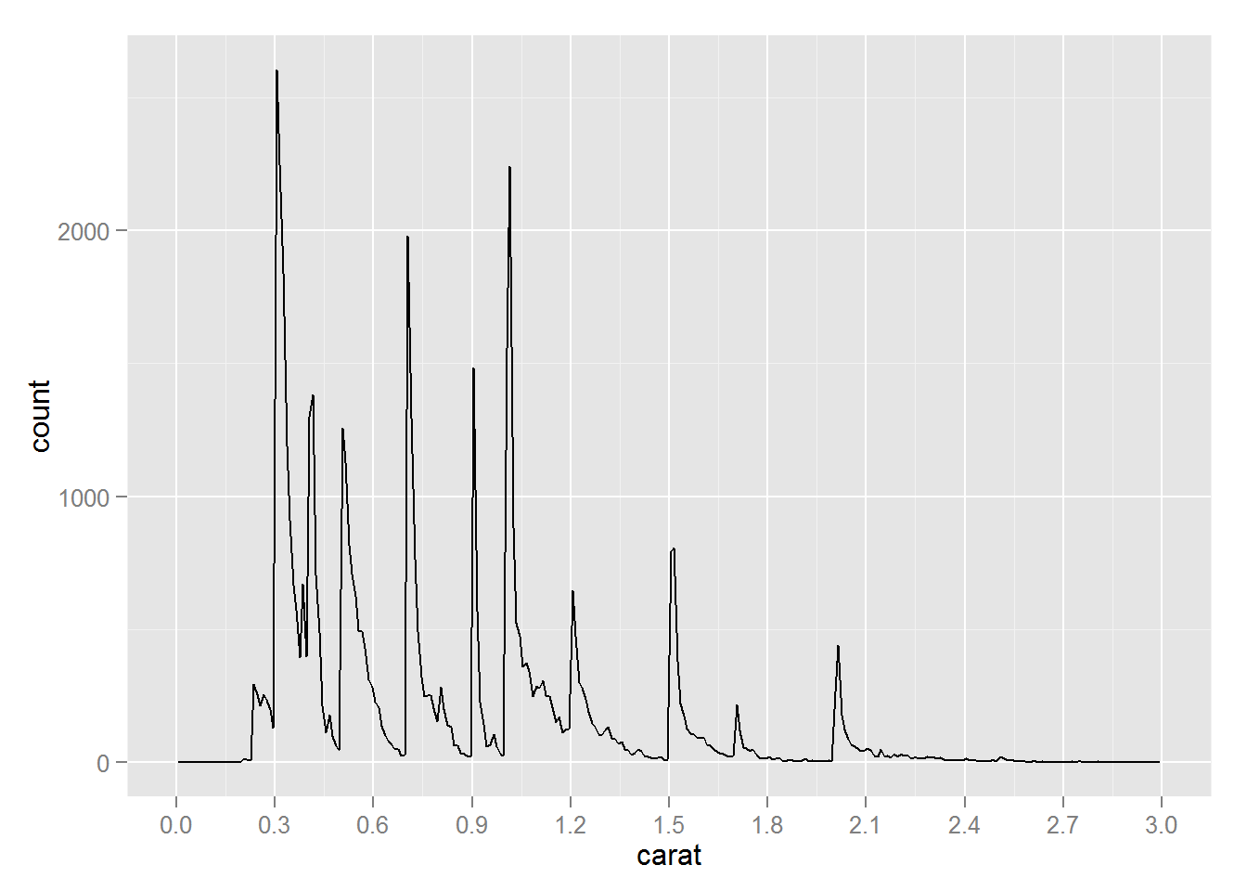

Data Wrangling with R
Data munging or data wrangling can take up much of a data scientist's or data analyst's time. There are two R packages that make these tasks easier in R: tidyr and dplyr.
tidyr -a package that reshapes the layout of your data
dplyr - a package that helps you transform tidy, tabular data
Review Data Wrangling in R to get a sense of how these packages allow you to manipulate data. You can use these packages to help you in the next programming task and in your future investigations.
There are some useful cheat sheets on RStudio's webpage. The Data Import and Data Transformation cheat sheets available at that site will be especially good references for working with tidyr and dplyr, respectively.

Gapminder Data

# The Gapminder website contains over 500 data sets with information about
# the world's population. Your task is to download a data set of your choice
# and create 2-5 plots that make use of the techniques from Lesson 3.

# You might use a simple histogram, a boxplot split over a categorical variable,
# or a frequency polygon. The choice is yours!

# You can find a link to the Gapminder website in the Instructor Notes.

# Once you've completed your investigation, create a post in the discussions that includes:
# 1. any questions you answered, your observations, and summary statistics
# 2. snippets of code that created the plots
# 3. links to the images of your plots

maria@DESKTOP-JE8E5E3 MINGW64 ~/Documents/All about R (master)
$ ls
R/ 'R Notes.DOCX' RScripts/ R_gapminder/ reddit.csv

maria@DESKTOP-JE8E5E3 MINGW64 ~/Documents/All about R (master)
$ cd R_gapminder/

maria@DESKTOP-JE8E5E3 MINGW64 ~/Documents/All about R/R_gapminder (master)
$ ls
01_make-gapminder-color-scheme.r gapminder-country-colors.png gapminder-ggplot2-shock-and-awe.md gapminder-ggplot2-univariate-quantitative.md
02-merge-color-into-data.r gapminder-country-colors.tsv gapminder-ggplot2-shock-and-awe.r gapminder-ggplot2-univariate-quantitative.r
LICENSE gapminder-gganimate.gif gapminder-ggplot2-stripplot.md gapminderDataColorReadySorted.tsv
README.md gapminder-gganimate.rmd gapminder-ggplot2-stripplot.r gapminderDataFiveYear.tsv
figure/ gapminder-ggplot2-colors.md gapminder-ggplot2-themes.md ggplot2-tutorial-slides/
from_yair_goldberg/ gapminder-ggplot2-colors.r gapminder-ggplot2-themes.r
gapminder-continent-colors.tsv gapminder-ggplot2-scatterplot.md gapminder-ggplot2-univariate-factor.md
gapminder-country-colors.pdf gapminder-ggplot2-scatterplot.r gapminder-ggplot2-univariate-factor.r

maria@DESKTOP-JE8E5E3 MINGW64 ~/Documents/All about R/R_gapminder (master)
$ ls
01_make-gapminder-color-scheme.r gapminder-country-colors.png gapminder-ggplot2-shock-and-awe.md gapminder-ggplot2-univariate-quantitative.md
02-merge-color-into-data.r gapminder-country-colors.tsv gapminder-ggplot2-shock-and-awe.r gapminder-ggplot2-univariate-quantitative.r
LICENSE gapminder-gganimate.gif gapminder-ggplot2-stripplot.md gapminderDataColorReadySorted.tsv
README.md gapminder-gganimate.rmd gapminder-ggplot2-stripplot.r gapminderDataFiveYear.tsv
figure/ gapminder-ggplot2-colors.md gapminder-ggplot2-themes.md ggplot2-tutorial-slides/
from_yair_goldberg/ gapminder-ggplot2-colors.r gapminder-ggplot2-themes.r
gapminder-continent-colors.tsv gapminder-ggplot2-scatterplot.md gapminder-ggplot2-univariate-factor.md
gapminder-country-colors.pdf gapminder-ggplot2-scatterplot.r gapminder-ggplot2-univariate-factor.r

maria@DESKTOP-JE8E5E3 MINGW64 ~/Documents/All about R/R_gapminder (master)
$ cd ..

maria@DESKTOP-JE8E5E3 MINGW64 ~/Documents/All about R (master)
$ ls
R/ 'R Notes.DOCX' RScripts/ R_gapminder/ reddit.csv

maria@DESKTOP-JE8E5E3 MINGW64 ~/Documents/All about R (master)
$ cd RScripts/

maria@DESKTOP-JE8E5E3 MINGW64 ~/Documents/All about R/RScripts (master)
$ ls
'Lessons Code Summary.R' gapminderDataFiveYear.tsv

maria@DESKTOP-JE8E5E3 MINGW64 ~/Documents/All about R/RScripts (master)

GGPLOT
# Setup
options(scipen=999) # turn off scientific notation like 1e+06
library(ggplot2)
data("midwest", package = "ggplot2") # load the data
# midwest <- read.csv("http://goo.gl/G1K41K") # alt source

# Init Ggplot
ggplot(midwest, aes(x=area, y=poptotal)) # area and poptotal are columns in 'midwest'

library(ggplot2)
g <- ggplot(midwest, aes(x=area, y=poptotal)) + geom_point() + geom_smooth(method="lm") # set se=FALSE to turnoff confidence bands
plot(g)

library(ggplot2)
g <- ggplot(midwest, aes(x=area, y=poptotal)) + geom_point() + geom_smooth(method="lm") # set se=FALSE to turnoff confidence bands

# Delete the points outside the limits
g + xlim(c(0, 0.1)) + ylim(c(0, 1000000)) # deletes points
# g + xlim(0, 0.1) + ylim(0, 1000000) # deletes points

library(ggplot2)
gg <- ggplot(midwest, aes(x=area, y=poptotal)) +
geom_point(aes(col=state), size=3) + # Set color to vary based on state categories.
geom_smooth(method="lm", col="firebrick", size=2) +
coord_cartesian(xlim=c(0, 0.1), ylim=c(0, 1000000)) +
labs(title="Area Vs Population", subtitle="From midwest dataset", y="Population", x="Area", caption="Midwest Demographics")
plot(gg)

library(ggplot2)
get()
list.files()

gg + scale_colour_brewer(palette = "Set1") # change color palette

gg <- ggplot(midwest, aes(x=area, y=poptotal)) +
geom_point(aes(col=state), size=3) + # Set color to vary based on state categories.
geom_smooth(method="lm", col="firebrick", size=2) +
coord_cartesian(xlim=c(0, 0.1), ylim=c(0, 1000000)) +
labs(title="Area Vs Population", subtitle="From midwest dataset", y="Population", x="Area", caption="Midwest Demographics")

library(ggplot2)
fb = read.csv('./pseudo_facebook.tsv', sep='\t')
head(fb)

ggplot(aes(x=age, y=friend_count), data=fb) +
geom_jitter(alpha = 1/20) + xlim(13, 90)

library(ggplot2)
ggplot(midwest, aes(x=area, y=poptotal)) + geom_point()

