Git installing

My System information:

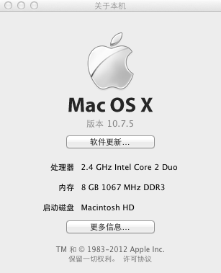

1. Install home brew:



ruby -e "$(curl -fsSL https://raw.github.com/Homebrew/homebrew/go/install)"

I found this command was not easily.

(Maybe you need to type the pass and some keyboard to accomplished the installing).

brew doctor

1. Install Git

brew install git

After these commands had been executed, restart the terminal.

Then test the Git is it had been installed successfully.

Type “git --version” in the terminal and ‘return key’.



If anything is OK, you will get the version of the git, which you ware installed.

But the version number maybe not the same as mine.

Now, It is end of installing of git.