***Setting and Initial***

***Setting***

• /etc/gitconfig file: Contains values for every user on the system and all their repositories. If you pass the option--system to git config, it reads and writes from this file specifically.

• /.gitconfig file: Specific to your user. You can make Git read and write to this file specifically by passing the --global option.

• config file in the git directory (that is, .git/config) of whatever repository you’re currently using: Specific to that single repository. Each level overrides values in the previous level, so values in .git/config trump those in /etc/gitconfig.

Below is setting only for my user (when logon the system that the system support many users, using the name and password, such as a user name “mqx”). If you want to setting for all the users, using “--system” instead of “--global”.

git config --global user.name "MaoQiuxiang.dms"

git config --global user.email maoqiuxiang@dmsecg.com

Setting the Text color is true is the good idea (like the IDE, if all colors are black, what do you feel?).

Git config –global color.ui=true

And more and more items you can set to, such as color.diff, color.branch …

Using “git config --list” to list the configuration that you setting or default.

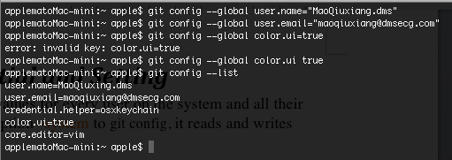

***Initial***

1. Go to a specify directory and type “git init”, this will create a new subdirectory named “.git” that contains all of your necessary repository files – a Git repository skeleton.
2. And you can using “git init [path]folder_name” to create a Git repository in the specify path and folder. This will create the “.git” repository in the folder too.
3. Use “git clone source_url” you can create a git repository too. This will clone the source_url’s git_repo for the git repository in current directory for you. Of cause you can specify the destination directory (git clone source_url dest_dir).

Now, I create a git repository for the document.

All of “applematoMac-mini:~ apple$” didn’t typed by me.

applematoMac-mini:~ apple$ cd /Users/apple/Documents/mygit

applematoMac-mini:mygit apple$ git init

Initialized empty Git repository in /Users/apple/Documents/mygit/.git/

applematoMac-mini:mygit apple$

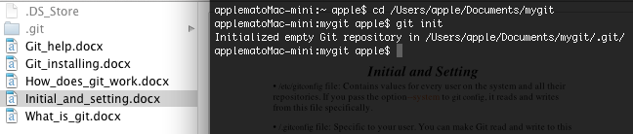

And now you can see the “.git” folder in the specify directory, by default this folder is hidden.