

Global Warming
T
Submitted by : Ashish kumar sah

Under the guidance of
Prof. Neha Khare

Department of Civil Engineering

October 2024
DEPARTMENT OF CIVIL ENGINEERING SAGAR INSTITUTE OF RESEARCH & TECHNOLOGY EXCELLENCE, BHOPAL (AFFILIATED TO RAJIV GANDHI PROUDYOGIKI VISHWAVIDYALAYA) Bhopal (M.P) - 462041

Global Warming
"We are the first generation to feel the impact of climate change and the last generation that can do something about it."
Global Warming refers to the long-term increase in Earth's average surface temperature due to the accumulation of greenhouse gases (GHGs) in the atmosphere. These gases, such as carbon dioxide (CO₂), methane (CH₄), and nitrous oxide (N₂O), trap heat from the sun and prevent it from escaping back into space, leading to a "greenhouse effect."

Human activity affects global surface temperatures by changing Earth’s radiative balance—the “give and take” between what comes in during the day and what Earth emits at night. Increases in greenhouse gases—i.e., trace gases such as carbon dioxide and methane that absorb heat energy emitted from Earth’s surface and reradiate it back—generated by industry and transportation cause the atmosphere to retain more heat, which increases temperatures and alters precipitation patterns..

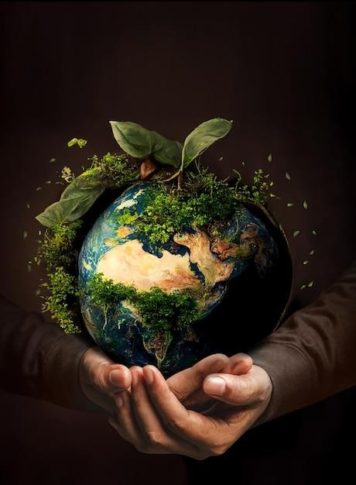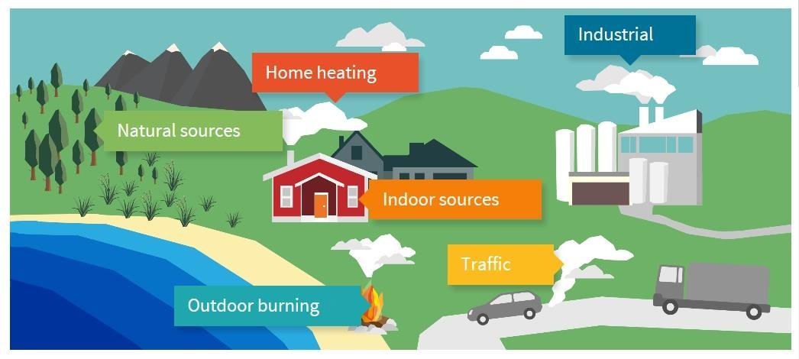

Causes & Effects

Causes: Global warming is primarily driven by human activities that increase the concentration of greenhouse gases in the atmosphere. These gases trap heat from the sun, leading to a gradual rise in the Earth's average temperature.

Effect: The effects of global warming are far-reaching and affect every aspect of life on Earth. As temperatures rise, the planet's climate system is disrupted, leading to a variety of environmental, social, and economic consequences

Causes | Effect
1. Burning of Fossil Fuels | 1. Rising Global Temperatures
2. Deforestation | 2. Extreme Weather Events
3. Agriculture and Livestock | 3. Rising Sea Levels
4. Industrial Processes | 4. Melting Polar Ice and Glaciers
5. Waste Management and Landfills | 5. Impact on Ecosystems and Biodiversity
6. Use of Fluorinated Gases | 6. Human Health Impacts

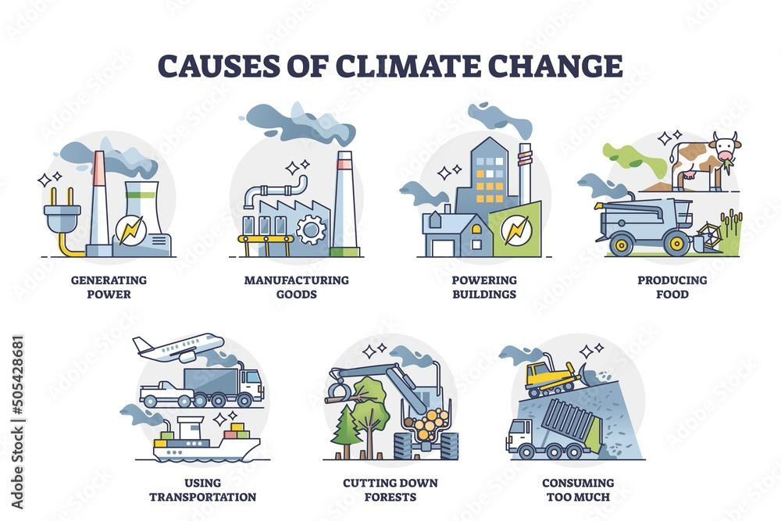

Causes

Burning of Fossil Fuels
The largest contributor to global warming is the combustion of fossil fuels—coal, oil, and natural gas—for energy production, transportation, and industrial activities. When burned, fossil fuels release large amounts of carbon dioxide (CO₂), the most significant greenhouse gas.

Deforestation
Trees play a critical role in absorbing CO₂ from the atmosphere through photosynthesis. However, deforestation—especially in tropical regions—leads to a significant loss of this natural carbon sink. The cleared trees are often burned or left to decompose, releasing stored CO₂ back into the atmosphere. Deforestation is mainly driven by agriculture, logging, and urban expansion.

Agriculture and Livestock
Agriculture contributes to global warming through several processes:
- Methane emissions: Livestock, such as cattle, produce methane (CH₄), a potent greenhouse gas, during digestion. Methane has over 25 times the heat-trapping capacity of CO₂.
- Fertilizer use: The application of nitrogen-based fertilizers releases
nitrous oxide (N₂O), another powerful greenhouse gas.

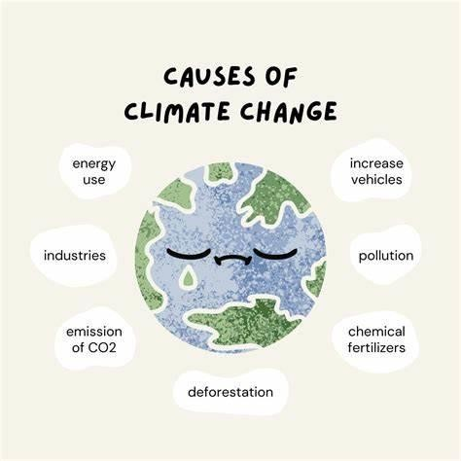

Causes

Industrial Processes
Industries, particularly cement, steel, and chemical production, emit large amounts of CO₂ and other gases during their processes. The manufacturing of cement alone is responsible for about 8% of global CO₂ emissions due to the energy-intensive nature of the process and the chemical reactions involved.

Waste Management and Landfills
Organic waste in landfills decomposes anaerobically, releasing methane into the atmosphere. Inadequate waste management systems exacerbate this problem. Additionally, wastewater treatment plants and improperly disposed solid waste can also emit significant quantities of methane

Use of Fluorinated Gases
Certain industrial products like refrigerators, air conditioners, and aerosol sprays contain fluorinated gases (e.g., hydrofluorocarbons or HFCs). These gases, though emitted in smaller amounts, have a high global warming potential, trapping more heat than CO₂ on a per molecule basis

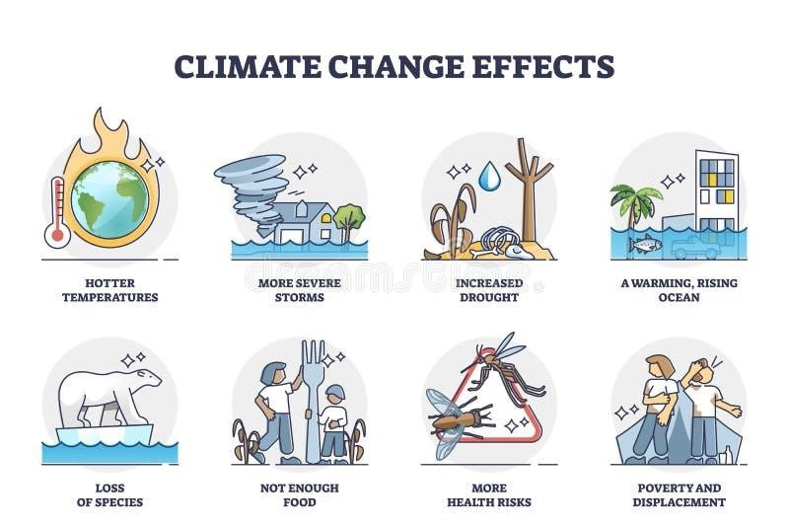Effects

Rising Global Temperatures:
The average global temperature has already increased by more than 1°C since pre-industrial times, with many regions experiencing even higher temperature anomalies. This warming trend:
- Causes more frequent and severe heatwaves, Leads to longer and
hotter summers.

Extreme Weather Events:
Global warming intensifies the frequency, duration, and severity of extreme weather events:
- Heatwaves: Increased global temperatures result in more frequent and intense heatwaves, affecting human health, agriculture, and water supplies.
- Droughts: Prolonged droughts are becoming more common in various regions, leading to water shortages, crop failures, and wildfires.

Rising Sea Levels:
Global sea levels have risen by about 8 inches (20 cm) since 1880, with the rate of rise accelerating in recent decades. This rise is due to:
- Melting glaciers and ice sheets.
- Thermal expansion of seawater as it warms. Rising sea levels lead to:
- Coastal erosion and flooding.
- Saltwater intrusion into freshwater supplies.

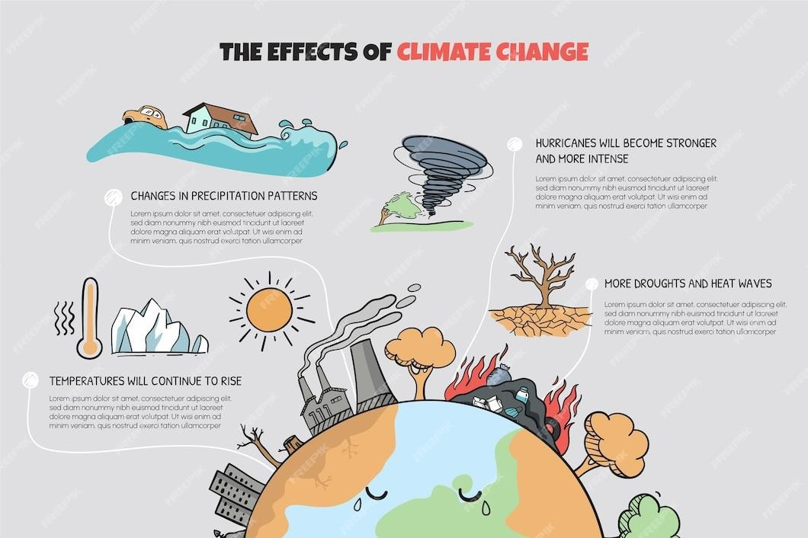

Effect

Melting Polar Ice and Glaciers
Global warming is accelerating the melting of ice in polar regions and glaciers worldwide. The Arctic is particularly vulnerable, with sea ice coverage diminishing rapidly. Effects include:
- Sea-level rise: Melting ice sheets in Greenland and Antarctica contribute to rising sea levels, threatening coastal cities and small island nations.
- Habitat loss: Wildlife species like polar bears and penguins are losing their habitats due to the shrinking ice cover.

Impact on Ecosystems and Biodiversity
As temperatures rise, many ecosystems are undergoing significant changes:
- Species migration: Animals and plants are shifting their ranges toward the poles or higher altitudes to find suitable habitats. This disrupts existing ecosystems and leads to increased competition for resources.
- Extinction risks: Many species, particularly those adapted to specific climates, are at risk of extinction if they cannot adapt quickly enough to changing conditions.

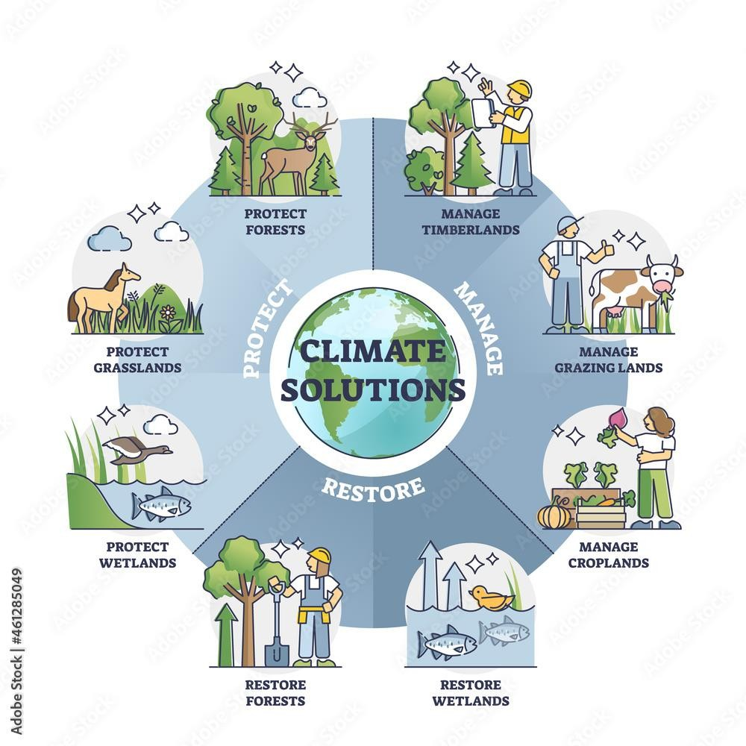

Mitigation Effort

- Reducing Emissions: Shifting to renewable energy sources like solar and wind, and improving energy efficiency, can reduce CO₂ levels.

- Reforestation: Planting trees and preserving forests help absorb
CO₂ from the atmosphere

- Sustainable Practices: Reducing waste, promoting public transportation, and adopting eco-friendly farming can help mitigate the effects of global warming.

- Global Agreements: International efforts like the Paris Agreement aim to limit global temperature rise to below 2°C to avoid the worst impacts of climate change.

Without urgent action, global warming could lead to irreversible damage to ecosystems, economies, and human societies.

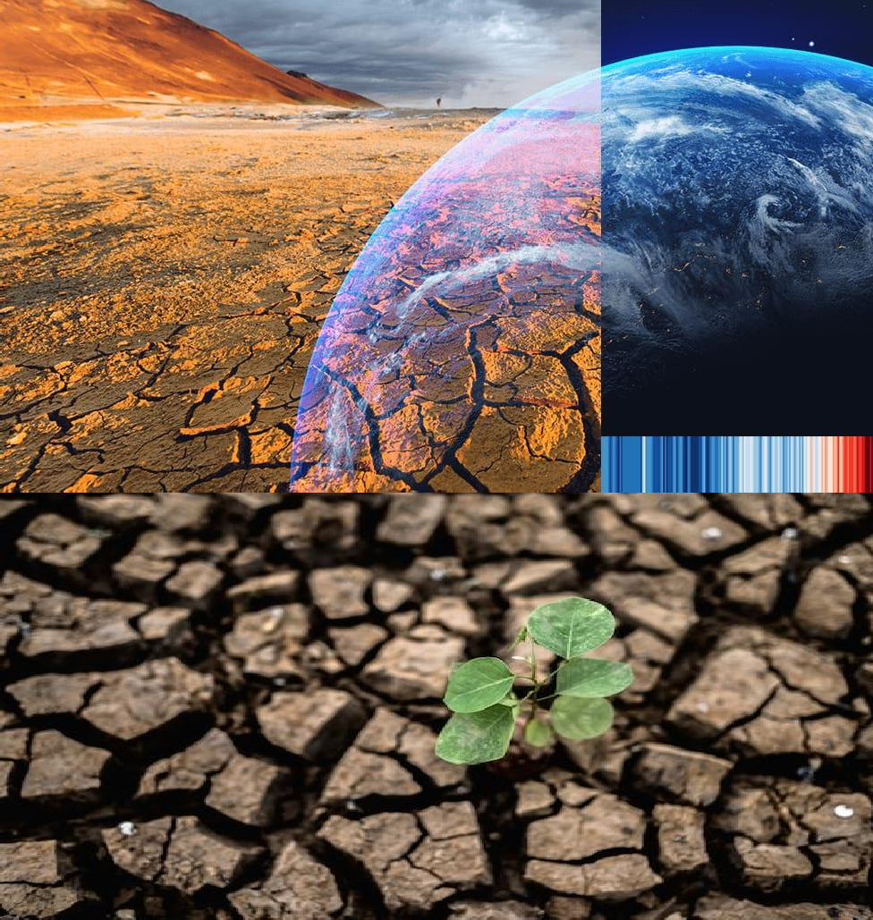Forces Driving Global Warming

Greenhouse Gases (GHGs):
The main force behind global warming is the accumulation of greenhouse gases in the atmosphere, which include:
  - Carbon Dioxide (CO₂): Produced primarily from burning fossil fuels (coal,
oil, natural gas) and deforestation.
  - Methane (CH₄): Emitted from livestock, rice paddies, landfills, and natural gas leaks.
  - Nitrous Oxide (N₂O): Released from fertilizers and industrial processes.

Solar Radiation:
Incoming solar radiation is the energy from the sun that reaches the Earth's surface. While a portion is reflected back into space, most of it is absorbed, warming the planet. The imbalance caused by trapped heat (due to GHGs) is what leads to a gradual rise in global temperatures.

Deforestation:
Trees absorb CO₂ from the atmosphere, helping regulate the carbon cycle. When forests are cut down or burned (deforestation), this natural "carbon sink" is lost, and more CO₂ remains in the atmosphere, enhancing global warming. Additionally, deforestation often involves burning trees, which releases more CO₂.

Forces Driving Global Warming

Industrial Activities:
Industrial processes, particularly those related to the production of cement, steel, and chemicals, release large amounts of CO₂ and other gases into the atmosphere. These industrial emissions are key drivers of global warming

Ocean Currents:
The oceans play a crucial role in regulating the Earth’s climate by absorbing excess heat and CO₂ from the atmosphere. However, warming oceans alter ocean currents, which can affect weather patterns and lead to phenomena like stronger hurricanes and shifts in rainfall patterns.

Feedback Loops:
Positive feedback mechanisms in nature can amplify the warming process:
  - Ice-Albedo Feedback: As ice and snow melt due to rising temperatures, less sunlight is reflected (since ice is highly reflective), and more heat is absorbed by the Earth's surface, leading to further warming.
  - Permafrost Thawing: As permafrost melts, it releases methane trapped beneath the ice. Methane is a powerful greenhouse gas, which accelerates warming when released into the atmosphere

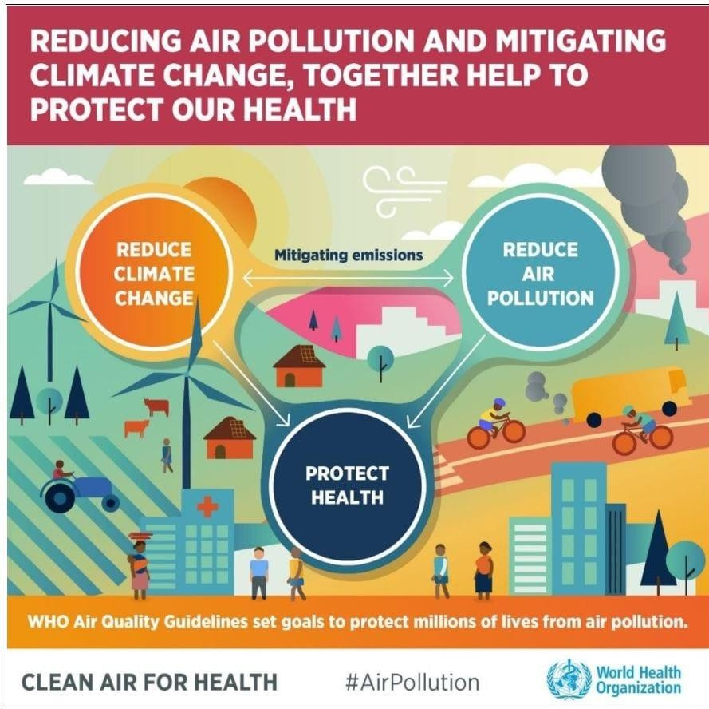Forces Driving Global Warming

Human Consumption and Energy Use
The demand for energy, especially from fossil fuels like coal, oil, and gas, is a primary force behind global warming. Increased industrialization, transportation, and energy consumption in power plants lead to higher CO₂ emissions.

Land Use Changes
Besides deforestation, changes in land use such as urbanization, agricultural expansion, and habitat destruction affect the Earth's carbon cycle and the planet's ability to naturally regulate GHGs. This can worsen the global warming problem by increasing carbon emissions and reducing the Earth’s natural absorptive capacity.

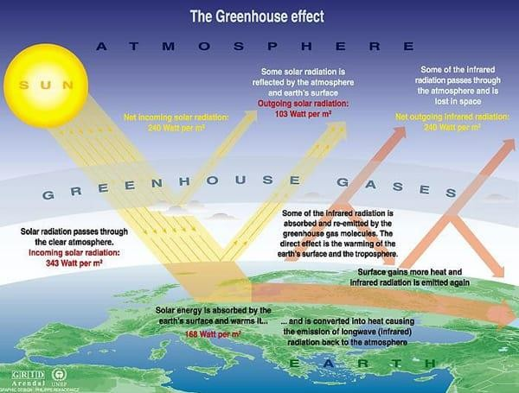
Greenhouse Effect

The atmosphere, such as carbon dioxide and methane, trap heat from the sun and prevent it from escaping back into space. This leads to an increase in the planet's temperature, known as global warming. The greenhouse effect is a significant factor contributing to climate change and its associated impacts on the environment and ecosystems greenhouse effect is a phenomenon where certain gases in Earth’s. The greenhouse effect is a natural process that warms the Earth’s surface. It occurs when certain gases in the Earth's atmosphere trap heat, preventing it from escaping into space and reflecting it back to the Earth's surface. Without this effect, the Earth would be too cold to support most forms of life. However, human activities have intensified this effect, leading to global warming.

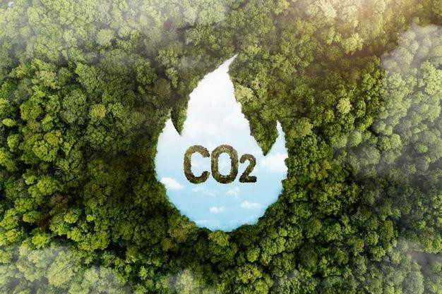
How the Greenhouse Effect Works

Sunlight Reaches Earth:
Solar energy in the form of sunlight passes through the Earth's atmosphere and reaches the surface. About 30% of this energy is reflected back into space by clouds, ice, and reflective surfaces, while about 70% is absorbed by the Earth's surface, warming it.

Earth's Surface Heats Up:

As the Earth absorbs sunlight, it warms up. To balance this, the Earth emits infrared radiation (heat) back toward space Greenhouse Gases.

Trap Heat:
Certain gases in the atmosphere, known as greenhouse gases (GHGs),
trap some of this heat. The major greenhouse gases include:
- Carbon Dioxide (CO₂): Produced from burning fossil fuels and deforestation.
- Methane (CH₄): Emitted from agriculture, landfills, and livestock.
- Nitrous Oxide (N₂O): Released from fertilizers and industrial activities.

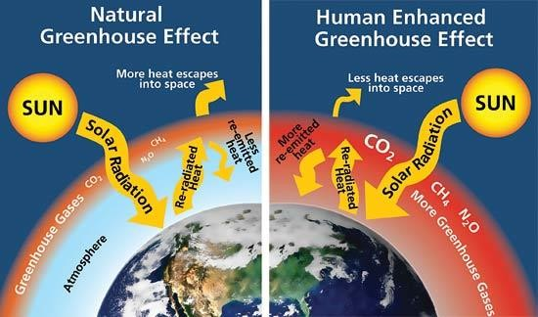Enhanced Greenhouse Effect
The enhanced greenhouse effect refers to the additional warming caused by human activities that increase the concentration of greenhouse gases in the atmosphere. Since the Industrial Revolution, human actions such as burning fossil fuels (coal, oil, gas), deforestation, and large-scale agriculture have significantly increased the levels of greenhouse gases, particularly CO₂, in the atmosphere.
This has intensified the natural greenhouse effect, leading to:

- Global Warming: A steady rise in global average temperatures.

- Climate Change: Changes in weather patterns, including more extreme weather events like heatwaves, storms, droughts, and heavy rainfall.

- Sea-Level Rise: Melting ice caps and glaciers contribute to rising sea
levels.

- Ocean Acidification: Increased CO₂ absorption by oceans leads to
more acidic waters, harming marine ecosystems.

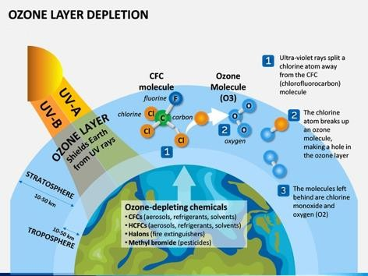
Ozone Depletion

Ozone depletion refers to the thinning and reduction of the ozone layer in Earth's stratosphere. The ozone layer, located about 15-30 kilometers above Earth, plays a critical role in protecting life on the planet by absorbing the majority of the Sun's harmful ultraviolet (UV) radiation. Depletion of this layer allows more UV radiation to reach the Earth's surface, which can have serious environmental and health consequences.

Structure and Function of the Ozone Layer:

  - Ozone (O₃) is a molecule made up of three oxygen atoms. The ozone layer is concentrated in the lower portion of the stratosphere, where it absorbs most of the Sun's ultraviolet (UV-B and UV-C) radiation.
  - This filtering of UV rays is essential because excessive exposure to UV radiation can lead to harmful effects, including skin cancer, cataracts, and damage to crops and marine ecosystems.

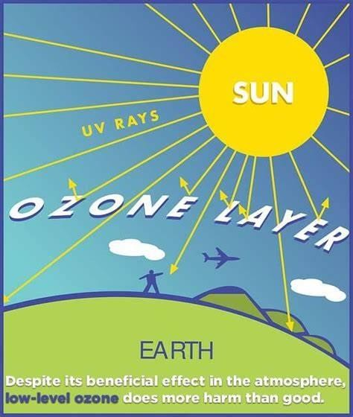The primary cause of ozone depletion is the release of chlorofluorocarbons (CFCs) and other ozone-depleting substances (ODS) into the atmosphere. CFCs were widely used in refrigerants, aerosol sprays, and solvents before their harmful effects were understood. Here's how ozone depletion occurs.
Causes of Ozone Depletion

Release of CFCs and ODS:
CFCs and other ozone-depleting chemicals, such as halons, carbon tetrachloride, and methyl chloroform, are released into the atmosphere. These substances are very stable in the lower atmosphere and can persist for many years.

CFCs Reach the Stratosphere:
Over time, these chemicals drift into the stratosphere, where they are broken down by the Sun's ultraviolet (UV) radiation. This process releases chlorine (Cl) and bromine (Br) atoms.

Breakdown of Ozone Molecules:
The chlorine and bromine atoms released from CFCs react with ozone (O₃) molecules in the stratosphere, breaking them apart into oxygen (O₂) and a single oxygen atom (O). One chlorine atom can destroy thousands of ozone molecules before deactivated, leading to significant depletion.

Ozone Hole Formation:
Ozone depletion is most severe in polar regions, especially over Antarctica, where extreme cold temperatures form polar stratospheric clouds.

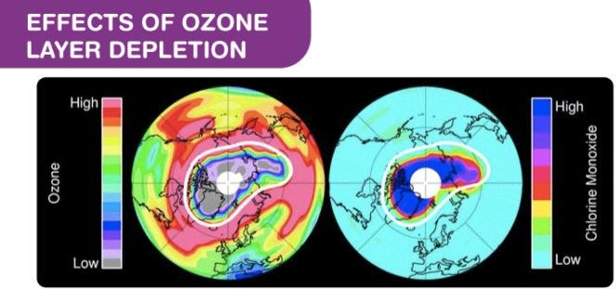
Effect of Ozone Depletion

Increased UV Radiation:
Ozone depletion leads to an increase in the amount of UV-B and UV-C radiation reaching the Earth's surface. Increased exposure to UV radiation can cause:
      - Health Problems: Higher risks of skin cancer (especially melanoma), cataracts, and other eye damage.
      - Immune System Suppression: UV radiation can weaken the human immune system, making individuals more vulnerable to infections and diseases.

Environmental Impact:
.Damage to Ecosystems: Increased UV radiation can harm phytoplankton, the foundation of the marine food chain, which in turn affects fish populations and biodiversity in oceans.

- Impact on Plants: Excessive UV radiation can reduce crop yields by
damaging plant tissues, affecting photosynthesis and growth.

Climate Change Link:
Some ozone-depleting substances, such as CFCs, are also potent greenhouse gases that contribute to global warming. Though ozone depletion and climate change are separate issues, they are interconnected through shared chemical processes.

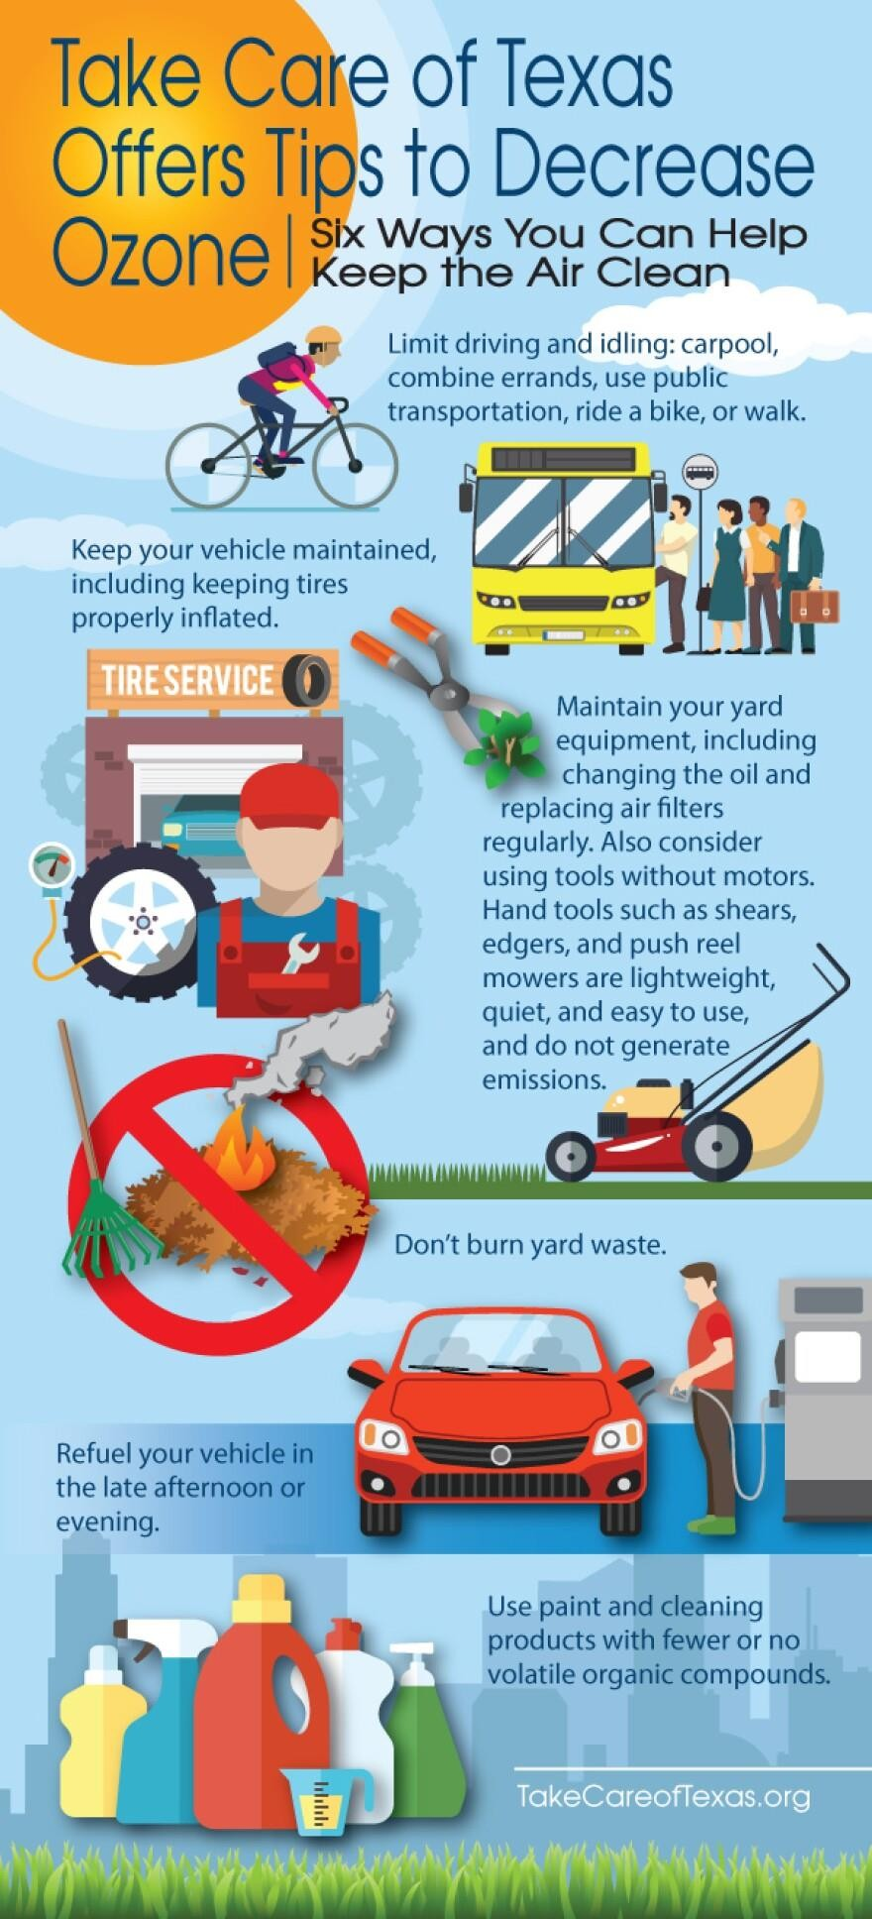Efforts to Combat Ozone Depletion

Montreal Protocol:
The Montreal Protocol on Substances that Deplete the Ozone Layer, signed in 1987, is an international treaty designed to phase out the production and consumption of ozone-depleting substances. It has been successful in reducing the use of CFCs and other harmful chemicals. As a result, the ozone layer is slowly recovering, and it is expected to return to pre-1980 levels by around 2060 if current regulations remain in place.

Use of Alternatives:
Safer alternatives to ozone-depleting substances, such as hydrofluorocarbons (HFCs), have been developed for use in refrigeration and air conditioning. However, while HFCs do not deplete the ozone layer, they are potent greenhouse gases and contribute to global warming. As a result, efforts are underway to phase down HFCs under the Kigali Amendment to the Montreal Protocol.

Public Awareness:
Increasing public awareness about the harmful effects of ozone depletion has led to changes in consumer behavior and a reduction in the use of aerosol products and chemicals that contribute to the problem.

Conclusion

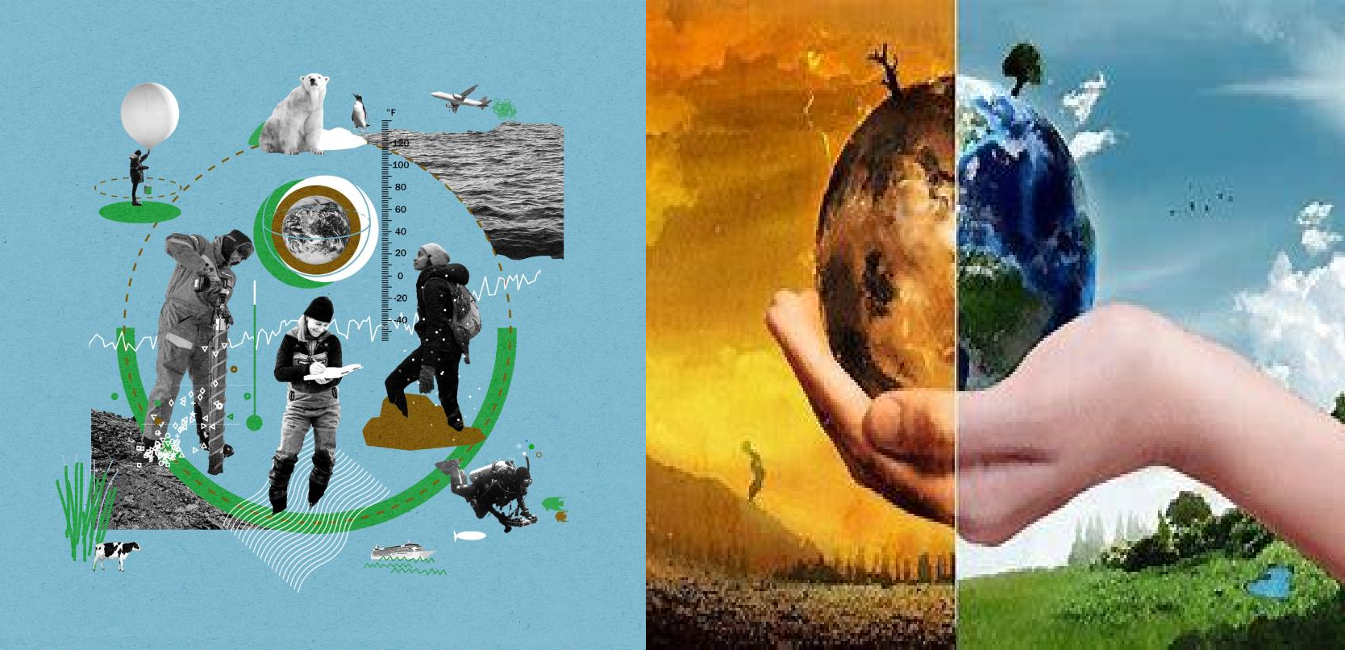Stopping global warming requires concerted efforts from individuals, governments, and industries worldwide
Stopping global warming requires concerted efforts from individuals, governments, and industries worldwide. By reducing greenhouse gas emissions through renewable energy, improving energy efficiency, protecting forests, and adopting sustainable practices in agriculture, transportation, and industry, we can mitigate global warming and protect the planet for future generations.
Global cooperation and commitment to international climate agreements are also essential to making
meaningful progress..

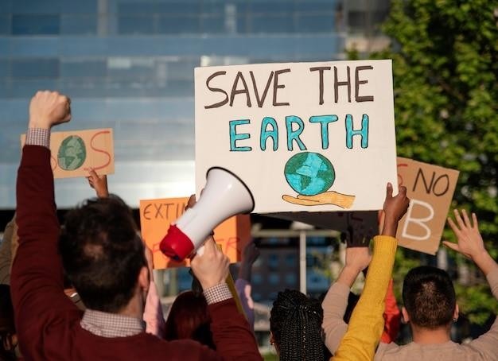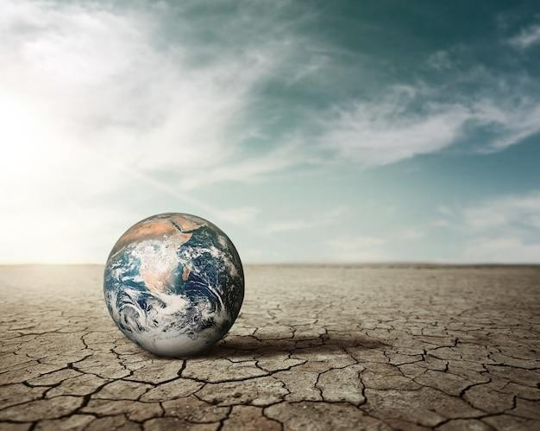

Climate Justice

Climate justice is the recognition that the impacts of global warming disproportionately affect vulnerable communities, particularly in developing countries, who contribute the least to greenhouse gas emissions. It calls for equitable solutions that address both the causes and consequences of climate change, ensuring that the rights and needs of marginalized groups are prioritized.

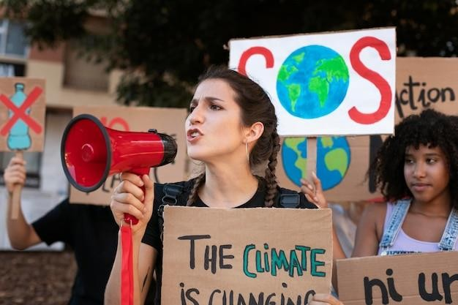

Public Awareness and Education
Public awareness and education play crucial roles in addressing global warming and promoting sustainable practices. By increasing awareness about climate change, its causes, and its impacts, individuals can make informed decisions and take action to mitigate their carbon footprint. Education programs can focus on the importance of renewable energy, energy conservation, waste reduction, sustainable agriculture, and transportation choices.

Thank You!

