INSTITUTO TECNOLÓGICO Y DE ESTUDIOS SUPERIORES DE OCCIDENTE

NoSQL Databases - O2026_ESI3891A


MongoDB Lab 2 - From Data Model to REST API & Query Optimization

Student:
Luis Mariano Romo Medina , 758007 , IDS : 50%.

Teacher: Leobardo Ruiz

Date: 30/03/2026

Table of Contents
Step 1 — Adapt the Data Model to an API 3
/Teams 5
POST 5
GET 8
UPDATE 11
DELETE 13
/Tournaments 16
POST 16
GET 18
UPDATE 20
DELETE 23
/People 25
POST 25
GET 28
UPDATE 31
DELETE 34
/Matches 36
POST 36
GET 39
UPDATE 41
DELETE 44
Step 2 — Extend Search Functionality 46
Step 3 — Pagination (Limit & Skip) 51
Step 4 — Index Design and Implementation 52
Index 1: Text Index on tournaments name. 52
Index 2: Text Index on team’s name. 52
Index 3: Numeric Index on matches Match_day. 53
Step 5 — Update the Client 54
Step 6 — Demonstrate CRUD Operations 55
20 Inserted Documents. 55
10 Queries ( Gets ) 55
5 Updates 59
5 Deletions 60
Step 7 — Reflection: Performance & Design 62

Step 1 — Adapt the Data Model to an API

Operation | Endpoint Example
Create | POST /resource
Get all | GET /resource
Get by ID | GET /resource/{id}
Update | PUT /resource/{id}
Delete | DELETE /resource/{id}

First of all, this laboratory enforced multiple changes to the original schemas designed for each entity (in this case, collections). Regardless of MongoDB or any other NoSQL database being highly flexible, that doesn’t translate into “accepting anything.” The challenges start to appear when connecting the backend to the database. Most of the validations are done on the backend side, where the entities are highly typed, so not everything is inserted into the database—only what was intended to be stored in the collections (in this case with MongoDB).
So, I will introduce the endpoints designed in the laboratory, but first, a brief explanation of the general structure of the project.
In the original repo, 3 main modules were given: main, client, and resources. This was fine because of the small example that was present in it.
But as the project grew from 1 (/books) to 4 endpoints (the ones explained in the next steps), a modularization and a different level of structure were needed.
Following a general backend project structure, I decided to separate responsibilities from the business logic (services), which make use of structure validation (validators) and an ORM (Object Relational Mapping) from JSON models to a Python data-modeled structure (models), and the endpoints for each resource inside a (resources) folder.
The workflow in the elaboration of this project was thought as:
Controllers → Services → Validators / Models → DB Manipulation

IMPORTANT CLARIFICATION
There are rules that I defined for how data is inserted, updated, and deleted for each resource, but there are validations that occur that enforce a certain level of consistency within the documents in the collections where there are references to documents in different collections.
People
- A person can’t be created without a team_id. Therefore, to insert a new person, at least one team document needs to be present to be linked with the new resource in people.
- A person can’t be deleted if it is present as a reference in some field within match documents.
Tournaments
- A tournament can be created with or without initial teams, for later updates.
- A tournament can’t be deleted if it is referenced within match documents.
Teams
- A team doesn’t have any restriction during the creation phase; meaning it doesn’t store references to other documents.
- A team can’t be deleted if it is referenced in tournaments, people, or match documents.
Matches
- A match needs to reference 2 teams (home and away) in the creation phase. Therefore, at least 2 documents in teams need to be present before creating a match. Also, a reference to a tournament is required, forcing the creation of a tournament before posting a new match.
- The deletion of a document in the matches collection is always possible and not restricted by any other collection reference.

/Teams
app.add_route('/teams', team_resource, suffix="collection")
app.add_route('/teams/{id}', team_resource)
Each endpoint regardless of the resource type made use of the same resource that acts as the controller for the named resource in each scenario.

POST
POST endpoint required of data to be passed by the user in each case ( tournaments, teams, people, matches ) and the service of each resource validate the structure and type correctness expected by the backend before try inserting a new resource to that collection.
async def on_post_collection(self, req, res):
data = await req.media
team_id = team_service.create_team(data, self.db)
…

Success
Example CLI:
By the terminal the user can either input stats for the new given team or not.
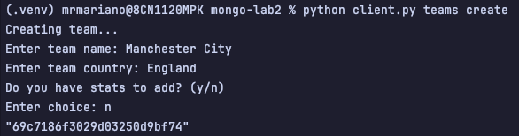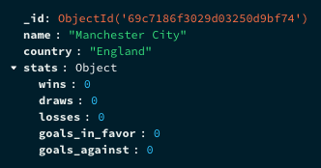

Example HTTP:
In the HTTP method, the user is required to pass all the necessary fields for creation.
# POST TEAM
POST http://localhost:8000/teams
Content-Type: application/json
{
"name": "Real Oviedo",
"country": "Spain",
"stats": {
"wins": 4,
"draws": 9,
"losses": 16,
"goals_in_favor": 20,
"goals_against": 48
}
}
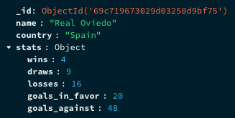

Failures
# POST TEAM
POST http://localhost:8000/teams
Content-Type: application/json
{
"name": "Real Oviedo",
"country": "Spain"
}
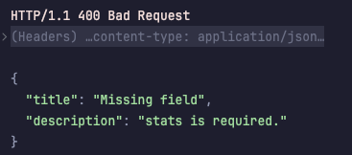
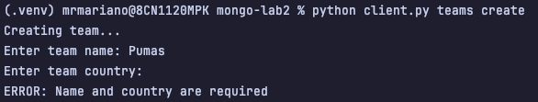
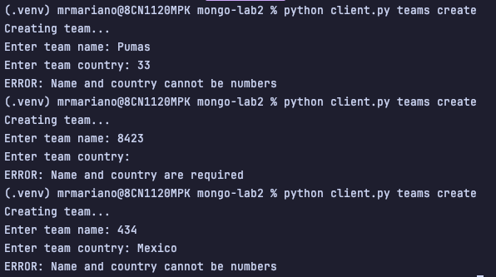

GET
GET /teams and /teams/{id}
#GET ALL
def get_all_teams(db):
teams = list(db.teams.find())
for t in teams:
t["_id"] = str(t["_id"])
return teams
#GET BY ID
def get_team_by_id(team_id, db):
try:
team_id = ObjectId(team_id)
except InvalidId:
raise falcon.HTTPBadRequest(title="Invalid ID",
description="Invalid team id")
team = db.teams.find_one({"_id": team_id})
This methods are in themselves self-explanatories, in comparison to other GET methods implemented in different resources where reference between collections exist and some mapping methods are applied so ID are mapped with the name of the reference document, here the requests to the db are done directly, the only validation requirements previous to querying the Database is in the case of getting by ID where a typecast is attempted as verifying that what the user passed is in fact valid ID reference.
Success Gets
Example CLI:
With ID
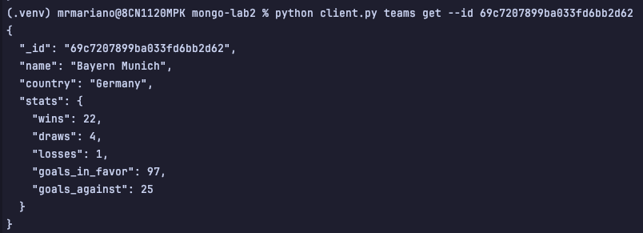

Without ID
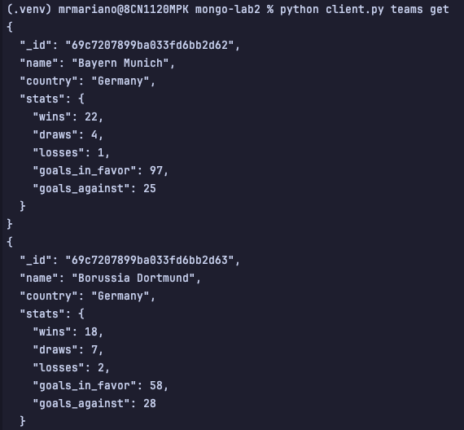
Example HTTP:
With ID
###
# GET TEAM BY ID
GET http://localhost:8000/teams/69c7207899ba033fd6bb2d62
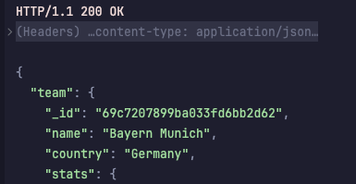

Without ID
###
# GET ALL TEAMS
GET http://localhost:8000/teams
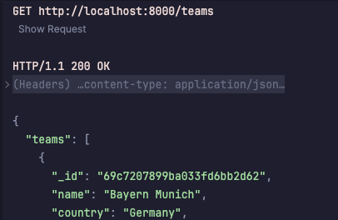

Failure Gets
###
# GET TEAM BY WRONG ID
GET http://localhost:8000/teams/69c7207899ba033fd6bb2d6
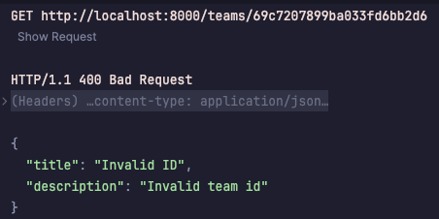

UPDATE
UPDATE /teams/{id}
#UPDATE BY ID
def update_team_by_id(team_id, data, db):
try:
obj_id = ObjectId(team_id)
except InvalidId:
raise falcon.HTTPBadRequest(title="Invalid ID",
description="Invalid team id")
team_validator.validate_team_data(data, partial=True)
result = db.teams.update_one({"_id": obj_id}, {"$set": data})
if result.matched_count == 0:
raise falcon.HTTPNotFound(description="Team not found")
team = db.teams.find_one({"_id": obj_id})
team["_id"] = str(team["_id"])
return team
The only fields allowed to update for a team are “name” and “country”.
Success Updates
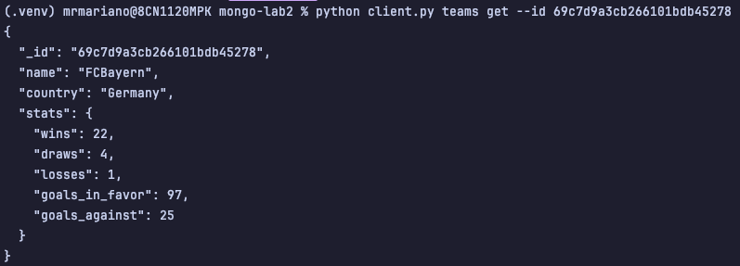
Example CLI:
With ID
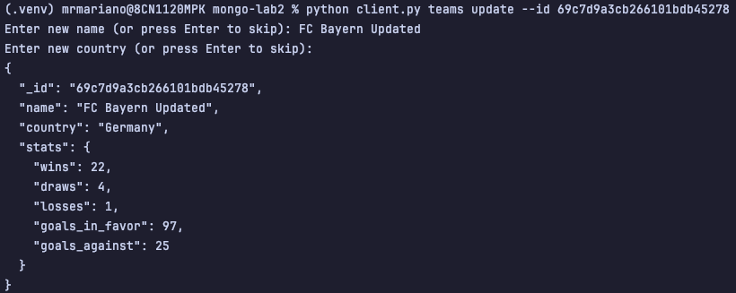
With Incorrect ID
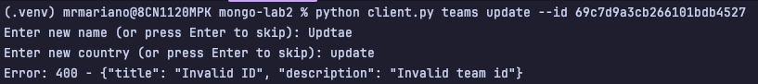
Example HTTP:
With ID
# UPDATE TEAM BY ID
PUT http://localhost:8000/teams/69c7d9a3cb266101bdb45278
Content-Type: application/json
{
"name": "Real Oviedo Updated",
"country": "Spain"
}
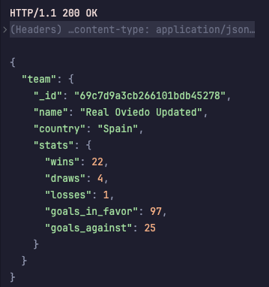
With Incorrect ID
# UPDATE TEAM BY ID
PUT http://localhost:8000/teams/69c7d9a3cb266101bdb4527
Content-Type: application/json
{
"name": "Real Oviedo Updated",
"country": "Spain"
}
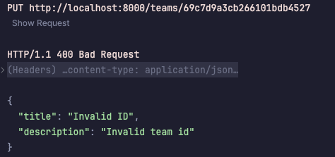
Failure Updates
# UPDATE TEAM BY ID
PUT http://localhost:8000/teams/69c7d9a3cb266101bdb45278
Content-Type: application/json
{
"name": 32332
}
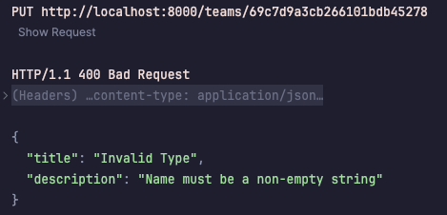
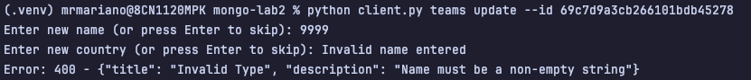

DELETE
DELETE /teams/{id}
# DELETE BY ID
def delete_team_by_id(team_id, db):
try:
obj_id = ObjectId(team_id)
except InvalidId:
raise falcon.HTTPBadRequest(…)
team = db.teams.find_one({"_id": obj_id})
if not team:
raise falcon.HTTPNotFound(description="Team not found")
# Check if team is in any tournament
# Check if team has any people associated
# Check if team is in any match (home_team or away_team)
# If no references found, proceed with deletion
db.teams.delete_one({"_id": obj_id})
team["_id"] = str(team["_id"])
return team
To delete a match is restricted to various conditions, the ones stated here as comments are indicatives of those conditions, that the team is not referenced first in any tournaments, then that a person is also not linked to that team and finally that the team is not present as a reference in either home or away team in matches, this is done for enforcing some level of consistency within the data.
Success Deletes
Example CLI:
With ID
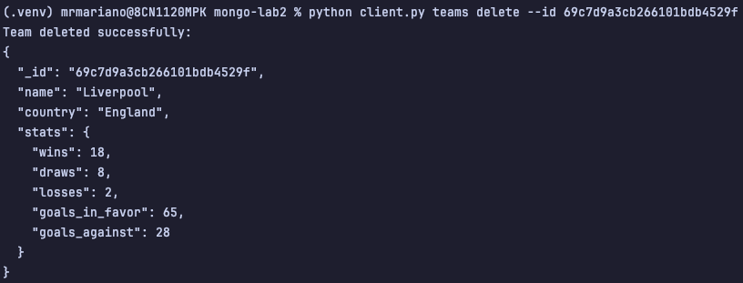
With Incorrect ID
Example HTTP:
With ID
# DELETE TEAM BY ID
DELETE http://localhost:8000/teams/69c7d9a3cb266101bdb452a1
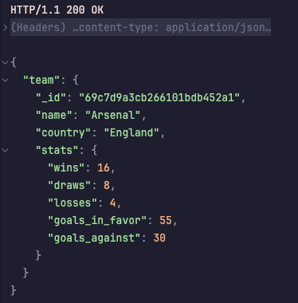
Failure Deletes
# DELETE TEAM BY ID
DELETE http://localhost:8000/teams/69c7d9a3cb266101bdb45294
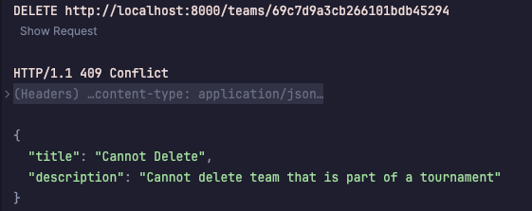

/Tournaments
app.add_route('/tournaments', tournament_resource, suffix="collection")
app.add_route('/tournaments/{id}', tournament_resource)

POST
# Create POST /
async def on_post_collection(self, req, res):
data = await req.media
tournament_id = tournament_service.create_tournament(data, self.db)
log.info(f"Tournament created: {tournament_id}")
res.status = falcon.HTTP_201
res.media = {"tournament": tournament_id}

A winner_team may not exist yet at the creation of the tournament so it is allowed to create a tournament that has no winner and, teams in the tournament may still have not been created so it is allowed to create the tournament with an empty array field, for later updates to this field.
Required fields : name, country, total_match_days.
Optional fields : winner team, teams
Success
Example CLI:
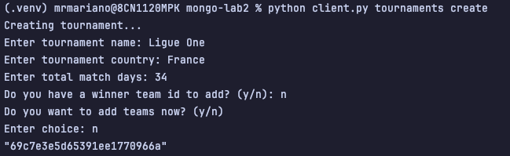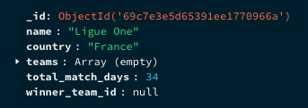

Example HTTP:
# POST TOURNAMENT
POST http://localhost:8000/tournaments
Content-Type: application/json
{
"name": "Eredivise",
"country": "Netherlands",
"total_match_days" : 34
}
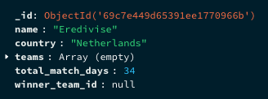
Failures
# POST TOURNAMENT
POST http://localhost:8000/tournaments
Content-Type: application/json
{
"name": "Eredivise",
"country": "Netherlands"
}
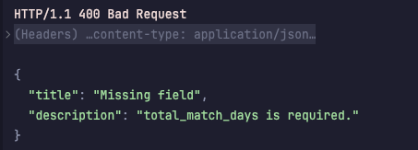
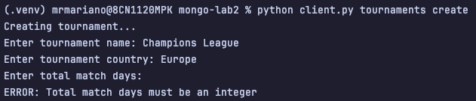

GET
GET /tournaments and /tournaments/{id}
# Get all GET /
async def on_get_collection(self, req, res):
tournaments = tournament_service.get_all_tournaments(self.db)
res.media = { "tournaments" : tournaments }
# Get by Id GET /{id}
async def on_get(self, req, res, id):
tournament = tournament_service.get_tournament_by_id(id, self.db)
res.media = { "tournament" : tournament }
This GET methods retrieve the tournaments either all or by ID, but the reference between the team’s collections in a tournament exist via Id reference, so some mapping methods are applied, for getting the names of the teams not the ids in tournaments.
Success Gets
Example CLI:
With ID
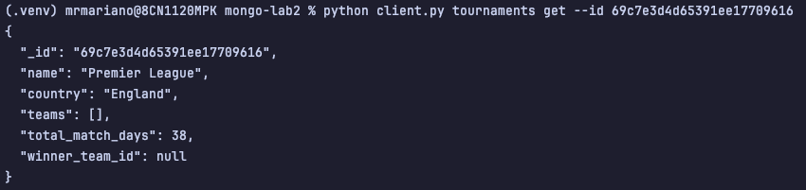
Without ID

Example HTTP:
With ID
###
# GET TOURNAMENT BY ID
GET http://localhost:8000/tournaments/69c7e3d4d65391ee17709616
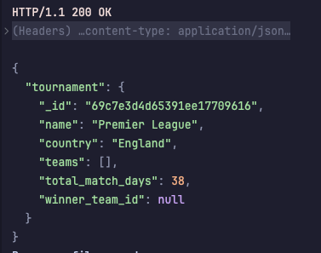
Without ID
# GET ALL TOURNAMENTS
GET http://localhost:8000/tournaments
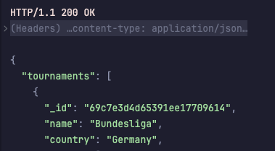
Failure Gets
# GET TOURNAMENT BY WRONG ID
GET http://localhost:8000/tournaments/69c7e3d4d65391ee1770961
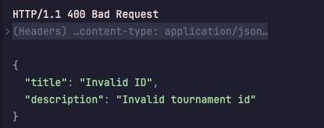

UPDATE
UPDATE /tournaments/{id}
# Update by Id PUT /{id}
async def on_put(self, req, res, id):
data = await req.media
tournament = tournament_service.update_tournament(id, data, self.db)
log.info(f"Tournament updated: {id}")
res.media = { "tournament" : tournament}
The all fields are allowed to be updated from [name, country, winner, teams, total_match_days]
Success Updates
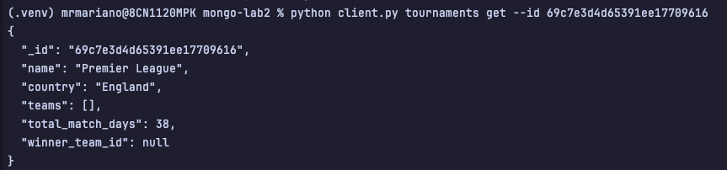
Example CLI:
With ID
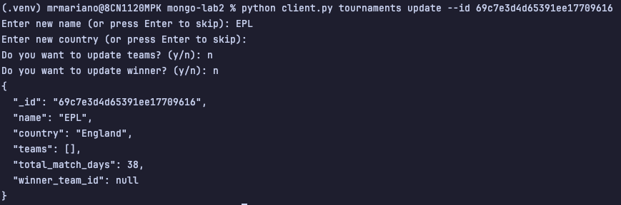
With Incorrect ID
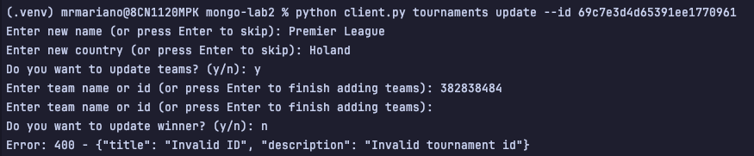

Example HTTP:
With ID
# UPDATE TOURNAMENT
PUT http://localhost:8000/tournaments/69c7e3d4d65391ee17709616
Content-Type: application/json
{
"name": "Eredivisie",
"country": "Netherlands"
}
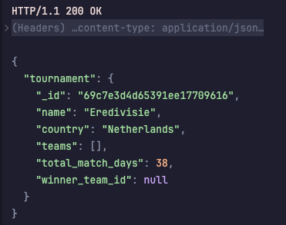
With Incorrect ID
# UPDATE TOURNAMENT
PUT http://localhost:8000/tournaments/69c7e3d4d65391ee1770961
Content-Type: application/json
{
"name": "Eredivisie",
"country": "Netherlands"
}
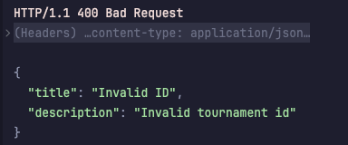

Failure Updates
# UPDATE TOURNAMENT ( failure )
PUT http://localhost:8000/tournaments/69c7e3d4d65391ee17709616
Content-Type: application/json
{
"winner_team_id": "64c7e3d4d65391ee17709"
}
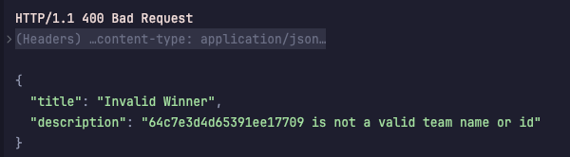
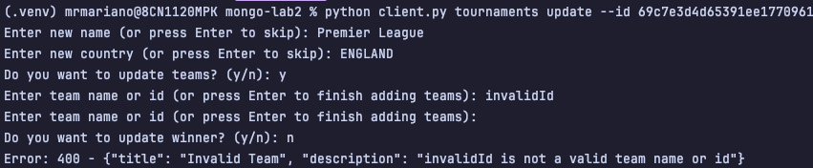
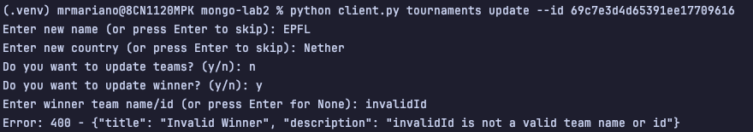

DELETE
DELETE /tournaments/{id}
# Delete by Id DELETE /{id}
async def on_delete(self, req, res, id):
deleted = tournament_service.delete_tournament(id, self.db)
if deleted:
log.info(f"Tournament deleted with id: {id}")
res.status = falcon.HTTP_200
res.media = {"tournament": "Tournament deleted successfully"}
else:
res.status = falcon.HTTP_404
res.media = {"error": "Tournament not found"}
To delete a tournament is restricted only to if it is referenced by some match document
Success Deletes
Example CLI:
With ID ( Not present in any match )
With Incorrect ID
Example HTTP:
With ID
# DELETE TOURNAMENT
DELETE http://localhost:8000/tournaments/69c7edcc83d10dec2706a39f
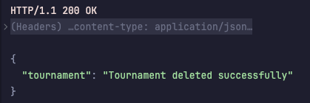

Failure Deletes
With ID of a tournament that is present in some match.
# DELETE TOURNAMENT
DELETE http://localhost:8000/tournaments/69c7edcc83d10dec2706a39e
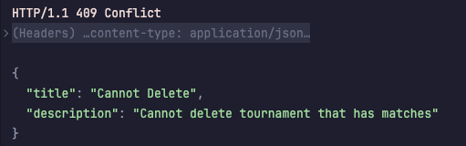

/People
app.add_route('/people', people_resource, suffix="collection")
app.add_route('/people/{id}', people_resource)

POST
# Create POST /
async def on_post_collection(self, req, res):
data = await req.media
people_id = people_service.create_people(data, self.db)
if not people_id:
log.error("Failed to create person")
res.status = falcon.HTTP_400
res.media = { "error" : "Invalid data" }
return
log.info(f"Person created: {people_id}")
res.status = falcon.HTTP_201
res.media = { "person" : people_id }

A person can be created in two ways, being of type player or manager, something I mentioned in the lab 1, was that this is a discriminator field, so different rules applied in regard of the type of person is created
Player
- Required fields: first_name, last_name, shirt_number
- Optional fields: team_id, attributes
Manager
- Required fields: first_name, last_name
- Optional fields: team_id

Success
Example CLI:
Player
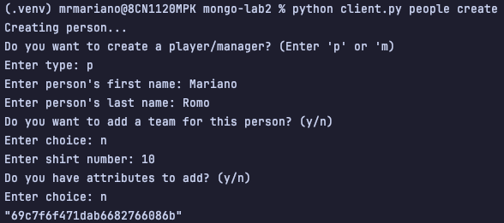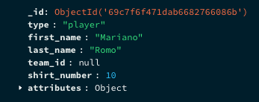
Manager
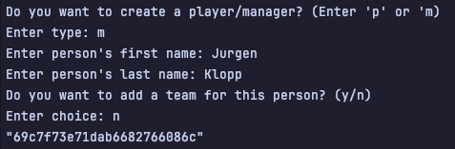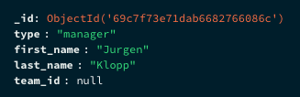

Example HTTP:
Player
# POST PEOPLE ( player )
POST http://localhost:8000/people
Content-Type: application/json
{
"type": "player",
"first_name": "John",
"last_name": "Doe",
"shirt_number": 10
}
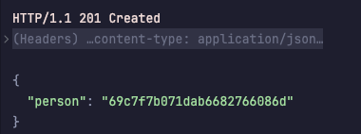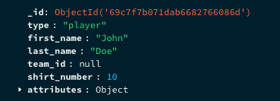
Manager
# POST PEOPLE ( manager )
POST http://localhost:8000/people
Content-Type: application/json
{
"type": "manager",
"first_name": "Jane",
"last_name": "Smith"
}
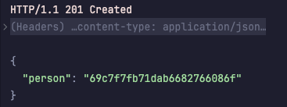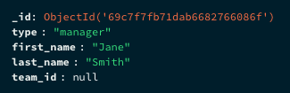

Failures
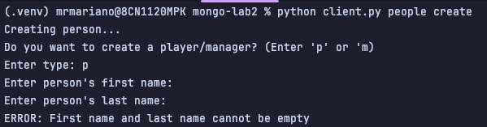
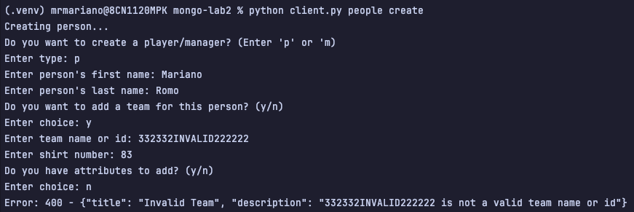
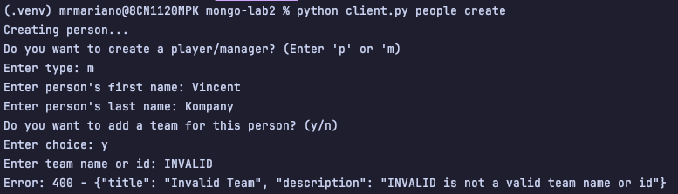

GET
GET /people and /people/{id}
# Get all GET /
async def on_get_collection(self, req, res):
people = people_service.get_all_people(self.db)
log.info(f"People: {people}")
res.media = { "people" : people}
# Get by Id GET /{id}
async def on_get(self, req, res, id):
person = people_service.get_people_by_id(id, self.db)
if person:
log.info(f"Person: {person}")
res.media = { "person" : person }
else:
log.info(f"Person with id {id} not found")
res.status = falcon.HTTP_404
res.media = { "error" : "Person not found" }
This GET methods retrieve persons either all or by ID, but the reference between the team’s collections in people exists via Id reference, so some mapping methods are applied, for getting the names of the teams not the ids.
Success Gets
Example CLI:
With ID
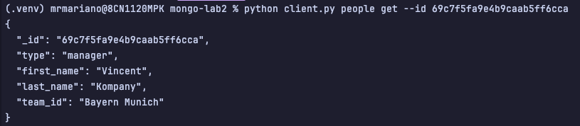
Without ID
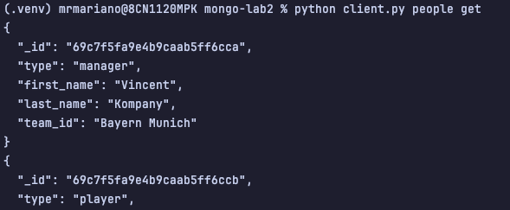

Example HTTP:
With ID
# GET PEOPLE BY ID ( manager )
GET http://localhost:8000/people/69c7f5fa9e4b9caab5ff6cca
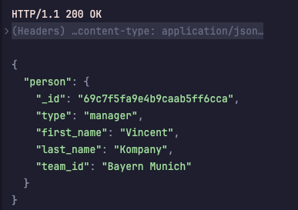
Without ID
# GET ALL PEOPLE
GET http://localhost:8000/people
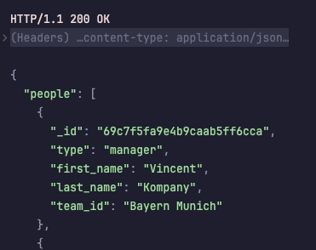

Failure Gets
# GET PEOPLE BY wrong ID
GET http://localhost:8000/people/69c7f5fa9e4b9caab5ff6cc
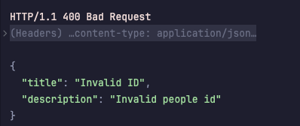

UPDATE
UPDATE /people/{id}
# Update by Id PUT /{id}
async def on_put(self, req, res, id):
try:
data = await req.media
result = people_service.update_people_by_id(id, data, self.db)
res.media = {"person": result}
except ValueError as e:
log.error(f"Failed to update person: {e}")
res.status = falcon.HTTP_400
res.media = {"error": str(e)}
A type in person cannot be changed, but other aspects can.
- Team id can be updated for both players and managers
- Only a player can change the shirt_number attribute and attribute “attributes” because only he, has them
Success Updates
Example CLI:
With ID ( player )
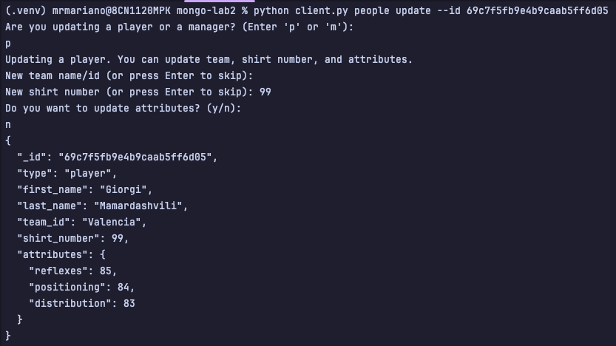

With ID ( manager )
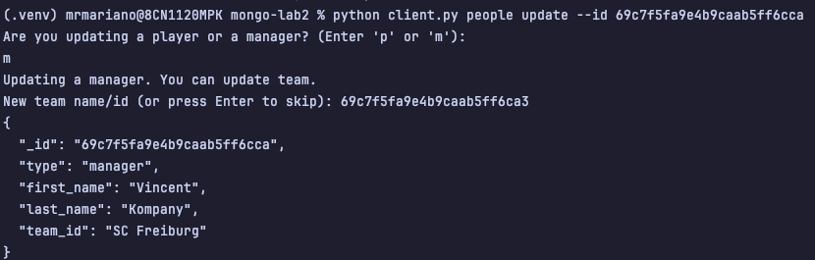
Example HTTP:
With Player ID
# UPDATE PEOPLE ( player )
PUT http://localhost:8000/people/69c7f7b071dab6682766086d
Content-Type: application/json
{
"shirt_number": 7
}
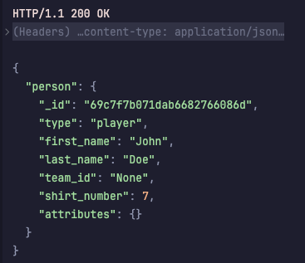
With Manager ID
# UPDATE PEOPLE ( manager )
PUT http://localhost:8000/people/69c7f7f771dab6682766086e
Content-Type: application/json
{
"team_id": "69c7f5fa9e4b9caab5ff6ca4"
}
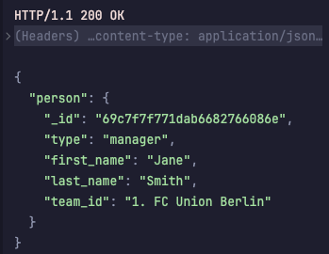
Failure Updates
Trying to update a player with the wrong attributes
# UPDATE PEOPLE ( player )
PUT http://localhost:8000/people/69c7f7b071dab6682766086d
Content-Type: application/json
{
"first_name" : "INVALID UPDATE CAMP",
"last_name" : "INVALID UPDATE CAMP"
}
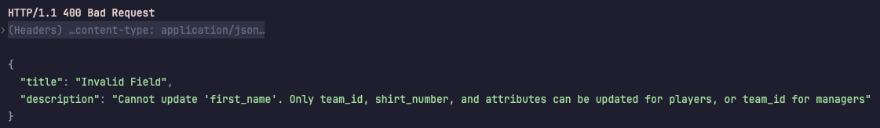
Trying to update a player with an invalid new team_id
# UPDATE PEOPLE ( player )
PUT http://localhost:8000/people/69c7f7b071dab6682766086d
Content-Type: application/json
{
"team_id" : "INVALID UPDATE CAMP"
}
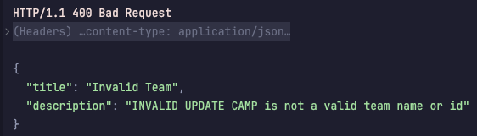
Trying to update a manager with an invalid new team_id
# UPDATE PEOPLE ( manager )
PUT http://localhost:8000/people/69c7f7f771dab6682766086e
Content-Type: application/json
{
"team_id": "69c7f5fa9e4b9caab5ffa4"
}
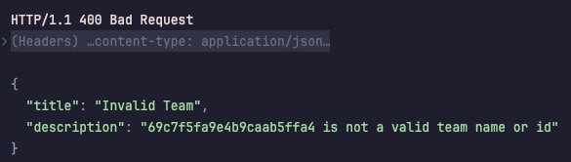

Trying to update a manager with an invalid camp
# UPDATE PEOPLE ( manager )
PUT http://localhost:8000/people/69c7f7f771dab6682766086e
Content-Type: application/json
{
"invalid_camp": "69c7f5fa9e4b9caab5ffa4"
}
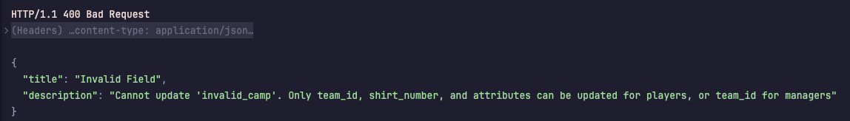

DELETE
DELETE /people/{id}
# Delete by Id DELETE /{id}
async def on_delete(self, req, res, id):
result = people_service.delete_people_by_id(id, self.db)
if result:
log.info(f"Person with id {id} deleted")
res.media = {"people": "Person deleted"}
else:
log.info(f"Person with id {id} not found for deletion")
res.status = falcon.HTTP_404
res.media = {"error": "Person not found"}
To delete a person regardless of the type, it needs to not be present in the matches collections as a reference attribute.
Success Deletes
Example CLI:
With ID ( Not present in any match )

Example HTTP:
With ID
# DELETE PEOPLE
DELETE http://localhost:8000/people/69c7f7f771dab6682766086e
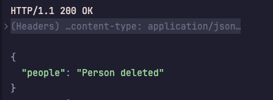

Failure Deletes
With ID of a person that is present in some match.

/Matches
app.add_route('/matches', match_resource, suffix="collection")
app.add_route('/matches/{id}', match_resource)

POST
# Create POST /
async def on_post_collection(self, req, res):
data = await req.media
match_id = match_service.create_match(data, self.db)
res.status = falcon.HTTP_201
res.media = {"match": match_id}

A person can be created in two ways, being of type player or manager, something I mentioned in the lab 1, was that this is a discriminator field, so different rules applied in regard of the type of person is created
- Required fields: all
- Optional fields: none

For this resource, is required everything is provided and there’s no escaping from this.
Success
Example CLI:
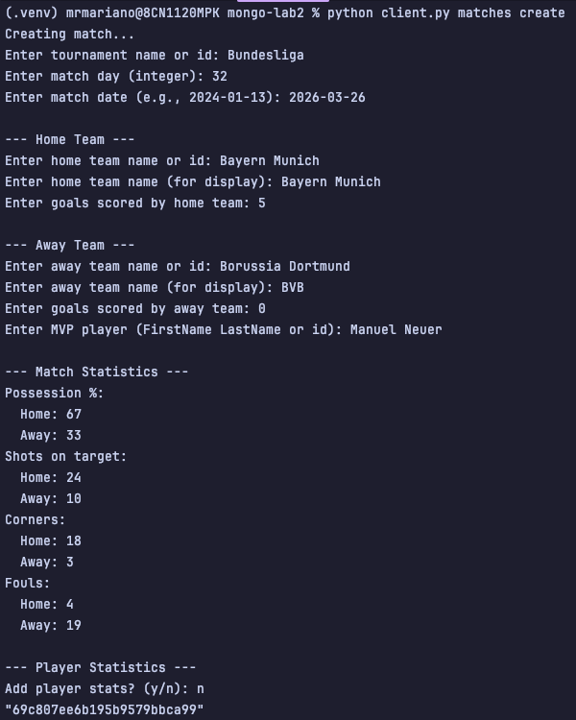

Example HTTP:
# POST MATCHES
###
POST http://localhost:8000/matches
Content-Type: application/json
{
"tournament_id": "Bundesliga",
"match_day": 32,
"date": "2026-03-26",
"home_team": {
"team_id": "Bayern Munich",
"name": "Bayern Munich",
"goals": 5
},
"away_team": {
"team_id": "Borussia Dortmund",
"name": "BVB",
"goals": 0
},
"mvp_player_id": "Manuel Neuer",
"stats": {
"possession": {
"home": 67,
"away": 33
},
"shots_on_target": {
"home": 24,
"away": 10
},
"corners": {
"home": 18,
"away": 3
},
"fouls": {
"home": 4,
"away": 19
}
},
"player_stats": []
}
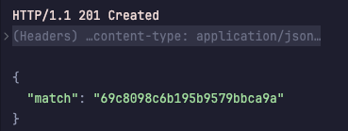

Failures
By no means the attempt to fail in creating a match resource is exhaustive as there are many permutations on how a match can be incorrectly created but here are some examples.
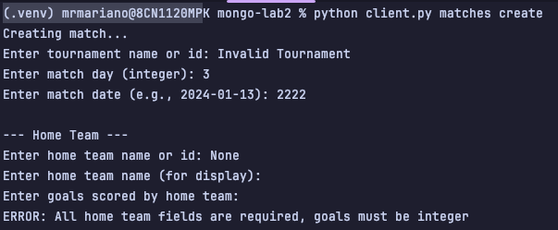
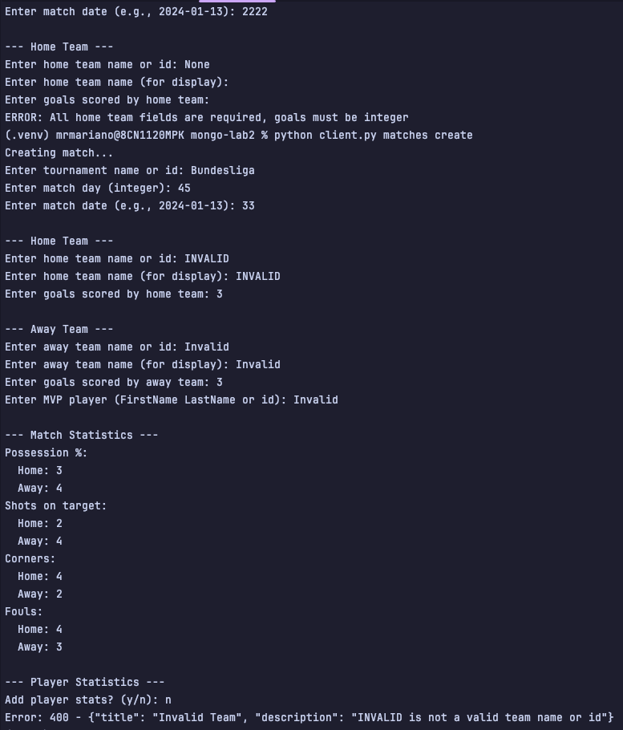

GET
GET /matches and /matches/{id}
# Get all GET /
async def on_get_collection(self, req, res):
matches = match_service.get_all_matches(self.db)
log.info(f"Matches: {matches}")
res.media = {"matches": matches}
# Get by Id GET /{id}
async def on_get(self, req, res, id):
match = match_service.get_match_by_id(id, self.db)
if match:
log.info(f"Match: {match}")
res.media = {"match": match}
else:
res.status = falcon.HTTP_404
res.media = {"error": "Match not found"}
This GET methods retrieve matches and replace the fields where and Id reference will be stored with the name of the reference, for a better user experience.
Success Gets
Example CLI:
With ID
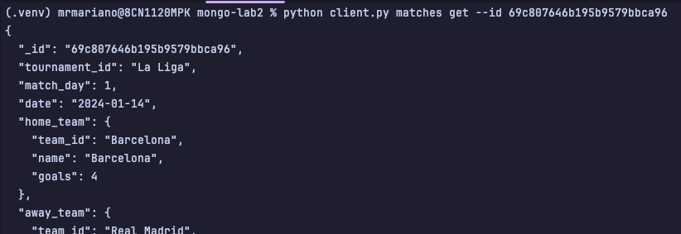
Without ID
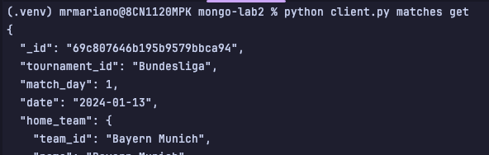

Example HTTP:
With ID
### GET MATCH BY ID
GET http://localhost:8000/matches/69c807646b195b9579bbca96
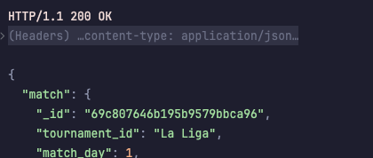
Without ID
# GET MATCHES
GET http://localhost:8000/matches
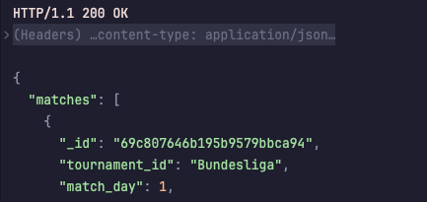
Failure Gets
# GET PEOPLE BY wrong ID
GET http://localhost:8000/matches/69c7f5fa9e4b9caab5ff6cc
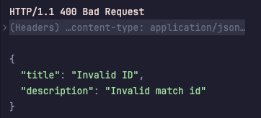

UPDATE
UPDATE /matches/{id}
# Update by Id PUT /{id}
async def on_put(self, req, res, id):
data = await req.media
updated_match = match_service.update_match(id, data, self.db)
if updated_match:
log.info(f"Updated Match: {updated_match}")
res.media = {"match": updated_match}
else:
res.status = falcon.HTTP_404
res.media = {"error": "Match not found"}
A match can only be updated by the fields ( mvp player, match stats, players stats and match date ) this was decided on top of time constraints, because allowing a user to update other fields would have increased the complexity and the delivery would have been put in risk.
Success Updates
Example CLI:
With ID
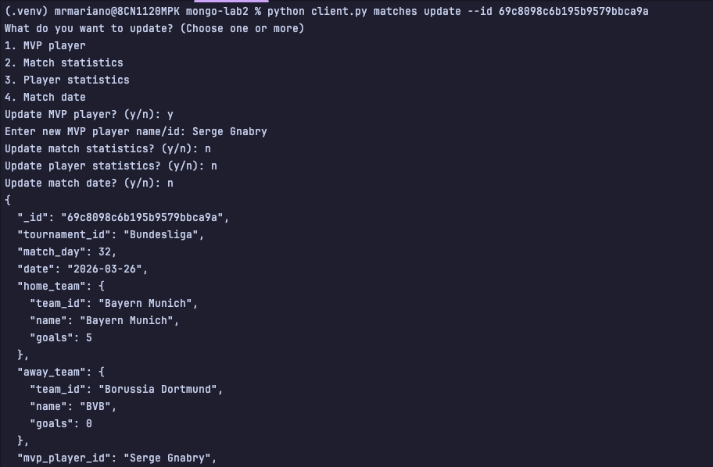

Example HTTP:
With Player ID
# UPDATE MATCH
PUT http://localhost:8000/matches/69c8098c6b195b9579bbca9a
Content-Type: application/json
{
"mvp_player_id" : "Manuel Neuer"
}
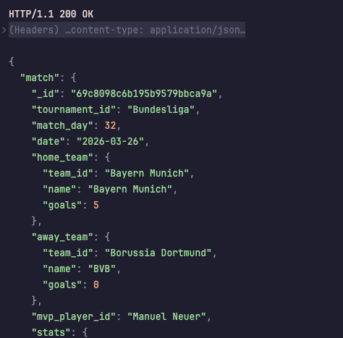

Failure Updates
Trying to update a match with 3 different invalid fields or data types.
# UPDATE WITH INVALID ID FORMAT
PUT http://localhost:8000/matches/69c8098c6b195b9579bbca9a
Content-Type: application/json
{
"mvp_player_id": "Robert Lewandowski"
}
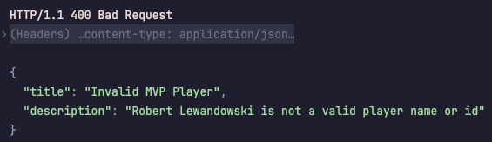
# UPDATE WITH NON-EXISTENT ID
PUT http://localhost:8000/matches/000000000000000000000000
Content-Type: application/json
{
"goals": -5
}
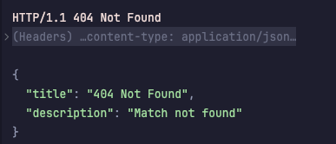
# UPDATE WITH INVALID FIELD
PUT http://localhost:8000/matches/69c8098c6b195b9579bbca9a
Content-Type: application/json
{
"invalid_field": "some_value",
"another_wrong_field": 123
}
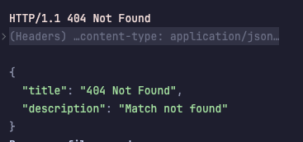

DELETE
DELETE /matches/{id}
# Delete by Id DELETE /{id}
async def on_delete(self, req, res, id):
deleted = match_service.delete_match(id, self.db)
if deleted:
log.info(f"Deleted Match with id: {id}")
res.status = falcon.HTTP_200
res.media = {"match": "Match deleted successfully"}
else:
res.status = falcon.HTTP_404
res.media = {"error": "Match not found"}
To delete a match there are not restrictions, as no person, tournament or team references a match resource.
Success Deletes
Example CLI:
Example HTTP:
# DELETE MATCH
DELETE http://localhost:8000/matches/69c807646b195b9579bbca98
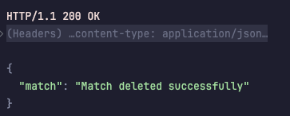

Failure Deletes
Incorrect ID
###
# DELETE MATCH
DELETE http://localhost:8000/matches/69c807646b195b9579bbca
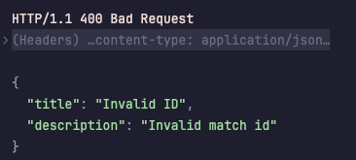

Step 2 — Extend Search Functionality

The decision on what endpoint the extended query with 4 parameters was going to be performed, was on the matches collections, as a match resource has the most variety in fields, allowing to make queries parametrized ( filter by different text or numeric fields ).

A GET/ endpoint for matches was implemented to support advanced filtering through query parameters allowing users to consult specific matches without the need to retrieving all the registries.

Supported Query Parameters

- Numeric with comparators

Match Day
  - Match_day = ? ( exact )
  - match_day_min=?&match_day_max=(Range match_day >= 1 AND match_day <= 3)

Goals
- home_goals=3 (exact )
- home_goals_min=2&home_goals_max=5 (range)
- away_goals=2 (exact)
- away_goals_min=1&away_goals_max=3 (range)

- Text parameters ( partial and case-insensitive )

Tournament
- tournament=Bundesliga (partial search)
The search is case insensitive so the search for “Bundesliga”, “BUNDESLIGA”, “Bundesliga” returns the same results.

MVP Player
- mvp=Musiala (partial search)
- mvp=Gna (finds "Gnabry")
Internally, it searches in the people table by first_name or last_name letters that fits, then it resolves the ObjectId of the found players for filtering the matches.

Benefits

  - Reducing the network traffic, instead of returning a thousand matches, the end user only receives the 10 he is most interested in.
  - Upgrade in performance, as MongoDB process the filtering directly, and is not performed by the application.
  - Flexibility, the user a has control in exactly what data he receives.

Examples

Query 1: Obtains all matches (without filters)

###
#GET /matches
Response:
{
"matches": [
{ "tournament_id": "Bundesliga", "match_day": 1, ... },
{ "tournament_id": "La Liga", "match_day": 1, ... },
...
]
}

Query 2: Filter by exact day

#GET /matches
GET http://localhost:8000/matches?match_day=1

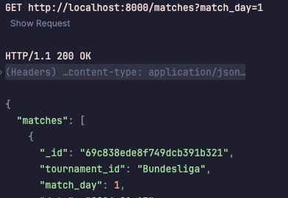

Query 3: Range of days

#GET /matches
GET http://localhost:8000/matches?match_day_min=1&match_day_max=4

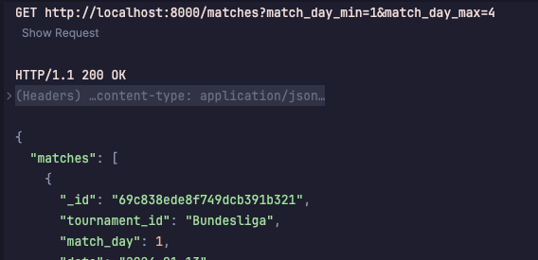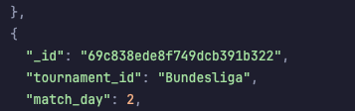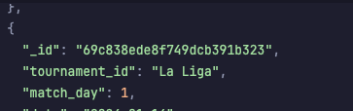

Query 4: filter by goals (home_goals >= 3)

#GET /matches
GET http://localhost:8000/matches?home_goals_min=5

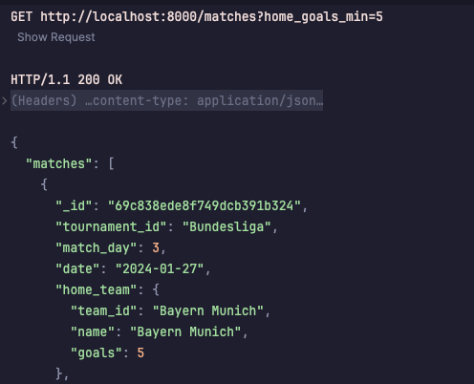

Query 5: search by tournament

#GET /matches
GET http://localhost:8000/matches?tournament=la%20liga

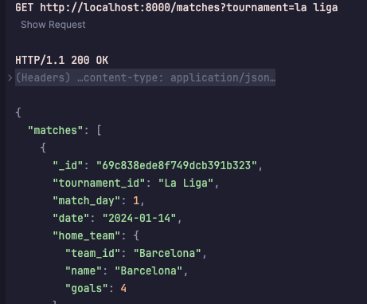

Query 6: Search by MVP

#GET /matches
GET http://localhost:8000/matches?mvp=jamal

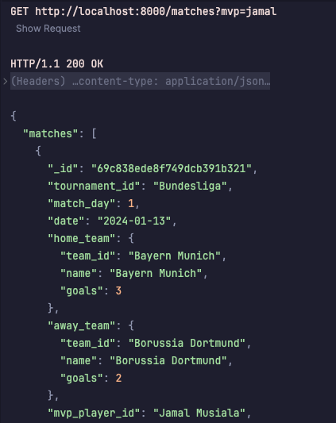

Query 8: Combined filters

#GET /matches
GET http://localhost:8000/matches?mvp=king&home_goals_min=3&match_day=3&tournament=bundesliga

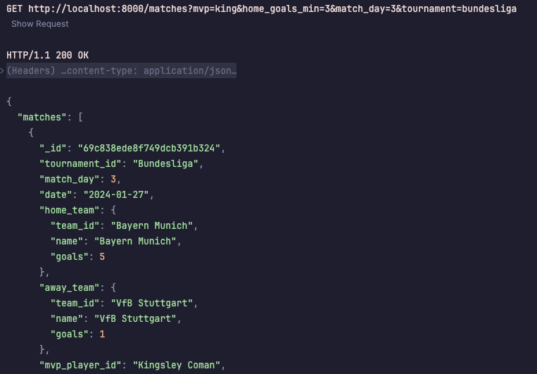

Technical Details.
- The search in tournaments utilizes the $regex option with the “I” option that is for case insensitive matching
- Mvp search filtering , searches in people.first_name and .last_name insensitively of casing, extracts the ObjectId and finally filters the matches by $in option using the formed list of ObjectId of players.

Step 3 — Pagination (Limit & Skip)
# Get all GET /
async def on_get_collection(self, req, res):
"""GET /matches - Get all matches with filters and pagination"""
try:
# Parse parameters
limit, skip = match_service.parse_pagination(req)
params = match_service.parse_filter_params(req)
# Build filter
query_filter = match_service.build_match_filter(params, self.db)
if query_filter is None:
res.media = {"matches": [],
"limit": limit, "skip": skip,
"total": 0, "returned": 0}
return
# Execute query
total_count = self.db.matches.count_documents(query_filter)
matches = list(self.db.matches
.find(query_filter)
.skip(skip)
.limit(limit))
….

The pagination a limit is done through the methods provided by the MongoDB client, as it has built in skip and limit methods, the only challenge relies on parsing the query parameters of limit and skip to integers and ensure the parameters are rightly requested as ( no negatives, no over 100 in limit).

#GET /matches
GET http://localhost:8000/matches?limit=1&skip=1

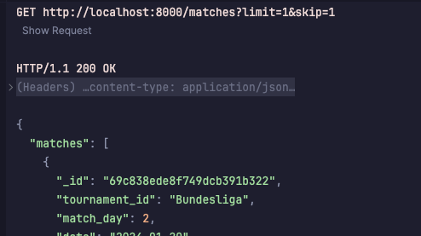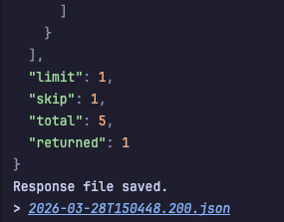

Step 4 — Index Design and Implementation

Index 1: Text Index on tournaments name.

Command:
db.tournaments.createIndex([("name", "text")])

Query Supported:

GET /matches?tournament=Bundesliga
db.tournaments.find({"name": {"$regex": "Bundesliga", "$options": "i"}})

Why It Improves Performance:

Without this index, the application had to perform a full collection scan
on the tournaments collection to find matches by tournament name. The text index
enables partial string matching at the database level, eliminating the need
for the application to maintain an in-memory mapping of tournament names to ObjectIds.

Index 2: Text Index on team’s name.

Command:
db.teams.createIndex([("name", "text")])

Query Supported:

GET /teams?name=Bayern
db.teams.find({"name": {"$regex": "Bayern", "$options": "i"}})

Why It Improves Performance:

Similarly to tournaments, the team’s collection requires frequent name-based
lookups during match creation and filtering. The text index enables case-insensitive
partial matching without collection-wide scans. This reduces database query time
and decreases memory overhead in the application layer.

Index 3: Numeric Index on matches Match_day.
Command:
db.matches.createIndex([("match_day", 1)])

Query Supported:

GET /matches?match_day=1
GET /matches?match_day_min=1&match_day_max=3
db.matches.find({"match_day": {"$gte": 1, "$lte": 3}})

Why It Improves Performance:

Match day is a frequently queried numeric field that supports both exact matches
and range queries (greater than, less than). Without an index, MongoDB must scan
every match document to find records matching the criteria, but with an index on
match_day now efficient range scans and direct lookups can be performed. This index is crucial for performance as the matches collection grows, especially when filtering by
match day ranges.

Step 5 — Update the Client

parser.add_argument("--limit", type=int)
parser.add_argument("--skip", type=int)

if args.action == "search":
if args.resource != "matches":
print("ERROR: Search action is only supported for matches resource")
exit(1)
search_params = {}
if args.search_params:
for param in args.search_params:
if "=" in param:
key, value = param.split("=", 1)
search_params[key] = value
else:
print(f"ERROR: Invalid search parameter format:
{param}. Expected format is key=value.")
exit(1)
if args.limit is not None:
search_params["limit"] = args.limit
if args.skip is not None:
search_params["skip"] = args.skip
api.search_matches(search_params)

If a search wants to be performed in other than the matches collections, the program exits with an error because is only with the matches collections where a search can be performed passing query parameters, in essence, only there are validations and parsing of the arguments, because the implementation was already done in the previous step.

Example of execution

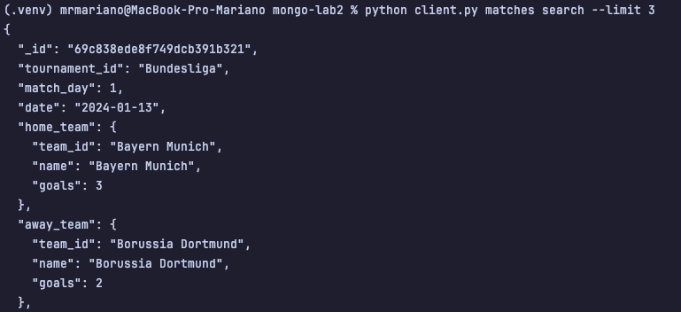

Step 6 — Demonstrate CRUD Operations

20 Inserted Documents.
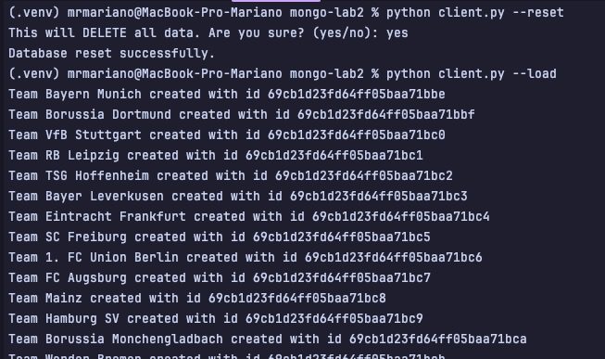
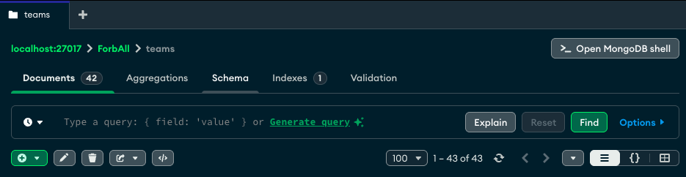

10 Queries ( Gets )
- Get the resource of the Bayern Team
ForbAll> db.teams.find({ name : "Bayern Munich"}, { _id : 1, name: 1})
[
{ _id: ObjectId('69cb1d23fd64ff05baa71bbe'), name: 'Bayern Munich' }
]

- Get the matches that were played on the matchday 2

ForbAll> db.matches.find({match_day : 2 }, {_id : 1})
[
{ _id: ObjectId('69cb1d23fd64ff05baa71c3b') },
{ _id: ObjectId('69cb1d23fd64ff05baa71c3e') }
]

- Get the matches where the MVP was Jamal
ForbAll> db.matches.find(
{ mvp_player_id: ObjectId("69cb1d23fd64ff05baa71bf0") },
{ _id: 1, mvp_player_id: 1 }
)
> [
{
_id: ObjectId('69cb1d23fd64ff05baa71c3a'),
mvp_player_id: ObjectId('69cb1d23fd64ff05baa71bf0')
}
]

- Get the tournaments that are played in Germany

ForbAll> db.tournaments.find({ country : "Germany"})
[
{
_id: ObjectId('69cb1d23fd64ff05baa71be9'),
name: 'Bundesliga',
country: 'Germany',
teams: [
ObjectId('69cb1d23fd64ff05baa71bbe'),
ObjectId('69cb1d23fd64ff05baa71bbf'),
ObjectId('69cb1d23fd64ff05baa71bc0'),
ObjectId('69cb1d23fd64ff05baa71bc1'),
ObjectId('69cb1d23fd64ff05baa71bc2'),
ObjectId('69cb1d23fd64ff05baa71bc3'),
ObjectId('69cb1d23fd64ff05baa71bc4'),
ObjectId('69cb1d23fd64ff05baa71bc5'),
ObjectId('69cb1d23fd64ff05baa71bc6'),
ObjectId('69cb1d23fd64ff05baa71bc7'),
ObjectId('69cb1d23fd64ff05baa71bc8'),
ObjectId('69cb1d23fd64ff05baa71bc9'),
ObjectId('69cb1d23fd64ff05baa71bca'),
ObjectId('69cb1d23fd64ff05baa71bcb'),
ObjectId('69cb1d23fd64ff05baa71bcc'),
ObjectId('69cb1d23fd64ff05baa71bcd'),
ObjectId('69cb1d23fd64ff05baa71bce'),
ObjectId('69cb1d23fd64ff05baa71bcf')
],
total_match_days: 34,
winner_team_id: null
}
]

- Get the teams with more than 15 wins

ForbAll> db.teams.find({"stats.wins" : { "$gt" : 15 } }, { _id : 0, name : 1, "stats.wins" : 1 })
[
{ name: 'Bayern Munich', stats: { wins: 22 } },
{ name: 'Borussia Dortmund', stats: { wins: 18 } },
{ name: 'VfB Stuttgart', stats: { wins: 16 } },
{ name: 'Barcelona', stats: { wins: 24 } },
{ name: 'Real Madrid', stats: { wins: 22 } },
{ name: 'Villarreal', stats: { wins: 18 } },
{ name: 'Atletico de Madrid', stats: { wins: 17 } },
{ name: 'Manchester United', stats: { wins: 20 } },
{ name: 'Liverpool', stats: { wins: 18 } },
{ name: 'Chelsea', stats: { wins: 17 } },
{ name: 'Arsenal', stats: { wins: 16 } }
{ name: 'Manchester City', stats: { wins: 22 } }

- Get the players that play for Bayern
ForbAll> db.people.find({ type : "player", team_id : ObjectId("69cb1d23fd64ff05baa71bbe")}, {_id : 1 , first_name : 1, type : 1})
[
{
_id: ObjectId('69cb1d23fd64ff05baa71bed'),
type: 'player',
first_name: 'Manuel'
},
{
_id: ObjectId('69cb1d23fd64ff05baa71bee'),
type: 'player',
first_name: 'Dayot'
},
{
_id: ObjectId('69cb1d23fd64ff05baa71bef'),
type: 'player',
first_name: 'Alphonso'
},
{
_id: ObjectId('69cb1d23fd64ff05baa71bf0'),
type: 'player',
first_name: 'Jamal'
},
{
_id: ObjectId('69cb1d23fd64ff05baa71bf1'),
type: 'player',
first_name: 'Kingsley'
},
{
_id: ObjectId('69cb1d23fd64ff05baa71bf2'),
type: 'player',
first_name: 'Serge'
}
]

- Get the matches where the away team scored at least 2 goals.
ForbAll> db.matches.find({ "away_team.goals" : { "$gte" : 2 }}, { _id : 0 , "away_team" : 1 , "home_team" : 1})
[
{
home_team: {
team_id: ObjectId('69cb1d23fd64ff05baa71bbe'),
name: 'Bayern Munich',
goals: 3
},
away_team: {
team_id: ObjectId('69cb1d23fd64ff05baa71bbf'),
name: 'Borussia Dortmund',
goals: 2
}
},
{
home_team: {
team_id: ObjectId('69cb1d23fd64ff05baa71bd3'),
name: 'Atletico de Madrid',
goals: 2
},
away_team: {
team_id: ObjectId('69cb1d23fd64ff05baa71bd2'),
name: 'Villarreal',
goals: 2
}
}
]

- Get all the managers.
ForbAll> db.people.find({ type : "manager" } , { _id : 0 , first_name : 1, type : 1})
[
{ type: 'manager', first_name: 'Vincent' },
{ type: 'manager', first_name: 'Nuri' },
{ type: 'manager', first_name: 'Sebastian' },
{ type: 'manager', first_name: 'Marco' },
{ type: 'manager', first_name: 'Luis' },
{ type: 'manager', first_name: 'Carlo' },
{ type: 'manager', first_name: 'Marcelino' },
{ type: 'manager', first_name: 'Luis' },
{ type: 'manager', first_name: 'Manuel' },
{ type: 'manager', first_name: 'Claudio' },
{ type: 'manager', first_name: 'Imanol' },
{ type: 'manager', first_name: 'José' },
{ type: 'manager', first_name: 'Fernando' },
{ type: 'manager', first_name: 'Jagoba' },
{ type: 'manager', first_name: 'Luis' },
{ type: 'manager', first_name: 'Rubén' },
{ type: 'manager', first_name: 'Michel' },
{ type: 'manager', first_name: 'Iñigo' },
{ type: 'manager', first_name: 'Javier' },
{ type: 'manager', first_name: 'Luis' }
]

- Get all the matches played in the “La Liga” tournament.
ForbAll> db.tournaments.find( { name : "La Liga"}, { _id : 1 })
[ { _id: ObjectId('69cb1d23fd64ff05baa71bea') } ]
ForbAll> db.matches.find({ tournament_id : ObjectId("69cb1d23fd64ff05baa71bea")} , { tournament_id : 1 , _id : 1})
[
{
_id: ObjectId('69cb1d23fd64ff05baa71c3c'),
tournament_id: ObjectId('69cb1d23fd64ff05baa71bea')
},
{
_id: ObjectId('69cb1d23fd64ff05baa71c3e'),
tournament_id: ObjectId('69cb1d23fd64ff05baa71bea')
}
]

- Get all the matches where the local team didn’t score.
ForbAll> db.matches.find({ "home_team.goals" : { "$eq" : 0 }} , { home_team : 1})

5 Updates

- Update Bayern Munich Victories

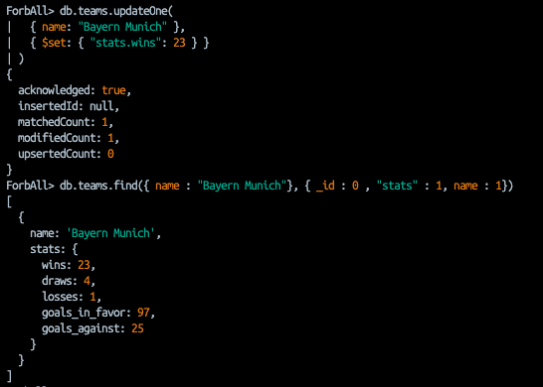

- Add a winner to the Bundesliga Tournament

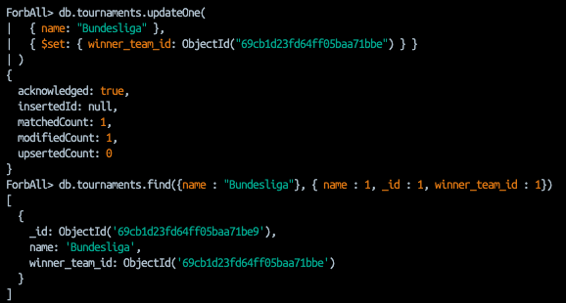

- Change the MVP of a match
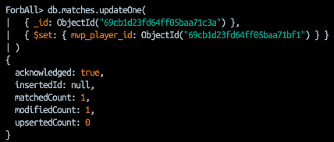

- Increment the goals of Bayern in one match
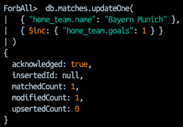

- Change the team of a player

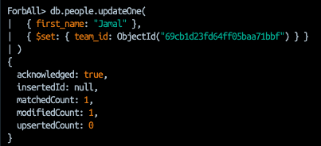

5 Deletions

- Delete a specific Match

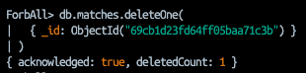

- Delete all matches of match_day = 2

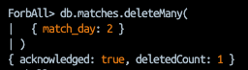

- Delete players of Bayern

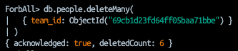

- Delete teams with low wins.

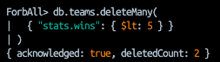

- Delete tournaments without winner.

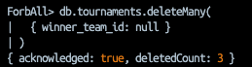

Step 7 — Reflection: Performance & Design
Which queries benefit the most from indexes?
The queries performed on text fields, either partial or complete matches, benefit the most from indexes. Without indexes on those fields, the search would be done in a linear way, which directly impacts performance as the data grows.
Which queries are still inefficient?
Queries performed on text fields that are not indexed are still inefficient, since they require scanning the entire collection.
Did your Lab 1 design need changes? Why?
My Lab 1 design needed multiple changes, especially in the bi-directional way the data was stored. Initially, I thought that storing references between collections in both directions would make querying by certain parameters easier.
However, while working on this second lab, I realized that the idea itself was not wrong, but I didn’t fully consider the trade-offs. Having multiple collections referencing each other increases the complexity of maintaining consistency, since now the responsibility of updating data correctly in multiple places moves to the application layer.
This makes the backend more complex, as more logic is needed to validate, allow, or deny operations in the database.
What would you change for a production system?
For a production system, I would change the structure of the services, validators, and how the output is processed, since currently there are inefficient mappings being done at the application layer.
I would also think more from a business perspective, focusing on the primary users of the system to better understand what kind of data they need and how they will retrieve it. This would help me make better decisions about where to create indexes and when it is better to use references between collections.
Personal Reflection
In a more personal reflection, I liked this lab. At the beginning, I saw it as a great challenge, not only to apply what we learned in class, but also what I have learned in Software Development I, trying to structure the project in a more backend-oriented way by separating responsibilities and modularizing the components.
However, as the complexity started to grow, I began to feel uncertain about whether I would be able to finish the lab. When time started to play against me, I decided to use AI as an assistant to suggest code (lines or methods), and based on my own understanding, I would accept, reject, or modify those suggestions.
Although I used a significant amount of AI-generated code, I did not accept any piece without understanding what it was doing. The main difficulty was not the complexity of the code itself, but rather the amount of validations and mappings between resources, IDs, names, and relationships that can be seen in the codebase.
If I were to start over, I would begin with simpler foundations, still aiming for a good backend structure, but limiting unnecessary mappings. I would also try to better define my end goal from the beginning instead of figuring it out as I progress, and most importantly, start earlier. Even though I didn’t start at the last moment, I could have started from day 0.

