**MAJOR PROJECT REPORT**

**(REVIEW-2)**

(Project Term March-August, 2024)

**ADVANCING DERMATOLOGICAL DIAGNOSIS WITH MULTICLASS LESION ANALYSIS**

**Submitted by**

D. Sri Anjaneyam – 21951A1291

T. Yashaswini – 21951A12C6

D. SaiTeja – 22955A1210

**Mentor:** Dr. M Pala Prasad Reddy,   
Department of Information Technology



**Information Technology**

**INSTITUTE OF AERONAUTICAL ENGINEERING**

**(Autonomous)**

**Dundigal, Hyderabad–500 043, Telangana**

**May, 2024**

**ABSTRACT**

Skin cancer is one of the most prevalent and deadly types of cancer. Dermatologists diagnose this disease primarily visually. Multiclass skin cancer classification is challenging due to the fine-grained variability in the appearance of its various diagnostic categories. On the other hand, recent studies have demonstrated that convolutional neural networks outperform dermatologists in multiclass skin cancer classification. We developed a preprocessing image pipeline for this work. We removed hairs from the images, augmented the dataset, and resized the imageries to meet the requirements of each model. By performing transfer learning on pre-trained ImageNet weights and fine-tuning the Convolutional Neural Networks, we trained the EfficientNets B0-B7 on the HAM10000 dataset. We evaluated the performance of all EfficientNet variants on this imbalanced multiclass classification task using metrics such as Precision, Recall, Accuracy, F1 Score, and Confusion Matrices to determine the effect of transfer learning with fine-tuning. This article presents the classification scores for each class as Confusion Matrices for all eight models. Our best model, the EfficientNet B4, achieved an F1 Score of 87 percent and a Top-1 Accuracy of 87.91 percent. We evaluated EfficientNet classifiers using metrics that take the high-class imbalance into account. Our findings indicate that increased model complexity does not always imply improved classification performance. The best performance arose with intermediate complexity models, such as EfficientNet B4 and B5. The high classification scores resulted from many factors such as resolution scaling, data enhancement, noise removal, successful transfer learning of ImageNet weights, and fine-tuning. Another discovery was that certain classes of skin cancer worked better at generalization than others using Confusion Matrices.

**Keywords:** Convolutional Neural Networks(CNN), Image Classification, Transfer  
 Learning, Skin Cancer, EfficentNets, EfficientNet Variants, Skin Lesion  
 Images, HAM10000 dataset.

**PROBLEM STATEMENT**

Skin cancer diagnosis is visually challenging (due to fine-grained variability), prompting the need for accurate multiclass classification. We developed an image preprocessing pipeline and fine-tuned EfficientNet models using transfer learning on the HAM10000 dataset. Our goal was to improve classification accuracy using metrics like Precision, Recall, Accuracy, and F1 Score, focusing on the impact of transfer learning and model complexity.

**OBJECTIVES**

* **Image Preprocessing Pipeline Development:**

Develop a comprehensive preprocessing pipeline to enhance the quality of skin lesion images. Include techniques such as hair removal, data augmentation, and resizing to ensure standardized input for the models.

* **Transfer Learning Implementation:**

Utilize transfer learning by initializing EfficientNet models with pre-trained weights from the ImageNet dataset. Fine-tune the models on the HAM10000 dataset to adapt to the specific characteristics of skin lesion classification.

* **Performance Evaluation Metrics:**

Evaluate the classification performance using a range of metrics, including Precision, Recall, Accuracy, F1 Score, and Confusion Matrices. Analyze the impact of model complexity (e.g., EfficientNet variants from B0 to B7) on these metrics to understand trade-offs between accuracy and computational efficiency.

* **Optimization and Model Selection:**

Identify the most effective model configurations by comparing the performance of different EfficientNet variants. Consider factors such as classification scores for each skin cancer class, computational resources required, and generalization ability of the models.

* **Insights and Recommendations:**

Provide insights into the factors contributing to high classification scores, such as resolution scaling, data augmentation techniques, and successful transfer learning.

**METHODOLOGY**

The methodology of this project involved developing a preprocessing image pipeline to enhance image quality by removing hairs, augmenting the dataset, and resizing images. Machine Learning models such as EfficientNets, ResNet, VGG(Visual Geometry Group) were selected for training, and transfer learning with pre-trained ImageNet weights was applied to adapt the models to skin cancer classification. Fine-tuning was conducted on the HAM10000 dataset, and model performance was evaluated using metrics such as Precision, Recall, Accuracy, F1 Score, and Confusion Matrices. The analysis focused on assessing the impact of transfer learning with fine-tuning, exploring model complexity, and identifying factors contributing to high classification scores, ultimately concluding that intermediate complexity models like EfficientNet B4 and B5 achieved optimal performance.

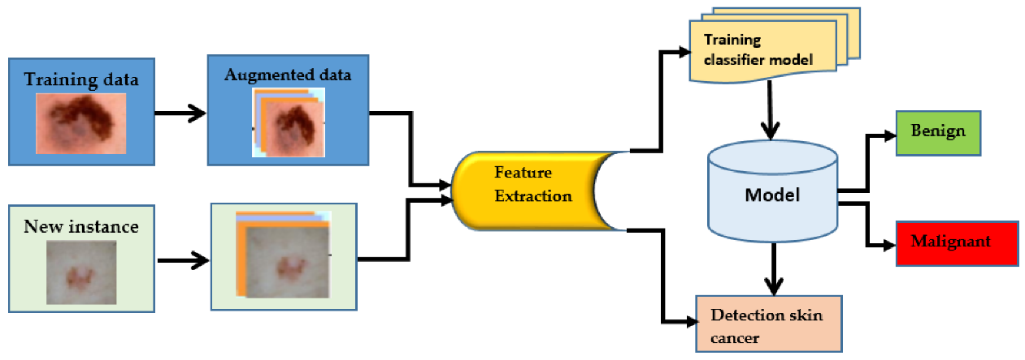

**EXPECTED OUTCOMES**

* Improved accuracy in multiclass skin cancer classification compared to traditional dermatological methods.
* Identification of the most effective EfficientNet model variant for skin cancer classification.
* Understanding the impact of transfer learning and fine-tuning on classification performance.
* Insights into factors contributing to high classification scores, such as preprocessing techniques and model complexity.
* Validation of the CNN-based approach for skin cancer diagnosis, potentially leading to enhanced clinical decision support systems in dermatology.

**CONCLUSION**

Skin cancer is one of the most prevalent and severe cancers. This condition is primarily diagnosed visually by dermatologists. Due to the fine-grained diversity in the look of its numerous di-agnostic categories, multiclass skin cancer classification is a tough undertaking. In recent studies, on the other hand, CNNs have outperformed dermatologists in multiclass skin cancer classification. For this effort, we constructed a pretreatment picture pipeline in which we eliminated hairs from the photos, enriched the dataset, and scaled images according to each model’s need. We trained the EfficientNets B0-B7 on the HAM10000 dataset by performing transfer-learning on pre-trained weights of ImageNet and fine-tuning the Convolutional Neural Networks. To analyze the influence of transfer learning and fine-tuning, we evaluated the performance of all EfficientNet variants on this imbalanced multiclass classification problem using measures such as Precision, Re-call, Accuracy, F1 Score, and Confusion Matrices. This study shows the per-class classification scores as Confusion Matrices for all eight models. In particular, our most robust model, the EfficientNet B4, scored an 87 percent F1 Score and 87.91 percent Top-1 Accuracy.

**REFERENCES**

[1]World Health Organization, Radiation: ultraviolet (UV) radiation and skin can-cer – how common is skin cancer, https://www.who .int /news -room /q -a -detail /radiation -ultraviolet -(uv )-radiation -and -skin -cancer#, 2017. (Accessed12 June 2021).

[2]N. Nordmann, M. Hubbard, T. Nordmann, P.W. Sperduto, H.B. Clark, M.A. Hunt, Effect of gamma knife radiosurgery and programmed cell death 1 receptor an-tagonists on metastatic melanoma, Cureus 9 (2017).

[3]U. Chukwueke, T. Batchelor, P. Brastianos, Management of brain metastases in patients with melanoma, J. Oncol. Pract. 12 (2016) 536–542.

[4]M.R. Lekkala, S. Mullangi, Malignant melanoma metastatic to the central nervous system, StatPearls 2020, https://www.statpearls .com /ArticleLibrary /viewarticle /24930. (Accessed12 June 2021).

[5]S. Morais, A. Cabral, G. Santos, N. Madeira, Melanoma brain metastases pre-senting as delirium: a case report, Arch. Clin. Psychiatry 44 (2017) 53–54.

[6]H.W. Rogers, M.A.S. Weinstock, R. Feldman, B.M. Coldiron, Incidence estimate of non-melanoma skin cancer (keratinocyte carcinomas) in the US population 2012, JAMA Dermatol. 151 (2015) 1081–1086.

[7]M. Thörn, F. Ponté, R. Bergström, P. Sparén, H.O. Adami, Clinical and histopathologic predictors of survival in patients with malignant melanoma: a population-based study in Sweden, J. Natl. Cancer Inst. 86 (1994) 761–769.

[8]W. Stolz, A. Riemann, A.B. Cognetta, L. Pillet, W. Abmayr, D. Holzel, P. Bilek, F. Nachbar, M. Landthaler, O. Braun-Falco, ABCD rule of dermatoscopy: a new practical method for early recognition of malignant melanoma, Eur. J. Dermatol. 4 (1994) 521–527.

[9]G. Argenziano, G. Fabbrocini, P. Carli, V. De Giorgi, E. Sammarco, M. Delfino, Epiluminescence microscopy for the diagnosis of doubtful melanocytic skin lesions. Comparison of the ABCD rule of dermatoscopy and a new 7-point checklist based on pattern analysis, Arch. Dermatol. 134 (1998) 1536–1570.

[10]S.D. Pande, P.P. Jadhav, R. Joshi, A.D. Sawant, V. Muddebihalkar, S. Rathod, S. Das, Digitization of handwritten devanagari text using CNN transfer learning–a better customer service support, Neurosci. Inform. (2021) 100016.