UML Reference Sheet

The Unified Modelling Language (UML) is a programming language neutral means of describing the structure of an OO application. There are many different types of UML diagram each of which fulfil a particular purpose.

The following examples review the basic elements used in a UML class diagram, and are a useful way to describe and investigate Java applications without having to examine the code line by line.

Aggregation

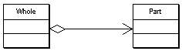
Aggregation is shown by a line between the two classes, with a clear diamond at the start of the line indicating the aggregate object, i.e. the line goes from the whole to the part.

Aggregation is a form of association between two classes. Therefore the aggregation relationship can be annotated as described below.

Association
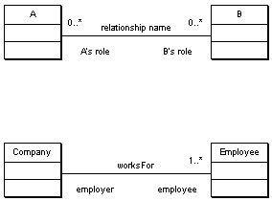

A line between two classes indicates a simple relationship. The line can be annotated with additional information that further defines the relationship:
- Its name
- The role of each class in the relationship
- The cardinality of the relationship.

Cardinality
Relationships in a UML diagram can indicate their cardinality. This shows how many instances of the objects are (or can be) involved in the relationship. Relationships can be

- 1 -- usually omitted if 1:1
- n – unlimited
- 0..1, 1..2, 1..n – a specified range
- 1..* -- one or more
- 0..* -- zero or more

The second example above indicates the following information about the relationship:

- The relationship is called worksFor. i.e. an Employee worksFor a Company
- In this relationship the Company class is the employer
- A Company can have one or many Employees, but an Employee only worksFor one Company (see below)

Comment
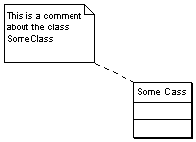
A comment is simply a way to add additional documentation for the reader of a diagram.

Class
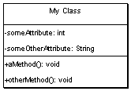

Classes are described as simple boxes that are divided up into three sections:
- Top – the name of the class
- Middle – the attributes of the class
- Bottom – the methods of the class

Attributes

attributeName: typeOfAttribute

Methods

methodName( ParameterType paramName, ParameterType2 param2Name, …): returnType

Visibility of Attributes and Methods
Methods and attributes definitions can optionally also indicate whether their visibility:
- Public (+)
- Protected (#)
- Private (-)
In the example both attributes are private, and both methods are public.

Implementing an Interface

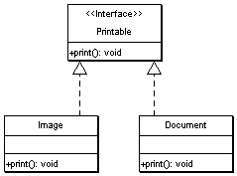
An interface specifies a set of public behaviours (a “contract”) that a class exposes to the world. In UML an interface is shown as a class, but is often distinguished as an interface by the marker “<<interface>>”.

A dotted arrow from a class to an interface indicates that this class fulfils the contract specified by that interface. In the above example both Document and Image share a common interface, Printable.

Inheritance
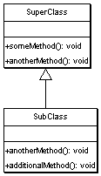
An arrow shows inheritance between classes, with the arrow pointing from the sub-class (or derived class) to the super-class (or base class)

The example diagram shows that instances of SubClass will have three methods:
- someMethod – inherited from the parent class
- anotherMethod – a polymorphic method inherited from the parent class. The behaviour is the same, but the implementation is different
- additionalMethod – a new method available only on the derived class

