Practical 1 :
Write a Python program that checks if the entered username and password match predefined values.
print("Name : Krishna \n Roll No : 1323215")
USERNAME = "admin"
PASSWORD = "12345"
entered_username = input("Enter username: ")
entered_password = input("Enter password: ")
if entered_username.lower() == USERNAME and entered_password.lower() == PASSWORD:
print(" Login successful! Welcome,", entered_username)
else:
print(" Invalid username or password. Please try again.")

OUTPUT
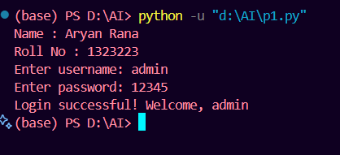

PRACTICAL 2 :
Write a program to print the given inverted right-angled triangle star pattern.
*****
****
***
**
*
print("Name : Krishna \n Roll No : 1323215")
rows = 5 # Number of rows
for i in range(rows, 0, -1):
print('*' * i)

OUTPUT
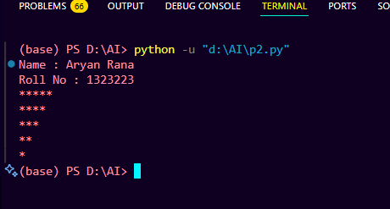

PRACTICAL 3 :
Write a program to print all prime numbers between 1 and 100.
print("Name : Krishna \n Roll No : 1323215")
print("Prime numbers between 1 and 100 are:")
for num in range(2, 101):
is_prime = True
for i in range(2, int(num ** 0.5) + 1):
if num % i == 0:
is_prime = False
break
if is_prime:
print(num, end=" ")
if num == 41 :
print("\n")

OUTPUT
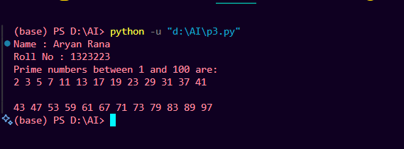

PRACTICAL 4 :
Convert a list of string numbers into integers and sort them in ascending order without using built-in sort functions.
print("Name : Krishna \n Roll No : 1323215")
string_numbers = ["10", "3", "45", "2", "8"]
int_numbers = [int(num) for num in string_numbers]
n = len(int_numbers)
for i in range(n):
for j in range(0, n - i - 1):
if int_numbers[j] > int_numbers[j + 1]:
int_numbers[j], int_numbers[j + 1] = int_numbers[j + 1], int_numbers[j]
print("Sorted numbers:", int_numbers)

OUTPUT
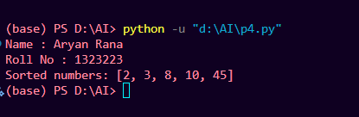

PRACTICAL 5 :
Use a dictionary to count the frequency of elements in a list.
print("Name : Krishna \n Roll No : 1323215")
my_list = ["apple", "banana", "apple", "orange", "banana", "apple"]
frequency = {}
for item in my_list:
if item in frequency:
frequency[item] += 1
else:
frequency[item] = 1
print("Frequency of elements:")
for key, value in frequency.items():
print(f"{key}: {value}")

OUTPUT
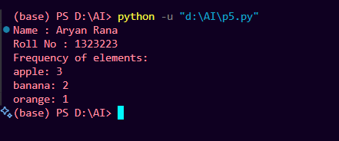

PRACTICAL 6 :
# Two sample lists
print("Name : Krishna \n Roll No : 1323215")
list1 = [1, 2, 3, 4, 5, 5, 2]
list2 = [4, 5, 6, 7, 5, 4]
common_elements = list(set(list1) & set(list2))
print("Unique common elements:", common_elements)

OUTPUT
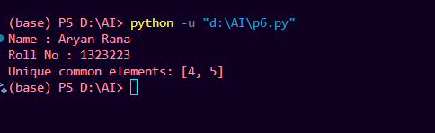

PRACTICAL 7 :
Replace all elements in a NumPy array greater than a threshold with that threshold
import numpy as np
print("Name : Krishna \n Roll No : 1323215")
arr = np.array([2, 5, 8, 10, 12, 15])
threshold = 10
arr = np.where(arr > threshold, threshold, arr)
print(arr)

OUTPUT
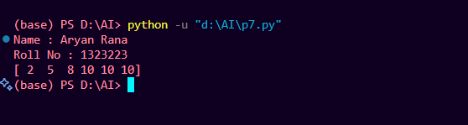

PRACTICAL 8 :
Replace missing values in a Pandas DataFrame with the mean of their columns.
import pandas as pd
import numpy as np
print("Name : Krishna \n Roll No : 1323215")
data = {
'A': [1, 2, np.nan, 4],
'B': [5, np.nan, 7, 8],
'C': [np.nan, 11, 12, 13]
}
df = pd.DataFrame(data)
print("Before filling missing values:\n", df)
df.fillna(df.mean(numeric_only=True), inplace=True)
print("\nAfter filling missing values:\n", df)

OUTPUT
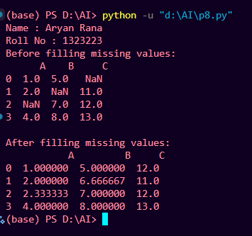
PRACTICAL 9 :
Load the Myntra dataset, perform info, shape, describe, and check for null values and calculate Total revenue and discount.
import pandas as pd
print("Name : Krishna \n Roll No : 1323215")
df = pd.read_csv("myntra.csv")
print(df.head(1), "\n")
print("=== Dataset Info ===")
print(df.info(), "\n")
print("=== Shape (Rows, Columns) ===")
print(df.shape, "\n")
print("=== Statistical Summary ===")
print(df.describe(), "\n")
print("=== Null Values ===")
print(df.isnull().sum(), "\n")
df["Revenue"] = df["discounted_price"]
df["Discount"] = df["marked_price"] - df["discounted_price"]
total_revenue = df["Revenue"].sum()
total_discount = df["Discount"].sum()
print("=== Totals ===")
print(f" Total Revenue: ₹{total_revenue:,.2f}")
print(f" Total Discount Given: ₹{total_discount:,.2f}")

OUTPUT
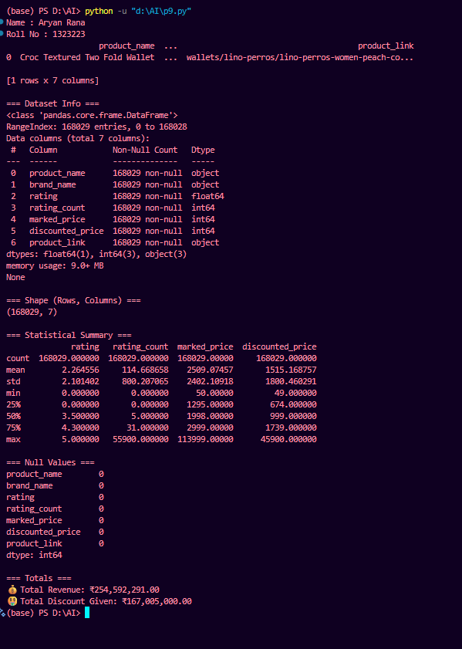
PRACTICAL 10 :
From the Myntra dataset, filter products priced above 2000 and belonging to the category “tshirts”.
import pandas as pd
df = pd.read_csv("myntra.csv")
df['category'] = df['product_link'].apply(lambda x: x.split('/')[0])
filtered_df = df[(df['discounted_price'] > 2000) & (df['category'] == 'tshirts')]
print(filtered_df)

OUTPUT
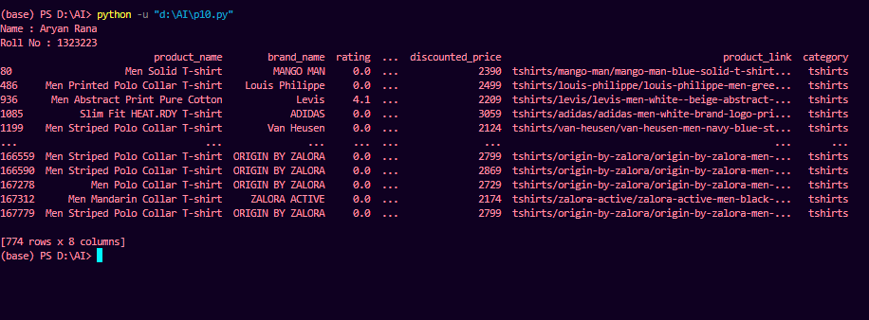

PRACTICAL 11 :
Plot a bar chart showing the number of products per brand
import pandas as pd
import matplotlib.pyplot as plt
df = pd.read_csv("myntra.csv")
brand_counts = df['brand_name'].value_counts()
plt.figure(figsize=(12, 6))
brand_counts.plot(kind='bar', color='skyblue')
plt.title('Number of Products per Brand', fontsize=16)
plt.xlabel('Brand', fontsize=12)
plt.ylabel('Number of Products', fontsize=12)
plt.xticks(rotation=45, ha='right')
plt.tight_layout()
plt.show()
OUTPUT
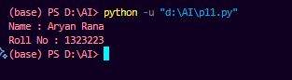
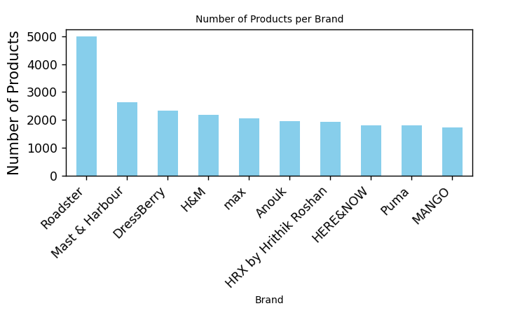
PRACTICAL 12 :
Find the average price of products grouped by category.
import pandas as pd
df = pd.read_csv("myntra.csv")
df['category'] = df['product_link'].apply(lambda x: x.split('/')[0])
avg_price = df.groupby('category')['discounted_price'].mean()
print("Average price of products per category:\n")
print(avg_price)

OUTPUT
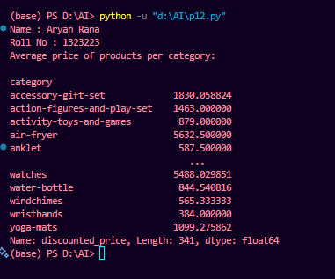

PRACTICAL 13:
Load the Housing dataset, clean it, visualize correlation, encode categorical values, split (70:30), train Linear Regression, evaluate with R² and MSE..
import pandas as pd
import numpy as np
import seaborn as sns
import matplotlib.pyplot as plt
from sklearn.datasets import fetch_california_housing
from sklearn.model_selection import train_test_split
from sklearn.linear_model import LinearRegression
from sklearn.metrics import r2_score, mean_squared_error
print("Name : Krishna \nRoll No : 1323215")
housing = fetch_california_housing(as_frame=True)
df = housing.frame
print("Shape:", df.shape)
print(df.head())
print("\nMissing values:\n", df.isnull().sum())
df = df.drop_duplicates()
plt.figure(figsize=(10, 6))
sns.heatmap(df.corr(), annot=True, cmap='coolwarm')
plt.title("Correlation Matrix")
plt.show()
print("\nData types:\n", df.dtypes)
X = df.drop('MedHouseVal', axis=1)
y = df['MedHouseVal']
X_train, X_test, y_train, y_test = train_test_split(
X, y, test_size=0.3, random_state=42)
model = LinearRegression()
model.fit(X_train, y_train)
y_pred = model.predict(X_test)
r2 = r2_score(y_test, y_pred)
mse = mean_squared_error(y_test, y_pred)
print("\nModel Performance:")
print(f"R² Score: {r2:.4f}")
print(f"Mean Squared Error: {mse:.4f}")
plt.figure(figsize=(6, 6))
sns.scatterplot(x=y_test, y=y_pred)
plt.xlabel("Actual Values")
plt.ylabel("Predicted Values")
plt.title("Actual vs Predicted House Prices")
plt.show()
OUTPUT
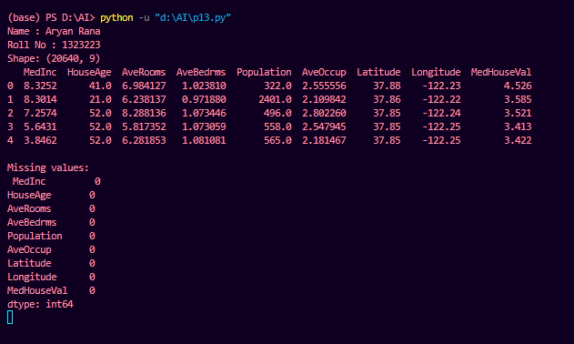

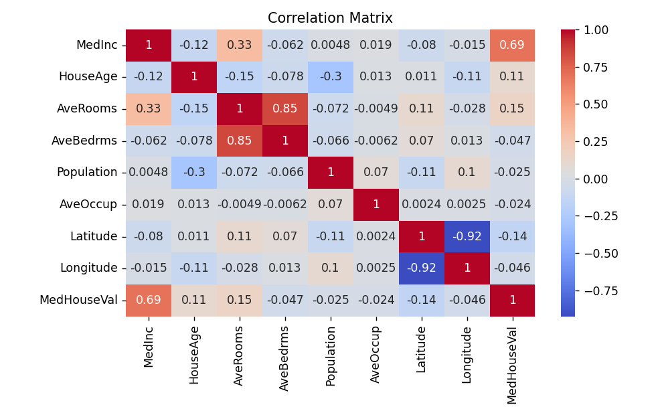
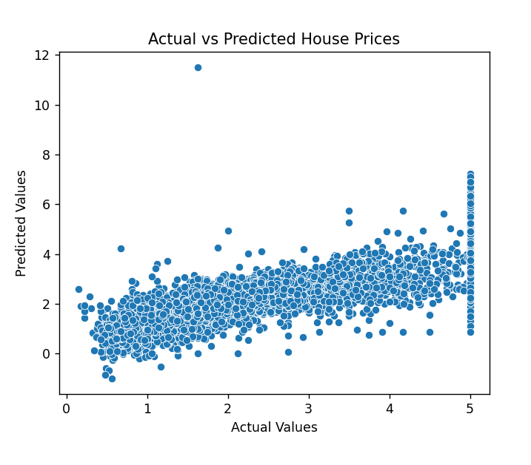
PRACTICAL 14:
Train a Decision Tree classifier on the Iris dataset and evaluate accuracy.
import pandas as pd
from sklearn.datasets import load_iris
from sklearn.model_selection import train_test_split
from sklearn.tree import DecisionTreeClassifier
from sklearn.metrics import accuracy_score, classification_report, confusion_matrix
import seaborn as sns
import matplotlib.pyplot as plt
print("Name : Krishna \nRoll No : 1323215")
iris = load_iris()
df = pd.DataFrame(iris.data, columns=iris.feature_names)
df['target'] = iris.target
print("Dataset shape:", df.shape)
print(df.head())
X = df.drop('target', axis=1)
y = df['target']
X_train, X_test, y_train, y_test = train_test_split(
X, y, test_size=0.3, random_state=42
)
model = DecisionTreeClassifier(random_state=42)
model.fit(X_train, y_train)
y_pred = model.predict(X_test)
accuracy = accuracy_score(y_test, y_pred)
print(f"\n✅ Model Accuracy: {accuracy:.4f}")
print("\nClassification Report:")
print(classification_report(y_test, y_pred, target_names=iris.target_names))
cm = confusion_matrix(y_test, y_pred)
plt.figure(figsize=(5, 4))
sns.heatmap(cm, annot=True, fmt='d', cmap='Blues',
xticklabels=iris.target_names,
yticklabels=iris.target_names)
plt.xlabel("Predicted")
plt.ylabel("Actual")
plt.title("Confusion Matrix - Decision Tree on Iris")
plt.show()

OUTPUT
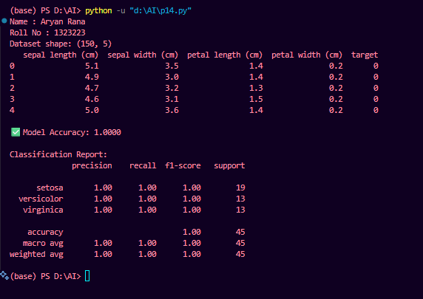
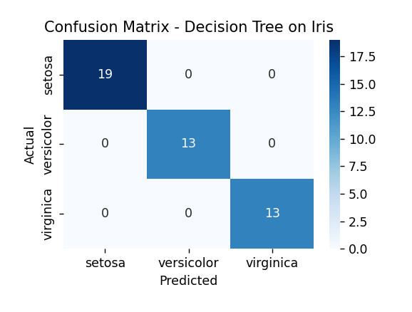
PRACTICAL 15:
Train a Random Forest on Pima Indian Diabetes dataset and compare results with other algorithms using LazyPredict.
# Import libraries
import pandas as pd
import numpy as np
import seaborn as sns
import matplotlib.pyplot as plt
from sklearn.model_selection import train_test_split
from sklearn.ensemble import RandomForestClassifier
from sklearn.metrics import accuracy_score, classification_report, confusion_matrix
from lazypredict.Supervised import LazyClassifier

print("Name : Krishna \nRoll No : 1323215")
df = pd.read_csv("diabetes.csv") # <-- ensure data.csv is in the same folder
print("Dataset shape:", df.shape)
print(df.head())
# Check for missing values
print("\nMissing values before cleaning:\n", df.isnull().sum())

# Replace 0 with NaN in certain medical features (invalid values)
cols_with_zero = ['Glucose', 'BloodPressure', 'SkinThickness', 'Insulin', 'BMI']
df[cols_with_zero] = df[cols_with_zero].replace(0, np.nan)

# Fill missing with median values
df.fillna(df.median(), inplace=True)
print("\nMissing values after cleaning:\n", df.isnull().sum())
plt.figure(figsize=(12,8))
sns.heatmap(df.corr(), annot=True, cmap='coolwarm')
plt.title("Feature Correlation - Pima Indians Diabetes Dataset")
plt.suptitle("Krishna", fontsize=12, fontweight='bold')
plt.show()
X = df.drop('Outcome', axis=1)
y = df['Outcome']
X_train, X_test, y_train, y_test = train_test_split(
X, y, test_size=0.3, random_state=42
)
rf = RandomForestClassifier(random_state=42)
rf.fit(X_train, y_train)
y_pred = rf.predict(X_test)
accuracy = accuracy_score(y_test, y_pred)
print(f"\n Random Forest Accuracy: {accuracy:.4f}")
print("\nClassification Report:\n", classification_report(y_test, y_pred))
cm = confusion_matrix(y_test, y_pred)
plt.figure(figsize=(5,4))
sns.heatmap(cm, annot=True, fmt='d', cmap='Blues')
plt.xlabel('Predicted')
plt.ylabel('Actual')
plt.suptitle("Krishna", fontsize=12, fontweight='bold')
plt.title('Confusion Matrix - Random Forest')
plt.show()
clf = LazyClassifier(verbose=0, ignore_warnings=True, custom_metric=None)
models, predictions = clf.fit(X_train, X_test, y_train, y_test)
print("\nModel Comparison Results:\n")
print(models.head(10)) # Show top 10 models

OUTPUT
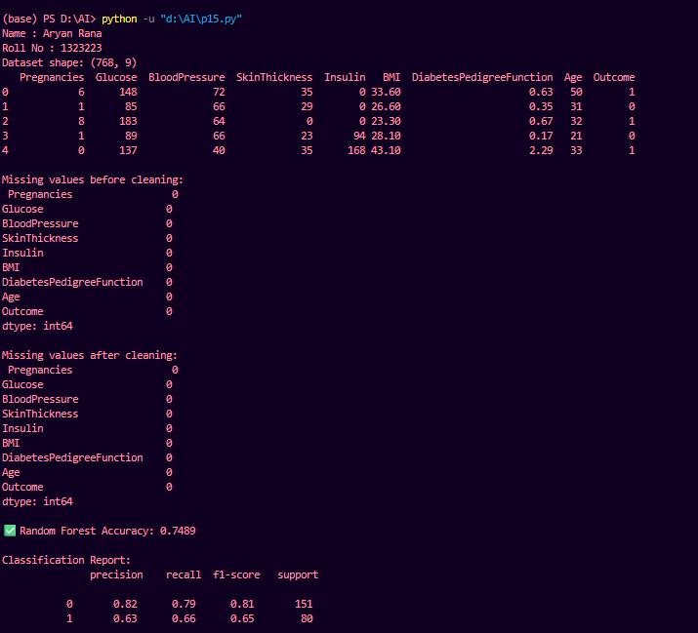
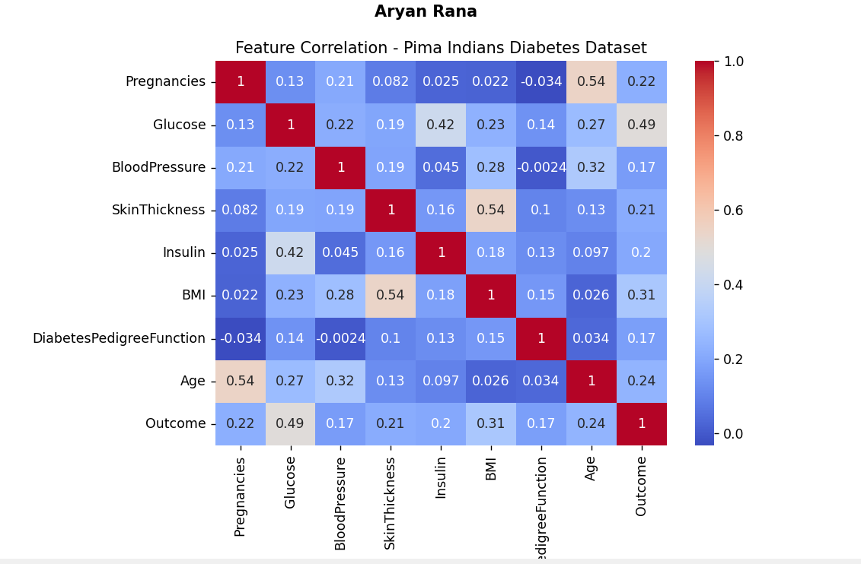

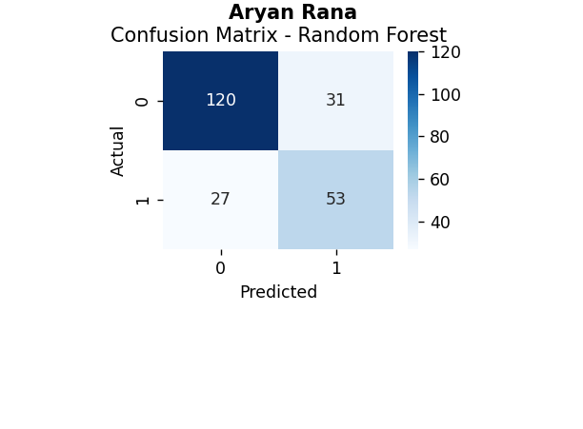
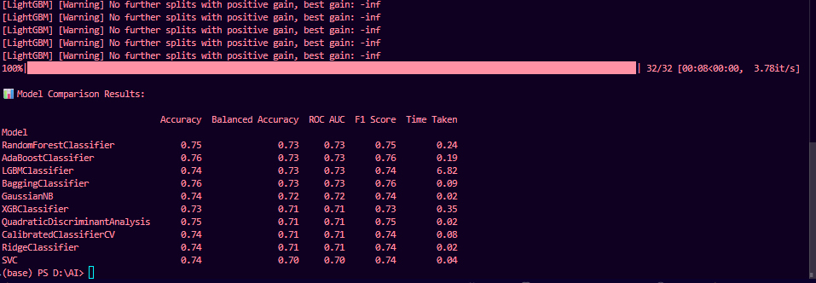

Q16. Perform K-Means on Iris dataset and visualize clusters.
import matplotlib.pyplot as plt
from sklearn.datasets import load_iris
from sklearn.cluster import KMeans
from sklearn.decomposition import PCA
import pandas as pd
print("Namer : Krishna \nRoll No. : 1323215")
iris = load_iris()
X = iris.data
y = iris.target
kmeans = KMeans(n_clusters=3, random_state=42)
kmeans.fit(X)
labels = kmeans.labels_
pca = PCA(n_components=2)
reduced_X = pca.fit_transform(X)
df = pd.DataFrame(reduced_X, columns=["PC1", "PC2"])
df["Cluster"] = labels
plt.figure(figsize=(8, 6))
plt.scatter(df["PC1"], df["PC2"], c=df["Cluster"], cmap="viridis", s=50)
plt.title("K-Means Clusters on Iris Dataset (PCA Reduced)")
plt.xlabel("Principal Component 1")
plt.ylabel("Principal Component 2")
plt.show()
print(df.head())
OUTPUT
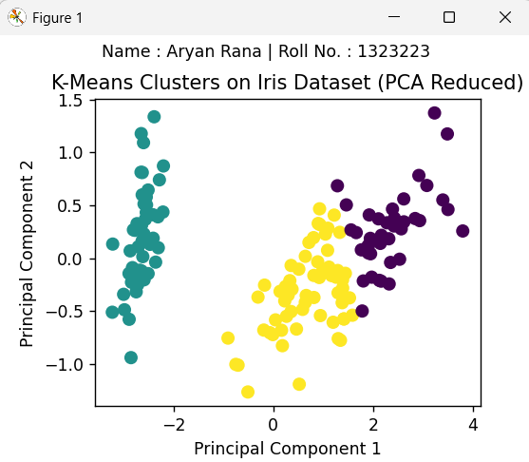
Q17. Use Tensorflow to build a feedforward neural network for MNIST digit classification.
import tensorflow as tf
from tensorflow.keras import layers, models
import matplotlib.pyplot as plt
import numpy as np
(x_train, y_train), (x_test, y_test) = tf.keras.datasets.mnist.load_data()
x_train, x_test = x_train / 255.0, x_test / 255.0
x_train = x_train.reshape(-1, 28*28)
x_test = x_test.reshape(-1, 28*28)
model = models.Sequential([
layers.Dense(128, activation='relu', input_shape=(784,)),
layers.Dense(64, activation='relu'),
layers.Dense(10, activation='softmax')
])
model.compile(optimizer='adam',
loss='sparse_categorical_crossentropy',
metrics=['accuracy'])
model.fit(x_train, y_train, epochs=5, batch_size=128, validation_split=0.1)
test_loss, test_acc = model.evaluate(x_test, y_test)
print(f"Test Accuracy: {test_acc:.4f}")
predictions = model.predict(x_test[:10])
predicted_labels = np.argmax(predictions, axis=1)
plt.figure(figsize=(10, 4))
for i in range(2):
plt.subplot(2, 5, i + 1)
plt.imshow(x_test[i].reshape(28, 28), cmap='gray')
plt.title(f"Pred: {predicted_labels[i]}, True: {y_test[i]}")
plt.axis('off')
plt.tight_layout()
plt.suptitle("Name : Krishna | Roll No. : 1323215", fontsize=10)
plt.show()

OUTPUT
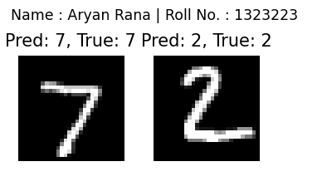
Q18. Train a CNN on a Brain Tumor Detection dataset to predict if an image has a tumor or not.
import os
import tensorflow as tf
import numpy as np
import matplotlib.pyplot as plt
import cv2
from tensorflow.keras.preprocessing.image import ImageDataGenerator
from tensorflow.keras import layers, models
import random
data_dir = r"D:\AI\archive\brain_tumor_dataset"
img_size = (128, 128)
datagen = ImageDataGenerator(rescale=1./255, validation_split=0.2)
train = datagen.flow_from_directory(data_dir, target_size=img_size, subset='training', class_mode='binary')
val = datagen.flow_from_directory(data_dir, target_size=img_size, subset='validation', class_mode='binary')
model = models.Sequential([
layers.Conv2D(32, (3,3), activation='relu', input_shape=img_size+(3,)),
layers.MaxPooling2D(2,2),
layers.Conv2D(64, (3,3), activation='relu'),
layers.MaxPooling2D(2,2),
layers.Flatten(),
layers.Dense(64, activation='relu'),
layers.Dense(1, activation='sigmoid')
])
model.compile(optimizer='adam', loss='binary_crossentropy', metrics=['accuracy'])
model.fit(train, validation_data=val, epochs=5)
sample_images = random.sample(val.filepaths, 3)
plt.figure(figsize=(12, 4)) # wide figure for single-row display
for i, path in enumerate(sample_images):
img = cv2.imread(path)
img_resized = cv2.resize(img, img_size)
gray = cv2.cvtColor(img_resized, cv2.COLOR_BGR2GRAY)
_, mask = cv2.threshold(gray, 180, 255, cv2.THRESH_BINARY)
contours, _ = cv2.findContours(mask, cv2.RETR_EXTERNAL, cv2.CHAIN_APPROX_SIMPLE)
marked = img_resized.copy()
cv2.drawContours(marked, contours, -1, (255, 0, 0), 2)
plt.subplot(1, 3, i + 1)
plt.imshow(cv2.cvtColor(marked, cv2.COLOR_BGR2RGB))
plt.title(f"Tumor: {'Yes' if 'yes' in path else 'No'}", fontsize=8)
plt.suptitle("Name : Krishna | Roll No. : 1323215", fontsize=10)
plt.axis('off')
plt.tight_layout()
plt.show()

OUTPUT
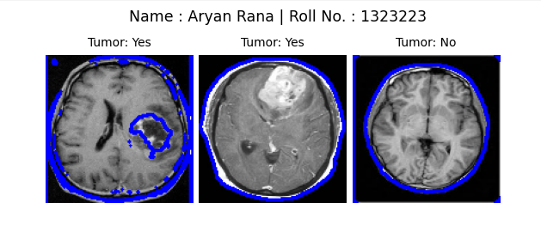

Q19. Train another feedforward neural network on MNIST to practice hyperparameter tuning.
import tensorflow as tf
from tensorflow.keras import layers, models, optimizers
from tensorflow.keras.datasets import mnist
import numpy as np
import matplotlib.pyplot as plt
(x_train, y_train), (x_test, y_test) = mnist.load_data()
x_train, x_test = x_train / 255.0, x_test / 255.0
x_train = x_train.reshape(-1, 28*28)
x_test = x_test.reshape(-1, 28*28)
def build_model(hidden_units=128, learning_rate=0.001):
model = models.Sequential([
layers.Dense(hidden_units, activation='relu', input_shape=(784,)),
layers.Dense(hidden_units // 2, activation='relu'),
layers.Dense(10, activation='softmax')
])
optimizer = optimizers.Adam(learning_rate=learning_rate)
model.compile(optimizer=optimizer,
loss='sparse_categorical_crossentropy',
metrics=['accuracy'])
return model
hidden_units_list = [64, 128, 256]
learning_rates = [0.01, 0.001]
batch_sizes = [64, 128]
best_acc = 0
best_config = None
for hidden_units in hidden_units_list:
for lr in learning_rates:
for batch in batch_sizes:
print(f"\nTraining model: hidden_units={hidden_units}, lr={lr}, batch={batch}")
model = build_model(hidden_units, lr)
history = model.fit(x_train, y_train, epochs=3, batch_size=batch, validation_split=0.1, verbose=0)
val_acc = history.history['val_accuracy'][-1]
print(f"Validation Accuracy: {val_acc:.4f}")
if val_acc > best_acc:
best_acc = val_acc
best_config = (hidden_units, lr, batch)
print(f"\nBest configuration -> Hidden Units: {best_config[0]}, Learning Rate: {best_config[1]}, Batch Size: {best_config[2]}")
final_model = build_model(best_config[0], best_config[1])
final_model.fit(x_train, y_train, epochs=5, batch_size=best_config[2], validation_split=0.1, verbose=1)
test_loss, test_acc = final_model.evaluate(x_test, y_test)
print(f"Test Accuracy (Best Model): {test_acc:.4f}")
predictions = final_model.predict(x_test[:10])
predicted_labels = np.argmax(predictions, axis=1)
plt.figure(figsize=(8, 4))
for i in range(2):
plt.suptitle("Name : Krishna | Roll No. : 1323215", fontsize=8)
plt.subplot(1, 2, i + 1)
plt.imshow(x_test[i].reshape(28, 28), cmap='gray')
plt.title(f"Pred: {predicted_labels[i]}, True: {y_test[i]}")
plt.axis('off')
plt.tight_layout()
plt.show()

OUTPUT

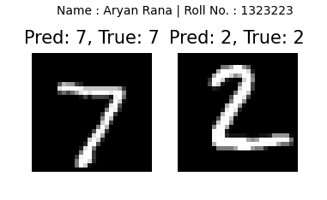
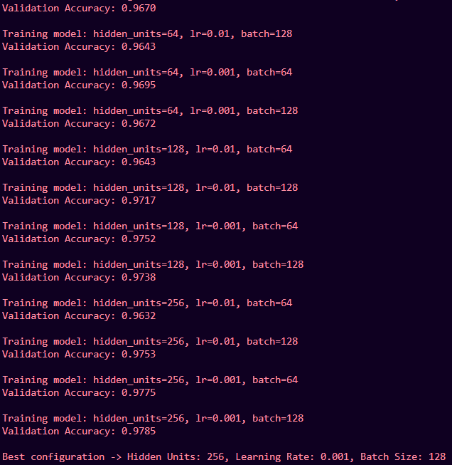

Q20. Use a pre-trained DistilBERT model for sentiment classification of text.
from transformers import pipeline
sentiment_pipeline = pipeline(
"sentiment-analysis",
model="distilbert-base-uncased-finetuned-sst-2-english",
tokenizer="distilbert-base-uncased-finetuned-sst-2-english"
)
texts = [
"I'm so excited about this new technology!",
"The quality is poor and I want a refund.",
"It's decent but could be better."
]

results = sentiment_pipeline(texts)

for text, result in zip(texts, results):
print(f"Text: {text}")
print(f"Label: {result['label']}, Score: {result['score']:.4f}")
print("-" * 50)

OUTPUT
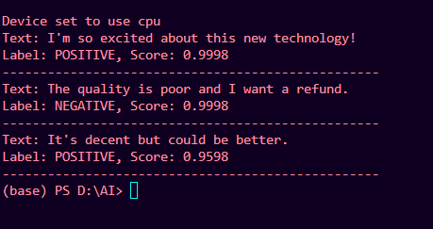

Q21. Use Hugging Face pipeline("text-generation") with GPT-2 to generate text from a prompt.
from transformers import pipeline, AutoTokenizer, AutoModelForCausalLM
tokenizer = AutoTokenizer.from_pretrained("gpt2")
tokenizer.pad_token = tokenizer.eos_token
model = AutoModelForCausalLM.from_pretrained("gpt2")
generator = pipeline(
"text-generation",
model=model,
tokenizer=tokenizer
)
def gpt(prompt):
result = generator(
prompt,
max_new_tokens=60,
temperature=0.7,
top_p=0.9,
truncation=True,
pad_token_id=tokenizer.eos_token_id
)
return result[0]["generated_text"]
print("Type 'exit' or 'quit' to end the program.\n")
while True:
user_input = input("You: ").strip()
if user_input.lower() in ("exit", "quit", "bye"):
print("GPT: Goodbye!")
break
elif user_input in ("hii", "hello", "hi","hey"):
print("GPT: Hello! How can I assist you today?")
continue
else:
response = gpt(user_input)
print("GPT:", response)

OUTPUT
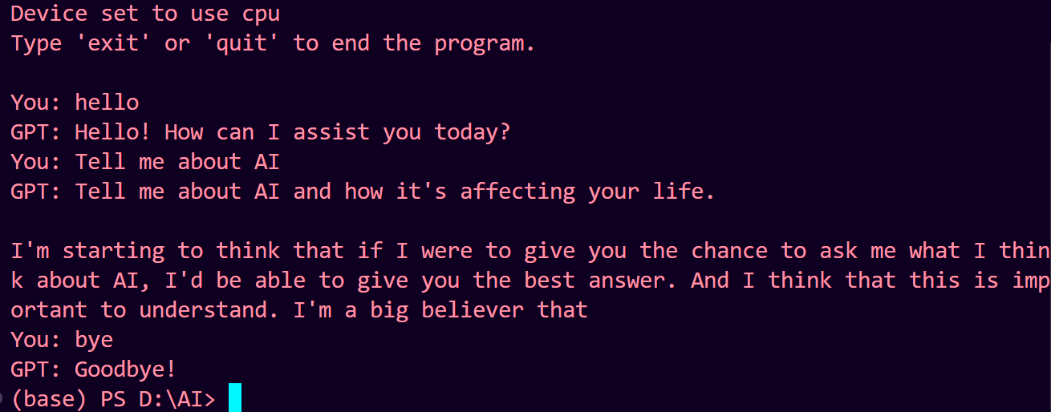
Q22. Use Hugging Face Diffusers (Stable Diffusion) to generate images from text prompts.
import torch
from diffusers import DiffusionPipeline
pipeline = DiffusionPipeline.from_pretrained(
"stabilityai/stable-diffusion-xl-base-1.0",
torch_dtype=torch.float16,
variant="fp16"
)
if torch.cuda.is_available():
pipeline.to("cuda")
else:
print("CUDA not available. Running on CPU (this will be very slow).")
prompt = "An astronaut riding a horse on Mars, high quality, digital art"
negative_prompt = "blurry, low quality, bad anatomy, text, watermark"
print("Generating image...")
image = pipeline(
prompt=prompt,
negative_prompt=negative_prompt,
num_inference_steps=30,
guidance_scale=7.5
).images[0]
image.save("astronaut_on_mars.png")
print("Image saved as 'astronaut_on_mars.png'")

OUTPUT
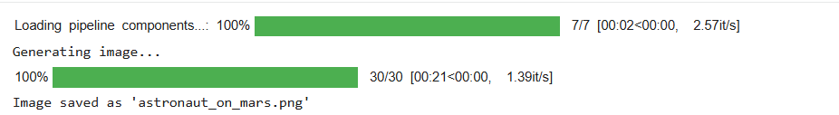


Q23. Use Google open source gemini api key and create a suitable promptings to build a personalize text summarizer
import os
from dotenv import load_dotenv
import google.generativeai as genai
load_dotenv()
api_key = os.getenv("GEMINI_API_KEY")
if not api_key:
raise ValueError("GEMINI_API_KEY is missing in the .env file.")
genai.configure(api_key=api_key)
PERSONAL_SUMMARY_PROMPT = """
You are a personalized text-summarizer.
Summarize the given text with the following rules:
1. Output must be factual and concise.
2. Remove repetitive, irrelevant, or emotional filler.
3. Preserve important technical details, data, and definitions.
4. Maintain a professional tone.
5. Format the output using short paragraphs or bullet points.
6. Do not add assumptions or opinions.
Text to summarize:
{input_text}
Generate the best possible summary.
"""
model = genai.GenerativeModel("gemini-2.5-flash")
def summarize_text(text):
prompt = PERSONAL_SUMMARY_PROMPT.format(input_text=text)
try:
response = model.generate_content(prompt)
return response.text
except Exception as e:
return f"An error occurred during summarization: {e}"
input_text = """
Artificial Intelligence is transforming industries by automating tasks,
enhancing decision-making, and increasing operational efficiency.
However, concerns such as job displacement, ethical risks, and privacy
issues are rising as AI adoption grows.
"""
print(summarize_text(input_text))

OUTPUT
