**VPN Setup & Usage Report – Kali Linux**

Tool Used: RiseUp VPN (Free, Unlimited, No Account Required)

**1. VPN Setup Steps in Kali Linux**

**✅ Install RiseUp VPN Client**

sudo apt install riseup-vpn -y

**✅ Launch the RiseUp VPN Application**

riseup-vpn &  
# or open from Applications → Internet → RiseUp VPN

**✅ Connect to a VPN Server**

Click RiseUp VPN tray icon → Connect

**✅ Verify Your IP Address Has Changed**

curl ifconfig.me  
# Compare before and after connection  
# Or check https://whatismyipaddress.com

**✅ Confirm Traffic is Encrypted**

Open Wireshark → Select active interface → Browse websites  
# Look for TLS/HTTPS packets

**✅ Disconnect from VPN**

Click tray icon → Disconnect  
# OR  
pkill riseup-vpn

**2. VPN Connection Status Screenshot**

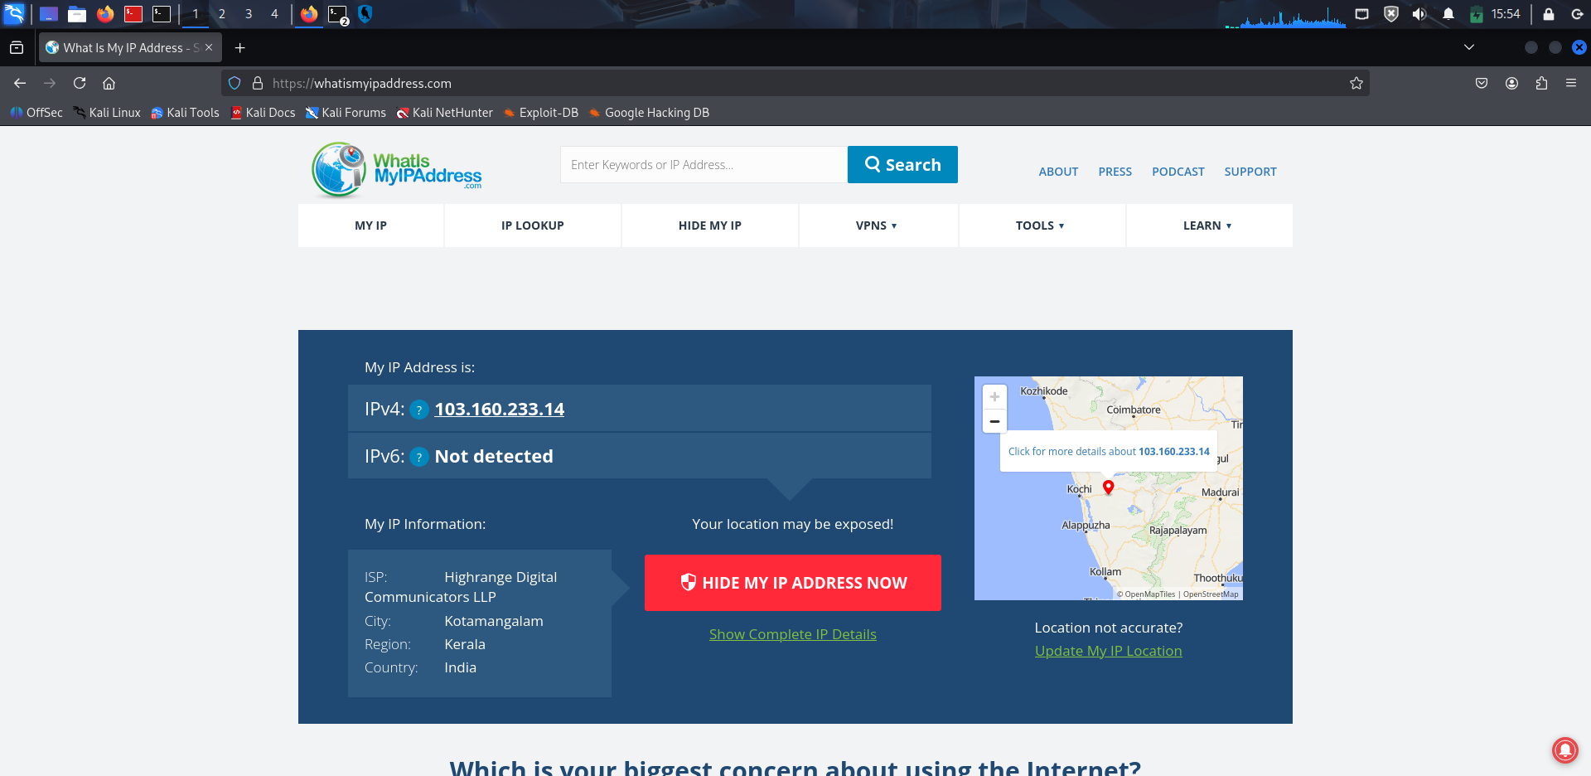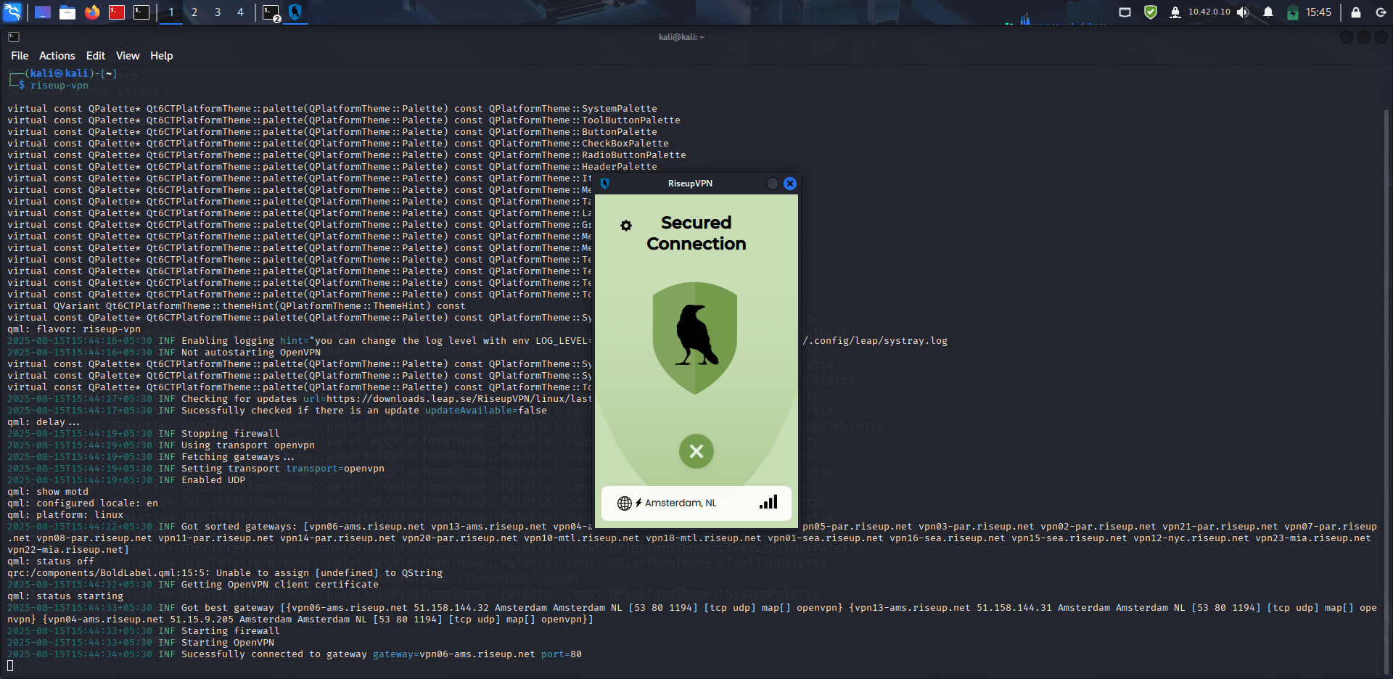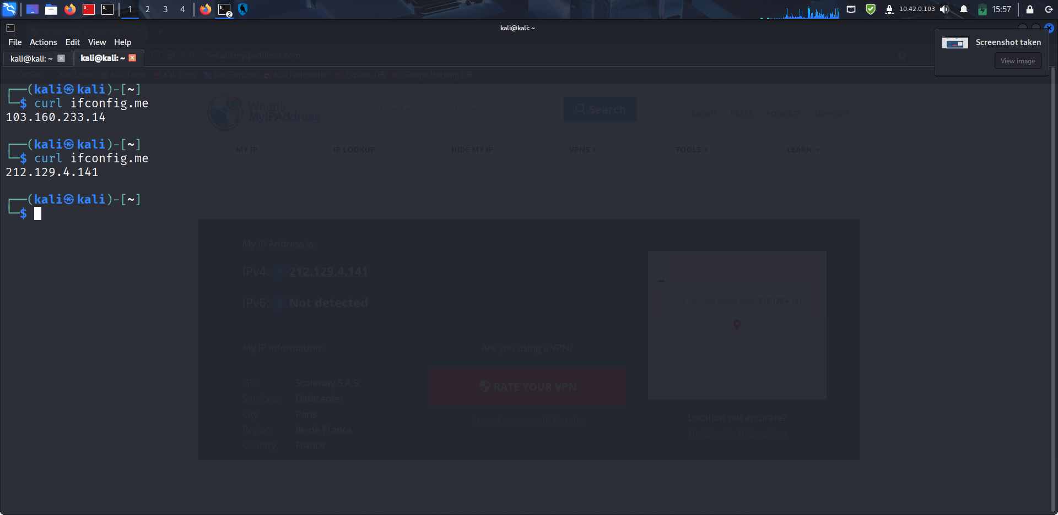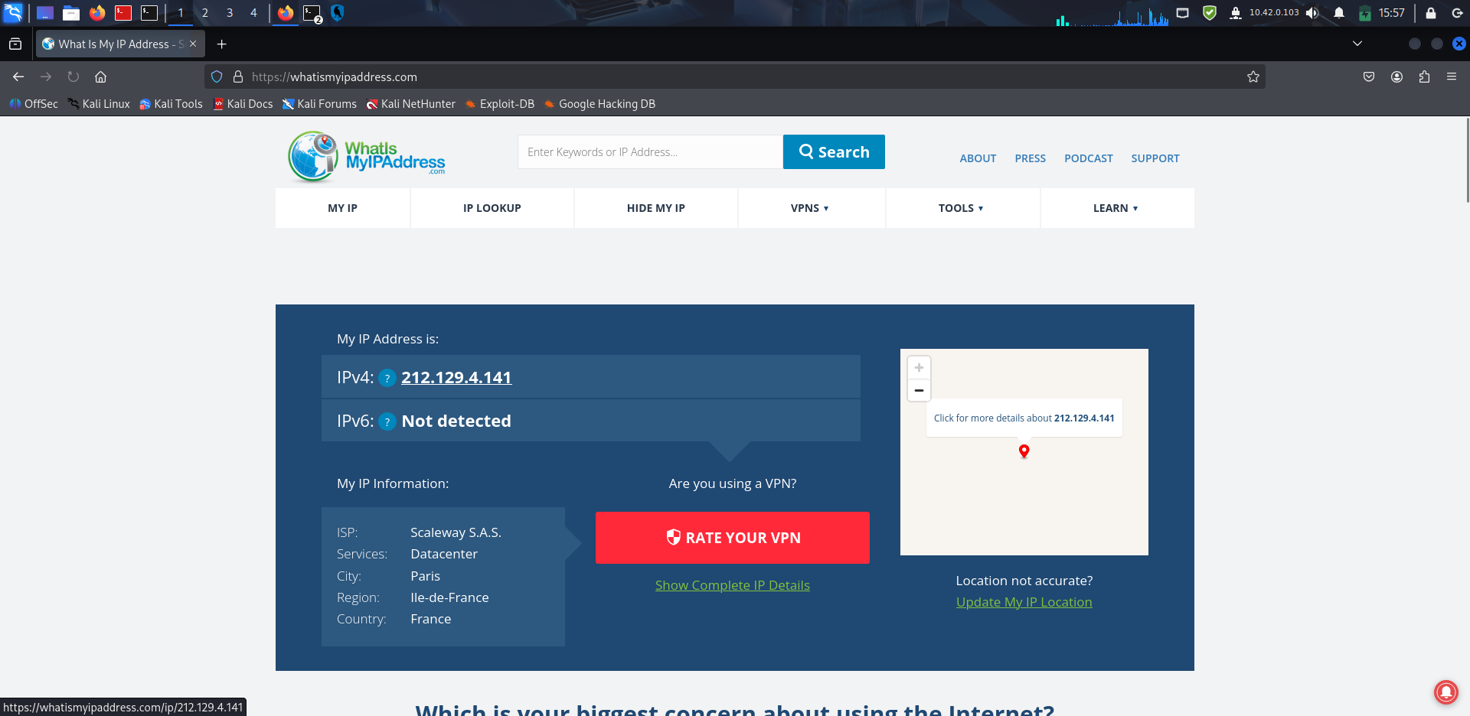

**3. RiseUp VPN Encryption & Privacy Features**

• Encryption: OpenVPN protocol with AES-256-bit encryption.

• No Account Needed: Preserves anonymity from the start.

• DNS Leak Protection: Prevents DNS requests from leaking to ISP.

• Privacy Focused: Built for journalists, activists, and privacy-conscious users.

**4. Benefits of Using RiseUp VPN**

• Protects Privacy – Hides your real IP address.

• Encrypts Traffic – Prevents data interception.

• Bypasses Censorship – Access blocked sites.

• No Sign-Up Needed – Fully anonymous from the start.

**5. Limitations**

• No Server Choice – Automatic location selection only.

• Potential Speed Drops – Especially during peak times.

• Basic Interface – No advanced protocol or location options.

**6. Outcome**

Successfully installed and configured RiseUp VPN on Kali Linux.  
Verified IP change and encrypted browsing.  
Gained hands-on understanding of VPN security and privacy features.