Web design project 2018

Project report

Andrea Baccolini

x18147518@student.ncirl.ie

Table of Contents

Introduction 2

The reasons behind 2

Target markets 2

Concept development 3

Actual action plan 4

Milestones 7

Competition 7

Conclusion 8

Personas Introduction 8

Personas 9

Conclusion 10

Wireframes 10

Usability test 13

Test methodology 13

Questionnaire 13

Conclusion 14

# Introduction

The document describes the preliminary activity and the development of a website for building your own bicycle or simply buy a new one from the available set.

The website is basically the showcase of my personal bicycle laboratory / café’ where bicycles are assembled and in few cases created custom based on customer specifications, between coffees and pastries. The café/lab is a small activity basically in-house where I create bicycles and assemble them by buying second hand parts or brand new: depends on what is the requirement from the buyers.

## The reasons behind

Reason to build a website for this activity are the following:

[A] Giving the audience a straight forward simple online tool to consult for buying a new bicycle or a custom one when they are at home, in office [during breaks], or on the train/bus during their commute. With the website the users can browse the different options and surf the pages, looking for the bikes available or parts available and eventually, if they like something, make a purchase with delivery straight to their address. With the website also the user can create a custom version of a specific idea they have in mind, by assembling the different pieces available.

[B] Create a sort of small centre where people that have passion for bicycle and coffee and ideas can meet and discuss, share ideas and also fix their issues with their bicycle, if any. The website contains a section where users can exchange their ideas on how “the perfect bicycle” should be or, in the majorities of the cases, to receive consultation from other users on how to fix something or to build something.

[C] Meet the growing demand for custom products and solutions, maintaining the price reasonable and reusing parts from existing bicycles/second hand products. This is also an important reason t create the website. As the demand of “being unique” is growing in all the markets, basically, also the small sized bicycle should adapt itself to this wave. On the website the users can create their own brand new customized bike, by assembling it with the available parts on the website. With the website is much easier for the users to visualize their idea of custom and to refine it during the assembling process.

## Target markets

The other reason for building the website is to reach the “silent” market, which is the amount of people that have no knowledge of my café/lab or do not have any time to pop in if they are around or they are geographically far away from my location.

The addressable market size in this case is huge. Considering the following main users to address in locations close to my location [Co. Dublin – Ireland]:

[A] Commuters [work and/or study]: around 500,000 and more are total workers and people commuting in and out Dublin if we consider a small percentage [let’s say 10%] of them, a total of around 50,000 users could be a target market for commuters [which is a huge number]

[B] Sport [amateurs] bikers: this is the second possible small-medium sized market, made of sport bikers, trekkers, mountain bikers and road bikers in general.

[C] Casual users: users that have low interest in bike, but they want/need it for daily small tasks [older

Geographical area: EU: as a website this virtual shop can be reached also outside my location [Co. Dublin – Ireland].

Average age of users: between 20 and 50 years of age for section [A and B]. casual users can be any age [no kids bicycles availability, thou]. Sex target is male and women.

# Concept development

The website has mostly to be useful for the 3 main reasons highlighted in section “The reasons behind” which are the following:

[A] browse and buy existing bicycles/parts

[B] create a custom version of a bicycle

[3] consult and ask/answer questions in the blog sections on bike issues and others

Please see the below site plan as provisional high level site plan.

The core areas of the website are the following:

* Product catalog: under this section, the users have the ability to surf the different pages for the different products: bicycles or components. That is done under the different pages of the products [product1 … product].

In addition, under this section the users are able to create their own custom version of a bicycle by entering the “make your own” part, where users are able to assemble the different parts and create their own custom version of bicycle.

Both the 2 subsections under “products catalog” end up with a search and a result and eventually to a shopping cart for final check out and payment of the product. In order to be able to buy products or services, the users are not forced to be part of the community and register themselves, guest users are also welcome even in the discussion board section.

* Discussion board: this is the other important section of the website where users are “virtually” gathering to exchange opinions and/or ask questions on how to fix a particular issue for a specific bike etc… there is no moderator in the area, so the section is self-moderated by the users.

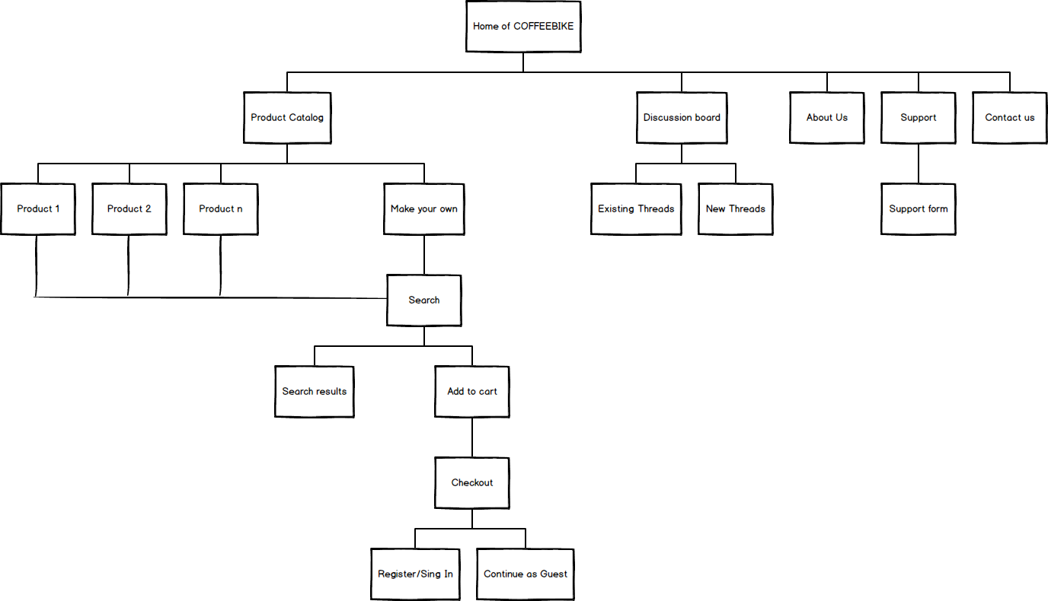

Figure 1

Other sections of the website are the following:

* About us: typical section where there is some history on who’s behind the website
* Support: section dedicated to support on bikes and spare parts, for faulty parts, returns etc…
* Contact us: section for who wants to get info on the products/solutions

## Actual action plan

The section describes the plan for delivering the website.

The initial plan is straight forward with some key main phases: additional breakdown of each phase is in the project plan.

[A] Planning: the initial phase includes the definition of the specifications and the scope for the website. During this phase is essential to have a clear understanding of the project scope and to prepare specific document as specifications to outline what needs to be done.

[B] Development and prototyping: this phase include design of the website and actual code development for the client and the server side, includes also potential connection with external third parties payment gateways [Paypal and Credit cards, this part has to be defined properly]. The technologies to be used for the development and the coding needs to be efficient and simple at the same time: preferred HTML for the front end so that pages can be easily maintained, and on the server side technologies like Ruby on rails can be very useful for the type of website.

[C] Testing: the testing phase includes prototype test and integration test for the actual potential deployment into the web.

[D] Release to production: this phase is critical in the sense that after a well done test period, the transition to production has to be as smooth as possible. Fortunately there is nothing to break on existing networks, and users, since this is brand new website.

Following the WBS structure of the website [preliminary] and the actual project plan.

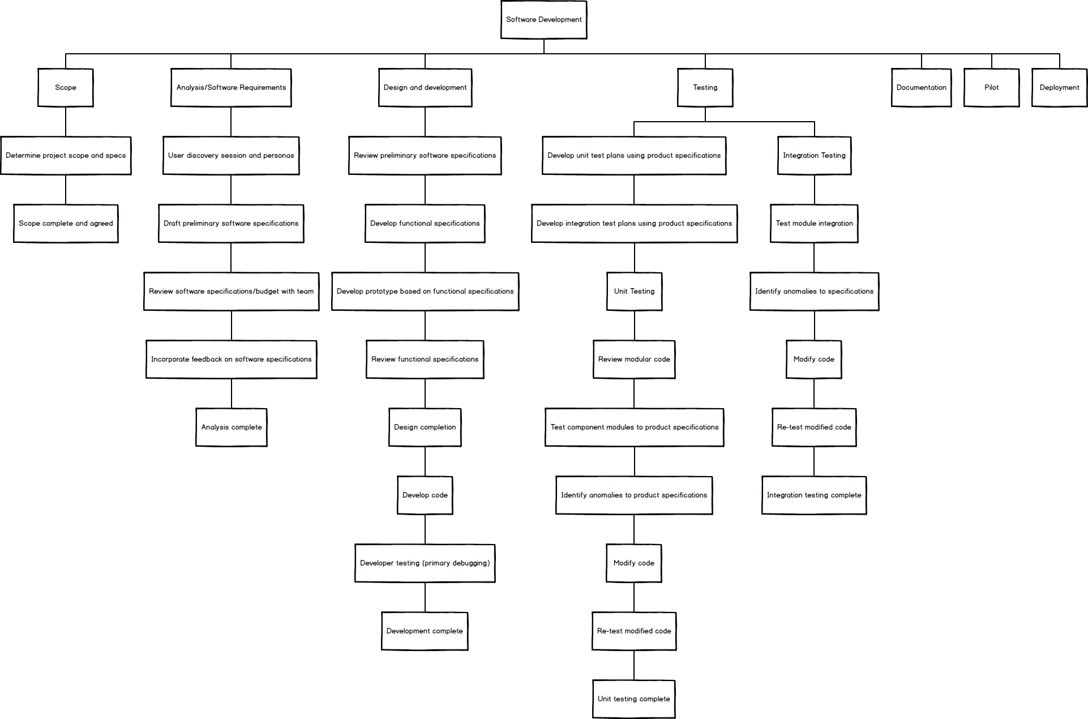

Figure 2



Figure 3



Figure 4



Figure 5



Figure 6

## Milestones

I have identified 4 key milestones for the entire project as following:

[A] Identification of the requirements and definition of the scope: this is clearly the most important milestone to pass, since a clear understanding of the requirement is necessary to obtain a good result. In this milestone I need to check the how the specs are close to what the market wants, therefore is very important the personas identification following the market test and the user discovery sessions.

[B] Testing: after the prototype and the development is finished, I think testing is the ultimate pre-production milestone that needs to be effectively met, in order to release a stable and usable version of the website to the market.

[C] a third milestone must be put right after the market launch to test the market response for the website launch and to potentially start tuning the offer based on the feedbacks received. Continuous milestones like this one can be very useful for the website.

# Competition

There is a lot of competition in the market, there are a lot of website for the following macro areas:

[A] urban bicycles [for commuters, city bikes, urban single speed/fixed]

[B] sport bicycles [including road, mountain and trekking]

[C] kids and folding bicycles

[D] forum and blogs

Some example of these websites can be the following with some of the ideas I like for my website too:

* <http://www.lastazionedellebiciclette.com/>
  + the format is clean in the format, with menu bar at the top and the bottom part with contacts, about us etc… very traditional and clean style. The main home page with picture showing the different bicycle types to be sold.
  + Links to the social on the bottom right.
* [www.fixedforum.it/](http://www.fixedforum.it/)
  + This is a forum website for mostly fixed/single speed bicycles, but you can also find the discussions for other types of bikes. This is exactly the type of forum I would like to have included in my website, people can easily find the discussion they are interested by just looking at the left column of the website and enter the discussion panel which is divided per subjects. A powerful search function is also available to search by thread, subject, discussion etc…

There are very few websites addressing the following 3 main areas at the same time:

[1] buy a bicycle

[2] custom section: create your own bicycle

[3] café/forum/blog to learn and exchange ideas on the “Zen and the art of Bicycle maintenance” [quasi quote ☺]

This is exactly what I am targeting to do. Bringing into one single website the best of these three areas.

## Conclusion

I hope to replicate the magic experience I have in real life by creating something new and combine passion to creativity.

The Website as it is planned, can be a very good virtual meeting location for passionate people and for creation of new ideas.

# Personas Introduction

The section describes the interview to the 4 different people to identify the personas for the website.

Following the list of questions asked to them as part of the interview process

1. Name
2. Age
3. Nationality
4. Profession
5. What’s your Primary mean of transport to work
6. Do you own or use a bicycle for any type of activity?
7. If so is it for sport, casual cycling or commuting?
8. What type of bicycle are you using?
   1. Road bicycle
   2. Trekking
   3. Mountain bike
   4. Touring
   5. Don't know
9. Would you be able to tell how many miles/km you bike every year?
10. Where did you buy your last bicycle
11. Can you tell me one thing you dislike in the process of buying your last bicycle?
12. What do you like and dislike about the current [or future] bicycle?
13. Would you be happy to create your own bicycle if you had the proper tools and knowledge?
14. Would you be willing to give and receive free advices about bicycle maintenance and/or locations to visit and/or anything around the world of bicycling?
15. How much would you budget for the right bicycle according to your needs?
16. Would you use the web as a place to look for advice or even to buy your perfect bicycle?
17. Would you define yourself as a beginner, intermediate or advanced user of computer and web browsing?
18. What are the three major characteristics of the webtool in your opinion to meet your needs?
19. Which social network do you use most?
20. Do you like coffee?

The questions have been submitted to 4 real people, 3 friends and my wife. All of them have answered in their own view, so the table below is “normalized” and showing their real answers.



## Personas

The persona that results at the end of this activity is the following

Name: LuChriBreiBarr

Profession: employee in a trade company

Around 34 years of age, male.

Loves outdoor sports and life, and has a lot of interests. Has experience in living in multicultural environments and open character and sociable.

LuChriBreiBarr is a hard worker and many times is job is inside 4 walls. He is not an avid sport fitness enthusiast, but he likes reserving time for his own physical health to boost his mental health. As a learner he likes to get his hand dirty with stuff and exploring new things. He needs a proper tool to make the above things easy and reliable so that he can enjoy more time outside and not spending too much time and effort finding the right bicycle by visiting ever shop around his place.

## Conclusion

The people interviewed come from different region, have different backgrounds and they live in different countries.

Their profession force them to live a different life from each other, in the sense that they have different type of interests and that reflects on the profession also.

The common item for each are coming out of the survey: something like: the use of bicycle for escaping everyday life but also for going to work. The need of having a nice comfortable place where they can get everything they want for their bicycle and also create their own which is a sign of distinction among the mass.

# Wireframes

Explanation and description of the wireframes as follow:

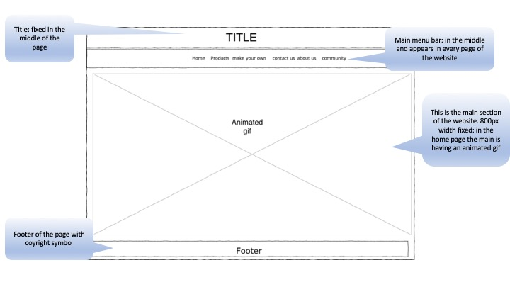

Homepage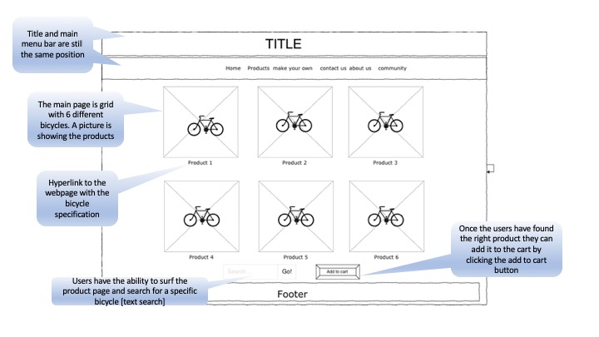products 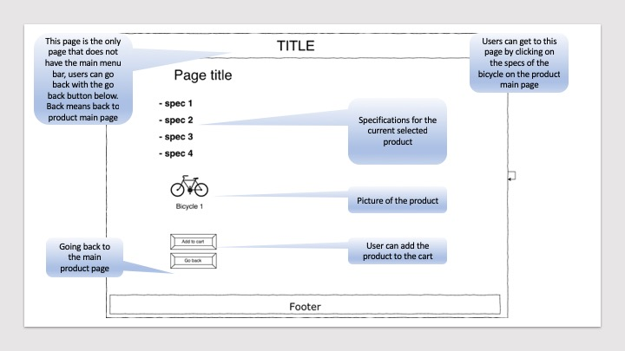spare parts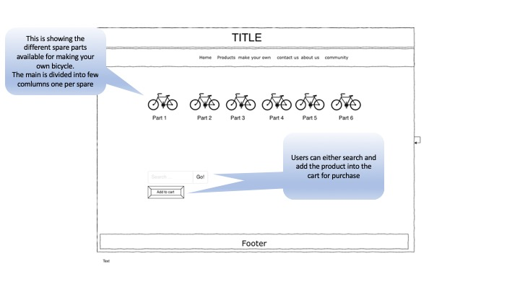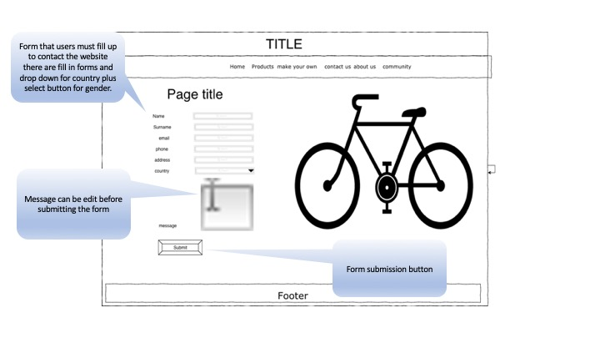contact us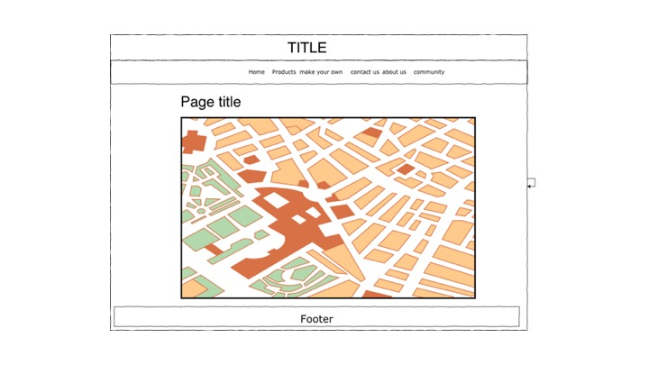about us

# Usability test

Luca is the guy that has been interviewed from the interview sheet [translated by me from Italian].

## Test methodology

the test used for checking the sanity of the website was pure user experience based test. Functional test mostly with a real user checking the page over the device using multiple different connection to the internet [mobile and cabled] at different speed rates. Subjective test in this case was used.

The objective of the test was to make sure that an interested user of the website, such as a potential buyer, could find the information he/she was looking into with minimum effort and with clarity. To assess this, few metrics were quite important, such as:

* Responsiveness of the pages over the different Connection speed
* Clarity of the content: do I know where I am on the website and am I finding the right things?
* Every user experience is different as people are all different, so was really very important to get an understanding of the different pages layout and images as well as because those are very important for the nature of the business.

## Questionnaire

1. **Did you like the website?**

**I did like the website, it is very focused and quite simple and straight forward**

1. **What about its layout, did you enjoy it?**

**I like the idea all the pages being framed in the same way, and I think that helps to find the information someone is looking for.**

1. **Did you find the information you were looking for easily?**

**I was looking for a bike you made for me few years ago and I found it there, there is no link to to expand it and look for the specs, but I am happy enough**

1. **Was the website navigation fast enough for you?**

**Website seems very light, navigation was fine except for the home page that was long to load, maybe just the poor connection I have in my shop..**

1. **What about intuitiveness of the navigation?**

**Pretty good I would say, I can navigate without problems**

1. **What are the missing pages in the website?**

**Well, I would love to see more details on the spare parts, and more details on the bicycles also. I would like to see a page where you can zoom on the parts of the bikes so that you can see the details**

1. **Were the images and tech info clear enough for you to find?**

**Yes pretty ok for me,**

1. **Was the style of fonts good in size and clear to read?**

**Loud and clear, maybe you can improve the fanciness of fonts ☺**

1. **Did the website help you in your search?**

**yes**

1. **Did you want to buy something after looking at the website?**

**I wanted to buy the whatever ☺**

## **Conclusion**

I would grade the result of the test as quite positive, because of the following reasons:

[A] the user seems to have appreciated the website and found the info that was looking for

[B] I got few important feedbacks on how to improve the site, and what road to take for it. There is still work to do, and the more the website will grow the more work will need to be done, but it is a very good starting point indeed.