Project Proposal

Project name: rockonnect

Andrea Baccolini

student number: 18147518

x18147518@student.ncirl.ie

HIGHER DIPLOMA in SCIENCE and WEB TECHNOLOGIES

National College of Ireland

Date: 03 June 2019

Contents

Project name: rockonnect 1

1. Objectives 3

2. Background 4

2.1. The idea behind the application 4

2.2. Target audience 4

3. Technical Approach 5

4. Special resources required 5

5. Project Plan 6

**6.** Technical Details 7

**7.** Evaluation 7

8. Appendix A: project plan gantt 8

# Objectives

The objective of the Project is to create an online platform which allows users to have a dedicated community focused on classical rock music. By “Classic Rock” is intended the music genre made of blues rock and hard rock music growing worldwide between the early 80s and the late 90s.

The online platform is a web application that can be accessed from any device having a browser and an internet connection. The web application is a way in between a social network app and a web forum. The name of the web app is “rockonnect”.

In more details rockonnect allows registered users to enjoy the following features:

[A] features pertaining to a traditional social media app: connect to/follow users that have an interesting profile and create / post user generated content like multimedia videos/pictures of classic rock events/instruments etc...

[B] features proper to a web forum: registered users can hold conversations [“threads”] in the form of posted messages. With this tool, users can exchange opinions and ideas about everything related to classic rock. Some examples are: threads on old published albums; concerts; rock bands performances, musicians; and musical instruments. The threads can be user even to organize and meet for jamming purposes. Anything that is related to classic rock can be discussed in the threads. There will be different user rights: seasoned users will also benefit of the admin rights which allow them to supervise the content and to ban users that might not comply with regulations. An email will be automatically generated from the web app to users for notifications purposes [such as like posts, users been added to somebody else list etc …]

rockonnect is not supposed to be used as a music file sharing system or for anything that can be subjected to copyright infringement and obscene/illegal material. It is responsibility of the users not to distribute such material through the web application.

Most of the current web applications are focused on the music streaming aspects of the classic rock music. There are plenty of these on the internet, and rockonnect is not going to provide any streaming radio functionality. Might collect a list of already available radio station streaming classic rocks songs, or users are free to exchange links to channels in the thread.

rockonnect content is going to be expanded by the community behind it, and the same community will drive the roadmap in term of features for the platform. The very first release of the web app might be very skinny in terms on content; the web app itself should be used as a framework and platform by the users who are then creating and expanding the community and the content behind it.

# Background

## The idea behind the application

Even thou there are a lot of existing web applications and website focused on music, the main driver for creating such an app is its goal to merge two of the most diffuse web application types: social media and web blogs/forums. rockonnect would like to offer the best aspects of both those type pf applications in a nice are like the classic rock where people like me, are sometimes struggling to share ideas or hints on musical instruments to use/techniques for playing some songs, for example, and having the possibility to connect with other users having the same struggles or a solution to those, or simply having shared more experience.

So, the “struggle” in finding a unique place as collector and booster of information specific to the genre had an important role in the decision behind the web app ideation. The first step in the research was to see what is available on the market today. I found a lot of applications that are music related mostly radio app broadcasting classic rock. I found also some social network applications, but not really focused on the genre. Most of the web applications on the internet are generic to music or rock and not specific to that genre. The initial release of the web app will look very “naked”. The more the community is growing the more the users of the web app will enrich the web app content.

## Target audience

The specific nature of rockonnect web application might be a good tool for the so called “generation X” [born between 1965 and 1980]. GenX could be the typical target market for the application. These people are usually commuting for work or working from home: most of the time a mix of the two. Their usage of the internet and the device that allow to access it, is different from the “millennial generation”, who are very focused on posting content and not only consuming it. According to some researches[1] “GenX” use the internet for social network, but a lot also for video streaming applications. In addition to that, a personal analysis of the behaviours of sample friends/family that has been run already, has showed that having a tool like rockonnect would mitigate the commuting and having such a platform that mixes social interaction and content focused on a subject that is specific and demanded, would mitigate the day during work pauses [for example].

# Technical Approach

The proposed technical approach is the following:

[1] **Research**: research the problem/objective of the web application: look for what problem the web application would like to solve in first place.

[2] **Analyse** what could be the main 3 features that could be an innovation and start from there. By researching gathering as many as details in terms of requirements: find what is available in the market already what could be missing and fill the gap if it is consistent with the objective of the web application.

[3] **Requirements**: once having a clear understanding of what’s available, what is missing and what could be the main requirements, drafting a concise but very details product specifications. The product specification document must include the main features that the web application has to provide. Including the flows from a user accessing the web application for the first time. So, the flows must include the steps that user has to follow to be able to enjoy the web application to the fullest. So, for example: the registration process, which is mandatory for the users that want to connect to others, needs to be specified in each step and this will be done via the use case scenario description available in the product specification document. Having the clearly specified the objectives upfront, is really the foundation for having a good result and to face the development stage by limiting the issues to face. So, this step is very important for the success of the project.

[4] **Development** using **Scrum** Sprints: the development phase will be sliced into few Sprints [please see section Project Plan] for development and testing. Each sprint will carry a limited number of incremental software features that will be developed, but the expected outcome of each will be very clear from the beginning. The timing scheduled in the project plan for each sprint take into consideration also the aspect of researching for aspects that might be unknown to the developer, debugging and testing. In addition to that, comments in the developed code are important. The web application is not yet started, but somebody else might take over some tasks in the future according to the web app roadmap, therefore clear comments on the developed code are useful to understand the steps and phases of the software generated.

[5] **Reporting** and **issues tracking**: a great tool like the project plan allows the monitoring of issues and tracking of those. Reporting to the supervisor on a constant base allows the development to run a bit more smoothly since reporting allows fine tuning of the application itself.

# Special resources required

There should be no need of use of special resources, but there are few resources on internet that can be used for reference. One of the most supported in terms of community are the mozilla-dev and stackoverflow:

* <https://developer.mozilla.org/en-US/docs/Learn/Server-side/Express_Nodejs>: this is a brilliant resource that helped me in the past with great and clear content for building decent web applications. Has a good community behind it.
* Stackoverflow: will require it for any potential issue encountered during the development and the testing
* “Write Modern Web Apps with the MEAN STACK”: author Jeff Dickey, published by Peachpit Press: reading suggested by the supervisor
* Other resources: existing youtube videos on dedicated building web applications and node.js use

# Project Plan

The project plan can be seen below: wbs and schedule are provided as following. Please refer to Section 8 [Appendix] for the complete gantt chart.

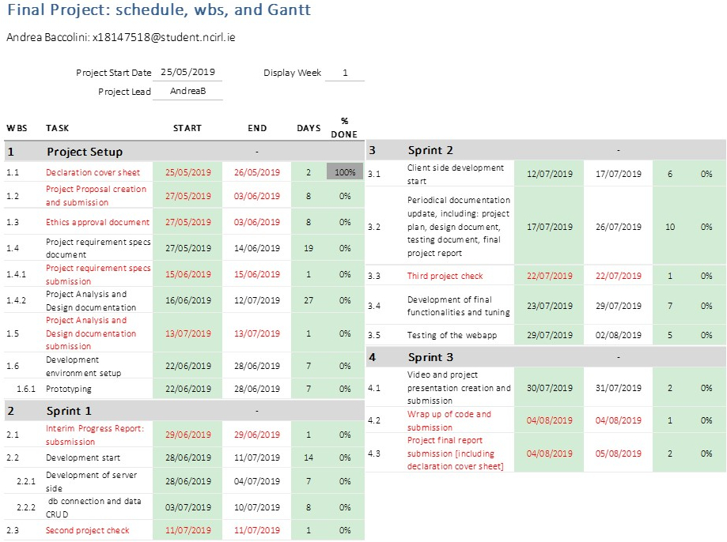

Figure 1 - Project WBS

# Technical Details

The web application should be written in node.js for both server side and client side. The following is the list of the main frameworks, and libraries that are planned for the development:

* Node.js and npm: server and client side javascript language
* Express: framework for web applications
* Mongo db or firebase db or couchdb or mySQL or JSON for data creation manipulation and storage [CRUD]
* Mongoose [ORM Object Related Mapper] for db communication [in case of mongo db]
* Pug: template engine [for the views]
* Bower: package manager
* jQuery and AJAX: for DOM [Document Object Manipulation]
* bootstrap: for website framework
* bcrypts: for password encryption
* passport: for user registration/login/logoff features
* nodemailer: for email service to users [notifications, account/password retrieval, initial registration and email confirmation etc …]
* other frameworks and libraries as needed

# Evaluation

The platform, as a web application, will be evaluated in a similar way as it will be tested. The plan for evaluating is to create different account with fake names but real emails in order to evaluate the experience for the functional features. As the web application is focused on making real people connect to each other, some information needs to be stored in the web application db. Therefore, the minimum storage info will be also evaluated for the web application to be fully compliant with GDPR regulations. The system test will evaluate that basic functionalities are working [e.g. user registration, login, logoff, etc …]. A further step is evaluating the UX [User Experience] by allowing “friendly” potential users of the web app to use it for the first time. Feedback is important.

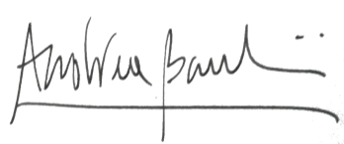

_____________________

Signature of student and date

# Appendix A: project plan gantt



1. https://www.social4retail.com/how-digital-behavior-differs-among-millennials-gen-xers-and-boomers.html#