

Project Proposal

Zen Scent (Natural Oils

E-commerce application)

Higher Diploma in Science in Web Technologies

Date: 5 October 2018

Table of Content:

Objectives 2

Background 3

Technical Approach 5

Special Resources Required 7

Project Plan 7

Technical Details 9

Evaluation 10

Appendices 11

Objectives

Main objective of this project is to develop responsive-commerce application for a small local business that sells Natural scented oils. The business will have to face the competition from its bigger rivals companies hence the objective is to go an extra mile and create an attractive and inventive e-commerce website that will serve the purpose and that will increase the traffic of targeted audience.

Following are the aims that my local business wants to achieve by opening and e-commerce business:

* Increase number of clients;
* Maximise profits - Increase monthly sales by 20% in 1st year and 50% in 2nd year ;
* Sell worldwide and 24/7;
* Build brand awareness more quickly ;
* Customer retention- making customers to repeat the orders;
* Opportunity do diversify business in the future;
* Increase customer satisfaction by designing easy to use website.

Security and compliance objectives

* Offer variety of secure payment options to customers;
* Private and secure customers’ data storage.

System Integration objectives

* Improve orders fulfilment process;
* Provide good customer support and product support service.

Project Objectives for developer:

* Create an app with simple and secure registration process. With option to register/sign up using social media profile.
* Responsive design
* Secure log in/log out process for buyers and admin.
* Application supports multiple payment options - cards and PayPal
* Social media integration
* Create product database (with CRUD functionality)
* Create shopping cart
* Product search button
* Online contact form
* Integrated blog or articles section
* User generated reviews
* Customer Service life chat
* Auto e-mail messaging
* Customer accounts management
* Discount and promotion management
* Order management

Background

Several online business models exist and it is very important find your niche and to choose the right model. There are several different business models to choose from:

* **E-Commerce site** – digital retails store that creates profits by selling products online. It has online catalogue and shopping cart, multiple payment options. Different types of products can be sold here: branded products or white label products
* **E-Bay auction model** – online auction that allows sell new and used products online. It can be very attractive for new starter companies that sell trending products. Company does not require fund to set up e-commerce website in order to sell. All you need to pay is for insertion fees and any other optional features.
* **Brochure site** – that give company web presence and acts as a company business card or brochure and simply provides information about company and contains few brochures or catalogues. Unfortunately, this type of website doesn’t work well anymore.
* **Stand-alone blog** – it is no matter what type of blog it is - photo blog or vlog - it can make money by selling affiliate products, including display adds, sell own digital products (eg. Courses, online classes or workshops, apps or photos)

All above mentioned business model bring success and profits if they are utilised correctly. Online sales are growing from year on year and more business start concentrating in online shoppers. Online shopping is fast, easy and convenient. Buyers can search for products and buy them from any location with no need to drive to the store, any time (24/7), no extra cost like parking fees. Online shopping is incredible shopping experience with few clicks of the mouse.

Research carried out show that the most trending products that people buy online are mobile phones and accessories, natural cosmetics and essential oils, books and computer equipment. Conservation awareness is growing substantially so has the consumer preference to use natural products including natural oils. Therefore the decision was made to develop e-commerce platform, which will sell natural essential oils and a potential product range diversification in the near future.

Online store should be designed for specific product group and specific target audience. Taking this into account market research need to be carried out in order to analyse target market, consumers, competitors and industry as a whole. There are cheap and easy ways of conducting market research using following tools:

* Google trends
* Nielsen data analytics company
* Search Engines Results Pages
* Etsy’s trending items
* Facebook groups

Target customer has to be identified taking into account demographic factors (age, location, gender, occupation etc.) psychographic factors (personality, attitudes, lifestyle etc.). More detailed analysis help of to gain better understanding of the target audience.

Detailed competitor analysis is also required. This can be done by identifying top competitors, carry out detailed analysis of each rival and compare them, looking at their SEO structure and social media integration. After research is carried out areas of improvement can be easy identified and implemented.

Changing consumer lifestyles as well as increase in consumers’ disposable income lead to a significant growth of essential oil industry. Substantial rise in consumer preference for “natural” products as opposed for synthetics and awareness of benefits of essential oils have contributed towards oil market sector.

Natural oils are used almost everywhere and in every occasion:

* Aromatherapy,
* Spa and relaxation,
* Medicine,
* Cosmetics and personal care products,
* Food and Drink,
* Home cleaning products,
* Others

Almost 50% of worldwide essential oil distribution was in Europe and market share expecting to grow by 2022 (marketsandmarkets.com, 2018).

Target Audience

Target audience is very broad:

* Majority of the buyers are female age group 20-59. 59% of these are mothers.
* Another target group is pet owners
* Holistic users
* Users of natural home cleaners

Competitors analysis

* There is number of essential oil major players like doTERRA International, Young Living Essential Oils and Biolanders. These are manufacturers and reseller of essential oil products. There are number shops as well as online stores that sell essential oils like Holland & Barrett, Boots, Kotanical, Evergreen.
* Holland & Barrett and Boots offer wide range of products in store and online. The product range they sell is massive, but selection of Natural oils in not large.
* Kotanical is Irish company that sells essential oils online. Selection of products is limited but oils are made in Ireland and this could be attractive to Irish consumers that like to support local business. Website has also a blog and press releases.
* There are many competitors in UK and rest of Europe. Variety of essential oils is sold on Amazon and eBay.

My aim is to build fully interactive site supporting the whole buying process, which provide a full range of marketing exchanges that supports buying.

Technical Approach

### Requirements capture

There are several requirements from a client for an e-commerce website:

User Management

* Customer Account Registration with specific fields like Username, Name, address, Email and password etc.;
* User account activation by email in order to avoid spam/junk customers
* Login Module for user login;
* Recovery Password Option

User Profile Page

* User profile page is displayed once user logged in
* Profile page can be amended by user
* Option to change user password
* User can view historic orders
* Check order status online
* User Wishlist

Admin functionality

* Admin can view all the user list
* Admin can edit the user profile details
* Admin can delete / Block any user
* Admin can view, edit, delete all orders and their status

Product Catalogue

* Products page show list of products with images
* Product details like name, price, discount are displayed above/below the image,
* Product listing can be sorted ascending/descending, by price or recommendation
* Products can be updated, deleted by administrator
* Customer can search for products using different keywords like name

Product Page

* Page contain product name and image as well as product information
* Zoom in effect
* Customers will be able to customise product by selecting product size
* Add to cart button
* Add to wishlist button
* Rate product

Order Management

* Orders managed by administrator
* Administrator can accept of cancel order

Shopping cart/checkout

* Customers can add products to the cart
* Customers can click buy button and buy product
* Again giving option for continue shopping or go to check out
* Customer can view items in the cart
* Customer can update / delete the Items from the cart
* Customers can choose preferred shipping method
* Update delivery address
* Payment Method select page (payment by card or PayPal)
* Order confirmation page
* Order email confirmation email will go to Admin and User once order placed online
* Shopping Cart with product images and editable quantities
* Estimated shipping cost and tax before check-out
* Automated abandoned cart recovery

Payment Gateway

* Payment methods can be viewed by admin
* Following payment methods are supported: Bank Card or PayPal;
* Redirect to PayPal website or fill in bank details if paying by card

Comments, Ratings & Sharing

* User can write comment and rate any product (5 star rating)
* Admin can add/delete or reply to a comment or rating
* Customers can share the link of the website on the social networking website like Facebook, twitter etc.

Provide the basic pages (i.e., about us, Contact Us, FAQ, help) for company information.

### Implementation

Programming language to be used is Node.js platform as it enables server-side and client-side scripting. The chosen framework also benefit with its vertical and horizontal scalability which makes Node.js one of the best technology to create an adaptable and powerful e-commerce marketplace.

It has many independent NPM package managers that eliminate dependencies. Products, order and customers data will be store in SQL cloud database.

Special resources required

No special equipment or resources are required except mobile phone for testing responsive design. Otherwise free tools like Google resizer or Screenfly can be used. Another requirement is active PayPal account in order to test payment stream (PayPal Sandbox can be used).

Project Plan

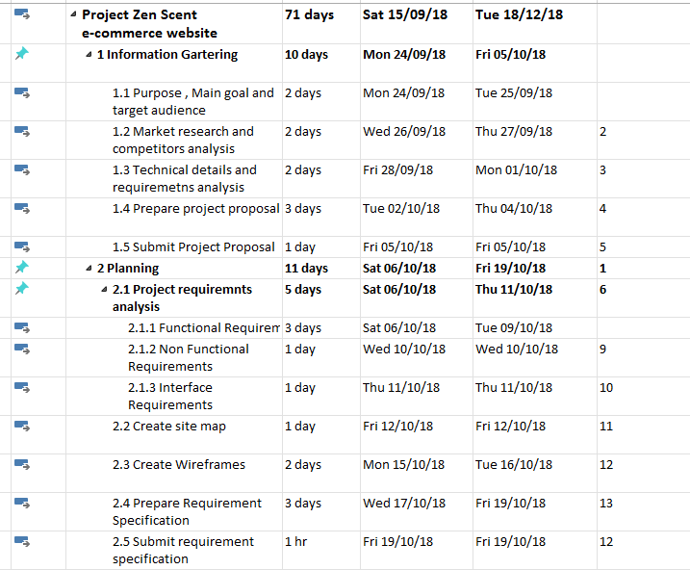

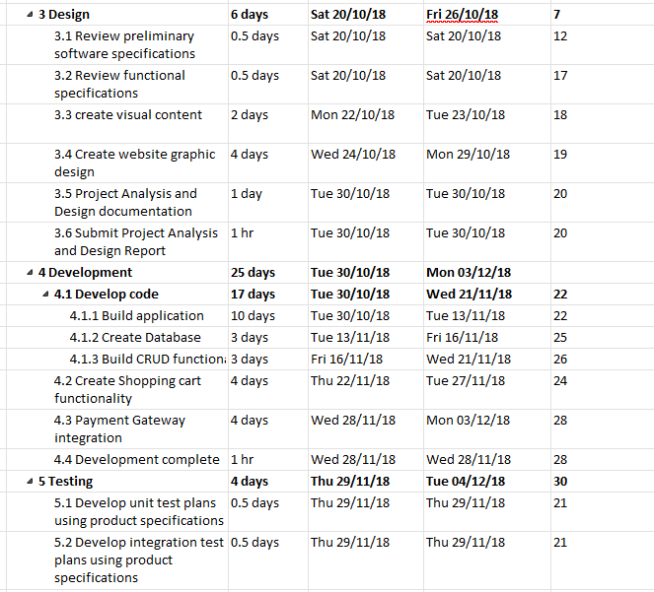

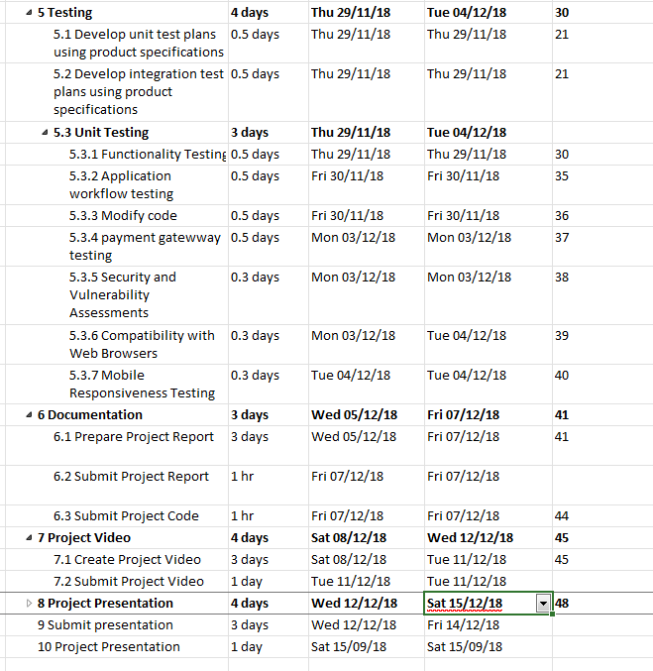

Technical Details

Node.JS framework will be used to build application. Node.js has large number of JavaScript modules that are easy to use and make development faster and efficient. Data will be store using SQL Database.

NPM packages planned to be used:

* Express.js framework to make application run
* Stripe or heroku will be used for card payments
* PayPal-checkout for PayPal payments
* SQL database
* Passport.js
* body-parser -for parsing incoming requests
* bcrypt for hashing passwords
* Reaction commerce
* express-cart – shopping cart

Evaluation

Once-commerce application will be created with most of its functionality admin and customer functionality can be tested. Once products database will be created, products can be tested (CRUD functionality). Admin panel’s functionality will be tested. Usability testing will be carried out to test user sessions – register and login and also cart functionality. Usability testing will help to understand real user experience and receive feedback. This also will help to determine what difficulties user can experience and is there anything that prevents user from using the site.

Appendices

Project Plan - MS Project