**Practical Assignment #01:**

**Perform and explain various networking commands and IP configuration**

1. Ipconfig
2. Ping
3. Getmac
4. Systeminfo
5. Traceroute/ tracert
6. Netstat
7. Nslookup
8. Hostname
9. Pathping
10. Arp

## ipconfig

### Description:

The ipconfig command displays all **current TCP/IP network** configuration values and refreshes **Dynamic Host Configuration Protocol (DHCP)** and **Domain Name System (DNS)** settings.

|  |  |  |
| --- | --- | --- |
| No. | Option | Description |
| 1 | **Ipconfig/all** | The ipconfig /all command in Windows is a powerful diagnostic tool that displays detailed network configuration information for all network adapters on your system. |
| 2 | **Ipconfig/release** | Releases the current IP address configuration assigned by the DHCP server. |
| 3 | **Ipconfig/renew** | Renews the IP address configuration from the DHCP server. |
| 4 | **Ipconfig/flushdns** | Clears the DNS resolver cache. |
| 5 | **Ipconfig/displaydns** | Shows the contents of the DNS resolver cache. |

### Implementation:

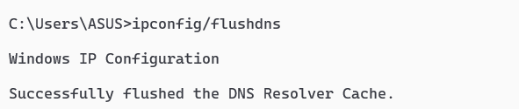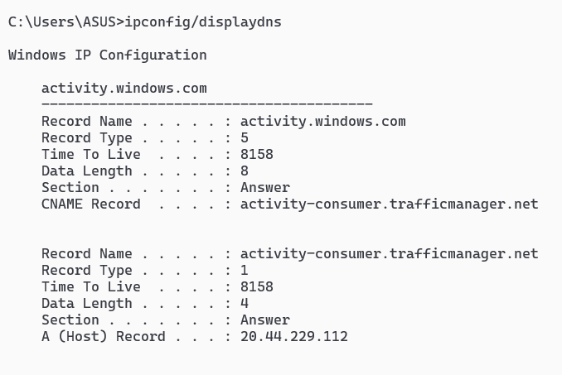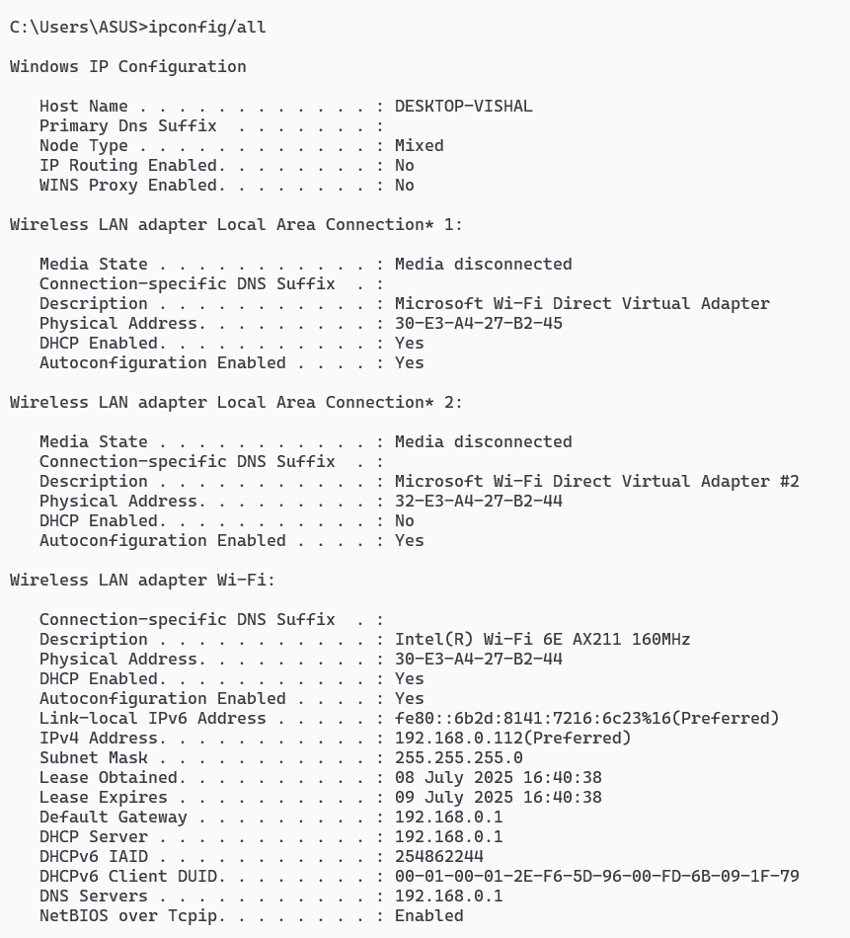

## ping

### Description:

The ping command is used to test the **connectivity** between your computer and another host (like a website or IP address). It sends **ICMP** Echo Request packets and listens for replies.

|  |  |  |
| --- | --- | --- |
| No. | Option | Description |
| 1 | **Ping <>-t** | Pings the target continuously until stopped manually |
| 2 | **Ping<>-n <count>** | Specifies the number of Echo Requests to send (default is 4). |
| 3 | **Ping<>-I <size>** | Sets the size (in bytes) of the ping packet (default is 32 bytes). |
| 4 | **Ping<>-a** | Resolves the IP address to a hostname, if possible. |
| 5 | **Ping<> -4** | Force using IPv4. |

### Implementation:

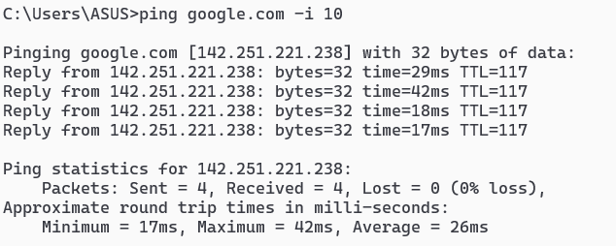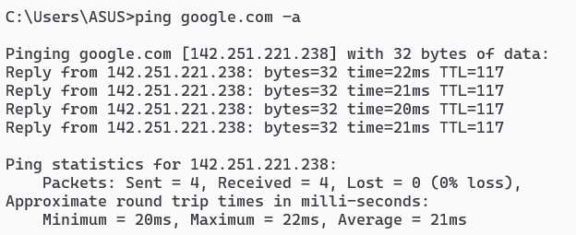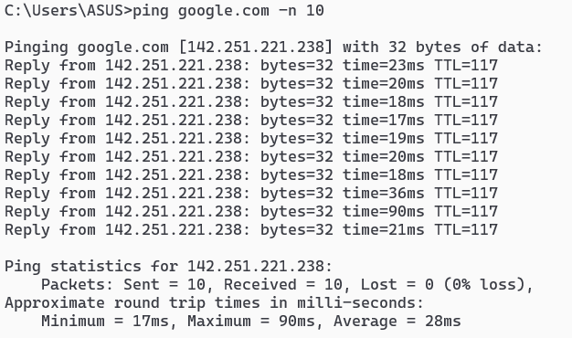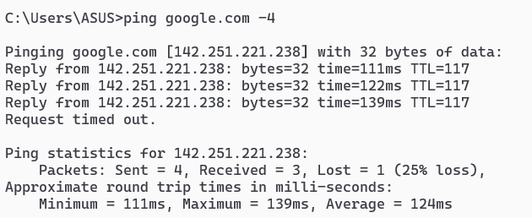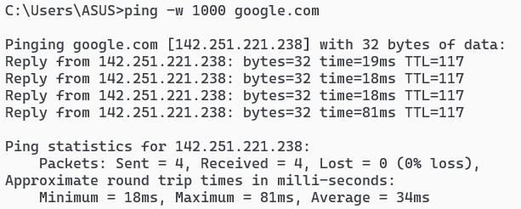

## getmac

**Description:** Displays the **MAC addresses** of all network adapters on the system.

|  |  |  |
| --- | --- | --- |
| No. | Option | Description |
| 1 | **getmac** | Intended to display all available MAC addresses and their corresponding transport names for every network interface. |
| 2 | **getmac/v** | Enables verbose mode showing more detailed adapter information. |
| 3 | **getmac/fo llist** | Formats output as a list for easier readability |
| 4 | **getmac/fo table** | Formats output as a table. |
| 5 | **getmac/nh** | Omits column header from output |

**Implementation:**

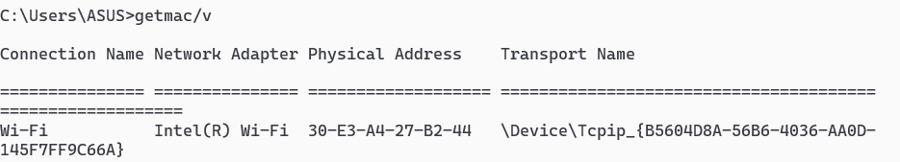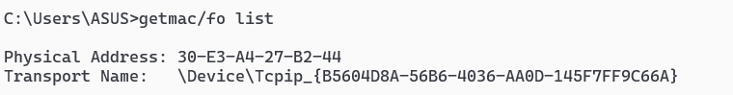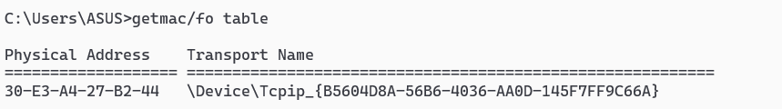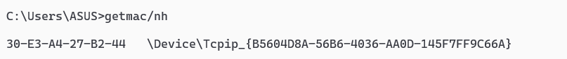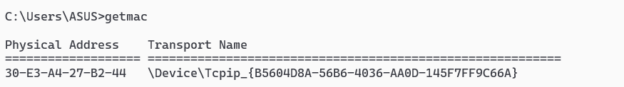

## Systeminfo

**Description:** Displays **comprehensive information** about the computer system, including OS version, hardware details, and installed updates.

|  |  |  |
| --- | --- | --- |
| No. | Option | Description |
| 1 | **/s <computer>** | Executes the command on a remote computer. Requires appropriate permissions. |
| 2 | **/u <domain/use>** | Specifies the user context for the remote system. Must be used with /s. |
| 3 | **/p <password>** | Supplies the password for the user |
| 4 | **/fo table** | Formats output as a table. |
| 5 | **/nh** | Omits column header from output |

**Implementation:**



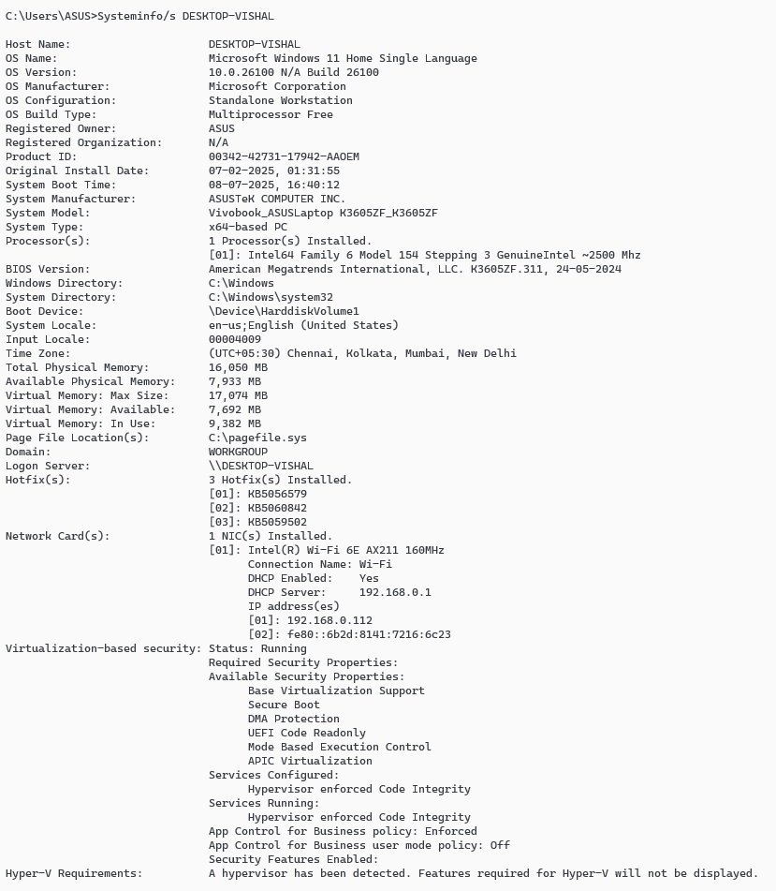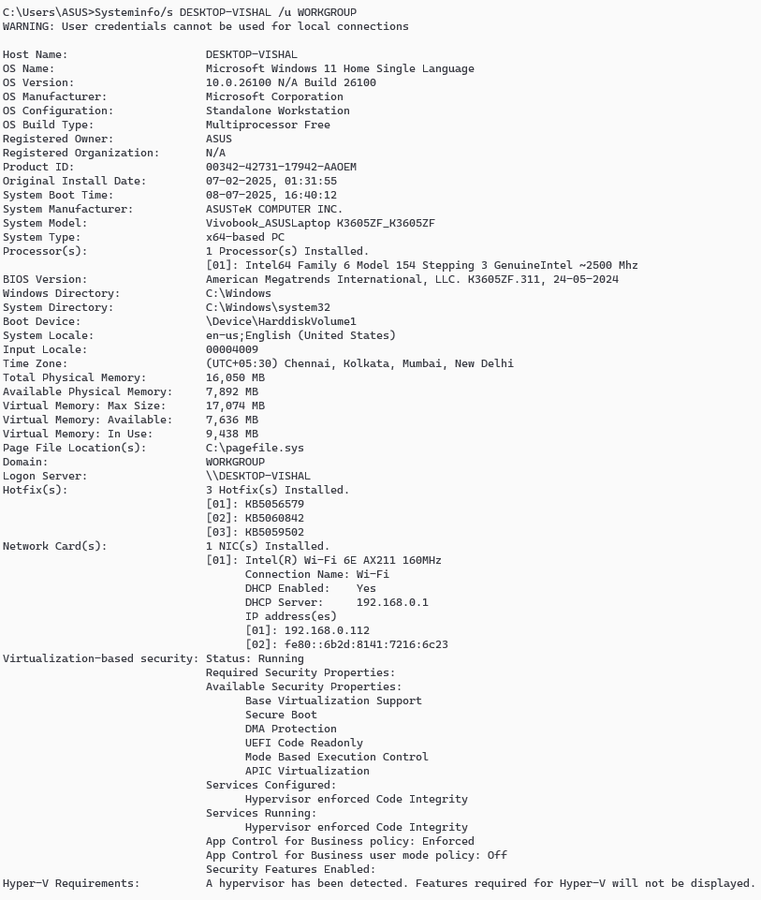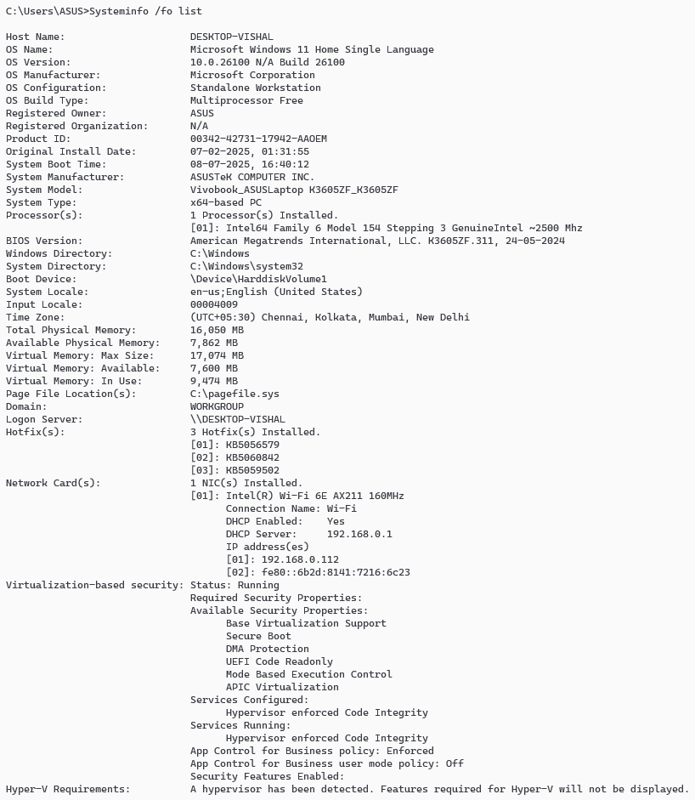

## traceroute/tracert

**Description:** Shows the path that packets take from your computer to a destination host. Useful for diagnosing network routing issues.

|  |  |  |
| --- | --- | --- |
| No. | Option | Description |
| 1 | **-d** | Do not resolve addresses to hostnames |
| 2 | **-h <maximum>** | Sets maximum number of hops to search for the target. Default is 30. |
| 3 | **-j <host>** | Uses loose source routing along the specified hosts |
| 4 | **-w <timeout>** | Wait time (in milliseconds) for each reply. |
| 5 | **-4 or -6** | Wait time (in milliseconds) for each reply. |

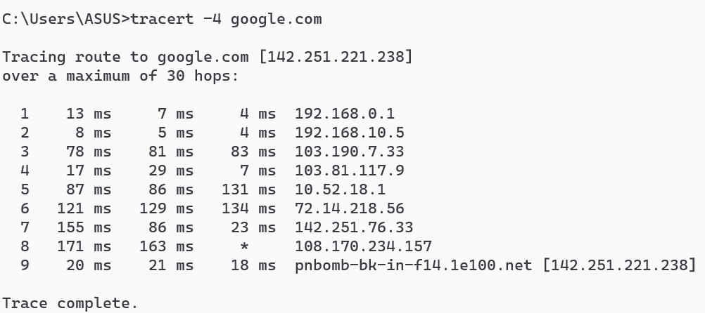

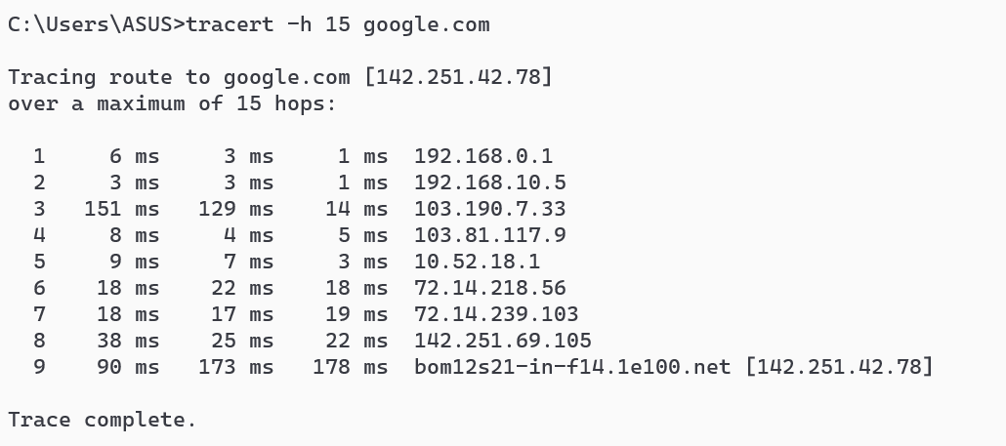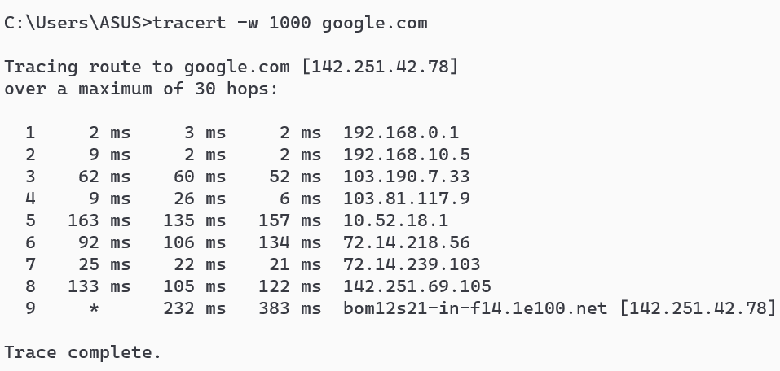

## netstat

**Description:** Shows **connections** and listening port

|  |  |  |
| --- | --- | --- |
| No. | Option | Description |
| 1 | **-a** | Shows all connections and listening port |
| 2 | **-b** | Displays the executable the behind each connection (needs admin) |
| 3 | **-n** | Shows aaddresses and port as numbers |
| 4 | **-o** | Includes the Process ID\ of each connection |
| 5 | **-e** | WDisplays Ethernet stats like bytes sent/received |

**Implementation:**

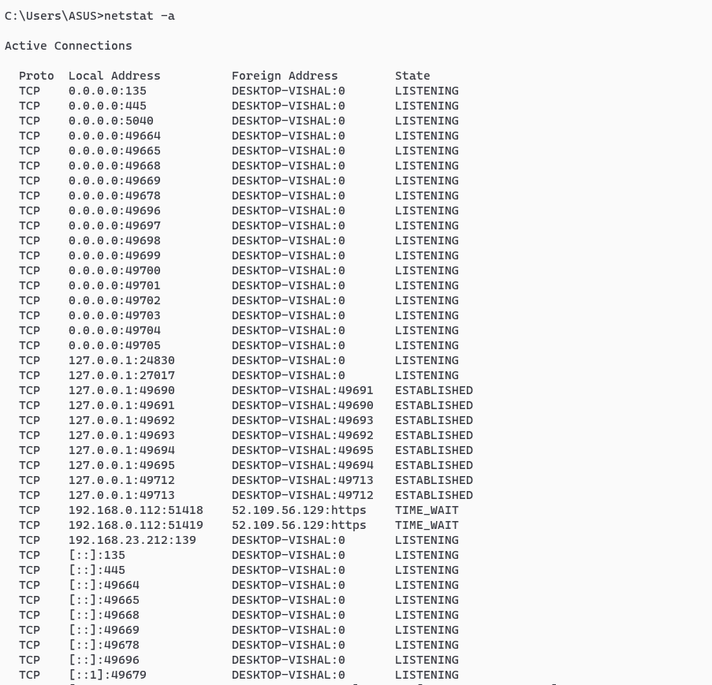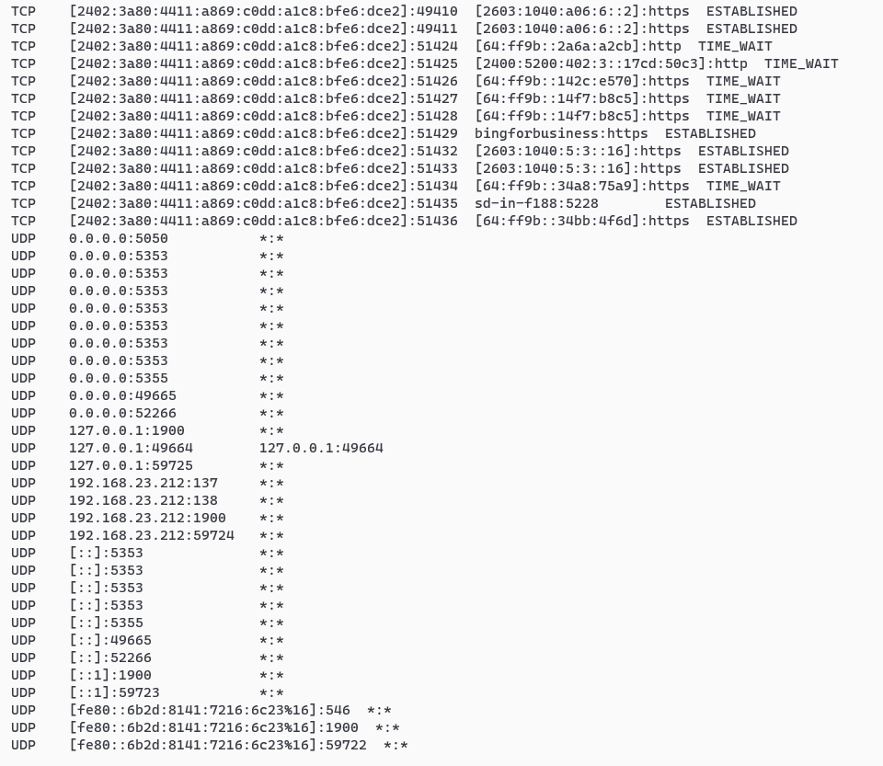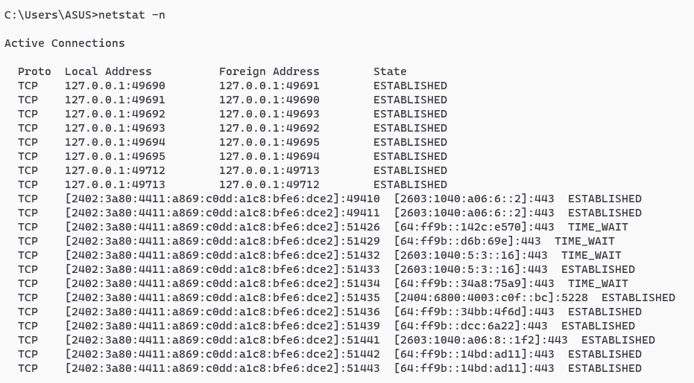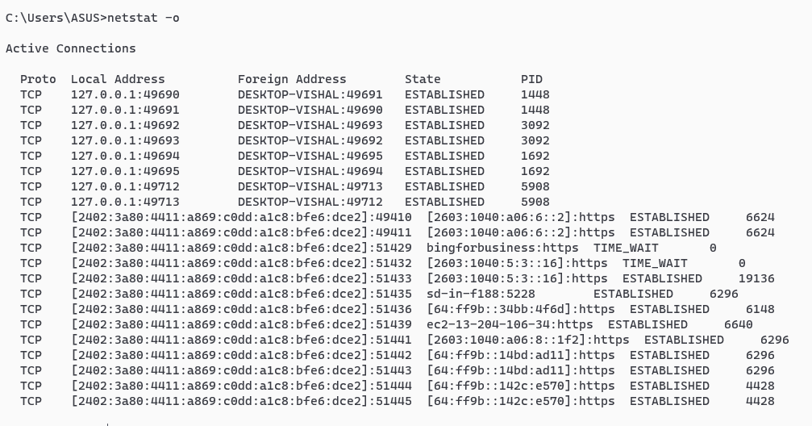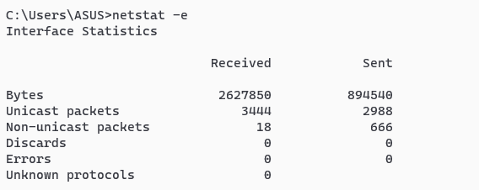

## nslookup

**Description:** Launches interactive mode to **query DNS** manually

|  |  |  |
| --- | --- | --- |
| No. | Option | Description |
| 1 | **<hostname>** | Returns IP address of the given domain name |
| 2 | **Server <DNS>** | Sets the DNS server to use for lookups in interactive mode |
| 3 | **set type=MX** | Queries Mail Exchange (MX) records |
| 4 | **Set type=NS** | Queries Name Server (NS) records |
| 5 | **Set type=A** | Queries IPv4 address (A) record |

**Implementation:**

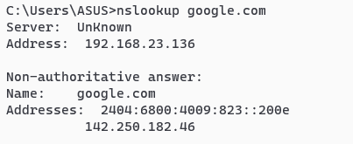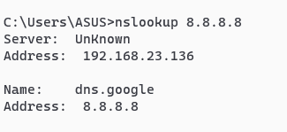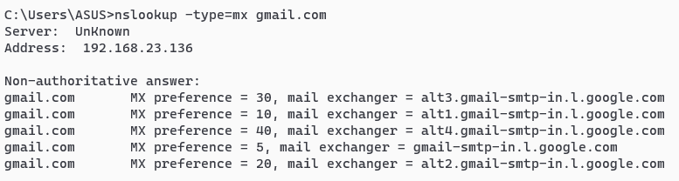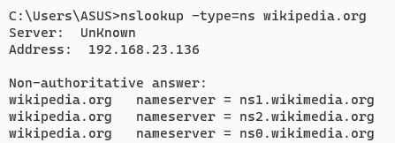

## hostname

**Description:** Displays the current **hostname** of your machine.

|  |  |  |
| --- | --- | --- |
| No. | Option | Description |
| 1 | **Hostname** | Shows current hostname |

**Implementation:**



## pathping

**Description:** Pathping is a **network diagnostic tool** in windows that combines the feature of **both ping and tracert.**

|  |  |  |
| --- | --- | --- |
| No. | Option | Description |
| 1 | **/h** | Skips resolving IPs to hostname |
| 2 | **/h <hops>** | Sets max number of hops |
| 3 | **/q <quries>** | Number of pings per hop |
| 4 | **/w <timeout>** | Wait time per reply in ms |
| 5 | **/4 or /6** | Force IPv4 or IPv6 usage |

**Implementation:**

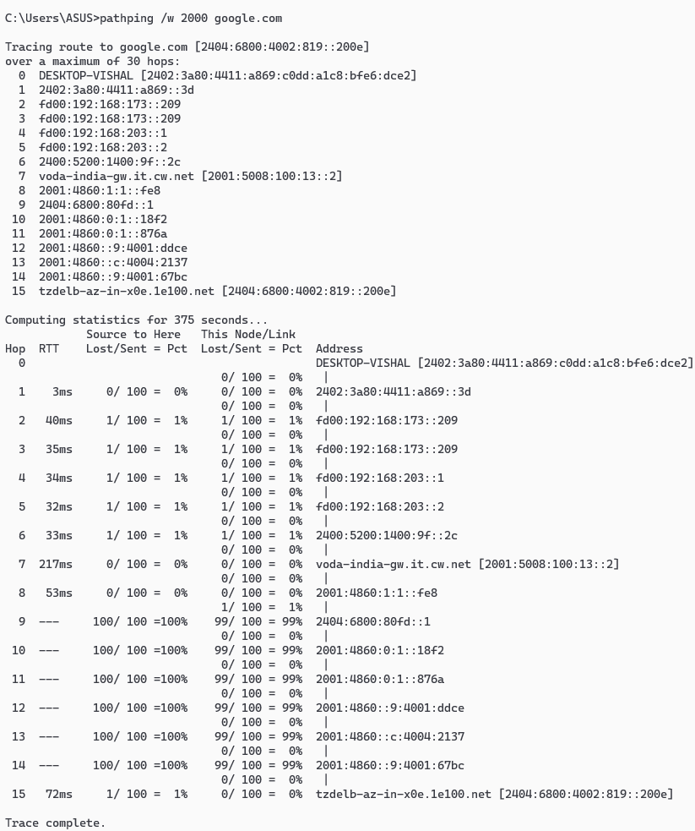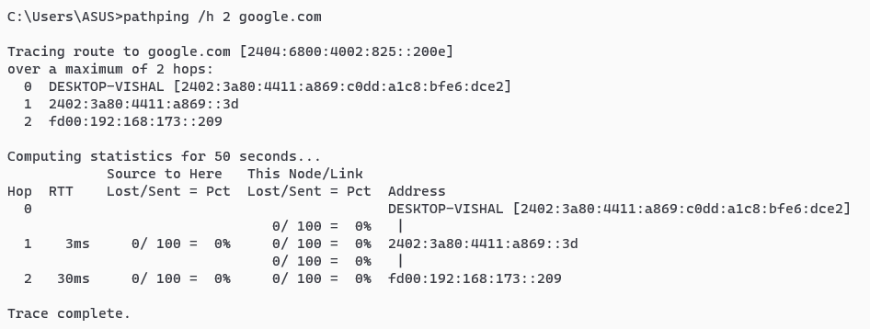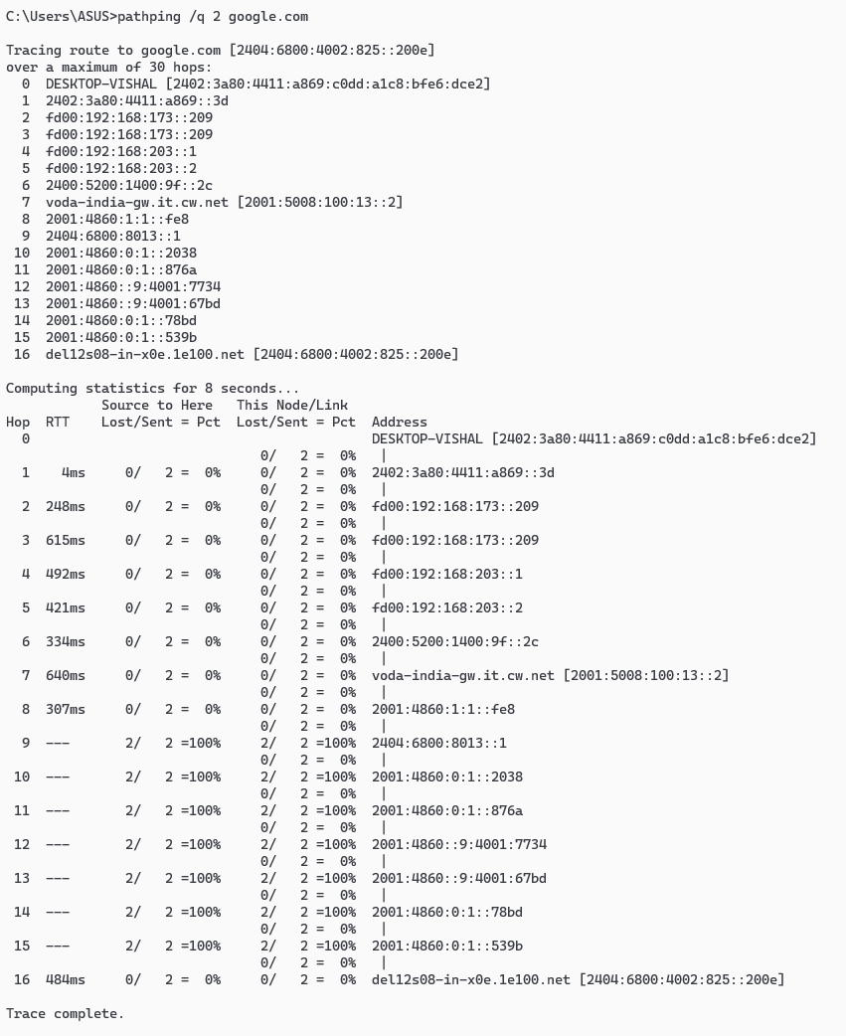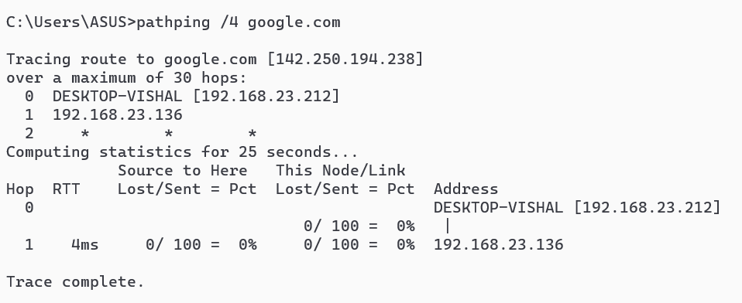

## arp

**Description:** Arp stands for Address Resolution Protocol.It’s a network utility used to **map IP addresses to MAC addresses** on local network.

|  |  |  |
| --- | --- | --- |
| No. | Option | Description |
| 1 | Arp-a | Displays the current ARP cache |
| 2 | Arp-d<IP> | Deletes the ARP entry for the specified IP |
| 3 | Arp -s<IP><MAC> | Adds a static ARP entry |

**Implementation:**