**Lab Practical #02:**

Study of different network devices in detail.

**Practical Assignment #02:**

1. Give difference between below network devices.

* Hub and Switch
* Switch and Router
* Router and Gateway

1. Working of below network devices:
   * Repeater
   * Modem((DSL and ADSL)
   * Hub
   * Bridge
   * Switch
   * Router
   * Gateway

# Hub and Switch

|  |  |  |
| --- | --- | --- |
| No. | Hub | Switch |
| 1 | Operates at **the Physical Layer (Layer 1)** of the OSI model | Operates at the **Data Link Layer (Layer 2)** |
| 2 | **Broadcasts** data to all connected devices | **Forwards** data only to the intended recipient using MAC addresses |
| 3 | **No MAC address** learning capability | Learns and stores **MAC addresses** in a table |
| 4 | Works **in half-duplex** mode only | Supports **full-duplex** communication |
| 5 | **Less efficient** and more prone to collisions | **More efficient** with reduced collisions |
| 6 | **orbits** of electrical **signals** are used | utilizes **frames** and **packets** |
| 7 | A **passive** device is a hub. | A switch is a **functioning** device. |

# Switch and Router

|  |  |  |
| --- | --- | --- |
| No. | Switch | Router |
| 1 | Connects devices within a **local network (LAN)** | Connects **multiple networks (LAN to WAN)** |
| 2 | Uses **MAC addresses** to forward data | Uses **IP addresses** to route data |
| 3 | Operates **at Layer 2** (some at Layer 3) | Operates **at Layer 3** of the OSI model |
| 4 | **No NAT** (Network Address Translation) support | **Supports NAT** to share a single IP among devices |
| 5 | Mainly used for **internal communication** | Used to **connect to the internet** or other networks |
| 6 | Through switch data is sent in the form of **frame**. | While through the router, data is sent in the form of **packets**. |
| 7 | There is **no collision** taking place in full duplex switch. | While there is **less collision** taking place in the router. |

# Router and Gateway

|  |  |  |
| --- | --- | --- |
| No. | Router | Gateway |
| 1 | Routes data between **similar** networks | Connects **different** networks with different protocols |
| 2 | Works at Network Layer (**Layer 3**) | Can operate at any OSI layer, often Layer 5 or higher |
| 3 | Uses routing tables and protocols like RIP, OSPF | Performs protocol conversion if needed |
| 4 | Typically used in **home and office** networks | Used in **enterprise or cross-platform** systems |
| 5 | Does **not modify** data format | May **translate data formats** and protocols |
| 6 | It is hosted on only the **dedicated** applications. | It is hosted on dedicated applications, physical servers or virtual applications. |
| 7 | The additional features provided by a router are Wireless networking, Static routing, NAT, DHCP server etc. | The additional features provided by a gateway are network access control, protocol  conversion etc. |

# Working of below network devices:

1. **Switch**
   * Switch is a network device which is used to enable the **connection establishment** and **connection termination** on the basis of need. Switch is operated on **Data link layer**. In this **packet filtering** is available. It is type of **full duplex transmission** mode and it is also called **efficient bridge**.
   * Basically, it is a kind of bridge that provides **better connections**. It is a kind of device that set up and stop the connections according to the requirements needed at that time. It comes up with many features such as **flooding, filtering and frame transmission**.

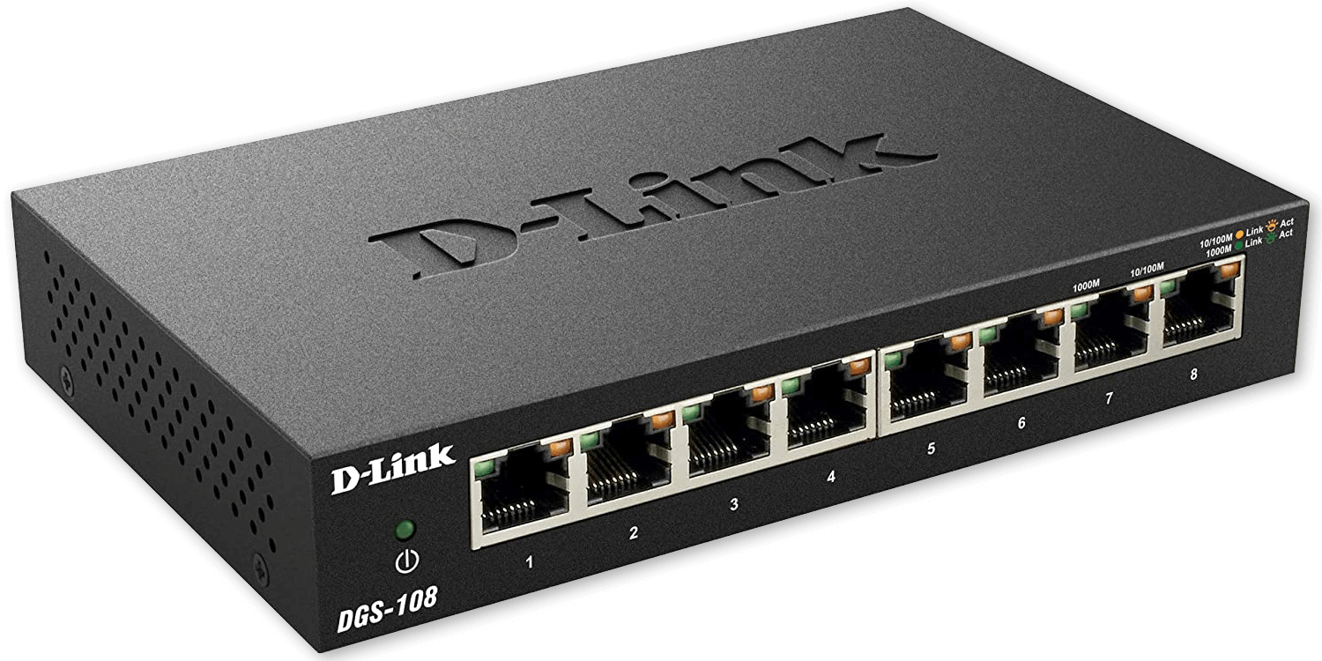

1. **Router**
   * Routers are the **multiport devices** and more sophisticated as compared to repeaters and bridges. It contains a **routing table** that enables it to make decision about the route i.e. to determine which of several possible paths between the **source and destination** is the best for a particular transmission.
   * It works on the network layer 3 and used in **LANs, MANs and WANs**. It stores IP address and maintains address on its own.

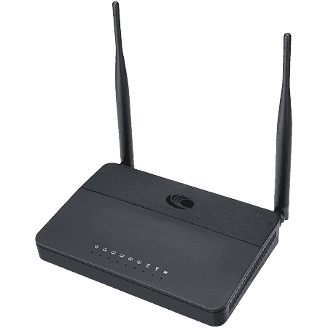

1. **Gateway**
   * A gateway acts as a **translator** between networks using **different protocols**. It receives data, analyzes it, converts it into a **compatible format**, and forwards it to the **destination network**. It’s essential for **cross-platform communication**, such as between a **private network** and the **internet**.
2. **Repeater**
   * A repeater is a network device used to **regenerate and amplify** signals in a network to extend the **transmission distance**. It works at the **Physical Layer (Layer 1)** of the OSI model.
   * When the signal weakens due to **long-distance transmission**, the repeater boosts the signal to its original **strength without changing the data content**. It’s mainly used in wired networks like **Ethernet** to overcome **signal attenuation**.
3. **Modem (DSL and ADSL)**
   * A **modem** (short for modulator-demodulator) is a device that converts **digital data** from a computer into **analog** for transmission over telephone lines and vice versa. It works at both the **Physical Layer (Layer 1)** and **Data Link Layer (Layer 2)**.
   * **DSL (Digital Subscriber Line)** and **ADSL (Asymmetric DSL)** modems allow high-speed internet over regular telephone lines. ADSL provides higher download speeds than upload speeds, making it ideal for typical internet users.
4. **Hub**
   * A hub is a basic networking device that **connects multiple computers** in a **LAN**. It operates at the **Physical Layer (Layer 1)** and transmits data to **all ports** regardless of the destination, resulting in unnecessary data traffic.
   * It has no **intelligence** to filter data or know the **destination address**. It’s mainly used in small networks for simple data sharing and is considered **outdated** due to its **inefficiency** compared to **switches**.
5. **Bridge**
   * A bridge is a device used to **divide a network** into **segments** and **reduce traffic**. It works at the **Data Link Layer (Layer 2)** and uses **MAC addresses** to filter and forward data between **network segments**.
   * It connects two or more LANs to make them function as a single network, helping to manage traffic and **improve performance**. Bridges can also help **isolate collision** domains.