**Lab Practical #05:**

Study the concept of VLAN using packet tracer.

**Practical Assignment #05:**

1. **Implement the different network structures in VLAN and VLAN trunking. Also check connectivity between them using ping command or PDU utility.**

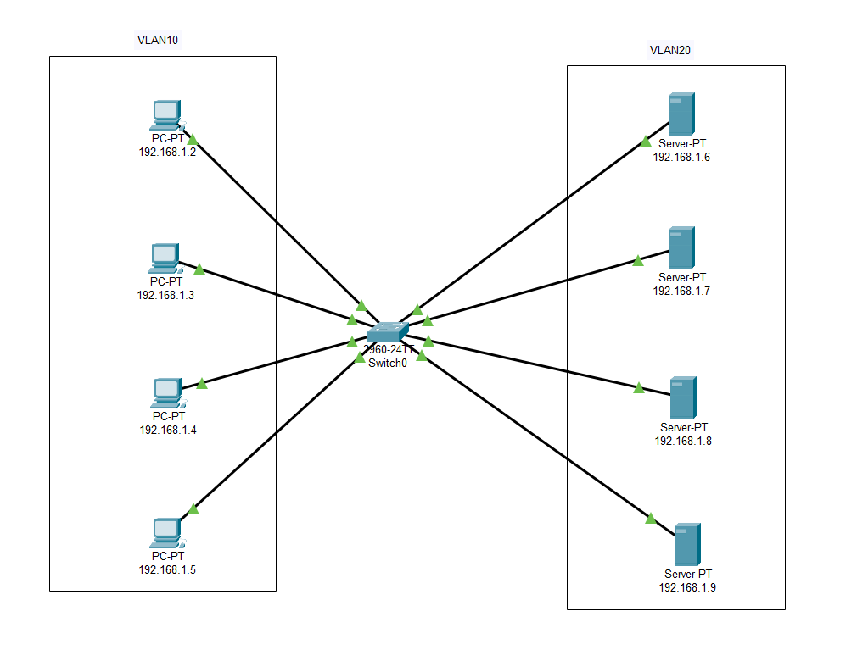

* **How to Create VLAN in packet tracer**
  + Open Cisco Packet Tracer on your computer.
  + First Create Network Topologies.
  + After Creating Topologies, Click on a switch to open its configuration window. Go to the Config tab. In the Config tab, find the VLAN Database section. Here, you can add new VLANs by entering the VLAN number and name.
  + To add Add Devices to Separate VLAN, Click on a switch to open its configuration window. Go to the Config tab and select the specific port that is connected to a device. In the port configuration section, set the port mode to Access and select the VLAN number .

