**Lab Practical #8:**

Study & Survey of Institute organization network infrastructure.

**Practical Assignment #8:**

1. **Type of Network in Institute**
   * The institute uses a **Local Area Network (LAN)** to connect computers, servers, and other devices within buildings.
   * **Wired LAN**: Provides high-speed and stable connectivity using Ethernet (Cat5e/Cat6) cables.
   * **Wireless LAN (Wi-Fi)**: Provides mobility to students and staff for laptops and mobile devices.
   * **Campus Backbone**: Buildings are interconnected using **fiber optic cables**, forming a **Campus Area Network (CAN)**.
2. **Network Design (Example: Computer Lab/Floor)**

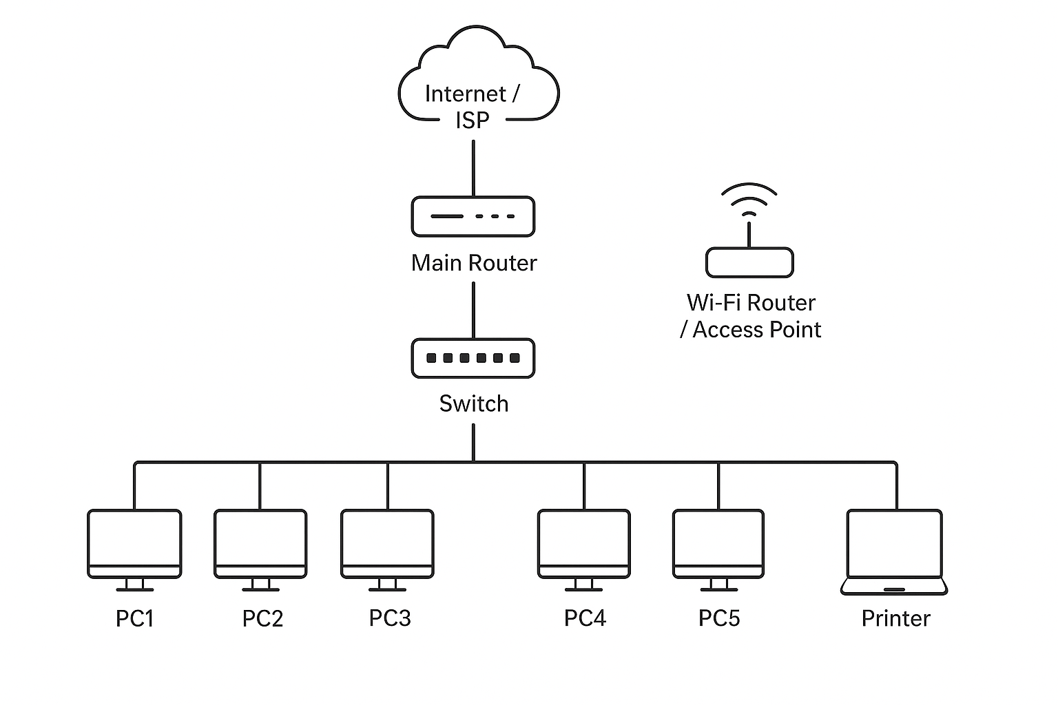

* + **Internet/ISP**: Provides external connectivity.
  + **Main Router**: Connects ISP to institute network.
  + **Switch**: Distributes wired connections to lab computers.
  + **Wi-Fi Router/Access Point**: Provides wireless access to mobile devices.
  + **Lab PCs & Printer**: End-user devices connected through wired LAN.

1. **Devices & Cables Used**
   * **Devices**
     1. **Router**
        + Connects institute to the ISP.
        + Manages routing between external internet and local network.
     2. **Switch**
        + 24/48 port switch connecting all lab PCs.
        + Provides wired LAN connectivity.
     3. **Wi-Fi Router / Access Point** 
        + Provides wireless connectivity to students and staff.
     4. **Computers (PCs) (e.g., 40 units)**
        + Workstations in computer lab connected via switch.
     5. **Printer / Server** 
        + Shared device accessible within LAN.
   * **Cables**
     1. **Ethernet Cable (Cat6)**
        + Used for PC-to-Switch and Switch-to-Router connections.
        + Supports up to 1 Gbps speed.
     2. **Fiber Optic Cable**
        + Used between buildings for backbone connection.
        + High bandwidth, supports long-distance data transfer.
     3. **Patch Cords**
        + Short Ethernet cables used from wall ports to end devices.

**Conclusion**

The institute network is a **hybrid LAN** infrastructure supported by routers, switches, and access points. It uses **Cat6 Ethernet cables** for lab connections and **fiber optics** for building interconnections. This setup ensures high-speed, reliable connectivity for both wired and wireless users across the institute.