**Lab Practical #01:**

Study of basic networking commands and IP configuration.

**Practical Assignment #01:**

1. Perform and explain various networking commands listed below:
   1. ipconfig
   2. ping
   3. getmac
   4. systeminfo
   5. traceroute / tracert
   6. netstat
   7. nslookup
   8. hostname
   9. pathping
   10. arp

## ipconfig

### Description:

The ‘ipconfig’ command is used in Windows to display and manage the network configuration of the

System.it provides detailed informatation about IP addresses,subnet masks,default gateways,and other network settings of all network adapter in the system.

|  |  |  |
| --- | --- | --- |
| No. | Option | Description |
| 1 | /all | Display the TCP/IP configuration for all adapter. |
| 2 | /release | Releases the IPv4 address for specified adapter. |
| 3 | /displaydns | Display the content of dns information. |
| 4 | /allcompartment | Show the informataion about all compartment. |
| 5 | /renew6 | Renew the IPv6 address for specified adapter. |

### Implementation:

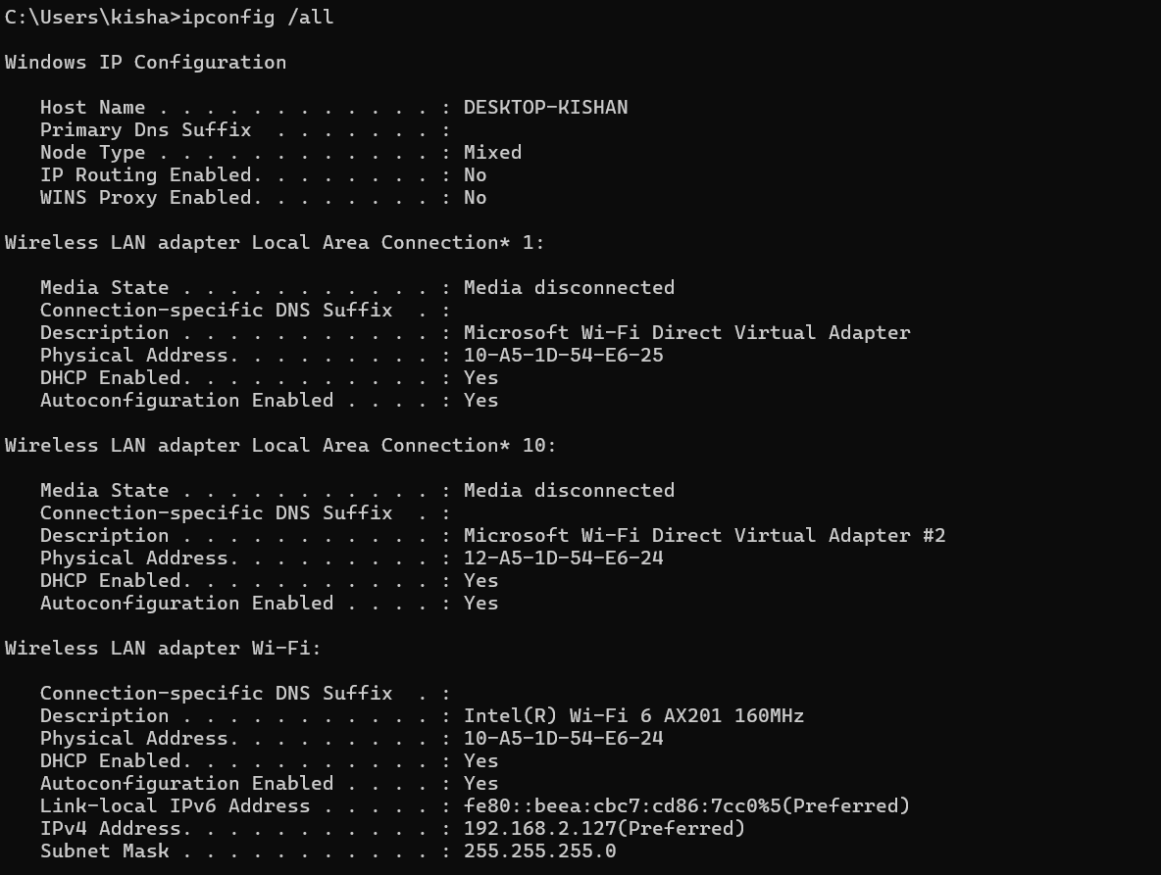

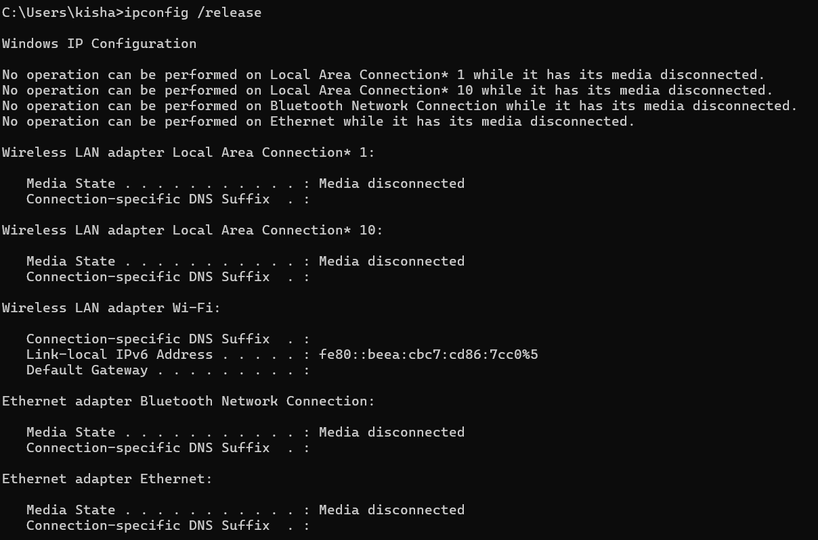

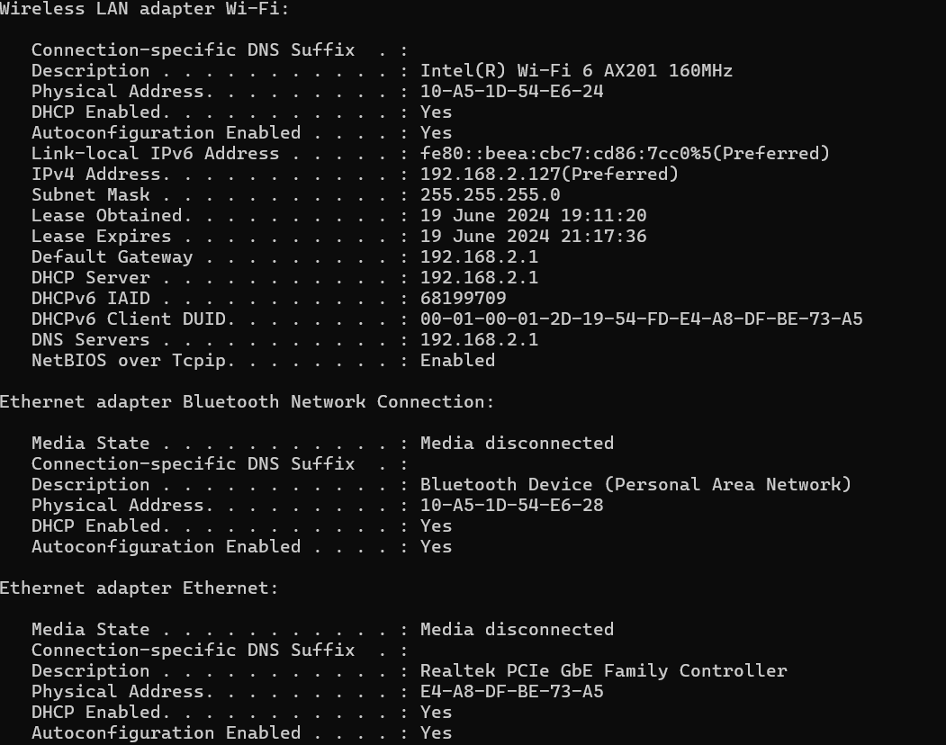

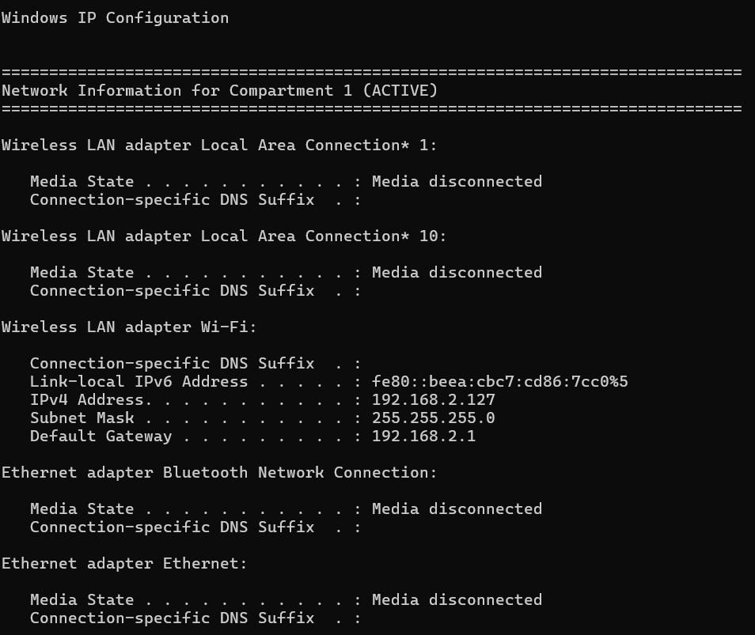

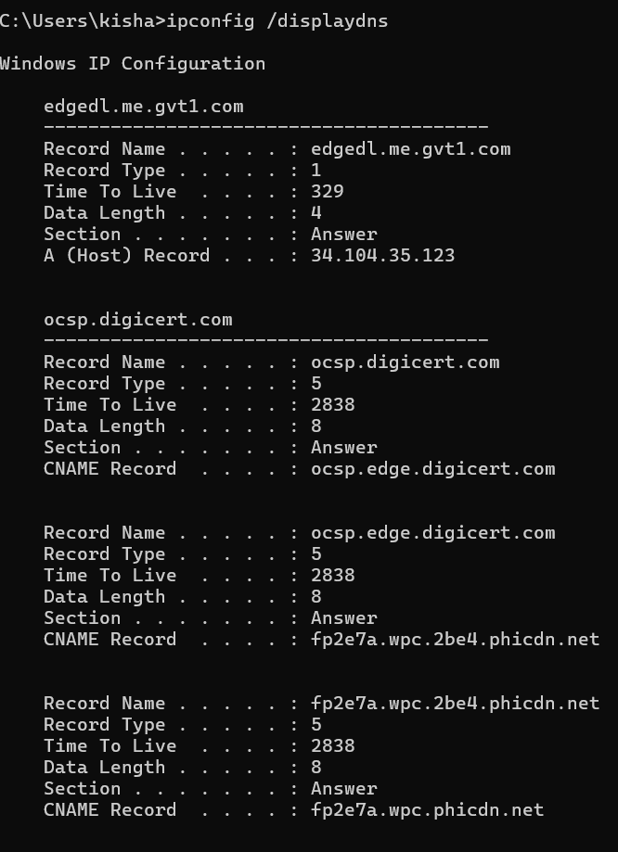

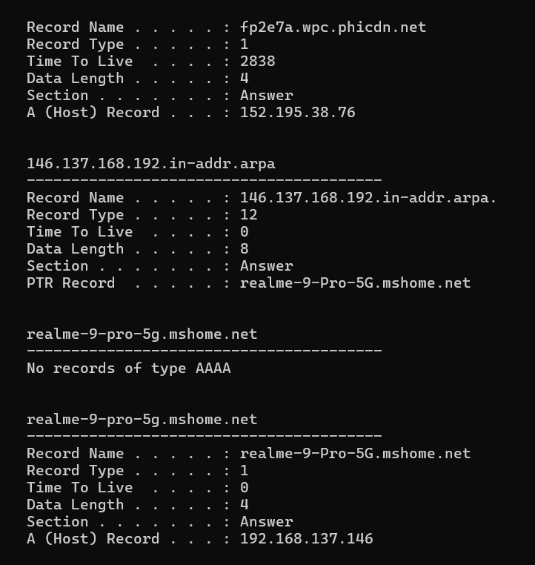

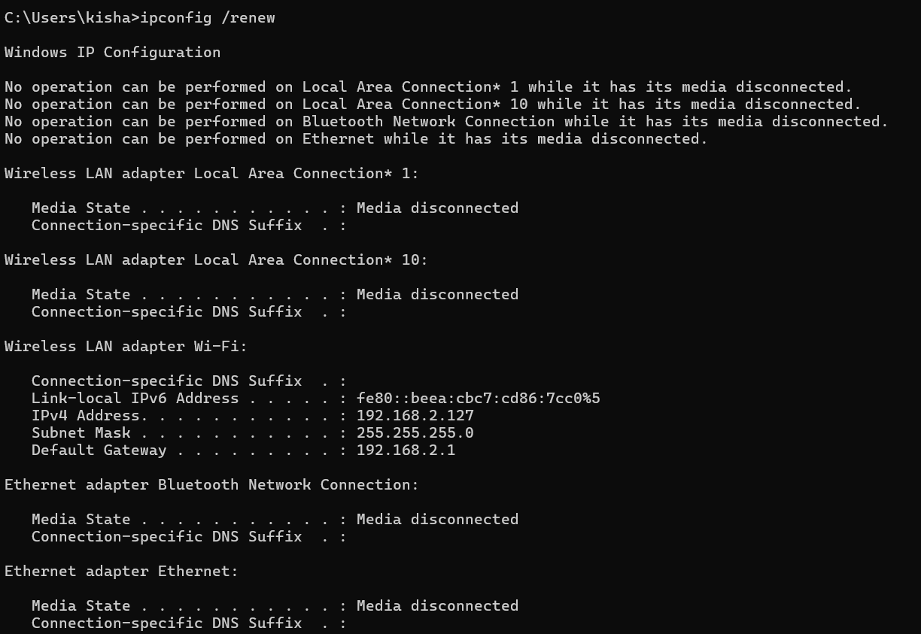

## ping

### Description:

The ‘ping’ command is a network utility to test the reachability of host on an IP network.it sends ICMP

Echo Request packets to the target host and listen ICMP Echo Reply packets,measuring round-trip time and packet loss diagnose network connectivity issue.

|  |  |  |
| --- | --- | --- |
| No. | Option | Description |
| 1 | -t | Ping the specified host until stopped.to stop ,  Press “ctrl+c”. |
| 2 | -n | Specify the number of echo requests to send. |
| 3 | -a | Resolve address to hostnames. |
| 4 | -f | Set the “Don’t Fragment” flag in the packet(IPv4-only). |
| 5 | -4 | Force using IPv4. |

### Implementation:

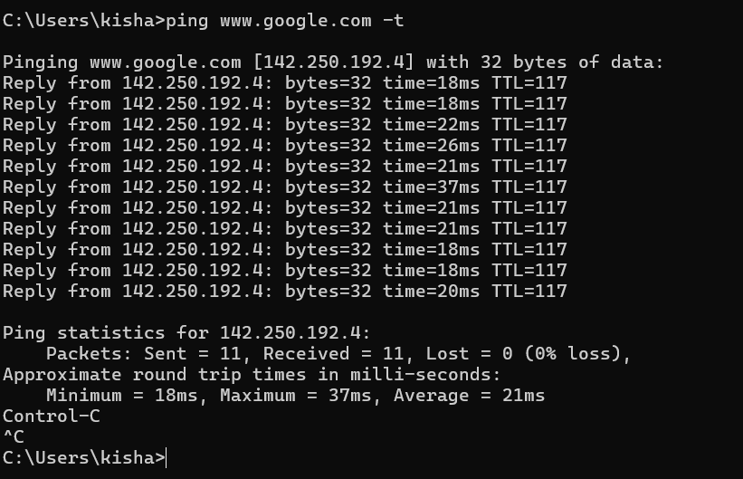

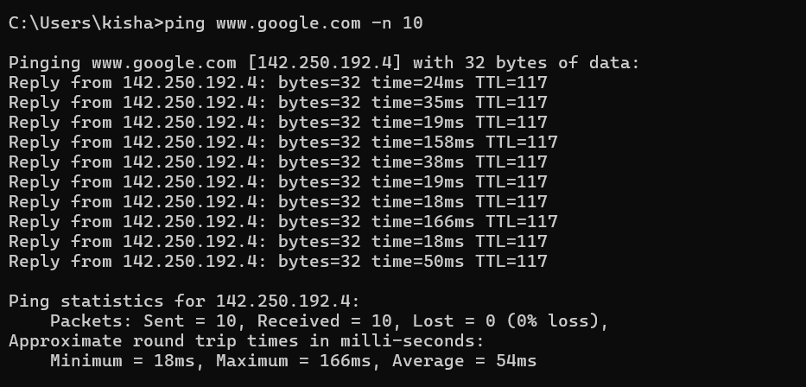

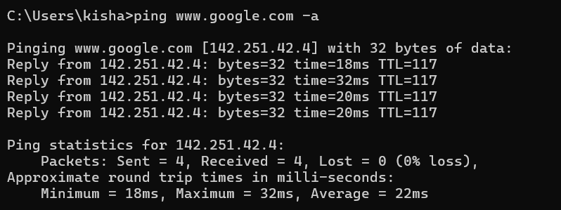

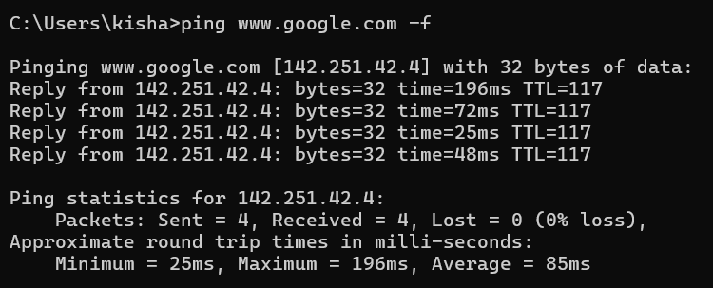

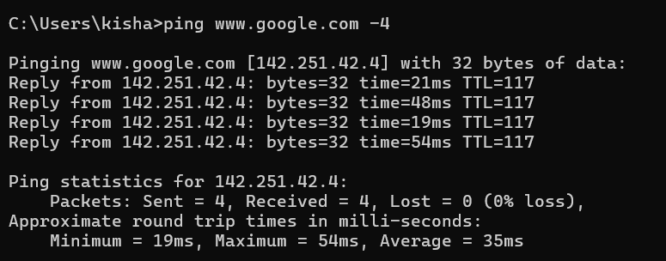

## getmac

### Description:

The getmac command is network utility used to display the Media Access Control(MAC) address for network adapters on system.it provides a quick way to find the physical address associated with each network

Iterface,which is essential for tasks such as network trobleshooting,securiy auditing and network management.

|  |  |  |
| --- | --- | --- |
| No. | Option | Description |
| 1 | /v | Specifies that verbose output is displayed. |
| 2 | /nh | Specifies that the column header should not be displayed in the output.Valid only for Table and CSV format. |
| 3 | /FO format | Format the information. |
| 4 | /S system | Connect to specific system. |
| 5 | /U | Specifies the user context under which the command should execute. |

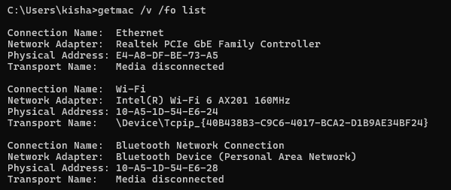

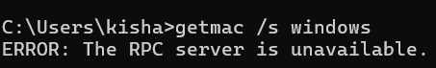

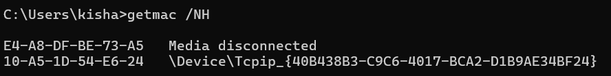

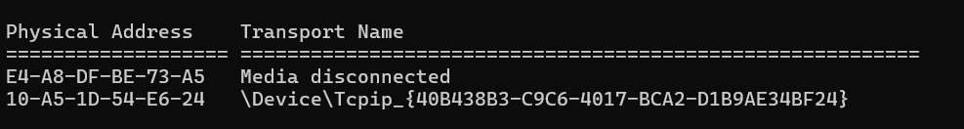

## systeminfo

### Description:

This tool displays operating system configuration information for a local or remote machine,including service pack levels.

|  |  |  |
| --- | --- | --- |
| No. | Option | Description |
| 1 | /v | Specifies that verbose output is displayed. |
| 2 | /nh | Specifies that the column header should not be displayed in the output.Valid only for Table and CSV format. |
| 3 | /FO format | Format the information. |
| 4 | /S system | Connect to specific system. |
| 5 | /U | Specifies the user context under which the command should execute. |

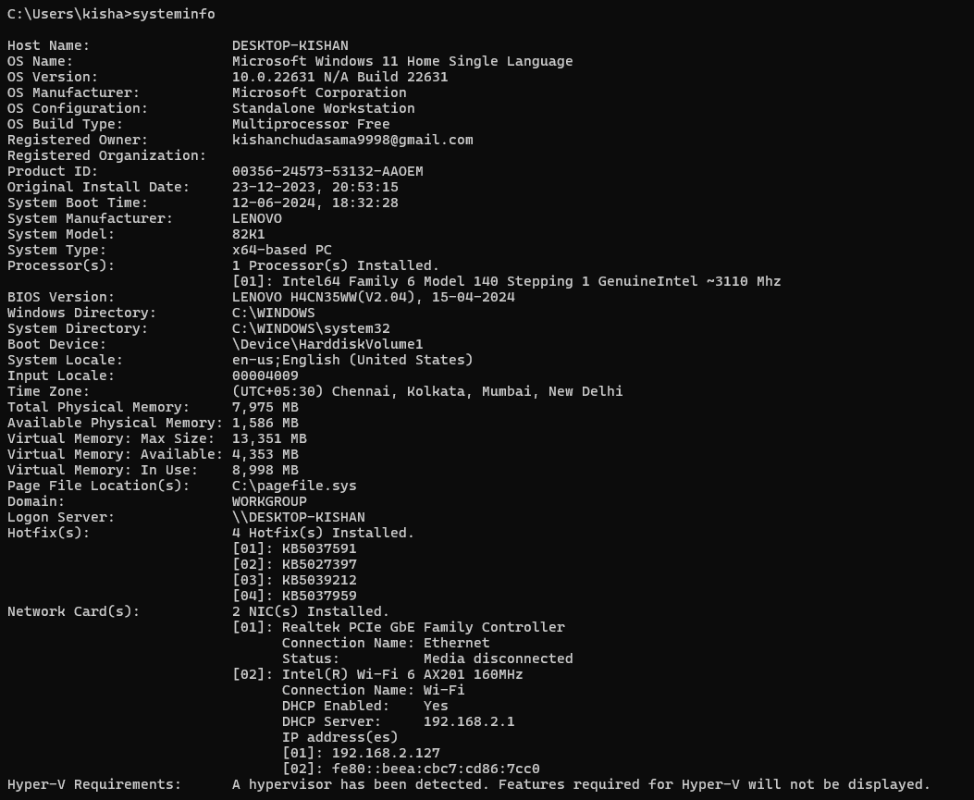

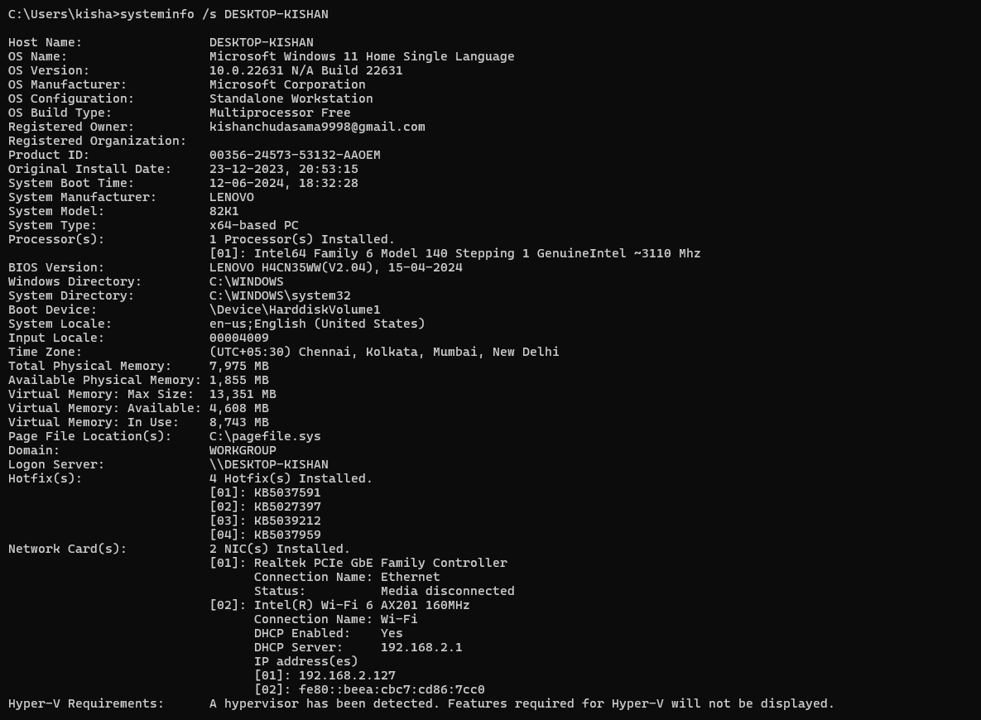

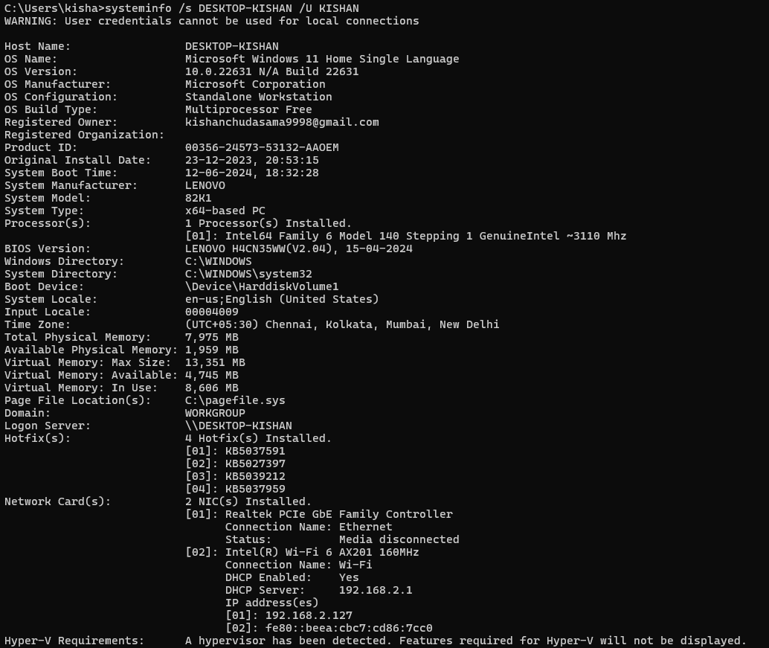

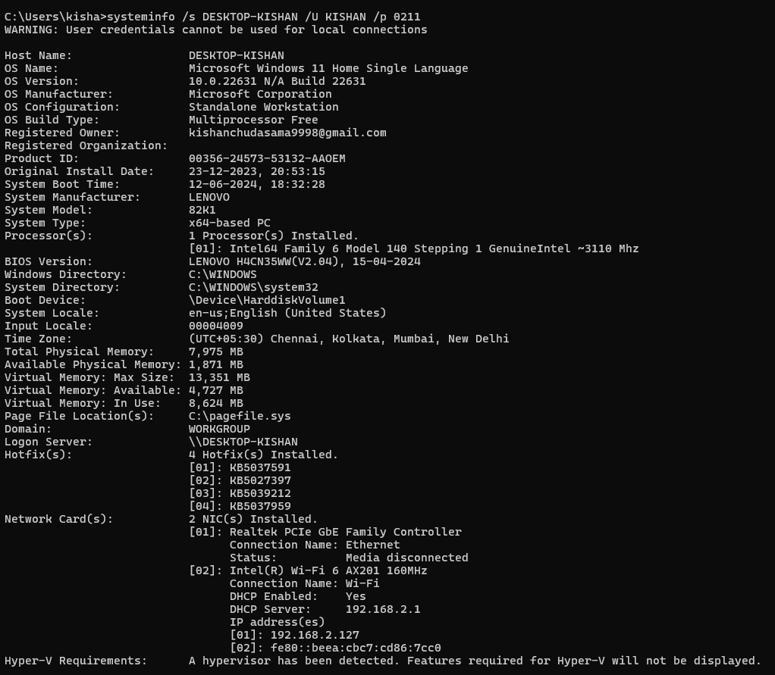

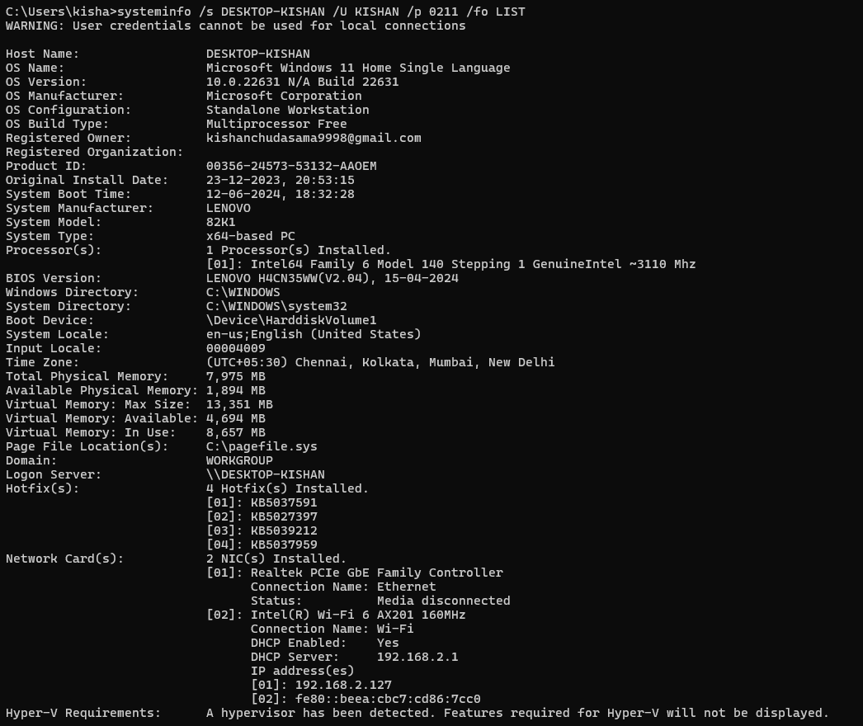



## traceroute

### Description:

The tranceroute(on Unix-based system) or trancert (on Windows) command is a network diagostic tool used to track the path packets take from the source to the destination host across an IP network.It helps in identifying the route taken by packets and location points of failure or high latency in the network path.

|  |  |  |
| --- | --- | --- |
| No. | Option | Description |
| 1 | -d | Do not resolve address to hostnames,displaying only IP address. |
| 2 | -h | Specifies the maximum number of hopes to search for the target.The default is typically 30 hops. |
| 3 | -w | Specifies the timeout in milliseconds to wait for each reply. This helps in adjusting the waiting time for responses from each hop |
| 4 | -4 | Force the use of IPv4 for the traceroute, even if the system is configured for IPv6. |
| 5 | -6 | Force the use of IPv6 for the traceroute, used in environments where IPv6 is deployed. |

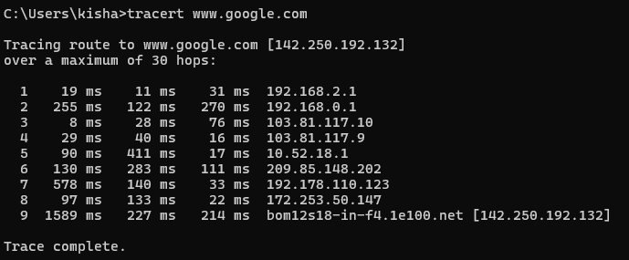

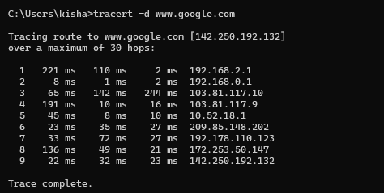

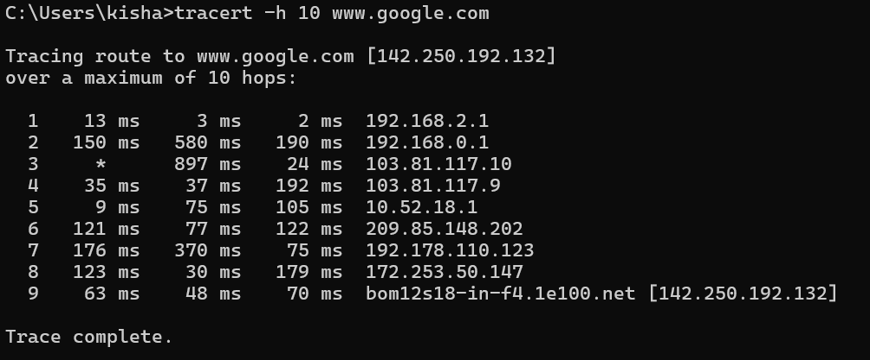

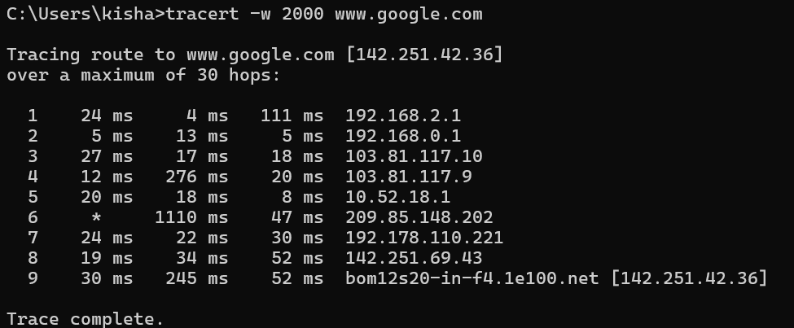

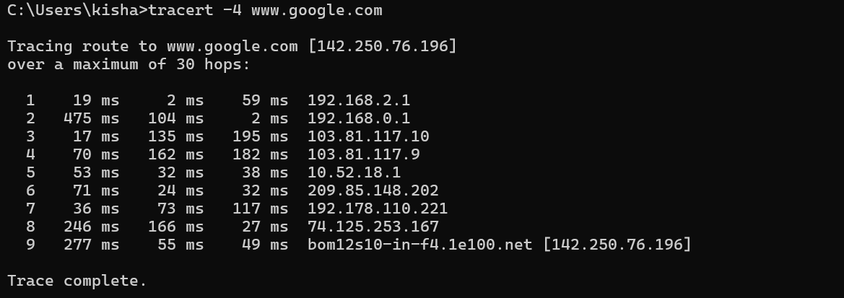

## nslookup

### Description:

**The nslookup command is a network utility used to query Domain Name System (DNS) servers to obtain domain name or IP address mapping. It is commonly used to troubleshoot DNS issues, verify DNS configurations, and gather DNS-related information.**

|  |  |  |
| --- | --- | --- |
| No. | Option | Description |
| 1 | < hostname> | Queries the specified hostname to find its corresponding IP address. |
| 2 | <IP address> | Queries the specified IP address to find its corresponding domain name. |
| 3 | server <DNS server> | Specifies a different DNS server to use for the query. Useful for checking DNS responses from specific DNS servers. |
| 4 | type=<record type> | Specifies the type of DNS record to query (e.g., A, AAAA, CNAME, MX, NS, PTR, SOA, SRV, TXT). This allows you to retrieve specific types of DNS information. |

### Implementation:

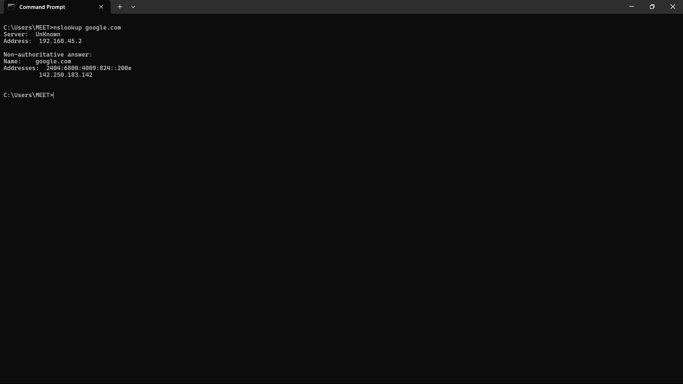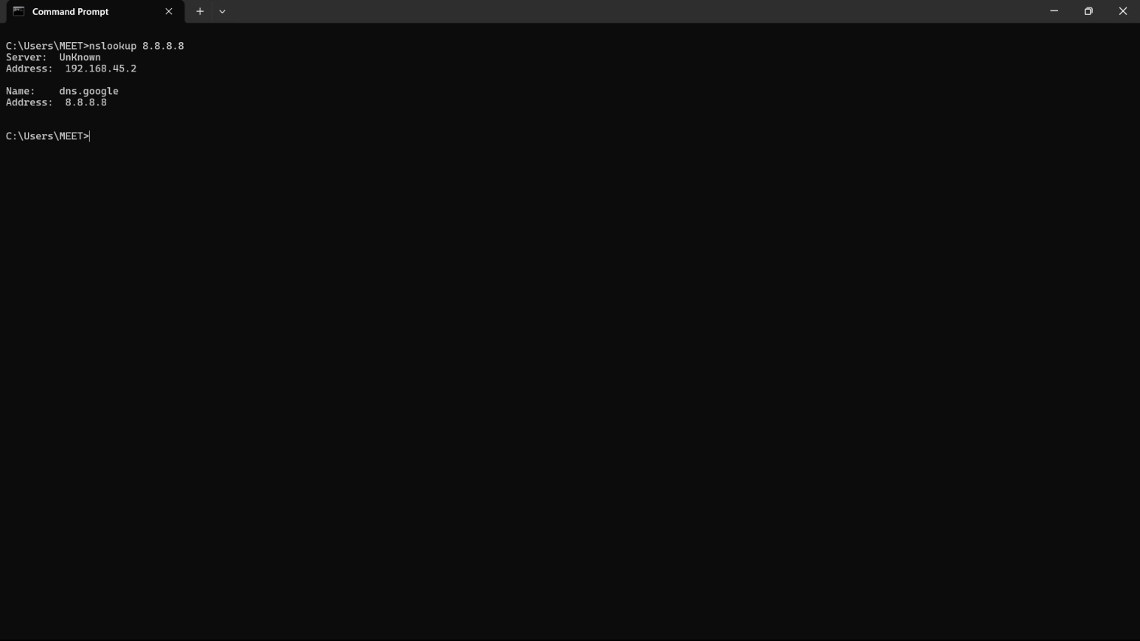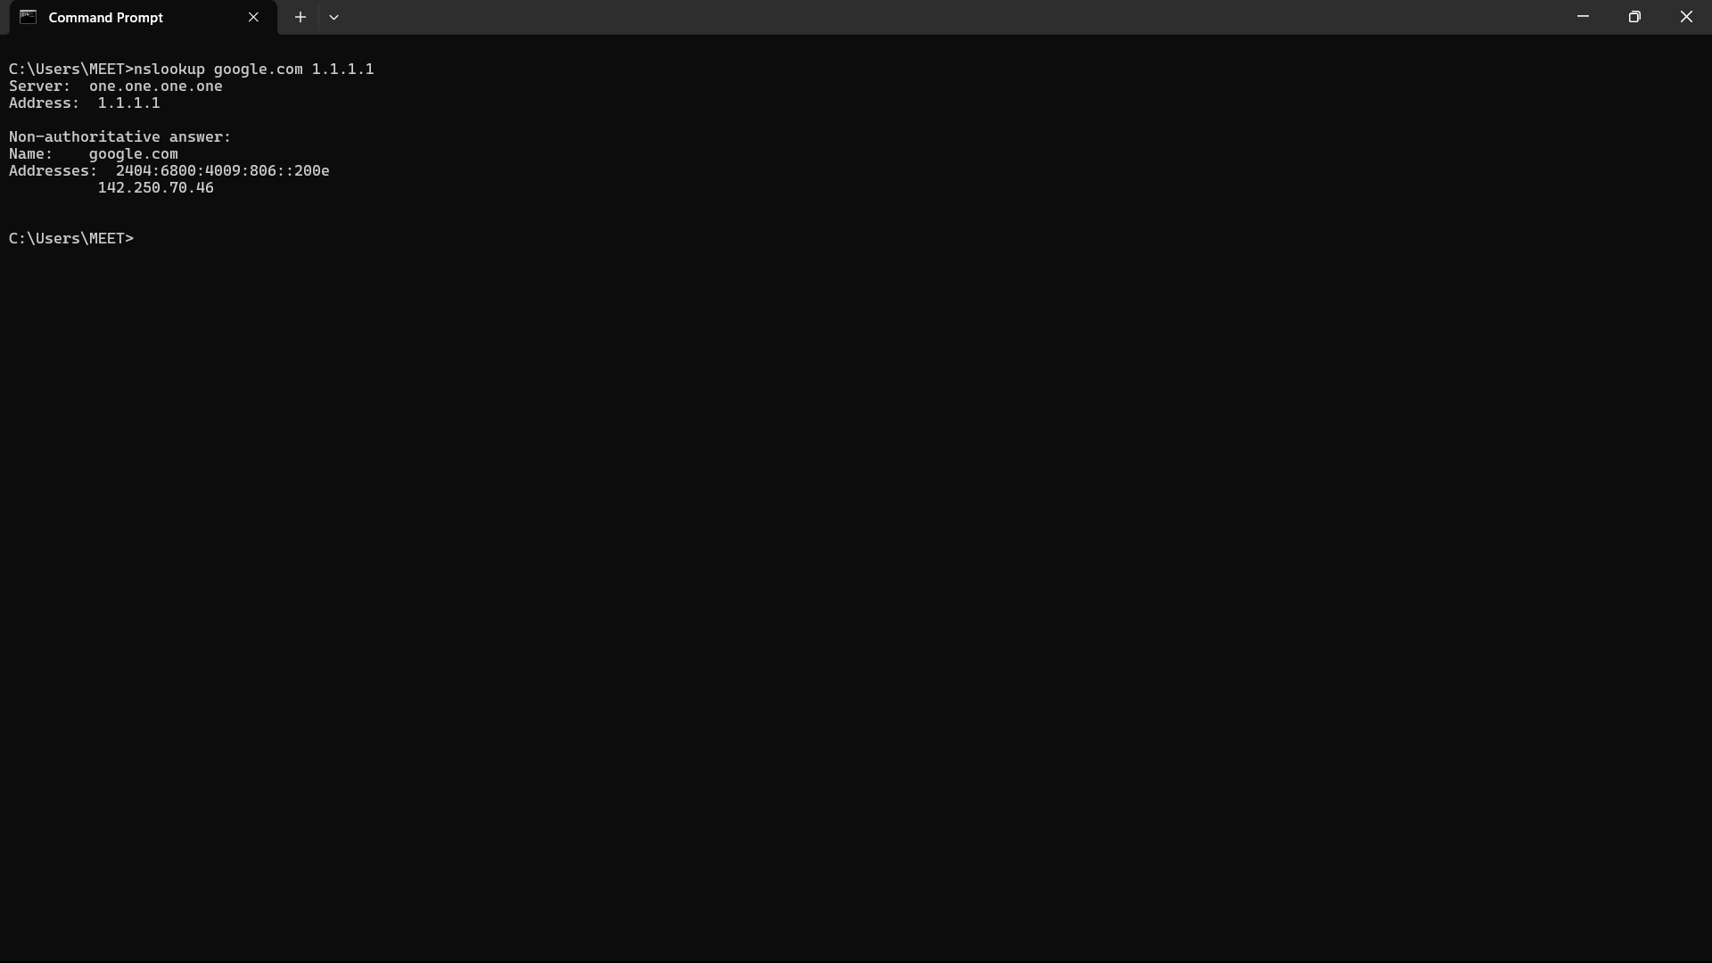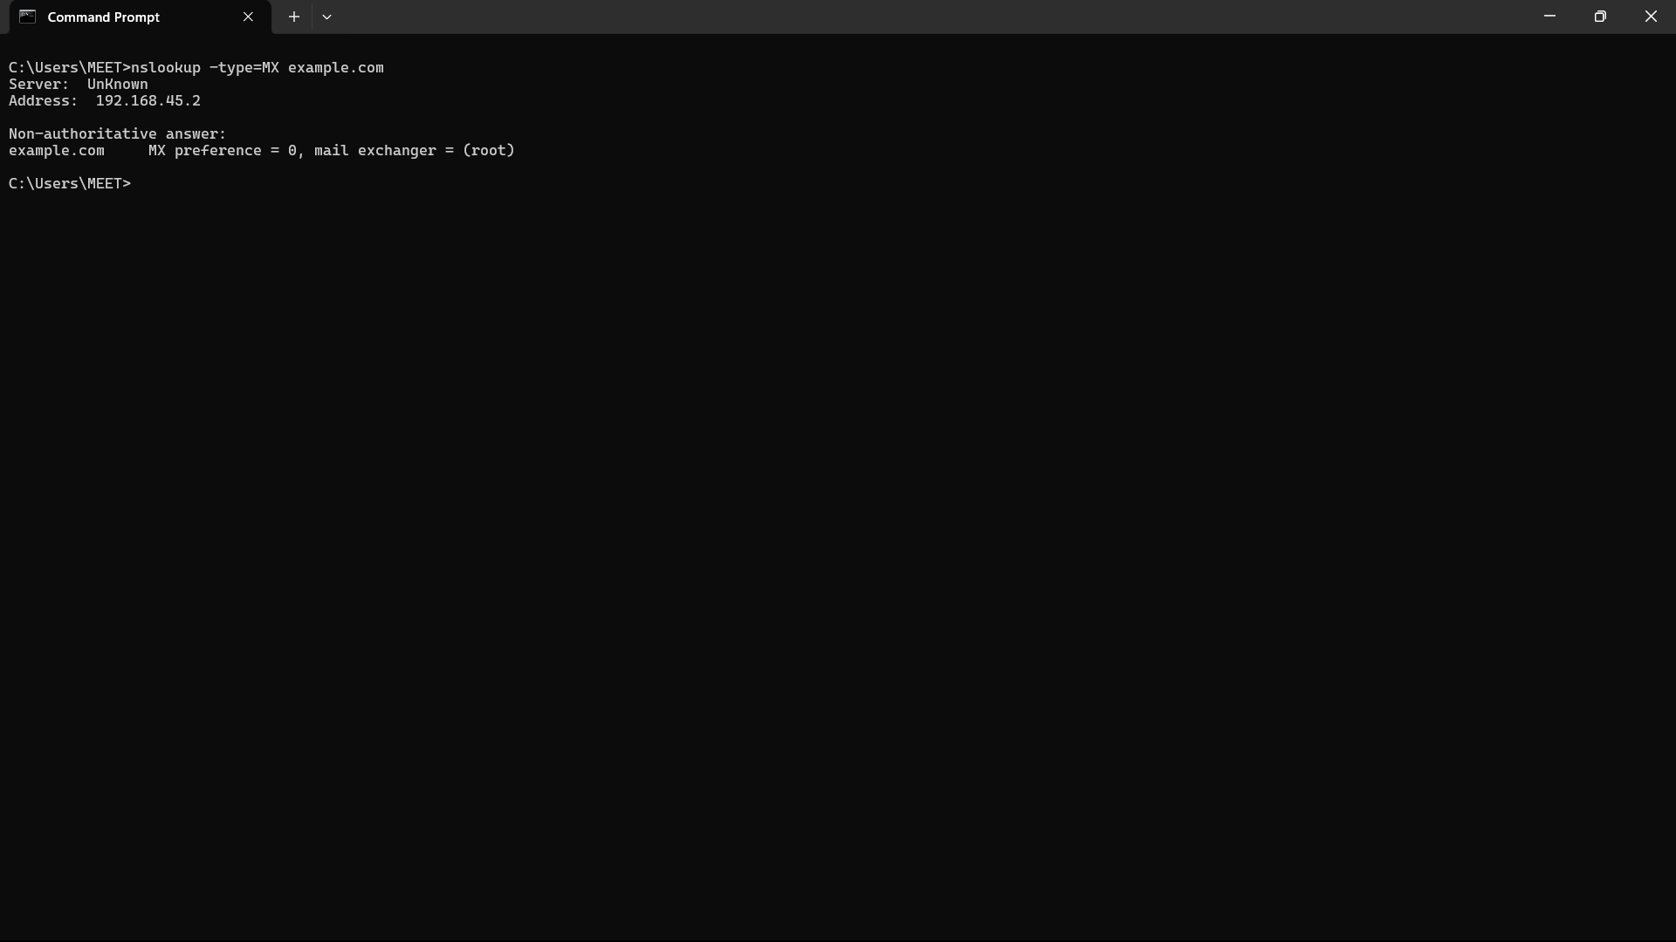

### Description:

The netstat command is a network utility used to display network connections (both incoming and outgoing), routing tables, interface statistics, masquerade connections, and multicast memberships. It is a valuable tool for diagnosing network issues and monitoring network activity.

|  |  |  |
| --- | --- | --- |
| No. | Option | Description |
| 1 | -a | Displays all active connections and listening ports, including those on the listening state. |
| 2 | -n | Displays addresses and port numbers in numerical form, without resolving to hostnames or service names. |
| 3 | -o | Shows the owning process ID associated with each connection, which can be useful for identifying which processes are using which network connections. |
| 4 | -e | Displays Ethernet statistics, such as bytes sent and received. This can be useful for monitoring network interface activity. |
| 5 | -r | Displays the routing table, showing the paths that network traffic will take to reach its destination. |

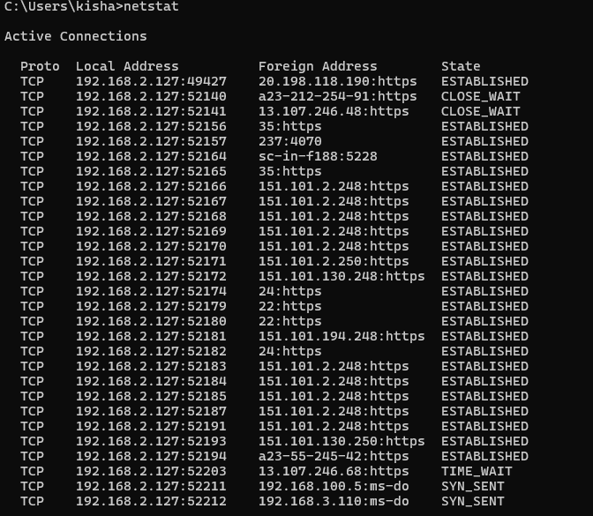

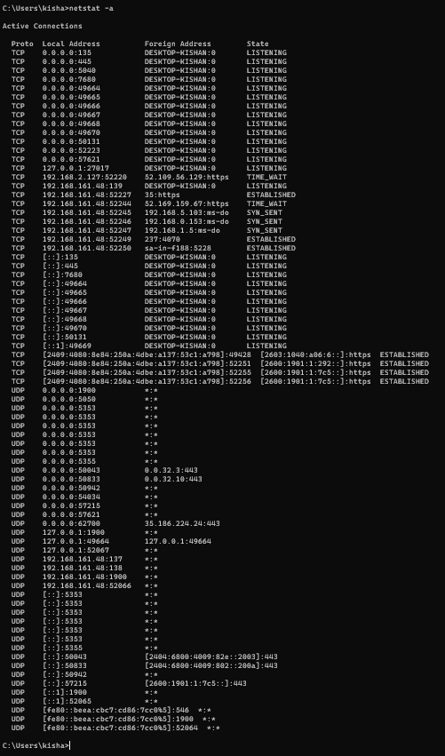

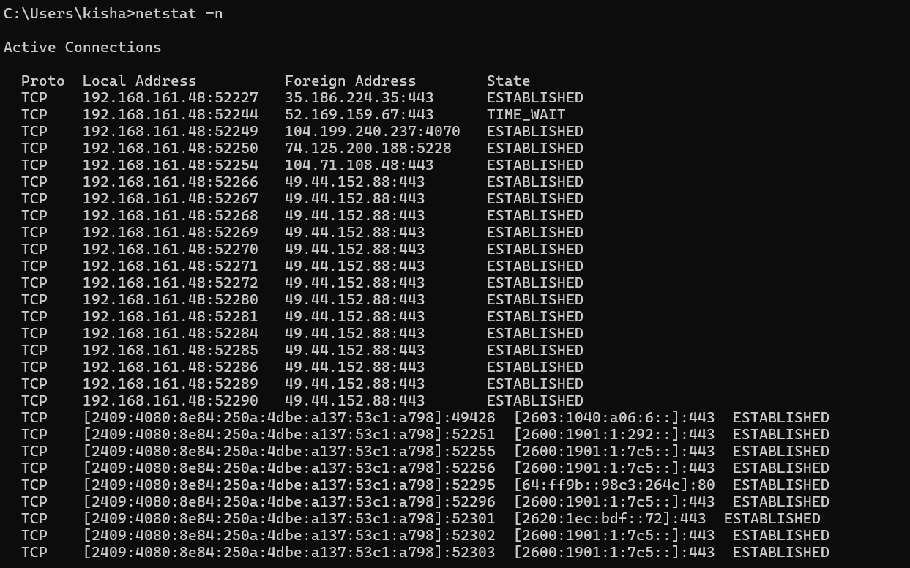

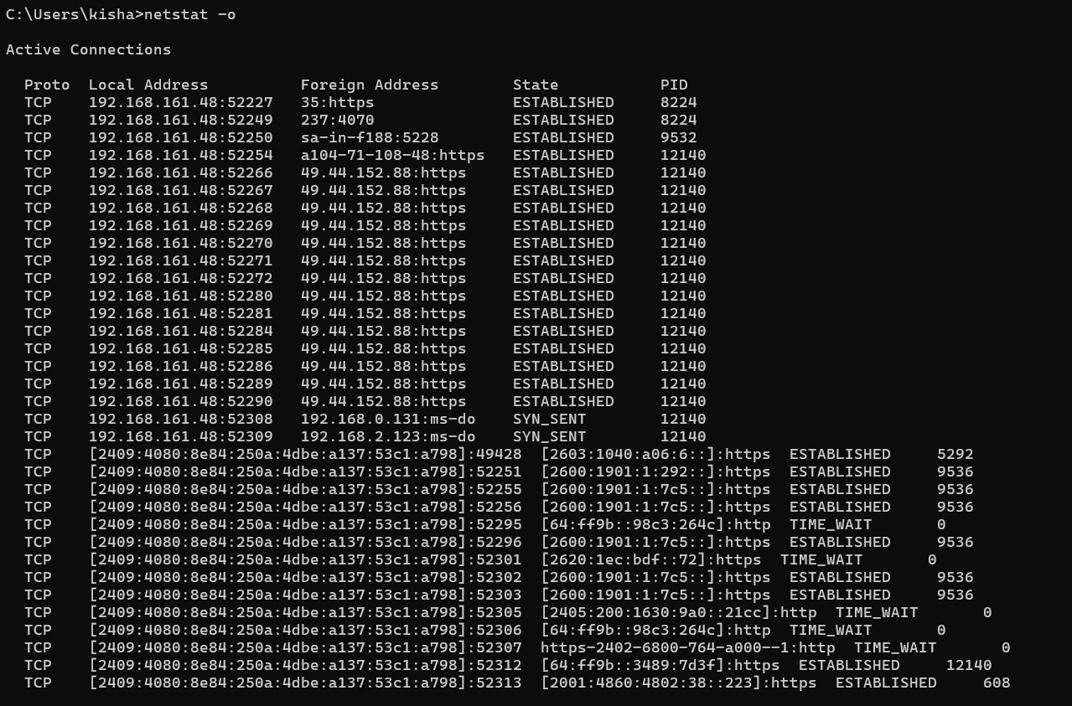

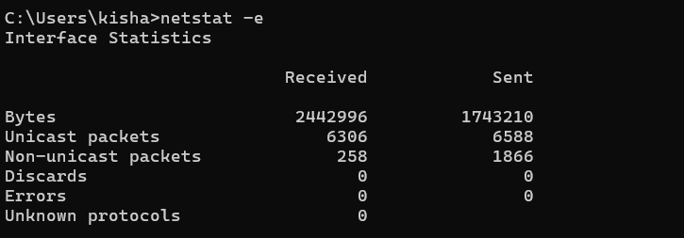

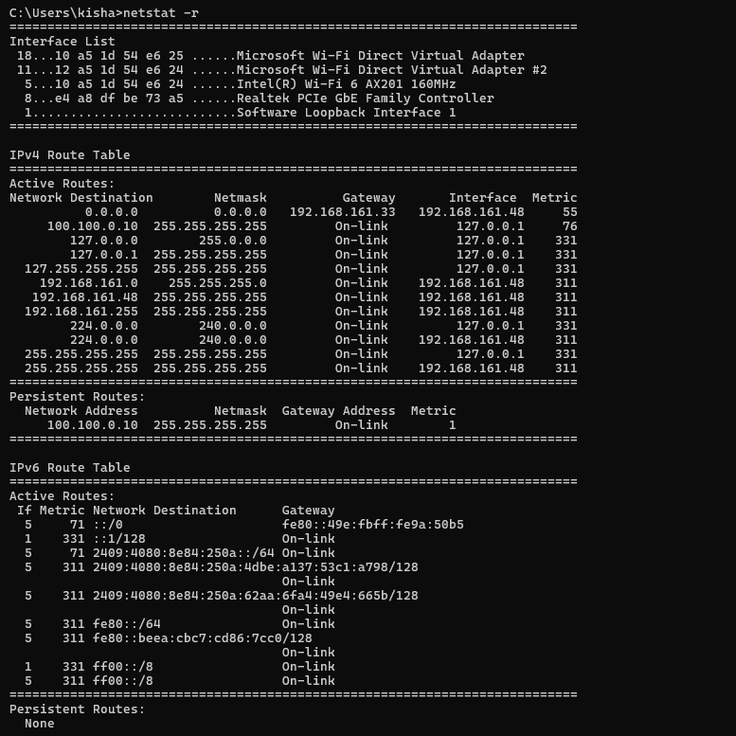

### 7. nslookup Description:

**The nslookup command is a network utility used to query Domain Name System (DNS) servers to obtain domain name or IP address mapping. It is commonly used to troubleshoot DNS issues, verify DNS configurations, and gather DNS-related information.**

|  |  |  |
| --- | --- | --- |
| No. | Option | Description |
| 1 | < hostname> | Queries the specified hostname to find its corresponding IP address. |
| 2 | <IP address> | Queries the specified IP address to find its corresponding domain name. |
| 3 | server <DNS server> | Specifies a different DNS server to use for the query. Useful for checking DNS responses from specific DNS servers. |
| 4 | type=<record type> | Specifies the type of DNS record to query (e.g., A, AAAA, CNAME, MX, NS, PTR, SOA, SRV, TXT). This allows you to retrieve specific types of DNS information. |

### 8. Hostname Description:

The hostname command is a simple utility used to display or set the hostname of the system. The hostname is a unique name assigned to a computer on a network, which is used to identify the system in network communications.

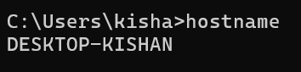

# 9. pathping

### Description:

The `ipconfig` command is used in Windows to display and manage the network configuration of the system. It provides detailed information about the IP addresses, subnet masks, default gateways, and other network settings of all network adapters in the system.

|  |  |  |
| --- | --- | --- |
| No. | Option | Description |
| 1 | -n | Does not resolve addresses to hostnames, displaying only IP addresses. |
| 2 | -h | Specifies the maximum number of hops (routing steps) to search for the target. The default is 30 hops. |
| 3 | -g | Allows for loose source routing along the specified list of hosts. |
| 4 | -p | Waits the specified number of milliseconds between pings. The default is 250 milliseconds. |
| 5 | -q | Specifies the number of queries per hop. The default is 100 queries. |

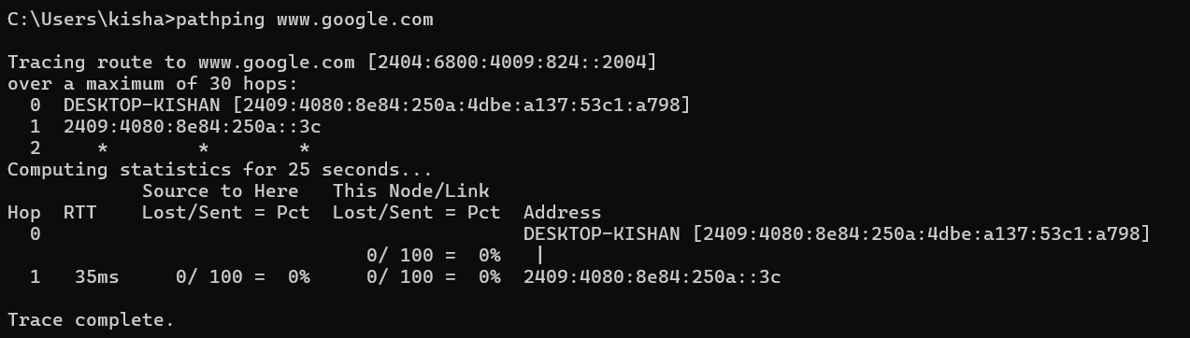

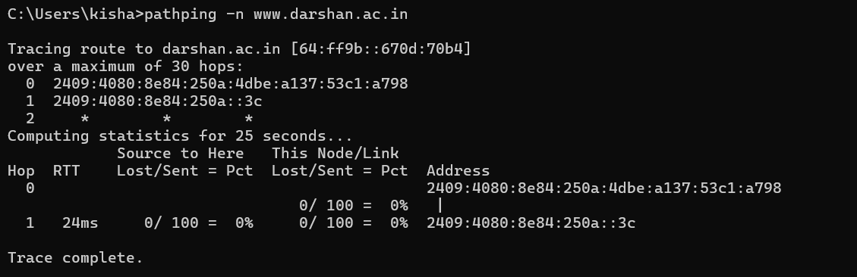

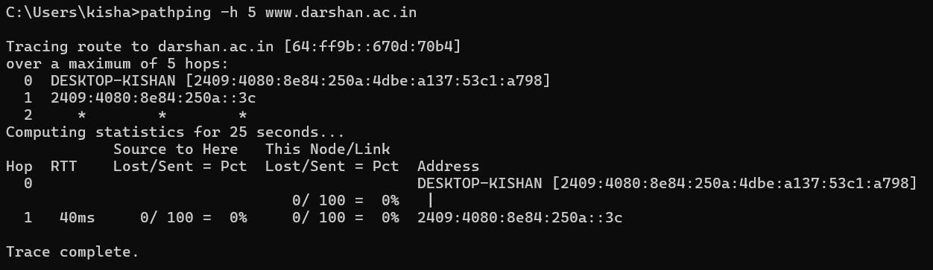

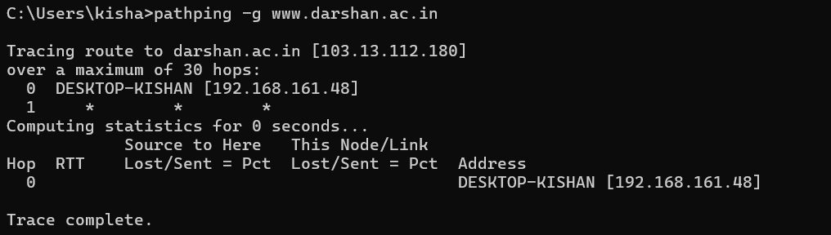

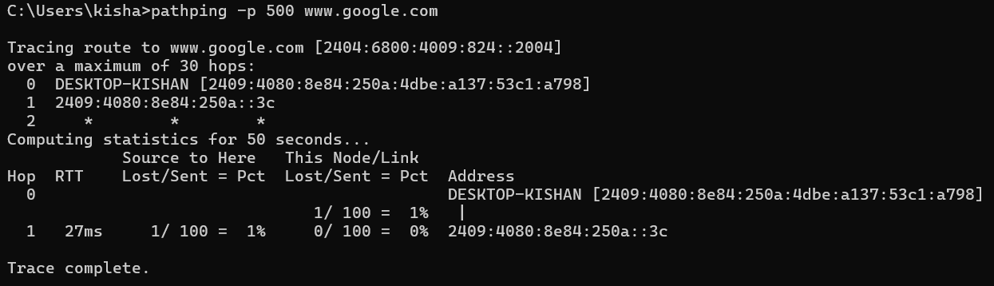  
  
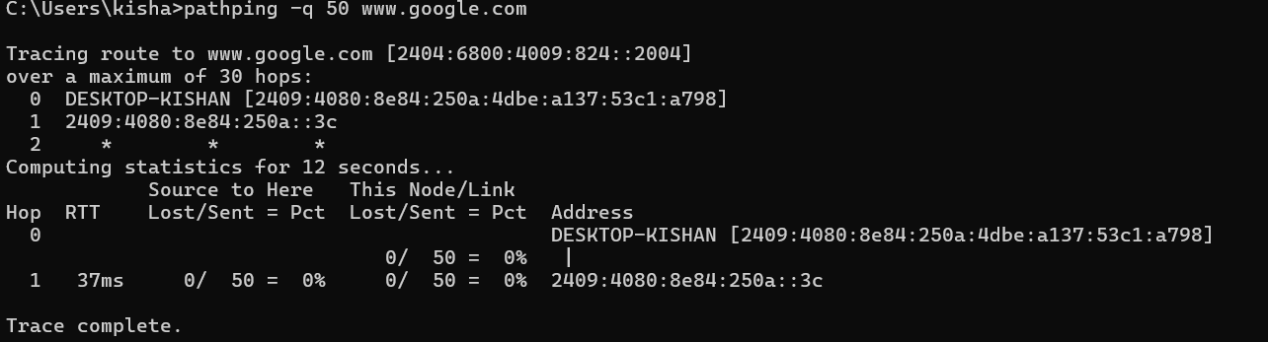

## 10. Arp

Description:  
 The arp command is used to display and manipulate the Address Resolution Protocol (ARP) cache, which maps IP addresses to physical MAC addresses on a local network. This is essential for network communication as it allows devices to find each other using their IP addresses by resolving them to the correct MAC addresses.

|  |  |  |
| --- | --- | --- |
| No. | Option | Description |
| 1 | -a | Displays the current ARP entries in the ARP cache for all interfaces. |
| 2 | -g | Same as -a, displays the current ARP entries in the ARP cache for all interfaces. |
| 3 | -s | Adds a static ARP entry to the ARP cache that associates the specified IP address with the MAC address on an optional interface index. |
| 4 | -v | Displays current ARP entries in verbose mode. All invalid entries and entries on the loop-back interface will be shown. |
| 5 | -N | Displays the ARP entries for the specified network interface identified by its IP address. |

