**Lab Practical #12:**

To develop network using distance vector routing protocol and link state routing protocol.

**Practical Assignment #12:**

1. **C/Java Program: Distance Vector Routing Algorithm using Bellman Ford's Algorithm.**

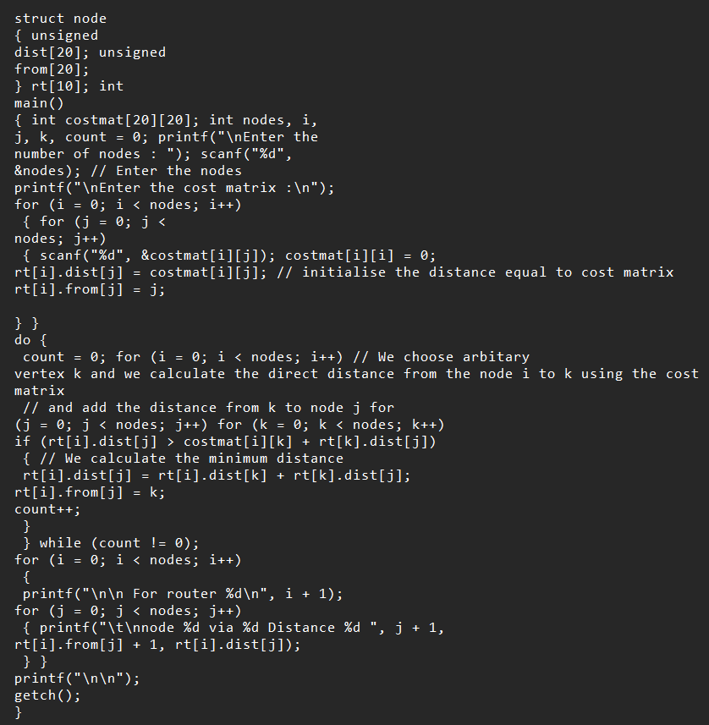

**2. C/Java Program: Link state routing algorithm.**

