**Date: 12 /07/2024**

# Lab Practical #03:

**Practical Assignment #03:**

## Give difference between below network devices.

* + Hub and Switch
  + Switch and Router
  + Router and Gateway

## Working of below network devices:

* + Switch

## Router

* + Gateway

# Hub and Switch

|  |  |  |
| --- | --- | --- |
| **No.** | **Hub** | **Switch** |
| **1** | A hub uses the physical layer to operate. | A switch controls the data connection layer. |
| **2** | Hubs carry out a broadcast, multicast, or unicast frame flooding. | When necessary, it executes broadcast, followed by unicast and multicast. |
| **3** | In a hub, there is just one domain of collision. | Different ports each have their collision domain. |
| **4** | Half-duplex is the transmission mode. | Full duplex transmission is the mode. |
| **5** | Following the OSI model, hubs function as Layer 1 devices. | Operating at Layer 2 of the OSI model is made possible by network switches. |
| **6** | orbits of electrical signals are used | utilizes frames and packets |
| **7** | does not provide Spanning-Tree | Multiple Spanning-Trees are possible. |
| **8** | In configurations with hubs, collisions happen most frequently. | In a full-duplex switch, there are no collisions. |
| **9** | A passive device is a hub. | A switch is a functioning device. |
| **10** | MAC addresses cannot be kept in a network hub. | Switches utilize CAM (Content Accessible  Memory), which an ASIC may access (Application Specific Integrated Chips). |

**Switch and Router**

|  |  |  |
| --- | --- | --- |
| **No.** | **Router** | **Switch** |
| **1** | The main objective of router is to connect various networks simultaneously. | While the main objective of switch is to connect various devices simultaneously. |
| **2** | It works in network Layer. | While it works in data link Layer. |
| **3** | Router is used by LAN as well as MAN | While switch is used by only LAN. |

**Date: 12 /07/2024**

|  |  |  |
| --- | --- | --- |
| **4** | Through the router, data is sent in the form of packets. | While through switch data is sent in the form of frame. |
| **5** | There is less collision taking place in the router. | While there is no collision taking place in full duplex switch. |
| **6** | Router is compatible with NAT | While it is not compatible with NAT. |
| **7** | Router is a relatively much more expensive device than switch. | Switch is an expensive device than hub. but cheaper than router. |
| **8** | maximum speed for wireless is 1-10 Mbps and  maximum speed for wired connections is 100 Mbps. | Maximum speed is 10Mbps to 100Mbps. |
| **9** | Router needs at least two networks to connect. | Switch needs at least single network is to connect. |

# Router and Gateway

|  |  |  |
| --- | --- | --- |
| **No.** | **Router** | **Gateway** |
| **1** | It is a hardware device which is responsible for receiving, analyzing and forwarding the data  packets to other networks. | It is a device that is used for the communication among the networks which  have a different set of protocols. |
| **2** | It supports the dynamic routing. | It does not support dynamic routing. |
| **3** | The main function of a router is routing the traffic from one network to the other. | The main function of a gateway is to translate one protocol to the other. |
| **4** | A router operates on layer 3 and layer 4 of the OSI model. | A gateway operates upto layer 5 of the OSI model. |
| **5** | Working principle of a router is to install routing details for multiple networks and  routing traffic based upon the destination address. | 5. Working principle of a gateway is to differentiate what is inside the network and what is outside the network. |
| **6** | It is hosted on only the dedicated applications. | It is hosted on dedicated applications, physical servers or virtual applications. |
| **7** | The additional features provided by a router are Wireless networking, Static routing, NAT,  DHCP server etc. | The additional features provided by a gateway are network access control, protocol  conversion etc. |

**Working of below network devices:**

# Switch

* + Switch is a network device which is used to enable the connection establishment and connection termination on the basis of need. Switch is operated on Data link layer. In this packet filtering is available. It is type of full duplex transmission mode and it is also called efficient bridge.
  + Basically, it is a kind of bridge that provides better connections. It is a kind of device that set up and stop the connections according to the requirements needed at that time. It comes up with many features such as flooding, filtering and frame transmission.

**Date: 12 /07/2024**

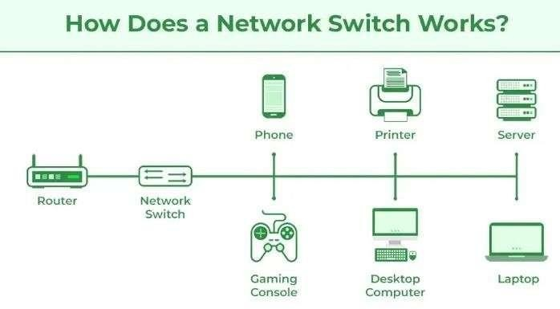

# Router

* + Routers are the multiport devices and more sophisticated as compared to repeaters and bridges. It contains a routing table that enables it to make decision about the route i.e. to determine which of several possible paths between the source and destination is the best for a particular transmission.
  + It works on the network layer 3 and used in LANs, MANs and WANs. It stores IP address and maintains address on its own.

# Gateway

* + A gateway is basically a device or a hardware which acts like a “gate” among the networks.Thus it can also be defined as a node which acts as an entrance for the other nodes in the network.It is also responsible for enabling the traffic flow within the network.Gateway uses more than one protocol for communication thus its activities are much more complex than a switch or a router.
  + So a gateway is basically a device that is used for the communication among the networks which have a different set of protocols and is responsible for the conversion of one protocol into the other.For any kind of workplace, the gateway is a computer system which is responsible for routing the traffic from the main workstation to outside network. For homes, it is responsible for giving the access to the internet thus acting as an internet service provider.