**Lab Practical #05:**

Study the concept of VLAN using packet tracer.

**Practical Assignment #05:**

1. **Implement the different network structures in VLAN and VLAN trunking. Also check connectivity between them using ping command or PDU utility.**

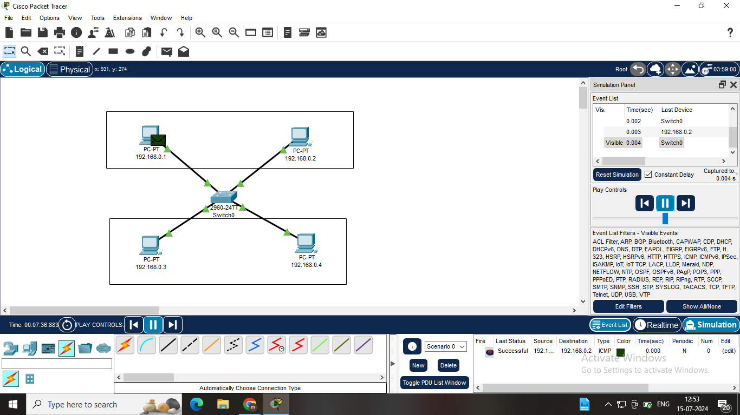

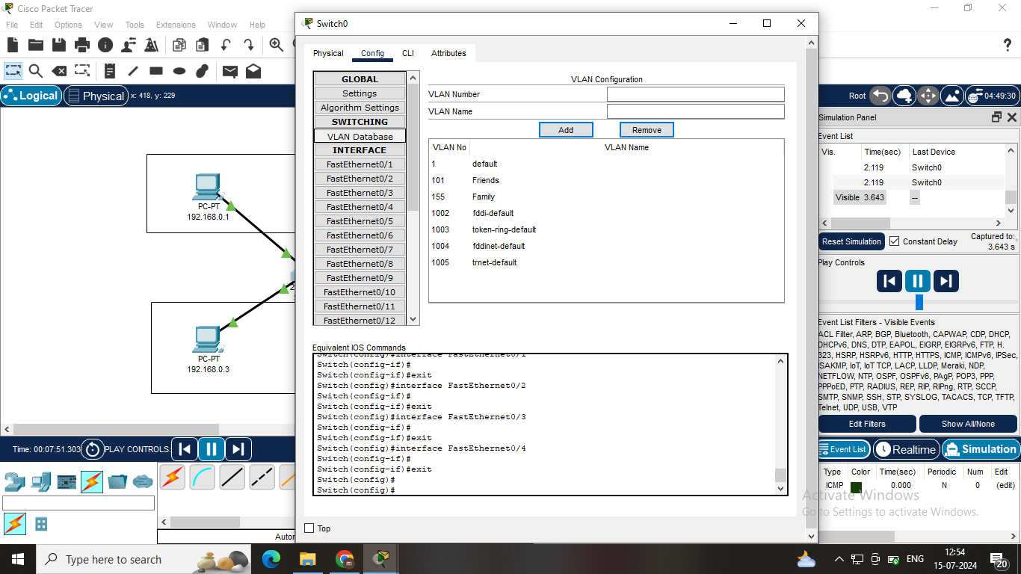

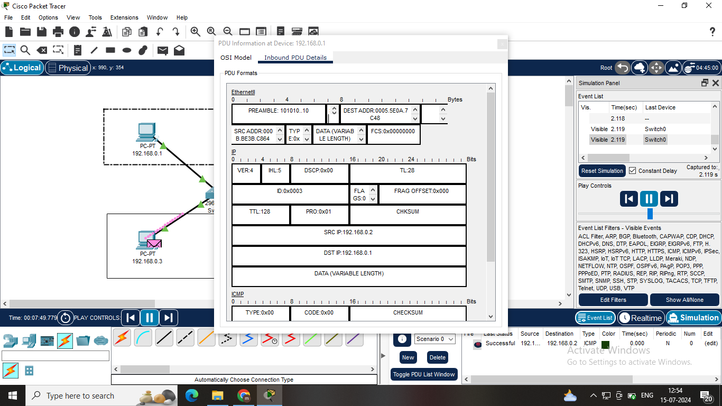

**Step-1:** **Assign IP Addresses And Name:** Assign IPs to four PCs in the range 192.168.0.1 to 192.168.0.4 and name as same as their IPs.

**Step-2:** **Configure VLANs on Switches:** Create VLAN 101 named "Friends" and VLAN 155 named "Family".

**Step-3:** **Assign PCs to VLANs:** PC1 & PC2 to VLAN 101(Friends). PC3 &PC4 to VLAN 155(Family).

**Step-4:** **Determine FastEthernet Ports:** Connect each PC to the appropriate switch port and assign the ports to the corresponding VLANs.

**Step-5: Verify Configuration:** Check VLAN assignments and IP addresses to ensure proper configuration and connectivity.

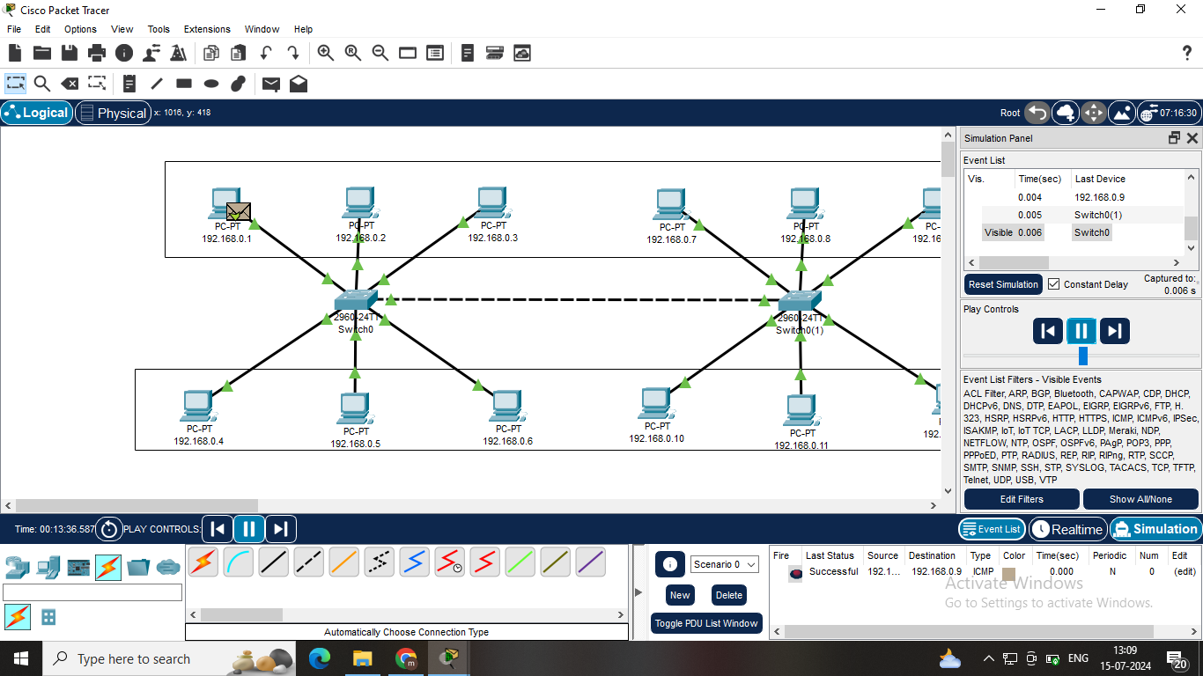

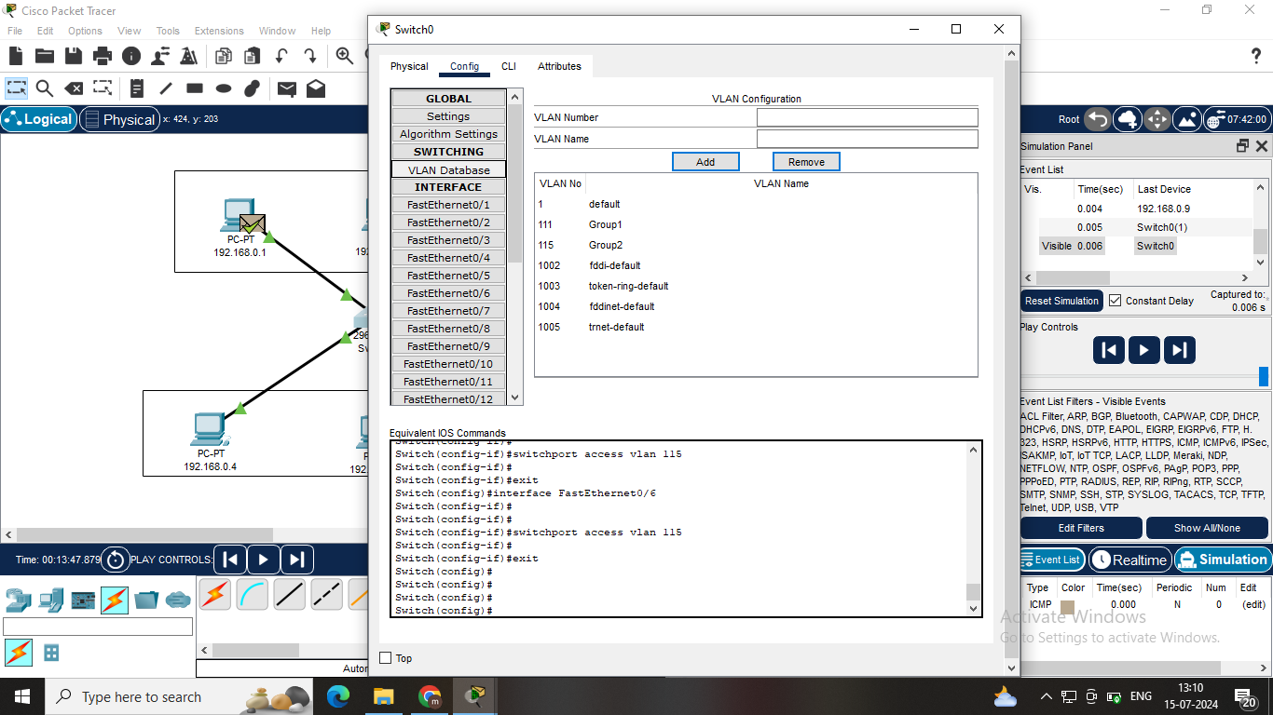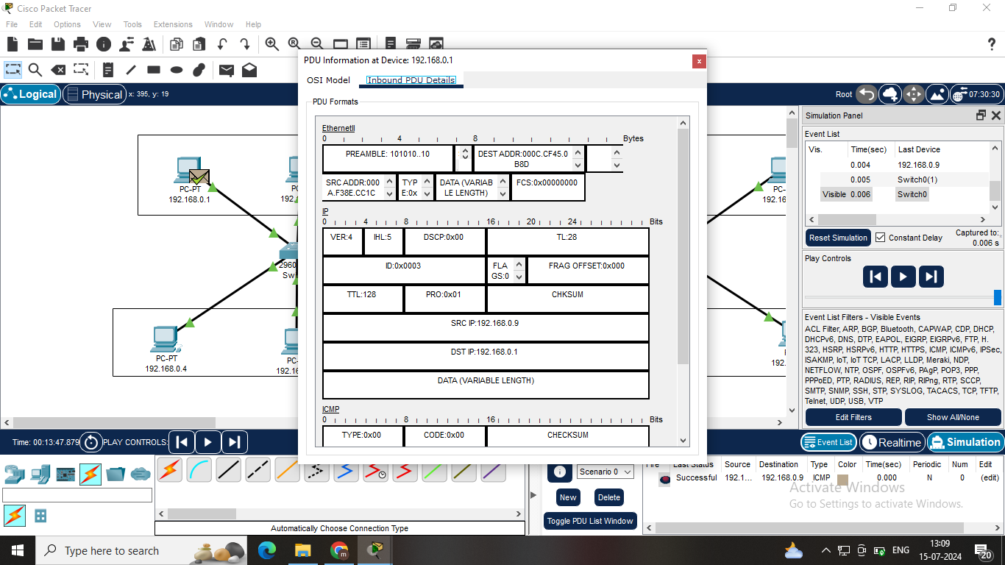

**Step-1:** **Assign IP Addresses And Name:** Assign IPs to Twelve PCs in the range 192.168.0.1 to 192.168.0.12 and name as same as their IPs.

**Step-2: Configure VLANs on Switches:** Create VLAN 111 named "Group1" and VLAN 115 named "Group2".

**Step-3: Assign PCs to VLANs:** 192.168.0.1 to 192.168.0.3 & 192.168.0.7 to 192.168.0.9 to VLAN 111(Group1). 192.168.0.4 to 192.168.0.6 & 192.168.0.10 to 192.168.12 to VLAN 115(Group2).

**Step-4:** **Determine FastEthernet Ports:** Connect each PC to the appropriate switch port and assign the ports to the corresponding VLANs.

**Step-5:** **Verify Configuration:** Check VLAN assignments and IP addresses to ensure proper configuration and connectivity.

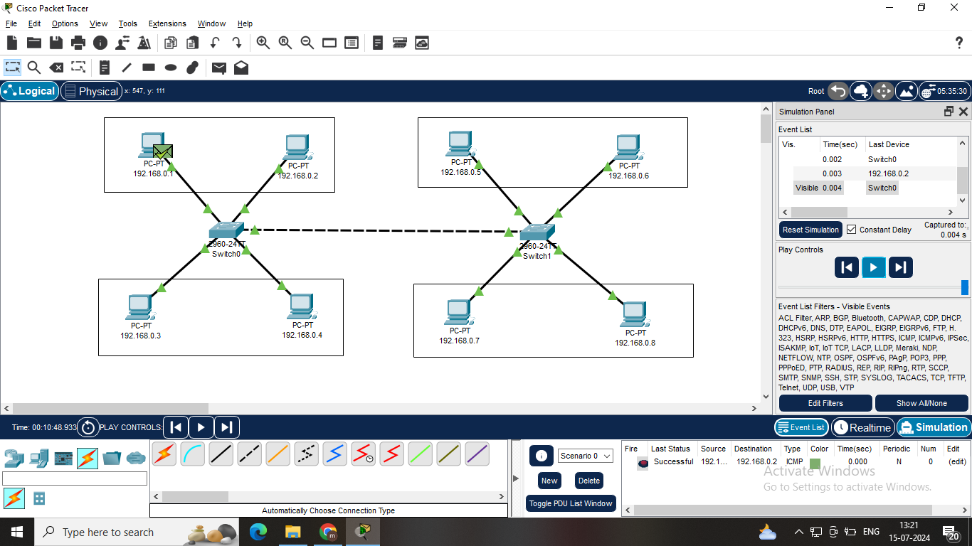

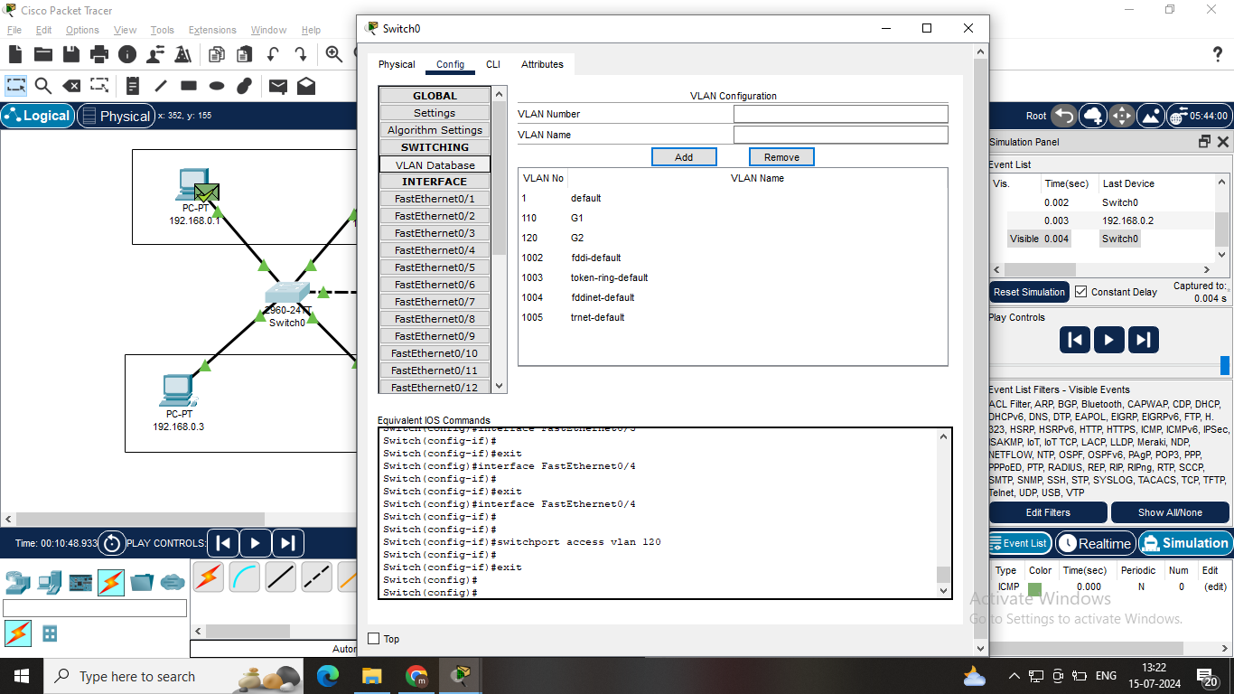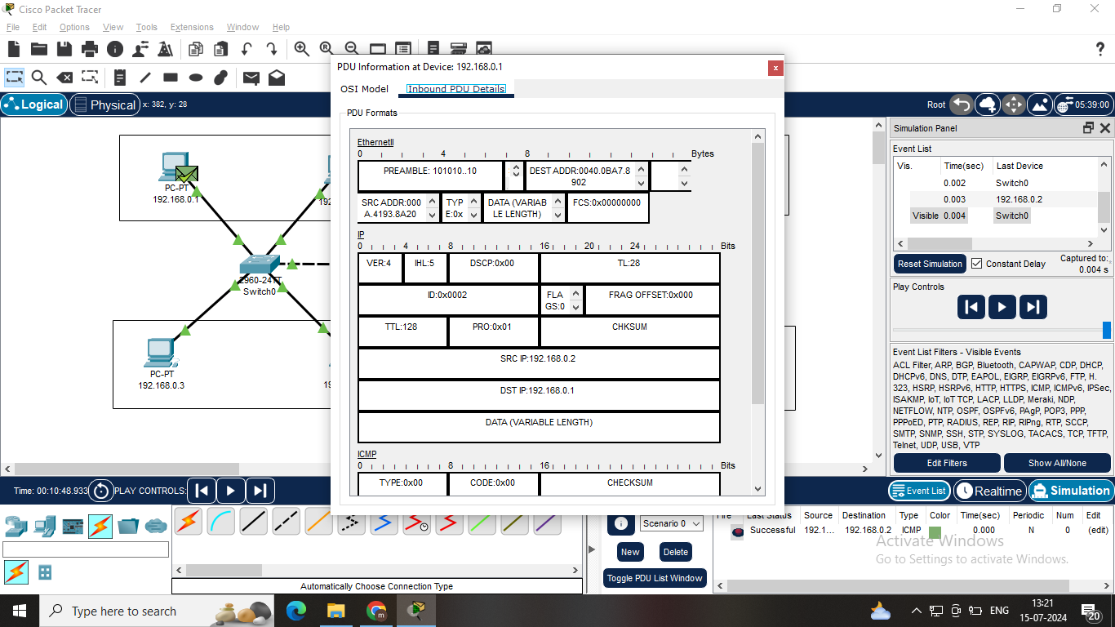

**Step-1: Assign IP Addresses And Name:** Assign IPs to eight PCs in the range 192.168.0.1 to 192.168.0.8 and name as same as their IPs.

**Step-2: Configure VLANs on Switches:** Create VLAN 110 named "G1" and VLAN 120 named "G2" VLAN 130 named "G3" and VLAN 140 named "G4".

**Step-3: Assign PCs to VLANs:** 192.168.0.1 & 192.168.0.2 to VLAN 110(G1), 192.168.0.3 & 192.168.0.4 to VLAN 120 (G2), 192.168.0.5 & 192.168.0.6 to VLAN (G3), 192.168.0.7 & 192.168.0.8 140(G4).

**Step-4: Determine FastEthernet Ports:** Connect each PC to the appropriate switch port and assign the ports to the corresponding VLANs.

**Step-5: Verify Configuration:**  Check VLAN assignments and IP addresses to ensure proper configuration and connectivity.

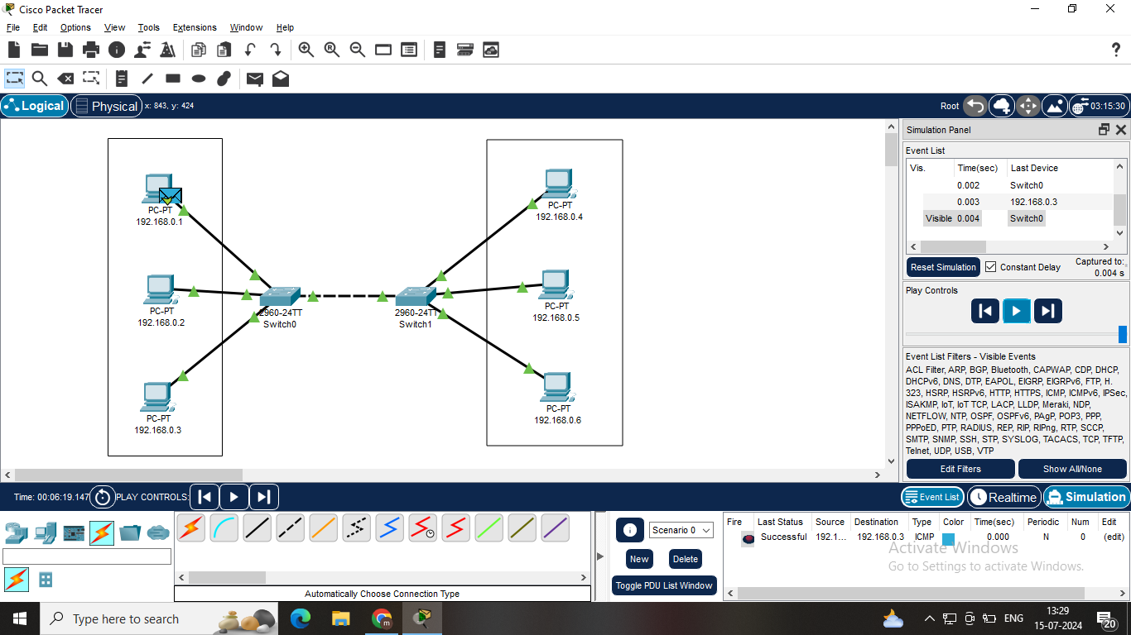

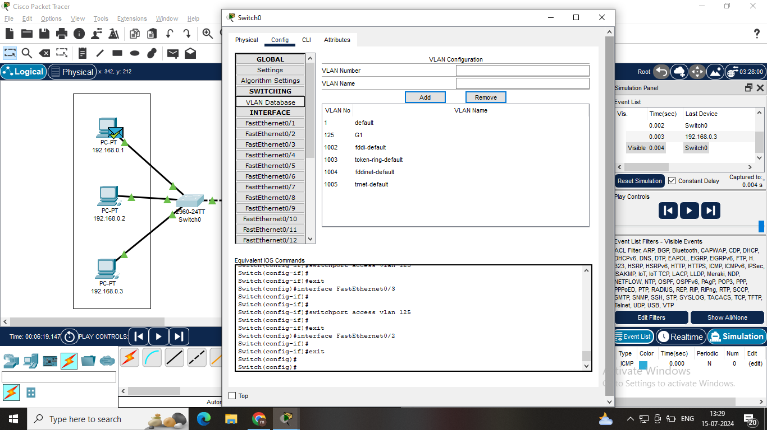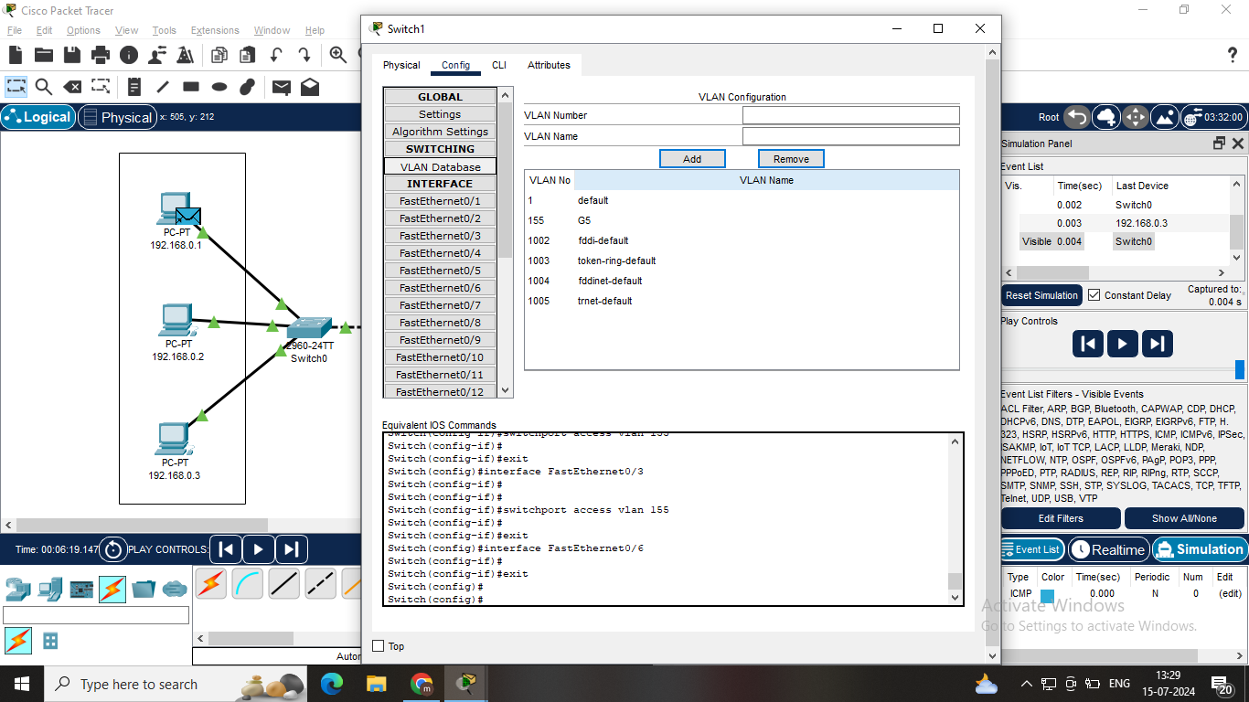

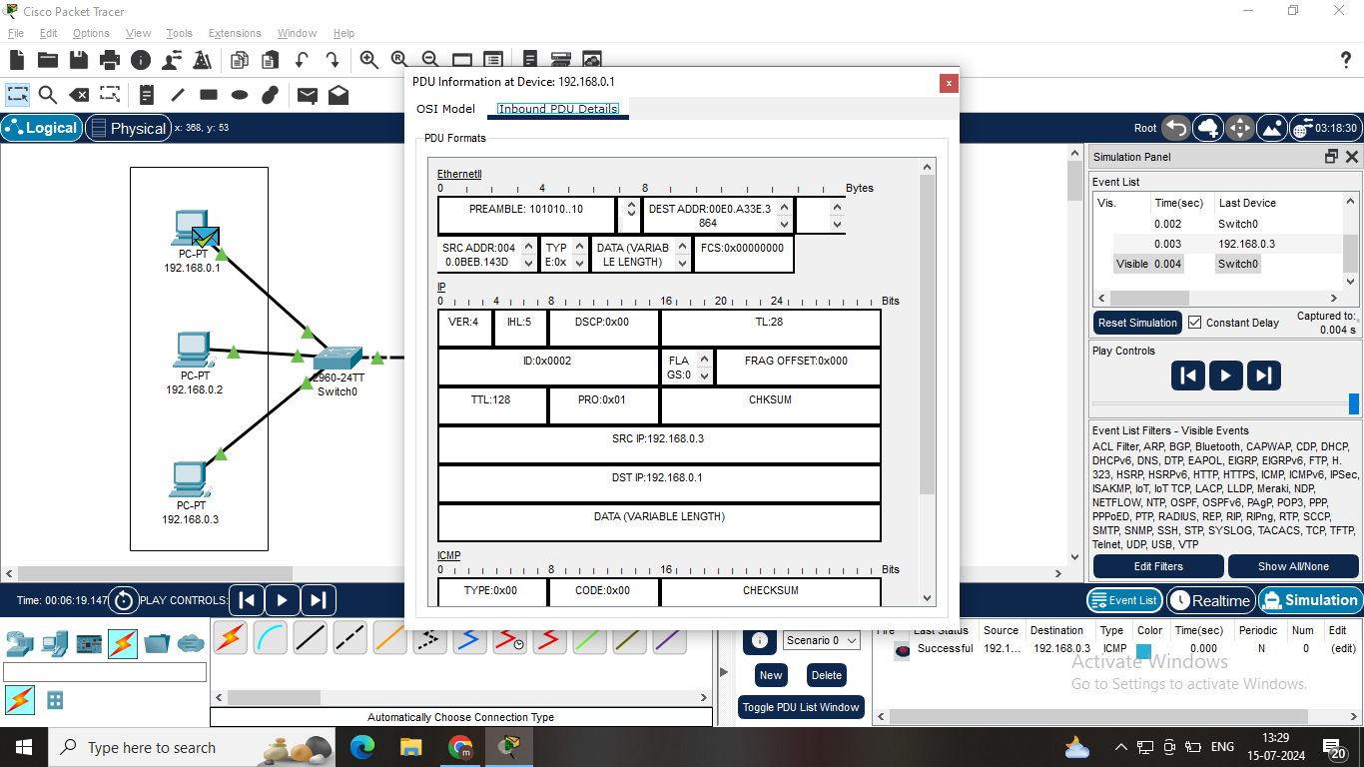

**Step-1: Assign IP Addresses And Name:** Assign IPs to six PCs in the range 192.168.0.1 to 192.168.0.6 and name as same as their IPs.

**Step-2:** **Configure VLANs on Switches:** Create VLAN 125 named "G1" and VLAN 155 named "G5".

**Step-3:** **Assign PCs to VLANs:** 192.168.0.1 to 192.168.0.3 to VLAN 125(G1). 192.168.0.4 to 192.168.0.6 to VLAN 155(G5).

**Step-4: Determine FastEthernet Ports:** Connect each PC to the appropriate switch port and assign the ports tothe corresponding VLANs.

**Step-5: Verify Configuration:** Check VLAN assignments and IP addresses to ensure proper configuration and connectivity.