**Lab Practical #06:**

Study the application layer protocol DNS, DHCP, FTP.

**Practical Assignment #06:**

1. **Implement the application layer protocol DNS, DHCP, and FTP. Also check connectivity between them using ping command or PDU utility.**
2. **DNS:-**

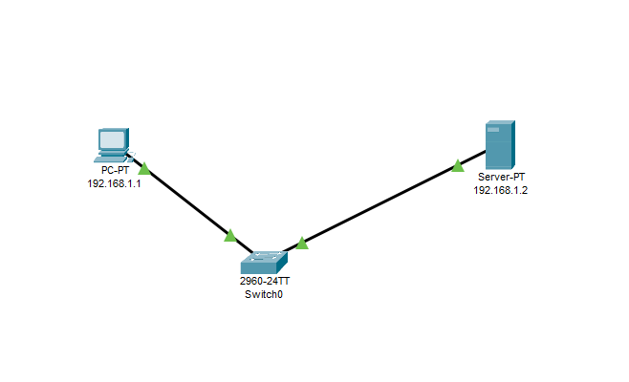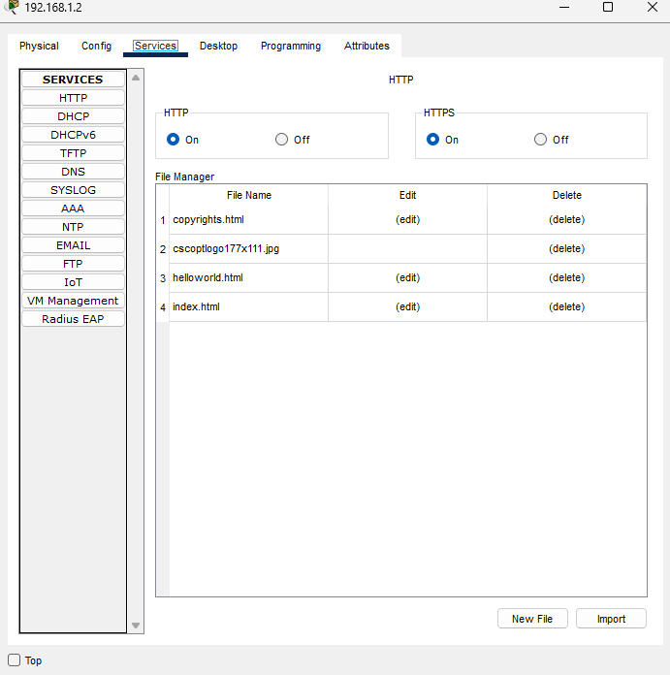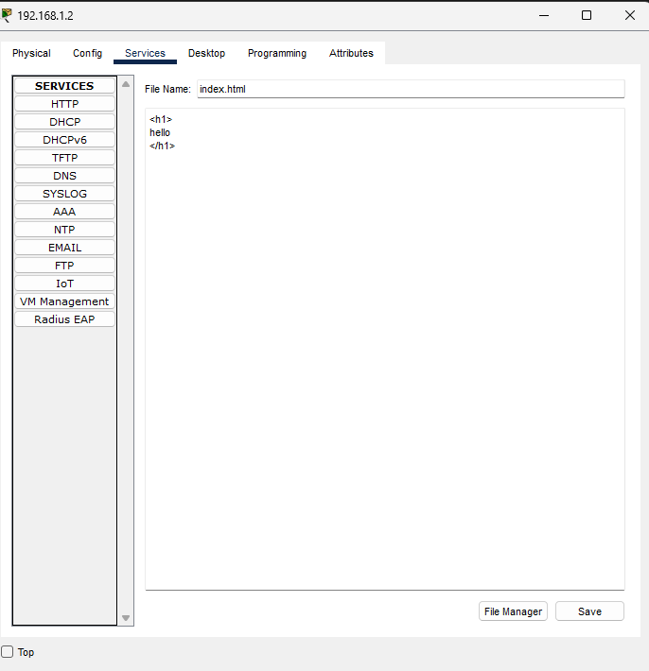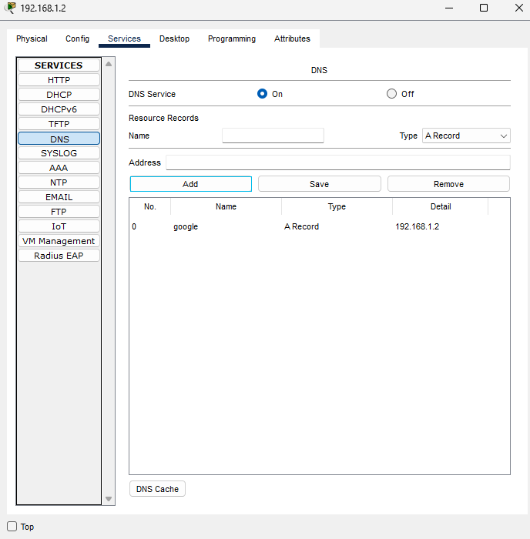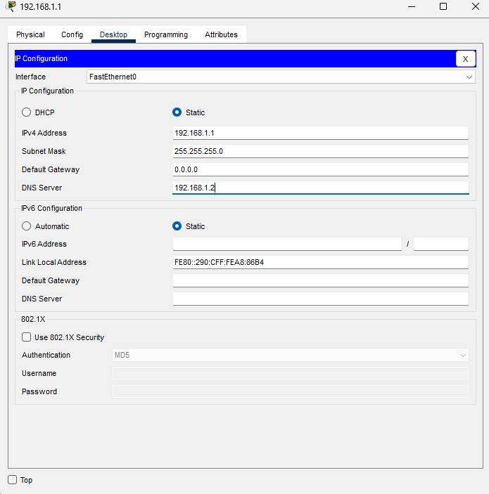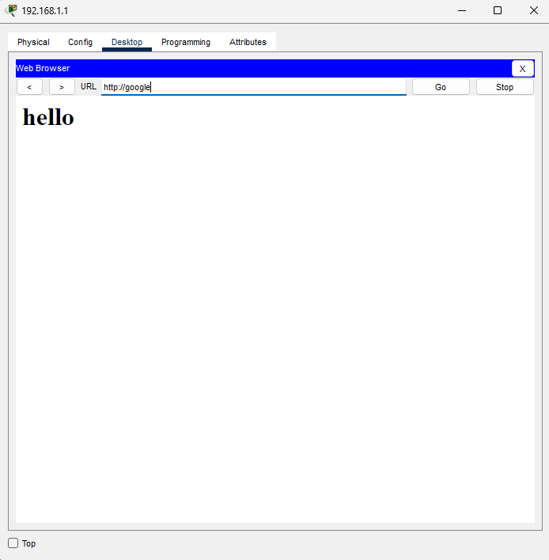

**Step:-**

* Drag a DNS server, client PC, and switch onto the workspace.
* Configure the DNS server with IP **192.168.1.2** and enable the DNS service.
* Add a DNS record for [**www.google.com**](http://www.google.com) with the IP address **192.168.1.2**.
* Set the client PC’s IP to **192.168.1.1** and DNS server to **192.168.1.2**.
* Connect the DNS server and client PC to the switch.
* Open the command prompt on the client PC and run ping www.google.com to ensure it resolves to **192.168.1.2**.
* Open a web browser on the client PC and navigate to [**www.google.com**](http://www.google.com) to verify that the web page is displayed.

1. **DHCP :-**

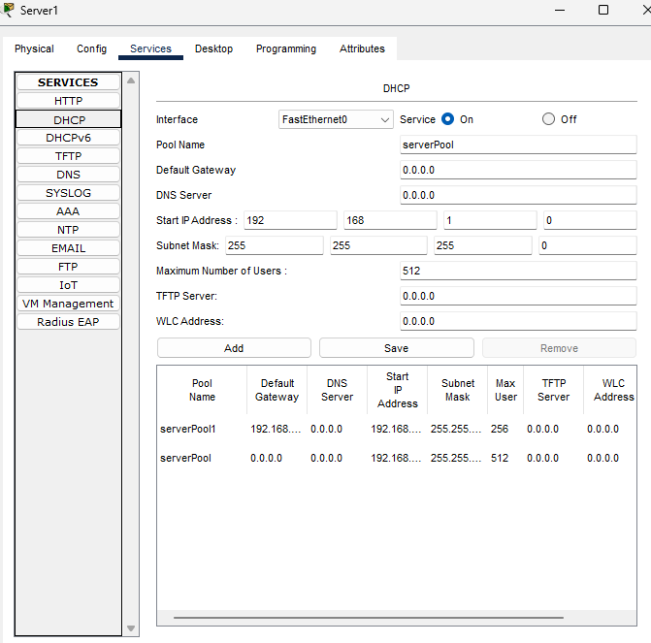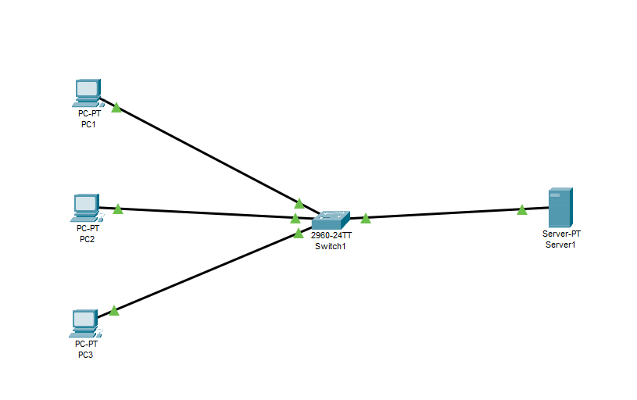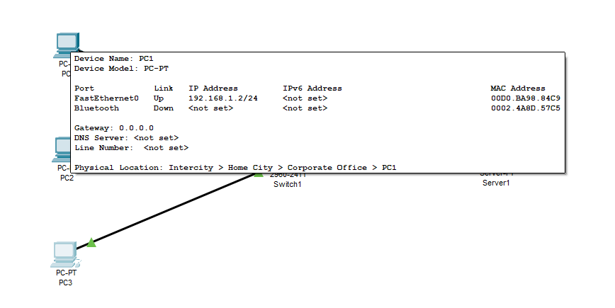

**Step:-**

* Drag and drop the following devices onto the workspace:
  + One Router and One Web Server.
  + One or more client PCs.
  + Switches to connect the devices if needed.
* Connect the devices using appropriate cables (use Copper Straight-Through cables to connect PCs to the switch and the switch to the router).
* Click on the server to open its IP configuration panel. Assign a static IP address (e.g., 192.168.1.0) and subnet mask (e.g., 255.255.255.0).
* Click on the DNS server icon to open its configuration panel. Go to the Config tab. Assign a static IP address and click Add button.
* Then go to PCs give IP configuration select DHPC.
* After selecting DHPC you can see the PCs automatic tack IP Address and Default Getway.

1. **FTP :-**

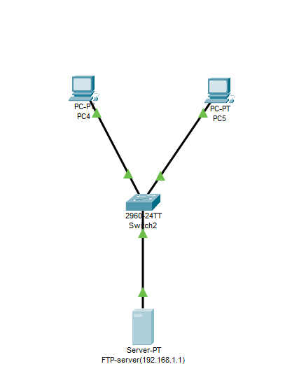

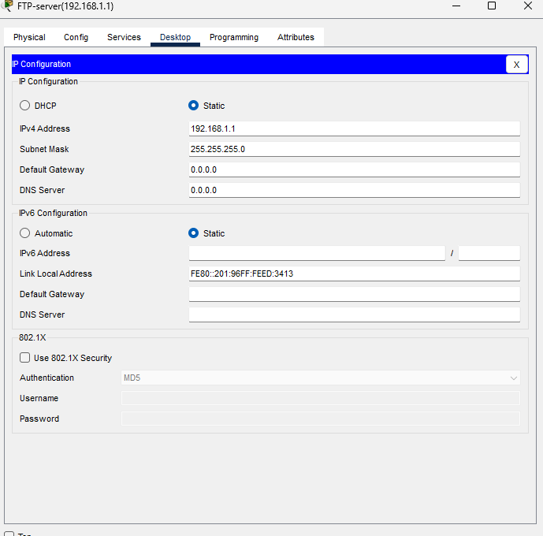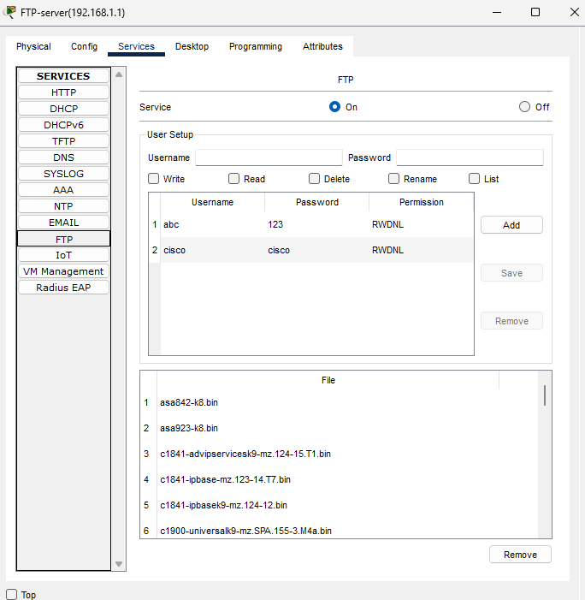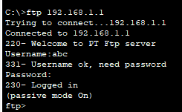

**Step:-**

* + Drag two PCs, an FTP server, and a switch onto the workspace.
  + Connect the PCs and the FTP server to the switch using Copper Straight-Through cables.
  + Configure the FTP server with IP **192.168.1.1** and subnet mask **255.255.255.0**.
  + Assign IP addresses to the PCs (e.g., **192.168.0.2** and **192.168.0.3**) and set the default gateway on each PC to the switch’s IP (**192.168.0.1**).
  + Set up a new username (**abc**) and password (**123**) on the FTP server.
  + On the FTP server, create a text file (e.g., **hello.txt**) using a text editor and save it.
  + On one of the PCs, open the command prompt and ping the FTP server IP (**192.168.1.1**) to check connectivity.
  + Connect to the FTP server using the command ftp 192.168.1.1, and enter the username (**abc**) and password (**123**) when prompted.
  + Upload the text file from the PC to the FTP server using the command put hello.txt.
  + Use the dir command to list the files on the FTP server and confirm the text file is uploaded.