# Introduction

|  |
| --- |
| ***Digital Design and Computer Architecture***   **Keyboard Input Lab** By: Hannah Gamiel, Jonathan Burge, Michael Lindahl, Edited slightly by Kent Jones |

In the VGA lab, you became familiar with displaying colors on a monitor. The finished project from this lab will display colors based off user input from a keyboard. This lab will address various requirements for adding additional inputs and displaying outputs using an FPGA. To obtain a basic understanding of keyboard input, we will view an example project provided by XESS. We will use this understanding of keyboard input to change the VGA output from the FPGA.

# Sprint Goals (required by all):

* Develop a simple VGA display.
* Develop VHDL keyboard scanner that retrieves key scan codes.

# Stretch Goals (not required, unless you have already completed the Sprint goals last semester):

**NOTE**: for the stretch goals you will need to start by researching the information yourself on the XESS website. In the next lab we will cover the information regarding how the dual port ram works. You will learn the information better if you attempt to research and implement this by yourself first.

* Research and attempt to develop a more advanced keyboard scanner that sends keyboard information to the XESS boards SDRAM using the dual port SDRAM driver provided by XESS.
* Research and attempt to implement a more advanced VGA display driver that display data from the FPGA SDRAM using the dual port SDRAM driver provided by XESS.

# PART 1: VGA Review

This lab will begin by reviewing and running the VGA lab we did last semester. First, modify that project and make each color that displays fill the entire screen. (This should only require the modification of one line of code.) Now change the color to be a different color of your choice.

# PART 2: Keyboard Input Lab (XESS)

Read XESS’ [Application Note “PS/2 Keyboard Interface for the XSA Boards”](http://www.xess.com/static/media/appnotes/an-102104-keybrd.pdf) document to gain a better understanding of how keyboard input works.

1. What are the two signals that a PS/2 keyboard uses to connect to the XSA Board?

________________________________________

1. What scancodes are used to indicate when a key released on the keyboard?

________________________________________

Download the “PS/2 Keyboard Test Application” found in the document. Unzip and save the folder to your student drive. Read and follow the instructions in the “readme” text file inside of the unzipped folder.

1. What needs to be done for our boards concerning clock frequency?

________________________________________

1. What happens when you press any other key besides 0-9?

________________________________________

Follow the instructions in the readme to run the keyboard application. As a reminder, will be using an XSA-3S1000 board. Test out the application and verify that it works.

Take a look at the .UCF file to gain a better understanding of how communication between the board and the architecture files (test_kbd.vhd) works. How does this communication work?

__________________________________________________________________

__________________________________________________________________

__________________________________________________________________

Each key on the keyboard is assigned a hexadecimal number. Figure 2 shows what these values are on the keyboard. Convert the numbers from keys 0-9 into binary.

|  |  |
| --- | --- |
| 0 |  |
| 1 |  |
| 2 |  |
| 3 |  |
| 4 |  |
| 5 |  |
| 6 |  |
| 7 |  |
| 8 |  |
| 9 |  |

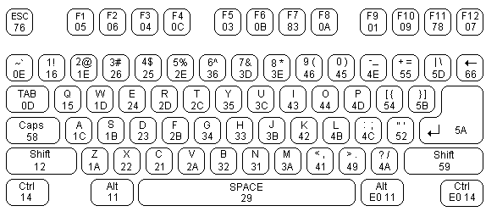

**Figure 2. PS2 Keyboard Scancodes**

Note how these numbers match the scancodes in the architecture file. These scancodes are used to detect when certain keys are pressed. It is important to understand how the XESS project works for when we combine the two projects together.

# PART 3: Combined Application

Combine your knowledge of both the keyboard application lab and the VGA test lab to create an application that:

1. Takes input from keys of your choice on the keyboard (in addition to 0-9)
2. Displays a color on the monitor depending on the key pressed
3. Creates an intuitive color pattern depending on the key pressed (don’t just assign random color values to random keys). This may be an association of the key pressed to the color name (e.g. pressing “B” will give you a blue screen), or it may also be a color scale that is relative to the key position on the keyboard, in hue, tint, tone, and/or shade.

When choosing colors, it is important to note that the color system we are using is base 7. This was illustrated earlier in the VGA lab when we learned that you received the maximum signal at 0.7 volts and no signal at 0 volts. Thus, when each signal is at 0.7 volts, a white color is produced. In the VGA lab, we used a 3-bit value for each RGB value.

**We advise that you start with a copy of the VGA lab and modify it to contain the code needed for PS2 input.**

Show your professor your completed project.

# What to Turn In

1. Please indicate how much time you spent on this lab. This will not affect your grade, but will be helpful for calibrating the workload for next semester’s labs.
2. The written answers to each of the questions in this document.
3. A paragraph describing your design method and design choice.
4. Your finished project file should be placed in your student folder.
5. **Optional**: A photograph of your application running with your group in it for departmental use. Place this in your student folder as well. As a student, you waive all rights of photo usage by the university.