Question 1
What will be the result of the code below?
public class Enemy : MonoBehaviour
{
public Transform ground;

void Update()
{
if (transform.position.y < ground.position.y)
{
Destroy(gameObject);
}
}
}
Select only one
If the player touches an enemy, destroy the player.
If the player goes beneath the ground, destroy the player.
If an enemy goes above the ground, destroy the enemy.
If an enemy goes below the ground, destroy the enemy.

Question 2
What would be the appropriate line of code to replace the comment below?
public float[] values = new float[5];

void Start()
{
// assign the first element in the array the value of 5.0
}
Select only one
values[0] = 5.0f;
float[0] = 5.0f;
value[1] = 5.0f;
float.0 = 5.0f;

Question 3
Which comment best describes the code below?
public class Player : MonoBehaviour
{
// Comment
private void OnTriggerEnter(Collider other) {
if(other.CompareTag("Spike")) {
Destroy(other.gameObject);
}
}
}
Select only one
// If the player collides with an enemy, destroy the enemy
// If the player collides with a spike, destroy the spike
// If the enemy collides with a spike, destroy the enemy
// If the player collides with a spike, destroy the player

Question 4
The image below shows the preferences window that allows you to change which script editing tool (or IDE) you want to use. Where would you click to choose an alternative code editing tool?
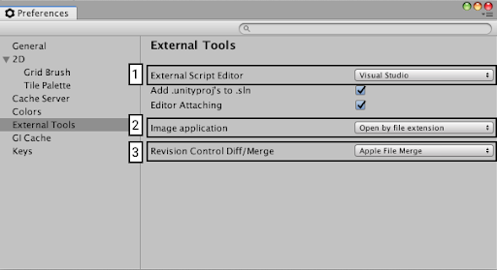
Select only one
Box 1 (External Script Editor)
Box 2 (Image application)
Box 3 (Revision control Diff/Merge)

Question 5
In Visual Studio, “5.0f;” would be underlined with a red squiggly line. When you hover the mouse over the error, what do you think the message would say?
int health = 5.0f;
Select only one
The value 5.0 is out of bounds.
Cannot implicitly convert type ‘float’ to ‘int’.
Cannot complete statement. Remove semicolon.
The value “f” could not be interpreted for type ‘int’.

Question 6
Using the information shown in the autocomplete pop-up window below, which of the following would be a valid call of the Instantiate method?
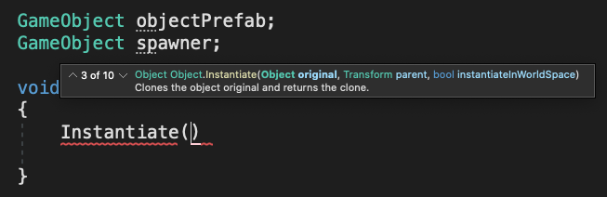
Select only one
Instantiate(objectPrefab.transform, spawner, true);
Instantiate(objectPrefab, spawner, false);
Instantiate(objectPrefab, spawner.transform, true);
Instantiate(objectPrefab, spawner, bool);

Question 7
What would be the code required to produce the debug message shown below?
Hello world.
Select only one
Debug.Log("Hello world.");
Debug(“Hello world.”);
Debug(Log(“Hello world.”));
Debug.Log(Hello world.);

Question 8
Which of the following is true about either the Start() or Update() functions in a Unity Monobehavior class?
Select only one
The Update() function runs only one time.
Player input should be handled in the Update() function.
The Update() function runs before the Start() function.
The Start() function runs at the start of every Update() function.

Question 9
In what order do the parts of this script appear?
using System.Collections;
using System.Collections.Generic;
using UnityEngine;

public class PlayerController : MonoBehaviour
{
public float speed;
public string playerName;

void Start()
{
playerName = "Test";
}

void Update()
{
speed++;
}

}
Select only one these 4 choices
-namespaces, class declaration, variables, functions
-class declaration, namespaces, functions, variables
-variables, namespaces, functions, class declaration
-functions, class declaration, namespaces, variables

Question 10
Which of the following lines of code is using standard Unity naming conventions?
- Public Float Speed = 40.0f;
- Public float Speed = 40.0f;
- public float Speed = 40.0f;
- public float speed = 40.0f;
Select only one
Line 1
Line 2
Line 3
Line 4

Question 11
Given the inspector shown below, showing variables for “Speed” and “Player Name,” which of the following lines of code would you expect to see in PlayerController.cs?
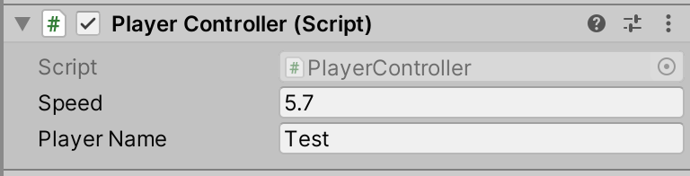
Select only one of the four options here(2 lines of code per choice)
float speed;
string playerName;

new Float speed;
new String playerName;

public float Speed;
public text Player Name;

public float speed;
public string playerName;

