
A WORLD CLASS UNIVERSITY
Assignment No. : 1
Course Title:
Data Structures
Course Code:
SE-200
Course Section:
C
Instructor:
Muhammad Sabeeh
Submitted by:
Muhammad Ali Abid
Roll Number:
25021598-010
Submitted to:
Muhammad Sabeeh
Date:
______________


Table of Contents:
Question 1 -- Array Operations 3
Java Code: 3
Sample Output: 8
Question 2 -- Stack Operations 9
Java Code: 9
Sample Output: 12
Question 3 -- Queue Operations 13
Java Code: 13
Sample Output: 17
Question 4 – Real World Examples 17
1. Array: 17
2. Stack: 18
3. Queue: 18
Question 5 — Advantages and Disadvantages 19
Array: 19
Stack: 19
Queue: 19

Question 1 -- Array Operations
Scenario:
A small library wants a simple program to manage the list of book IDs currently on a shelf. The shelf can hold a limited number of books at a time, and the librarian needs a menu-driven console program to manage this list.
Requirements:
An array-based program was implemented in Java, using a single fixed-size array (10 slots) to represent the shelf. The program supports the following operations through a console menu: Add value, Insert at index, Fill array, Delete last element, Delete by index, Display, Search value, Get value at index, Replace/Update value at index, Size, and Exit.

Java Code:
import java.util.*;

class Assignment_1_Program_1 {

public static final String RESET = "\u001B[0m";
public static final String BOLD = "\u001B[1m";
public static final String CYAN = "\u001B[36m";
public static final String GREEN = "\u001B[32m";
public static final String YELLOW = "\u001B[33m";
public static final String PURPLE = "\u001B[35m";
public static final String RED = "\u001B[31m";
public static final String BLUE = "\u001B[34m";
public static final String WHITE = "\u001B[37m";

private static final Scanner sc = new Scanner(System.in);

public static void main(String[] args) {
int[] books = new int[10];
printBanner();
loadingAnimation("Initializing Library Shelf Manager");

boolean running = true;
while (running) {
displayMenu();
int choice = readChoice();

switch (choice) {
case 1: {
printActionHeader("Add value");
AdditionOFBooks additionOFBooks = new AdditionOFBooks();
additionOFBooks.addBook(books);
break;
}
case 2: {
printActionHeader("Insert at index");
AdditionOFBooks additionOFBooks = new AdditionOFBooks();
additionOFBooks.indexInsertion(books);
break;
}
case 3: {
printActionHeader("Fill array");
AdditionOFBooks additionOFBooks = new AdditionOFBooks();
additionOFBooks.fillArray(books);
break;
}
case 4: {
printActionHeader("Delete last element");
DeletionBooks deletionBooks = new DeletionBooks();
deletionBooks.deleteLastElement(books);
break;
}
case 5: {
printActionHeader("Delete by index");
DeletionBooks deletionBooks = new DeletionBooks();
deletionBooks.deleteByIndex(books);
break;
}
case 6: {
printActionHeader("Display");
AdditionOFBooks additionOFBooks = new AdditionOFBooks();
additionOFBooks.displayBook(books);
break;
}
case 7: {
printActionHeader("Search value");
UpdationBooks updationBooks = new UpdationBooks();
updationBooks.searchValue(books);
break;
}
case 8: {
printActionHeader("Get value at index");
UpdationBooks updationBooksGet = new UpdationBooks();
updationBooksGet.displayByIndex(books);
break;
}
case 9: {
printActionHeader("Replace/Update value at index");
UpdationBooks updationBooksUpdate = new UpdationBooks();
updationBooksUpdate.updateValueAtindex(books);
break;
}
case 10:
printActionHeader("Size");
System.out.println("Current size of the array: " + books.length);
break;
case 11:
running = false;
exitAnimation();
break;
default:
System.out.println(RED + BOLD + "\n ✖ Invalid choice! Please select 1-11.\n" + RESET);
}

if (running) pauseForEffect();
}

sc.close();
}

private static void printBanner() {
String[] banner = {
" █████╗ ██████╗ ██████╗ █████╗ ██╗ ██╗",
"██╔══██╗ ██╔══██╗██╔══██╗ ██╔══██╗ ╚██╗ ██╔╝",
"███████║ ██████╔╝██████╔╝ ███████║ ╚████╔╝ ",
"██╔══██║ ██╔══██╗██╔══██╗ ██╔══██║ ╚██╔╝ ",
"██║ ██║ ██║ ██║██║ ██║ ██║ ██║ ██║ ",
"╚═╝ ╚═╝ ╚═╝ ╚═╝╚═╝ ╚═╝ ╚═╝ ╚═╝ ╚═╝ "
};

String[] colors = { CYAN, BLUE, PURPLE, PURPLE, BLUE, CYAN };

System.out.println();
for (int i = 0; i < banner.length; i++) {
System.out.println(BOLD + colors[i] + banner[i] + RESET);
sleep(80);
}
System.out.println(BOLD + YELLOW + " L I B R A R Y S H E L F M A N A G E R" + RESET);
System.out.println(GREEN + " " + "─".repeat(44) + RESET);
sleep(300);
}

private static void displayMenu() {
clearConsoleEffect();
String title = "ARRAY MENU";
String border = "═".repeat(38);

System.out.println(CYAN + BOLD + "╔" + border + "╗" + RESET);
System.out.println(CYAN + BOLD + "║" + centerText(title, 38) + "║" + RESET);
System.out.println(CYAN + BOLD + "╠" + border + "╣" + RESET);

printMenuItem(1, "Add value", GREEN);
printMenuItem(2, "Insert at index", GREEN);
printMenuItem(3, "Fill array", GREEN);
printMenuItem(4, "Delete last element", YELLOW);
printMenuItem(5, "Delete by index", YELLOW);
printMenuItem(6, "Display", BLUE);
printMenuItem(7, "Search value", BLUE);
printMenuItem(8, "Get value at index", PURPLE);
printMenuItem(9, "Replace/Update value at index", PURPLE);
printMenuItem(10, "Size", WHITE);
printMenuItem(11, "Exit", RED);

System.out.println(CYAN + BOLD + "╚" + border + "╝" + RESET);
System.out.print(BOLD + YELLOW + "\n➤ Enter your choice: " + RESET);
}

private static void printMenuItem(int number, String label, String color) {
String numStr = String.format("%2d", number);
System.out.println(CYAN + "║ " + RESET + color + BOLD + numStr + ". " + RESET
+ String.format("%-33s", label) + CYAN + "║" + RESET);
}

private static String centerText(String text, int width) {
int padding = (width - text.length()) / 2;
StringBuilder sb = new StringBuilder();
for (int i = 0; i < padding; i++) sb.append(" ");
sb.append(BOLD).append(text).append(RESET).append(CYAN).append(BOLD);
while (sb.length() < width + (BOLD + RESET + CYAN + BOLD).length()) sb.append(" ");
return sb.toString();
}

private static int readChoice() {
int choice = -1;
try {
choice = Integer.parseInt(sc.nextLine().trim());
} catch (NumberFormatException e) {
choice = -1;
}
return choice;
}

private static void loadingAnimation(String message) {
System.out.print(PURPLE + BOLD + message + RESET);
for (int i = 0; i < 5; i++) {
System.out.print(GREEN + "." + RESET);
sleep(200);
}
System.out.println(GREEN + BOLD + " Done!\n" + RESET);
}

private static void printActionHeader(String action) {
System.out.println(BOLD + GREEN + "\n▶ " + action + " selected...\n" + RESET);
}

private static void pauseForEffect() {
System.out.print(WHITE + "\nPress ENTER to continue..." + RESET);
sc.nextLine();
}

private static void exitAnimation() {
System.out.println(YELLOW + BOLD + "\nClosing Library Shelf Manager");
for (int i = 0; i < 3; i++) {
System.out.print(YELLOW + "." + RESET);
sleep(300);
}
System.out.println(GREEN + BOLD + "\n✔ Goodbye!\n" + RESET);
}

private static void clearConsoleEffect() {
System.out.print("\n".repeat(1));
}

private static void sleep(int ms) {
try {
Thread.sleep(ms);
} catch (InterruptedException ignored) {
}
}
}

class AdditionOFBooks {
Scanner scanner = new Scanner(System.in);

public void displayBook(int[] books) {
if(books.length == 0) {
System.out.println("Array is empty. No book IDs to display.");
} else {
System.out.println("Current book IDs in the array:");
for(int i = 0; i < books.length; i++) {
System.out.println("Index " + i + ": Book ID " + books[i]);
}
}
}

public void addBook(int[] books) {
if(books != null && books.length > 0) {
System.out.print("Enter the number of books to add (up to " + books.length + "): ");
int count = scanner.nextInt();
for(int i = 0; i < count && i < books.length; i++) {
System.out.print("Enter book ID for book " + (i + 1) + ": ");
int bookId = scanner.nextInt();
books[i] = bookId;
}
}
}

public void indexInsertion(int[] books) {
System.out.print("How many books do you want to insert? ");
int count = scanner.nextInt();
if(count <= books.length) {
for(int i = 0 ; i < count; i++) {
System.out.print("Enter the index where you want to insert the book ID: ");
int index = scanner.nextInt();
if(index >= 0 && index < books.length) {
System.out.print("Enter the book ID to insert: ");
int bookId = scanner.nextInt();
books[index] = bookId;
} else {
System.out.println("Invalid index. Please enter a value between 0 and " + (books.length - 1));
}
}
} else {
System.out.println("You cannot insert more books than the array size.");
}
}

public void fillArray(int[] books) {
if(books != null && books.length > 0) {
System.out.println("Filling the array with book IDs.");
for(int i = 0; i < books.length; i++) {
System.out.print("Enter book ID for book " + (i + 1) + ": ");
books[i] = scanner.nextInt();
}
} else {
System.out.println("The array is empty or not initialized.");
}
}
}

class DeletionBooks {
Scanner scanner = new Scanner(System.in);

public void deleteLastElement(int[] books) {
int size = books.length;
if(size > 0) {
books[size - 1] = 0;
System.out.println("Last book ID deleted.");
} else {
System.out.println("Array is empty. No book ID to delete.");
}
}

public void deleteByIndex(int[] books) {
if(books.length == 0){
System.out.println("Array is empty. No book ID to delete.");
} else {
System.out.println("Array contents:");
for(int i = 0; i < books.length; i++) {
System.out.println("Index " + i + ": Book ID " + books[i]);
}
System.out.print("Enter the index of the book ID to delete (0 to " + (books.length - 1) + "): ");
int index = scanner.nextInt();
if(index >= 0 && index < books.length) {
books[index] = 0;
System.out.println("Book ID at index " + index + " deleted.");
} else {
System.out.println("Invalid index. Please enter a value between 0 and " + (books.length - 1));
}
}
}
}

class UpdationBooks {
Scanner scanner = new Scanner(System.in);

public void searchValue(int[] books) {
if(books.length == 0) {
System.out.println("Array is empty. No book ID to search.");
} else {
System.out.print("Enter the book ID to search for: ");
int bookId = scanner.nextInt();
boolean found = false;
for(int i = 0; i < books.length; i++) {
if(books[i] == bookId) {
System.out.println("Book ID " + bookId + " found at index " + i);
found = true;
break;
}
}
if(!found) {
System.out.println("Book ID " + bookId + " not found.");
}
}
}

public void displayByIndex(int[] books) {
if(books.length == 0) {
System.out.println("Array is empty. No book ID to display.");
} else {
System.out.print("Enter the index of the book ID to display (0 to " + (books.length - 1) + "): ");
int index = scanner.nextInt();
if(index >= 0 && index < books.length) {
System.out.println("Book ID at index " + index + ": " + books[index]);
} else {
System.out.println("Invalid index. Please enter a value between 0 and " + (books.length - 1));
}
}
}

public void updateValueAtindex(int[] books) {
if(books.length == 0) {
System.out.println("Array is empty. No book ID to update.");
} else {
System.out.println("Array Content:");
for(int i = 0; i < books.length; i++) {
System.out.println("Index " + i + ": Book ID " + books[i]);
}
System.out.print("Enter the index of the book ID to update (0 to " + (books.length - 1) + "): ");
int index = scanner.nextInt();
if(index >= 0 && index < books.length) {
System.out.print("Enter the new book ID to replace the old one: ");
int newBookId = scanner.nextInt();
books[index] = newBookId;
System.out.println("Book ID at index " + index + " updated to " + newBookId);
} else {
System.out.println("Invalid index. Please enter a value between 0 and " + (books.length - 1));
}
}
}
}

Sample Output:
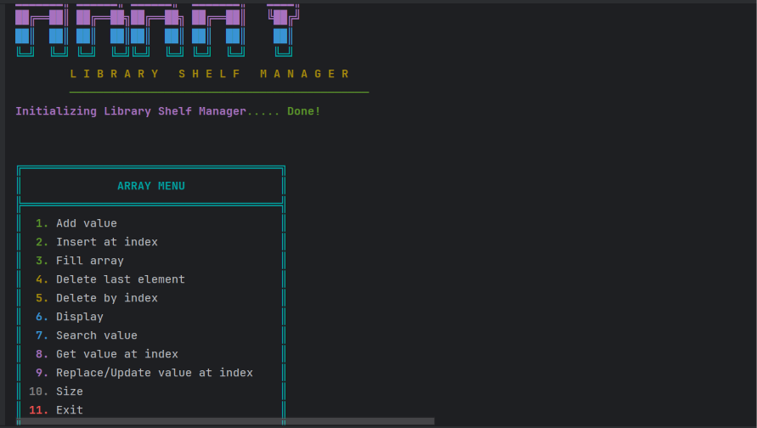
Console output of the Array (Library Shelf Manager) program -- Main menu.

Question 2 -- Stack Operations
Scenario
A pile of plates, each carrying a whole number, is stacked one on top of another. A new plate can only be added on top, and only the topmost plate can be removed. A program was built to simulate this Last-In-First-Out (LIFO) stack of integer values.
Requirements
A stack-based program was implemented in Java using a single array and a top variable (no built-in Stack class). The program supports: Push, Pop, Display, Size, isEmpty, isFull, and Exit, through a console menu.

Java Code:
import java.util.*;

public class Assignment_1_Program_2 {
public static final String RESET = "\u001B[0m";
public static final String BOLD = "\u001B[1m";
public static final String CYAN = "\u001B[36m";
public static final String GREEN = "\u001B[32m";
public static final String YELLOW = "\u001B[33m";
public static final String PURPLE = "\u001B[35m";
public static final String RED = "\u001B[31m";
public static final String BLUE = "\u001B[34m";
public static final String WHITE = "\u001B[37m";

private static final Scanner sc = new Scanner(System.in);

public static void main(String[] args) {
printBanner();
loadingAnimation("Initializing Stack Manager");

System.out.print(BOLD + YELLOW + "\nEnter the maximum capacity of the stack: " + RESET);
int capacity = readIntInput();
Plate stack = new Plate(capacity);
boolean running = true;
while (running) {
displayMenu();
int choice = readChoice();

switch (choice) {
case 1: {
printActionHeader("Push");
System.out.print(BOLD + YELLOW + "Enter the plate number to push: " + RESET);
int plateNumber = readIntInput();
stack.push(plateNumber);
break;
}
case 2: {
printActionHeader("Pop");
stack.pop();
break;
}
case 3: {
printActionHeader("Display");
stack.display();
break;
}
case 4: {
printActionHeader("Size");
int size = stack.size();
System.out.println(BOLD + YELLOW + "Current size of the stack: " + size + RESET);
break;
}
case 5: {
printActionHeader("isEmpty");
boolean empty = stack.isEmpty();
if(empty){
System.out.println(GREEN + BOLD + "✔ The stack is empty.\n" + RESET);
} else {
System.out.println(RED + BOLD + "✖ The stack is not empty.\n" + RESET);
}
break;
}
case 6: {
printActionHeader("isFull");
boolean full = stack.isFull();
if(full){
System.out.println(GREEN + BOLD + "✔ The stack is full.\n" + RESET);
} else {
System.out.println(RED + BOLD + "✖ The stack is not full.\n" + RESET);
}
break;
}
case 7: {
running = false;
exitAnimation();
break;
}
default:
System.out.println(RED + BOLD + "\n ✖ Invalid choice! Please select 1-7.\n" + RESET);
}

if (running) pauseForEffect();
}

sc.close();
}

private static void printBanner() {
String[] banner = {
"███████╗████████╗ █████╗ ██████╗██╗ ██╗",
"██╔════╝╚══██╔══╝██╔══██╗██╔════╝██║ ██╔╝",
"███████╗ ██║ ███████║██║ █████╔╝ ",
"╚════██║ ██║ ██╔══██║██║ ██╔═██╗ ",
"███████║ ██║ ██║ ██║╚██████╗██║ ██╗",
"╚══════╝ ╚═╝ ╚═╝ ╚═╝ ╚═════╝╚═╝ ╚═╝"
};

String[] colors = { PURPLE, BLUE, CYAN, CYAN, BLUE, PURPLE };

System.out.println();
for (int i = 0; i < banner.length; i++) {
System.out.println(BOLD + colors[i] + banner[i] + RESET);
sleep(80);
}
System.out.println(BOLD + YELLOW + " L I F O S T A C K M A N A G E R" + RESET);
System.out.println(GREEN + " " + "─".repeat(40) + RESET);
sleep(300);
}

private static void displayMenu() {
clearConsoleEffect();
String title = "STACK MENU";
String border = "═".repeat(34);

System.out.println(CYAN + BOLD + "╔" + border + "╗" + RESET);
System.out.println(CYAN + BOLD + "║" + centerText(title, 34) + "║" + RESET);
System.out.println(CYAN + BOLD + "╠" + border + "╣" + RESET);

printMenuItem(1, "Push", GREEN);
printMenuItem(2, "Pop", GREEN);
printMenuItem(3, "Display", BLUE);
printMenuItem(4, "Size", BLUE);
printMenuItem(5, "isEmpty", PURPLE);
printMenuItem(6, "isFull", PURPLE);
printMenuItem(7, "Exit", RED);

System.out.println(CYAN + BOLD + "╚" + border + "╝" + RESET);
System.out.print(BOLD + YELLOW + "\n➤ Enter your choice: " + RESET);
}

private static void printMenuItem(int number, String label, String color) {
String numStr = String.format("%2d", number);
System.out.println(CYAN + "║ " + RESET + color + BOLD + numStr + ". " + RESET
+ String.format("%-29s", label) + CYAN + "║" + RESET);
}

private static String centerText(String text, int width) {
int padding = (width - text.length()) / 2;
StringBuilder sb = new StringBuilder();
for (int i = 0; i < padding; i++) sb.append(" ");
sb.append(BOLD).append(text).append(RESET).append(CYAN).append(BOLD);
while (sb.length() < width + (BOLD + RESET + CYAN + BOLD).length()) sb.append(" ");
return sb.toString();
}

private static int readChoice() {
return readIntInput();
}

private static int readIntInput() {
while (true) {
try {
return Integer.parseInt(sc.nextLine().trim());
} catch (NumberFormatException e) {
System.out.print(RED + BOLD + "Invalid input. Please enter a valid number: " + RESET);
}
}
}

private static void loadingAnimation(String message) {
System.out.print(PURPLE + BOLD + message + RESET);
for (int i = 0; i < 5; i++) {
System.out.print(GREEN + "." + RESET);
sleep(200);
}
System.out.println(GREEN + BOLD + " Done!\n" + RESET);
}

private static void printActionHeader(String action) {
System.out.println(BOLD + GREEN + "\n▶ " + action + " selected...\n" + RESET);
}

private static void pauseForEffect() {
System.out.print(WHITE + "\nPress ENTER to continue..." + RESET);
sc.nextLine();
}

private static void exitAnimation() {
System.out.println(YELLOW + BOLD + "\nClosing Stack Manager");
for (int i = 0; i < 3; i++) {
System.out.print(YELLOW + "." + RESET);
sleep(300);
}
System.out.println(GREEN + BOLD + "\n✔ Goodbye!\n" + RESET);
}

private static void clearConsoleEffect() {
System.out.println("\n".repeat(1));
}

private static void sleep(int ms) {
try {
Thread.sleep(ms);
} catch (InterruptedException ignored) {
}
}
}

class Plate {

private int[] plates;
private int top;
private int capacity;

public Plate(int capacity) {
this.capacity = capacity;
plates = new int[capacity];
top = -1;
}

public void push(int plate) {
if(isFull()) {
System.out.println("Stack is full. Cannot push plate " + plate);
} else {
plates[++top] = plate;
System.out.println("Plate " + plate + " pushed to stack.");
}
}

public int pop() {
if(isEmpty()) {
System.out.println("Stack is empty. Cannot pop.");
return -1;
} else {
int popped = plates[top--];
System.out.println("Plate " + popped + " popped from stack.");
return popped;
}
}

public void display() {
if(isEmpty()) {
System.out.println("Stack is empty.");
} else {
System.out.println("Current stack (top to bottom):");
for(int i = top; i >= 0; i--) {
System.out.println(plates[i]);
}
}
}

public boolean isFull() {
return top == capacity - 1;
}
public boolean isEmpty() {
return top < 0;
}
public int size() {
return top + 1;
}
}

Sample Output:
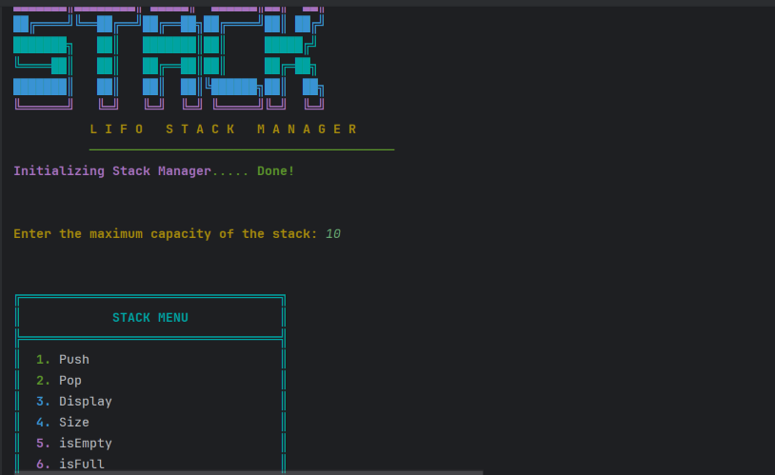
Console output of the Stack (LIFO Stack Manager) program -- Main menu.

Question 3 -- Queue Operations
Scenario
A small bank counter serves customers using integer token numbers. Every arriving customer receives a token that joins the back of the queue, and the counter always serves the token currently at the front. A program was built to manage this First-In-First-Out (FIFO) queue of token numbers.
Requirements
A queue-based program was implemented in Java using a single array with front and rear variables, implemented as a circular queue (no built-in Queue class). The program supports: Enqueue, Dequeue, Display, Size, isEmpty, isFull, and Exit, through a console menu.

Java Code:
import java.util.*;

public class Assignment_1_Program_3 {
public static final String RESET = "\u001B[0m";
public static final String BOLD = "\u001B[1m";
public static final String CYAN = "\u001B[36m";
public static final String GREEN = "\u001B[32m";
public static final String YELLOW = "\u001B[33m";
public static final String PURPLE = "\u001B[35m";
public static final String RED = "\u001B[31m";
public static final String BLUE = "\u001B[34m";
public static final String WHITE = "\u001B[37m";

private static final Scanner sc = new Scanner(System.in);

public static void main(String[] args) {
printBanner();
loadingAnimation("Initializing Queue Manager");
System.out.print(BOLD + YELLOW + "\nEnter the maximum capacity of the queue: " + RESET);
int capacity = readIntInput();
Queue queue = new Queue(capacity);

boolean running = true;
while (running) {
displayMenu();
int choice = readChoice();

switch (choice) {
case 1:
printActionHeader("Enqueue");
System.out.print(BOLD + YELLOW + "Enter token to enqueue: " + RESET);
int token = readIntInput();
queue.enqueue(token);
break;
case 2:
printActionHeader("Dequeue");
queue.dequeue();
break;
case 3:
printActionHeader("Display");
queue.display();
break;
case 4:
printActionHeader("Size");
int size = queue.size();
System.out.println(BOLD + YELLOW + "Queue size: " + size + RESET);
break;
case 5:
printActionHeader("isEmpty");
boolean empty = queue.isEmpty();
if(empty){
System.out.println(GREEN + BOLD + "✔ The queue is empty.\n" + RESET);
} else {
System.out.println(RED + BOLD + "✖ The queue is not empty.\n" + RESET);
}
break;
case 6:
printActionHeader("isFull");
boolean full = queue.isFull();
if(full){
System.out.println(GREEN + BOLD + "✔ The queue is full.\n" + RESET);
} else {
System.out.println(RED + BOLD + "✖ The queue is not full.\n" + RESET);
}
break;
case 7:
running = false;
exitAnimation();
break;
default:
System.out.println(RED + BOLD + "\n ✖ Invalid choice! Please select 1-7.\n" + RESET);
}

if (running) pauseForEffect();
}

sc.close();
}

private static void printBanner() {
String[] banner = {
" ██████╗ ██╗ ██╗███████╗██╗ ██╗███████╗",
"██╔═══██╗██║ ██║██╔════╝██║ ██║██╔════╝",
"██║ ██║██║ ██║█████╗ ██║ ██║█████╗ ",
"██║▄▄ ██║██║ ██║██╔══╝ ██║ ██║██╔══╝ ",
"╚██████╔╝╚██████╔╝███████╗╚██████╔╝███████╗",
" ╚══▀▀═╝ ╚═════╝ ╚══════╝ ╚═════╝ ╚══════╝"
};

String[] colors = { BLUE, CYAN, GREEN, GREEN, CYAN, BLUE };

System.out.println();
for (int i = 0; i < banner.length; i++) {
System.out.println(BOLD + colors[i] + banner[i] + RESET);
sleep(80);
}
System.out.println(BOLD + YELLOW + " F I F O Q U E U E M A N A G E R" + RESET);
System.out.println(GREEN + " " + "─".repeat(40) + RESET);
sleep(300);
}

private static void displayMenu() {
clearConsoleEffect();
String title = "QUEUE MENU";
String border = "═".repeat(34);

System.out.println(CYAN + BOLD + "╔" + border + "╗" + RESET);
System.out.println(CYAN + BOLD + "║" + centerText(title, 34) + "║" + RESET);
System.out.println(CYAN + BOLD + "╠" + border + "╣" + RESET);

printMenuItem(1, "Enqueue", GREEN);
printMenuItem(2, "Dequeue", GREEN);
printMenuItem(3, "Display", BLUE);
printMenuItem(4, "Size", BLUE);
printMenuItem(5, "isEmpty", PURPLE);
printMenuItem(6, "isFull", PURPLE);
printMenuItem(7, "Exit", RED);

System.out.println(CYAN + BOLD + "╚" + border + "╝" + RESET);
System.out.print(BOLD + YELLOW + "\n➤ Enter your choice: " + RESET);
}

private static void printMenuItem(int number, String label, String color) {
String numStr = String.format("%2d", number);
System.out.println(CYAN + "║ " + RESET + color + BOLD + numStr + ". " + RESET
+ String.format("%-29s", label) + CYAN + "║" + RESET);
}

private static String centerText(String text, int width) {
int padding = (width - text.length()) / 2;
StringBuilder sb = new StringBuilder();
for (int i = 0; i < padding; i++) sb.append(" ");
sb.append(BOLD).append(text).append(RESET).append(CYAN).append(BOLD);
while (sb.length() < width + (BOLD + RESET + CYAN + BOLD).length()) sb.append(" ");
return sb.toString();
}

private static int readChoice() {
return readIntInput();
}

private static int readIntInput() {
while (true) {
try {
return Integer.parseInt(sc.nextLine().trim());
} catch (NumberFormatException e) {
System.out.print(RED + BOLD + "Invalid input. Please enter a valid number: " + RESET);
}
}
}

private static void loadingAnimation(String message) {
System.out.print(PURPLE + BOLD + message + RESET);
for (int i = 0; i < 5; i++) {
System.out.print(GREEN + "." + RESET);
sleep(200);
}
System.out.println(GREEN + BOLD + " Done!\n" + RESET);
}

private static void printActionHeader(String action) {
System.out.println(BOLD + GREEN + "\n▶ " + action + " selected...\n" + RESET);
}

private static void pauseForEffect() {
System.out.print(WHITE + "\nPress ENTER to continue..." + RESET);
sc.nextLine();
}

private static void exitAnimation() {
System.out.println(YELLOW + BOLD + "\nClosing Queue Manager");
for (int i = 0; i < 3; i++) {
System.out.print(YELLOW + "." + RESET);
sleep(300);
}
System.out.println(GREEN + BOLD + "\n✔ Goodbye!\n" + RESET);
}

private static void clearConsoleEffect() {
System.out.println("\n".repeat(1));
}

private static void sleep(int ms) {
try {
Thread.sleep(ms);
} catch (InterruptedException ignored) {
}
}
}

class Queue {
private int[] tokens;
private int front, rear, capacity, currentSize;

public Queue(int size) {
tokens = new int[size];
capacity = size;
front = 0;
rear = -1;
currentSize = 0;
}

public void enqueue(int token) {
if (isFull()) {
System.out.println("Queue is full. Cannot enqueue.");
} else {
rear = (rear + 1) % capacity;
tokens[rear] = token;
currentSize++;
System.out.println("Enqueued: " + token);
}
}

public int dequeue() {
if (isEmpty()) {
System.out.println("Queue is empty. Cannot dequeue.");
return -1;
} else {
int token = tokens[front];
front = (front + 1) % capacity;
currentSize--;
System.out.println("Dequeued: " + token);
return token;
}
}

public void display() {
if (isEmpty()) {
System.out.println("Queue is empty.");
} else {
System.out.print("Queue elements (front to rear): ");
for (int i = 0; i < currentSize; i++) {
int index = (front + i) % capacity;
System.out.print(tokens[index] + " ");
}
System.out.println();
}
}

public boolean isFull() {
return currentSize == capacity;
}

public boolean isEmpty() {
return currentSize == 0;
}

public int size() {
return currentSize;
}
}

Sample Output:
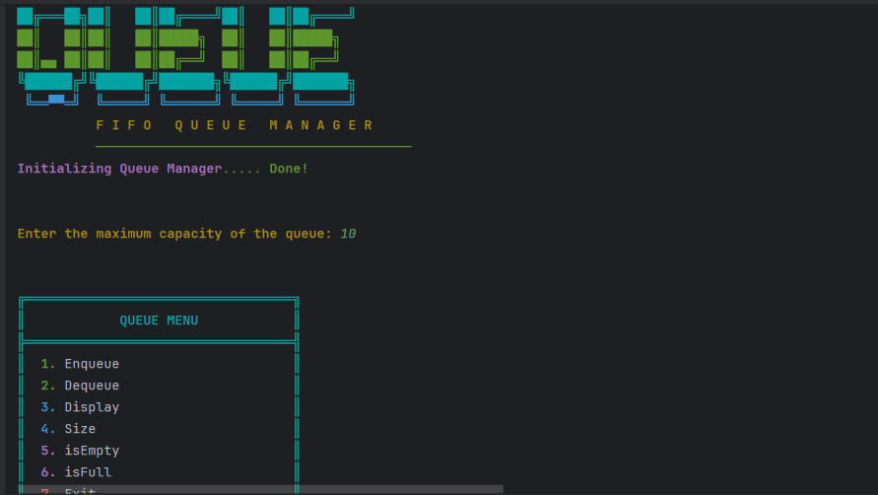
Console output of the Queue (FIFO Queue Manager) program -- Main menu.

Question 4 – Real World Examples
For each data structure, five real-world or software examples are listed where that data structure is a natural fit, along with the reason for the fit. Advantages and disadvantages are also given for each.

1. Array:
# | Real-world / software example | Why an array fits
1 | Student marks | Stores marks using indexes.
2 | Book IDs | Stores books in fixed positions.
3 | Monthly sales | 12 months can use 12 positions.
4 | Employee IDs | Stores IDs for quick access.
5 | Game scores | Stores scores in order.
Advantages and Disadvantages of Array:
Advantages:
- Fast access using index.
- Easy to implement.
- Memory efficient.
- Good for fixed-size data.
Disadvantages:
- Fixed size.
- Insertion may require shifting.
- Deletion may require shifting.
- Can waste unused space.

2. Stack:
# | Real-world / software example | Why a stack fits
1 | Plates | Last plate added is removed first.
2 | Undo operation | Latest action is undone first.
3 | Browser history | Recent page can be accessed first.
4 | Function calls | Last function call finishes first.
5 | Parentheses checking | Matches opening and closing brackets.
Advantages and Disadvantages of Stack:
Advantages:
- Simple LIFO structure.
- Push and pop are fast.
- Useful for undo and history.
- Easy to implement.
Disadvantages:
- Only top element is normally accessed.
- Fixed capacity with arrays.
- Can cause overflow.
- Not suitable for random access.

3. Queue:
# | Real-world / software example | Why a queue fits
1 | Bank customers | First customer is served first.
2 | Printer jobs | Jobs are processed in order.
3 | Restaurant orders | Orders can be handled in arrival order.
4 | CPU tasks | Tasks wait for processing.
5 | Customer support | Requests are handled in order received.
Advantages and Disadvantages of Queue
Advantages:
- Follows FIFO.
- Simple to understand.
- Useful for scheduling.
- Enqueue/dequeue can be fast.
Disadvantages:
- Limited access.
- Fixed capacity with arrays.
- Simple implementation may require shifting.
- Not suitable for random access.

Question 5 — Advantages and Disadvantages
Based on the observations made while completing Questions 1 to 3, the advantages and disadvantages of each data structure are summarized below.

Array:
Advantages:
- Fast index-based access.
- Easy to implement.
- Suitable for fixed-size data.
Disadvantages:
- Fixed size.
- Insertion and deletion may require shifting.
- Can waste memory.

Stack:
Advantages:
- Follows LIFO.
- Push and pop are fast.
- Useful for undo and history.
Disadvantages:
- Only top element is normally accessible.
- Fixed capacity with arrays.
- Can cause overflow.

Queue:
Advantages:
- Follows FIFO.
- Useful for waiting lines and scheduling.
- Easy to implement.
Disadvantages:
- Limited access.
- Fixed capacity with arrays.
- Simple array implementation may require shifting.

