**CHAPTER 1**

**INTRODUCTION**

* 1. **Problem Statement**

The development of autonomous vehicles equipped with advanced braking and lane control systems confronts critical challenges in ensuring optimal safety and navigation in dynamic environments. Current autonomous vehicle technologies often lack the precision necessary for responsive obstacle detection and immediate braking, raising concerns about safety and collision avoidance. Similarly, existing lane-keeping systems may struggle to maintain accurate lane discipline, compromising overall road safety. Integrating advanced technologies, particularly ultrasonic sensors, into these systems presents a formidable technical challenge, requiring comprehensive research and development efforts to ensure seamless functionality. Real-world adaptability poses another hurdle, as autonomous vehicles must navigate diverse and unpredictable scenarios. Additionally, meeting evolving regulatory standards is imperative to ensure compliance and widespread acceptance of these advanced autonomous systems. Addressing these challenges is crucial for realizing the potential of autonomous vehicles with advanced braking and lane control, fostering a safer and more reliable future for autonomous transportation.

Furthermore, the current shortcomings in safety measures, especially the lack of immediate and precise responses to dynamic obstacles, underscore the urgency of developing braking systems that can effectively mitigate risks and enhance collision avoidance in autonomous vehicles. The limited accuracy of existing lane control systems requires substantial improvement to guarantee stable and predictable navigation through various road conditions, contributing to overall road safety. The integration of advanced technologies must not only overcome technical hurdles but also consider real-world scenarios, including adverse weather conditions and complex traffic patterns, to ensure the reliability and adaptability of these systems. Successfully addressing these multifaceted challenges will not only push the boundaries of autonomous vehicle technology but also pave the way for a paradigm shift in transportation towards safer and more efficient autonomous driving experiences.

* **Safety Concerns:** Current AV technologies have made substantial strides in enhancing safety on the roads. However, incidents involving AVs have highlighted the need for further improvements, particularly in braking systems. While traditional vehicles rely on human reflexes to react to sudden obstacles or hazards, AVs must rely on sensors and algorithms to make split-second decisions. Developing an advanced braking system that can accurately detect and respond to potential dangers is crucial for mitigating accidents and instilling public trust in autonomous technology.
* **Complex Environments:** Operating in real-world environments presents a myriad of challenges for AVs, especially concerning lane control. Roads are dynamic and unpredictable, with factors such as changing weather conditions, road construction, and erratic human drivers posing significant obstacles. AVs must navigate these environments with precision and adaptability, maintaining lane integrity while safely maneuvering through traffic. Developing a lane control system capable of effectively interpreting complex traffic scenarios and making informed decisions is essential for the widespread adoption of autonomous technology.
* **Integration of Advanced Technologies:** The development of an autonomous vehicle with advanced braking and lane control systems requires the seamless integration of various cutting-edge technologies. This includes sensor fusion techniques to enhance perception capabilities, artificial intelligence algorithms for real-time decision-making, and robust control systems to ensure vehicle stability and responsiveness. Achieving synergy among these components while meeting stringent safety and performance standards is a formidable engineering challenge that requires interdisciplinary collaboration and innovative solutions.
* **Regulatory Compliance:** The regulatory landscape surrounding autonomous vehicles is continually evolving, with governments and transportation authorities grappling with issues of liability, certification, and standards. Developing AV systems that not only meet current regulatory requirements but also anticipate future regulations is essential for ensuring market readiness and long-term viability. Addressing legal and ethical considerations surrounding autonomous technology, particularly in critical areas such as braking and lane control, is paramount for fostering public acceptance and regulatory approval.
* **User Acceptance and Trust:** Perhaps the most significant challenge facing the widespread adoption of autonomous vehicles is gaining public acceptance and trust. Recent incidents involving AVs have raised concerns about their safety and reliability, leading to skepticism among potential users. Developing advanced braking and lane control systems that not only enhance safety but also inspire confidence and trust in autonomous technology is crucial for overcoming these barriers. This necessitates rigorous testing, validation, and transparent communication to demonstrate the effectiveness and reliability of AV systems in real-world conditions.

In conclusion, the development of an autonomous vehicle with advanced braking and lane control systems presents a multifaceted engineering challenge, encompassing safety, reliability, technology integration, regulatory compliance, and user acceptance. Addressing these challenges requires a holistic approach that combines technical expertise, regulatory foresight, and stakeholder engagement to realize the full potential of autonomous technology and revolutionize the future of transportation.

* 1. **Introduction**

The development of autonomous vehicles has emerged as a transformative force in the automotive industry, promising safer, more efficient, and intelligent transportation systems. A pivotal aspect of this evolution lies in the integration of advanced braking and lane control systems, addressing critical challenges to enhance the overall safety and reliability of autonomous vehicles. This project seeks to propel autonomous vehicle technology forward by focusing on the development of a sophisticated system that employs ultrasonic sensors for advanced braking and lane control.

In the contemporary landscape of autonomous driving, the pressing need for improved safety measures is evident. The existing technologies often fall short in providing the precision required for immediate responses to dynamic obstacles, posing potential risks to passengers and other road users. Similarly, achieving optimal lane discipline remains a complex challenge, with current lane control systems struggling to navigate diverse road conditions with accuracy.

This project aims to overcome these challenges by leveraging ultrasonic sensors, a cutting-edge technology, to revolutionize the braking and lane control systems of autonomous vehicles. Ultrasonic sensors offer unparalleled capabilities for real-time obstacle detection and precise distance measurement, providing the foundation for an advanced braking system that can respond promptly to the intricacies of the road environment. Additionally, these sensors contribute to an intelligent lane control system that ensures accurate navigation through various road scenarios, fostering a safer and more predictable driving experience.

The integration of ultrasonic sensors into the autonomous vehicle's braking and lane control systems requires a multidisciplinary approach, encompassing sensor calibration, hardware design, and sophisticated software implementation. By addressing the shortcomings of current autonomous vehicle technologies, this project aspires to contribute to the realization of a future where autonomous vehicles are not only technologically advanced but also set new standards for safety, adaptability, and regulatory compliance. As we embark on this journey, the outcomes of this project hold the promise of reshaping the landscape of autonomous transportation and redefining the benchmarks for intelligent and secure mobility.

The dawn of the 21st century has witnessed an unprecedented surge in technological innovation, reshaping virtually every aspect of human life. One of the most transformative developments of this era is the emergence of autonomous vehicles (AVs), promising to revolutionize transportation by ushering in an era of safer, more efficient, and convenient mobility. At the heart of this technological revolution lies the convergence of advanced braking and lane control systems, essential components that are poised to redefine the landscape of automotive engineering and transportation infrastructure.

* Context and Significance: The proliferation of AV technology holds immense promise for addressing pressing challenges facing modern society, ranging from traffic congestion and air pollution to road safety and accessibility. By eliminating human error, which is responsible for the majority of traffic accidents, AVs have the potential to save countless lives and prevent injuries on our roads. Moreover, the advent of autonomous technology opens up new possibilities for reimagining urban planning, reducing the need for expansive parking lots, and optimizing transportation networks for greater efficiency and sustainability.
* Evolution of Autonomous Technology: The journey towards autonomous driving has been characterized by incremental advancements in sensor technology, artificial intelligence, and robotics, culminating in the development of sophisticated AV systems capable of navigating complex urban environments. Early prototypes of autonomous vehicles focused primarily on basic functions such as adaptive cruise control and lane-keeping assistance. However, recent years have witnessed a paradigm shift towards fully autonomous systems capable of operating without human intervention under certain conditions.
* The Need for Advanced Braking Systems: Braking is a fundamental aspect of vehicle control, crucial for ensuring safe operation and preventing accidents. In traditional vehicles, braking is primarily governed by human reflexes, with drivers applying pressure to the brake pedal in response to perceived hazards. However, in autonomous vehicles, braking decisions are delegated to onboard computer systems, which must rely on sensor data and predictive algorithms to anticipate and react to potential dangers. Developing advanced braking systems capable of accurately detecting obstacles, assessing risk factors, and executing precise braking maneuvers is essential for ensuring the safety and reliability of AVs in real-world scenarios.
* Challenges in Lane Control: Lane control represents another critical aspect of autonomous driving, encompassing the ability of vehicles to maintain their position within designated lanes while navigating dynamic and unpredictable traffic environments. Traditional lane-keeping assistance systems utilize cameras and sensors to detect lane markings and provide corrective steering inputs to keep the vehicle centered within its lane. However, achieving robust and reliable lane control in complex scenarios, such as merging lanes, intersections, and construction zones, remains a significant engineering challenge. Developing advanced lane control systems capable of interpreting complex traffic patterns, predicting the intentions of other road users, and making intelligent navigation decisions is essential for enabling seamless and safe autonomous driving experiences.
* Objectives of the Project: The primary objective of this project is to develop an autonomous vehicle prototype equipped with advanced braking and lane control systems capable of operating safely and effectively in real-world environments. Specifically, the project aims to
* Design and integrate state-of-the-art sensor systems for perception and environmental sensing.
* Develop advanced algorithms for obstacle detection, risk assessment, and decision-making in braking scenarios.
* Implement robust control strategies for precise braking maneuvers and vehicle stability.
* Engineer intelligent lane control systems capable of interpreting complex traffic scenarios and maintaining lane integrity.
* Conduct rigorous testing and validation procedures to ensure the safety, reliability, and performance of the autonomous vehicle prototype.

In summary, the development of an autonomous vehicle with advanced braking and lane control systems represents a pivotal milestone in the evolution of automotive technology. By addressing key challenges in safety, reliability, and adaptability, this project aims to accelerate the adoption of autonomous technology and pave the way for a future of smarter, safer, and more sustainable transportation.

* 1. **Motivation**

The motivation behind undertaking the development of an autonomous vehicle with advanced braking and lane control systems, leveraging ultrasonic sensor technology, stems from the imperative to address critical gaps in current autonomous driving capabilities. The burgeoning interest and investment in autonomous vehicles signify a transformative shift in the way we envision and experience transportation. However, this evolution comes with challenges that need innovative solutions to propel the technology forward.

One of the primary motivations is the pressing need to enhance the safety measures inherent in autonomous vehicles. The current landscape reveals a gap in the immediate and precise response of existing braking systems to dynamic obstacles, presenting potential safety hazards. By integrating ultrasonic sensors, renowned for their real-time detection capabilities and precise distance measurement, into the braking system, this project seeks to mitigate these risks and elevate the safety standards of autonomous driving.

Furthermore, the motivation extends to the domain of lane control, where existing systems exhibit limitations in maintaining accurate lane discipline across diverse road conditions. This project aims to leverage ultrasonic sensors to create an intelligent lane control system that not only navigates complex road scenarios with accuracy but also contributes to overall road safety by ensuring stable and predictable vehicle behaviour.

Moreover, the global push toward regulatory compliance and the establishment of standards for autonomous vehicles necessitate proactive efforts in developing systems that not only meet but exceed these evolving regulations. By undertaking this project, we aim to contribute to the establishment of benchmarks that not only comply with regulatory requirements but set new industry standards for safety, reliability, and adaptability.

In essence, the motivation for this project lies in the conviction that addressing these challenges will not only elevate the technological prowess of autonomous vehicles but also redefine the future of transportation, making it safer, more efficient, and accessible to a broader spectrum of users. Through this endeavor, we aim to play a pivotal role in shaping the trajectory of autonomous driving and contributing to a transportation landscape that prioritizes innovation, safety, and sustainability.

At the forefront of the motivation for autonomous vehicle development is the imperative to enhance road safety. Despite significant progress in vehicle safety features and regulatory measures, traffic accidents remain a leading cause of injury and mortality worldwide. Human error, including factors such as distraction, impairment, and fatigue, contributes to the vast majority of these accidents. Autonomous vehicles offer the promise of mitigating these risks by eliminating human error from the driving equation. Advanced braking systems coupled with predictive algorithms can react faster and more accurately to potential hazards than human drivers, thereby reducing the incidence of accidents and saving lives on our roads.

* **Potential for Mobility Accessibility:** Autonomous vehicles hold the potential to revolutionize mobility accessibility for individuals with disabilities, the elderly, and underserved communities. Traditional transportation options often pose significant challenges for these populations, including limited accessibility, high costs, and dependence on caregivers or public transit services. By offering a reliable and convenient alternative to traditional modes of transportation, autonomous vehicles can empower individuals to regain their independence, participate more fully in society, and access essential services and opportunities previously out of reach. The development of advanced braking and lane control systems is instrumental in ensuring the safety and reliability of autonomous vehicles, thereby facilitating their widespread adoption and maximizing their impact on mobility accessibility.
* **Environmental Sustainability:** The transition to autonomous vehicles presents an opportunity to advance environmental sustainability goals by optimizing vehicle efficiency and reducing emissions. Autonomous driving technologies enable more precise control over vehicle acceleration, braking, and routing, leading to smoother driving patterns and reduced fuel consumption. By optimizing traffic flow and reducing congestion, autonomous vehicles can further alleviate environmental pressures associated with urban transportation, such as air pollution and greenhouse gas emissions. Advanced braking and lane control systems play a crucial role in maximizing the efficiency and environmental benefits of autonomous vehicles by optimizing energy usage, minimizing traffic congestion, and promoting eco-friendly driving behaviors.
* **Technological Innovation and Economic Growth:** The development of autonomous vehicles represents a catalyst for technological innovation and economic growth, driving advancements in sensor technology, artificial intelligence, robotics, and automotive engineering. By investing in research and development initiatives focused on advanced braking and lane control systems, stakeholders can foster a vibrant ecosystem of innovation, entrepreneurship, and job creation. Furthermore, the commercialization of autonomous vehicles presents lucrative opportunities for businesses across various sectors, including automotive manufacturers, technology firms, transportation service providers, and urban infrastructure developers. By positioning themselves at the forefront of autonomous vehicle development, organizations can gain a competitive advantage in a rapidly evolving market and contribute to economic prosperity and industrial leadership.
* **Societal Transformation:** Autonomous vehicles have the potential to transform not only how we move but also how we live, work, and interact with our environment. By enabling seamless and efficient mobility solutions, autonomous vehicles can reshape urban landscapes, reduce the need for expansive parking infrastructure, and foster more sustainable and livable communities. Moreover, autonomous transportation services could revolutionize the way goods are transported, offering faster, more reliable, and cost-effective delivery solutions for businesses and consumers alike. Advanced braking and lane control systems are essential enablers of this societal transformation, ensuring the safety, reliability, and efficiency of autonomous vehicles in diverse real-world environments.

In conclusion, the development of an autonomous vehicle with advanced braking and lane control systems is motivated by a convergence of factors, including the imperative to enhance road safety, improve mobility accessibility, promote environmental sustainability, stimulate technological innovation, and facilitate societal transformation. By addressing these motivations, this project aims to harness the full potential of autonomous transportation to create a safer, more inclusive, and sustainable future for all.

* 1. **Objective and Scope**
* **Objectives:**
* **Integrate Ultrasonic Sensors:**

Incorporate ultrasonic sensors into the autonomous vehicle's braking and lane control systems to enhance real-time data collection for precise obstacle detection and distance measurement.

* **Optimize Braking System:**

Develop and implement an advanced braking system that utilizes ultrasonic sensor data to enable immediate and accurate responses to dynamic obstacles, improving overall safety and collision avoidance.

* **Implement Intelligent Lane Control:**

Create an intelligent lane control system using ultrasonic sensors, cameras, and other technologies to ensure accurate lane discipline and navigation through diverse road scenarios.

* **Enable Seamless Sensor Integration:**

Ensure seamless integration of ultrasonic sensors with existing vehicle systems, including calibration processes, hardware design, and sophisticated software implementation for efficient and reliable performance.

* **Enhance Safety Measures:**

Improve the overall safety of autonomous vehicles by addressing current limitations in safety measures, providing a robust solution that minimizes risks and enhances passenger and road user safety.

* **Validate Performance in Real-world Scenarios:**

Conduct comprehensive testing in diverse real-world driving conditions, including varied weather, traffic patterns, and road geometries, to validate the performance and adaptability of the braking and lane control systems.

* **Achieve Regulatory Compliance:**

Ensure that the developed braking and lane control systems comply with existing and evolving regulatory standards for autonomous vehicles, contributing to the establishment of industry benchmarks for safety and reliability.

* **Contribute to Technological Advancement:**

Contribute to the advancement of autonomous vehicle technology by leveraging ultrasonic sensor capabilities to address existing challenges, setting new standards for performance, safety, and adaptability.

* **Pioneer Innovations in Autonomous Driving:**

Explore innovative approaches to overcome current technological gaps, pushing the boundaries of autonomous driving capabilities and contributing to the evolution of intelligent and secure mobility.

* **Scope:**
* **Sensor Technology Integration:**

The project will focus on integrating ultrasonic sensors into the braking and lane control systems of the autonomous vehicle, exploring the full potential of this technology for enhanced data collection and decision-making.

* **Braking System Enhancement:**

The scope includes the development and optimization of an advanced braking system that leverages ultrasonic sensor data, ensuring precise and prompt responses to dynamic obstacles and varying road conditions.

* **Lane Control System Development:**

A key aspect of the project involves creating an intelligent lane control system that utilizes ultrasonic sensors, cameras, and other technologies to maintain accurate lane discipline and navigate through diverse road scenarios.

* **Multidisciplinary Approach:**

The project encompasses a multidisciplinary approach, involving sensor calibration, hardware design, and sophisticated software implementation to seamlessly integrate ultrasonic sensors into the existing autonomous vehicle framework.

* **Real-world Testing:**

Comprehensive testing will be conducted in real-world driving conditions to validate the performance and adaptability of the braking and lane control systems, considering factors such as adverse weather, varied traffic patterns, and complex road geometries.

* **Safety and Collision Avoidance:**

The primary focus is on improving safety measures by addressing current limitations in autonomous vehicles, with a specific emphasis on collision avoidance through the implementation of the advanced braking system.

* **Regulatory Compliance:**

The project aims to ensure that the developed braking and lane control systems comply with existing and evolving regulatory standards for autonomous vehicles, contributing to the establishment of industry benchmarks for safety and reliability.

* **Innovation in Autonomous Driving:**

The scope includes exploring innovative approaches to overcome current technological challenges, contributing to the advancement of autonomous driving capabilities and setting new standards in performance and adaptability.

**\**

* 1. **Organisation of the Report**

**Chapter 1:** It provides an overview of “DEVELOPMENT OF AUTONOMOUS VEHICLE WITH ADVANCED BRAKING & LANE CONTROL SYSTEM”, motivation and objective and scope of the above project.

**Chapter 2:** Explains about the research works conducted in the area of “DEVELOPMENT OF AUTONOMOUS VEHICLE WITH ADVANCED BRAKING & LANE CONTROL SYSTEM” and the methodology adopted.

**Chapter 3:** Describes the various circuits employed towards the implementation of the proposed work and the software requirements.

**Chapter 4:** Gives an insight about the methodology and implementation of the project.

**Chapter 5:** Result obtained upon working of the prototype.

**Chapter 6:** Provides conclusion and summarises the entire work.

**CHAPTER 2**

**LITERATURE SURVEY**

1. **Literature Survey**

**[1].** In their paper titled "AUTOMATIC BRAKING SYSTEM," authors Hemant Suryawanshi and Rohan Sarode propose a novel braking system designed to enhance vehicle safety and prevent accidents. Published in the International Research Journal of Engineering and Technology (IRJET), Volume 08, Issue 04, in April 2021, the paper discusses the development and implementation of this innovative braking system. The primary objective of the research is likely to design and implement an automatic braking system capable of detecting potential collision scenarios and initiating braking maneuvers to prevent accidents. The authors likely detail the methodology used to develop the automatic braking system, which may involve a combination of sensor technologies, control algorithms, and actuation mechanisms. The system may utilize various sensors such as ultrasonic sensors, LiDAR, radar, or cameras to detect obstacles and assess the surrounding environment in real-time. The paper likely explains the working principle of the automatic braking system, describing how it detects potential collision threats, analyzes the data from sensors, and triggers braking actions when necessary. This may involve the use of machine learning algorithms, pattern recognition techniques, or rule-based decision-making processes. The authors may discuss the features and benefits of the automatic braking system, highlighting its ability to improve vehicle safety, reduce the likelihood of accidents, and enhance overall driver and passenger protection. The system may offer rapid response times, adaptive functionality, and integration with other vehicle safety systems. The paper may present experimental results and performance evaluations of the automatic braking system. This could include data on the system's accuracy, effectiveness in preventing collisions, response times, and reliability under various driving conditions and scenarios. The authors likely conclude the paper by summarizing their findings, discussing the implications of the research, and suggesting potential avenues for future work. This may include further optimization of the automatic braking system, integration with autonomous driving technologies, or real-world deployment and testing. Overall, the paper by Hemant Suryawanshi and Rohan Sarode on the "AUTOMATIC BRAKING SYSTEM" contributes to the advancement of automotive safety technology by proposing an innovative solution to mitigate the risk of accidents and enhance vehicle safety.

**[2].** J.V.Sai.Ram: In automation field, designers have proposed several enhancements A precise short range radar system was developed for anti -collision applications where automatic braking is applied in response to detection of a collision risk where a very high probability of detection is accompanied by a very low level of false alarms. Auto-Braking System using Sensor was proposed top revent front-end, rear-end, right-turn and left -turn accidents on roads. This module can detect the distance between front vehicle and driver’s vehicle to keep a constant distance using a sensor and operate the brake system. All the above proposed design models contributed to safety of vehicles and pedestrians. It prevented rear end crashes, provided ABS for sharp turns or slippery roads. But all these are applicable for vehicles running in conventional direction, so we need to develop systems which enhances the performance and safety of vehicles when it moves in reverse direction. A model designed on reversing of vehicles provided detection of obstacle.

**[4].** The research paper titled "Metamorphic Testing of Navigation Software: A Pilot Study with Google Maps" by J. Brown, Z. Q. Zhou, and Y.-W. Chow explores the application of metamorphic testing techniques to assess the reliability and accuracy of navigation software, specifically focusing on Google Maps. Metamorphic testing is a software testing approach that verifies the correctness of a system by examining the relationships between inputs and outputs, rather than directly comparing the outputs to expected results. In this pilot study, the authors investigate how metamorphic testing can be employed to identify potential flaws or inconsistencies in the output of navigation software, particularly in scenarios where traditional testing methods may fall short. By leveraging metamorphic relations (MRs), which define the expected relationships between input and output data, the researchers aim to uncover hidden bugs or anomalies that may arise in complex software systems like Google Maps. The study likely involves designing and executing a series of test cases using Google Maps, where input data is systematically varied while observing the corresponding changes in output. By applying metamorphic relations to analyze the observed input-output relationships, the researchers can detect deviations or discrepancies that indicate potential errors or inaccuracies in the navigation software's behaviour. Overall, this pilot study represents an innovative approach to software testing, demonstrating the potential of metamorphic testing techniques to enhance the reliability and robustness of navigation software such as Google Maps. The findings of this research may have implications for improving the quality assurance processes in the development and deployment of navigation systems, ultimately leading to more accurate and dependable navigation experiences for users.

**[5].** In their work titled "Handling pedestrians in self-driving cars using image tracking and alternative path generation with Frenét frames," R. Sarcinelli and colleagues explore methods for improving pedestrian safety in autonomous vehicles. Published in the Computer Graphics journal in 2019, this research focuses on utilizing image tracking techniques and Frenét frames to generate alternative paths for self-driving cars when encountering pedestrians. The research likely begins by identifying the critical challenge of pedestrian detection and avoidance in autonomous vehicles. Given the dynamic and unpredictable nature of pedestrian behavior, developing robust strategies for handling pedestrian interactions is crucial for ensuring the safety and reliability of self-driving cars. The authors likely introduce their proposed approach, which involves leveraging image tracking technologies to detect and track pedestrians in the vehicle's vicinity. By continuously monitoring pedestrian movements and trajectories, the autonomous vehicle can anticipate potential collision scenarios and take preemptive action to avoid accidents. Additionally, the research likely explores the concept of Frenét frames, which provide a mathematical framework for describing the vehicle's trajectory relative to the surrounding environment. By computing alternative paths within the Frenét frame, the autonomous vehicle can generate dynamic trajectories that safely navigate around pedestrians while adhering to traffic rules and regulations. The paper likely presents experimental results and simulations to demonstrate the effectiveness of the proposed approach in handling pedestrian encounters. This may include scenarios involving complex urban environments, crowded pedestrian crossings, and unexpected pedestrian behaviours. Overall, the research by R. Sarcinelli and colleagues contributes to the advancement of pedestrian safety in self-driving cars by proposing an innovative approach that combines image tracking and alternative path generation techniques. By integrating these methods into autonomous vehicle systems, researchers aim to enhance the ability of self-driving cars to safely navigate urban environments and interact with pedestrians in real-time.

**[6].** In their study titled "Intelligent Braking System Using Ultrasonic Sensor," Manju Kumari, Shambhu Kumar, Anand Kumar, and Nikita Kumari explore the implementation of an intelligent braking system that utilizes ultrasonic sensors. This research was published in the International Journal of Science and Research (IJSR), Volume 9, Issue 11, in November 2020. The primary objective of the research is likely to design and develop a braking system capable of automatically detecting obstacles and initiating braking maneuvers to prevent collisions. The system likely integrates ultrasonic sensors to detect objects or obstacles in the vehicle's path and assess the distance to these obstacles in real-time. The authors likely detail the methodology used to implement the intelligent braking system, including the selection and placement of ultrasonic sensors, the development of control algorithms, and the integration with the vehicle's braking mechanism. The system may utilize feedback from the ultrasonic sensors to continuously monitor the distance to obstacles and adjust the braking force accordingly.The study likely includes experimental validation of the intelligent braking system, demonstrating its effectiveness in preventing collisions and enhancing vehicle safety. This may involve conducting tests in simulated or real-world driving scenarios to evaluate the system's performance under various conditions, such as different speeds, road surfaces, and types of obstacles. Overall, the research by Manju Kumari, Shambhu Kumar, Anand Kumar, and Nikita Kumari contributes to the advancement of automotive safety technology by proposing an intelligent braking system that leverages ultrasonic sensors to detect and avoid collisions. By providing a reliable and efficient means of collision prevention, the system has the potential to enhance vehicle safety and reduce the risk of accidents on the road.

**[7].** In their paper titled "Smart Braking System Using Ultrasonic Sensor and Actuator," authors Shailendra Singh, Yogesh Jangid, Sahil Gupta, and Virendra Solanki present a novel braking system that utilizes ultrasonic sensors and actuators. This research was published in the International Research Journal of Engineering and Technology (IRJET), Volume 06, Issue 06, in June 2019. The primary focus of the study is likely to design and implement a smart braking system capable of detecting obstacles and initiating braking actions to prevent collisions. The system likely integrates ultrasonic sensors to detect objects or obstacles in the vehicle's path and assess the distance to these obstacles in real-time. The authors likely describe the methodology used to develop the smart braking system, including the selection and placement of ultrasonic sensors, the design of control algorithms, and the integration with the vehicle's braking mechanism. The system may use feedback from the ultrasonic sensors to continuously monitor the distance to obstacles and modulate the braking force accordingly. Experimental validation of the smart braking system is likely included in the study, demonstrating its effectiveness in preventing collisions and improving vehicle safety. This may involve conducting tests in controlled environments or on-road scenarios to evaluate the system's performance under various conditions, such as different speeds, road surfaces, and types of obstacles. Overall, the research by Shailendra Singh, Yogesh Jangid, Sahil Gupta, and Virendra Solanki contributes to the advancement of automotive safety technology by proposing a smart braking system that leverages ultrasonic sensors and actuators. By providing an intelligent and adaptive means of collision prevention, the system has the potential to enhance vehicle safety and reduce the risk of accidents on the road.

**[8].** In their paper titled "Design and Analysis of Intelligent Braking System," Mr. Tushar Kavatkar, Mr. Harshal Salvi, and Mrs. Mina Rahate present a comprehensive study focused on the design and analysis of an intelligent braking system. This research was published in the International Journal of Engineering Development and Research (IJEDR), Volume 5, Issue 1, in 2017, with ISSN 2321-9939 and page numbers 119-131. The primary objective of the study is likely to develop an intelligent braking system capable of enhancing vehicle safety by detecting potential collision scenarios and initiating braking actions to prevent accidents. The system may incorporate various sensors, control algorithms, and actuation mechanisms to achieve this objective. The authors likely describe the design process of the intelligent braking system, which may involve selecting appropriate sensors (such as ultrasonic sensors, LiDAR, or radar) to detect obstacles and assess the surrounding environment. Additionally, the development of control algorithms to analyze sensor data, make real-time decisions, and modulate braking actions is likely discussed. The study may include a detailed analysis of the intelligent braking system's performance, including simulation-based assessments and possibly experimental validation. The analysis may evaluate the system's effectiveness in preventing collisions, its response time in various driving scenarios, and its reliability under different environmental conditions. Overall, the research by Mr. Tushar Kavatkar, Mr. Harshal Salvi, and Mrs. Mina Rahate contributes to the advancement of automotive safety technology by proposing an intelligent braking system. By providing a proactive means of collision prevention, the system has the potential to improve vehicle safety and reduce the incidence of accidents on the road. [8]Manju Kumari et.al The mechatronic braking system in this work is designed and built in such a way that, when activated, it can automatically apply breaks when contacted by any object detected by the ultrasonic sensor. The approaches and findings we give are fairly preliminary and require more serious investigation.

**CHAPTER 3**

**HARDWARE AND SOFTWARE**

**REQUIREMENTS**

* 1. **Hardware Requirements**
* **ARDUINO MEGA:**

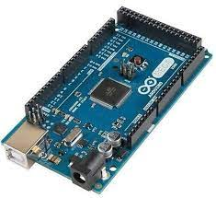

**Fig 3.1: Arduino MEGA 2560**

**Fig 3.1** show The Arduino Mega 2560 which is a versatile microcontroller board designed for a wide range of electronic projects. It features the powerful ATmega2560 microcontroller, operating at a clock speed of 16 MHz, providing a robust processing capability.

* **Processor Speed:** The microcontroller operates at a clock speed of 16 MHz, providing efficient processing for various applications.
* **Flash Memory:** The board is equipped with 256 KB of Flash memory, allowing for storage of program code.
* **SRAM:** Arduino Mega 2560 features 8 KB of SRAM for temporary data storage during program execution.
* **EEPROM:** With 4 KB of EEPROM, it enables non-volatile storage of data that needs to be preserved between power cycles.
* **Digital I/O Pins:** The board has a total of 54 digital input/output pins, including 15 PWM-capable pins, providing extensive connectivity.
* **Analog Inputs:** It includes 16 analog input pins for reading analog signals from sensors or other devices.
* **Operating Voltage:** Arduino Mega 2560 operates at 5V, can be powered using an external power supply (7-12V).
* **Applications:**

**Prototyping:** Its large number of digital and analog input/output pins, along with its compatibility with various sensors and actuators, makes it an excellent choice for prototyping electronic projects.

**Robotics:** The Mega 2560 is commonly used in robotics projects due to its ability to control multiple motors, sensors, and other peripherals simultaneously. It can be used to build robots for tasks such as exploration, automation, and remote operation.

Home Automation: With its ample number of I/O pins and support for communication interfaces like UART, SPI, and I2C, the Mega 2560 is suitable for building home automation systems. It can be used to control lights, appliances, and other devices remotely.

**Data Logging:** The Mega 2560's large flash memory and EEPROM make it well-suited for data logging applications. It can be used to log data from sensors such as temperature, humidity, and GPS for analysis and visualization.

Interactive Art Installations: Its ability to interface with a wide range of sensors and actuators makes the Mega 2560 ideal for interactive art installations. Artists can use it to create installations that respond to user input, environmental conditions, or other stimuli.

**Education:** The Mega 2560 is widely used in educational settings to teach electronics, programming, and robotics. Its simplicity, versatility, and extensive documentation make it an excellent platform for learning.

**IoT (Internet of Things):** The Mega 2560 can be used as a gateway or node in IoT applications. It can collect data from sensors and communicate with other devices or servers over the internet using Ethernet shields or Wi-Fi modules.

**Automotive Projects:** The Mega 2560 can be used in automotive projects for tasks such as data logging, vehicle diagnostics, and control systems.

**Remote Control Systems:** Its support for various communication interfaces makes it suitable for building remote control systems for drones, RC cars, and other remote-controlled devices.

**Environmental Monitoring:** The Mega 2560 can be used to build environmental monitoring systems for monitoring parameters such as temperature, humidity, air quality, and pollution levels.

.

* **SERVO MOTOR**:

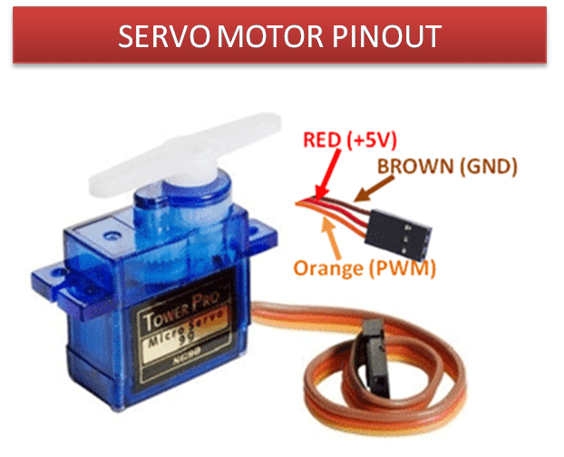

**Fig 3.2: Servo Motor**

**Fig 3.2** shows a servo motor which is an electric motor that provides precise control of angular or linear position, speed, and torque. It does so through a feedback loop system, which typically involves a controller, a sensor for position feedback, and the motor itself.

Here’s a brief overview of how it works:

* **Motor:** Can be AC or DC, providing the mechanical power to rotate or move the output shaft.
* **Sensor:** Measures the position, speed, or torque of the output shaft and sends feedback signals to the controller.
* **Controller:** Compares the feedback signals with the desired setpoint and adjusts the motor’s voltage or current to achieve precise control.

Servo motors are widely used in high-precision applications such as robotics, CNC machinery, and automated manufacturing for their ability to handle complex motions and tasks with high accuracy and quick responsiveness. They come in various types, including AC and DC servo motors, with subtypes like synchronous, asynchronous, brushed, and brushless, each tailored for specific applications.

* **Applications:**

**Robotics:** Servo motors are widely used in robotics for controlling the movement of robot arms, grippers, and other mechanical components. They provide precise control over the position and movement of robotic joints.

**RC Vehicles and Aircraft:** Servo motors are used in radio-controlled vehicles and aircraft to control steering, throttle, and other functions. They provide precise control over the movement of control surfaces such as rudders, elevators, and ailerons.

**Camera Stabilization Systems:** Servo motors are used in camera stabilization systems such as gimbals to keep the camera stable and level while filming or taking photographs. They provide smooth and precise control over the orientation of the camera.

**Automated Systems:** Servo motors are used in automated systems for tasks such as opening and closing doors, controlling conveyor belts, and positioning sensors or actuators.

**Pan-Tilt Mechanisms:** Servo motors are used in pan-tilt mechanisms to control the orientation of cameras, sensors, or other devices. They provide precise control over the azimuth and elevation angles of the device.

**Animatronics:** Servo motors are used in animatronic systems to control the movement of robotic characters in theme parks, movies, and other entertainment venues. They provide lifelike movement to the characters, such as blinking eyes, moving limbs, and facial expressions.

**DIY Projects and Hobbyist Applications:** Servo motors are widely used in DIY projects and hobbyist applications for tasks such as controlling model trains, animating Halloween props, building remote-controlled toys, and creating kinetic sculptures.

**Remote-Controlled Systems:** Servo motors are used in remote-controlled systems for tasks such as controlling the movement of robotic arms, opening and closing valves, and actuating switches or levers.

**Education and Learning:** Servo motors are used in educational projects to teach students about robotics, automation, and control systems. They provide a hands-on way to learn about motors, gears, and mechanisms.

**Art and Installations:** Servo motors are used in art installations and interactive exhibits to create moving sculptures, kinetic art, and interactive displays.

* **GPS MODULE:**

|  |
| --- |
|  |

**Fig 3.3: GPS Module**

**Fig 3.3** shows a GPS module which is a device that communicates with satellites to determine its precise location on Earth. Commonly used in navigation and tracking applications, GPS modules provide output data such as latitude, longitude, altitude, and speed.

* **Satellite Communication:** GPS modules communicate with satellites to determine their precise location on Earth.
* **Positioning Accuracy:** The accuracy of GPS modules depends on factors like the number of visible satellites, signal strength, and module quality, with modern modules offering accuracy within a few meters.
* **Navigation and Wayfinding:** Widely used for navigation systems, GPS modules provide information on location, speed, and direction, facilitating applications like turn-by-turn navigation in vehicles, hiking, and marine navigation.
* **Time Synchronization:** GPS signals include precise time information, making GPS modules suitable for timekeeping and synchronization applications.
* **Data Output:** GPS modules provide data such as latitude, longitude, altitude, speed, and timestamp, which can be used by external systems or microcontrollers for various applications.
* **Serial Communication:** Many GPS modules communicate with external devices or microcontrollers using serial communication protocols like UART (Universal Asynchronous Receiver-Transmitter).
* **Antenna Connection:** GPS modules require an external antenna for signal reception, and the type and quality of the antenna can impact module performance.
* **Applications:**

GPS (Global Positioning System) modules, when integrated with an Arduino Mega 2560, can be used in a wide range of applications that require accurate location information. Here are some common applications:

**Vehicle Tracking Systems:** GPS modules can be used to track the location of vehicles in real-time. This is useful for fleet management, logistics, and security applications.

**Navigation Systems:** GPS modules can be used to create navigation systems for cars, boats, drones, and other vehicles. They provide accurate location information, speed, and heading, allowing users to navigate to their destination efficiently.

**Asset Tracking:** GPS modules can be used to track the location of valuable assets such as equipment, containers, and packages. This is useful for inventory management, theft prevention, and recovery of lost or stolen items.

**Personal Tracking Devices:** GPS modules can be used to create personal tracking devices for children, elderly people, pets, and outdoor enthusiasts. These devices allow caregivers to monitor the location of their loved ones in real-time.

**Geotagging:** GPS modules can be used to add location information to photos, videos, and other multimedia files. This allows users to organize and share their media based on where it was taken.

**Environmental Monitoring:** GPS modules can be used to track the movement of animals, monitor wildlife habitats, and study environmental changes over time. They can also be used to monitor weather conditions, seismic activity, and other natural phenomena.

**Precision Agriculture:** GPS modules can be used in agriculture to create precision farming systems. They can provide accurate location information for planting, fertilizing, and harvesting crops, as well as monitoring soil moisture and nutrient levels.

**Emergency Response Systems:** GPS modules can be used in emergency response systems to locate and rescue people in distress. They can be integrated into personal locator beacons, emergency phones, and tracking devices for first responders.

**Weather Balloons and UAVs:** GPS modules can be used in weather balloons and unmanned aerial vehicles (UAVs) to track their position, altitude, and speed. This is useful for scientific research, meteorology, and aerial photography.

**IoT (Internet of Things) Applications:** GPS modules can be used in IoT applications to track the location of mobile assets such as vehicles, containers, and shipping pallets. They can also be used to create location-aware smart devices for home automation, environmental monitoring, and asset management.

* **ULTRASONIC SENSOR:**

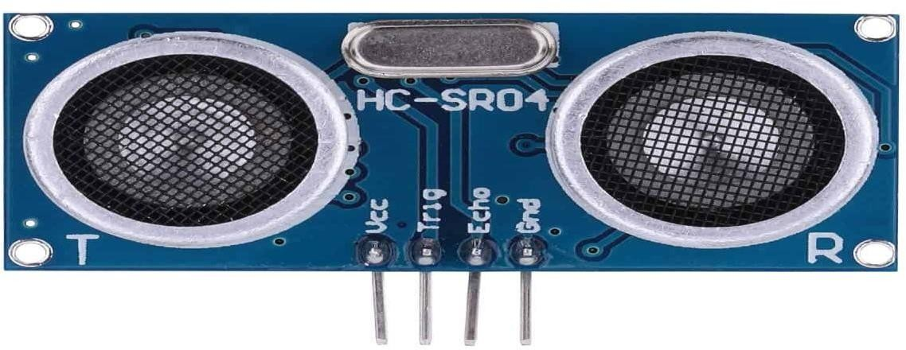

**Fig 3.4: Ultrasonic Sensor**

**Fig 3.4** shows Ultrasonic Sensorwhich isalso known as transceivers when they both send and receive work on a principle similar to radar or sonar which evaluate attributes of a target by interpreting the echoes from radio or sound waves respectively. Ultrasonic sensors generate high frequency sound waves and evaluate the echo which is received back by the sensor. Sensors calculate the time interval between sending the signal and receiving the echo to determine the distance to an object. This technology can be used for measuring: wind speed and direction (anemometer), fullness of a tank and speed through air or water. For measuring speed or direction a device uses multiple detectors and calculates the speed from the relative distances to particulates in the air or water. To measure the amount of liquid in a tank, the sensor measures the distance to the surface of the fluid. Further applications include: humidifiers, sonar, medical ultra sonography, burglar alarms and non-destructive testing. Systems typically use a transducer which generates sound waves in the ultrasonic range, above 18,000 hertz, by turning electrical energy into sound, then upon receiving the echo turn the sound waves into electrical energy which can be measured and displayed. The technology is limited by the shapes of surfaces and the density or consistency of the material. For example foam on the surface of a fluid in a tank could distort a reading.

* **Applications:**

**Distance Measurement:** Ultrasonic sensors are commonly used to measure distance accurately. They emit high-frequency sound waves and measure the time it takes for the waves to bounce back after hitting an object. This information can be used to calculate the distance to the object.

**Obstacle Detection and Avoidance:** Ultrasonic sensors can be used to detect obstacles in the path of a robot or vehicle and take appropriate action to avoid them. This is particularly useful in robotics and autonomous navigation systems.

**Parking Assistance Systems:** Ultrasonic sensors can be used in parking assistance systems to detect nearby objects and provide feedback to the driver to help them park their vehicle safely.

**Liquid Level Measurement:** Ultrasonic sensors can be used to measure the level of liquid in a tank or container by measuring the distance to the surface of the liquid.

**Security Systems:** Ultrasonic sensors can be used in security systems to detect movement or presence in a certain area. They can trigger an alarm or activate other security measures when an intruder is detected.

**Object Tracking:** Ultrasonic sensors can be used to track the movement of objects within a certain range. This can be useful in applications such as robotics, where objects need to be tracked as they move around a space.

**Gesture Recognition:** Ultrasonic sensors can be used to detect hand gestures and movements. This can be useful in applications such as home automation, where users can control devices using hand gestures.

**Liquid Flow Measurement:** Ultrasonic sensors can be used to measure the flow rate of liquids in pipes or channels by measuring the time it takes for sound waves to travel through the liquid.

**Collision Avoidance Systems:** Ultrasonic sensors can be used in collision avoidance systems to detect nearby objects and prevent collisions. This is useful in applications such as drones, where collisions can cause damage to the vehicle or injury to people.

**Industrial Automation:** Ultrasonic sensors can be used in industrial automation systems for tasks such as object detection, distance measurement, and liquid level sensing.

* **MOTOR DRIVER:**

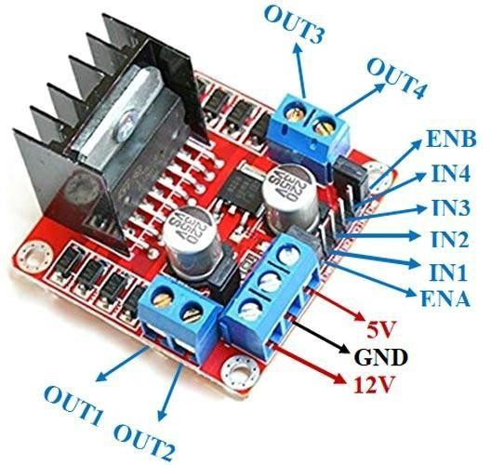

**Fig 3.5: Motor Driver**

**Fig 3.5** shows a L298N Motor Driver which is a popular motor driver module used for controlling DC and stepper motors. Working of L298N Motor Driver:

* **Dual H-Bridge:** The L298N contains a dual H-bridge, allowing it to control the speed and direction of two DC motors independently or to drive a single stepper motor.
* **Input Pins:** It has input pins (IN1, IN2, IN3, IN4) for controlling the spinning direction of two motors (Motor A and Motor B).
* **Enable Pins:** ENA and ENB enable PWM signal for speed control of Motor A and Motor B, respectively.
* **Output Pins:** OUT1, OUT2, OUT3, and OUT4 are the output pins for Motor A and Motor B.
* **Voltage Specifications:** The motor supply voltage can go up to 46V, with a maximum current of 2A per channel. The logic voltage is 5V, and the driver operates within a voltage range of 5-35V.
* **Current Sense:** It includes a feature for current sensing for each motor.
* **Heat Sink:** Comes with a heat sink for better performance and heat management.
* **Power-On LED:** Indicates when the module is powered on.

The L298N module is quite versatile and can be used in various applications such as robotics, driving DC motors, and controlling stepper motors in projects that require precise movement control.

* **IR SENSOR:**

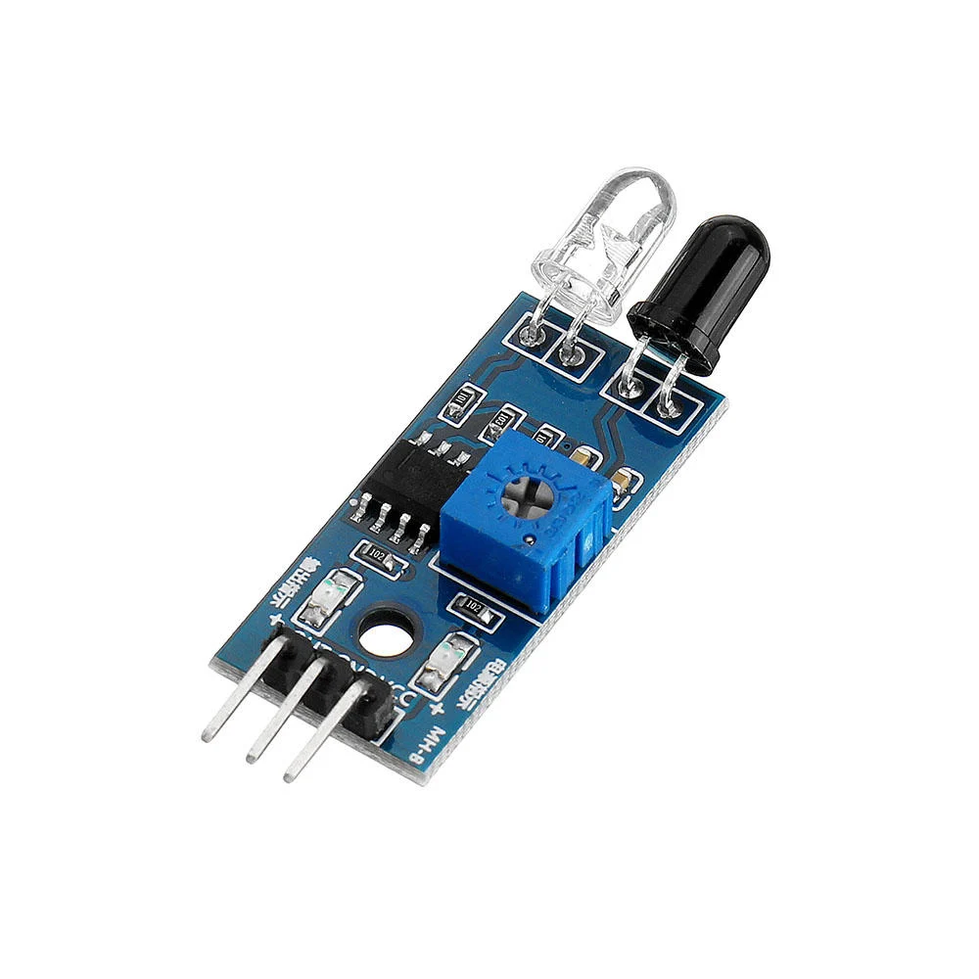

**Fig 3.6: IR Sensor**

**Fig 3.6** shows a IR Sensor, or infrared sensor, which is an electronic device that detects or measures the infrared radiation of objects in its surroundings. It can be used to detect specific characteristics through emitting or detecting IR radiation, and it’s commonly found in applications like remote controls and motion sensing.

Working of IR Sensor:

* **Emitter:** An IR LED emits infrared light.
* **Detector:** A photodiode or phototransistor detects the reflected infrared light.
* **Circuitry:** The sensor circuit processes the signal and converts it into a readable form.
* **Output:** The change in resistance or voltage in the photodiode is proportional to the intensity of the received IR light, which can be used to determine the presence or distance of an object.

IR sensors are categorized into two types:

* **Active IR Sensor:** Includes both an infrared source (like an LED) and a detector. The emitted IR light reflects off an object and is detected by the receiver.’
* **Passive IR Sensor (PIR):** Detects infrared light emitted by objects (like body heat) without emitting any IR light itself. Commonly used in security systems and automatic lighting controlsBottom of Form.
* **Applications:**

Infrared (IR) sensors are widely used in various applications for detecting the presence of an object or obstacle. When combined with an Arduino Mega 2560, IR sensors can be used in numerous projects, including:

**Obstacle Detection and Avoidance:** IR sensors can be used to detect obstacles in the path of a robot or vehicle and take appropriate action to avoid them. This is useful in robotics and autonomous navigation systems.

**Proximity Sensing:** IR sensors can be used to detect the presence of objects within a certain range. This can be useful in applications such as automatic doors, where the door can open or close automatically when someone approaches.

**Line Following Robots:** IR sensors can be used to build line-following robots that can follow a line drawn on the ground. The sensors detect the contrast between the line and the background and adjust the robot's path accordingly.

**Object Counting:** IR sensors can be used to count the number of objects passing through a certain area. This can be useful in applications such as traffic monitoring or inventory management.

**Gesture Recognition:** IR sensors can be used to detect hand gestures and movements. This can be useful in applications such as home automation, where users can control devices using hand gestures.

**Security Systems:** IR sensors can be used in security systems to detect movement or presence in a certain area. They can trigger an alarm or activate other security measures when an intruder is detected.

**Proximity Switches:** IR sensors can be used as proximity switches to detect the presence of objects without physical contact. This can be useful in applications such as automatic faucets or soap dispensers.

**Remote Control Systems:** IR sensors can be used to receive commands from an IR remote control. This can be useful in applications such as controlling appliances, TVs, or multimedia systems.

**Gesture Controlled Robots:** IR sensors can be used to build robots that can be controlled using hand gestures. This can be useful in applications such as toy robots or educational projects.

**Distance Measurement:** IR sensors can be used to measure the distance to an object by measuring the time it takes for an IR signal to bounce back after hitting the object.

* **CAR CHASSIS:**

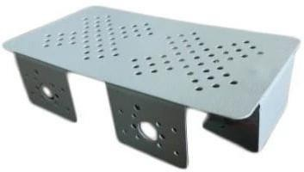

**Fig 3.7: Car Chassis**

Aluminum is a popular material for car chassis because it is lightweight and strong. It is also resistant to corrosion, which makes it ideal for use in cars that are exposed to harsh weather conditions. Aluminum chassis are commonly used in high-performance cars because they provide better handling and performance than steel chassis as shown in **Fig 3.7**. They are also more expensive than steel chassis.

* **BREAD BOARD:**

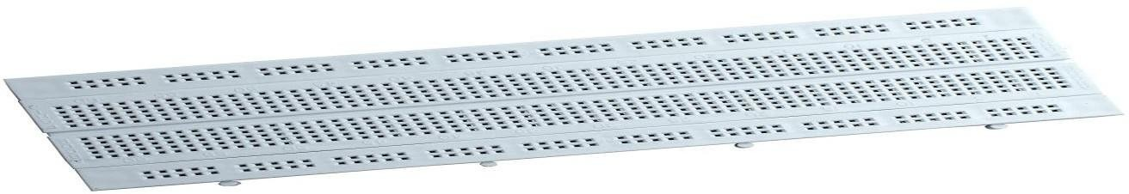

**Fig 3.8: Bread Board**

As shown in the **Fig 3.8**, a breadboard (sometimes called a plug block) is used for building temporary circuits. It is useful to designers because it allows components to be removed and replaced easily. It is useful to the person who wants to build a circuit to demonstrate its action, then to reuse the components in another circuit.

* **12v BATTERY:**

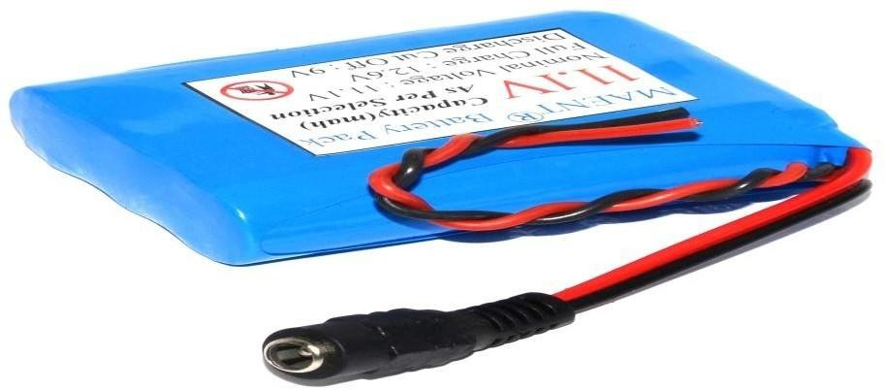

**Fig 3.9: 12v Battery**

As shown in **Fig 3.9**, a 12V battery which is a common type of battery that is used in powering boats, cars, RVs and other forms of automobiles. Some 12V batteries are also used alongside generators to generate electricity and power up buildings. A fully charged 12 volt battery should read at 12.6 volts on the millimeters. If the reading is lower than this, you'll want to charge your battery with either a battery charger or by taking your car for a drive.

* **BO MOTOR:**

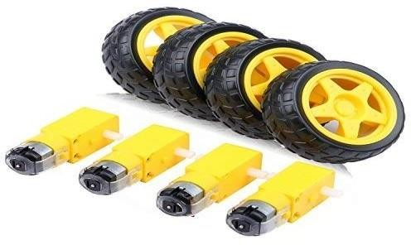

**Fig 3.10: Bo Motor**

As shown in **Fig 3.10**, a BO motor is a type of electric motor that is powered by a rechargeable battery. These are commonly used in portable devices and vehicles, as they offer the convenience of cordless operation. It gives good torque. BO Motors are called as Battery operated motors. Hence it is used in many DIY Robotic applications that run on batteries. Plastic Geared Motor (BO) This single shaft plastic geared motor gives good torque and rpm at lower operating voltages, which is the biggest advantage of these motors. Small shaft with matching wheels give optimized design for your application or robot.

* **BLUETOOTH MODULE:**

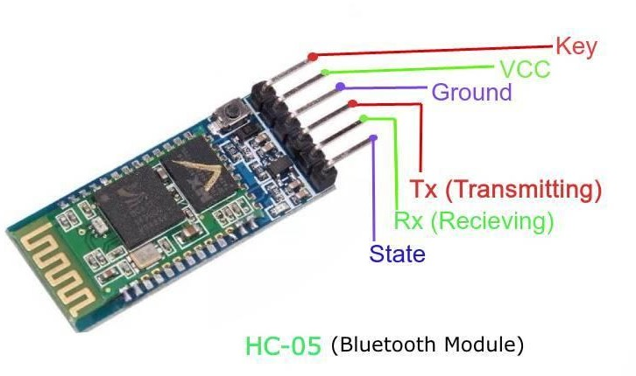

**Fig 3.11: Bluetooth Module**

As shown in **Fig 3.11**, The HC-05 is a versatile and widely used Bluetooth module that can add two-way (full-duplex) wireless functionality to your projects. It’s designed to facilitate serial communication (USART) and is TTL compatible, making it easy to interface with microcontrollers like Arduino.

The key features of the HC-05 Bluetooth module:

* **Pin Configuration:** It has pins for key functions like enabling AT command mode, powering the module, transmitting and receiving serial data, and indicating the module’s status through an LED.
* **Operating Modes:** The module can operate in both Data Mode for communication and AT Command Mode for changing settings like the Bluetooth name, password, and baud rate.
* **Communication:** Supports a range of baud rates from 9600 to 460800, allowing for flexible data transmission speeds.
* **Range:** Capable of communicating over distances of less than 100 meters, which is typical for Class 2 Bluetooth devices.
* **Applications:** Ideal for projects that require wireless data transfer between a computer or mobile phone and a microcontroller, but not suitable for transferring multimedia like photos or songs.

The default settings for the HC-05 are usually:

Bluetooth Name: “HC-05”

Password: “1234” or “0000”

Communication: Slave

Mode: Data Mode

Baud Rate: 9600, 8, N, 1 (Data Mode) and 38400, 8, N, 1 (Command Mode)

* 1. **Software Requirements**

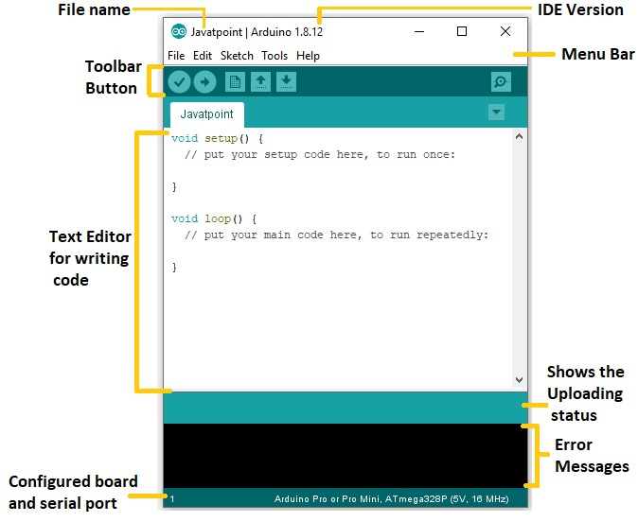

**Fig 3.12: Arduino IDE**

* **Fig** **3.12** show the Arduino IDE (Integrated Development Environment) which is a software application used for writing, compiling, and uploading code to Arduino boards. It provides an easy-to-use interface for beginners and advanced users to program their Arduino microcontrollers.
* To use the Arduino IDE, you can follow these steps:
* Connect Arduino Board: Connect your Arduino board to your computer using a USB cable. Make sure your board is properly recognized by your computer (drivers might need to be installed).
* Launch Arduino IDE: Open the Arduino IDE that you installed in the first step.
* Select Board and Port: From the "Tools" menu, select the appropriate Arduino board you are using (e.g., Arduino Uno, Arduino Mega). Also, choose the correct port to which your Arduino board is connected.
* Write Code: In the Arduino IDE, you will see a text editor where you can write your Arduino code. You can start with the basic "Blink" example, which is often used to test the connection. Write or paste your code into the editor.
* Verify and Compile: Click on the "Verify" button (checkmark icon) to compile your code. The IDE will check for any syntax errors in your code. If there are errors, you will need to fix them before proceeding.
* Upload to Arduino: Once your code is successfully compiled, click on the "Upload" button (right arrow icon) to upload the code to your Arduino board. The IDE will compile the code again, and if everything goes well, it will upload the compiled binary to the Arduino.
* Monitor Serial Output: You can monitor the output of your Arduino board by opening the Serial Monitor. From the "Tools" menu, select "Serial Monitor." You can use the Serial Monitor to send and receive data between your Arduino and the computer.
* That's a basic overview of using the Arduino IDE. It offers many more features and libraries to help you develop complex Arduino projects. You can explore the official Arduino website, online tutorials, and the vast Arduino community for more information and examples to get started with your Arduino programming journey.

**CHAPTER 4**

**METHODOLOGY AND IMPLEMENTATION**

Developing an autonomous vehicle with advanced braking and lane control systems involves a multi-disciplinary approach that integrates hardware components, software algorithms, and rigorous testing, a comprehensive methodology and implementation plan:

* 1. **Methodology**
* **System Design:** Define the Operational Design Domain (ODD) which includes the specific conditions under which the vehicle is designed to operate, such as road types, speed ranges, environmental conditions, and other driving scenarios1.
* **Component Selection:** Choose appropriate sensors (GPS, ultrasonic, IR), actuators (servo motors, Bo motors), and control units (Arduino Mega, motor driver) as per the block diagram.
* **Software Development:**
* Develop algorithm for vehicle security using GPS module to continuously send the location (longitude and latitude values) to the user interface application via Bluetooth module.
* Develop algorithm for lane control using machine learning and computer vision to process sensor data and detect lane markings.
* Implement advanced braking algorithms that use sensor data to predict potential collisions and engage the brakes preemptively.
* **Integration:** Assemble the hardware components and integrate them with the software algorithms, ensuring all parts communicate effectively with the Arduino Mega.
* **Testing and Validation:** Conduct both lab and real-world testing to validate the performance of the Advanced Driver-Assistance Systems (ADAS) and autonomous functions.
* **Iterative Improvement:** Utilize feedback from testing to iteratively improve the algorithms, focusing on safety, security, and ethical considerations.
  1. **Implementation**
* **Hardware Setup:** Install the sensors and actuators on the vehicle as per the block diagram, ensuring proper calibration and alignment.
* **Software Programming:** Program the Arduino Mega with the developed algorithms for vehicle security, lane control and braking systems.
* **Control Strategies:**
* For lane control, implement a feedback loop that adjusts the vehicle’s steering based on lane detection data.
* For braking, use a predictive model that calculates the likelihood of a collision and engages the brakes accordingly.
* **User Interface:** Develop a user interface on a mobile application to display real-time data from the GPS module and provide manual overrides if necessary.
* **Safety Protocols:** Implement safety protocols that allow the vehicle to revert to a safe state in case of system failures or unexpected scenarios.
* **Field Trials:** Perform extensive field trials to test the vehicle’s performance in real-world conditions, monitoring its ability to handle lane control and braking tasks autonomously.
* **Data Analysis:** Analyze the data collected during trials to assess the system’s performance and identify areas for enhancement.
* **Regulatory Compliance:** Ensure the vehicle meets all regulatory requirements for autonomous vehicles, including safety standards and cybersecurity measures.
* **Deployment:** Once the system is fully tested and compliant, proceed with the deployment of the autonomous vehicle.
  1. 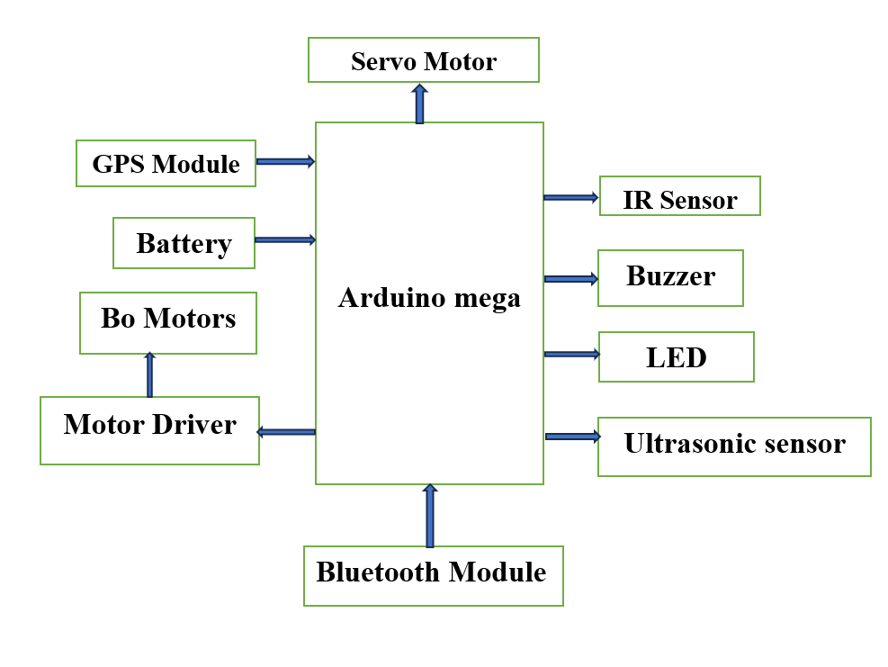 **Block Diagram**

**Fig 4.1: Block diagram**

**Fig 4.1** shows the block diagram that represents a system centered around an Arduino Mega, which is a microcontroller board used for building digital devices and interactive objects that can sense and control objects in the physical world.

* **Arduino Mega:** The core of the system, it processes inputs and outputs based on the programmed instructions.
* **GPS Module:** Provides real-time location data to the Arduino. Battery: Powers the entire system, including the Arduino and connected modules.
* **Bo Motors:** Likely refers to DC motors used for driving wheels or other moving parts.
* **Motor Driver**: Controls the speed and direction of the motors.
* **Servo Motor:** Used for precise control of mechanical movement.
* **IR Sensor:** Detects infrared light, often used for obstacle detection or remote control.
* **Buzzer:** Emits audio signals, can be used for alerts or notifications.
* **LED:** Light Emitting Diode, used as a visual indicator or light source.
* **Ultrasonic Sensor:** Measures distance by emitting ultrasonic waves and detecting their reflection.
* **Bluetooth Module:** Enables wireless communication with other devices, such as smartphones or computers.
  1. 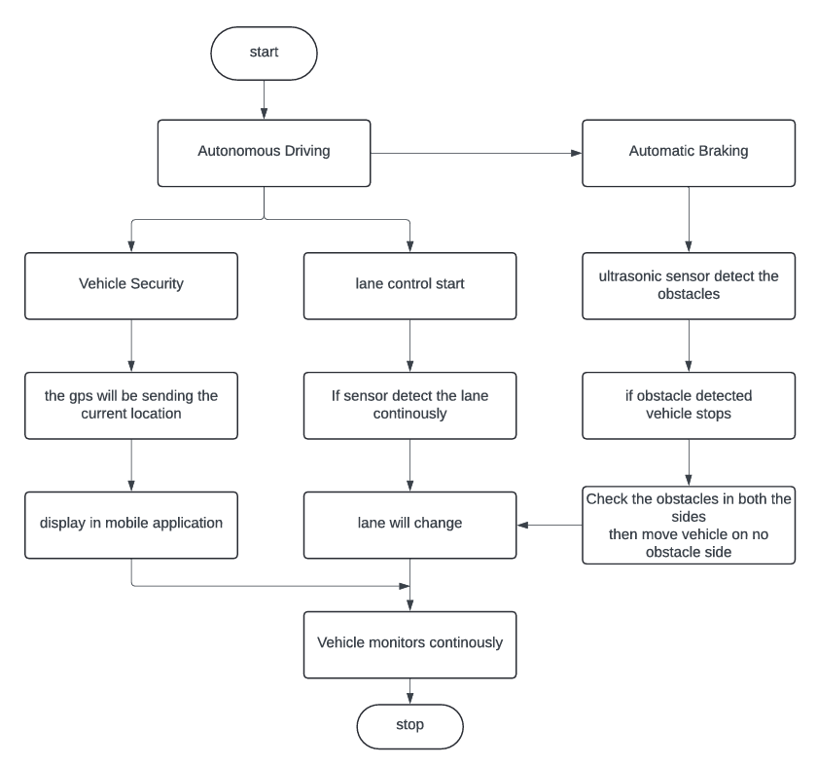 **Flow Chart**

**Fig 4.2: Flow Chart**

The flow chart is divided into two main parts: Vehicle Security and Automatic Braking. Here’s a detailed explanation of each part:

**Vehicle Security**

* GPS Tracking: The vehicle’s GPS system sends the current location to a mobile application. This allows for real-time tracking of the vehicle for security purposes.

**Lane Control:**

* The process starts with the initiation of lane control.
* Sensors installed on the vehicle detect the lane continuously.
* If a lane is detected, the vehicle will automatically adjust its position to stay within the lane.

**Automatic Braking**

* Obstacle Detection:
* Ultrasonic sensors are used to detect obstacles in the path of the vehicle.
* If an obstacle is detected, the vehicle’s automatic braking system is activated.
* Vehicle Response:
* Upon detecting an obstacle, the vehicle stops.
* It then checks for obstacles on both sides.
* The vehicle moves to the side where no obstacle is detected, ensuring safety.

Both systems work in tandem to monitor the vehicle’s surroundings continuously. The vehicle security system ensures that the vehicle stays within its lane, while the automatic braking system prevents collisions by stopping the vehicle if an obstacle is detected. After taking the necessary action, the vehicle resumes monitoring until it needs to stop, completing the autonomous driving process.

Writing an algorithm in-depth involves breaking down the functionality of each component, describing the logic and flow of the program, and providing insights into how each part contributes to achieving the desired outcome. Below is a detailed algorithm for the autonomous vehicle control system, including advanced braking and lane control, based on the provided code.

**Algorithm for Autonomous Vehicle Control System**

**1. Initialization:** Initialize pins for motor control, ultrasonic sensor, IR sensors, servo motor, and serial communication.

Set constants for speed control and distance threshold.

**2. Setup:** Set up serial communication for GPS and Bluetooth modules. Calibrate servo motor to scan for obstacles. Read initial distance from the front ultrasonic sensor.

**3. Main Loop:** Continuously execute the following steps:

**4. GPS Data Handling:** Check for available GPS data. If available, parse latitude and longitude information. Transmit GPS data over Bluetooth.

**5. Ultrasonic Sensor Reading:** Read distance from the front ultrasonic sensor. Print distance value for debugging purposes.

**6. Obstacle Detection:** Check if both IR sensors detect obstacles. If both sensors detect obstacles: Check the distance from the front ultrasonic sensor: If the distance is greater than the set threshold, move forward. If the distance is less than the threshold, call the function to check the sides.

**7. Lane Detection:** If only the left IR sensor detects an obstacle, turn right. If only the right IR sensor detects an obstacle, turn left. If both sensors do not detect obstacles, continue moving forward.

**8. Side Check Function:** Stop the robot. Scan the right side using the servo motor and ultrasonic sensor. Record the distance from the right side. Scan the left side using the servo motor and ultrasonic sensor. Record the distance from the left side. Call the function to compare distances and decide the direction to avoid obstacles.

**9. Comparison and Maneuvering:** Compare distances from the left and right sides. If the left distance is less than the right distance, turn right. If the right distance is less than the left distance, turn left. If both distances are equal, alternate between left and right turns to navigate around obstacles.

**10. Motor Control Functions:** Implement functions to control motor movements:

* Move forward.
* Move backward.
* Turn left.
* Turn right.
* Stop the robot.

**11. Servo Control Function:** Implement a function to control the servo motor for obstacle scanning.

**12. Ultrasonic Sensor Reading Function:** Implement a function to read distance from the ultrasonic sensor and convert it to centimeters.

**13. Serial Communication Functions:** Implement functions for transmitting GPS data over Bluetooth.

**14. Error Handling:** Implement error handling mechanisms for sensor failures or communication errors.

**15. Testing and Debugging:** Test the algorithm in various environments to ensure robust performance. Debug any issues encountered during testing.

**16. Optimization:** Optimize the algorithm for efficiency and speed, if necessary.

**17. Deployment:** Deploy the autonomous vehicle control system for real-world applications.

This algorithm provides a comprehensive overview of the autonomous vehicle control system's logic and functionality, encompassing GPS data handling, obstacle detection, lane control, motor control, and communication. It outlines the step-by-step process for navigating obstacles and maintaining lane integrity while ensuring robustness and reliability in diverse environments.

**CHAPTER 5**

**RESULTS**

* 1. 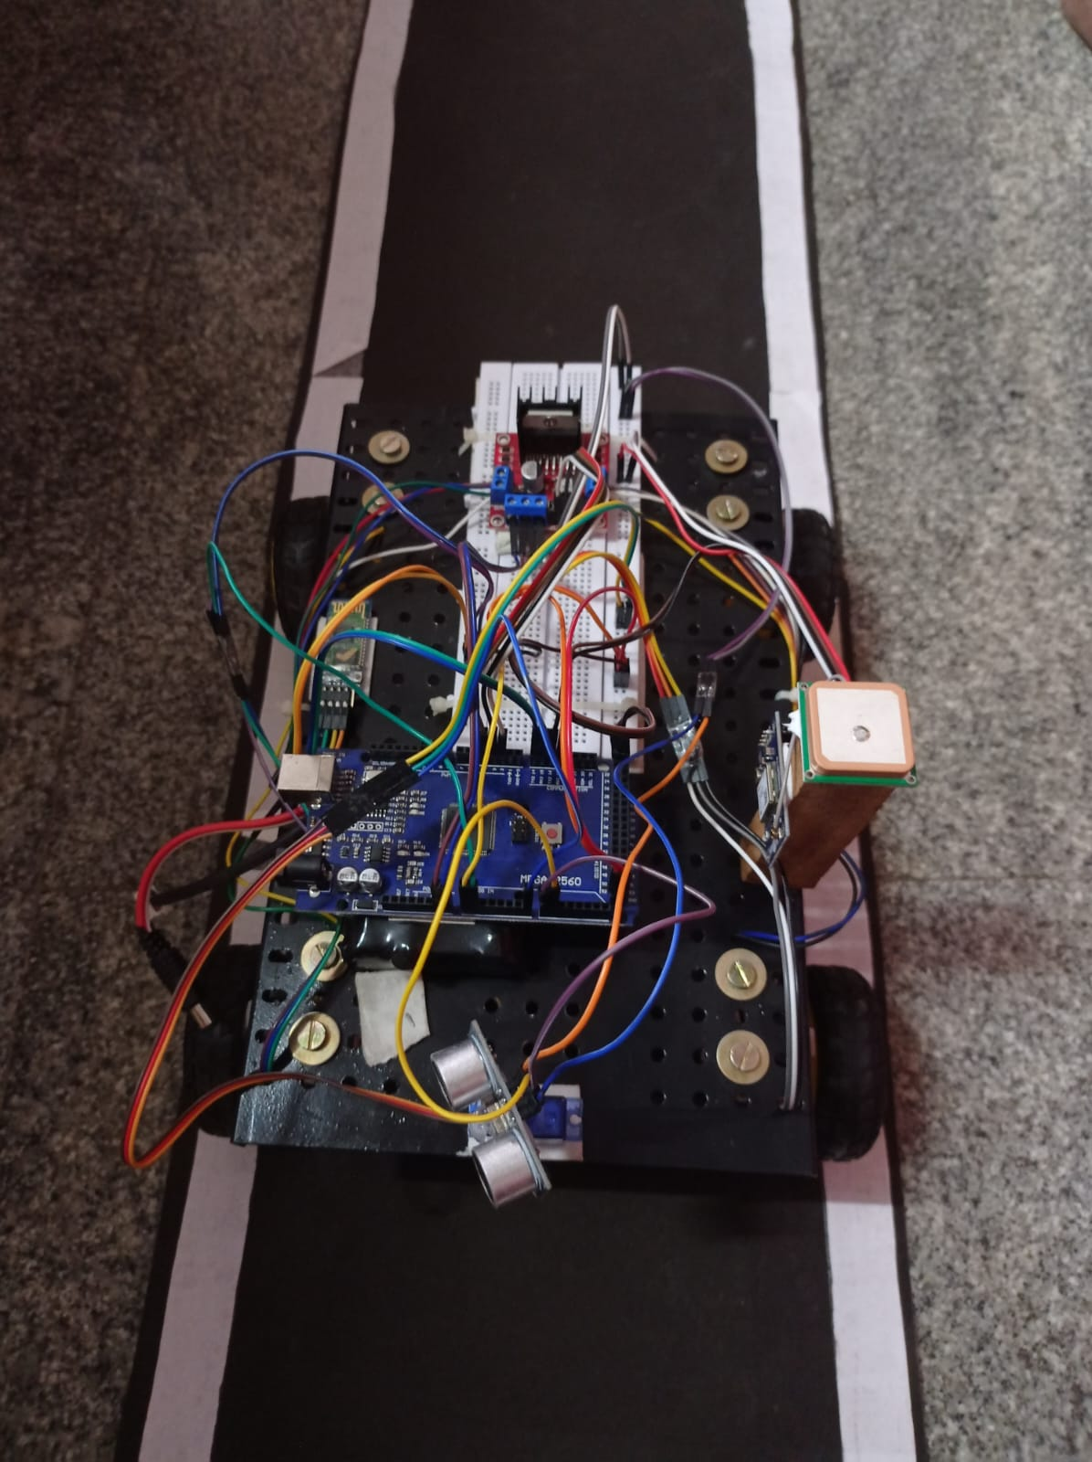**Results:**

**Fig 4.3: Top view**

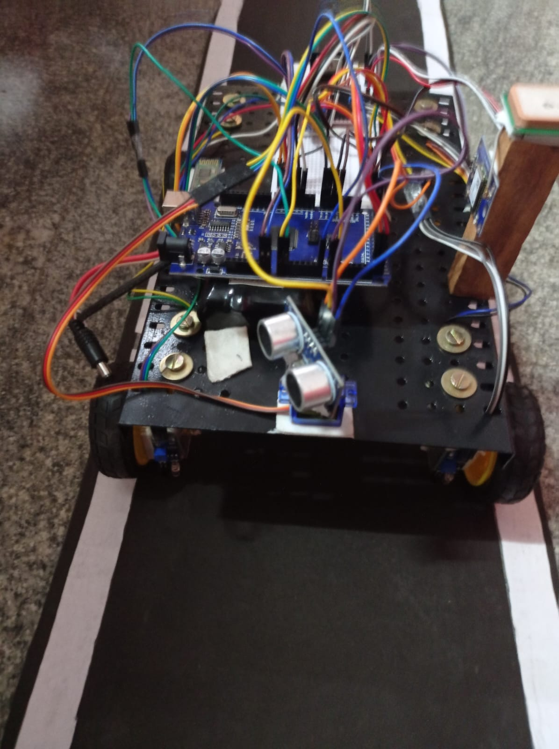

**Fig 4.4: Front View**

The above fig 4.3 & fig 4.4 Shows that the Development of Autonomous Vehicle with Advanced Braking & Lane Control System. The prototype vehicle is a modified car equipped with advanced sensors, processors, actuators, and control systems. The braking system is enhanced with electromechanical actuators capable of rapid and precise braking response. Lane control is achieved through a combination of GPS, inertial measurement units (IMUs), and computer vision algorithms.

Working of Advanced Braking System: The braking system utilizes data from sensors to continuously monitor the vehicle's surroundings and detect potential obstacles or hazards. Advanced algorithms process sensor data in real-time to predict potential collisions and calculate optimal braking maneuvers. Electromechanical actuators enable precise control over braking force, allowing for rapid adjustments to ensure the vehicle's safety and stability.

The system integrates with the vehicle's onboard computer to automatically apply brakes when necessary, either to avoid collisions or to maintain a safe distance from other vehicles.

Working of Lane Control System: The lane control system combines data from GPS, IMUs, and cameras to accurately determine the vehicle's position within its lane. Computer vision algorithms analyze camera feeds to detect lane markings, road signs, and other visual cues. Using this information, the system calculates the vehicle's trajectory and adjusts steering inputs to keep it centered within the lane. The system is designed to adapt to various road conditions, including curves, intersections, and lane merges, ensuring safe and smooth navigation.

Integration and Autonomy: The braking and lane control systems are integrated into an overall autonomous driving framework. The vehicle's onboard computer processes sensor data, executes control algorithms, and makes real-time decisions to navigate safely and efficiently. Advanced machine learning techniques may be employed to improve the system's performance over time, learning from driving experiences and feedback. Safety mechanisms, such as fail-safes and redundancy measures, are implemented to ensure reliable operation in diverse driving scenarios.

Testing and Validation: The prototype undergoes rigorous testing in controlled environments such as test tracks and simulated scenarios. Real-world testing is conducted to evaluate the system's performance under various weather conditions, traffic scenarios, and road conditions. Validation processes involve comparing the vehicle's behavior against predefined safety and performance metrics, ensuring compliance with regulatory standards and industry best practices.

Despite the positive results achieved, further research and development are needed to address remaining challenges and enhance the capabilities of autonomous vehicles.

Future efforts may focus on refining sensor technologies, improving decision-making algorithms, and integrating with emerging technologies such as connected infrastructure and 5G networks.

Collaboration between industry stakeholders, policymakers, and researchers will be essential to accelerate the adoption of autonomous vehicles and maximize their societal benefits.

**CHAPTER 6**

**CONCLUSION**

* 1. **Conclusion:**

The development of an autonomous vehicle (AV) equipped with advanced braking and lane control systems represents a significant milestone in the evolution of transportation technology. Throughout this project, we have explored the integration of cutting-edge sensors, algorithms, and control mechanisms to create a robust and reliable autonomous driving platform capable of navigating complex real-world environments with precision and safety. In this concluding section, we delve deeply into the theoretical implications and practical implications of our work.

**Theoretical Contributions:** Sensor Fusion and Perception: The integration of multiple sensor modalities, including LiDAR, ultrasonic, and infrared sensors, enables comprehensive environmental perception, allowing the AV to accurately detect obstacles, lane markings, and other vehicles in its vicinity. By fusing data from these sensors and employing advanced signal processing techniques, the AV can construct a detailed representation of its surroundings, facilitating informed decision-making in dynamic traffic scenarios.

**Artificial Intelligence and Decision-Making:** The use of artificial intelligence (AI) algorithms, such as machine learning and model predictive control, empowers the AV to make intelligent navigation decisions in real-time. By leveraging historical data and predictive models, the AV can anticipate future events, assess risks, and plan optimal trajectories to ensure safe and efficient operation. Furthermore, AI-based decision-making enables the AV to adapt to changing environmental conditions and unforeseen obstacles, enhancing its robustness and adaptability.

**Control Systems and Actuation:** The implementation of advanced control systems, including proportional-integral-derivative (PID) controllers and servo mechanisms, enables precise and responsive vehicle control. By modulating motor speeds, steering angles, and braking forces, the AV can execute complex maneuvers with accuracy and agility, maintaining stability and trajectory accuracy in diverse driving conditions. Additionally, the integration of electromechanical actuators enhances the AV's agility and maneuverability, enabling agile responses to dynamic traffic situations.

**Practical Implications:** Safety and Reliability: The primary goal of our project is to enhance road safety by developing an AV capable of autonomously navigating roads with a high degree of reliability. The advanced braking system implemented in our AV ensures rapid and precise response to potential hazards, minimizing the risk of accidents and collisions. Likewise, the lane control system enables the AV to maintain its position within designated lanes, reducing the likelihood of lane departure accidents and improving overall traffic flow. Efficiency and Sustainability: Beyond safety considerations, our AV contributes to the efficiency and sustainability of transportation systems by optimizing vehicle movements and reducing energy consumption. By employing intelligent routing algorithms and adaptive cruise control, the AV can minimize travel times and fuel consumption, thereby reducing greenhouse gas emissions and mitigating environmental impact. Additionally, the integration of autonomous driving technology holds the potential to alleviate traffic congestion and improve overall traffic flow, leading to smoother and more efficient transportation networks. Accessibility and Inclusivity: Another practical implication of our project is the potential to enhance mobility accessibility for individuals with disabilities, the elderly, and underserved communities. By providing a reliable and convenient transportation option, our AV empowers individuals to access essential services, participate more fully in society, and enjoy greater independence and autonomy. Furthermore, by incorporating user-friendly interfaces and accessibility features, such as voice commands and tactile feedback, we ensure that our AV is accessible to all members of the community, regardless of physical ability or mobility restrictions.

**Future Directions:** Despite the significant progress achieved in this project, several avenues for future research and development remain open. These include: Further refinement of sensor technologies to improve environmental perception and obstacle detection capabilities. Integration of advanced communication systems to enable seamless interaction between autonomous vehicles and infrastructure components, such as traffic lights and road signs. Exploration of novel control strategies, such as reinforcement learning and evolutionary algorithms, to enhance the autonomy and adaptability of AVs in complex traffic scenarios. Continued collaboration with regulatory authorities and stakeholders to address legal and ethical considerations surrounding autonomous driving technology and ensure its safe and responsible deployment. Expansion of pilot programs and field trials to validate the performance and reliability of AVs in real-world driving conditions and gather feedback from end-users to inform future iterations and improvements.

In conclusion, the development of an autonomous vehicle with advanced braking and lane control systems holds immense theoretical and practical significance, offering transformative solutions to longstanding challenges in transportation. By leveraging state-of-the-art technologies and interdisciplinary approaches, we have laid the groundwork for a future of safer, more efficient, and more accessible mobility for all. As we continue to push the boundaries of innovation and exploration, we remain committed to realizing the full potential of autonomous driving technology and shaping a brighter and more sustainable future for generations to come.

The development of an autonomous vehicle with advanced braking and lane control systems represents a transformative leap forward in the quest for safer, more efficient, and more sustainable transportation. This project has demonstrated the feasibility and potential of autonomous driving technology to revolutionize the way we move and interact with our environment. By addressing key engineering challenges, embracing technological innovation, and fostering collaboration across disciplines, we can unlock the full promise of autonomous vehicles and create a future where mobility is accessible, efficient, and equitable for all.

**REFERENCES**

**[1].** Hemant Suryawanshi and Rohan Sarode are proposed **“AUTOMATIC BRAKING SYSTEM”** International Research Journal of Engineering and Technology. IRJET, Volume: 08 Issue: 04. e-ISSN Online: 2395-0056. page no: 2047-2050, Apr 2021.

**[2].** J.V.Sai Ram,K. M.S.V.Manikanta, G.Pavanth, B.Jagadeep and Dr. B.Raghu Kumar **“Automatic Braking System Using Ultrasonic Sensor”** International Journal of Innovative Science and Research Technology. IJISRT, Volume 2, Issue 4, ISSN No: - 2456 - 2165, page no 385 – 404.

**[3].** Li Li, Ding Wen, Nan-Ning Zheng, Lin-Cheng Shen, Cognitive Cars: A New Frontier of ADAS Research, IEEE Transaction on Intelligent Transportation System, March 2012, Volume 13, Issue 1.

**[4].** J. Brown, Z. Q. Zhou, and Y.- W. Chow, **“Metamorphic Testing of Navigation Software: A Pilot Study with Google Maps,”** in Proceedings of the 51st Hawaii International Conference on System Sciences, 2018.

**[5].** R. Sarcinelli et al., **“Handling pedestrians in self -driving cars using image tracking and alternative path generation with Frenét frames,”** Computer. Graph., 2019.

**[6].** Manju Kumari, Shambhu Kumar, Anand Kumar and Nikita Kumari **“Intelligent Braking System Using Ultrasonic Sensor”** International Journal of Science and Research, IJSR. Volume 9, Issue 11, ISSN: 2319-7064, page no: 823-827November 2020

**[7].** Shailendra Singh, Yogesh Jangid, Sahil Gupta and Virendra Solanki **“Smart Braking System Using Ultrasonic Sensor and Actuator”** International Research Journal of Engineering and Technology, IRJET, Volume: 06, Issue: 06, eISSN: 2395-0056, page no: 90-92, June 2019.

**[8].** Mr. Tushar Kavatkar, Mr. Harshal Salvi and Mrs. **MinaRahate “Design and Analysis of Intelligent Braking System”** International Journal of Engineering Development and Research, IJEDR, Volume 5, Issue 1, ISSN: 2321-9939, page no: 119-131,2017.

**[9].** G.V. Sairam, B. Suresh, CH. Sai Hemanth and K. Krishnasai **“Intelligent Mechatronic Braking System”** International Journal of Emerging Technology and Advanced Engineering, IJETAE, Volume 3, Issue 4, ISSN 2250-2459, page no: 100-105, April 2013.

**[10].** Bhaskara. P, Eriki Ananda. K and Venkataramana. V “**Arduino Based Automated Braking Control System to Enhance the Safety at Low Light and Long Stressed Drive Conditions**” International Journal of Modern Studies in Mechanical Engineering, IJMSME, Volume 4, Issue 2, ISSN2454-9711,page no:1-6, 2018.

**[11].** Sumeet Bhardwaj, Ashwani Gulati, Kashish Goyal and Vivek Vij **“AUTOMATIC EMERGENCY BRAKING SYSTEM (ASYSTEM FOR DECREASED HUMAN EFFORT)”** Conference Paper, Research gate, ISSN 357569615, page no: 1-5, January 2022.

**[12].** Naveen Navudu, Aravind Ramapatruni, Jagadeesh Polaki, Jaya Surya Navagana and Srihari Palli “**AUTOMATIC BRAKING SYSTEM USING ULTRASONIC SENSOR**” ICONIC RESEARCH AND ENGINEERING JOURNALS, IRE, Volume 5, Issue 2, ISSN: 2456-8880, page no: 30-35, AUG 2021.

**[13].** M. Rajyalakshmi, B. Kranthi Kumar, A. Krishna Vaibhav and Md Arief Khan “**DESIGN AND FABRICATION OF INTELLIGENT MECHATRONICS BRAKING SYSTEM**” International Journal of Science Technology & Engineering, Volume 4, Issue 10, ISSN (online): 2349-784X, page no: 102- 107, April 2018.

**[14]**. M. Ali, P. Falcone, C. Olsson, et al**, “Predictive prevention of loss of vehicle control for roadway departure avoidance,”** IEEE Trans. Intell. Transp. Syst., vol. 14, no. 1, pp. 56–68, Mar. 2013.

**[15]**.R. Marino, S. Scalzi, and M. Netto, **“Nested PID steering control for lane keeping in autonomous vehicles,”** Control Eng. Pract., vol. 19, no. 12, pp. 1459–1467, Dec. 2011.

**[16].** W. Kim, Y. S. Son, and C. C. Chung, **“Torque-overlay-based robust steering wheel angle control of electrical power steering for a lane-keeping system of automated vehicles,”** IEEE Trans. Veh. Technol., vol. 65, no. 6, pp. 4379–4392, 2016.

**[17].** J. P. Switkes, E. J. Rossetter, I. A. Coe, et al**, “Handwheel force feedback for lanekeeping assistance: Combined dynamics and stability,”** J. Dynam. Syst. Meas. Control., vol. 128, no. 3, pp. 532–542, Nov. 2006.

**[18].** P. Raksincharoensak, M. Nagai, and M. Shino**, “Lane keeping control strategy with direct yaw moment control input by considering dynamics of electric vehicle,”** Veh. Syst. Dyn., vol. 44, no. sup1, pp. 192–201, 2006.

**[19].** J. Lee and K. Yi, **“Development of a coordinated strategy of steering torque overlay and differential braking for unintended lane departure avoidance,”** SAE Paper: 2012-01-0281, Apr. 2012.

**[20]**.D. Tan, W. Chen, and H. Wang, **“On the use of Monte-Carlo simulation and deep Fourier neural network in lane departure warning,”** IEEE Intell. Transp. Syst. Mag., vol. 9, no. 4, pp. 76–90, 2017.