Late Ventricular Potentials

Late Atrial Potentials

Late Ventricular and Atrial Potentials

Data for "s0010_re" (Late Ventricular and Atrial Potentials)
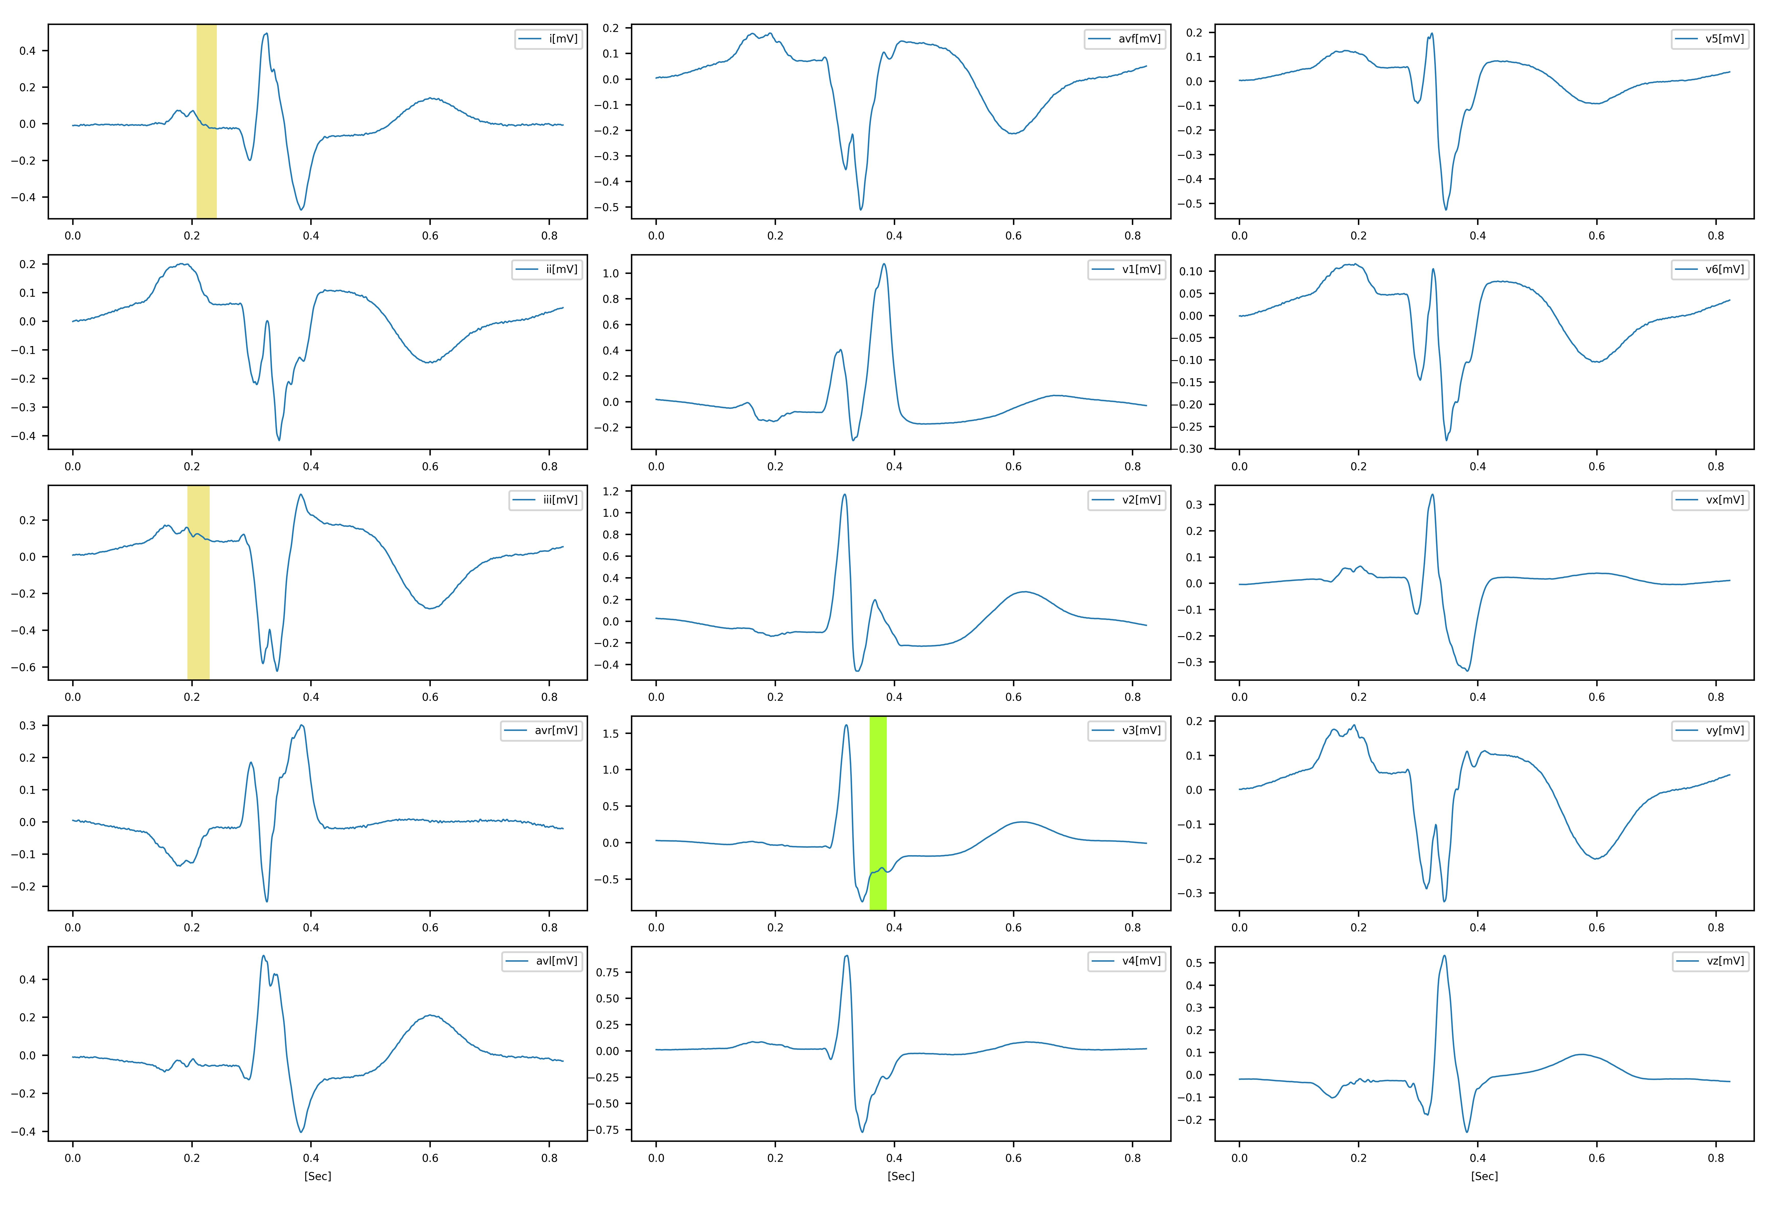

Late potentials Simson features
LAP features{"rms_20": (2.5320596395641553, False), "p_dur": (147.0, True)}, LVP features{"las_40": (75.0, True), "rms_40": (12.141842213232657, True), "qrs_dur": (161.0, True)},
Metadata
age: 81, sex: female, ECG date: 01/10/1990,
Diagnose:
, Reason for admission: Myocardial infarction, Acute infarction (localization): infero-latera, Former infarction (localization): no, Additional diagnoses: Diabetes mellitus, Smoker: no, Number of coronary vessels involved: 1, Infarction date (acute): 29-Sep-90, Previous infarction (1) date: n/a, Previous infarction (2) date: n/a,
Hemodynamics:
, Catheterization date: 16-Oct-90, Ventriculography: Akinesia inferior wall, Chest X-ray: Heart size upper limit of norm, Peripheral blood Pressure (syst/diast): 140/80 mmHg, Pulmonary artery pressure (at rest) (syst/diast): n/a, Pulmonary artery pressure (at rest) (mean): n/a, Pulmonary capillary wedge pressure (at rest): n/a, Cardiac output (at rest): n/a, Cardiac index (at rest): n/a, Stroke volume index (at rest): n/a, Pulmonary artery pressure (laod) (syst/diast): n/a, Pulmonary artery pressure (laod) (mean): n/a, Pulmonary capillary wedge pressure (load): n/a, Cardiac output (load): n/a, Cardiac index (load): n/a, Stroke volume index (load): n/a, Aorta (at rest) (syst/diast): 160/64 cmH2O, Aorta (at rest) mean: 106 cmH2O, Left ventricular enddiastolic pressure: 11 cmH2O, Left coronary artery stenoses (RIVA): RIVA 70% proximal to ramus diagonalis_2, Left coronary artery stenoses (RCX): No stenoses, Right coronary artery stenoses (RCA): No stenoses, Echocardiography: n/a,
Therapy:
, Infarction date: 29-Sep-90, Admission date: 29-Sep-90, Medication pre admission: Isosorbit-Dinitrate Digoxin Glibenclamide, Start lysis therapy (hh.mm): 1945, Lytic agent: Gamma-TPA, Dosage (lytic agent): 30 mg, Additional medication: Heparin Isosorbit-Mononitrate ASA Diazepam, In hospital medication: ASA Isosorbit-Mononitrate Ca-antagonist Amiloride+Chlorothiazide Glibenclamide Insulin, Medication after discharge: ASA Isosorbit-Mononitrate Amiloride+Chlorothiazide Glibenclamide,

No_Late_Potentials

