

(Aﬃliated to University of Madras)

Chrompet, Chennai-44

DEPARTMENT OF COMPUTER SCIENCE

RELATIONAL DATABASE MANAGEMENT SYSTEM

NAME

:

CLASS

:

REG NO

:

TAGORE COLLEGE OF ARTS AND SCIENCE



(Affiliated to the University of Madras)

Chrompet, Chennai – 600 044

DEPARTMENT OF COMPUTER SCIENCE
Certified to be the Bonafide Record of Practical work done by Mr. /Miss.
…………………………. Reg. No…………………………. of Third Year B.Sc., in
the Department of Computer Science, Shift-II, Tagore College of Arts & Science,
Chrompet, Chennai – 600 044 during the year 2025-2026
STAFF IN-CHARGE
HEAD OF THE DEPARTMENT
Submitted for B.Sc., Degree Practical Examination held on …………………
at the Department of Computer Science, Shift-II, Tagore College of Arts and
Science, Chrompet, Chennai –44.
Examiners
Date :
1.
2.

TAGORE COLLEGE OF ARTS AND SCIENCE

S.
Page
DATE
Sign
EXERCISE
No
No
1.
DDL COMMENTS WITH CONSTRAINTS
2.
DML COMMENTS WITH CONSTRAINTS
3.
QUERIES, SUBQUERIES & AGGREGATE FUNCTION
4.
PL/SQL – EXECUTION HANDLING
5.
PL/SQL – CURSOR
6.
PL/SQL – TRIGGER
7.
PL/SQL – PACKAGES
8.
LIBRARY MANAGEMENT SYSTEM
9.
STUDENT MARKSHEET PROCESSIG
10.
PAYROLL PROCESSING

INDEX

1) DDL COMMENTS WITH CONSTRAINTS

DDL commands:
✴ CREATE
✴ ALTER
✴ DROP
✴ RENAME
✴ TRUNCATE

Queries:

CREATE TABLE
Q1 → create table student(stid number, stname varchar(20), score integer);
Q2 → desc student;
Q3 → create table stu(sid number primary key, sname varchar(20) not null, email
varchar(30) unique, age decimal(10,2) check (age>=18));
Q4 → desc stu;

ALTER TABLE
Q5 → alter table student drop column score;
Q6 → alter table student add gender varchar(5);
Q7 → alter table stu modify age number;

RENAME TABLE
Q8 → rename student to stu10;

Q9 → desc stu10;
Q10 → alter table stu rename column email to emailid;
Q11 → desc stu;

TRUNCATE AND DROP
Q12 → truncate table stu;
Q13 → drop table stu;
Q14 → desc stu;

Prima

Le

Co

ngt

Null

ry

Defa

Scal

mm

Data

Colu

Prec

ult

Table

able

ent

Key

e

ision

h

Type

mn
Numbe
STUDE
-
-
-
-
-
STID
-
NT
r
STNA
Varcha
-
20
-
-
-
-
r2
ME
SCOR
Numbe
-
-
0
-
-
-
r
E
O/P →
O/P → Table created.
O/P →

Preci

Sc

Defa

Com

Null

Len

Data

Ta

Colu

Primar

gth

ment

ult

ble

able

y Key

mn

ale

sion

Type
ST
Numbe
-
SID
-
-
-
1
-
-
r
U
SNA
Varchar
-
-
-
-
-
20
-
2
ME
EMA
Varchar
-
-
-
-
30
-
2
IL
Numbe
-
-
-
2
10
-
AGE
r

ALTER TABLE
O/P →

OUTPUT:

CREATE TABLE
O/P → Table created.

Com

Data

Colu

Null

Primar

Def

Sc

Len

Preci

Table

ale

ment

ault

able

sion

gth

Type

y Key

mn
STUD
Numbe
-
-
-
-
-
STID
-
r
ENT
STN
Varcha
-
-
-
-
-
20
AME
r2
O/P → Table altered.
O/P → Table altered.

Data

Colu

Len

Preci

Sc

Null

Defa

Ta

Com

Primar

ble

ult

gth

ment

mn

ale

Type

sion

able

y Key
ST
Numbe
-
-
-
SID
-
-
-
1
r
U
Varchar
SNA
-
-
-
-
-
20
-
2
ME
EMA
Varchar
-
-
-
-
30
-
2
IL
Numbe
-
-
-
-
-
AGE
-
r

RENAME TABLE
O/P → Statement processed.
O/P →

Len

Defa

Sca

Nulla

Data

Colum

Tabl

Comm

Primary

Precis

le

ion

gth

ble

ent

Type

n

e

Key

ult
STU
Numbe
-
STID
-
-
-
-
-
r
10
STNA
Varcha
-
-
20
-
-
-
ME
r2

GEND
Varcha
-
5
-
-
-
-
ER
r2
O/P →

Defa

Sca

Comm

Primary

Nulla

Leng

Tab

Data

Colum

Precis

ble

th

ent

ult

le

n

le

ion

Type

Key
ST
Numbe
1
-
-
-
-
SID
-
-
r
U
SNAM
Varchar
-
-
-
-
-
20
-
2
E
EMAI
Varchar
-
-
-
-
30
-
2
LID
Numbe
-
AGE
-
-
-
-
-
r

TRUNCATE AND DROP
O/P → Table truncated.
O/P → Table dropped.
O/P → Object to be described could not be found.

2) DML COMMENTS WITH CONSTRAINTS

DML commands:
✴ INSERT
✴ UPDATE
✴ DELETE
✴ SELECT

Queries:

INSERT QUERY
Q1 → insert into stu10(stid,stname,gender) values (1001,'aaa','f');
Q2 → insert into stu10(stid,stname,gender) values (1002,'bbb','f');
Q3 → insert into stu10(stid,stname,gender) values (1003,'cccc','f');
Q4 → insert into stu10(stid,stname,gender) values (1004,'ddd','m');
Q5 → insert into stu10(stid,stname,gender) values (1005,'EEE','M');

SELECT QUERY
Q6 → select * from stu10;
Q7 → select stname from stu10;
Q8 → select * from stu10 where gender='f';

UPDATE QUERY
Q9 → update stu10 set stname='anu' where stid=1001;

Q10 → update stu10 set stname='bala', gender='m' where stid=1002;
Q11 → select * from stu10;

DELETE QUERY
Q12 → delete from stu10 where stid=1003;
Q13 → select * from stu10;
Q14 → delete from stu10;
Q15 → select * from stu10;

STID

STNAME

GENDER
f
aaa
1001
1002
bbb
f
1003
cccc
f
m
ddd
1004
1005
EEE
M
O/P →

STNAME
aaa
bbb
cccc
ddd
EEE
O/P →

STID

STNAME

GENDER
1001
aaa
f

OUTPUT:

INSERT QUERY
O/P → 1 row(s) inserted.

SELECT QUERY
O/P →

f
1002
bbb
1003
cccc
f

UPDATE QUERY
O/P → 1 row(s) updated.
O/P → 1 row(s) updated.
O/P →

STNAME

STID

GENDER
1001
anu
f
1002
bala
m
cccc
f
1003
1004
m
ddd
1005
EEE
M

DELETE QUERY
O/P → 1 row(s) deleted.
O/P →

GENDER

STID

STNAME
1001
anu
f
1002
bala
m
1004
ddd
m

1005
EEE
M
O/P → 4 row(s) deleted.
O/P → no data found

3) QUERIES, SUBQUERIES AND AGGREGATE FUNCTION

Queries:

BASIC QUERY
Q1 → create table empl(eid number primary key, ename varchar(20), deptid number,
deptname varchar(20),salary number);
Q2 → insert into empl(eid,ename,deptid,deptname,salary) values
(1201,'Arun',104,'CS',50000);
Q3 → insert into empl(eid,ename,deptid,deptname,salary) values
(1202,'Bala',104,'CS',60000);
Q4 →insert into empl(eid,ename,deptid,deptname,salary) values
(1203,'Chandru',105,'COMMERCE',40000);
Q5 →insert into empl(eid,ename,deptid,deptname,salary) values
(1204,'Dilip',104,'CS',45000);
Q6 →insert into empl(eid,ename,deptid,deptname,salary) values
(1205,'Dhanu',106,'TAMIL',30000);
Q7 →insert into empl(eid,ename,deptid,deptname,salary) values
(1206,'Guru',106,'TAMIL',58000);
Q8 →insert into empl(eid,ename,deptid,deptname,salary) values
(1207,'Hari',105,'COMMERCE',38000);

SELECT QUERY
Q9 → select * from empl;
Q10 → select eid,ename,salary from empl;
Q11 → select * from empl where salary>=50000;

AGGREGATE FUNCTION
Q12 → select COUNT(*) as totalemp from empl;
Q13 → select SUM(salary) as totalsal from empl;
Q14 → select AVG(salary) as totalsal from empl;
Q15 →select MAX(salary) as maxsalary from empl;
Q16 →select MIN(salary) as minsalary from empl;
Q17 →select eid,salary from empl order by salary desc;
Q18 →select deptid, sum(salary)as sal from empl group by deptid;

SUBQUERIES
Q19 → select * from empl where salary > (select avg(salary) from empl);
Q20 →create table dept(deptid number,deptname varchar(20));
Q21 →insert into dept(deptid,deptname) values (104,'CS');

Q22 →insert into dept(deptid,deptname) values (105,'COMMERCE');
Q23 →insert into dept(deptid,deptname) values (106,'TAMIL');
Q24 →insert into dept(deptid,deptname) values (107,'ENGLISH');
Q25 →select * from dept;
--- List department wise employee count:
Q26 →select d.deptname, e.empcount from dept d JOIN (select deptid, count(*) as empcount
from empl group by deptid) e on d.deptid = e.deptid;

JOIN QUERIES
Q27 →select e.eid, e.ename, e.salary, d.deptid, d.deptname from empl e join dept d on
e.deptid = d.deptid;
Q28 → select e.eid, e.ename, e.salary, d.deptid, d.deptname from empl e LEFT JOIN dept d
on e.deptid = d.deptid;
Q29 → select e.eid, e.ename, e.salary, d.deptid, d.deptname from empl e RIGHT JOIN dept d
on e.deptid = d.deptid;
Q30 → select e.eid, e.ename, e.salary, d.deptid, d.deptname from empl e CROSS JOIN dept
d;

EID

ENAME

DEPTID

DEPTNAME

SALARY
CS
104
50000
Arun
1201
CS
104
60000
Bala
1202
1203
40000
COMMERCE
105
Chandru
Dilip
45000
CS
1204
104
106
1205
Dhanu
TAMIL
30000
TAMIL
106
1206
58000
Guru
105
38000
1207
Hari
COMMERCE
O/P →

SALARY

ENAME

EID
Arun
1201
50000
60000
1202
Bala
Chandru
1203
40000
45000
Dilip
1204
30000
1205
Dhanu
1206
Guru
58000
1207
Hari
38000

OUTPUT:

BASIC QUERY
O/P → Table created.

SELECT QUERY
O/P →

EID

SALARY

DEPTNAME

DEPTID

ENAME
104
50000
Arun
1201
CS
104
1202
Bala
CS
60000
1206
Guru
TAMIL
106
58000

AGGREGATE FUNCTION
O/P →

TOTALEMP
7
O/P →

TOTALSAL
321000
O/P →

TOTALSAL
45857.1428571428571428571428571428571429
O/P →

MAXSALARY
60000
O/P →

EID

SALARY
1202
60000
1206
58000
1201
50000
1204
45000
1203
40000
1207
38000
1205
30000
O/P →

DEPTID

SAL
104
155000
105
78000
106
88000

SUBQUERIES
O/P →

EID

ENAME

DEPTID

DEPTNAME

SALARY
O/P →

MINSALARY
30000
O/P →

Arun
1201
104
CS
50000
1202
Bala
104
CS
60000
1206
Guru
106
TAMIL
58000
O/P →

DEPTID

DEPTNAME
104
CS
105
COMMERCE
106
TAMIL
107
ENGLISH
O/P →

DEPTNAME

EMPCOUNT
COMMERCE
2
CS
3
TAMIL
2

JOIN QUERIES
O/P →

DEPTNAME

DEPTID

SALARY

EID

ENAME
104
CS
Arun
1201
50000
1202
Bala
60000
104
CS
1203
Chandru
40000
105
COMMERCE

Dilip
1204
45000
104
CS
1205
Dhanu
30000
106
TAMIL
Guru
1206
58000
106
TAMIL
Hari
COMMERCE
105
38000
1207
O/P →

DEPTID

DEPTNAME

SALARY

ENAME

EID
104
1204
45000
Dilip
CS
Bala
60000
104
CS
1202
Arun
1201
50000
CS
104
1207
COMMERCE
105
38000
Hari
Chandru
1203
40000
COMMERCE
105
Guru
1206
58000
106
TAMIL
1205
Dhanu
30000
106
TAMIL
O/P →

DEPTNAME

ENAME

EID

SALARY

DEPTID
CS
1201
Arun
50000
104
Bala
104
1202
CS
60000
105
1203
Chandru
40000
COMMERCE
Dilip
45000
104
CS
1204
1205
TAMIL
106
30000
Dhanu
58000
106
TAMIL
Guru
1206

COMMERCE
1207
Hari
38000
105
-
-
-
107
ENGLISH
O/P →

DEPTNAME

DEPTID

SALARY

EID

ENAME
CS
1201
Arun
104
50000
Bala
CS
1202
60000
104
1203
CS
Chandru
40000
104
1204
Dilip
104
CS
45000
1205
CS
Dhanu
30000
104
1206
CS
Guru
58000
104
1207
Hari
38000
104
CS
1201
COMMERCE
105
50000
Arun
COMMERCE
1202
60000
105
Bala
1203
Chandru
40000
105
COMMERCE

4) PL/SQL – EXCEPTION HANDLING

Queries:

Predefined Exceptions
Q1 →
DECLARE
num1 NUMBER := 10;
num2 NUMBER := 0;
result NUMBER;
BEGIN
result := num1 / num2;
DBMS_OUTPUT.PUT_LINE('Result: ' || result);
EXCEPTION
WHEN ZERO_DIVIDE THEN
DBMS_OUTPUT.PUT_LINE('Cannot divide by zero.');
END;

User-Defined Exceptions
Q2 →
DECLARE
insufficient_balance EXCEPTION;
balance NUMBER := 500;
BEGIN
IF balance < 1000 THEN
RAISE insufficient_balance;
END IF;
EXCEPTION
WHEN insufficient_balance THEN

DBMS_OUTPUT.PUT_LINE('Balance is too low.');
END;

Named System Exceptions
Q3 →
DECLARE
ename emp.name%TYPE;
BEGIN
SELECT name into ename
FROM emp
WHERE eid = 1001; -- assuming invalid ID
DBMS_OUTPUT.PUT_LINE('Employee Name: ' || ename);
EXCEPTION
WHEN NO_DATA_FOUND THEN
DBMS_OUTPUT.PUT_LINE('No employee found with that ID.');
END;

Unhandled (OTHERS) Exception
Q4 →
BEGIN
EXECUTE IMMEDIATE 'DROP TABLE nonexistent_table';
EXCEPTION
WHEN OTHERS THEN
DBMS_OUTPUT.PUT_LINE('Some unexpected error occurred: ' || SQLERRM);
END;

OUTPUT:

Predefined Exceptions
O/P →
Cannot divide by zero.

User-Defined Exceptions
O/P →
Balance is too low.

Named System Exceptions
O/P →
No employee found with that ID.

Unhandled (OTHERS) Exception
O/P →
Some unexpected error occurred: ORA-00942: table or view does not exist

5) PL/SQL – CURSOR

Queries:
Q1 → select * from emp;

Implicit Cursor
Q2 →
BEGIN
UPDATE emp SET salary = salary + 1000 WHERE eid = 103;
IF SQL%ROWCOUNT = 1 THEN
DBMS_OUTPUT.PUT_LINE('1 row updated successfully.');
END IF;
END;
Q3 → select * from emp;

Explicit Cursor
Q4 →
DECLARE
CURSOR emp_cursor IS SELECT eid, name FROM emp;
v_id emp.eid%TYPE;
v_name emp.name%TYPE;
BEGIN
OPEN emp_cursor;
LOOP
FETCH emp_cursor INTO v_id, v_name;
EXIT WHEN emp_cursor%NOTFOUND;
DBMS_OUTPUT.PUT_LINE('ID: ' || v_id || ', Name: ' || v_name);

END LOOP;
CLOSE emp_cursor;
END;

Cursor FOR Loop
Q5 →
BEGIN
FOR emp_rec IN (SELECT eid, name FROM emp) LOOP
DBMS_OUTPUT.PUT_LINE('ID: ' || emp_rec.eid || ', Name: ' || emp_rec.name);
END LOOP;
END;

Parameterized Cursor
Q6 →
DECLARE
CURSOR emp_cursor(p_dept_id NUMBER) IS
SELECT eid, name FROM emp WHERE dept_id = p_dept_id;
v_id emp.eid%TYPE;
v_name emp.name%TYPE;
BEGIN
OPEN emp_cursor(123); -- passing department id
LOOP
FETCH emp_cursor INTO v_id, v_name;
EXIT WHEN emp_cursor%NOTFOUND;
DBMS_OUTPUT.PUT_LINE('ID: ' || v_id || ', Name: ' || v_name);
END LOOP;
CLOSE emp_cursor;
END;

DEPT_ID

DOJ

NAME

SALARY

EID
103
123
30000
12-FEB-20
Cholan
104
Hari
22-FEB-24
20000
122
12-FEB-20
101
40000
123
Arun
50000
121
102
Bala
01-DEC-19
Guru
10-JAN-18
105
60000
122
121
46000
01-JUN-20
Mathi
106

Implicit Cursor
O/P →
1 row updated successfully.
1 row(s) updated.
O/P →

SALARY

NAME

EID

DOJ

DEPT_ID
103
12-FEB-20
Cholan
31000
123
22-FEB-24
20000
122
Hari
104
123
101
12-FEB-20
Arun
40000
50000
121
01-DEC-19
Bala
102
60000
105
Guru
122
10-JAN-18
106
Mathi
01-JUN-20
46000
121
OUTPUT:
O/P →

Explicit Cursor
O/P →
ID: 103, Name: Cholan
ID: 104, Name: Hari
ID: 101, Name: Arun
ID: 102, Name: Bala
ID: 105, Name: Guru
ID: 106, Name: Mathi

Cursor FOR Loop
O/P →
ID: 103, Name: Cholan
ID: 104, Name: Hari
ID: 101, Name: Arun
ID: 102, Name: Bala
ID: 105, Name: Guru
ID: 106, Name: Mathi

Parameterized Cursor
O/P →
ID: 103, Name: Cholan
ID: 101, Name: Arun

6) PL/SQL – TRIGGER

PL/SQL Queries:
Q1 → CREATE TABLE students (roll_no NUMBER PRIMARY KEY,
name VARCHAR2(50), marks NUMBER);

BEFORE INSERT TRIGGER
Q2 →
CREATE OR REPLACE TRIGGER trg_before_insert_students
BEFORE INSERT ON students
FOR EACH ROW
BEGIN
-- If marks not given, set to 0
IF :NEW.marks IS NULL THEN
:NEW.marks := 0;
END IF;
END;

AFTER INSERT TRIGGER
Q3 →
CREATE OR REPLACE TRIGGER trg_after_insert_students
AFTER INSERT ON students
BEGIN
DBMS_OUTPUT.PUT_LINE('A new student was added!');
END;
Q4 → INSERT INTO students (roll_no, name) VALUES (1, 'John');
Q5 → select * from students;

Q10 →
DELETE FROM students WHERE roll_no = 1;

BEFORE UPDATE TRIGGER
Q6 →
CREATE OR REPLACE TRIGGER trg_before_update_students
BEFORE UPDATE ON students
FOR EACH ROW
BEGIN
-- Prevent marks from being more than 100
IF :NEW.marks > 100 THEN
:NEW.marks := 100;
END IF;
END;
Q7 → UPDATE students SET marks = 120 WHERE roll_no = 1;
Q8 → select * from students;

AFTER DELETE TRIGGER
Q9 →
CREATE OR REPLACE TRIGGER trg_after_delete_students
AFTER DELETE ON students
BEGIN
DBMS_OUTPUT.PUT_LINE('A student record was deleted!');
END;

ROLL_NO

NAME

MARKS
1
John
0

BEFORE UPDATE TRIGGER
O/P →
Trigger created.
O/P →
1 row(s) updated.

OUTPUT:
O/P →
Table Created.

BEFORE INSERT TRIGGER
O/P →
Trigger created.

AFTER INSERT TRIGGER
O/P →
Trigger created.
O/P →
A new student was added!
1 row(s) inserted.
O/P →

ROLL_NO

NAME MARKS
1
John
100
AFTER DELETE TRIGGER
O/P → Trigger created.
O/P → A student record was deleted!
1 row(s) deleted.
O/P →

7) PL/SQL – PACKAGES
.

PL/SQL Queries:

Package Specification
Q1 →
CREATE OR REPLACE PACKAGE math_pkg AS
FUNCTION square_num(p_num NUMBER) RETURN NUMBER;
END math_pkg;

Package Body
Q2 →
CREATE OR REPLACE PACKAGE BODY math_pkg AS
FUNCTION square_num(p_num NUMBER) RETURN NUMBER IS
BEGIN
RETURN p_num * p_num;
END;
END math_pkg;

Test the Package
Q3 →
BEGIN
DBMS_OUTPUT.PUT_LINE('Square of 5: ' || math_pkg.square_num(5));
END;

Predefined Package
Q4 →
BEGIN
-- Random number between 1 and 50
DBMS_OUTPUT.PUT_LINE

('Random Number: ' || ROUND(DBMS_RANDOM.VALUE(1, 50)));
-- Random uppercase string of length 8
DBMS_OUTPUT.PUT_LINE('Random String: ' || DBMS_RANDOM.STRING('U', 8));
END;

OUTPUT:

Package Specification
O/P →
Package created.

Package Body
O/P →
Package Body created.

Test the Package
O/P →
Square of 5: 25

Predefined Package
O/P →
Random Number: 34
Random String: ZOWXBLHK

8) LIBRARY MANAGEMENT SYSTEM

Coding:

FORM1

Private Sub addcmd_Click()
form2.Show

End Sub

Private Sub issuecmd_Click()
form3.Show

End Sub

Private Sub membercmd_Click()
Form5.Show

End Sub

Private Sub reportcmd_Click()
DataReport1.Show

End Sub

Private Sub returncmd_Click()
form4.Show

End Sub

FORM 2
Dim cn As New ADODB.Connection
Dim rs As New ADODB.Recordset

Private Sub addcmd_Click()
rs.AddNew

rs.Fields(0).Value = Text1.Text
rs.Fields(1).Value = Text2.Text
rs.Fields(2).Value = Text3.Text
rs.Fields(3).Value = Text4.Text
rs.Update
MsgBox "Succssfully Inserted"
Text1.Text = ""
Text2.Text = ""
Text3.Text = ""
Text4.Text = ""

End Sub

Private Sub closecmd_Click()
form1.Show

End Sub

Private Sub Form_Load()
cn.Open "Provider=Microsoft.Jet.OLEDB.4.0;Data Source=E:\lib.mdb;Persist Security
Info=False"
rs.Open "select * from book", cn, adOpenKeyset, adLockOptimistic

End Sub

FORM 3
Dim cn As New ADODB.Connection
Dim rs As New ADODB.Recordset

Private Sub Command2_Click()
form1.Show

End Sub

Private Sub Form_Load()

cn.Open "Provider=Microsoft.Jet.OLEDB.4.0;Data Source=E:\lib.mdb;Persist Security
Info=False"
rs.Open "select * from book", cn, adOpenKeyset, adLockOptimistic
Text1.Enabled = False
Text2.Enabled = False

End Sub

Private Sub issuecmd_Click()
Dim bid As String
Dim sql, sql1 As String
Set rs = New ADODB.Recordset
bid = InputBox("Enter the Book ID :")
sql = "SELECT * FROM book WHERE bookid = " & bid
rs.Open sql, cn, adOpenForwardOnly, adLockReadOnly
If rs.EOF Then
MsgBox "No record found with ID: "
rs.Close
Exit Sub
End If
Text1.Text = rs.Fields(0).Value
Text2.Text = rs.Fields(1).Value
sql1 = "update book set quan= quan-1 where bookid= " & bid
cn.Execute sql1
MsgBox "Book Issued"
End Sub

FORM 4
Dim cn As New ADODB.Connection
Dim rs As New ADODB.Recordset

Private Sub Command2_Click()
form1.Show

End Sub

Private Sub Form_Load()
cn.Open "Provider=Microsoft.Jet.OLEDB.4.0;Data Source=E:\lib.mdb;Persist Security
Info=False"
rs.Open "select * from book", cn, adOpenKeyset, adLockOptimistic
Text1.Enabled = False
Text2.Enabled = False

End Sub

Private Sub retcmd_Click()
Dim bid As String
Dim sql, sql1 As String
Set rs = New ADODB.Recordset
bid = InputBox("Enter the Book ID to return book :")
sql = "SELECT * FROM book WHERE bookid = " & bid
rs.Open sql, cn, adOpenForwardOnly, adLockReadOnly
If rs.EOF Then
MsgBox "No record found with ID: "
rs.Close
Exit Sub
End If
Text1.Text = rs.Fields(0).Value
Text2.Text = rs.Fields(1).Value
sql1 = "update book set quan= quan+1 where bookid= " & bid
cn.Execute sql
MsgBox "Book Returned"

End Sub

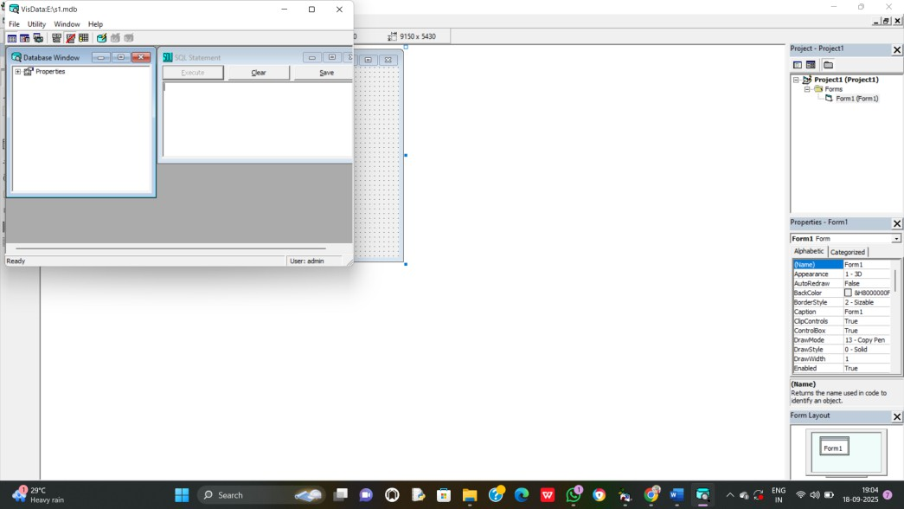
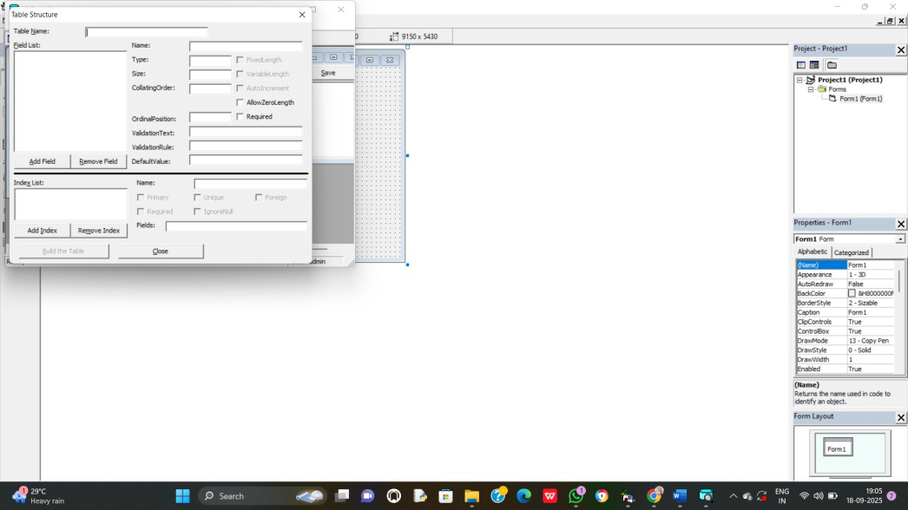

Data Report
✓ In property window of data report1, Set the following
➢ DataSourse as “Data Environment1”
➢ DataMember as “Command1”

How to Connect Visual Basic with Access database?
1) Design the application with desired control in VB 6.0
2) Goto Add-Ins in menu bar → select Visual Data Manager
3) Small VisData Window will appear
4) In that select File → New → Microsoft Access → Version 7.0 MDB
5) Choose the path and Type your database name like library.mdb and click “Save”
6) Right click on Properties and select “New Table”

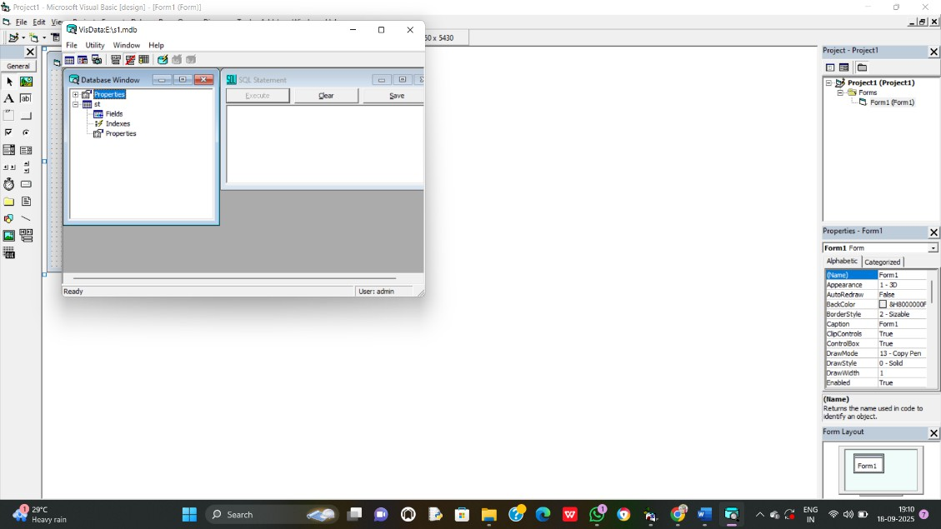
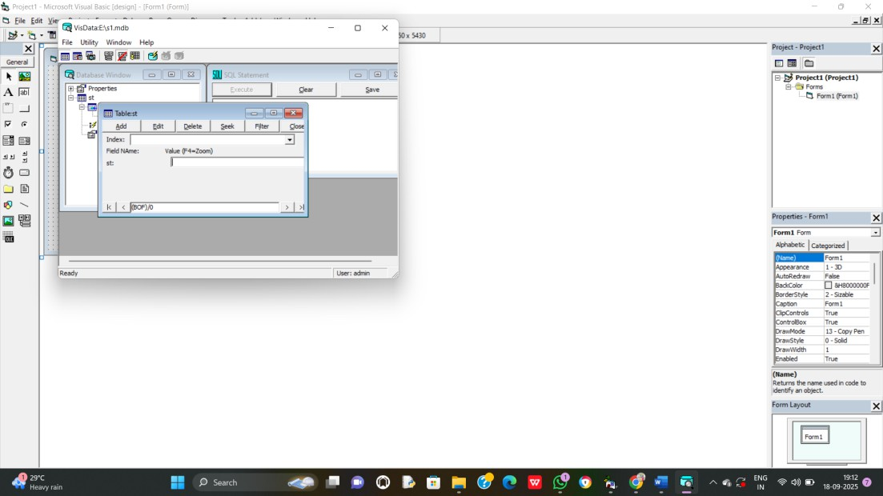
Right click on your table name and click “Open”

11)
12) Click “Add”
13) Type the values for your field and click “Update”
14) That’s all for this close all the small window
7) Type the table name and click “Add Field”
8) Type the field name and select “type” of the field name
9) Once all the fields are added click “Ok” and then “Close”
10) Fields are added in the table and click “Build the Table”

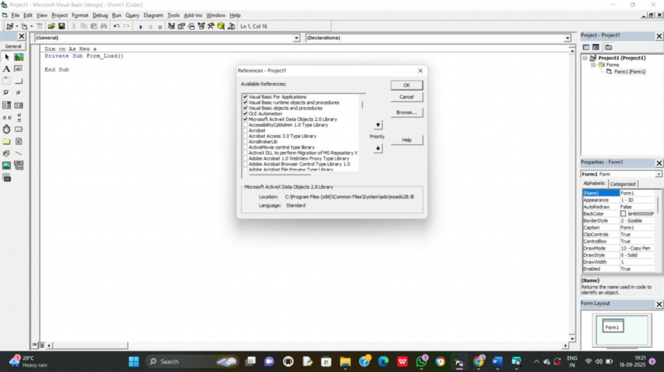
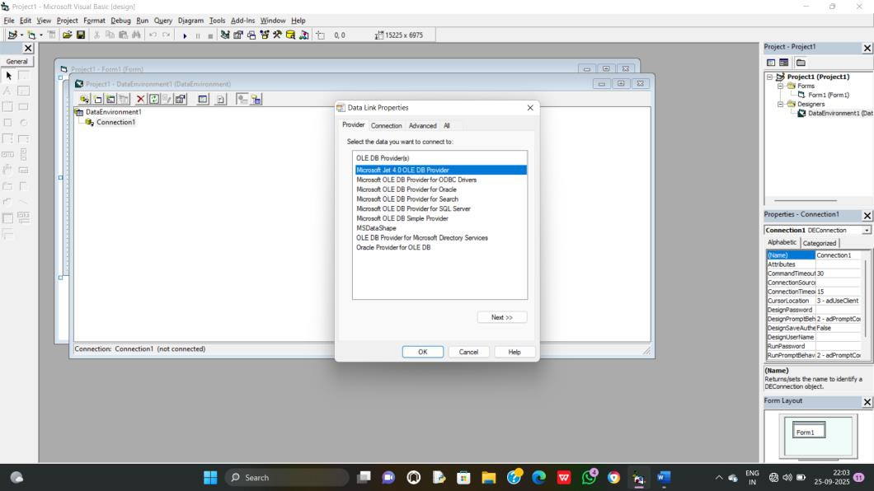

If ADODB is Not added in your Project, proceed the following
1) Click “Project” in Menu bar
2) Select “References”
3) In “Available References”, Tick the Checkbox “Microsoft ActiveX Data Object 2.0
Library”
4) Then Click “Ok”

How to add Data Environment and Data Report?
1. In Project Explorer, Right click on Project1 → Add → Data Environment
2. Data Environment window will occur.
3. Right click on “Connection1” → Click Properties

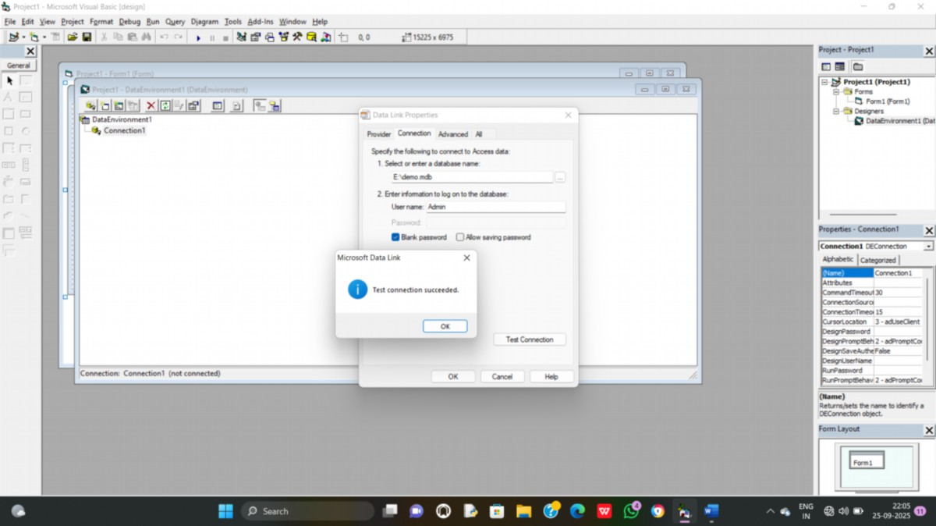
4. Click “Microsoft Jet 4.0 OLE DB Provider” and then click “next”
5. Browse and select “Database Name” that was already created and click “Test
Connection”
6. Click “OK”
7. Again, Right Click on “Connection1” → Add Command1
8. Right Click on “Command1” → Properties

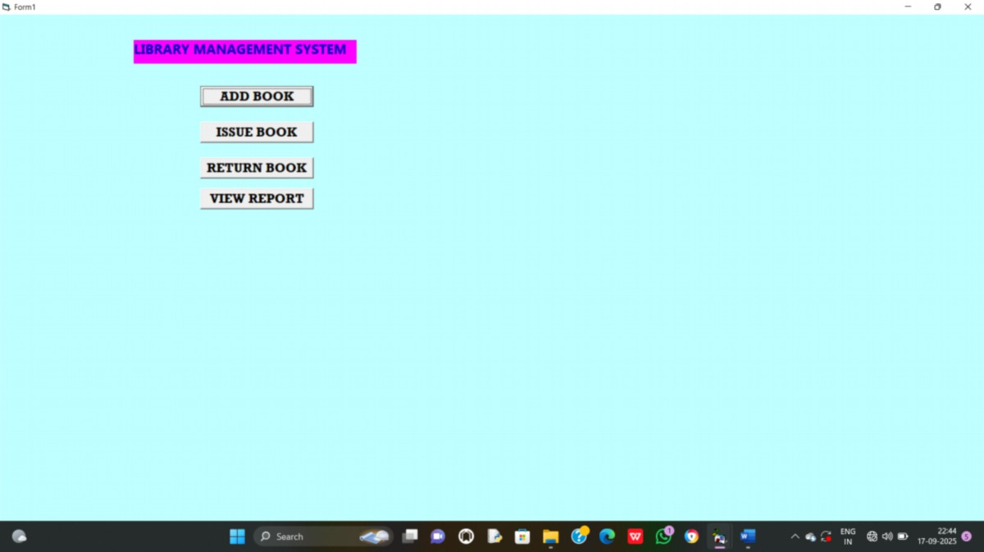
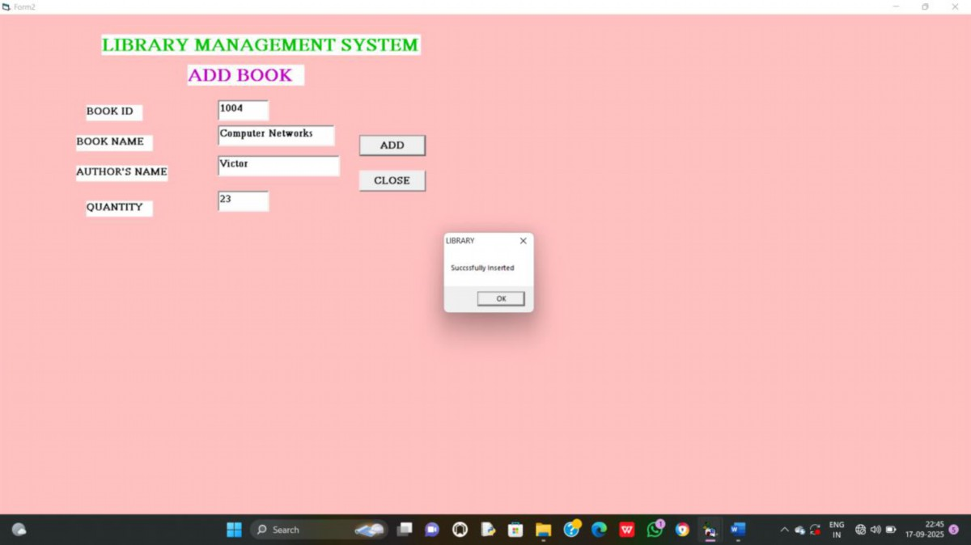

Output:

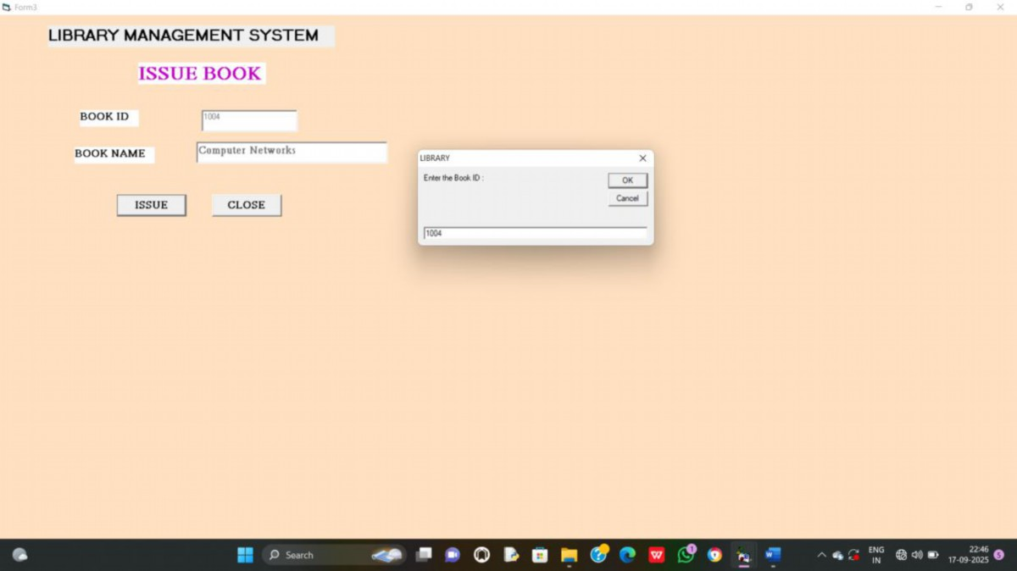
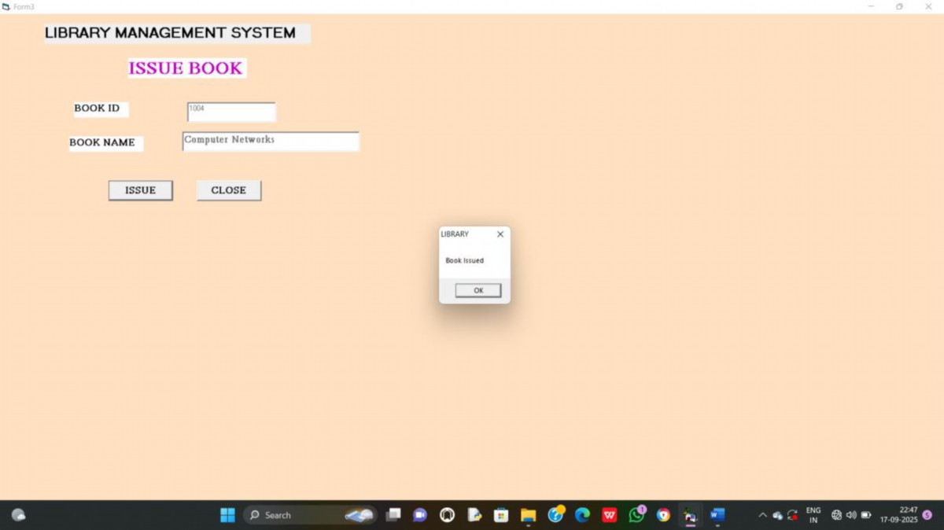

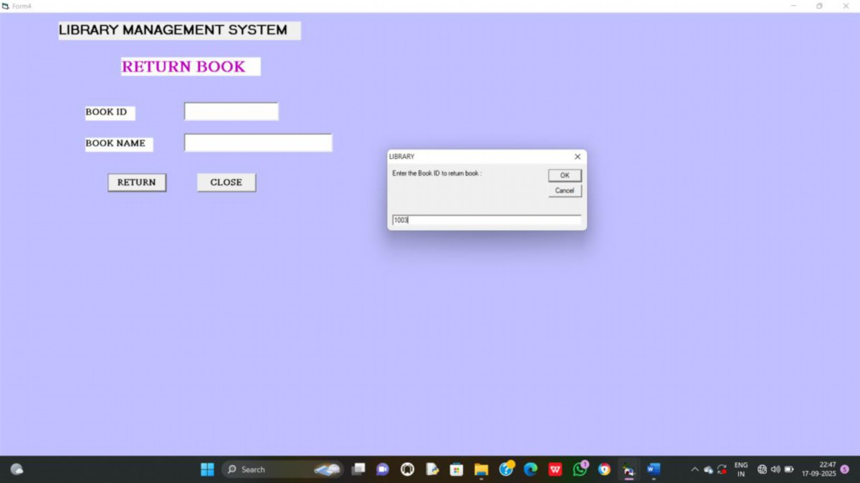
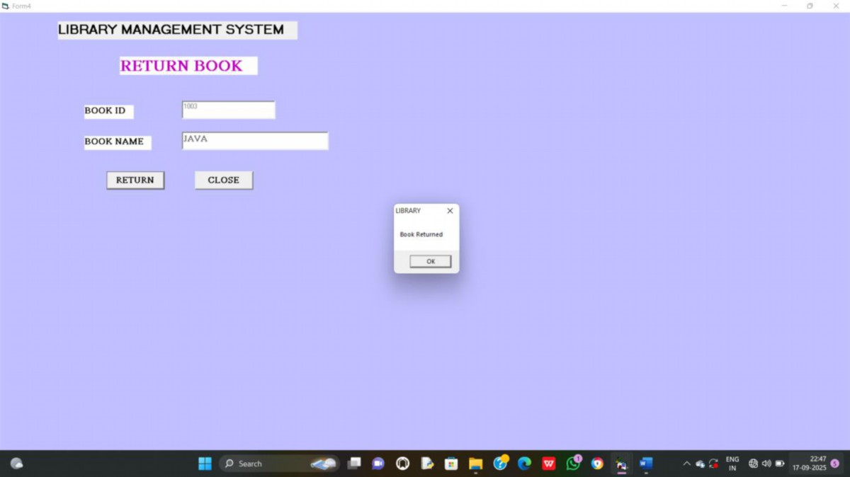

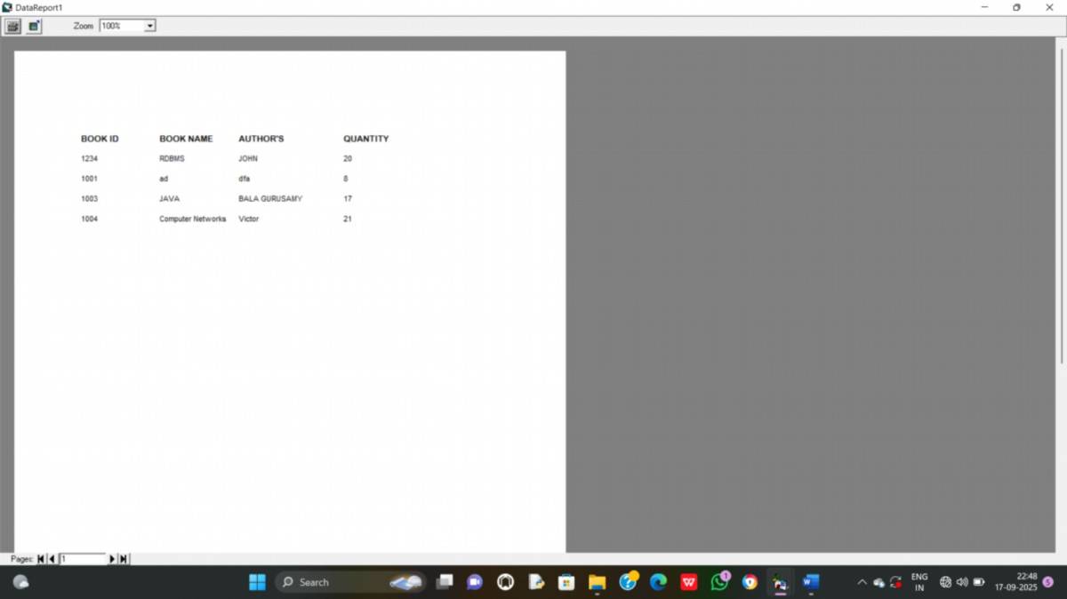
.

9) STUDENT MARKSHEET PROCESSING

Coding:
Dim cn As New ADODB.Connection
Dim rs As New ADODB.Recordset

Private Sub calcmd_Click()
Dim tot As Integer
Text7.Text = Val(Text3.Text) + Val(Text4.Text) + Val(Text5.Text) + Val(Text6.Text)
If (Val(Text3.Text <= 30 And Text4.Text <= 30 And Text5.Text <= 30 And Text6.Text <= 30))
Then
Text8.Text = "FAIL"
Else
Text8.Text = "PASS"
End If
Text9.Text = (Val(Text7.Text) / 4)

End Sub

Private Sub delcmd_Click()
Dim studentID As String
Dim sql As String
studentID = InputBox("Enter the Student ID to delete:")
If Trim(studentID) = "" Then
MsgBox "No ID entered. Operation cancelled."
Exit Sub
End If
Set rs = New ADODB.Recordset
sql = "SELECT * FROM st WHERE stid = " & studentID

rs.Open sql, cn, adOpenForwardOnly, adLockReadOnly
If rs.EOF Then
MsgBox "No record found with ID: "
rs.Close
Exit Sub
End If
sql = "DELETE FROM st WHERE stid = " & studentID
cn.Execute sql
MsgBox "Record with ID " & studentID & " deleted successfully!"
End Sub
Private Sub Form_Load()
cn.Open "Provider=Microsoft.Jet.OLEDB.4.0;Data Source=E:\student.mdb;Persist Security
Info=False"
rs.Open "select * from st", cn, adOpenKeyset, adLockOptimistic

End Sub

Private Sub insertcmd_Click()
rs.AddNew
rs.Fields(0).Value = Text1.Text
rs.Fields(1).Value = Text2.Text
rs.Fields(2).Value = Text3.Text
rs.Fields(3).Value = Text4.Text
rs.Fields(4).Value = Text5.Text
rs.Fields(5).Value = Text6.Text
rs.Fields(6).Value = Text7.Text
rs.Fields(7).Value = Text8.Text
rs.Fields(8).Value = Text9.Text
rs.Update
MsgBox "Succssfully Inserted"

Text1.Text = ""
Text2.Text = ""
Text3.Text = ""
Text4.Text = ""
Text5.Text = ""
Text6.Text = ""
Text7.Text = ""
Text8.Text = ""
Text9.Text = ""

End Sub

Private Sub reportcmd_Click()
DataReport1.Show

End Sub

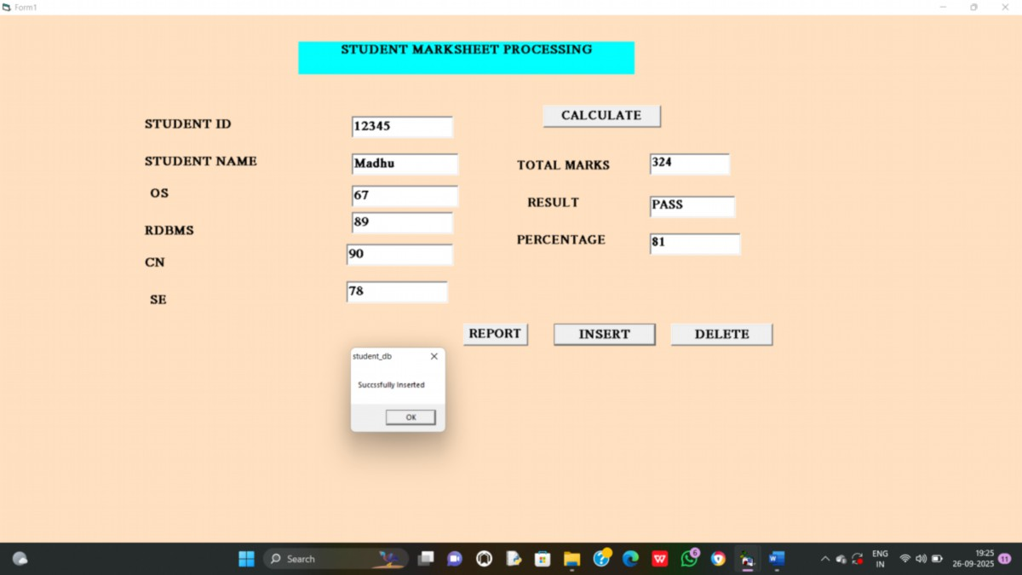
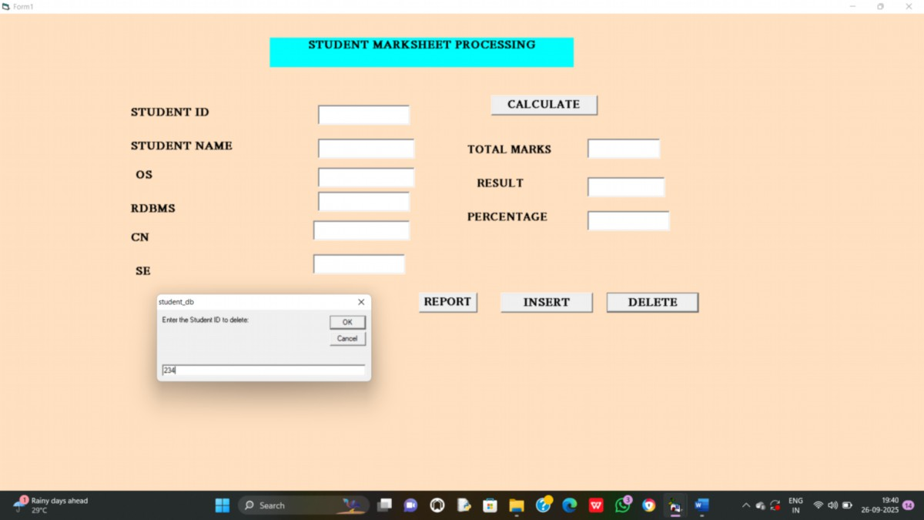

Output:

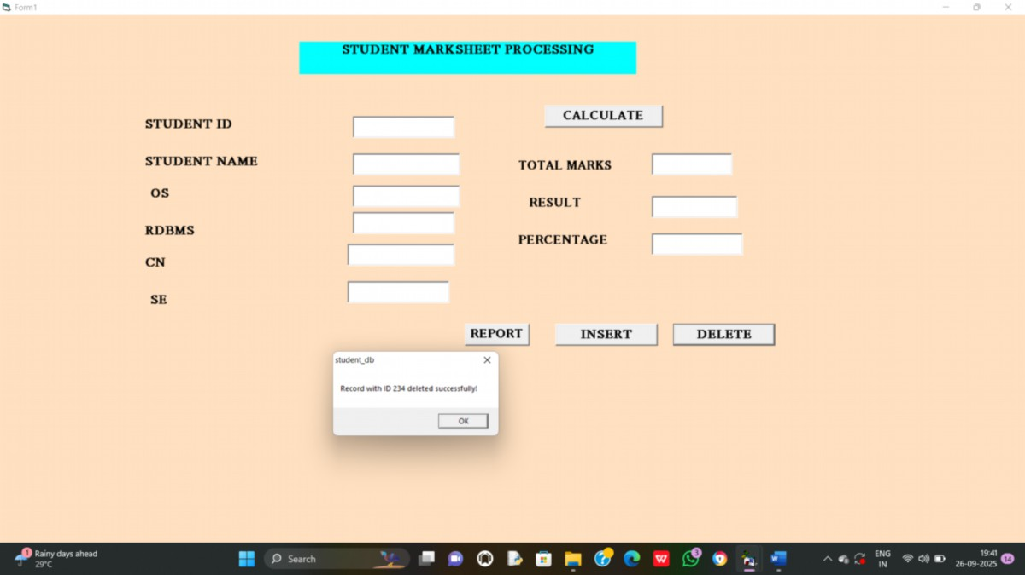
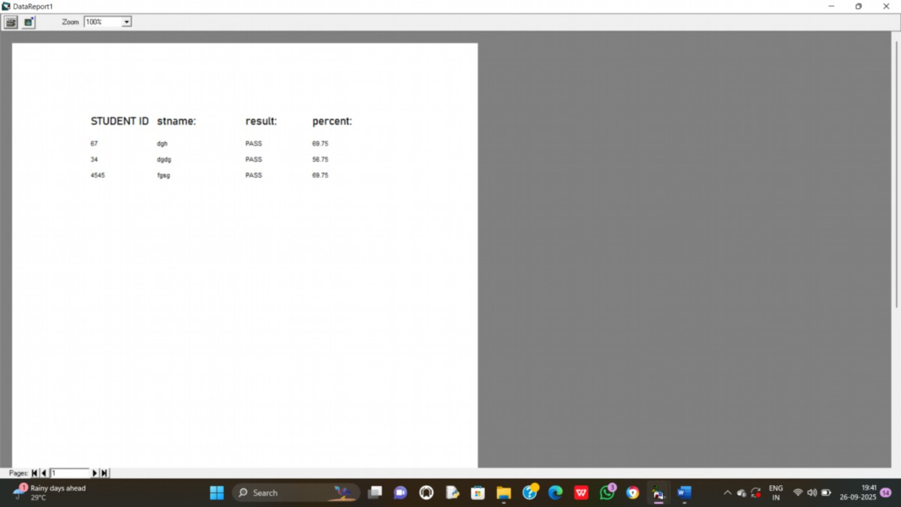

10) PAYROLL PROCESSING

Coding:
Dim cn As New ADODB.Connection
Dim rs As New ADODB.Recordset

Private Sub calcmd_Click()
Text4.Text = Val(Text3.Text) * 0.25
Text5.Text = Val(Text3.Text) * 0.12
Text6.Text = Val(Text3.Text) + Val(Text4.Text)
Text7.Text = Val(Text6.Text) - Val(Text5.Text)

End Sub

Private Sub delcmd_Click()
Dim eid As String
Dim sql As String
eid = InputBox("Enter the EMPLOYE E ID to delete:")
If Trim(eid) = "" Then
MsgBox "No ID entered. Operation cancelled."
Exit Sub
End If
Set rs = New ADODB.Recordset
sql = "SELECT * FROM emp WHERE empid = " & eid
rs.Open sql, cn, adOpenForwardOnly, adLockReadOnly
If rs.EOF Then
MsgBox "No record found with ID: "
rs.Close
Exit Sub

End If
sql = "DELETE FROM emp WHERE empid = " & eid
cn.Execute sql
MsgBox "Record with ID " & eid & " deleted successfully!"

End Sub

Private Sub exitcmd_Click()
End

End Sub

Private Sub Form_Load()
cn.Open "Provider=Microsoft.Jet.OLEDB.4.0;Data Source=E:\payroll.mdb;Persist Security
Info=False"
rs.Open "select * from emp", cn, adOpenKeyset, adLockOptimistic

End Sub

Private Sub insertcmd_Click()
rs.AddNew
rs.Fields(0).Value = Text1.Text
rs.Fields(1).Value = Text2.Text
rs.Fields(2).Value = Text3.Text
rs.Fields(3).Value = Text6.Text
rs.Fields(4).Value = Text7.Text
rs.Update
MsgBox "Succssfully Inserted"
Text1.Text = ""
Text2.Text = ""
Text3.Text = ""
Text4.Text = ""
Text5.Text = ""
Text6.Text = ""
Text7.Text = ""

FIELD NAME

TYPE
empid
Integer
empname
Text
salary
Double
gross
Double
net
Double

End Sub

Private Sub reportcmd_Click()
DataReport1.Show

End Sub

Data Report
✓ In property window of data report1, Set the following
➢ DataSourse as “Data Environment1”
➢ DataMember as “Command1”

Table in MS Access

Database name : payroll

Table name : emp

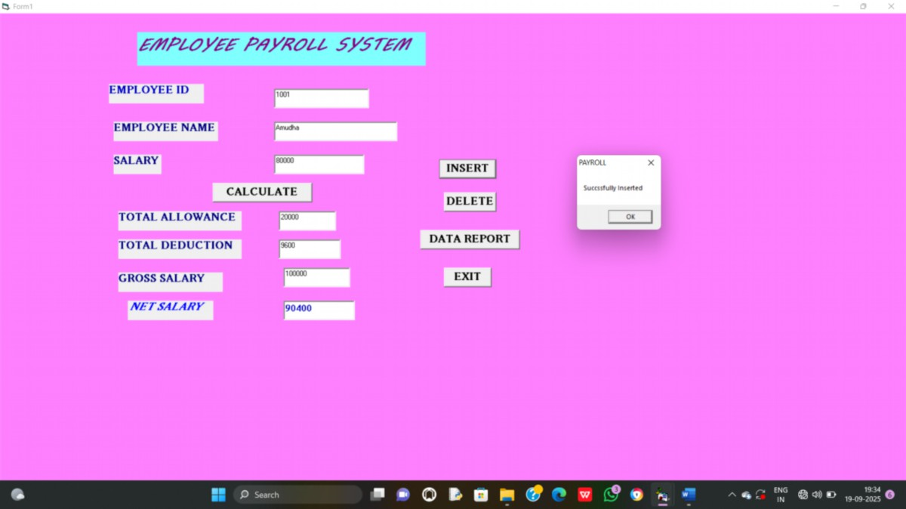
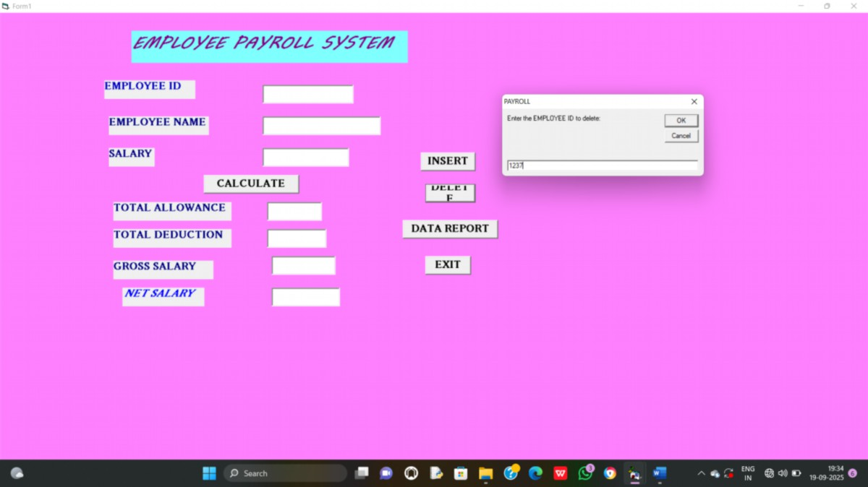

Output:

