
Approved by the Govt. of Tamil Nadu & Affiliated to the University of Madras
Works Road, Chromepet, Chennai – 600 044

DEPARTMENT OF COMPUTER SCIENCE
Certified to be the Bonafide Record of Practical work done by Mr. /Miss.
…………………………. Reg. No………………………….of Third Year B.Sc., in the
Department of Computer Science, Shift – I, Tagore College of Arts & Science, Chromepet,
Chennai – 600 044 during the year 2026-2027.
LECTURER IN – CHARGE
HEAD OF THE DEPARTMENT
Department of Computer Science
Submitted for B.Sc., Degree Practical Examination held on …………………… at the
Department of Computer Science, Shift – I,Tagore College of Arts and Science,
Chromepet, Chennai –44.
Date :
Examiners
1.
2.

TAGORE COLLEGE OF ARTS AND SCIENCE

S.NO

P.NO

SIGN

NAME OF PROGRAM

DATE
1.
BASIC I/O PROGRAMMING
CPU SCHEDULING ALGORITHM :
2.
FIRST COME FIRST SERVED (FCFS)
CPU SCHEDULING ALGORITHM :
3.
SHORTEST JOB FIRST (SJF)
CPU SCHEDULING ALGORITHM :
4.
ROUND ROBIN (RR)
CPU SCHEDULING ALGORITHM :
5.
PRIORITY
READER/WRITER PROBLEM USING
6.
SEMAPHORE
BANKER’S ALGORITHM - DEADLOCK
7.
AVOIDANCE
PAGE REPLACEMENT ALGORITHM
8.
FIRST IN FIRST OUT (FIFO)
PAGE REPLACEMENT ALGORITHM :
9.
LEAST RECENTLY USED (LRU)
MEMORY MANAGEMENT ALGORITHM
10. A
– FIRST FIT
MEMORY MANAGEMENT ALGORITHM
10. B
– BEST FIT
MEMORY MANAGEMENT ALGORITHM
10. C
– WORST FIT
INTER PROCESS COMMUNICATION
11.
(IPC)

INDEX

SOURCE CODE :
#include<stdio.h>
#include<conio.h>
#include<string.h>
void main()
{
int i,len,s=0,w=1,c=0,v=0;
char s1[50],ch;
clrscr();
printf("\n\t\tINPUT:");
printf("\n\t\t------");
printf("\n\t\tEnter the Text: ");
gets(s1);
len=strlen(s1);
for(i=0;i<=len-1;i++)
{
ch=s1[i];
switch(ch)
{
case 'A':
case 'E':
case 'I':
case 'O':
case 'U':
case 'a':
case 'e':
case 'i':

case 'o':
case 'u':
v++;
break;
case ' ':
s++;
break;
default:
c++;
}
if(s1[i]==' ' && s1[i-1]!=' ')
{
w++;
}
}
printf("\n\t\tOUTPUT:");
printf("\n\t\t-------");
printf("\n\t\tThe number of vowels is: %d",v);
printf("\n\t\tThe number of consonats is: %d",c);
printf("\n\t\tThe number of words is: %d",w);
printf("\n\t\tThe number of white spaces is: %d",s);
getch();
}

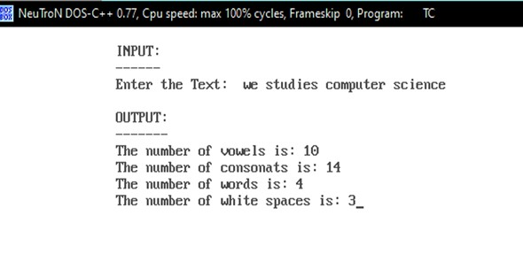

OUTPUT:

SOURCE CODE :
#include<stdio.h>
#include<conio.h>
main()
{
int bt[20],wt[20],tat[20],i,n;
float wtavg, tatavg;
clrscr();
printf("\nEnter the number of processes--");
scanf("%d",&n);
for(i=0;i<n;i++)
{
printf("\nEnter Burst time of Process%d--",i);
scanf("%d",&bt[i]);
}
wt[0]=wtavg=0;
tat[0]=tatavg=bt[0];
for(i=1;i<n;i++)
{
wt[i]=wt[i-1]+bt[i-1];
tat[i]=tat[i-1]+bt[i];
wtavg=wtavg+wt[i];
tatavg=tatavg+tat[i];
}
printf("\tPROCESS\tBURST TIME\tWAITING TIME\t\TURNAROUND TIME\n");
for(i=0;i<n;i++)
printf("\n\tp%d\t\t%d\t\t%d\t\t%d",i,bt[i],wt[i],tat[i]);
printf("\nAverage Waiting Time--%f",wtavg/n);
printf("\nAverage Turnaround Time--%f",tatavg/n);
getch();
}

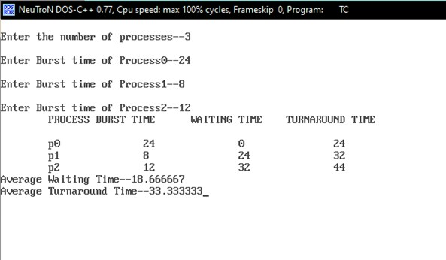

OUTPUT:

SOURCE CODE :
#include<stdio.h>
#include<conio.h>
main()
{
int p[20],bt[20],wt[20],tat[20],i,k,n,temp;
float wtavg,tatavg;
clrscr();
printf("\nEnter the number of processes--");
scanf("%d",&n);
for(i=0;i<n;i++)
{
p[i]=i;
printf("\nEnter Burst time for process%d--",i);
scanf("%d",&bt[i]);
}
for(i=0;i<n;i++)
for(k=i+1;k<n;k++)
if(bt[i]>bt[k])
{
temp=bt[i];
bt[i]=bt[k];
bt[k]=temp;
temp=p[i];
p[i]=p[k];
p[k]=temp;
}
wt[0]=wtavg=0;
tat[0]=tatavg=bt[0];

for(i=1;i<n;i++)
{
wt[i]=wt[i-1]+bt[i-1];
tat[i]=tat[i-1]+bt[i];
wtavg=wtavg+wt[i];
tatavg=tatavg+tat[i];
}
printf("\n\tprocess\tBurst time\tWaiting time\t Turnaround time\n");
for(i=0;i<n;i++)
printf("\n\tp%d\t\t%d\t\t%d\t\t%d",p[i],bt[i],wt[i],tat[i]);
printf("\nAverage Waiting time--%f",wtavg/n);
printf("\nAverage Turnaround time--%f",tatavg/n);
getch();
}

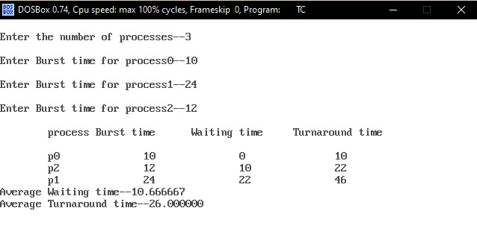

OUTPUT:

SOURCE CODE :
#include<stdio.h>
void main()
{
int i,j,n,bu[10],wa[10],tat[10],t,ct[10],max;
float awt=0,att=0,temp=0;
clrscr();
printf("\nEnter the no of process--");
scanf("%d",&n);
for(i=0;i<n;i++)
{
printf("\nEnter Burst time for process%d--",i+1);
scanf("%d",&bu[i]);
ct[i]=bu[i];
}
printf("\nEnter the size of time slice--");
scanf("%d",&t);
max=bu[0];
for(i=1;i<n;i++)
if(max<bu[i])
max=bu[i];
for(j=0;j<(max/t)+1;j++)
for(i=0;i<n;i++)
if(bu[i]!=0)
if(bu[i]<=t)
{
tat[i]=temp+bu[i];
temp=temp+bu[i];

bu[i]=0;
}
else{
bu[i]=bu[i]-t;
temp=temp+t;
}
for(i=0;i<n;i++)
{
wa[i]=tat[i]-ct[i];
att+=tat[i];
awt+=wa[i];
}
printf("\nThe Average Turaround time is--%f",att/n);
printf("\nThe Average Waiting time is--%f",awt/n);
printf("\n\tPROCESS\tBURST TIME\tWAITING TIME\tTURNAROUND TIME\n");
for(i=0;i<n;i++)
printf("\t%d\t%d\t\t%d\t\t%d\n",i+1,ct[i],wa[i],tat[i]);
getch();
}

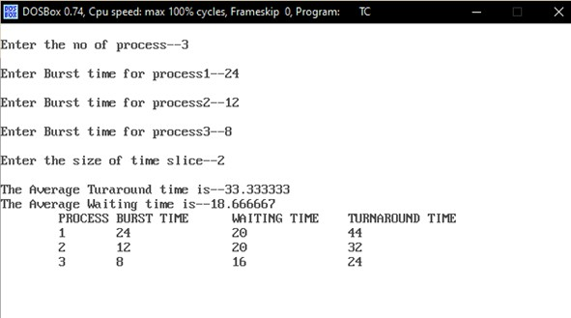

OUTPUT:

SOURCE CODE :
#include<stdio.h>
main()
{
int p[20],bt[20],pri[20],wt[20],tat[20],i,n,k,temp;
float wtavg,tatavg;
clrscr();
printf("/nEnter the number of processes--");
scanf("%d",&n);
for(i=0;i<n;i++)
{
p[i]=i;
printf("\nEnter the Burst Time & Priority of process%d--",i);
scanf("%d%d",&bt[i],&pri[i]);
}
for(i=0;i<n;i++)
for(k=i+1;k<n;k++)
if(pri[i]<pri[k])
{
temp=p[i];
p[i]=p[k];
p[k]=temp;
temp=bt[i];
bt[i]=bt[k];
bt[k]=temp;
temp=pri[i];
pri[i]=pri[k];
pri[k]=temp;

}
wtavg=wt[0]=0;
tatavg=tat[0]=bt[0];
for(i=1;i<n;i++)
{
wt[i]=wt[i-1]+bt[i-1];
tat[i]=tat[i-1]+bt[i];
wtavg=wtavg+wt[i];
tatavg=tatavg+tat[i];
}
printf("\nPROCESS\t\tPRIORITY\tBURST TIME\tWAITING TIME\tTURNROUND TIME");
for(i=0;i<n;i++)
printf("\n%d\t\t%d\t\t%d\t\t%d\t\t%d",p[i],pri[i],bt[i],wt[i],tat[i]);
printf("\nAverage Waiting Time is--%f",wtavg/n);
printf("\nAverage Turnaround Time is--%f",tatavg/n);
getch();
}

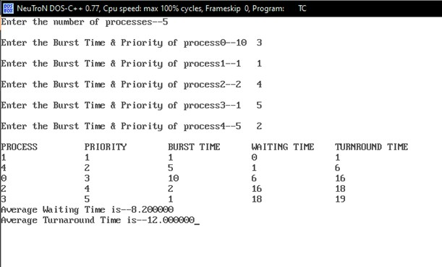

OUTPUT:

SOURCE CODE :
#include<semaphore.h>
#include<stdio.h>
#include<stdlib.h>
sem_t x,y;
pthread_t tid;
pthread_t
writerthreads[100],readerthreads[100];
int readercount;
void * reader (void * param)
{
sem_wait(&w);
readercount++;
if(readercount==1)
sem_wait(&y);
sem_post(&x);
printf("\n%d reader is inside", readercount);
sem_wait(&x);
readercound--;
if(readercount==0)
{
sem_post(&y);
}
sem_post(&x);
printf("\n%d Reader is leaving", readercount+1);
}
void * writer(void * param)

{
printf("\nWriter is trying to enter");
sem_wait(&y);
printf("\nWriter has entered");
sem_post(&y);
printf("\nWriter is leaving");
}
int main()
{
inbt n2,i;
printf("Enter the number of readers:");
scanf("%d",&n2);
int n1[n2];
sem_init(&x,0,1);
sem_init(&y,0,1);
for(i=0;i<n2;i++)
pthread_create(&writerthreads[i],NULL,reader,NULL);
pthread_create(&readerthreads[i],NULL,writer,NULL);
}
for(i=0;i<n2;i++)
{
pthread_join(writerthreads[i],NULL);
pthread_join(readerthreads[i],NULL);
}
}

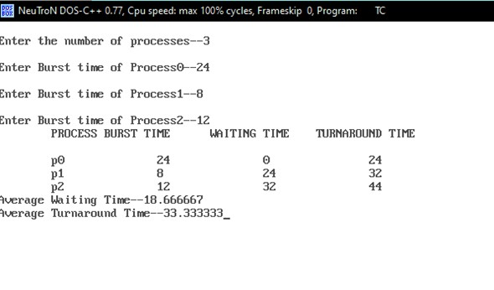

OUTPUT:

The output goes in the form of

reader is inside

reader is leaving

reader is inside

reader is leaving

writer is trying to enter

writer has entered

SOURCE CODE :
#include<stdio.h>
#include<conio.h>
#include<string.h>
void main()
{
int alloc[10] [10],max[10] [10];
int avail[10],work[10],total[10];
int i,j,n,need[10][10];
int m,k;
int count=0,c=0;
char finish[10];
clrscr();
printf("Enter the no. of processes and resources:");
scanf("%d%d",&n,&m);
for(i=0;i<=n;i++)
finish[i]='n';
printf("Enter the claim matrix:\n");
for(i=0;i<n;i++)
for(j=0;j<m;j++)
scanf("%d",&max[i][j]);
printf("Enter the allocation matrix:\n");
for(i=0;i<n;i++)
for(j=0;j<m;j++)
scanf("%d",&alloc[i][j]);
printf("Resource vector:");
for(i=0;i<m;i++)
scanf("%d",&total[i]);

for(i=0;i<m;i++)
avail[i]=0;
for(i=0;i<n;i++)
for(j=0;j<m;j++)
avail[j]+=alloc[i][j];
for(i=0;i<m;i++)
work[i]=avail[i];
for(j=0;j<m;j++)
work[j]=total[j]-work[j];
for(i=0;i<n;i++)
for(j=0;j<n;j++)
need[i][j]=max[i][j]-alloc[i][j];
A:
for(i=0;i<n;i++)
{
c=0;
for(j=0;j<m;j++)
if((need[i][j]<=work[j])&&(finish[i]=='n'))
c++;
if(c==m)
{
printf("All the resources can be allocated to process %d",i+1);
printf("\n\nAvailable resources are:");
for(k=0;k<m;k++)
{
work[k]+=alloc[i][k];
printf("%d",work[k]);
}
printf("\n");
finish[i]='y';

printf("\nProcess %d executed?:%c\n",i+1,finish[i]);
count++;
}
}
if(count!=n)
goto A;
printf("\nSystem is in safe mode");
printf("\nThe given state is safe state");
getch();
}

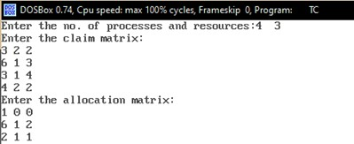
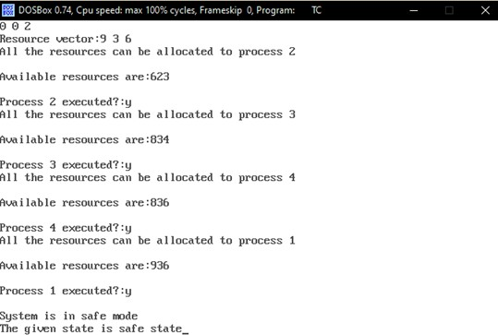

OUTPUT:

SOURCE CODE :
#include<stdio.h>
#include<conio.h>
int fr[3];
void main()
{
void display();
int i,j,page[12]={2,3,2,1,5,2,4,5,3,2,5,2};
int flag1=0,flag2=0,pf=0,frsize=3,top=0;
clrscr();
for(i=0;i<3;i++)
{
fr[i]=-1;
}
for(j=0;j<12;j++)
{
flag1=0;
flag2=0;
for(i=0;i<12;i++)
{
if(fr[i]==page[j])
{
flag1=1;
flag2=1;
break;
}
}
if(flag1==0){

for(i=0;i<frsize;i++)
{
if(fr[i]==-1)
{
fr[i]=page[j];
flag2=1;
break;
}
}
}
if(flag2==0)
{
fr[top]=page[j];
top++;
pf++;
if(top>=frsize)
top=0;
}
display();
}
printf("Number of page faults:%d",pf+frsize);
getch();
}
void display()
{
int i;
printf("\n");
for(i=0;i<3;i++)
printf("%d\t",fr[i]);
}

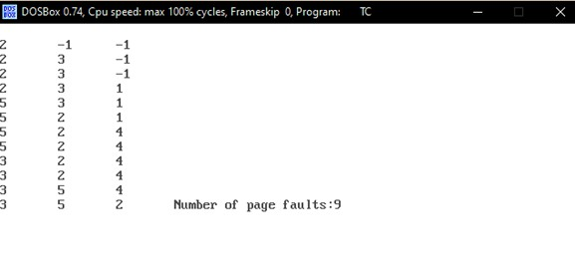
OUTPUT:

SOURCE CODE :
#include<stdio.h>
#include<conio.h>
int fr[3];
void main()
{
void display();
int p[12]={2,3,2,1,5,2,4,5,3,2,5,2},i,j,fs[3];
int index,k,l,flag1=0,flag2=0,pf=0,frsize=3;
clrscr();
for(i=0;i<3;i++)
{
fr[i]=-1;
}
for(j=0;j<12;j++)
{
flag1=0,flag2=0;
for(i=0;i<3;i++)
{
if(fr[i]==p[j])
{
flag1=1;
flag2=1;
break;
}
}
if(flag1==0)
{

for(i=0;i<3;i++)
{
if(fr[i]==-1)
{
fr[i]=p[j];
flag2=1;
break;
}
}
}
if(flay2==0)
{
for(i=0;i<3;i++)
fs[i]=0;
for(k=j-1,l=1;l<=frsize-1;l++,k--)
{
for(i=0;i<3;i++)
{
if(fr[i]==p[k])
fs[i]=1;
}
}
for(i=0;i<3;i++)
{
if(fs[i]==0)
index=i;
}
fr[index]=p[j];
pf++;
}

display();
}
printf("\n no of page faults:%d",pf+frsize);
getch();
}
void display()
{
int i;
printf("\n");
for(i=0;i<3;i++)
printf("\t%d",fr[i]);
}

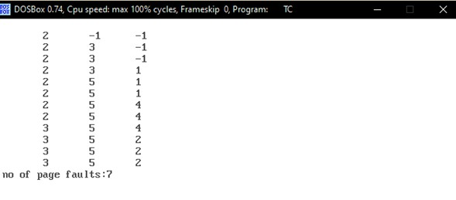

OUTPUT:

SOURCE CODE :
#include<stdio.h>
#include<conio.h>
#define max 25
void main()
{
int frag[max],b[max],f[max],i,j,nb,nf,temp,highest=0;
static int bf[max],ff[max];
clrscr();
printf("\nMemory Management scheme Worst Fit");
printf("\nEnter the number of blocks:");
scanf("%d",&nb);
printf("Enter the number of files:");
scanf("%d",&nf);
printf("\nEnter the size of the blocks:-\n");
for(i=1;i<=nb;i++)
{
printf("Block %d:",i);
scanf("%d",&b[i]);
}
printf("Enter the size of the files:-\n");
for(i=1;i<=nf;i++)
{
printf("File %d:",i);
scanf("%d",&f[i]);
}
for(i=1;i<=nf;i++)

{
for(j=1;j<=nb;j++)
{
if(bf[j]!=1)
{
temp=b[j]-f[i];
if(temp>=0)
if(highest<temp)
{
}
}
frag[i]=highest;
bf[ff[i]]=1;
highest=0;
}
ff[i]=j;
highest=temp;
}
printf("\nFile_no:\tFile_Size:\tBlock_no:\tBlock_size:\tFragement");
for(i=1;i<=nf;i++)
printf("\n%d\t\t%d\t\t%d\t\t%d\t\t%d",i,f[i],ff[i],b[ff[i]],frag[i]);
getch();
}

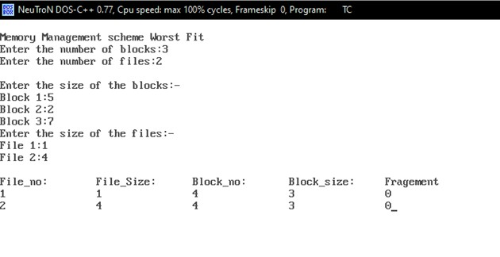

OUTPUT:

SOURCE CODE :
#include<stdio.h>
#include<conio.h>
#define max 25
void main()
{
int frag[max],b[max],f[max],i,j,nb,nf,temp,lowest=10000;
static int bf[max],ff[max];
clrscr();
printf("\nMemory Management scheme Best Fit");
printf("\nEnter the number of blocks:");
scanf("%d",&nb);
printf("Enter the number of files:");
scanf("%d",&nf);
printf("\nEnter the size of the blocks:-\n");
for(i=1;i<=nb;i++)
{
printf("Block %d:",i);
scanf("%d",&b[i]);
}
printf("Enter the size of the files:-\n");
for(i=1;i<=nf;i++)
{
printf("File%d:",i);
scanf("%d",&f[i]);
}
for(i=1;i<=nf;i++)

{
for(j=1;j<=nb;j++)
{
if(bf[j]!=1)
{
temp=b[j]-f[i];
if(temp>=0)
{
ff[i]=j;
lowest=temp;
}
}
}
frag[i]=lowest;
bf[ff[i]]=1;
lowest=10000;
}
printf("\nFile_no\tFile_size\tBlock_No\tBlock_size\tFragment");
for(i=1;i<=nf && ff[i]!=0;i++)
printf("\n%d\t\t%d\t\t%d\t\t%d\t\t%d",i,f[i],ff[i],b[ff[i]],frag[i]);
getch();
}

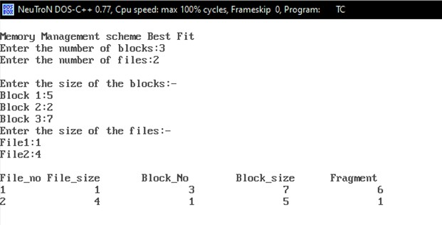

OUTPUT:

SOURCE CODE :
#include<stdio.h>
#include<conio.h>
#define max 25
void main()
{
int frag[max],b[max],f[max],i,j,nb,nf,temp;
static int bf[max],ff[max];
clrscr();
printf("\nmemory management schema first fit");
printf("\nEnter the number of blocks:");
scanf("%d",&nb);
printf("Enter the number of files:");
scanf("%d",&nf);
printf("\nEnter the size of the blocks:-\n");
for(i=1;i<=nb;i++)
{
printf("Block%d:",i);
scanf("%d",&b[i]);
}
printf("Enter the size of the files:-\n");
for(i=1;i<=nf;i++)
{
printf("file%d:",i);
scanf("%d",&f[i]);
}
for(i=1;i<=nf;i++)

{
for(j=1;j<=nb;j++)
{
if(bf[j]!=1)
{
temp=b[j]-f[i];
if(temp>=0)
{
ff[i]=j;
break;
}
}
}
frag[i]=temp;
bf[ff[i]]=1;
}
printf("\nFile_no:\tfile_size:\tBlock_no:\tBlock_size:\Fragement");
for(i=1;i<=nf;i++)
printf("\n%d\t\t%d\t\t%d\t\t%d\t\t%d",i,f[i],ff[i],b[ff[i]],frag[i]);
getch();
}

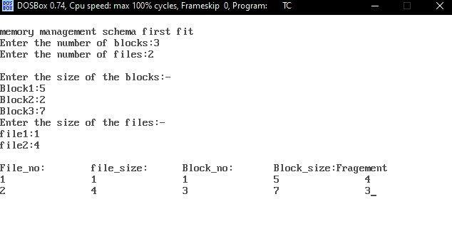

OUTPUT:

SOURCE CODE :
#include<stdio.h>
#include<unistd.h>
#include<string.h>
main()
{
int p1[2],p2[2],p3[2],p4[2];
int i,j=0,k=0;l=0;
char r[10],s[10],t[10],u[10];
printf("\tPROCESS 1 ENTER THE STRING");
scanf("%s",r);
pipe(p1);
pipe(p2);
write(p1[1],r,sizeof(r));
write(p2[1],r,sizeof(r));
if(a==0)
{
printf("\n\t PROCESS 2: it splite the given string\n");
read(p1[0],r,sizeof(r));
int n=strlen(r);
for(i=0;i<n/2;i++)
{
t[j++]=r[i];
}
pipe(p3);
pipe(p4);
write(p3[1],s,sizeof(s));

write(p4[1],t,sizeof(t));
int b=fork();
if(b==0)
{
printf("p4 %d\t", getpid());
printf("p2 %d\n", getppid());
read(p3[0],s,sizeof(s));
printf("\t PROCESS 4: sub string \t %d\t",s);
printf("no of char=%d\n",strlen(s));
}
else{
int c=fork();
if(c==0)
{
printf("p5 %d\t",getpid());
printf("p2 %d\n",getppid());
read(p4[0],t,sizeof(t));
printf("\t PROCESS 5: sub string \t %s\t",t);
else
{
wait();
printf("p2 %d\t",getpid());
printf("p1 %d\nn",getppid());
}
}
}
else
{

wait();
int d=fork();
if(d==0)
{
printf("p3 %d\t",getpid());
printf("p1 %d\n",getppid());
read(p2[0],r,sizeof(r));
for(i=strlen(r)-1;i>=0;i--)
{
u[l++]=r[i];
}
for(i=0;i<strlen(r);i++)
{
if(u[i]==r[i])
k++;
else continue;
}
if(k==strlen(r))
printf("\tPROCESS 3: the given string is palindrome\n");
else
{
printf("p1 %d\t,getpid());
printf("kernal %d\t\n",getppid());
}
}
}

OUTPUT:
Process 1: enter the string
ARUN
Process 2: it split eth string
P4 8137 p2 8136
Process 3: sub string a r no of char=2
P5 8138 p2 8136
Process 4: sub string u n no of char=2
P2 8136 P1 8132
Process 3: the given string string is not
palindrome
Process 1: enter the string MADAM
Process 2: it splits the string
P4 8137 P2 8136
Process 4: sub string m a no of char=2
P5 8138 P2 8136
Process 5: sub string dam no of char=3
P2 8136 P1 8132
P3 8139 P1 8132
Process 3: the given string is
palindrome

