Logging in to CrewClock
Sign in to your CrewClock account and reach your dashboard.
Overview
This guide walks you through signing in to CrewClock for the first time. It's intended for workers and supervisors who have been invited to an organization by their admin.
Prerequisites
- Your work email address
- The password set or provided by your admin
- A modern browser (Chrome, Edge, Safari, or Firefox)
Steps
1. Navigate to the login page
Open your browser and go to https://crewclock.app/login.
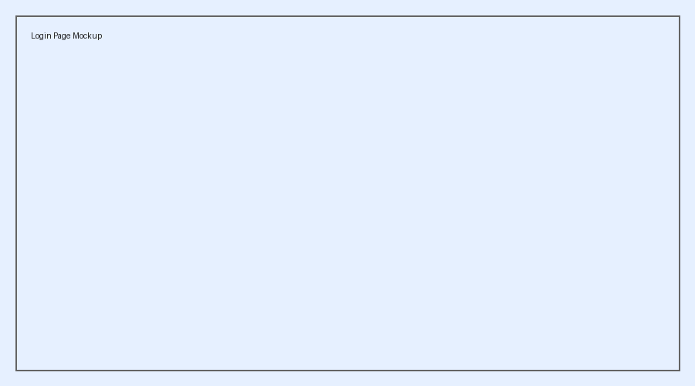
CrewClock login page
2. Enter your credentials
Type your work email in the Email field and your password in the Password field. Then click Sign In.
TIP
If you've forgotten your password, use the "Forgot password?" link below the form.

3. Land on your dashboard
After signing in successfully, you'll be taken to your dashboard where you can view your schedule and clock in.
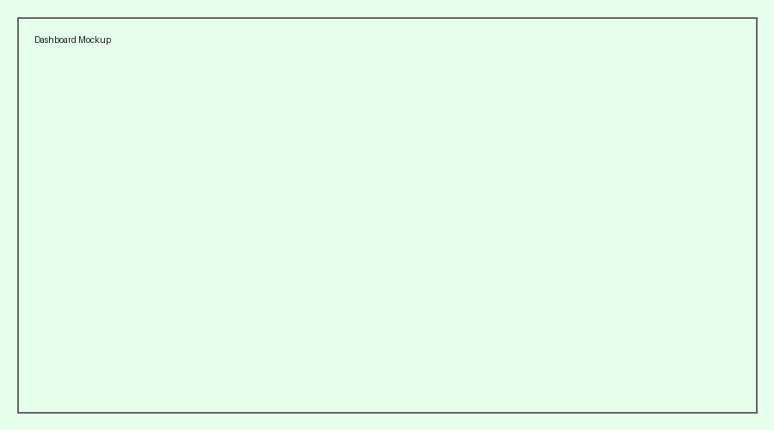
CrewClock dashboard
WARNING
Do not share your login URL or credentials with anyone outside your organization.

Helpful Resources
- Login URL: https://crewclock.app/login
- Support: support@crewclock.app
- Mobile app: Available on iOS and Android
Troubleshooting
I get "Invalid credentials"
Double-check your email for typos and make sure Caps Lock is off. If the problem persists, use "Forgot password?" to reset.
The page won't load
Confirm you're on a supported browser and check your internet connection. If your organization uses SSO, you may need to go through your company portal instead.

