ENTERPRISE SOC PROJECT
AI-Assisted Lightweight Enterprise SOC
using Splunk, Sysmon, MITRE ATT&CK and Automated Incident Response
Technical Project Documentation

Author | Muhammad Jamal
Environment | VMware-based lightweight SOC laboratory
SIEM | Splunk Enterprise 10.4.3
Primary Telemetry | Windows Event Logs + Sysmon
Documentation Date | 17 September 2026

Project statement
This project implements a compact enterprise-style Security Operations Center laboratory. It collects Windows and Sysmon telemetry in Splunk, develops custom detections, maps detections to MITRE ATT&CK, validates the environment with controlled security testing, demonstrates a scripted response workflow, and produces a lightweight incident-analysis prototype.

Table of Contents
1. Executive Summary
2. Project Background and Problem Statement
3. Objectives
4. Scope and Design Principles
5. System Architecture
6. Lab Inventory and Network Topology
7. Infrastructure Implementation
8. Splunk Deployment and Configuration
9. Windows Event and Sysmon Collection
10. Detection Engineering
11. MITRE ATT&CK Mapping
12. Attack Simulation and Validation
13. SOC Dashboard
14. Automated Response
15. Lightweight AI-Assisted Analysis
16. Testing and Validation Results
17. Security and Operational Considerations
18. Known Limitations and Unresolved Items
19. Final Project Assessment
20. Future Improvements
21. Conclusion
Appendix A. Evidence Screenshots
Appendix B. Detection SPL Reference
Appendix C. LinkedIn Presentation Set

1. Executive Summary
The project is a lightweight enterprise-style Security Operations Center (SOC) laboratory designed to demonstrate practical defensive security operations without requiring a large number of virtual machines or resource-intensive security platforms. The environment uses pfSense as the lab gateway, a Windows Server 2022 Domain Controller, a Windows 10 client, Kali Linux for controlled security testing, and an Ubuntu Server running Splunk Enterprise.
Windows telemetry is collected using the Splunk Universal Forwarder (UF). Sysmon provides detailed process creation telemetry on the Domain Controller, while Windows Security logs provide authentication and account management events. Splunk indexes the data in the windows index and provides searches, dashboards and scheduled detections.
The detection layer includes five saved and enabled alerts: PowerShell Process Execution, Suspicious PowerShell Activity, Windows Account Creation, Suspicious Process Execution, and Brute-Force Login Attempt. Failed-login Event ID 4625 data was successfully generated and searched, although the separate DET-002 alert was not reliably completed and is therefore not counted as a saved alert.
MITRE ATT&CK mapping was implemented for the detection logic. A scripted response component was created and manually validated, and a lightweight incident-analysis prototype generates structured JSON containing the incident context, MITRE technique, analysis and recommendations. The AI prototype is deterministic rather than a large language model; it is intentionally lightweight.
Evidence status
The project is technically functional and suitable as a portfolio/lab project. Some features are demonstrated but not fully end-to-end proven: scheduled alert execution was affected by the Splunk timezone/scheduling display, automated script execution was manually tested but not conclusively observed as a scheduler-triggered action, and Nmap traffic was not proven to generate Sysmon Event ID 3 telemetry.

2. Project Background and Problem Statement
Modern organizations generate large volumes of endpoint and authentication telemetry. Without centralized collection and correlation, an analyst must inspect multiple systems separately. This project addresses that problem by creating a small SOC workflow in which endpoint events are forwarded to a central SIEM, searched with detection logic, visualized in a dashboard, mapped to ATT&CK techniques and connected to response/analysis steps.

2.1 Problem Statement
- Security logs are distributed across Windows endpoints and are difficult to analyze centrally without a SIEM.
- PowerShell, authentication failures and process execution can provide useful indicators of suspicious activity.
- A SOC needs repeatable detections rather than relying only on manual event review.
- Detection results benefit from standardized ATT&CK mapping and documented response procedures.
- A portfolio SOC should demonstrate both technical implementation and evidence of validation.

3. Objectives
- Build a lightweight multi-system SOC lab in VMware.
- Centralize Windows telemetry in Splunk Enterprise.
- Deploy Sysmon on the Windows Server 2022 Domain Controller.
- Use Splunk Universal Forwarder to transmit endpoint logs to the Splunk server.
- Create a professional SOC dashboard for visibility.
- Develop custom detection rules for common Windows security events.
- Map detections to MITRE ATT&CK techniques.
- Perform controlled attack/reconnaissance simulations from Kali Linux.
- Create and test a scripted automated-response component.
- Create a lightweight incident-analysis prototype that outputs structured recommendations.
- Document testing evidence, limitations and future improvements.

4. Scope and Design Principles

4.1 In Scope
- Windows Server 2022 Domain Controller telemetry.
- Windows 10 endpoint telemetry.
- Sysmon process creation telemetry.
- Windows Security authentication and account-management events.
- Splunk Enterprise indexing, searching, dashboards and alerts.
- MITRE ATT&CK technique mapping.
- Kali-based reconnaissance/security testing.
- Scripted response logging.
- Lightweight structured incident analysis.

4.2 Design Principles
- Lightweight: avoid unnecessary VMs and heavy platforms.
- Practical: every major component should produce observable evidence.
- Modular: collection, detection, response and analysis are separate layers.
- Safe: simulations are performed inside the controlled lab.
- Honest evidence: features are documented as proven, partially proven or planned.

5. System Architecture
The implemented logical flow is:
Internet / Lab Gateway
|
pfSense
10.10.10.1
|
VMnet1
|
+-----+----------+----------------+----------------+
| | | |
DC01 Windows 10 Kali Splunk Server
10.10.10.10 10.10.10.11 10.10.10.30 10.10.10.40
Windows Server Windows client Testing Ubuntu Server
2022 + AD/DNS + UF/Sysmon / Nmap + Splunk
| | |
+-- Sysmon ------+---- UF -----> TCP/9997 --------+
|
Detection
|
Dashboard / Alerts
|
Response + Analysis
Important architecture note
The core telemetry path proven during testing is DC01 Sysmon → Splunk Universal Forwarder → 10.10.10.40:9997 → Splunk windows index. The Windows 10 forwarder was configured and active, but the project evidence relies primarily on the DC01 telemetry that was successfully observed in Splunk.

6. Lab Inventory and Network Topology
System | Role | IP Address | Key Components | Evidence
pfSense | Lab gateway/router | 10.10.10.1 | LAN gateway | Console screenshot
DC01 | Domain Controller + DNS | 10.10.10.10 | Windows Server 2022, AD, Sysmon, UF | AD / Sysmon / UF screenshots
Windows 10 | Endpoint | 10.10.10.11 | Windows 10, UF, Sysmon | IP configuration screenshot
Kali | Security testing | 10.10.10.30 | Nmap and testing tools | Nmap screenshot
Splunk Server | SIEM | 10.10.10.40 | Ubuntu Server, Splunk Enterprise | IP + Splunk screenshots

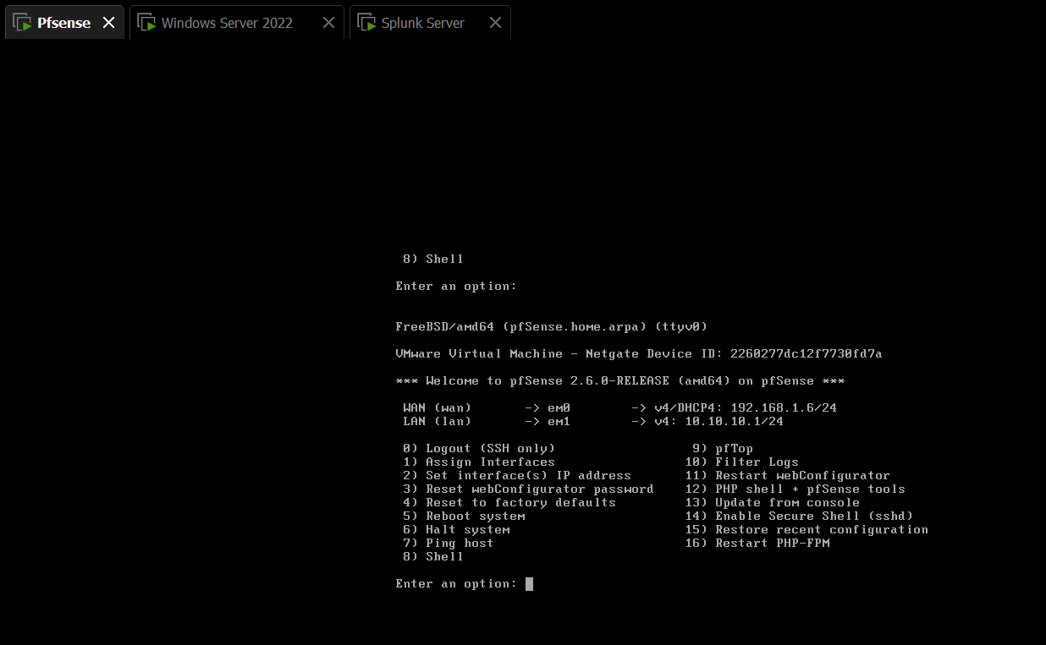
Figure 1. pfSense lab gateway console and LAN configuration context.
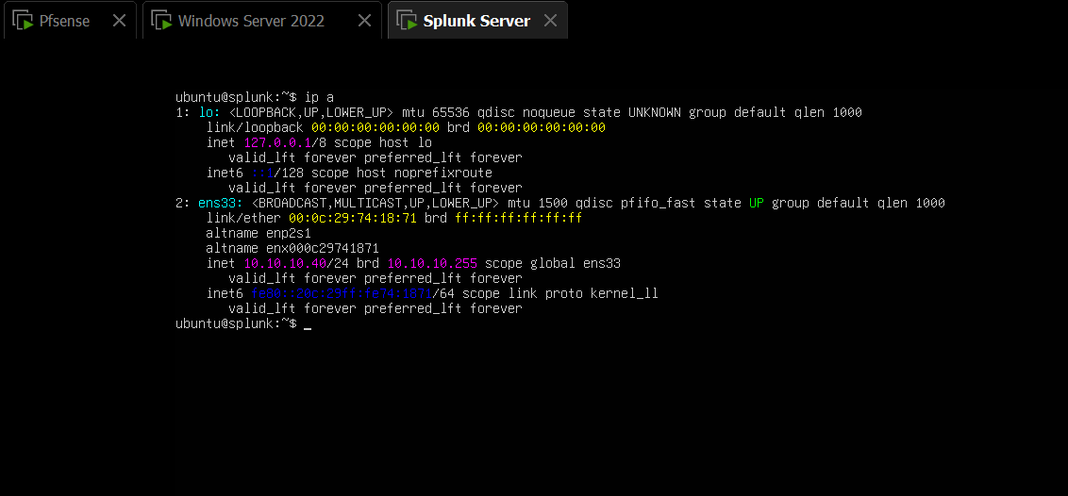
Figure 2. Splunk Ubuntu Server network interface showing 10.10.10.40/24.
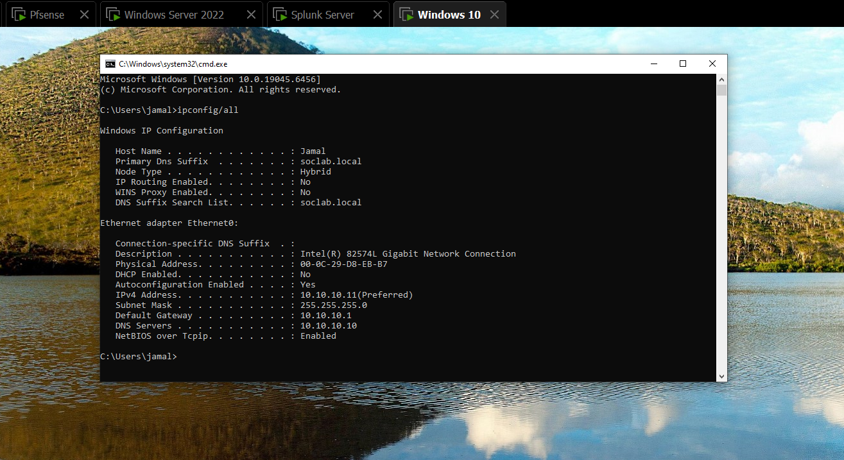
Figure 3. Windows 10 network configuration showing 10.10.10.11 and DNS 10.10.10.10.
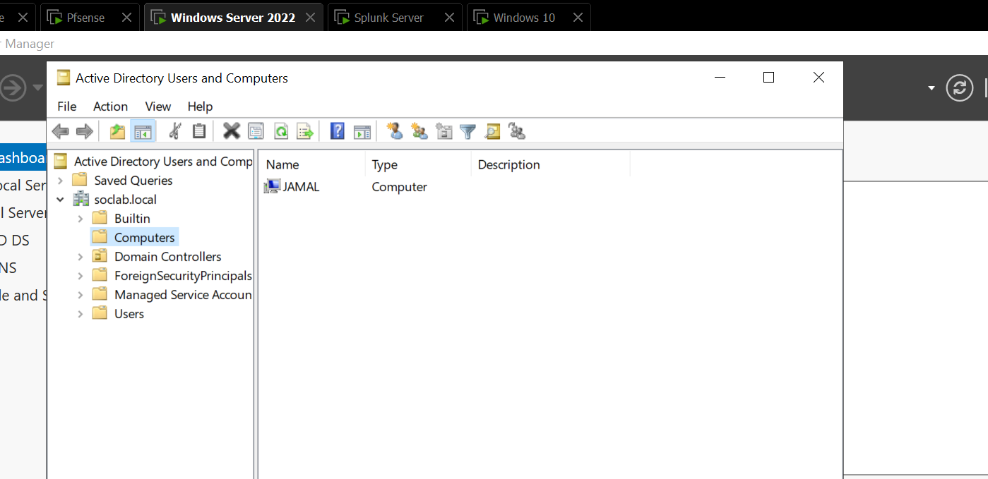
Figure 4. Active Directory Users and Computers showing the soclab.local domain.

7. Infrastructure Implementation

7.1 Domain Controller
Windows Server 2022 was promoted to a Domain Controller for the soclab.local domain and provides Active Directory and DNS services. This gives the lab an enterprise-like identity and authentication context.

7.2 Windows 10 Endpoint
The Windows 10 machine was joined to soclab.local and configured with a static address of 10.10.10.11/24. The system was used as an endpoint telemetry source.

7.3 Kali Linux
Kali Linux was connected to the same VMnet1 internal network and configured at 10.10.10.30/24. Connectivity to DC01 and the Splunk server was verified with ping.

7.4 Splunk Server
Ubuntu Server was configured at 10.10.10.40/24 and Splunk Enterprise 10.4.3 was installed under /opt/splunk. Splunk Web was accessed at http://10.10.10.40:8000 and the receiving port 9997 was enabled.

8. Splunk Deployment and Configuration

8.1 Splunk Indexes
- windows — primary Windows/Sysmon event index.
- soc_alerts — SOC alert pipeline/test index.

8.2 Forwarding
The Universal Forwarder on DC01 was configured to forward events to 10.10.10.40:9997. The forwarder status reported an active forward and no inactive configured forward.
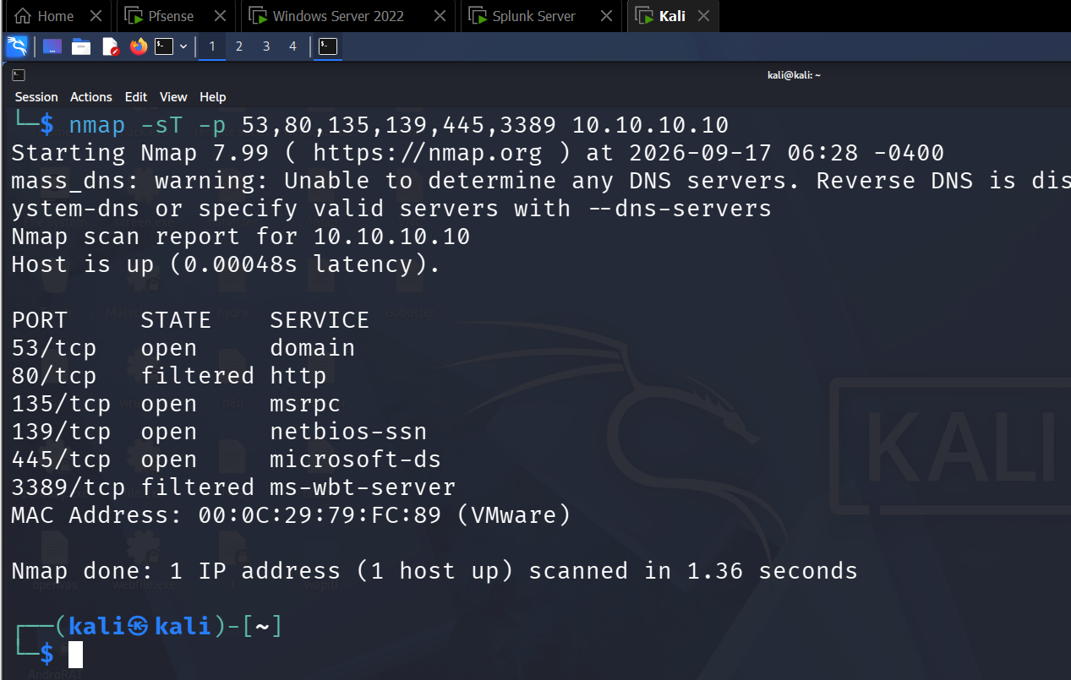
Figure 5. DC01 Universal Forwarder showing an active forward to 10.10.10.40:9997.

8.3 Ingestion Verification
The following SPL query was used to verify that the windows index contained multiple Windows event sources:
index=windows | stats count by host sourcetype
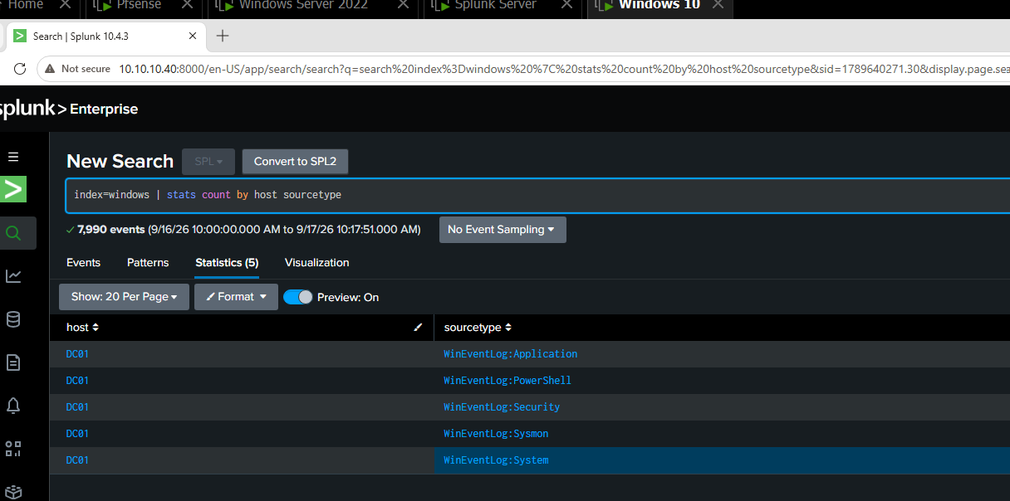
Figure 6. Splunk ingestion verification showing DC01 data across Application, PowerShell, Security, Sysmon and System sourcetypes.

9. Windows Event and Sysmon Collection

9.1 Sysmon Installation
Sysmon 15.22 was installed on DC01 and verified as a running service. The Microsoft-Windows-Sysmon/Operational log was enabled and produced Event ID 1 process-creation events.
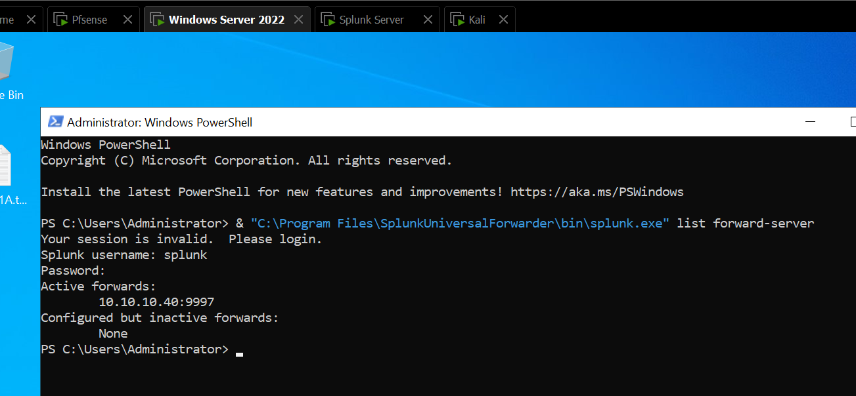
Figure 7. Sysmon64 service running on Windows Server 2022.
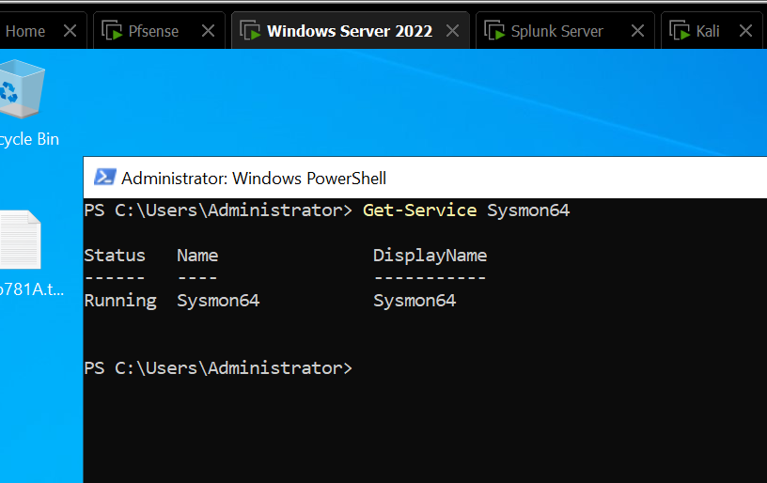
Figure 8. Native Windows Sysmon Operational log showing Event ID 1 Process Create events.

9.2 Splunk Sysmon Search
index=windows sourcetype=WinEventLog:Sysmon EventCode=1
| table _time host User Image CommandLine ParentImage
| head 15
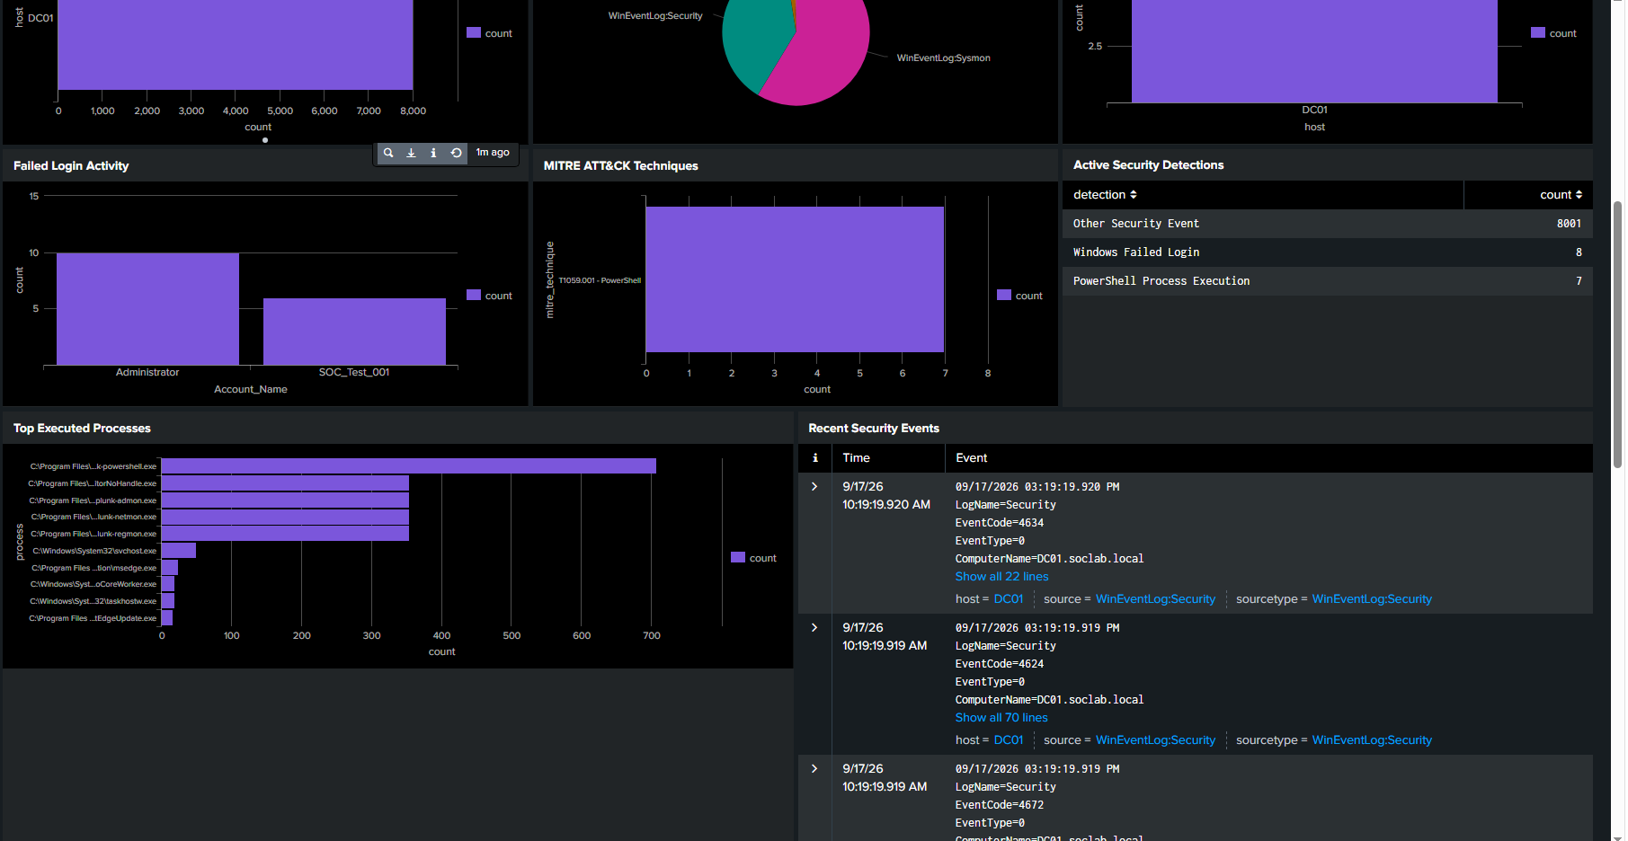
Figure 9. Splunk search returning Sysmon Event ID 1 process creation telemetry.

10. Detection Engineering
Detection engineering was implemented as a set of saved scheduled searches. Five detections are currently saved and enabled. DET-002 failed-login data was successfully collected but its dedicated saved alert was not reliably completed.

10.1 DET-001 — PowerShell Process Execution
index=windows sourcetype=WinEventLog:Sysmon EventCode=1
| search Image="*\\powershell.exe"
| eval severity="Medium"
| eval detection="PowerShell Process Execution"
| eval mitre_technique="T1059.001"
| table _time host User Image CommandLine ParentImage severity detection mitre_technique
A harmless PowerShell command was executed to generate a controlled detection event.
powershell.exe -NoProfile -Command "Write-Output 'SOC PowerShell Detection Test'"
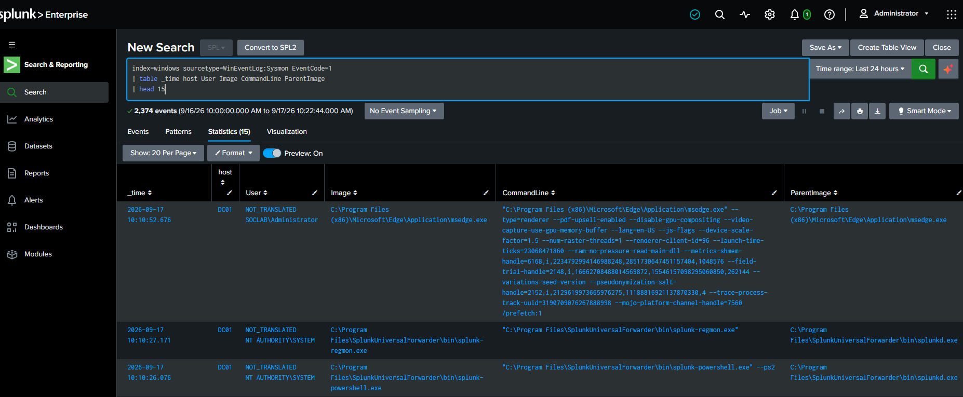
Figure 10. Splunk PowerShell process detection results, including controlled test commands.

10.2 DET-003 — Suspicious PowerShell Activity
DET-003 extends PowerShell monitoring toward suspicious command-line activity. A controlled test included a command containing the Invoke-Expression string to create observable telemetry.
powershell.exe -NoProfile -Command "Write-Output 'Invoke-Expression DET-003 FINAL TEST'"

10.3 DET-004 — Windows Account Creation
Windows Security Event ID 4720 was successfully observed and used as the basis for account-creation detection.
index=windows sourcetype=WinEventLog:Security EventCode=4720
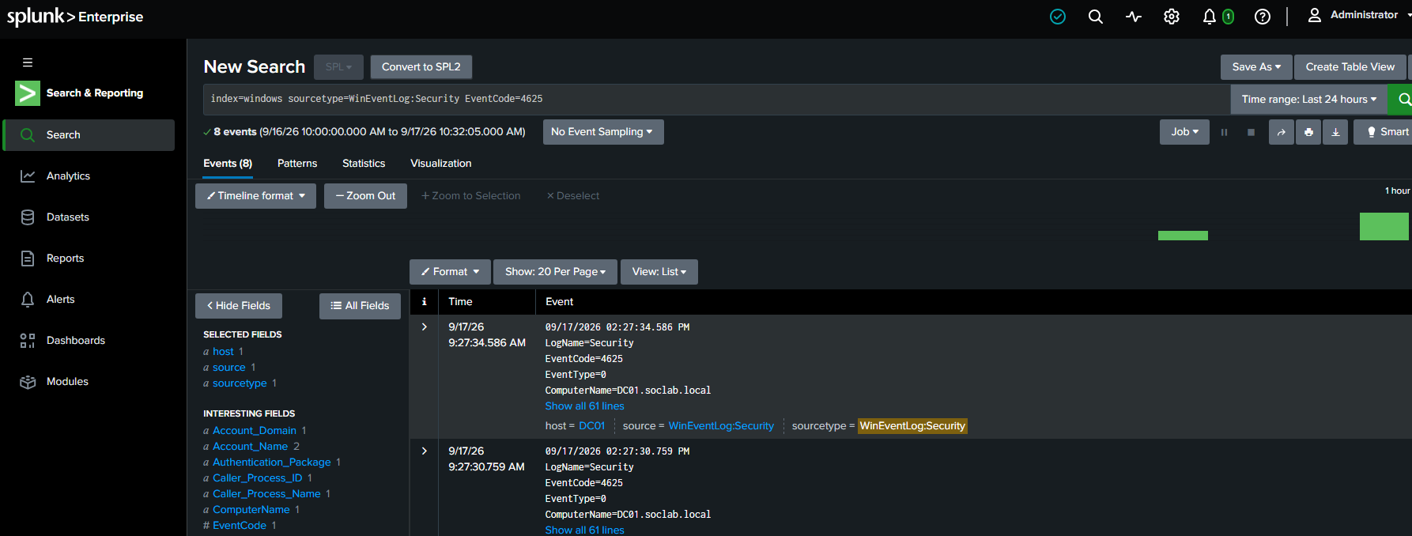
Figure 11. Splunk evidence for Windows Security Event ID 4720 (account creation).

10.4 DET-005 — Suspicious Process Execution
This detection focuses on process execution that may be useful for command-and-scripting visibility, including cmd.exe-related activity.

10.5 DET-006 — Brute-Force Login Attempt
This detection uses Windows failed authentication events as the basis for identifying repeated login failures.
index=windows sourcetype=WinEventLog:Security EventCode=4625
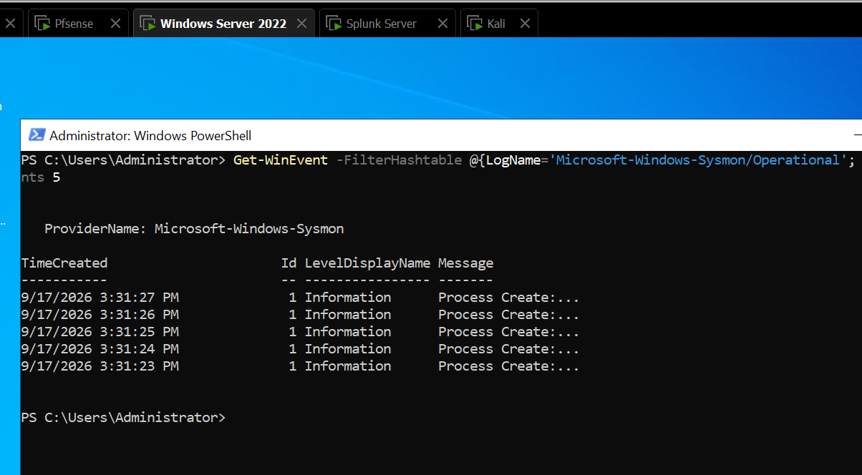
Figure 12. Splunk evidence for Windows Security Event ID 4625 failed-login events.

10.6 Saved Alert Status
The Alerts page showed five enabled saved detections.
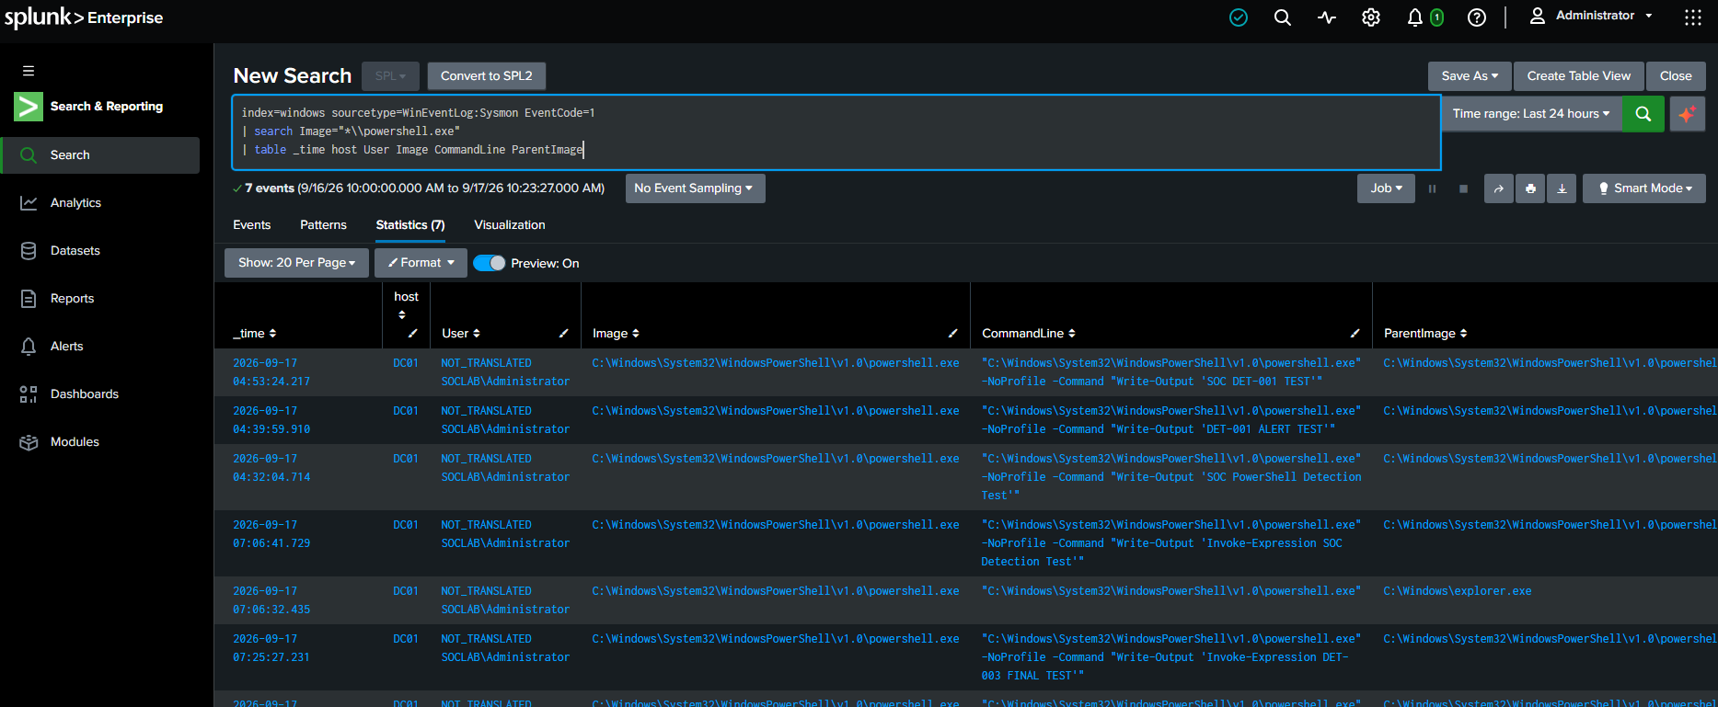
Figure 13. Splunk Alerts page showing five saved and enabled detections.

11. MITRE ATT&CK Mapping
The project maps the detection logic to MITRE ATT&CK techniques so that detections can be described using a standard adversary-behavior framework.
Detection | Technique ID | Technique | Purpose
DET-001 / DET-003 | T1059.001 | PowerShell | PowerShell execution/activity
DET-004 | T1136.002 | Domain Account | Account creation in Active Directory
DET-005 | T1059 | Command and Scripting Interpreter | Suspicious command/process execution
DET-006 | T1110 | Brute Force | Repeated failed authentication

The mapping search used in the project was:
index=windows
| eval detection=case(
sourcetype="WinEventLog:Sysmon" AND EventCode=1 AND like(Image,"%\\powershell.exe"), "DET-001 / DET-003 - PowerShell Activity",
sourcetype="WinEventLog:Security" AND EventCode=4625, "DET-002 / DET-006 - Failed Login / Brute Force",
sourcetype="WinEventLog:Security" AND EventCode=4720, "DET-004 - Account Creation",
sourcetype="WinEventLog:Sysmon" AND EventCode=1 AND like(Image,"%\\cmd.exe"), "DET-005 - Suspicious Process",
true(), null()
)
| eval mitre_technique=case(
like(detection,"%PowerShell%"), "T1059.001 - PowerShell",
like(detection,"%Failed Login%"), "T1110 - Brute Force",
like(detection,"%Account Creation%"), "T1136.002 - Domain Account",
like(detection,"%Suspicious Process%"), "T1059 - Command and Scripting Interpreter"
)
| where isnotnull(detection)
| stats count by detection mitre_technique
| sort detection
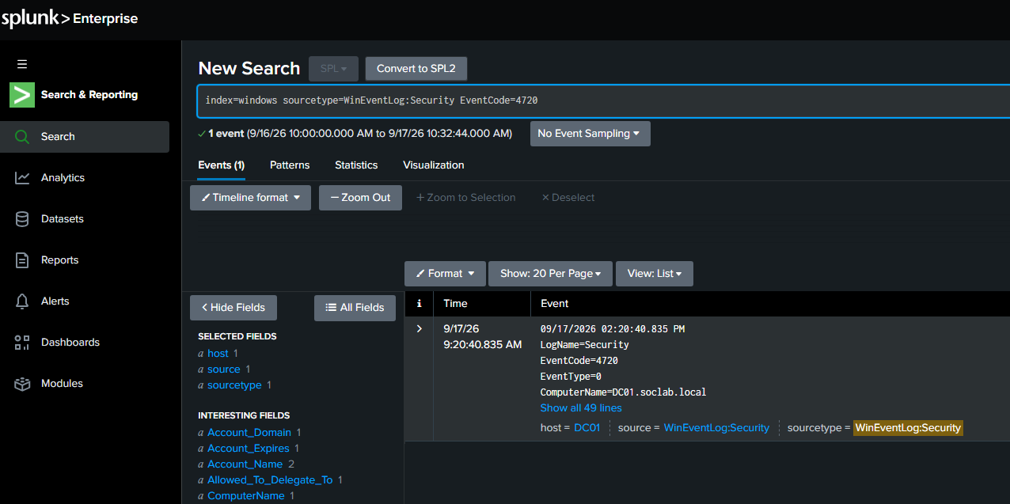
Figure 14. Splunk MITRE/detection evidence from the project.

12. Attack Simulation and Validation
Kali Linux was used as the controlled security-testing system. Network connectivity was verified before performing reconnaissance. The main demonstrated simulation was an Nmap TCP scan against DC01.
nmap -sT -p 53,80,135,139,445,3389 10.10.10.10
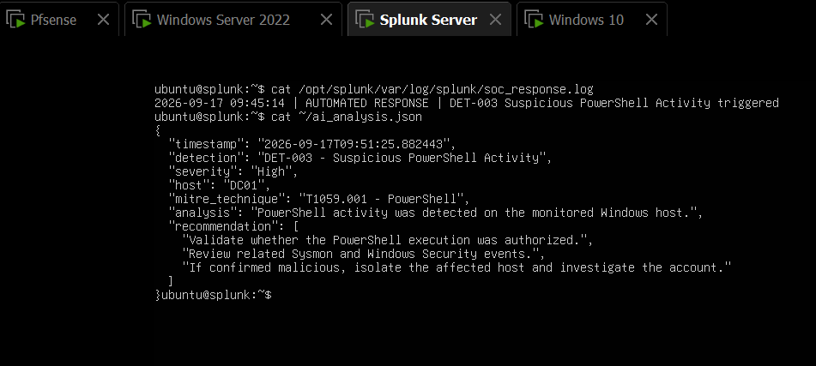
Figure 15. Kali Linux Nmap TCP scan against the lab Domain Controller.

12.1 Observed Scan Results
- 53/tcp — open — DNS/domain
- 80/tcp — filtered — HTTP
- 135/tcp — open — MSRPC
- 139/tcp — open — NetBIOS-SSN
- 445/tcp — open — Microsoft-DS/SMB
- 3389/tcp — filtered — RDP
Validation boundary
The Nmap scan proves the Kali-to-DC01 testing path and exposes the lab service surface. It was not proven that this Nmap scan generated a corresponding Sysmon Event ID 3 network-connection event, so the documentation does not claim that the scan was detected by Splunk.

13. SOC Dashboard
The Enterprise SOC Dashboard consolidates the most important visibility points into a single interface. The dashboard includes KPI panels, event trends, host and sourcetype distributions, PowerShell activity, failed-login activity, MITRE technique information, active detection counts, top processes and recent events.
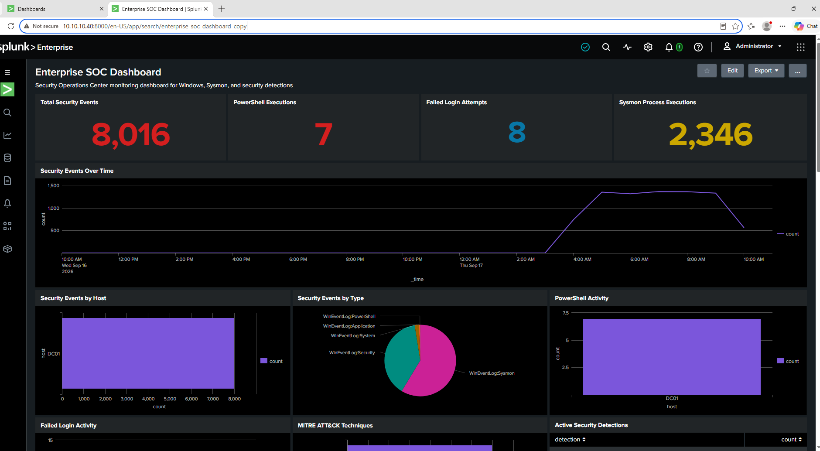
Figure 16. Enterprise SOC Dashboard — full primary view.
Figure 17. Lower dashboard panels showing process activity, recent events and security context.

13.1 Dashboard Panels
Panel | Purpose / Query
Total Security Events | index=windows | stats count
PowerShell Executions | index=windows sourcetype=WinEventLog:Sysmon EventCode=1 | search Image="*\\powershell.exe" | stats count
Failed Login Attempts | index=windows sourcetype=WinEventLog:Security EventCode=4625 | stats count
Sysmon Process Executions | index=windows sourcetype=WinEventLog:Sysmon EventCode=1 | stats count
Security Events Over Time | index=windows | timechart span=1h count
Security Events by Host | index=windows | stats count by host | sort - count
Security Events by Type | index=windows | stats count by sourcetype | sort - count
PowerShell Activity | index=windows sourcetype=WinEventLog:Sysmon EventCode=1 | search Image="*\\powershell.exe" | stats count by host | sort - count
Failed Login Activity | index=windows sourcetype=WinEventLog:Security EventCode=4625 | stats count by Account_Name | sort - count
MITRE ATT&CK Techniques | PowerShell activity mapped to T1059.001
Active Security Detections | case-based detection classification
Top Executed Processes | Sysmon Event ID 1 process counts
Recent Security Events | latest Windows/Sysmon events

14. Automated Response
A response script named soc_response.sh was created under /opt/splunk/bin/scripts/. Its current behavior is deliberately lightweight: it appends a timestamped response message to the Splunk log directory.
#!/bin/bash
echo "$(date '+%Y-%m-%d %H:%M:%S') | AUTOMATED RESPONSE | DET-003 Suspicious PowerShell Activity triggered" >> /opt/splunk/var/log/splunk/soc_response.log
The script was added to the DET-003 trigger-action configuration as a Run a Script action. A manual execution successfully created the expected response log entry.
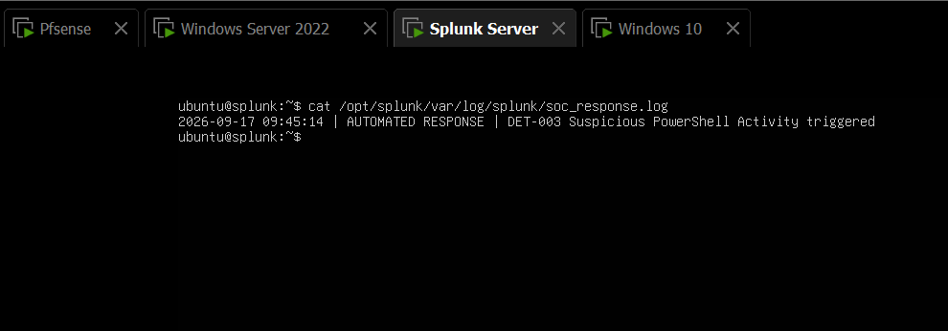
Figure 18. Automated response log showing the DET-003 response message.
Important evidence distinction
The script itself is proven to execute and write its response log. The project did not conclusively observe Splunk's scheduler executing the script automatically after a fresh detection, so this is documented as a tested response component rather than a fully proven end-to-end automatic containment system.

15. Lightweight AI-Assisted Analysis
The project includes a lightweight incident-analysis prototype. An incident is represented as JSON and then processed by a Python script that produces another JSON document containing a timestamp, detection, severity, host, MITRE technique, analysis statement and recommended actions.
{
"detection": "DET-003 - Suspicious PowerShell Activity",
"severity": "High",
"host": "DC01",
"technique": "T1059.001 - PowerShell",
"description": "Potentially suspicious PowerShell command-line activity detected."
}
The prototype output includes recommendations such as validating authorization, reviewing related Sysmon and Security events, and isolating the host if malicious activity is confirmed.
Figure 19. Project evidence context for the suspicious PowerShell incident and test environment.
Figure 20. Response logging evidence associated with the incident workflow.
Figure 21. Response evidence retained for auditability; the structured AI output is documented below.
{
"timestamp": "2026-09-17T09:51:25.882443",
"detection": "DET-003 - Suspicious PowerShell Activity",
"severity": "High",
"host": "DC01",
"mitre_technique": "T1059.001 - PowerShell",
"analysis": "PowerShell activity was detected on the monitored Windows host.",
"recommendation": [
"Validate whether the PowerShell execution was authorized.",
"Review related Sysmon and Windows Security events.",
"If confirmed malicious, isolate the affected host and investigate the account."
]
}
AI implementation note
The current prototype is rule-based/deterministic Python analysis, not an actual machine-learning model or LLM. It is intentionally lightweight and can later be connected to a cloud/API model if desired.

16. Testing and Validation Results
Test | Method | Observed Result | Status
VM network connectivity | Ping between lab hosts | Hosts communicated on 10.10.10.0/24 | PASS
UF forwarding | splunk list forward-server | 10.10.10.40:9997 active | PASS
Sysmon service | Get-Service Sysmon64 | Running | PASS
Sysmon Event ID 1 | Get-WinEvent + Splunk search | Process Create events observed | PASS
PowerShell detection | Controlled PowerShell command | 7 matching events observed | PASS
Failed login telemetry | Controlled bad-password attempt | Event ID 4625 observed | PASS
Account creation telemetry | Event ID 4720 search | 1 event observed | PASS
Kali reconnaissance | Nmap TCP scan | Ports/services identified | PASS
Response script | Manual script execution | soc_response.log entry created | PASS
AI analysis prototype | Python script | Structured JSON output created | PASS
DET-002 saved alert | Scheduled alert build | Not reliably completed | PARTIAL
Automatic scheduler → script | Fresh detection trigger | Not conclusively observed | PARTIAL
Sysmon Event ID 3 for Nmap | Get-WinEvent Event ID 3 | No matching event found | NOT PROVEN
Splunk timezone scheduling | user-prefs Asia/Karachi | Preference saved; schedule display remained a caveat | PARTIAL

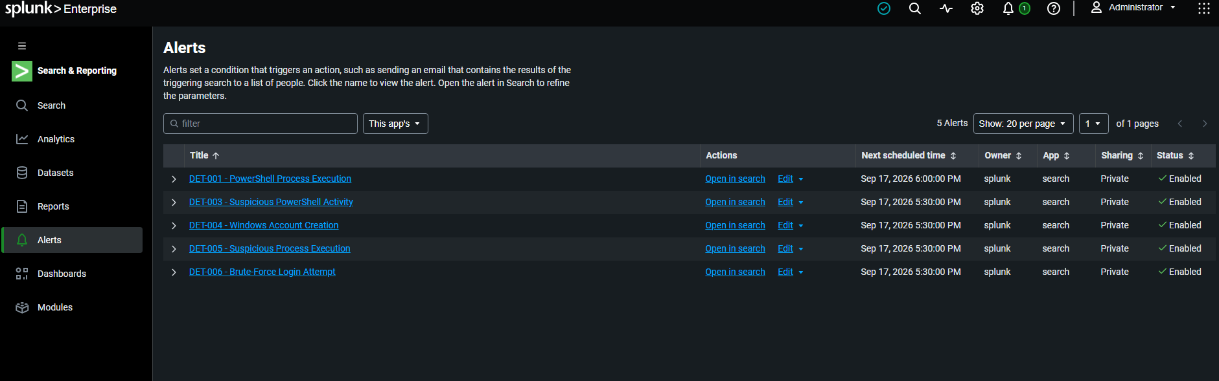
Figure 22. Splunk saved-alert list used during final validation.

17. Security and Operational Considerations
- All attack simulation should remain inside the authorized lab environment.
- Real production credentials, secrets, tokens and personal data should never be placed into the lab or public screenshots.
- Response actions such as host isolation should require analyst confirmation in a production design.
- Detection thresholds should be tuned to reduce false positives before deployment.
- Splunk indexes should use appropriate retention and access controls in a real organization.
- Sysmon configuration should be expanded carefully because high-volume telemetry can increase storage and CPU usage.
- Scheduled alert behavior should be validated with a known test event before relying on it operationally.

18. Known Limitations and Unresolved Items
DET-002: Failed-login telemetry exists, but the dedicated saved alert was not reliably completed.
Scheduler/timezone: The user preference was saved as Asia/Karachi, but the displayed next-run times remained a caveat. This was intentionally left unresolved to prioritize project completion.
Automated response: The soc_response.sh script was manually tested and configured as an alert action, but scheduler-triggered execution was not conclusively proven.
Nmap detection: The Nmap scan was successful, but a Sysmon Event ID 3 event was not observed; therefore scan detection is not claimed.
Windows 10 Sysmon: The project had earlier ingestion difficulties on the Windows 10 Sysmon source; the strongest validated Sysmon pipeline is DC01.
AI: The current analysis engine is deterministic Python logic and should not be presented as a trained AI model or LLM.
Dashboard counts: Dashboard values are lab/test data and should not be interpreted as production threat volume.

19. Final Project Assessment
The project demonstrates the complete core lifecycle of a lightweight SOC portfolio lab: endpoint telemetry collection, centralized SIEM ingestion, detection engineering, ATT&CK mapping, controlled security testing, dashboarding, scripted response and structured incident analysis.
Completion statement
The core technical project is complete enough for portfolio presentation and documentation. The remaining items are validation refinements rather than requirements for the basic SOC demonstration.

20. Future Improvements
- Complete and validate DET-002 as a saved scheduled alert.
- Prove the full Splunk scheduler → response-script chain with a controlled test event.
- Add Sysmon Event ID 3 collection with a suitable Sysmon configuration and validate network detections.
- Extend detection logic with parent-child process relationships, encoded PowerShell, suspicious LOLBins and privilege-related events.
- Add risk scoring and alert triage fields.
- Add a small incident queue and analyst workflow.
- Integrate a real lightweight cloud/API LLM only if needed, with privacy controls and redaction.
- Create response actions that can safely disable accounts or isolate endpoints only after analyst approval.
- Add Windows 10 telemetry as a second fully validated endpoint.
- Package the project with configuration files, screenshots, a README and a short demonstration video.

21. Conclusion
This project provides a practical demonstration of SOC engineering using a resource-conscious virtual lab. Splunk serves as the central SIEM, Sysmon supplies detailed endpoint process telemetry, Windows Security logs provide identity and authentication visibility, MITRE ATT&CK provides a standardized threat-behavior vocabulary, Kali provides controlled validation activity, and the response/analysis layer demonstrates how a SOC can move from detection toward action.
The most important achievement is not the number of tools installed, but the connected workflow: collect → analyze → detect → map → respond → document. The documented limitations also make the project more credible because they distinguish tested capabilities from planned or partially validated capabilities.

Appendix A. Evidence Screenshots
The following appendix consolidates the principal screenshots supplied during the project. They are arranged to provide traceable evidence for infrastructure, ingestion, Sysmon, detections, dashboarding, response and testing.
A1. pfSense gateway console.
A2. Splunk Ubuntu Server IP configuration.
A3. Active Directory Users and Computers.
A4. Windows 10 IP configuration.
A5. Universal Forwarder active forward.
A6. Sysmon64 service running.
A7. Native Sysmon Event ID 1 evidence.
A8. Splunk ingestion by host and sourcetype.
A9. Splunk Sysmon process-event search.
A10. PowerShell detection evidence.
A11. Five saved and enabled alerts.
A12. Failed-login Event ID 4625 evidence.
A13. Account-creation Event ID 4720 evidence.
A14. MITRE/detection evidence.
A15. Kali Nmap reconnaissance.
A16. Enterprise SOC Dashboard.
A17. Automated response log.

Appendix B. Detection SPL Reference

DET-001 — PowerShell Process Execution
index=windows sourcetype=WinEventLog:Sysmon EventCode=1
| search Image="*\\powershell.exe"
| eval severity="Medium"
| eval detection="PowerShell Process Execution"
| eval mitre_technique="T1059.001"
| table _time host User Image CommandLine ParentImage severity detection mitre_technique

Failed Login Telemetry / DET-006 Basis
index=windows sourcetype=WinEventLog:Security EventCode=4625
| stats count as failed_attempts by host Account_Name src_ip
| eval severity="Medium"
| eval detection="Windows Failed Login"
| eval mitre_technique="T1110"
| where failed_attempts >= 1
| table host Account_Name src_ip failed_attempts severity detection mitre_technique

Account Creation / DET-004 Basis
index=windows sourcetype=WinEventLog:Security EventCode=4720
| table _time host Account_Name Account_Domain

Sysmon Process Creation
index=windows sourcetype=WinEventLog:Sysmon EventCode=1
| table _time host User Image CommandLine ParentImage
| head 15

Ingestion Health
index=windows
| stats count by host sourcetype

Appendix C. LinkedIn Presentation Set
Six polished visuals were prepared separately for the eventual LinkedIn post. They should be treated as presentation graphics rather than primary technical evidence. The recommended order is:
Order | Visual | Purpose
1 | SOC Lab Architecture | High-level architecture and detection/response workflow.
2 | Enterprise SOC Dashboard | Clean overview of monitoring and SOC visibility.
3 | Detection Engineering | Saved detections and alerting workflow.
4 | MITRE ATT&CK Mapping | Detection-to-technique relationship.
5 | Attack Simulation & Reconnaissance | Controlled Kali/Nmap validation.
6 | Automated Response & AI Analysis | Response logging and incident-analysis concept.
Public-posting checklist
Before publishing, remove or crop sensitive lab details that you do not want public. Do not expose passwords, tokens, personal information or unnecessary internal configuration. Keep claims aligned with the evidence in this document.

Document Control and Evidence Notes
Prepared from the project implementation, terminal outputs, Splunk screenshots and testing evidence collected during September 2026.
Primary validated SIEM: Splunk Enterprise 10.4.3.
Primary validated endpoint telemetry source: DC01 / Windows Server 2022.
Primary validated Sysmon event: Event ID 1 — Process Create.
Primary validated authentication event: Event ID 4625 — Failed Logon.
Primary validated account-management event: Event ID 4720 — User Account Created.
Primary controlled reconnaissance test: Nmap TCP scan from Kali against 10.10.10.10.
Response component: /opt/splunk/bin/scripts/soc_response.sh.
Analysis prototype: /home/ubuntu/ai_analyze_incident.py producing /home/ubuntu/ai_analysis.json.

End of documentation
Enterprise SOC Project — Muhammad Jamal

